Modular Power and Fiber Distribution with DC Circuit Fault Notification
AUTHORS:
Caleb Quisenberry
Caleb Quisenberry
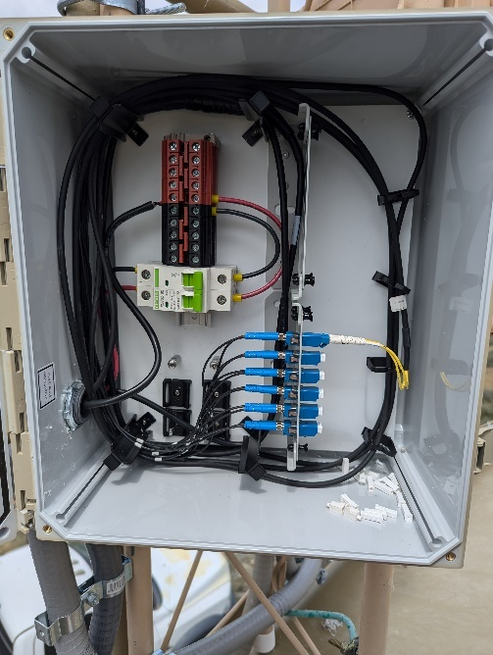

Technical Field
- This innovation applies to Network Engineering at Layer One of the OSI model, without the physical connections, there is no network to engineer. The same idea applies to the field of Network Security. Security of cabling and physical assets is a vital part of defense in depth strategies.
- Courses not taken yet that would be beneficial include CSC230, CSC235, CSC285, NTW233, and RBT173. Most of these are to learn about the microcontroller that would be used for monitoring and email alarm functionality.
- A list of required skills to complete this project include physical engineering skills, Python to program the microcontroller, IoT and IoT security skills, and the understanding of multiple layers of network security.

Background Information

This project is the result of a real-world need encountered while designing Fixed Wireless Access (FWA) sites. The network restraints of base nodes means that there is a hard cap on number of remote nodes that can connect. To increase site capacity more base nodes need to be added, but this is not usually necessary on initial site turn up. The ability to have power and fiber distribution near the base node means that additional cells can be added easily with much shorter cabling runs from the distribution node to the radio. The need for information about the state of the circuit protection without sending a tower professional up the tower inspired this innovation.

Prior Art

OptiFlex Hybrid Cables: This product is a solution to one aspect of the problem addressed by my solution. It does not address distribution, power circuit protection, or monitoring. https://www.cables-unlimited.com/products/optiflex-hybrid-cables-and-wireless-tower-solutions/

Eupen Cable USA Power and Fiber Distribution Junction Box: This product addresses power distribution and protection as well as fiber distribution. The innovations offered by my solution include monitoring and alarm notifications as well as a more cost-effective and modular design. https://eupen.us/products/power-and-fiber-distribution-junction-boxes/

Project Description
This project will focus on the design and programming of a Raspberry Pi to monitor the state of two relays. These relays will be in a normally open state while DC power is present at the point they monitor. A change in that status would cause the microcontroller to send email and SMS alerts. Depending on the site, external LEDs could be illuminated for visual confirmation of circuit status.

Innovation Claim
This project’s innovation comes from hands-on experience in the field and a drive to continuously improve site infrastructure. The possibilities for growth in the field of FWA means that the need for efficient, secure infrastructure management will only increase.

Usage Scenario
This monitoring and reporting system could easily be decoupled from the originally intended circuit and could be deployed to monitor anything that can affect the state of a relay. This could include alarm outputs from network monitoring devices or physical intrusion detection systems. With standalone power and a site independent data link, use as a backup or redundant alarm system is a real possibility.

Evaluation Criteria
The following questions will identify the successful completion of the project. Can the microcontroller connect to an LTE network? Are common security practices such as firewall usage and permission management implemented on the microcontroller? Can the microcontroller detect a change of state on both relays, independently? Can the microcontroller send both SMS and email alerts upon change of state?

Objectives and Tasks Associated with the Project
- Acquire a microcontroller for use as a prototype.
  - Research and comparison of platforms. Completion estimated by September 25th.
  - Raspberry Pi 4 has been chosen as the hardware, and a device has been ordered.
  - Further research is ongoing as to how to monitor the -48vdc, and if other monitoring such as current draw should be added.
- Develop familiarity with microcontroller operating systems and harden the device.
  - Update system
  - Change default logins
  - Add a sub root user
  - Install a firewall, UFW
- Configure microcontroller to send email and SMS
  - Python scripting
- Design and provision the power monitoring circuit
  - Decide on relays or more in-depth monitoring.
- Acquire and provision the LTE modem
  - https://www.jeffgeerling.com/blog/2022/using-4g-lte-wireless-modems-on-raspberry-pi
  - SIM card and data plan. A data only SIM is available from my current provider at no extra cost other than data usage.
- Assemble all the moving pieces and test until an MVP can be achieved.

Description of Design Prototype
The main parts of the project are the voltage monitoring devices, the microcontroller, and the modem. The voltage monitoring can be accomplished with a simple relay, though more in depth information could be monitored with voltage sensors. Testing of these would include a simulated power fail of the incoming circuit, a breaker trip, and restoration of the circuit. At a minimum, all three states should be detected. The Raspberry family of devices has been chosen, mostly due to the wealth of information available about them. A Pi 4 or Pi 5 would seem to be the optimal choice, with the five taking a slight lead due to less idle power consumption. This lowers the required storage capacity for the battery and allows for a smaller solar panel.

Evaluation Plan
The system will be evaluated by cycling through several circuit states. Initially voltage will be present on the line incoming to the circuit protection as well as the outgoing feed to the distribution bus. The circuit protection will be placed in a tripped state, and SMS and email alerts will be recorded. Next, the main power will be interrupted, and SMS and email alerts will be recorded. Main power will then be restored, and corresponding alerts recorded. Then, the circuit breaker will be reset and the circuit restored to functionality, with the corresponding alerts.

Project Completion Assessment
Note: This section must be completed prior to SIP408
Leaving this as a placeholder for use on project completion.

Provide an in-depth description of the completion assessment of your project. Describe how well the completed components function and highlight the innovative facets of your design. This is sometimes known as a “Post-Mortem” or “Lessons-Learned Report.” A good approach for this section is to answer the following 4 questions: “What went right? What went wrong? What was learned throughout the process? What would be done differently if you had to do it again?

Appendices
Appendix A: Diagram of monitoring circuit -MonDiag.png
Appendix B: Image of first prototype fiber distribution -RabbitRidge.jpg
Appendix C: Image of second prototype fiber and power distribution -VenturaTank.jpg
Appendix D: Image of a Raspberry Pi 4 -Pi4.png
Appendix E: Image of an LTE modem HAT for Pi 4 -LTEHat.png

