FlyingRC® 4IN1 AM32 45A ESC for FPV Drones Product Manual
FlyingRC® is a globally-oriented professional brand of electronic devices. We specialize in the R&D and sales of drone electronics, core robot circuits and sensors. Our design team is based in Singapore, and our products are sold worldwide.

Since launched in 2023, FlyingRC® products have gained widespread recognition from customers as well as strong market response. As of April 2026, our cumulative sales volume has exceeded 46,000 units. Our products are widely applied in industries, robotics, emergency rescue, environmental protection & inspection, aerial photography, public security, retail and many other fields. Above all, we are committed to distinctive design and superior reliable quality.

Our Chief Technology Officer Liu Yuhan possesses outstanding expertise in circuit design. Over the past four years, he has designed more than 80 circuit projects and contributed 39 to open-source platforms. Moreover, he won the Design Award on the open-source platform X.JLC.com twice in 2023 and 2024, and has become the youngest certified designer on this platform.

He holds the NUS (National University of Singapore, rank 8th worldwide) Science and Technology Scholarship, and is currently majoring in Electronic Engineering with a focus on Aerospace Technology. In addition, all members of our technical team are graduates from prestigious universities with extensive professional product experience.

Featuring CNC Aluminum Heat Sink (3.8g Ultra-Light) for Efficient Heat Dissipation.

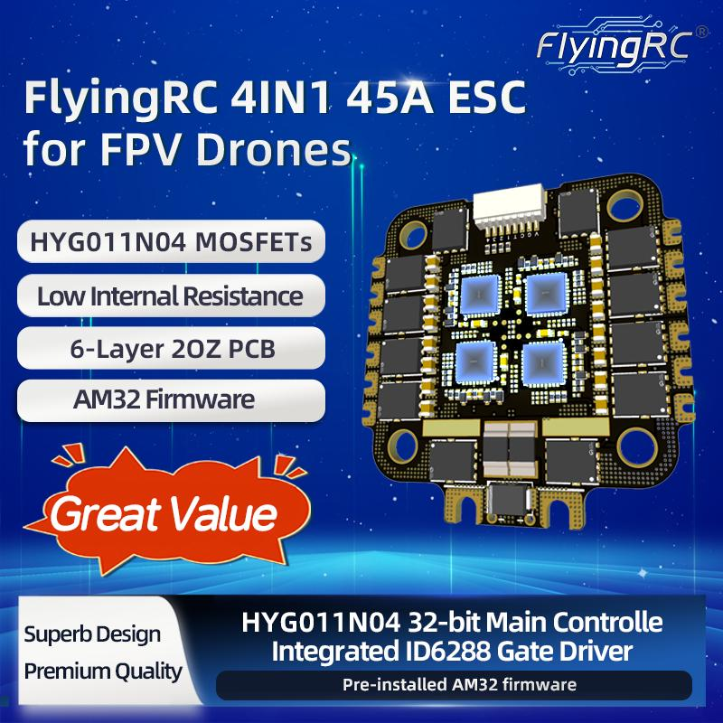
图中1处要修改：
图中底部应该改为：“ HYG011N04 MOS, 32-bit MCU”
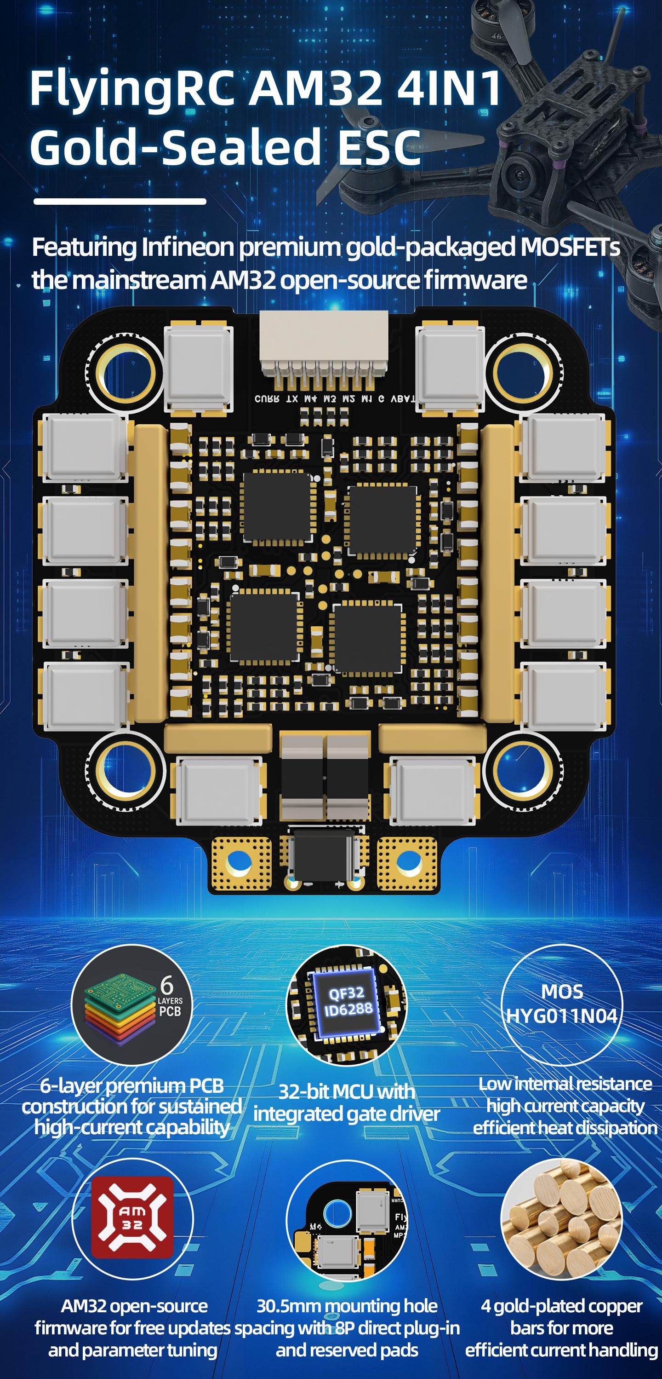
图片有3处要修改：
- 图片中电调是4合一75A电调（有4个铜条），应换成4合一45A电调图片（有2个铜条）
- 图片上方小字“Featuring Infineon premium gold-packaged MOSFETs
the mainstream AM32 open-source firmware”要改为"Featuring the mainstream AM32 open-source firmware"
3)这里的标注应该为：“Two gold and nickel-plated copper strips for high-efficiency current conduction.”
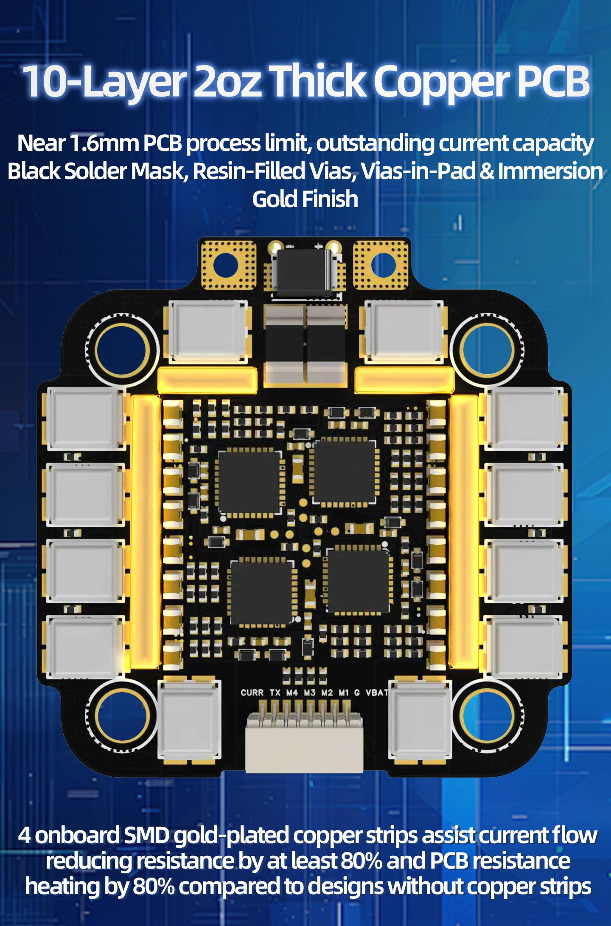
图片有2处要修改：
- 图片中电调是4合一75A电调（有4个铜条），应换成4合一45A电调图片（有2个铜条）
- 图片中的文字都不对：
1. 标题翻译：6-Layer 2oz PCB Technology
2. 上半部分正文翻译：
Featuring black solder mask, resin-filled vias, via-in-pad, and immersion gold plating, this design balances excellent electrical performance with long-term reliability.
3. 下半部分正文翻译：
The board is equipped with 2 gold and nickel-plated surface-mount copper bars, reducing resistance by over 80% compared to designs without copper bars.

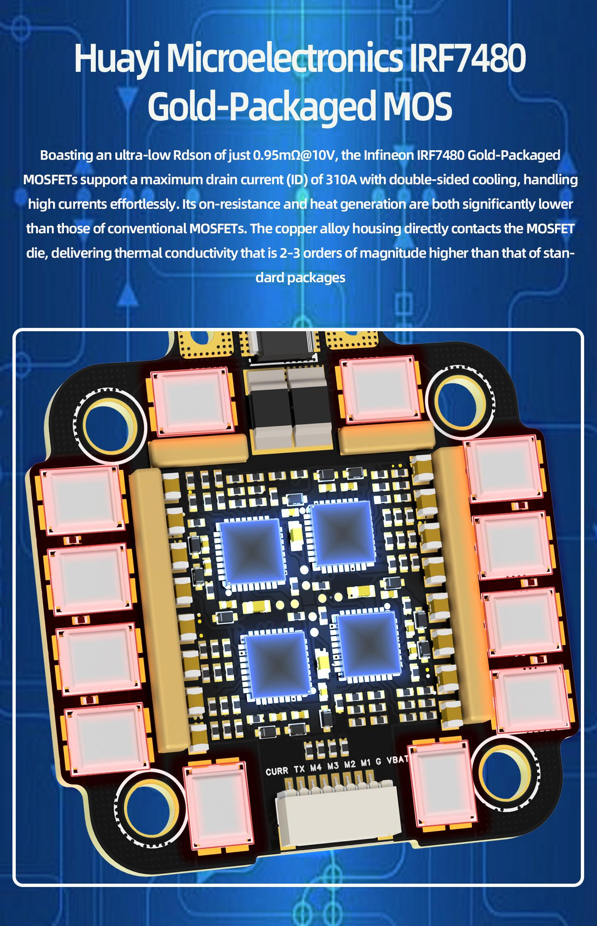
图片有2处要修改：
1）图片中电调是4合一75A电调（有4个铜条），应换成4合一45A电调图片（有2个铜条）
2）图中文字也不对，应改为：
Huayi Microelectronics HYG011N04 MOSFET
Featuring an on-resistance (Rds(on)) of just 1mΩ @ 10V and a continuous drain current of up to 310A, this MOSFET utilizes a DFN 5x6 package with a large bottom thermal pad. Compared to conventional MOSFET solutions in its class, it delivers significantly lower conduction losses and superior thermal management.
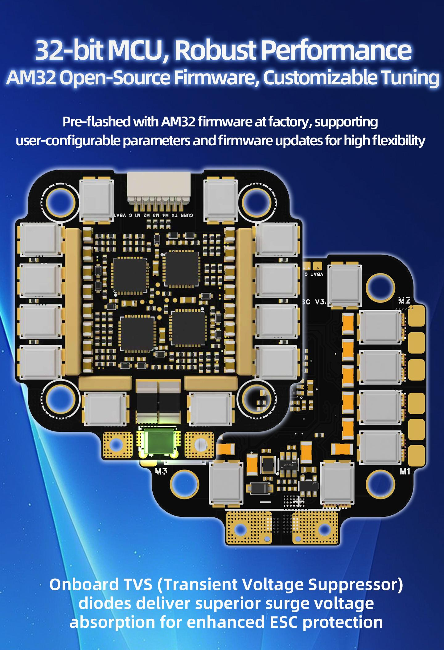

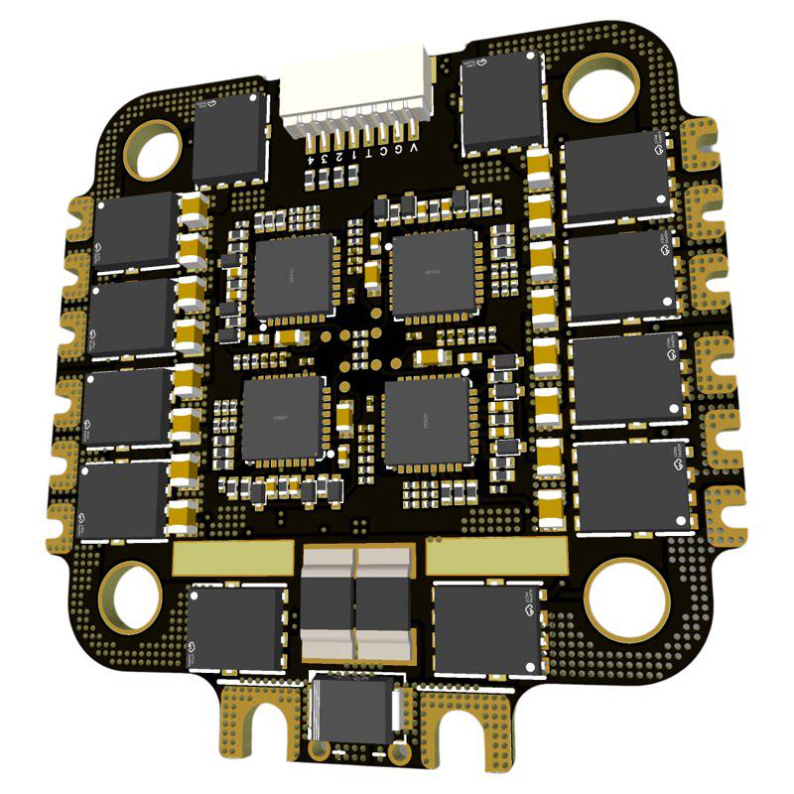

Technical Specifications:
- MCU QF32F4AK8U7 with integrated gate driver ID6288 and MOSFET HYG011N04
- Supports sinusoidal startup with high low-speed torque
- Input Voltage: 9~30V, 3~7S Lipo / 3~6S LiHV
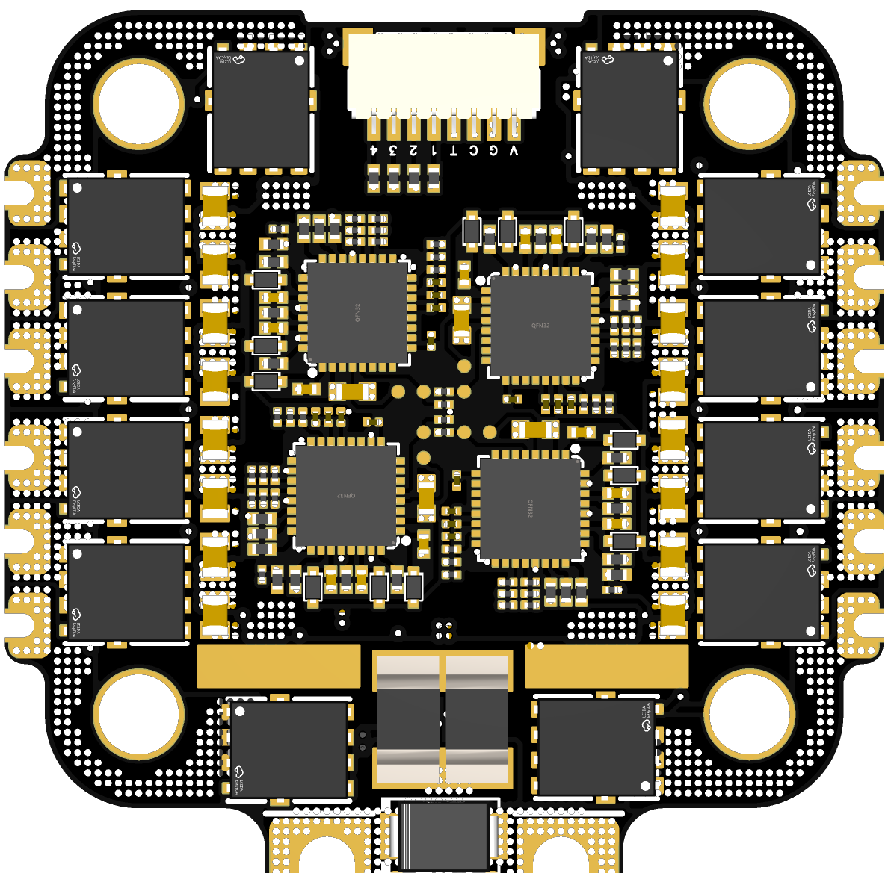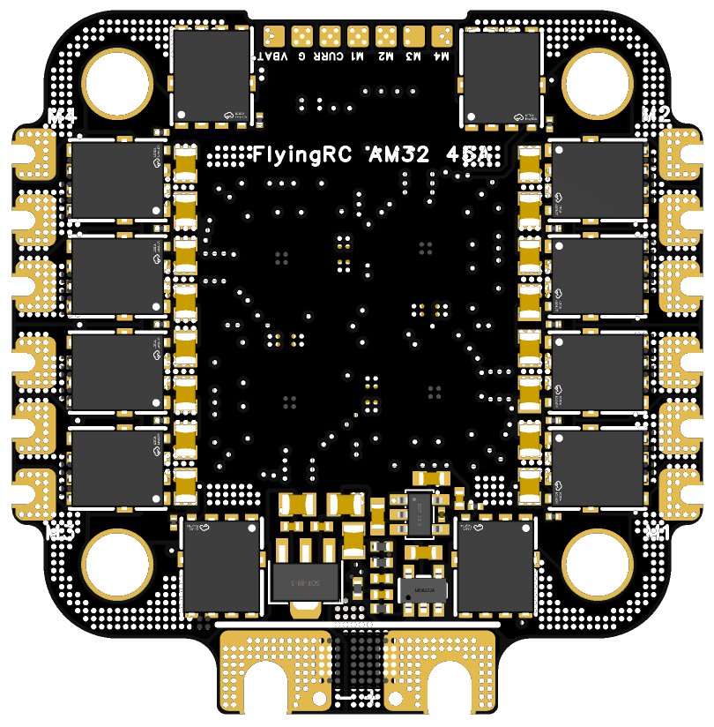
Front and Back view of the ESC
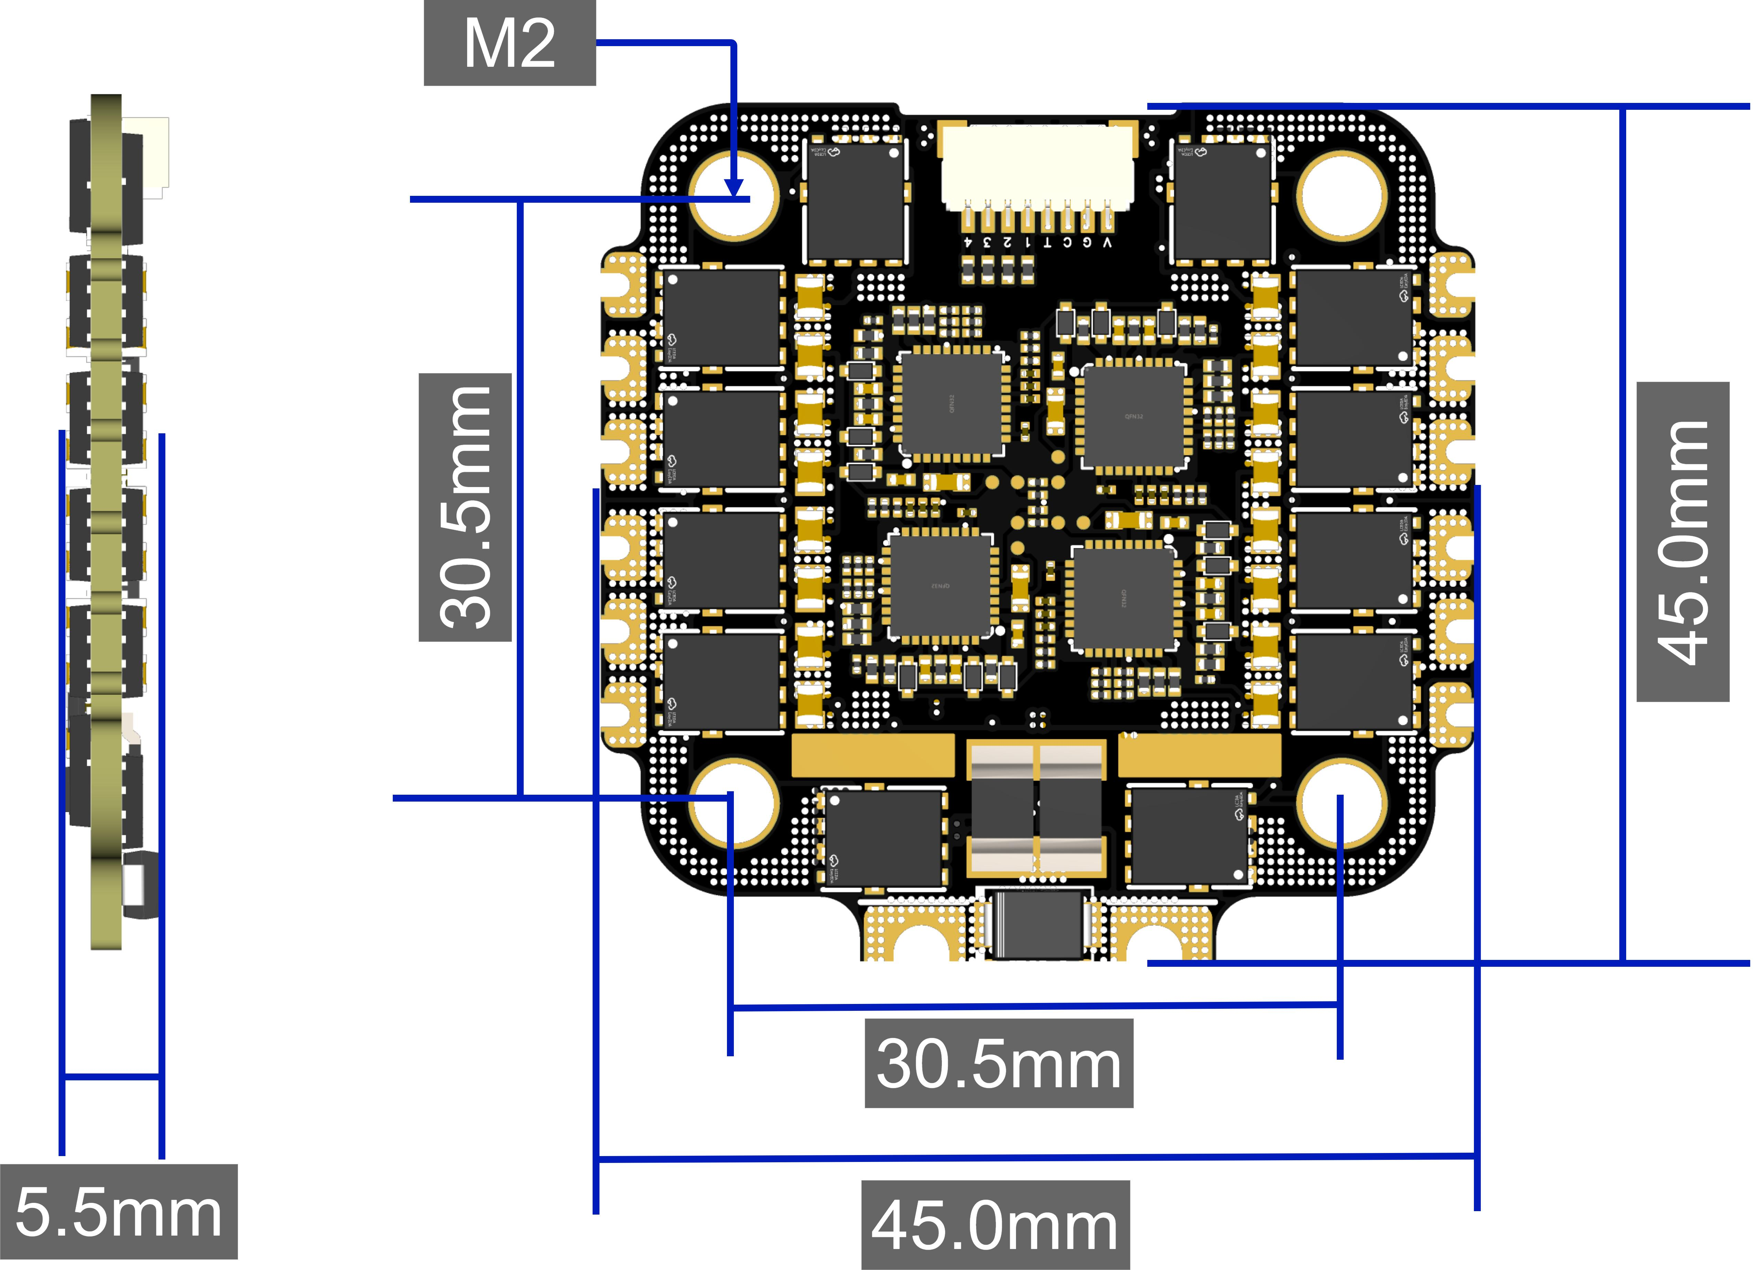

Basic Parameters |  | Voltage - Current
Model | FlyingRC® 4IN1 45A ESC | VBAT Voltage Range | 9-30V DC IN 3-7S LiPo
Dimensions | 45mm*45mm*5.5mm | Continuous Current per Channel | 45A *5s (Test condition: 4S)
Mounting Holes | 30.5mm M3 | Burst Current per Channel | 50A (Test condition: 4S)
Weight | 16.6g | Current Meter Ratio | 100 (1/10mV/A Betaflight)  100 (A/V Ardupilot)
Main Components |  | Firmware
MCU | QF32F4AK8U7 32-bit | AM32 | Supported
Clock Frequency | 120MHz | Input Signal Protocol | Supports DSHOT150/300/600，OneShot，PWM and other protocols
Flash | 64 KB | 工作环境
RAM | 16 KB | Operating Temperature | -10-100℃
Gate Driver | ID6288 | Storage Temperature | 0-40℃
MOSFETs/MOS | HYG011N04
Product Features
PCB Processes | Featuring a 6-layer 2oz PCB, this ESC balances high-density routing with robust continuous current handling, laying a solid foundation for high-current scenarios. It also adopts premium processes including black solder mask, resin-filled vias, via-in-pad, and immersion gold plating, ensuring both excellent electrical performance and long-term reliability.
SMD Copper Strips | Two gold and nickel-plated SMD copper strips act as high-efficiency auxiliary current paths, reducing the PCB's conduction resistance and associated heat generation by over 80% compared to designs without copper bars, delivering significantly improved thermal performance under high-current operation.
MOSFETs /MOS | Rated at 40V, the HYG011N04 MOSFETs feature an ultra-low RDS(on) of 1.0mΩ@10V gate drive and a continuous drain current (ID) of up to 310A. Paired with a DFN 5x6 package with a large bottom thermal pad for efficient heat dissipation, they achieve significantly lower conduction losses and superior thermal performance compared to conventional MOSFETs in the same class.

Product Features
- 6-layer 2oz PCB construction: Optimized layer stack-up and copper thickness design deliver an excellent balance between high-density routing with robust continuous current handling, providing a reliable foundation for high-current scenarios. Premium processes including black solder mask, resin-filled vias, via-in-pad and immersion gold plating ensure stable electrical performance and long-term service reliability.
- Two gold and nickel-plated SMD copper strips act as high-efficiency auxiliary current paths, reducing the PCB's conduction resistance and associated heat generation by over 80% compared to designs without copper bars, delivering significantly improved thermal performance under high-current operation.
- Rated at 40V, the HYG011N04 MOSFETs feature an ultra-low RDS(on) of 1.0mΩ@10V gate drive and a continuous drain current (ID) of up to 310A. Paired with a DFN 5x6 package with a large bottom thermal pad for efficient heat dissipation, they achieve significantly lower conduction losses and superior thermal performance compared to conventional MOSFETs in the same class.
- Powered by a high-performance 32-bit QF32MTF4AK8U7 MCU with an integrated ID6288 gate driver.
- Pre-flashed with AM32 firmware by default. Users can freely configure parameters and update firmware, with strong expandability and flexibility.

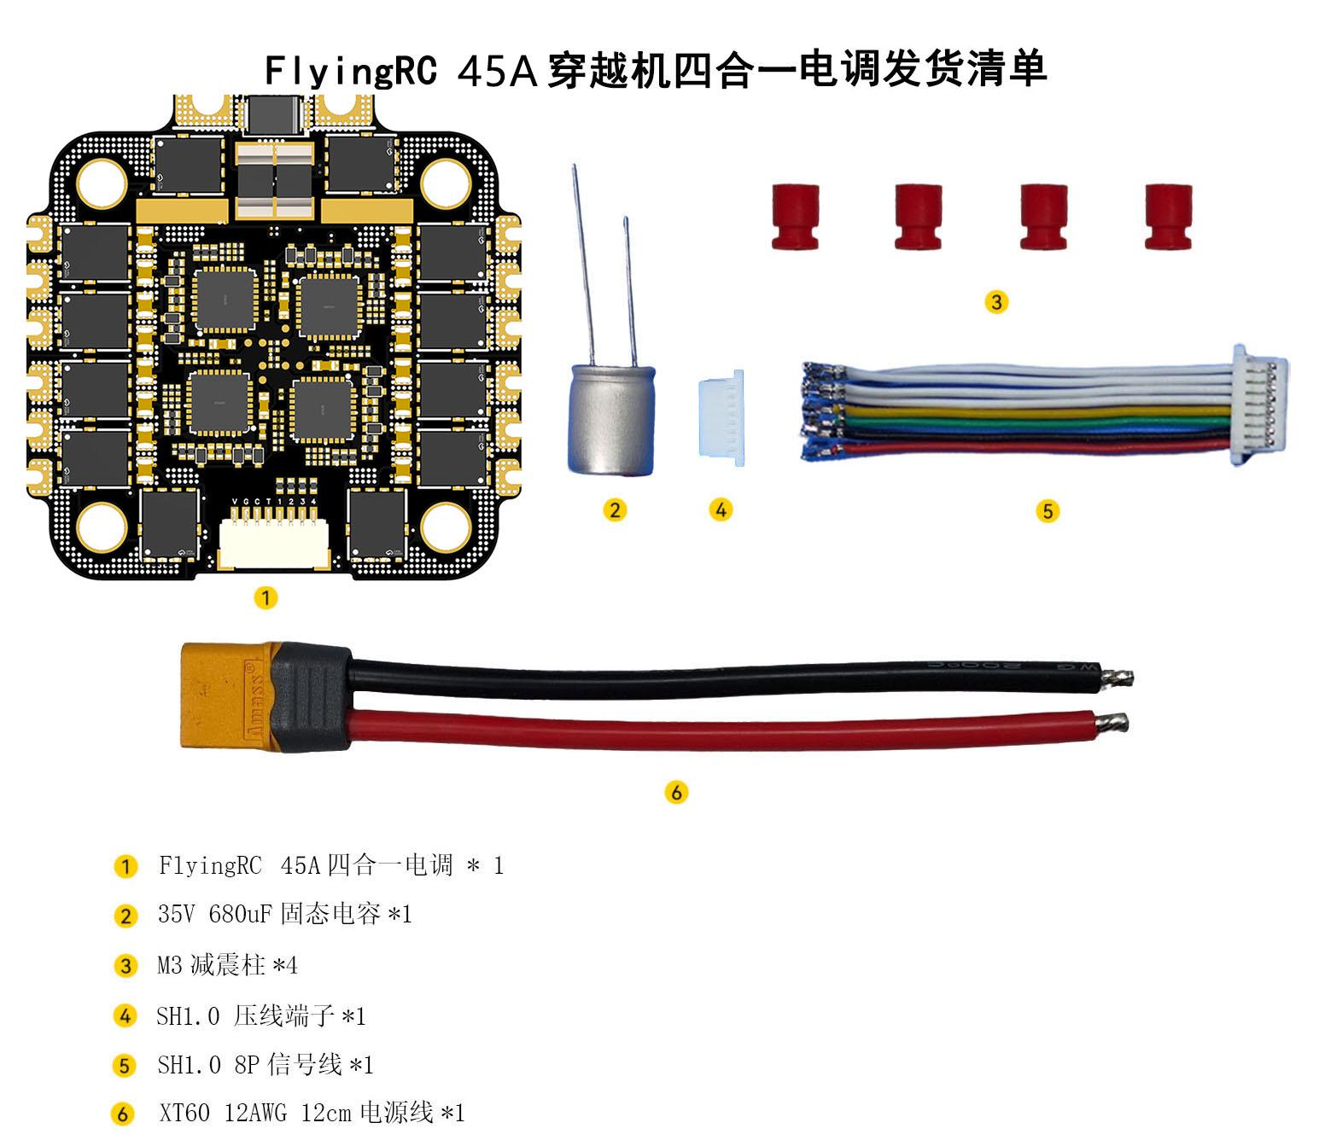
FlyingRC 4-in-1 45A ESC for FPV Drones - Packing List

- 1 x FlyingRC 4-in-1 45A ESC
- 1 x 35V 680uF Solid Capacitor
- 4 x M3 Anti-Vibration Standoffs
- SH1.0 Crimp Terminal × 1
- 1 x SH1.0 8P Signal Cable
- 1 x XT60 12AWG 12cm Power Cable

3.User Instructions


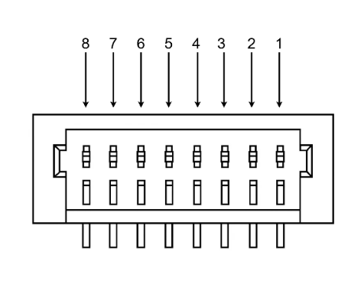

Pin No. | Pin Name | Pin Definition
1 | VBAT | Battery Voltage Input
2 | G | GND（Negative）
3 | CURR | Analog Current Meter Output Signal Pin
4 | TX | ESC Telemetry TX Port
5 | M1 | ESC 1 Signal Pin
6 | M2 | ESC 2 Signal Pin
7 | M3 | ESC 3 Signal Pin
8 | M4 | ESC 4 Signal Pin
Pin Definition Table

Pre-use Preparation
- Tools and Consumables Preparation：
Digital soldering iron / soldering station (T12 or 936 series recommended), solder wire (63% tin content recommended), 35V 680uF solid capacitor (included in the package), XT60 power plug cable (included in the package).

- Soldering the Power Cable and Capacity：Pay attention to the positive and negative poles of the capacitor; do not solder them reversely. The red mark on the capacitor indicates the negative pole.
Please click：Soldering Video Tutorial Link
Note: Due to the large pad area and high thermal conductivity of gold plating, beginners or users with inadequate soldering tools may select the pre-soldering option.
- Making the Signal Cable
Video Tutorial：Link
The signal cable included in the package is an SH1.0 8P double-ended cable. One end comes pre-crimped (wire order and colors match the ESC pinout and functions), while the other end is unset. An extra SH1.0 8P connector is included, allowing users to reorder the wires as needed to match their flight controller pinout.

- Install Anti-Vibration Standoffs.

- Install the ESC and solder the motor wires.

- Current Meter settings:
Betaflight Current Meter Scale：100 （1/10mV/A）
Ardupilot Current Meter Scale：100 （A/V）

Wiring Diagram
Connection to FlyingRC® F4D Flight Controller

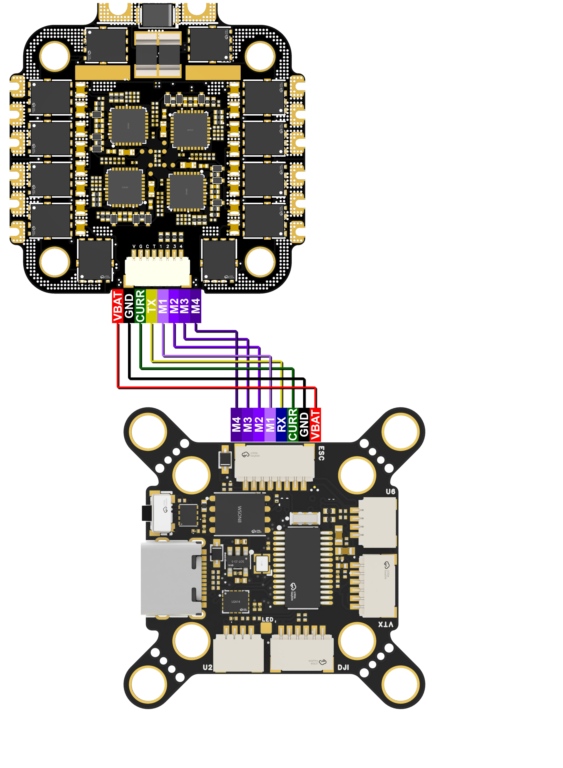
Wiring Diagram for Connection to FlyingRC® F4D Flight Controller

Connection to FlyingRC® H7D Flight Controller

Wiring Diagram for Connection to FlyingRC® H7D Flight Controller

4.Firmware Update
Close the Betaflight Configurator before using the ESC parameter tuning software to free up the flight controller port.
Propellers must be removed first. Power the ESC via a LiPo battery when tuning parameters or flashing firmware.
Download AM32-ESC-Tools from the group files, extract it locally, then double-click to run SerialPortConnector.exe.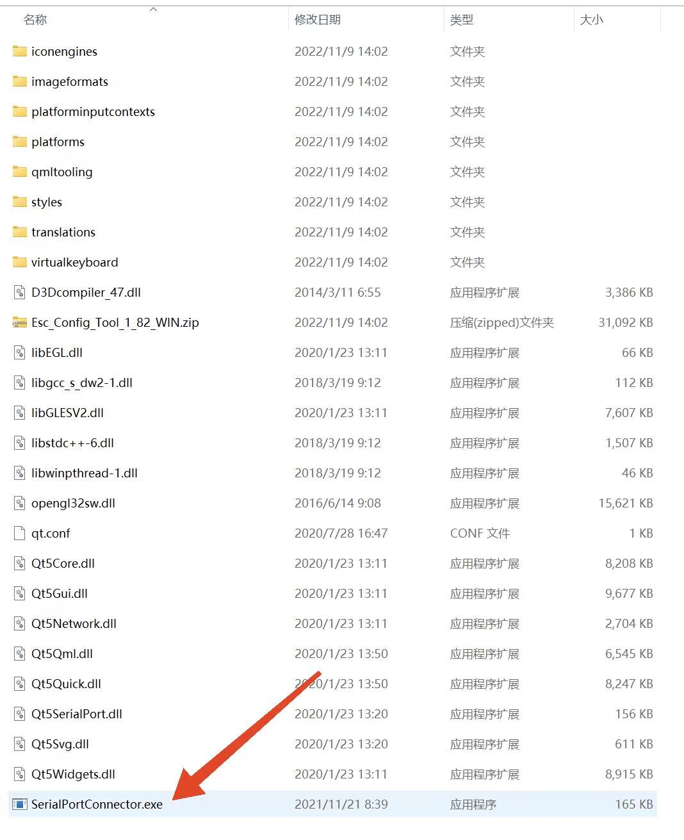

Locate the corresponding flight controller port number (COMx) in the bottom-right corner of the ESC parameter tuning software, then click Connect.
If no error message appears, the ESC tuning software has successfully connected to the flight controller.

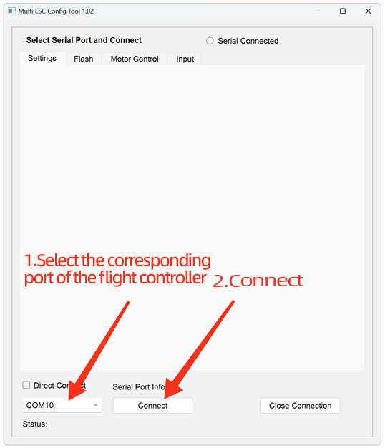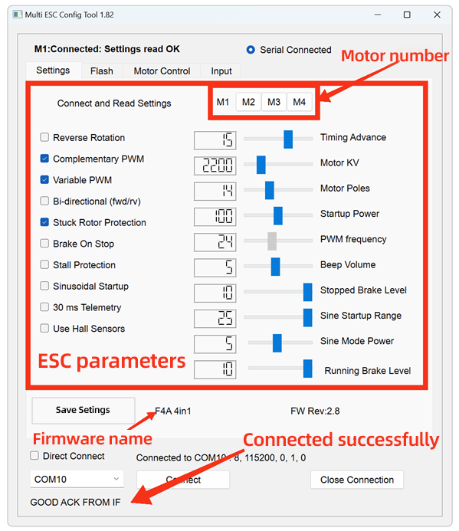
Before flashing the firmware, please download the latest ESC firmware in advance. The firmware can be obtained from github or the group file.

For the ESC parameter tuning software, navigate to the Flash page to proceed with firmware flashing.
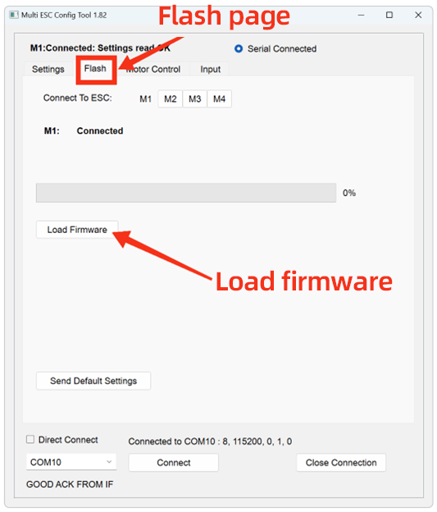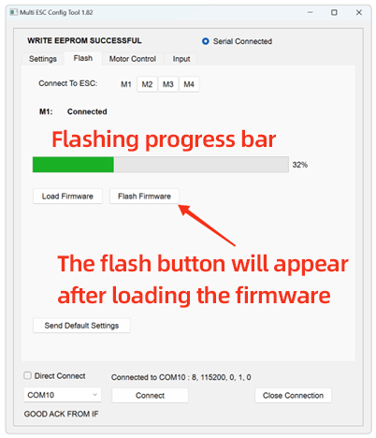
Click M1, then click “Load Firmware”.In the pop-up window, select the downloaded latest ESC firmware file and double-click to confirm. Click “Flash Firmware” and wait patiently for the progress bar to complete. Click “Send Default Settings” to restore the ESC to default parameters.*This step is strongly recommended when updating firmware across multiple versions. Repeat the above steps for M2, M3 and M4.
WARNING!
Do NOT use the web-based parameter tuning software.
Updating firmware with it may damage the ESC MCU. Multiple such cases have been reported.
In this situation, the product will require paid factory repair.

5.Parameter settings
For the parameter tuning software and connection instructions, please refer to the section 4 Firmware Update.
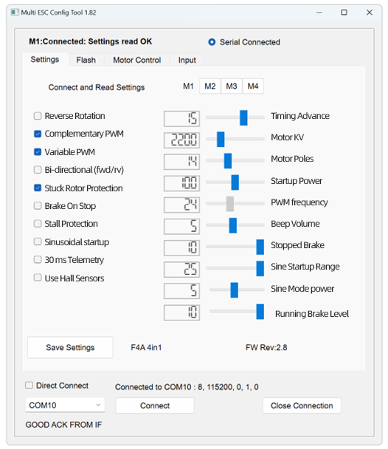
parameter setting page
Main Parameters：
KV Value: Must be set close to the motor’s rated KV rating. Deviation from the actual KV value shall not exceed 30%. If the KV value setting deviates by more than 100%, the motor may fail to operate normally, and the ESC hardware may even be damaged.
Advance Angle: Forbidden to adjust. Advanced users may optimize motor efficiency by adjusting the advance angle, but incorrect adjustment will damage the ESC, and such damage is usually irreparable.
Stall Protection: Can be enabled if using a low-KV motor (KV < 500), or must be enabled if using sine-wave startup.
Sine-Wave Startup: Not required for general FPV drones.

Notes：
1.All ESCs are pre-flashed with the latest official AM32 firmware and tested via multi-voltage rotation before shipment.
2.Offline paramteter tuning software is required for firmware flashing.
3.ESCs generate significant heat during operation. To ensure efficient heat dissipation, it is strictly prohibited to apply heat-shrink tubing or waterproof treatment, as such protective measures will impede heat exchange between the ESC and the environment. Damage caused by this will not be covered under warranty.
4.When the ESC’s operating environment parameters (e.g., temperature, humidity, air pressure, ventilation) deviate from rated conditions, the current-carrying capacity of its internal power devices will be limited, and the maximum continuous operating current will fall below the nominal value. Sufficient heat dissipation measures must be implemented to ensure stable and reliable operation.
5.Take care to prevent the ESC from contacting other conductors (carbon fiber plates, battery plugs, other circuit boards) during installation, as external short circuits may cause damage.
6.Signal wires shall be silicone insulated wires. The flight controller connector is of type SH1.0, which is compact. When plugging or unplugging, support the rear of the connector by hand to prevent it from being pulled off.

Other FlyingRC® Products
 |  |  |  | - FlyingRC® F4WSE Pro - F405 Fixed-Wing Flight Controller  Upgraded Version | Enhanced Performance  Manual：https://www.kdocs.cn/l/cavm9EoVEq5A |  |  | 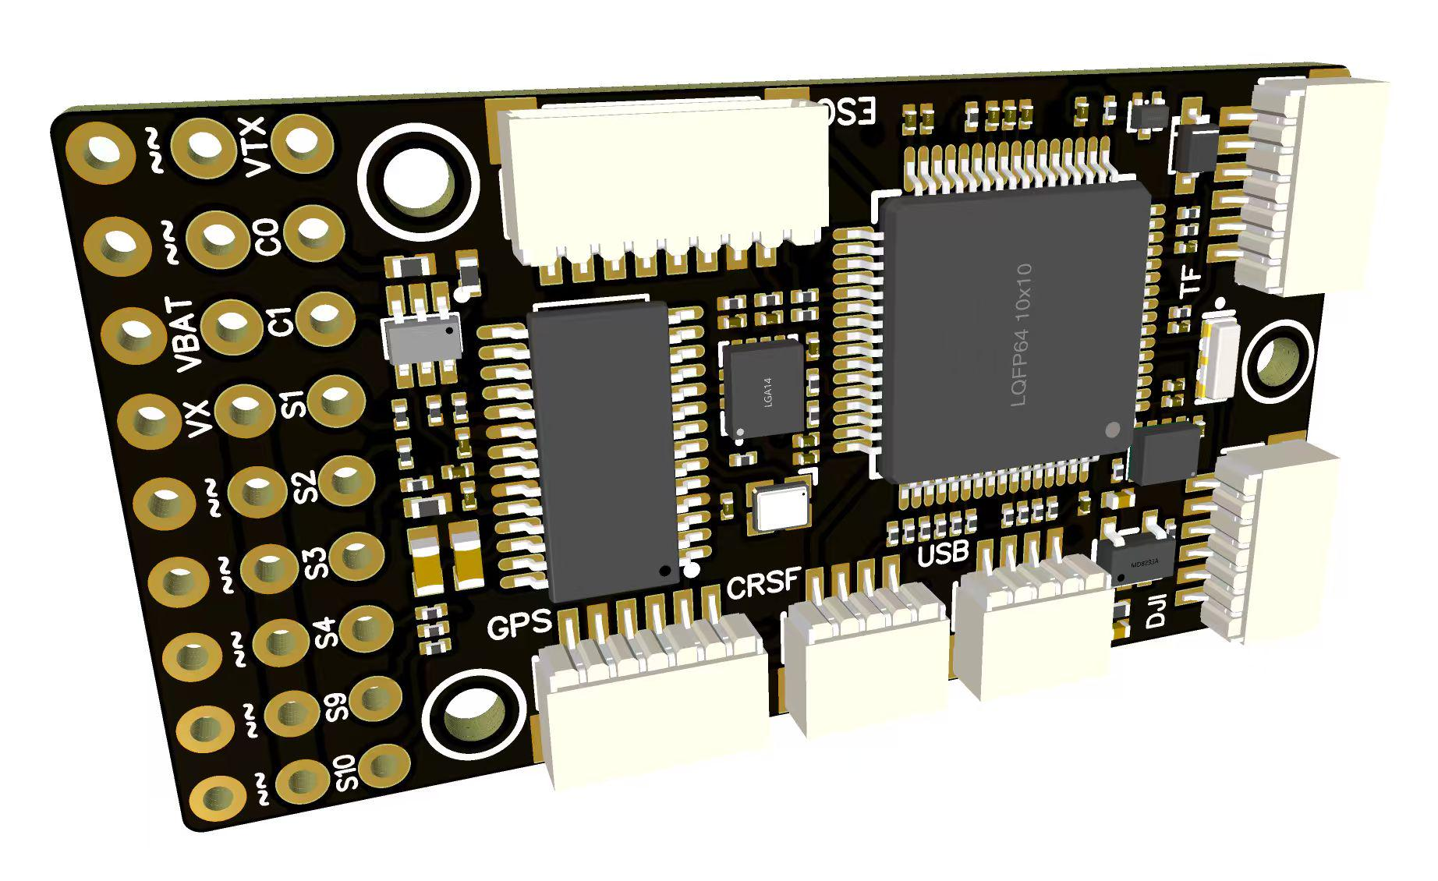
 |  |  | - FlyingRC® F4WSE MK1.5 - F405 Fixed-Wing Flight Controller  Classic model, unique design, highly acclaimed.  Manual：https://kdocs.cn/l/cpyd8MTS56DD |  |  | 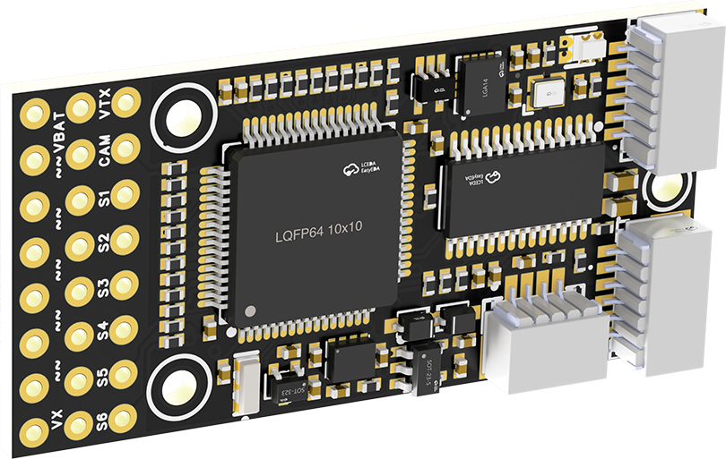
 |  |  |  | - FlyingRC® H7Wlite MK1 H743 Fixed-Wing Flight Controller  Flagship performance, full expansion, high-power BEC.  Manual：https://kdocs.cn/l/cpYaBiFKh8U1 |  |  | 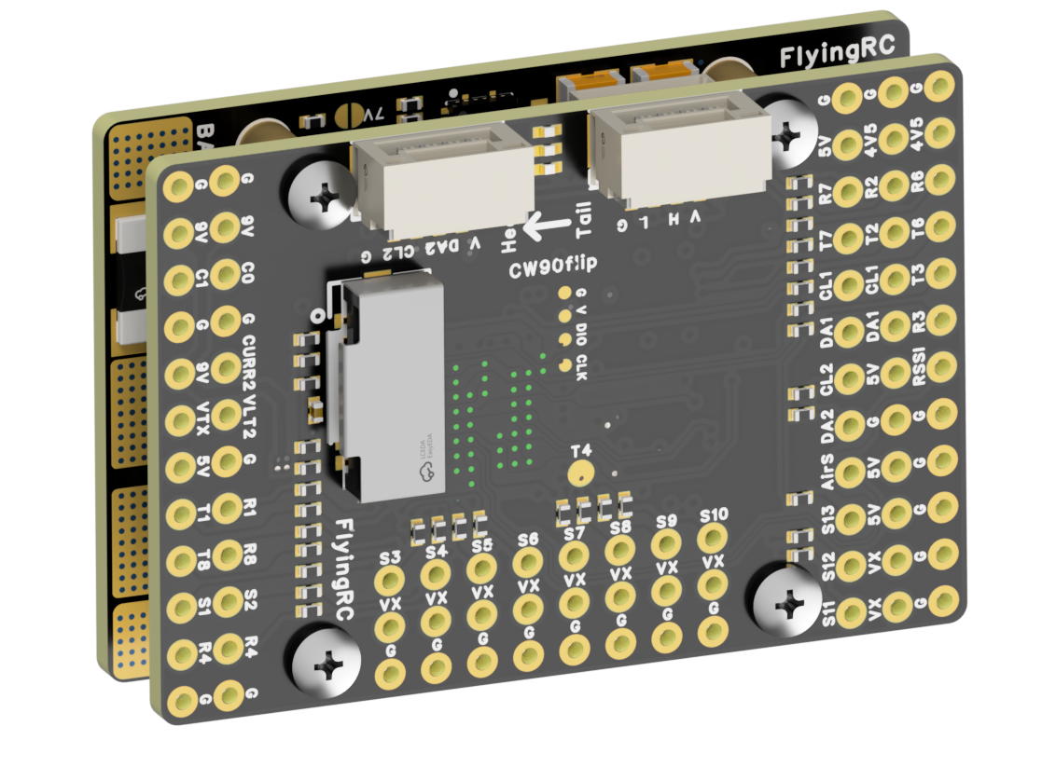
 |  |  |  | - FlyingRC® F4Wing Mini MK1 F405 Fixed-Wing Flight Controller  2025 bestseller, ultra-compact, smallest on the market, great value.  Manual：https://kdocs.cn/l/cdUIdmpSpW7J |  |  | 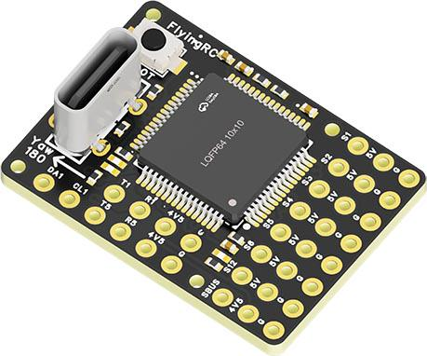
 | - FlyingRC® AM32 Dual ESC 40A 2-in-1 ESC  Unique design for dual-power aerial, land and water vehicles including drones.  Manual：https://www.kdocs.cn/l/cjwNtsKK6HeR |  |  |  | 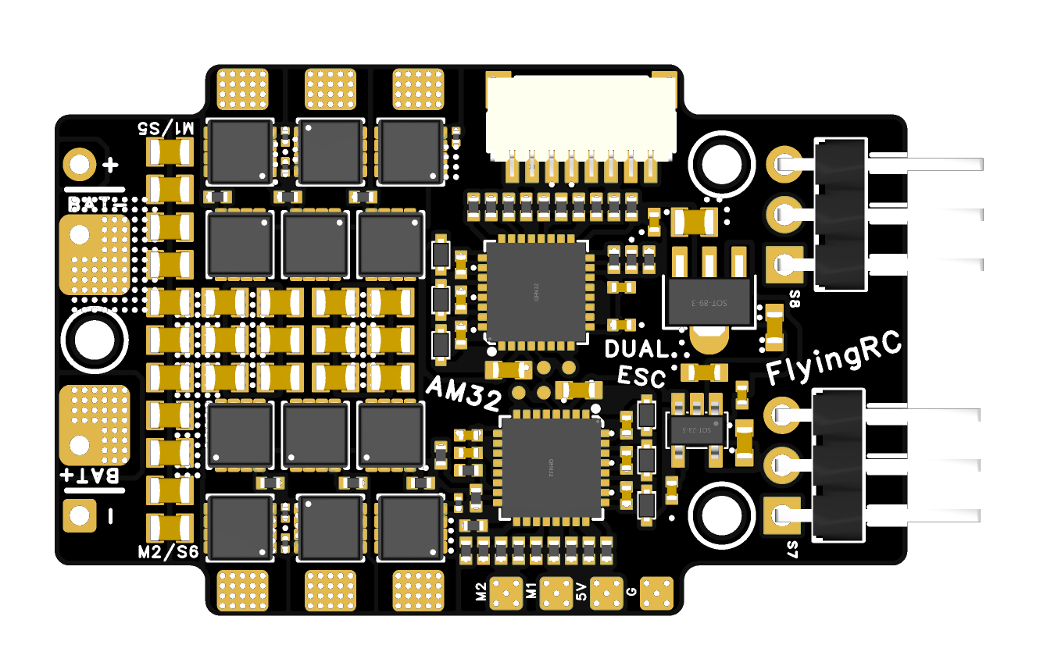
 |  |  | - FlyingRC® AM32 ESC V2.5 75A - Single ESC  Infineon gold-package MOSFETs, premium materials, superior heat dissipation.  Manual：https://kdocs.cn/l/cv6hUy67IdTJ |  |  |  | 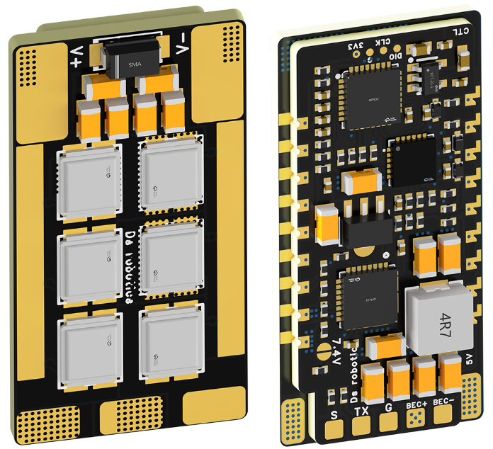
 |  |  | - FlyingRC® AM32 Mini ESC 40A V1.0 - Single ESC  Ultra-miniature, ideal for micro drones, high over-current capability, stable operation.  Manual：https://kdocs.cn/l/cqdLSysEyWFh |  |  |  |  | 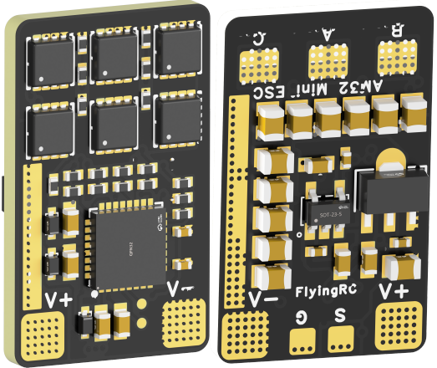
 |  |  | - FlyingRC® 10A 12S 440A Power Distribution Board for FPV Drones  Industry top choice, excellent quality and affordable price.  Manual：https://kdocs.cn/l/coel7OgrlCBP |  |  |  |  | 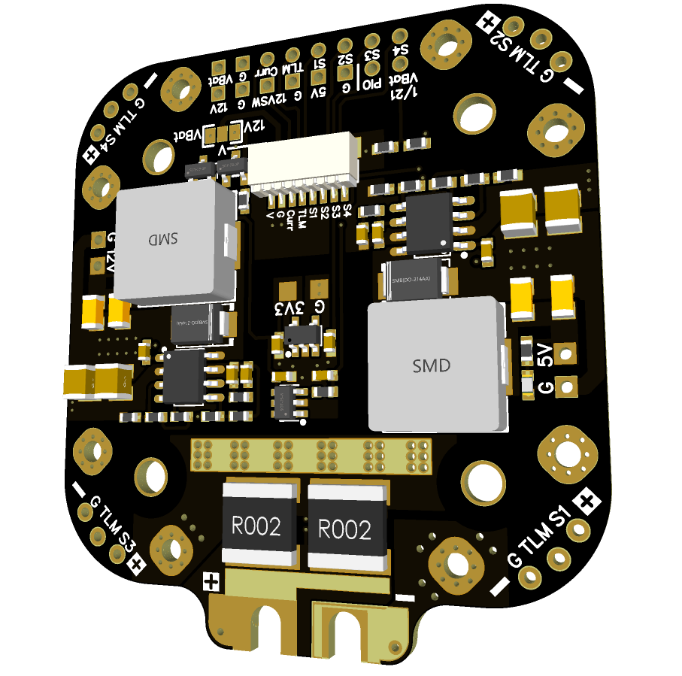
 |  |  | - FlyingRC® H7D Pro MK1 H743 FPV Flight Controller with Dual Gyro  Fully Upgraded & More Powerful  Manual：https://www.kdocs.cn/l/ctcekCy676Ez |  |  |  | 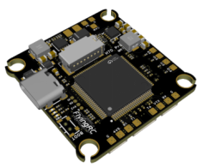
 |  |  | - FlyingRC® H7D MK1 H743 FPV Flight Controller with Dual Gyro  Powerful computing, stable and precise flight, rich interfaces, smooth control.  Manual：https://kdocs.cn/l/cqMh1I0RwAoD |  |  |  | 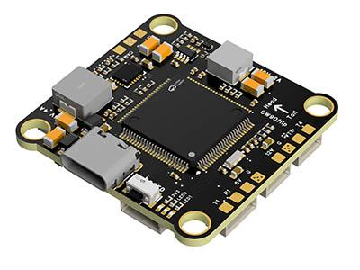
 |  |  | - FlyingRC® F420 MK1 F405 FPV Flight Controller (20/30.5mm Mounting)  Dual mounting holes, all connectors, no soldering required, compliant with Betaflight interface standards.  Manual：https://kdocs.cn/l/ctGeLiN9ZYKj |  |  |  | 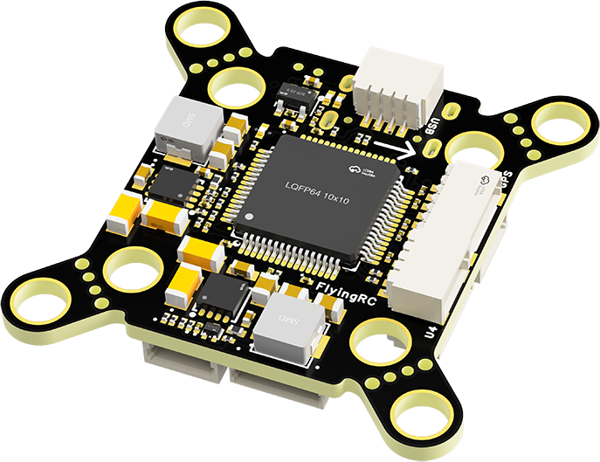
 |  | - FlyingRC® 4-in-1 75A V3.2 Gold-Sealed FPV ESC  Infineon gold-package MOSFETs, superior heat dissipation & over-current capability, premium choice.  Manual：https://kdocs.cn/l/ceLilc8Gaa21 |  |  |  |  | 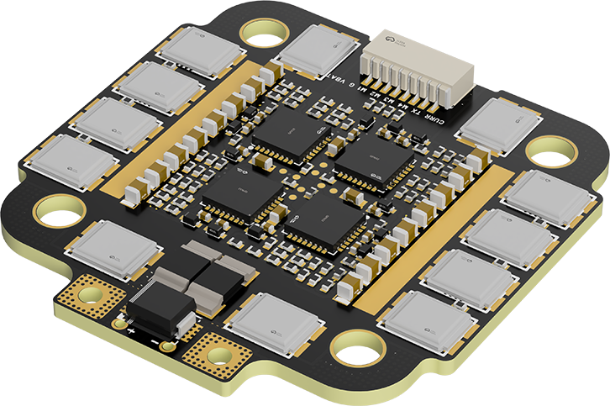
- FlyingRC® Stack Combo: H743 Flight Controller + 4-in-1 75A Gold-Sealed ESC  Professional flight choice, flagship materials & craftsmanship, reasonable price.  Manual：https://www.kdocs.cn/l/ctcekCy676Ez  https://kdocs.cn/l/ceLilc8Gaa21 |  |  |  |  |  |  | 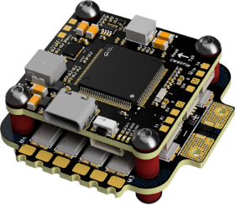
 |  | - FlyingRC® Stack Combo: F405 Flight Controller + 4-in-1 75A Gold-Sealed ESC  Best-selling combo, excellent performance, affordable price.  Manual：https://kdocs.cn/l/ctGeLiN9ZYKj  https://kdocs.cn/l/ceLilc8Gaa21 |  |  |  |  | 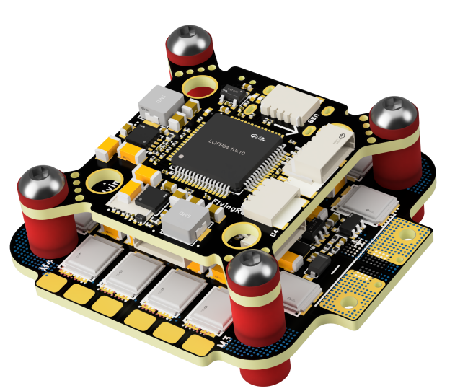
 |  | - FlyingRC® Stack Combo: H743 Flight Controller + 4-in-1 45A ESC  Winning combo: great performance, budget-friendly price  Manual：https://www.kdocs.cn/l/ctcekCy676Ez  https://kdocs.cn/l/ceLilc8Gaa21 |  |  |  |  | 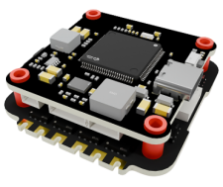
 |  | - FlyingRC® Stack Combo: F405 Flight Controller + 4-in-1 45A ESC  Hit combo, great value, budget-friendly  Manual：https://kdocs.cn/l/ctGeLiN9ZYKj  https://kdocs.cn/l/ceLilc8Gaa21 |  |  |  |  | 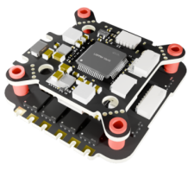
 |  | - FlyingRC® Stack Combo: F4WSE Pro - F405 Fixed-Wing Flight Controller + AM32 Dual ESC 40A 2-in-1 ESC  Unique Design • Exclusive Offer • Bestselling Bundle  Manual：https://www.kdocs.cn/l/cavm9EoVEq5A  https://www.kdocs.cn/l/cjwNtsKK6HeR |  |  |  |  | 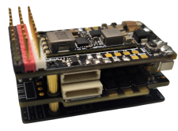
 | - FlyingRC® ELRS 2.4G Diversity Receiver  True diversity reception, temperature compensation, high-sensitivity reception.  Manual：https://kdocs.cn/l/cbvlOlShmsPS |  |  |  |  |  | 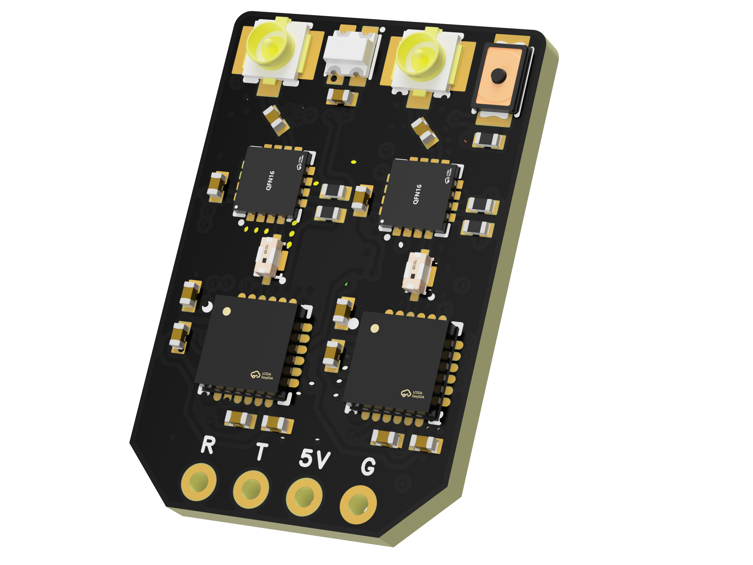
 | - FlyingRC® RM3100 SPI Module 罗盘模块  Ultra-high Resolution • Low Power • Industry Top Choice  Manual：https://www.kdocs.cn/l/cdGuHvBVyndC |  |  |  |  |  | 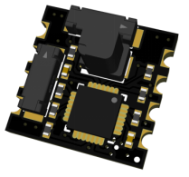
 | - FlyingRC® 10A 12S BEC Step-Down Module  Wide voltage input, high power, compact size, multiple voltages available, 10A continuous output.  Manual：https://kdocs.cn/l/clssNCKgNhLV |  |  |  |  |  | 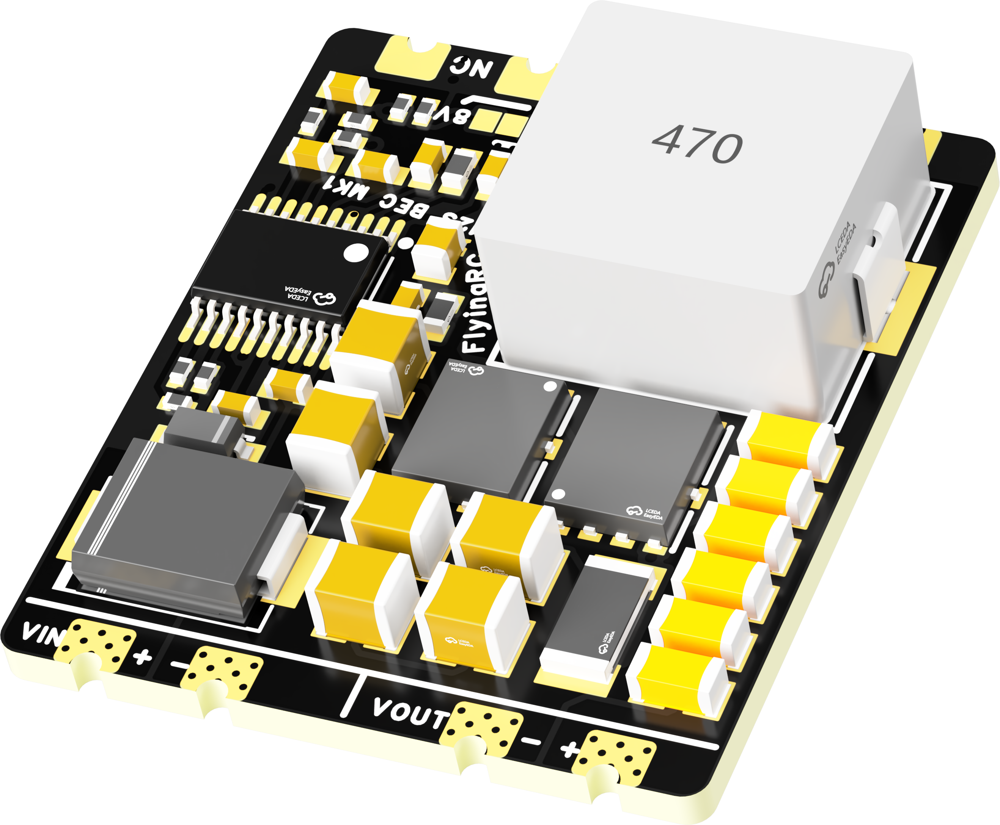
 | FlyingRC® 5A BEC Step-Down Module  Ultra-small size, multiple voltages available, 5A continuous output.  Manual：https://kdocs.cn/l/cb9VdNywqCKA |  |  |  |  |  | 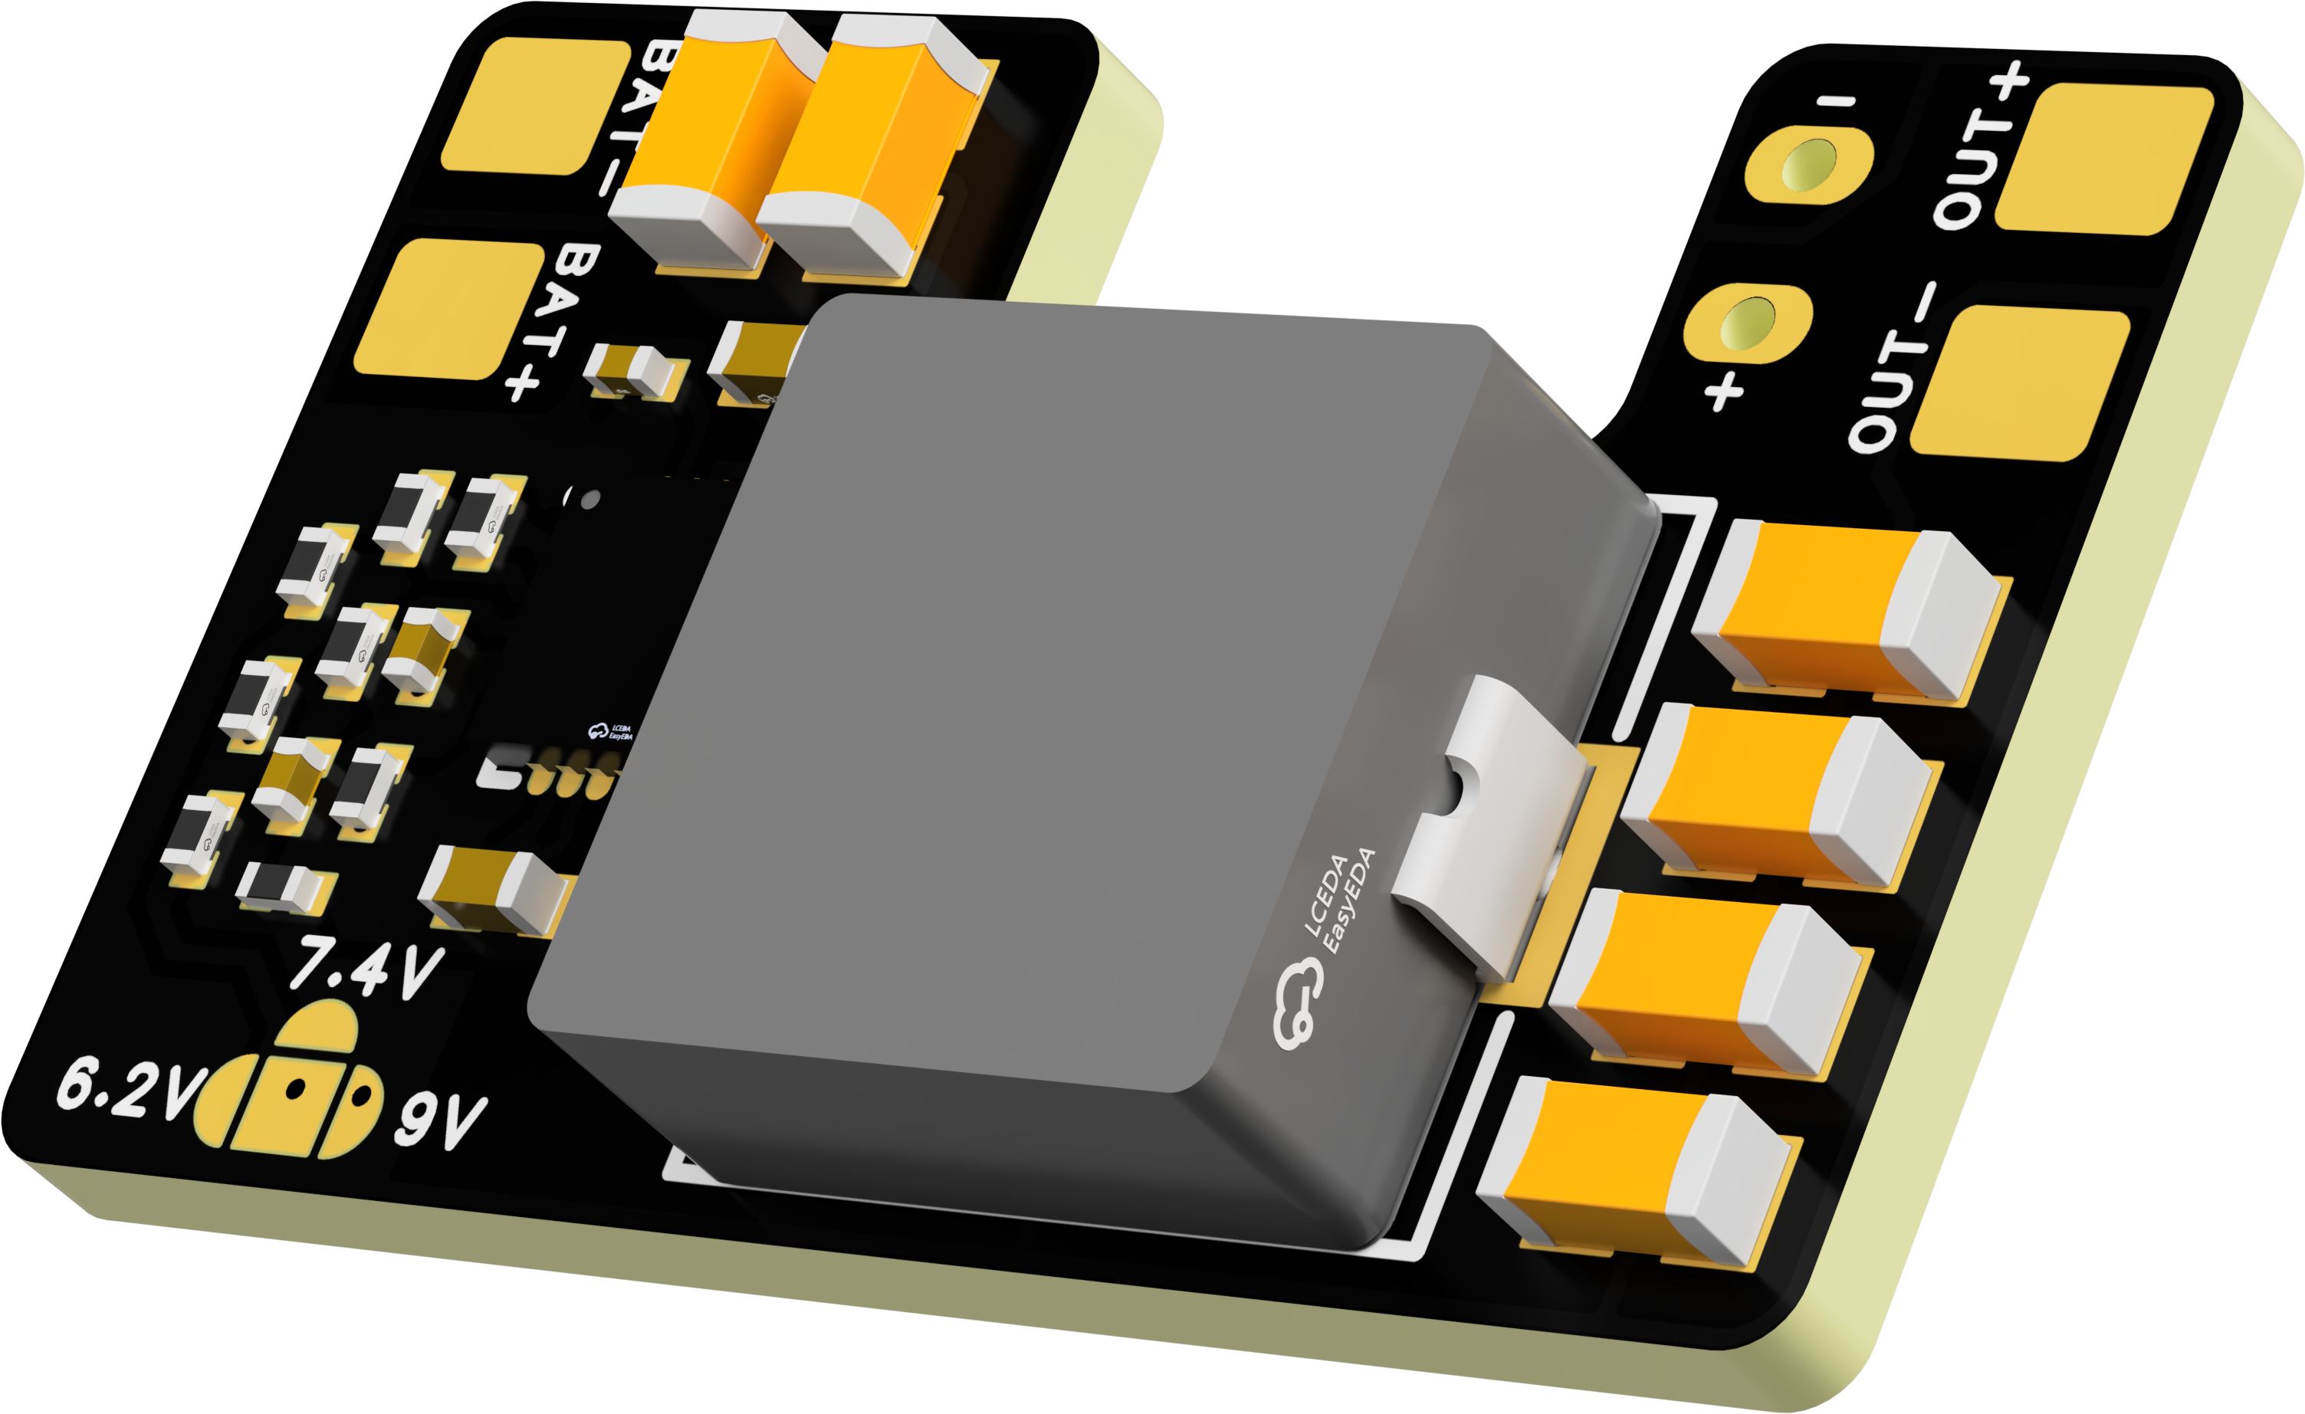
 | FlyingRC® Mini BEC For DJI O4  Easy wiring, ultra-small size, stable power supply.  Manual：https://www.kdocs.cn/l/ckkebieur37K |  |  |  |  |  | 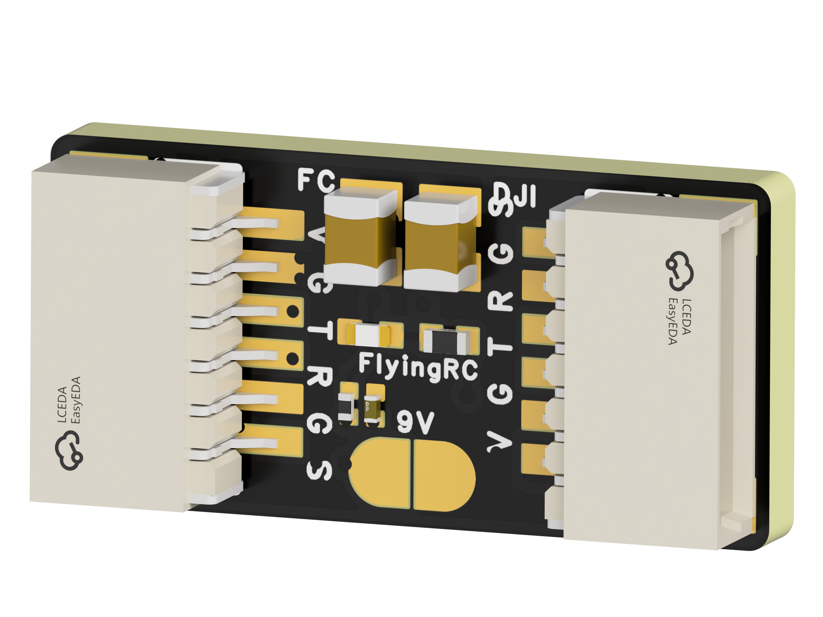
 | FlyingRC® CAN Bus Serial & PWM Expansion Board  Long-distance transmission, high speed, excellent stability.  Manual：https://www.kdocs.cn/l/cmxRyBnU4BXj |  |  |  |  |  | 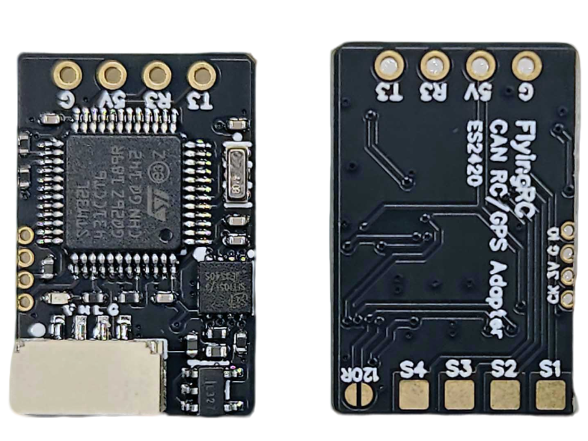
 | FlyingRC® AM3 2ESC Programmer  Supports BL, BL32, AM32. Simple and easy to use.  Manual：https://kdocs.cn/l/cogBSEBe67mE |  |  |  |  |  | 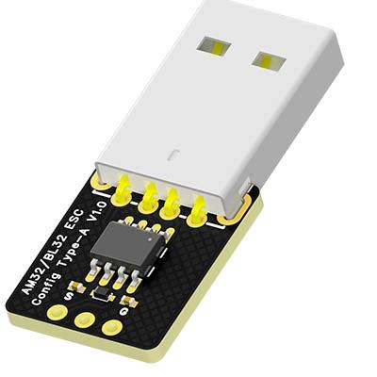
 | FlyingRC® Digital Airspeed Sensor without Pitot Tube  Integrated design, smallest on the market. MS4525D protocol, I2C interface.  Manual：https://www.kdocs.cn/l/clPvEEEcJgCC |  |  |  |  |  | 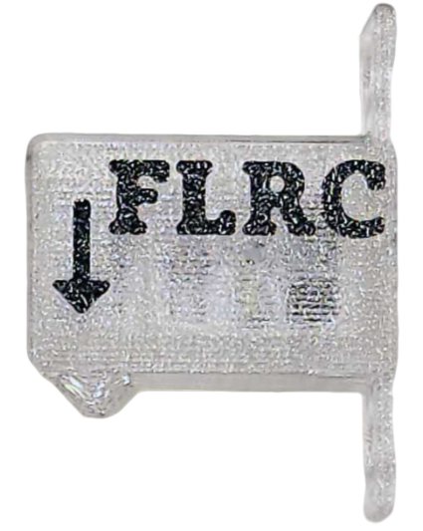
 | FlyingRC® U-Blox M10 GPS  Compatible with all open-source flight controllers.  Manual：https://www.kdocs.cn/l/cdSYQrzx74O8 |  |  |  |  |  | 