FlyingRC® AM32 ESC Parameter Programmer
Product Manual

FlyingRC® is a globally-oriented professional brand of electronic devices. We specialize in the R&D and sales of drone electronics, core robot circuits and sensors. Our design team is based in Singapore, and our products are sold worldwide.

Since launched in 2023, FlyingRC® products have gained widespread recognition from customers as well as strong market response. As of April 2026, our cumulative sales volume has exceeded 46,000 units. Our products are widely applied in industries, robotics, emergency rescue, environmental protection & inspection, aerial photography, public security, retail and many other fields. Above all, we are committed to distinctive design and superior reliable quality.

Our Chief Technology Officer Liu Yuhan possesses outstanding expertise in circuit design. Over the past four years, he has designed more than 80 circuit projects and contributed 39 to open-source platforms. Moreover, he won the Design Award on the open-source platform X.JLC.com twice in 2023 and 2024, and has become the youngest certified designer on this platform.

He holds the NUS (National University of Singapore, rank 8th worldwide) Science and Technology Scholarship, and is currently majoring in Electronic Engineering with a focus on Aerospace Technology. In addition, all members of our technical team are graduates from prestigious universities with extensive professional product experience.

- Specifications
Product Dimensions： 33.4mm*14.3mm
Product Weight：3.1g
PCB Layers: 2 layers
PCB Thickness：1.6mm
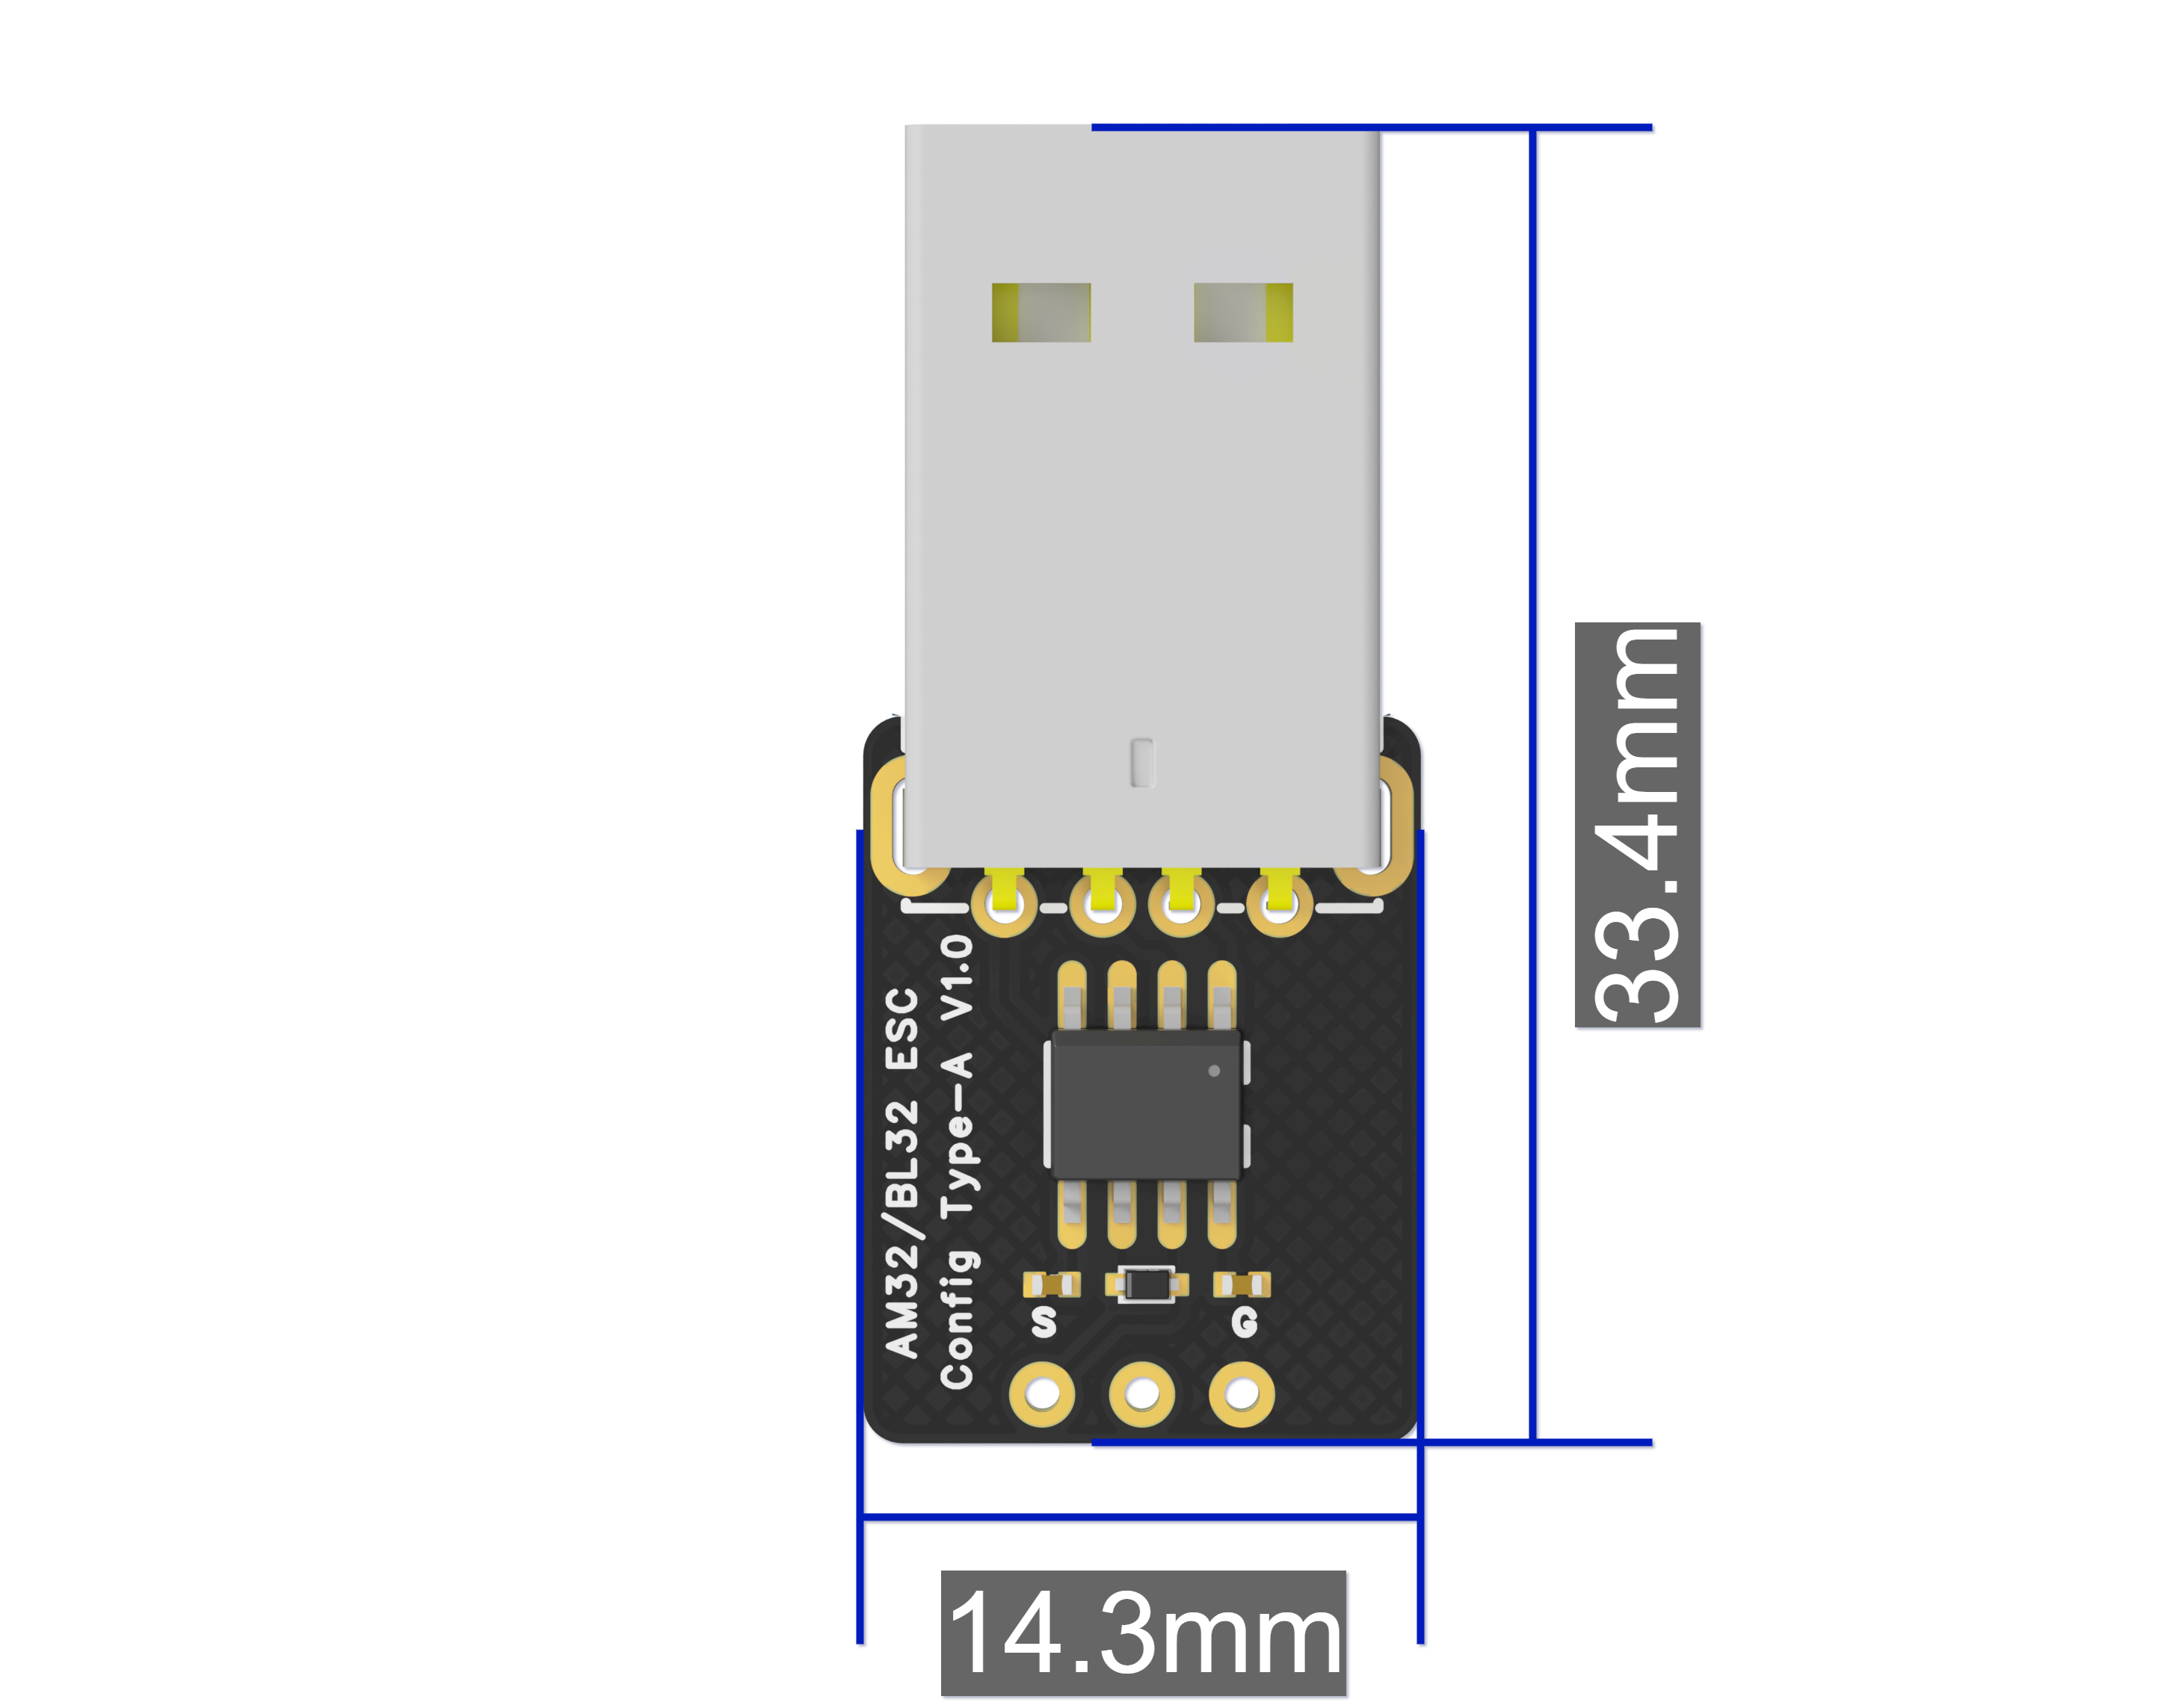

2. Product Applications
The FlyingRC® AM32 ESC Parameter Programmer is a professional tuning tool designed for brushless motor ESCs and other related devices. It allows precise and efficient parameter configuration to meet diverse user requirements in multiple application scenarios. Widely adopted in RC aircraft, cars, and boats, it provides stable and reliable parameter tuning for RC enthusiasts and professional users alike.

Compatible with various drones and RC cars. It enables easy adjustment of ESC parameters to boost device performance and optimize flight or driving experience.
Drone tuning: Compatible with multi-rotors, helicopters, fixed-wing aircraft, and other aerial devices, it assists in ESC parameter adjustment to improve flight stability and efficiency. As a professional ESC tuning tool for drones, it optimizes ESC configurations, upgrades overall flight performance and prolongs battery life.

RC car tuning: Suitable for various electric RC cars, it fine-tunes ESC parameters to deliver stronger acceleration and better handling control.

3. Product Features
Easy Operation: No complex setup required. Simply connect to ESCs for parameter adjustment, allowing even beginners to get started quickly.

Compact & Portable: Small in size and easy to carry, supporting convenient parameter tuning anytime, anywhere.

High Compatibility: Compatible with most AM32 ESCs on the market, suitable for a wide range of application .
4. Usage Instructions
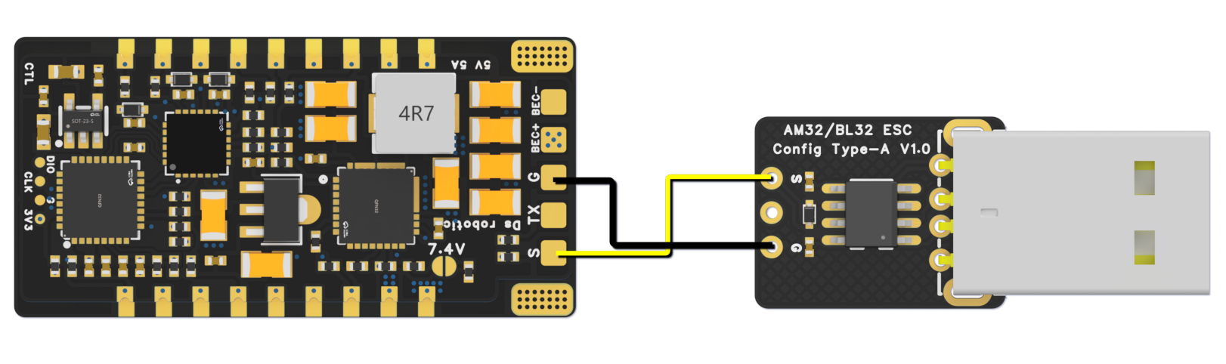
Wiring Diagram with ESC

- Hardware Connection: Connect the parameter programmer to the computer using a USB cable and ensure a stable connection. Connect the signal wire of the programmer to the signal port of the ESC (Note: Do not reverse the positive and negative poles--- The negative wire connects to the ESC negative terminal, and the S terminal corresponds to the signal wire.). The ESC must be connected to power during parameter tuning. Refer to the corresponding ESC manual for the specified input voltage range. If the ESC is connected to a motor while tuning, please fix the motor securely to avoid danger.

Important Note: To ensure safety, do not install propellers on the motor during parameter tuning. This avoids personal injury caused by sudden motor rotation resulting from improper operation.

- Driver Installation: For first-time use, please install the driver for the parameter programmer on your computer. (official link: https://www.wch.cn/downloads/ch341ser_exe.html).
After installation, open Device Manager on your PC and confirm that the port is displayed normally (e.g., CH340 port is shown).

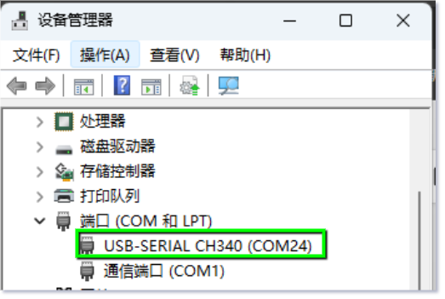
- Software Operation: Open the parameter tuning software, select the port in the software, then choose the corresponding M1 port to connect to the device. Once connected successfully, various parameter setting options such as throttle travel setting and firmware update will be available on the software interface. Modify the parameters according to actual needs and remember to click "Save" after modification. Please download AM32-ESC-Tools from the group files, unzip it to your local drive, and double-click SerialPortConnector.exe to open it.
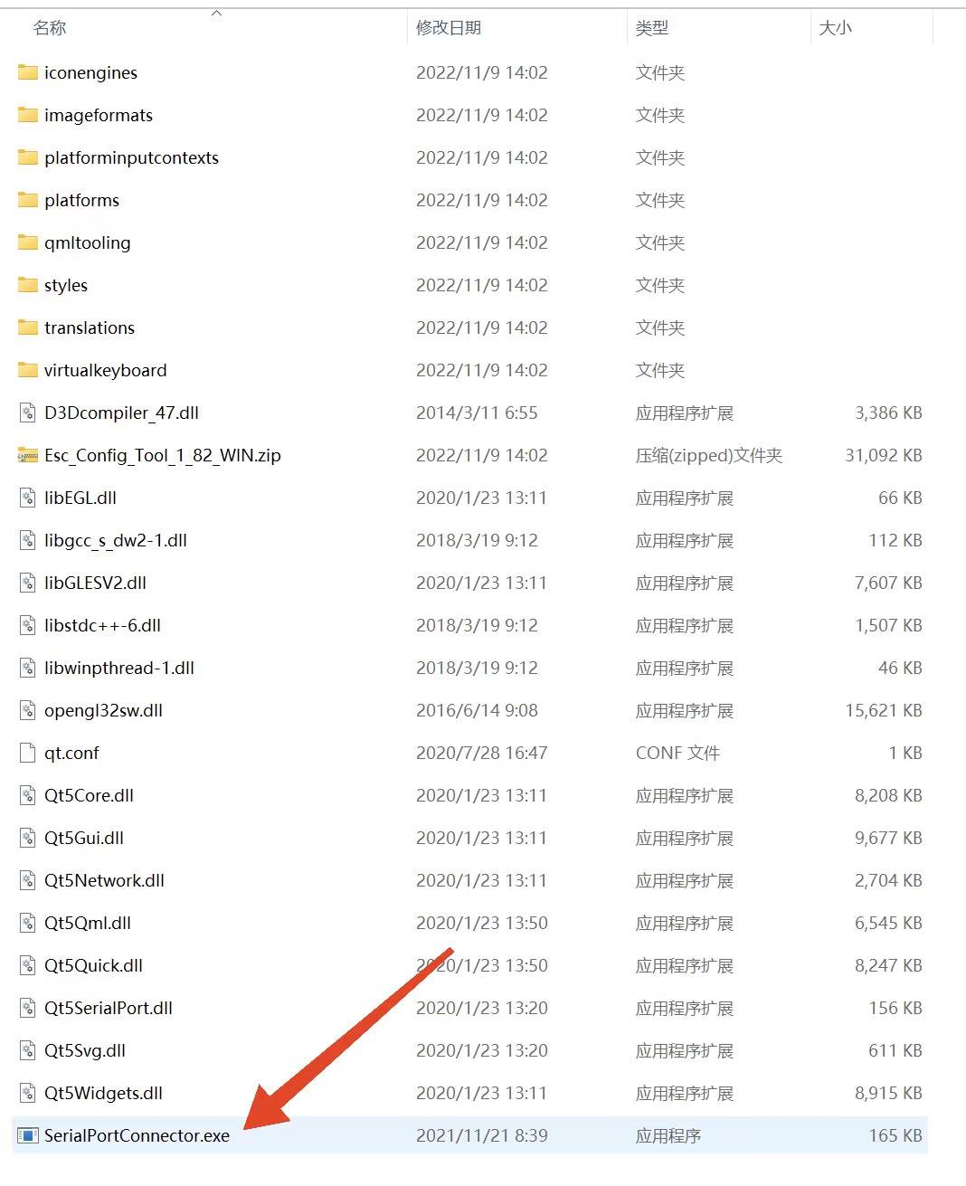
Locate the corresponding flight controller port number (COMx) in the bottom right corner of the ESC parameter adjustment software and click Connect. If no error prompt appears at this time, the ESC parameter adjustment software has successfully connected to the flight controller.
- Check "Direct Connect"
2. Select the corresponding COMx port
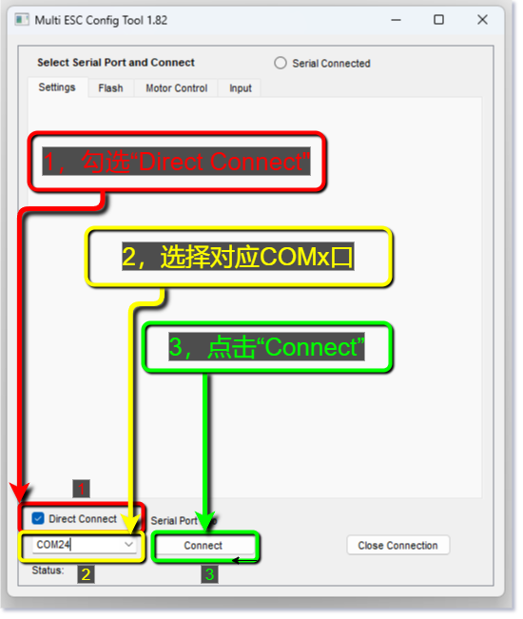
3. Click "Connect"

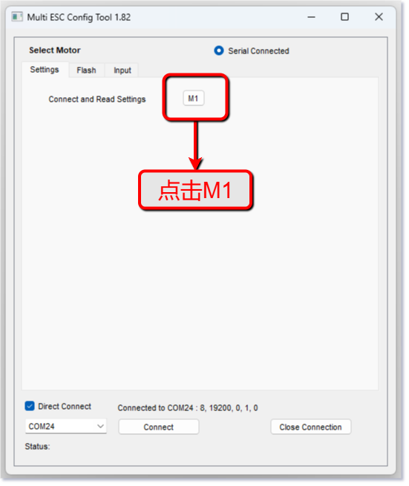
Click M1
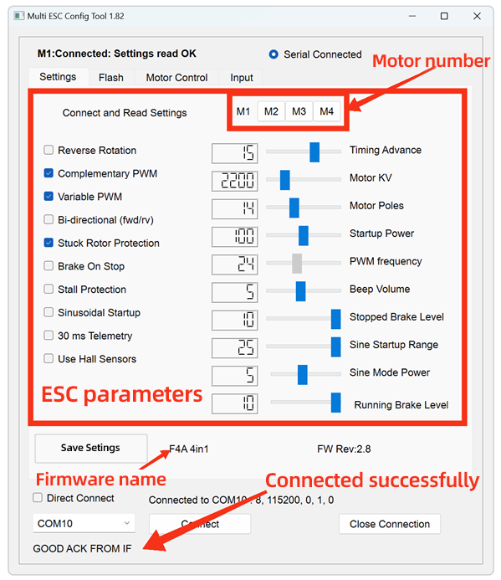
Before flashing the firmware, download the latest version of the ESC firmware in advance. Firmware download links (available on github or in the group files).
AM32_F4A_4IN1_F421

ESC Parameter Adjustment Software: Click on "Flash" (Firmware Flashing Page).
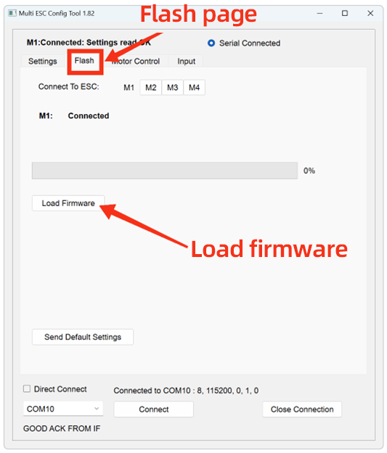
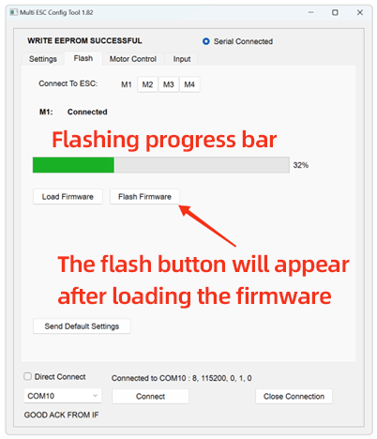
Click M1, then click "Load Firmware". In the pop-up window, locate the downloaded new ESC firmware file and double-click to confirm. Click "Flash Firmware" and wait patiently for the progress bar to complete. Click "Send Default Settings" to restore the ESC to its default parameters. *This step is not recommended to be skipped when updating firmware across multiple versions.
Repeat the above steps for M2, M3, and M4.

WARNING! Do NOT use the web-based parameter adjustment software. Using it to update firmware may damage the ESC MCU, and multiple such cases have been reported. Repairs for this issue will require factory return and incur a service fee.

（4）Parameter Settings
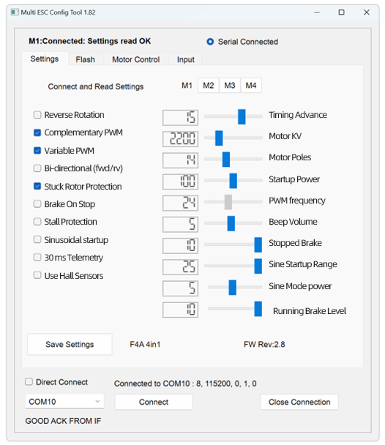
Parameter Explanation Diagram

Key Parameters：
KV Value: Adjust to a value close to the motor's KV rating, with a deviation not exceeding 30% from the actual KV value. A deviation exceeding 100% may cause the motor to fail to rotate normally or even result in hardware damage to the ESC.

Advance Angle: Adjustment is prohibited. Experienced users may optimize motor efficiency by adjusting the advance angle, but incorrect adjustment will damage the ESC, and such damage is generally irreparable.

Stall Protection: Enable this function if using a low-KV motor (KV < 500), or if sine wave startup is enabled (this option must be activated in such cases).

Sine Wave Startup: Not required for common FPV drones.

Precautions
- During parameter tuning, please carefully read the parameter instructions and modify settings with caution, so as to prevent equipment damage or abnormal performance caused by improper configuration.
- Different models of ESCs and motors require tailored parameter configurations. Please adjust the settings according to your actual device specifications.
- Do not operate the parameter programmer in harsh environments including high temperature, high humidity and strong magnetic fields, which may impair its performance and service life.
- If you encounter any issues during operation, please refer to the attached FAQ document or contact our customer support team for assistance.

Other FlyingRC® Products
 |  |  |  | - FlyingRC® F4WSE Pro - F405 Fixed-Wing Flight Controller  Upgraded Version | Enhanced Performance  Manual：https://www.kdocs.cn/l/cavm9EoVEq5A |  |  | 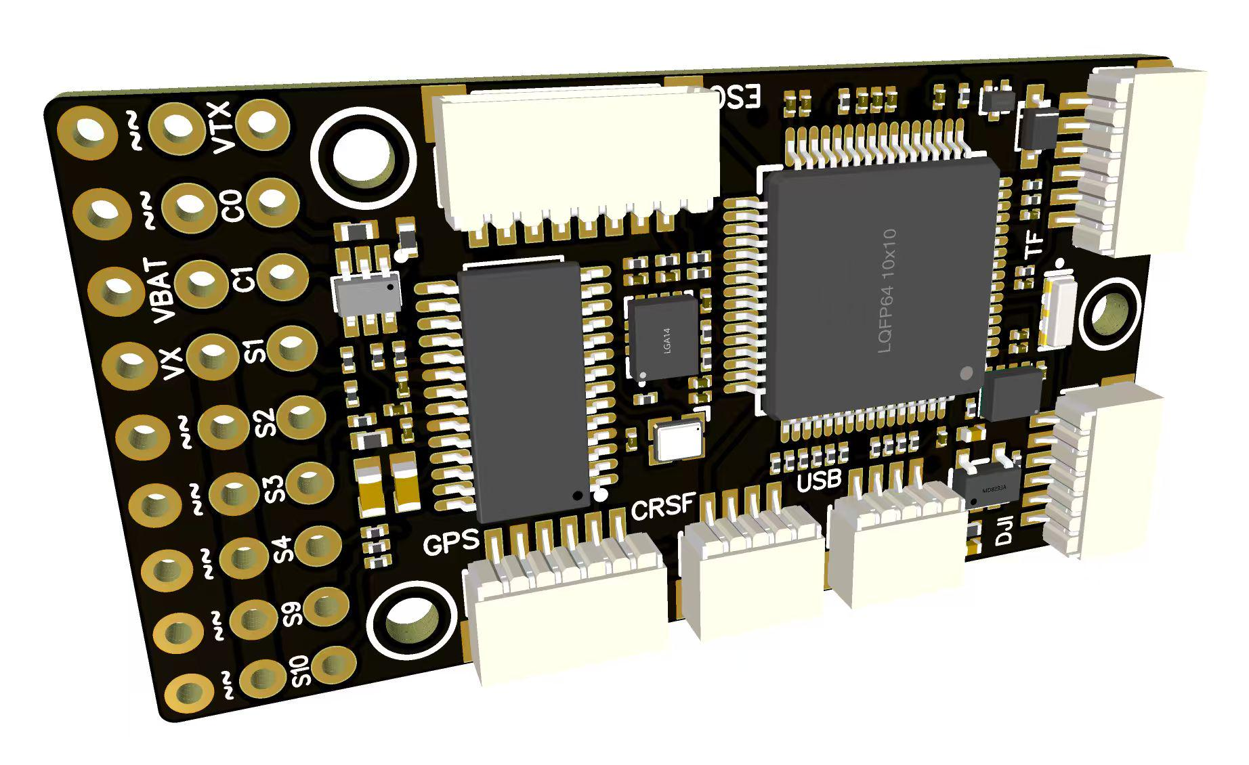
 |  |  | - FlyingRC® F4WSE MK1.5 - F405 Fixed-Wing Flight Controller  Classic model, unique design, highly acclaimed.  Manual：https://kdocs.cn/l/cpyd8MTS56DD |  |  | 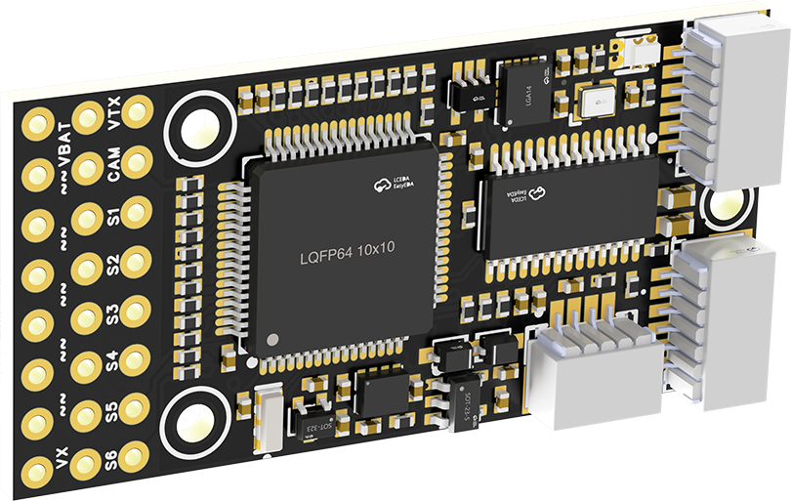
 |  |  |  | - FlyingRC® H7Wlite MK1 H743 Fixed-Wing Flight Controller  Flagship performance, full expansion, high-power BEC.  Manual：https://kdocs.cn/l/cpYaBiFKh8U1 |  |  | 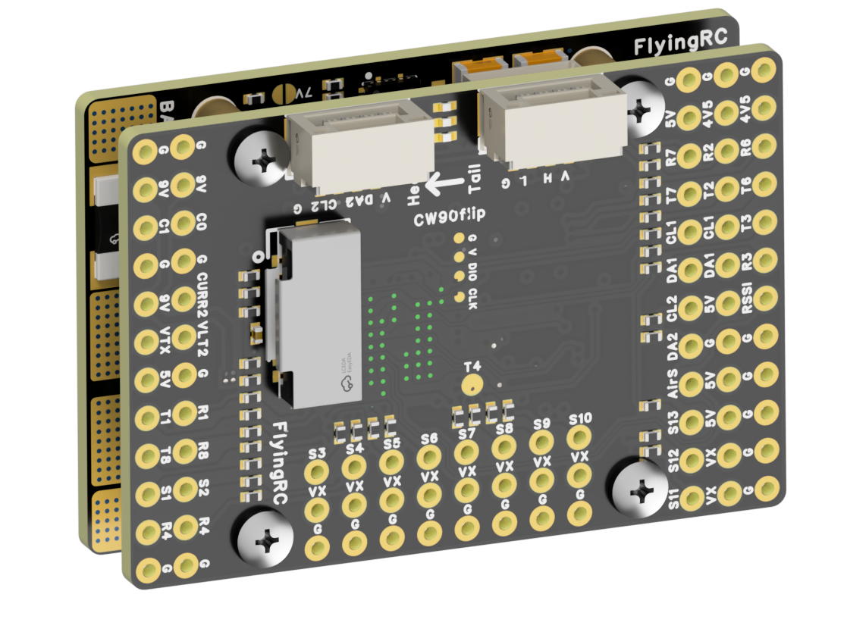
 |  |  |  | - FlyingRC® F4Wing Mini MK1 F405 Fixed-Wing Flight Controller  2025 bestseller, ultra-compact, smallest on the market, great value.  Manual：https://kdocs.cn/l/cdUIdmpSpW7J |  |  | 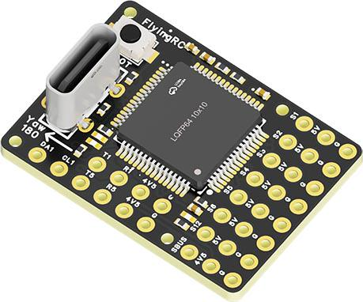
 | - FlyingRC® AM32 Dual ESC 40A 2-in-1 ESC  Unique design for dual-power aerial, land and water vehicles including drones.  Manual：https://www.kdocs.cn/l/cjwNtsKK6HeR |  |  |  | 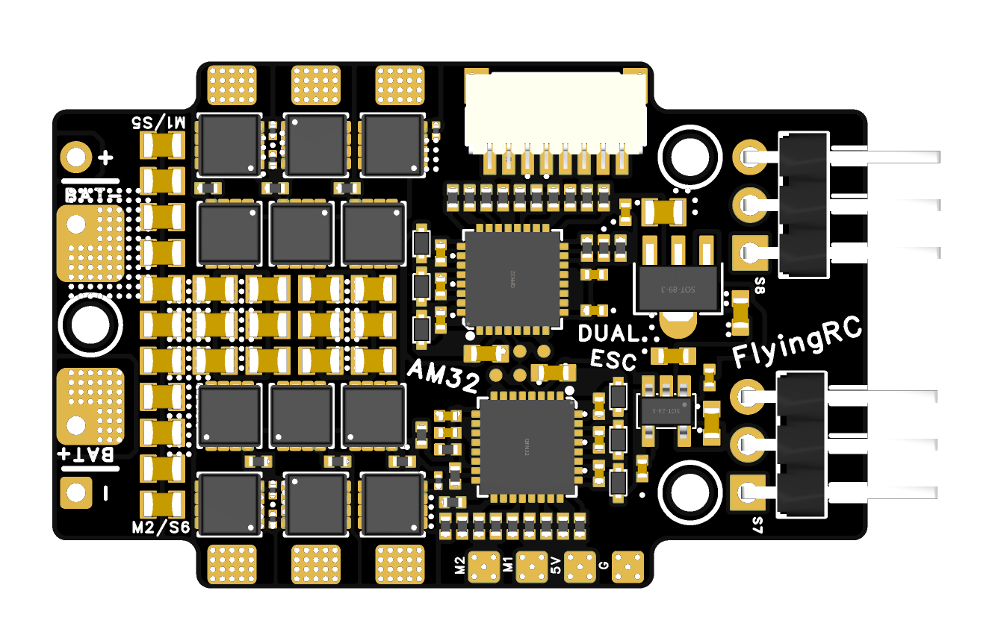
 |  |  | - FlyingRC® AM32 ESC V2.5 75A - Single ESC  Infineon gold-package MOSFETs, premium materials, superior heat dissipation.  Manual：https://kdocs.cn/l/cv6hUy67IdTJ |  |  |  | 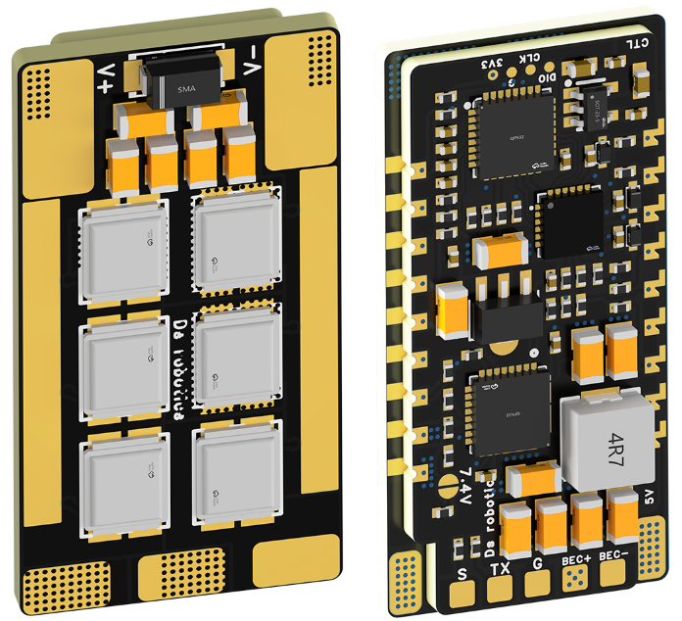
 |  |  | - FlyingRC® AM32 Mini ESC 40A V1.0 - Single ESC  Ultra-miniature, ideal for micro drones, high over-current capability, stable operation.  Manual：https://kdocs.cn/l/cqdLSysEyWFh |  |  |  |  | 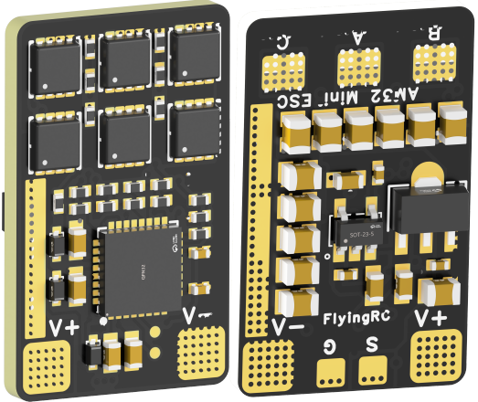
 |  |  | - FlyingRC® 10A 12S 440A Power Distribution Board for FPV Drones  Industry top choice, excellent quality and affordable price.  Manual：https://kdocs.cn/l/coel7OgrlCBP |  |  |  |  | 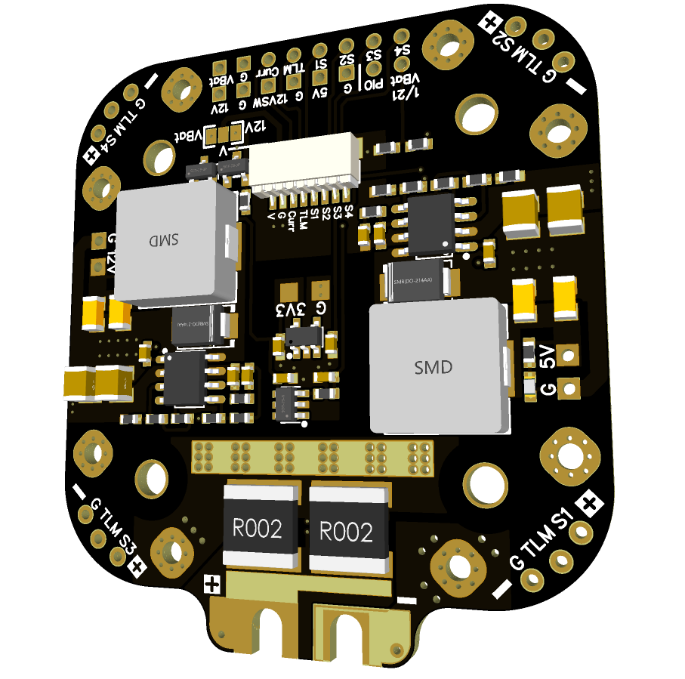
 |  |  | - FlyingRC® H7D Pro MK1 H743 FPV Flight Controller with Dual Gyro  Fully Upgraded & More Powerful  Manual：https://www.kdocs.cn/l/ctcekCy676Ez |  |  |  | 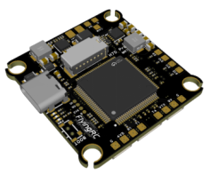
 |  |  | - FlyingRC® H7D MK1 H743 FPV Flight Controller with Dual Gyro  Powerful computing, stable and precise flight, rich interfaces, smooth control.  Manual：https://kdocs.cn/l/cqMh1I0RwAoD |  |  |  | 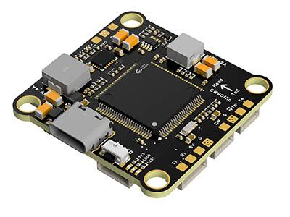
 |  |  | - FlyingRC® F420 MK1 F405 FPV Flight Controller (20/30.5mm Mounting)  Dual mounting holes, all connectors, no soldering required, compliant with Betaflight interface standards.  Manual：https://kdocs.cn/l/ctGeLiN9ZYKj |  |  |  | 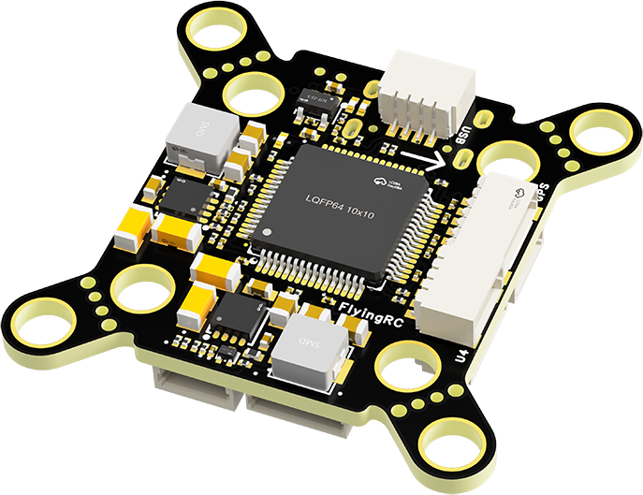
 |  | - FlyingRC® 4-in-1 75A V3.2 Gold-Sealed FPV ESC  Infineon gold-package MOSFETs, superior heat dissipation & over-current capability, premium choice.  Manual：https://kdocs.cn/l/ceLilc8Gaa21 |  |  |  |  | 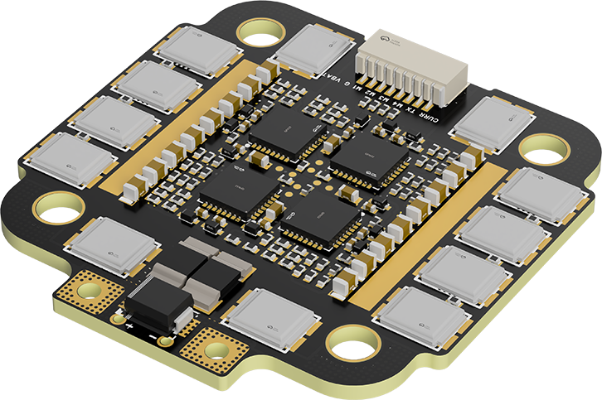
- FlyingRC® Stack Combo: H743 Flight Controller + 4-in-1 75A Gold-Sealed ESC  Professional flight choice, flagship materials & craftsmanship, reasonable price.  Manual：https://www.kdocs.cn/l/ctcekCy676Ez  https://kdocs.cn/l/ceLilc8Gaa21 |  |  |  |  |  |  | 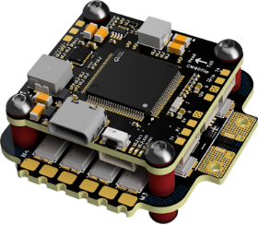
 |  | - FlyingRC® Stack Combo: F405 Flight Controller + 4-in-1 75A Gold-Sealed ESC  Best-selling combo, excellent performance, affordable price.  Manual：https://kdocs.cn/l/ctGeLiN9ZYKj  https://kdocs.cn/l/ceLilc8Gaa21 |  |  |  |  | 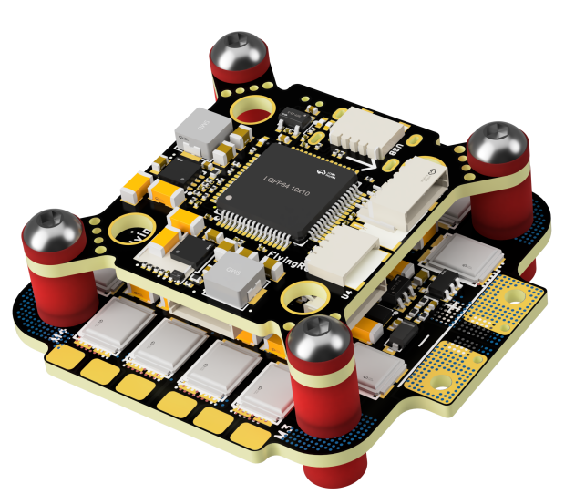
 |  | - FlyingRC® Stack Combo: H743 Flight Controller + 4-in-1 45A ESC  Winning combo: great performance, budget-friendly price  Manual：https://www.kdocs.cn/l/ctcekCy676Ez  https://kdocs.cn/l/ceLilc8Gaa21 |  |  |  |  | 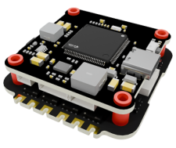
 |  | - FlyingRC® Stack Combo: F405 Flight Controller + 4-in-1 45A ESC  Hit combo, great value, budget-friendly  Manual：https://kdocs.cn/l/ctGeLiN9ZYKj  https://kdocs.cn/l/ceLilc8Gaa21 |  |  |  |  | 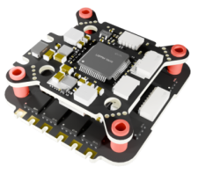
 |  | - FlyingRC® Stack Combo: F4WSE Pro - F405 Fixed-Wing Flight Controller + AM32 Dual ESC 40A 2-in-1 ESC  Unique Design • Exclusive Offer • Bestselling Bundle  Manual：https://www.kdocs.cn/l/cavm9EoVEq5A  https://www.kdocs.cn/l/cjwNtsKK6HeR |  |  |  |  | 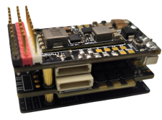
 | - FlyingRC® ELRS 2.4G Diversity Receiver  True diversity reception, temperature compensation, high-sensitivity reception.  Manual：https://kdocs.cn/l/cbvlOlShmsPS |  |  |  |  |  | 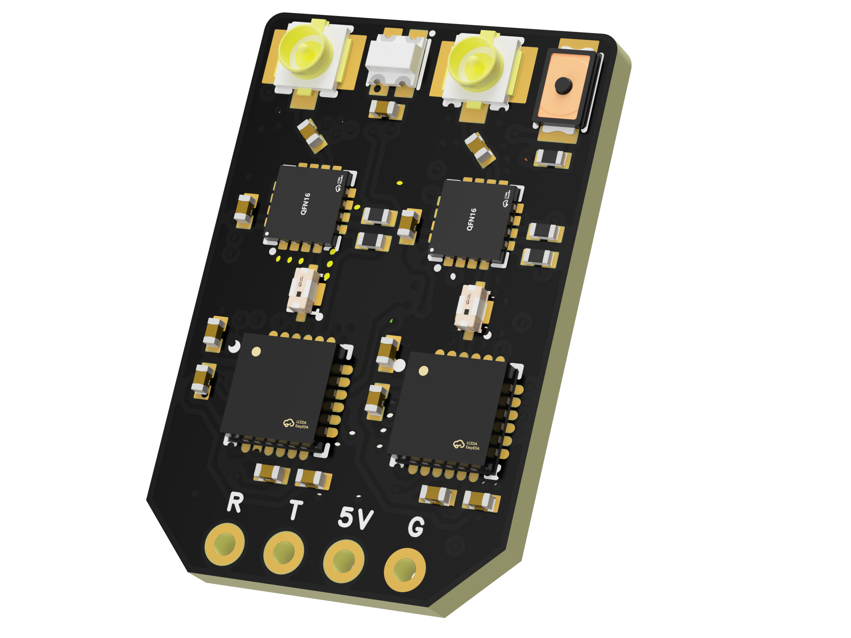
 | - FlyingRC® RM3100 SPI Module 罗盘模块  Ultra-high Resolution • Low Power • Industry Top Choice  Manual：https://www.kdocs.cn/l/cdGuHvBVyndC |  |  |  |  |  | 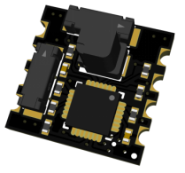
 | - FlyingRC® 10A 12S BEC Step-Down Module  Wide voltage input, high power, compact size, multiple voltages available, 10A continuous output.  Manual：https://kdocs.cn/l/clssNCKgNhLV |  |  |  |  |  | 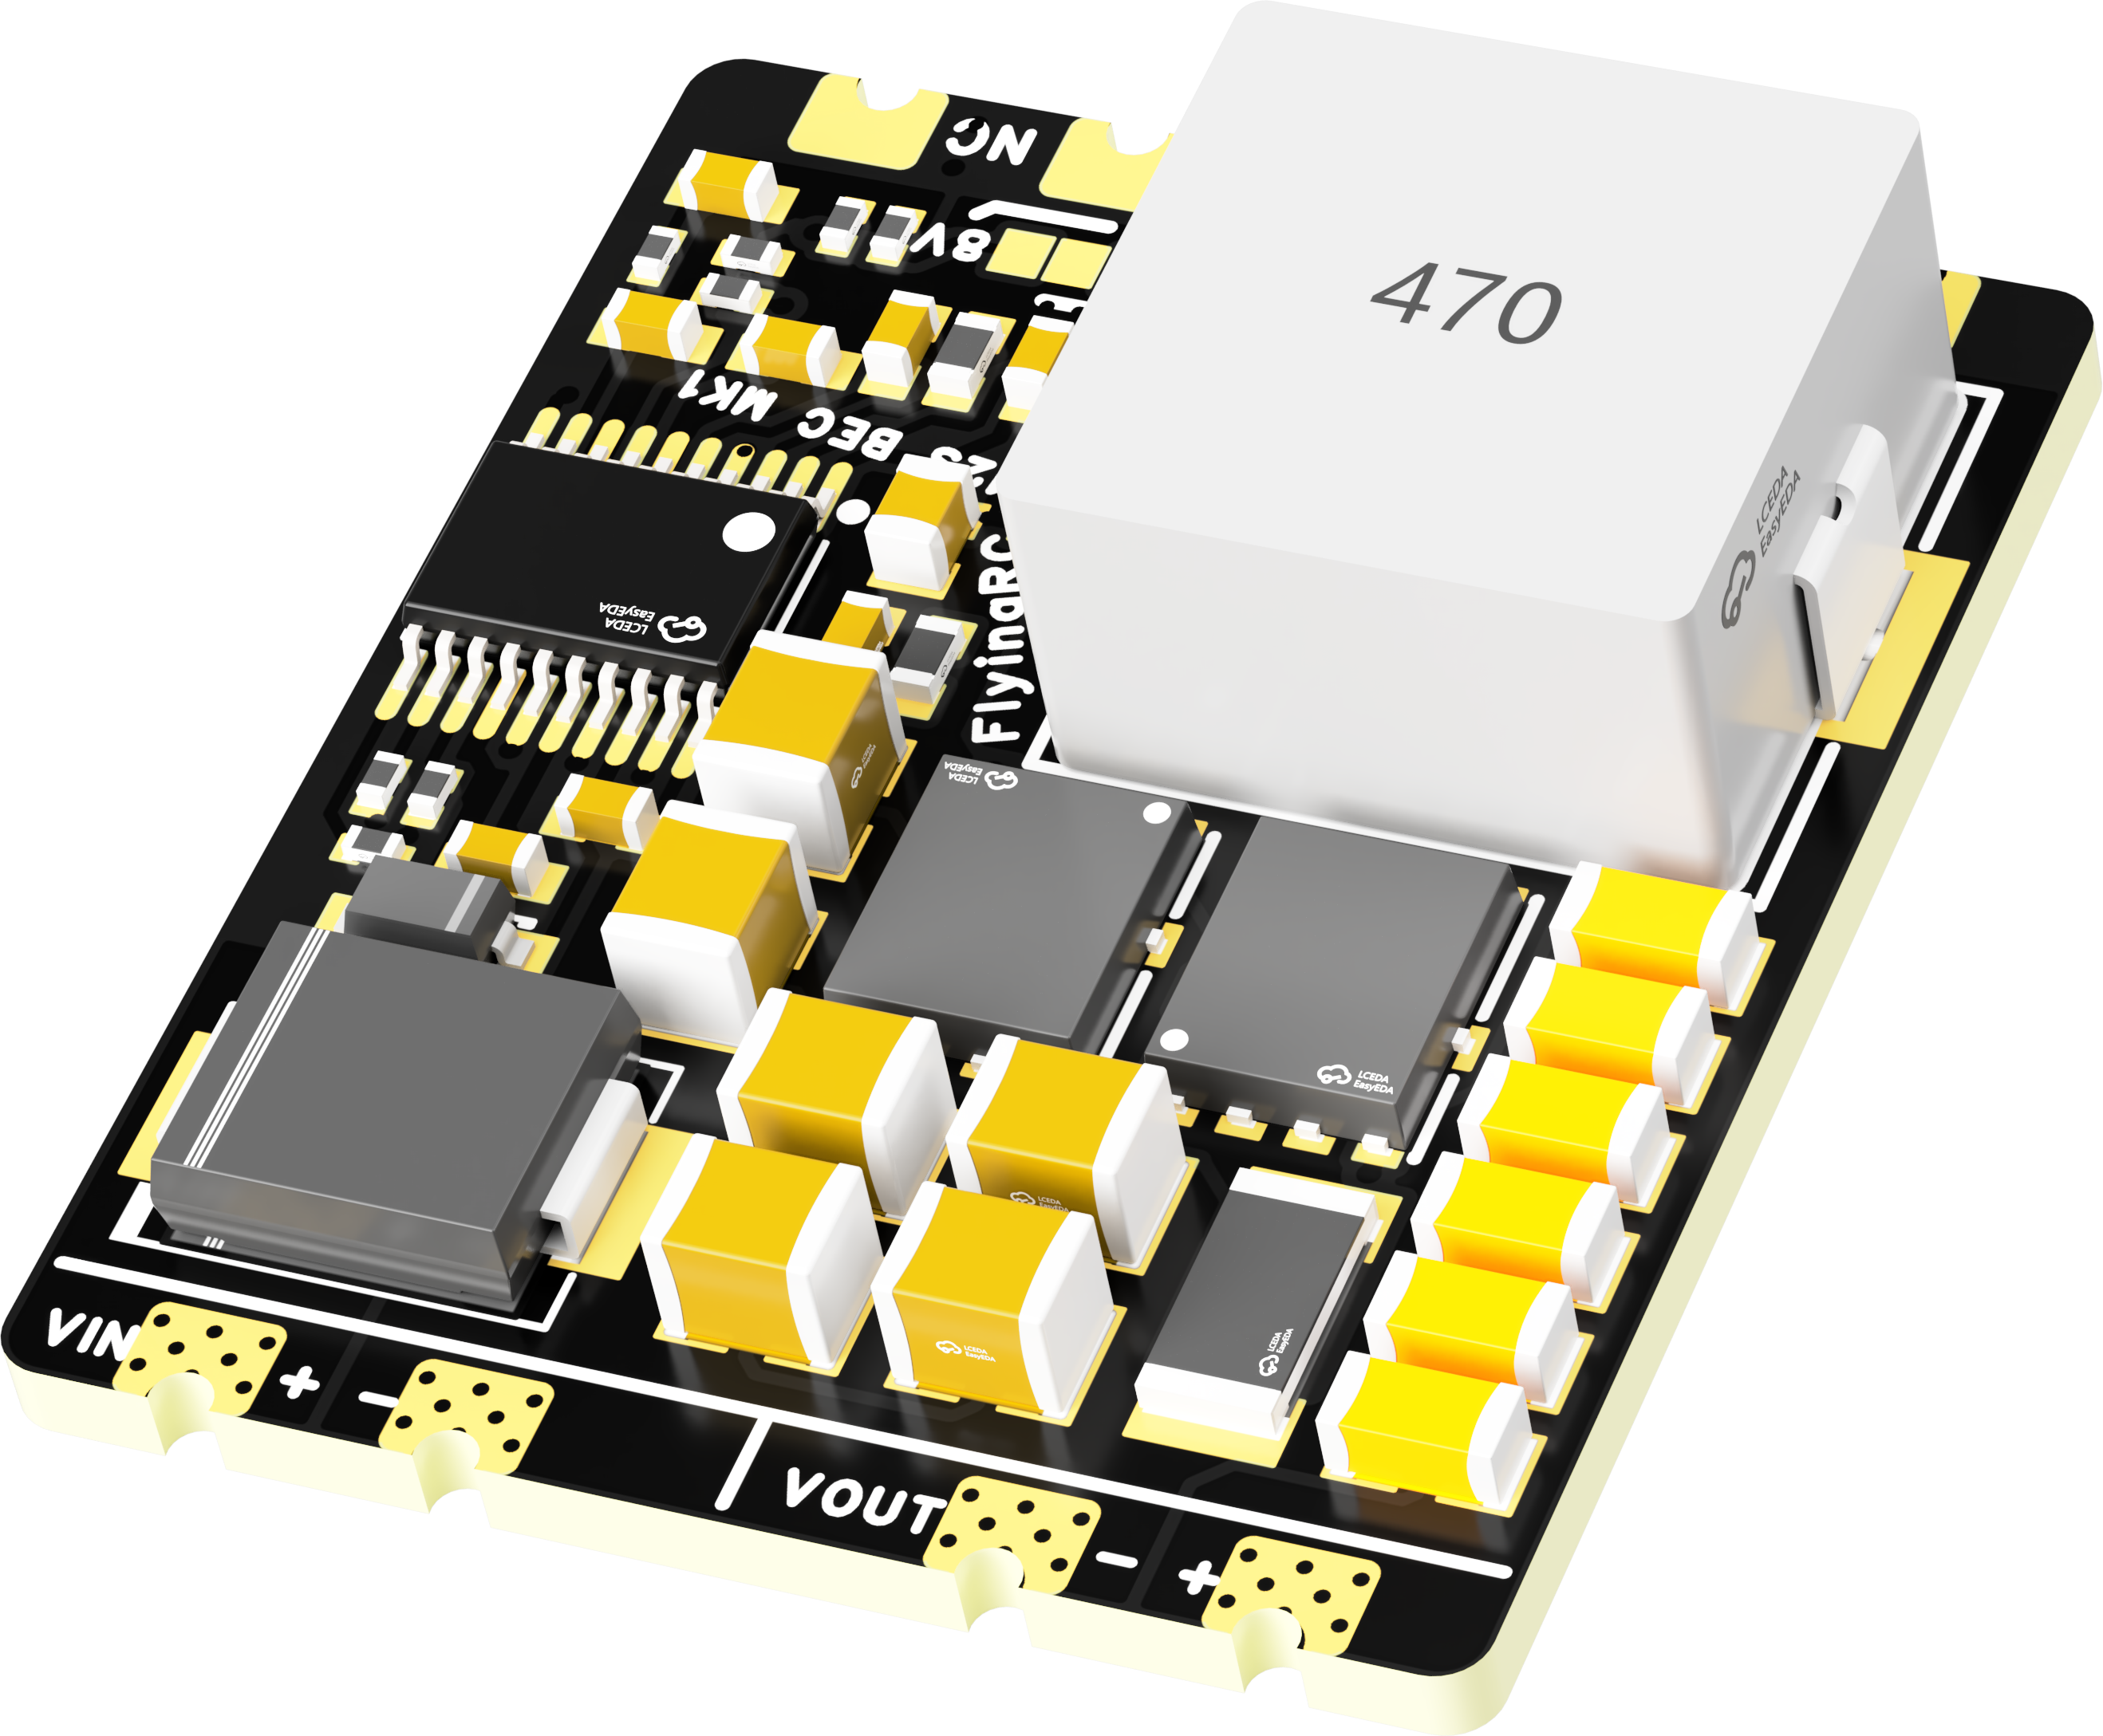
 | FlyingRC® 5A BEC Step-Down Module  Ultra-small size, multiple voltages available, 5A continuous output.  Manual：https://kdocs.cn/l/cb9VdNywqCKA |  |  |  |  |  | 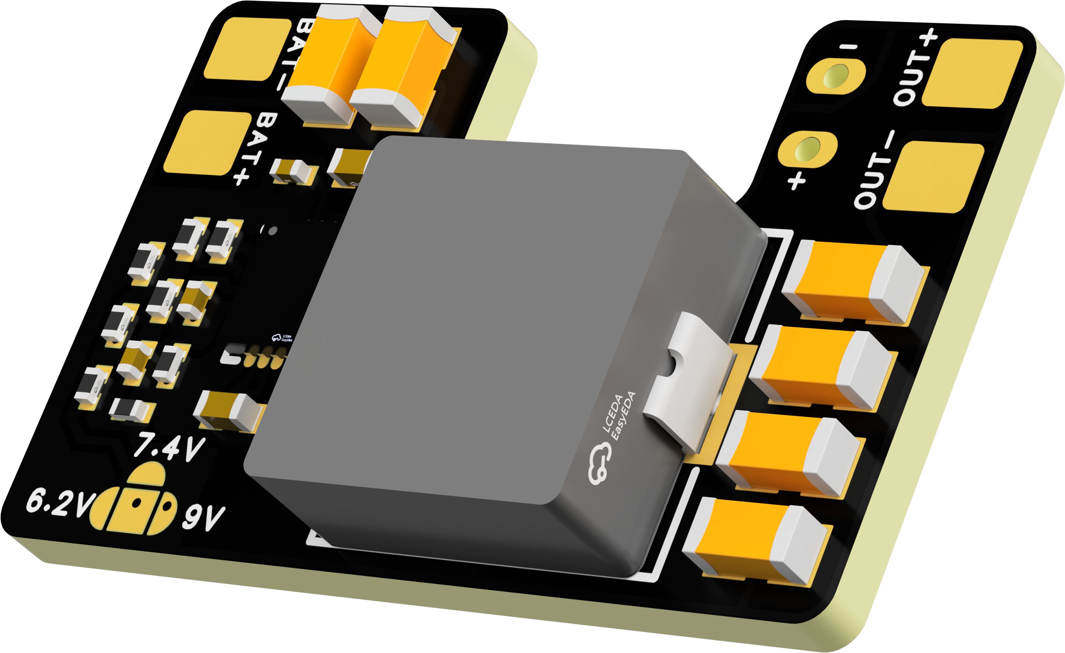
 | FlyingRC® Mini BEC For DJI O4  Easy wiring, ultra-small size, stable power supply.  Manual：https://kdocs.cn/l/cb9VdNywqCKA |  |  |  |  |  | 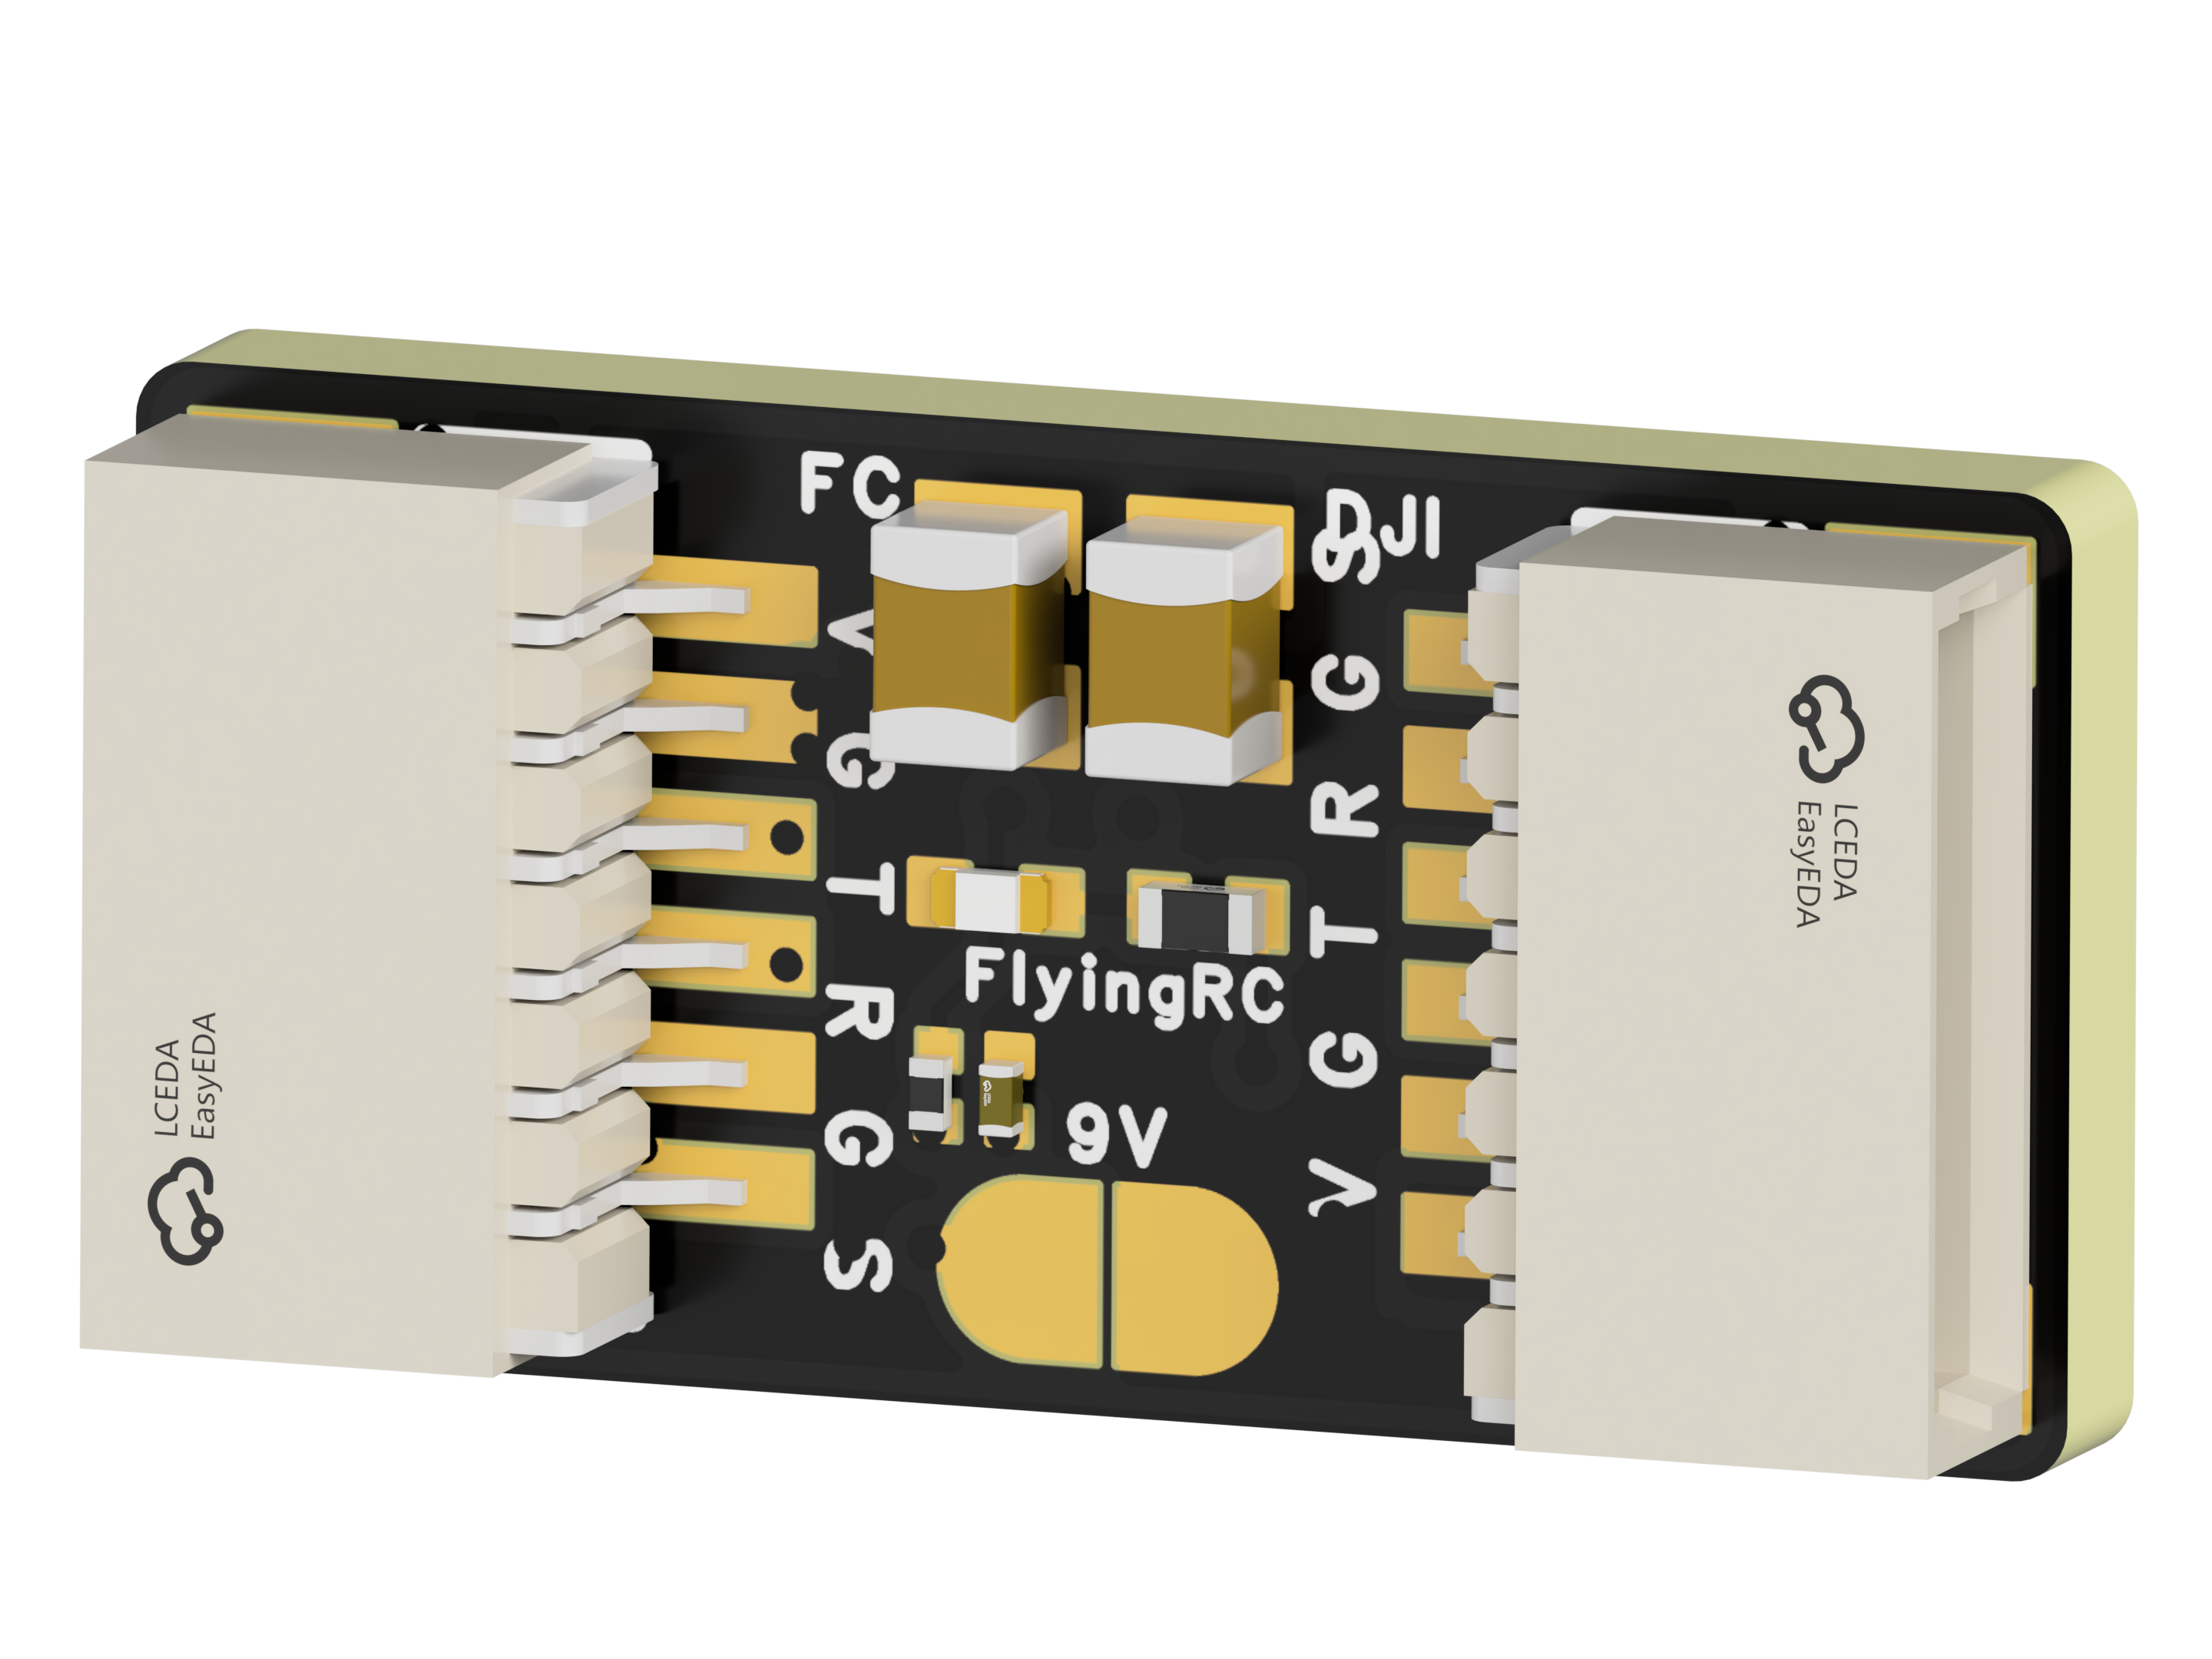
 | FlyingRC® CAN Bus Serial & PWM Expansion Board  Long-distance transmission, high speed, excellent stability.  Manual：https://www.kdocs.cn/l/cmxRyBnU4BXj |  |  |  |  |  | 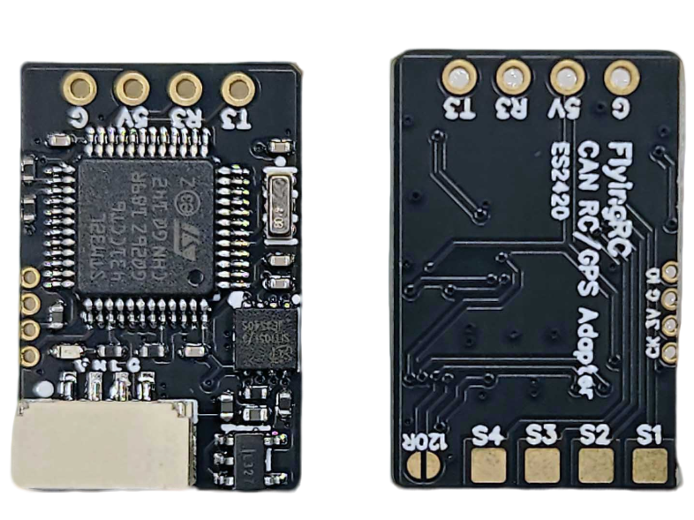
 | FlyingRC® AM3 2ESC Programmer  Supports BL, BL32, AM32. Simple and easy to use.  Manual：https://kdocs.cn/l/cogBSEBe67mE |  |  |  |  |  | 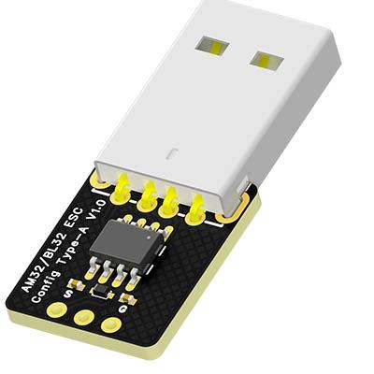
 | FlyingRC® Digital Airspeed Sensor without Pitot Tube  Integrated design, smallest on the market. MS4525D protocol, I2C interface.  Manual：https://www.kdocs.cn/l/clPvEEEcJgCC |  |  |  |  |  | 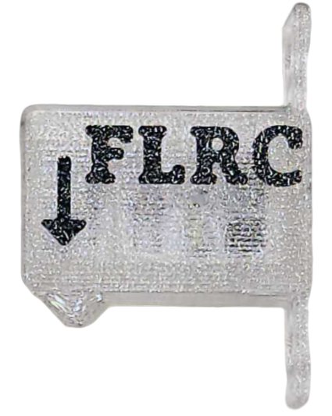
 | FlyingRC® U-Blox M10 GPS  Compatible with all open-source flight controllers.  Manual：https://www.kdocs.cn/l/cdSYQrzx74O8 |  |  |  |  |  | 