FlyingRC® 5A 6S BEC V1 （Step-Down Module） Product Manual
FlyingRC® is a globally-oriented professional brand of electronic devices. We specialize in the R&D and sales of drone electronics, core robot circuits and sensors. Our design team is based in Singapore, and our products are sold worldwide.

Since launched in 2023, FlyingRC® products have gained widespread recognition from customers as well as strong market response. As of April 2026, our cumulative sales volume has exceeded 46,000 units. Our products are widely applied in industries, robotics, emergency rescue, environmental protection & inspection, aerial photography, public security, retail and many other fields. Above all, we are committed to distinctive design and superior reliable quality.

Our Chief Technology Officer Liu Yuhan possesses outstanding expertise in circuit design. Over the past four years, he has designed more than 80 circuit projects and contributed 39 to open-source platforms. Moreover, he won the Design Award on the open-source platform X.JLC.com twice in 2023 and 2024, and has become the youngest certified designer on this platform.

He holds the NUS (National University of Singapore, rank 8th worldwide) Science and Technology Scholarship, and is currently majoring in Electronic Engineering with a focus on Aerospace Technology. In addition, all members of our technical team are graduates from prestigious universities with extensive professional product experience.

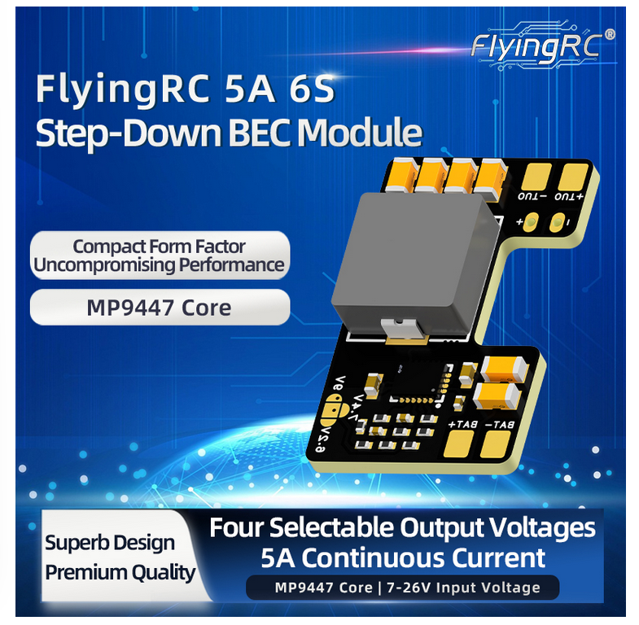
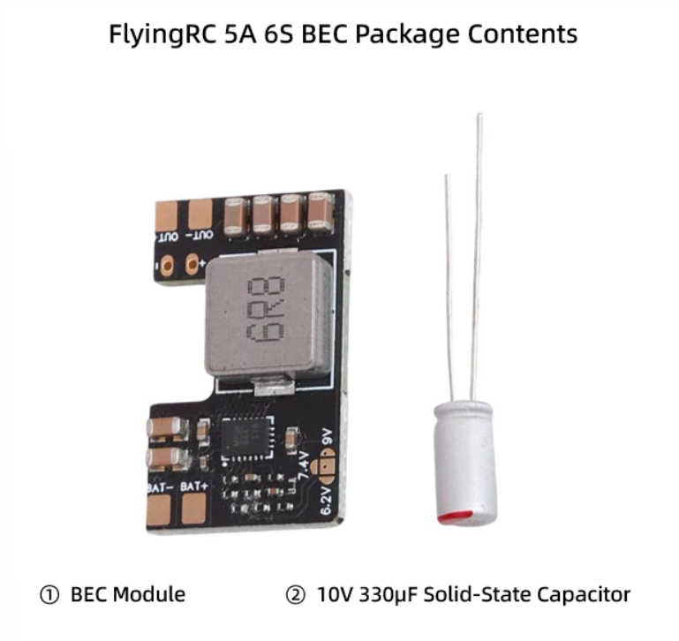
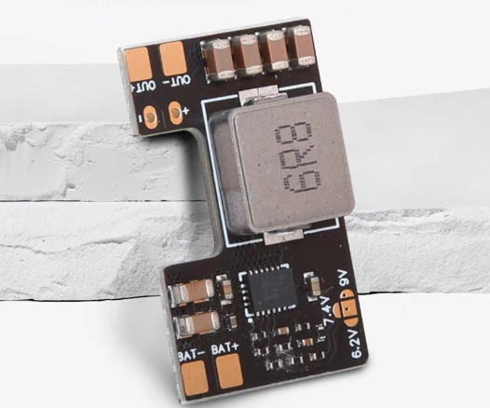
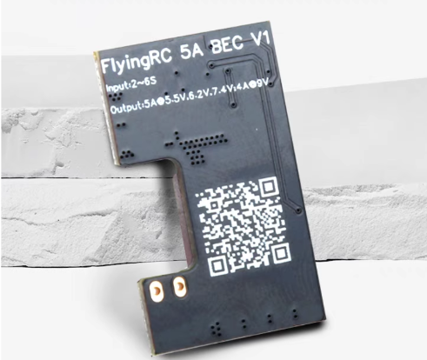

Technical Specifications

Product Dimensions: 28.9mm × 17.7mm × 5.4mm
Product Weight: 4.3 g (without capacitor), 4.6 g (with capacitor)
PCB Layers: 2 layers
PCB Thickness: 1.60 mm
Immersion Gold: 1μm

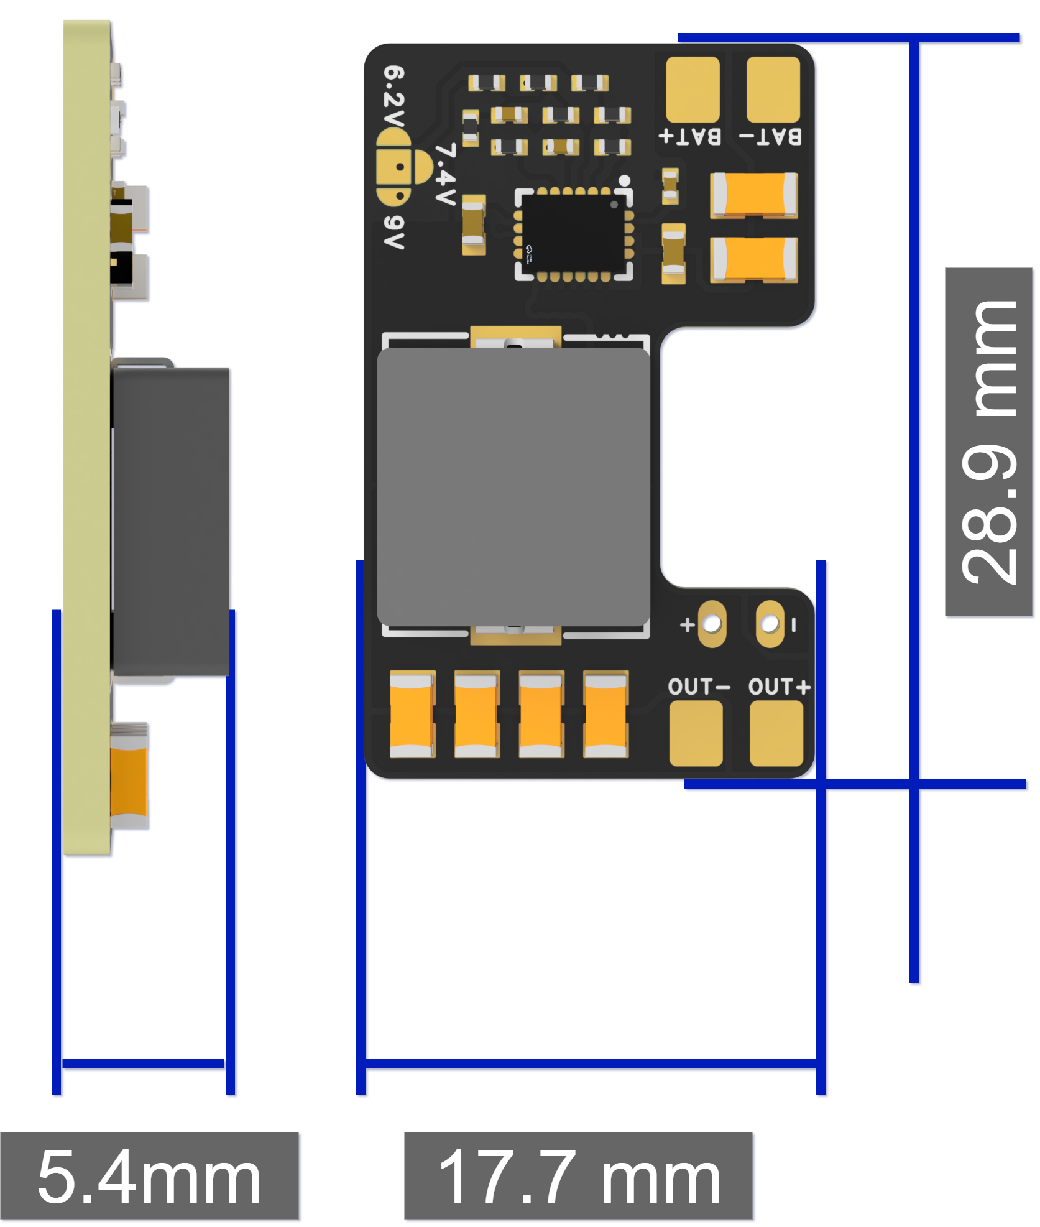

Product Features
FlyingRC® 5A BEC V1 is a compact, high-performance BEC (step-down module).
It adopts the MonolithicPower MP9447, a high-efficiency integrated buck converter IC with built-in buck controller and switching MOSFETs. It delivers a maximum instantaneous output current of 7A, 4A continuous output without heatsink and airflow, and 5A continuous output with heatsink or airflow.
- Input Voltage: 7–26V, 2–6S LiPo ( The Input voltage must be at least 0.8V higher than the set output voltage; otherwise, the output voltage will be input voltage – 0.8V.)
- Output Voltage: 5V, 6.2V, 7.4V, 9V selectable. Default output: 5V. The other three voltages can be selected via jumper pads.
- Continuous Output Current:
Without heat dissipation (no heat sink, no airflow): 5V/4A, 6.2V/4A, 7.4V/4A, 9V/3.5A
With heat dissipation (heat sink or airflow): 5V/5A, 6.2V/5A, 7.4V/5A, 9V/4.5A
- Instantaneous Output Current: 5V/7A, 6.2V/7A, 7.4V/6.5A, 9V/6A

3. Instructions for Use
- Solder the included capacitor: Insert the capacitor pins into the solder holes on the BEC. Note that the long pin is positive (+), the short pin is negative (-). Do not reverse the polarity.

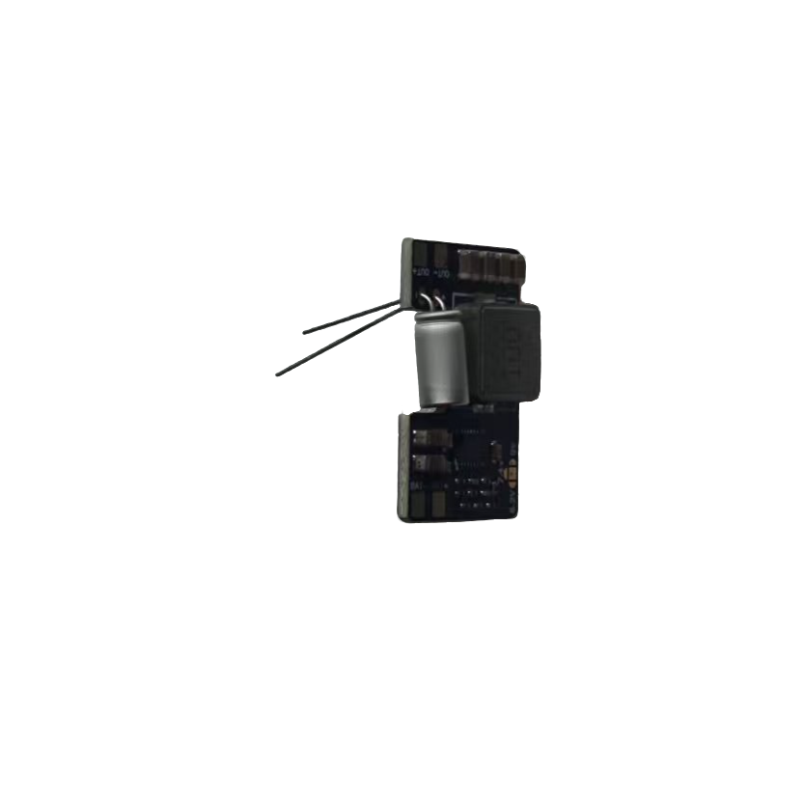

- After soldering, trim the excess part of the pins.

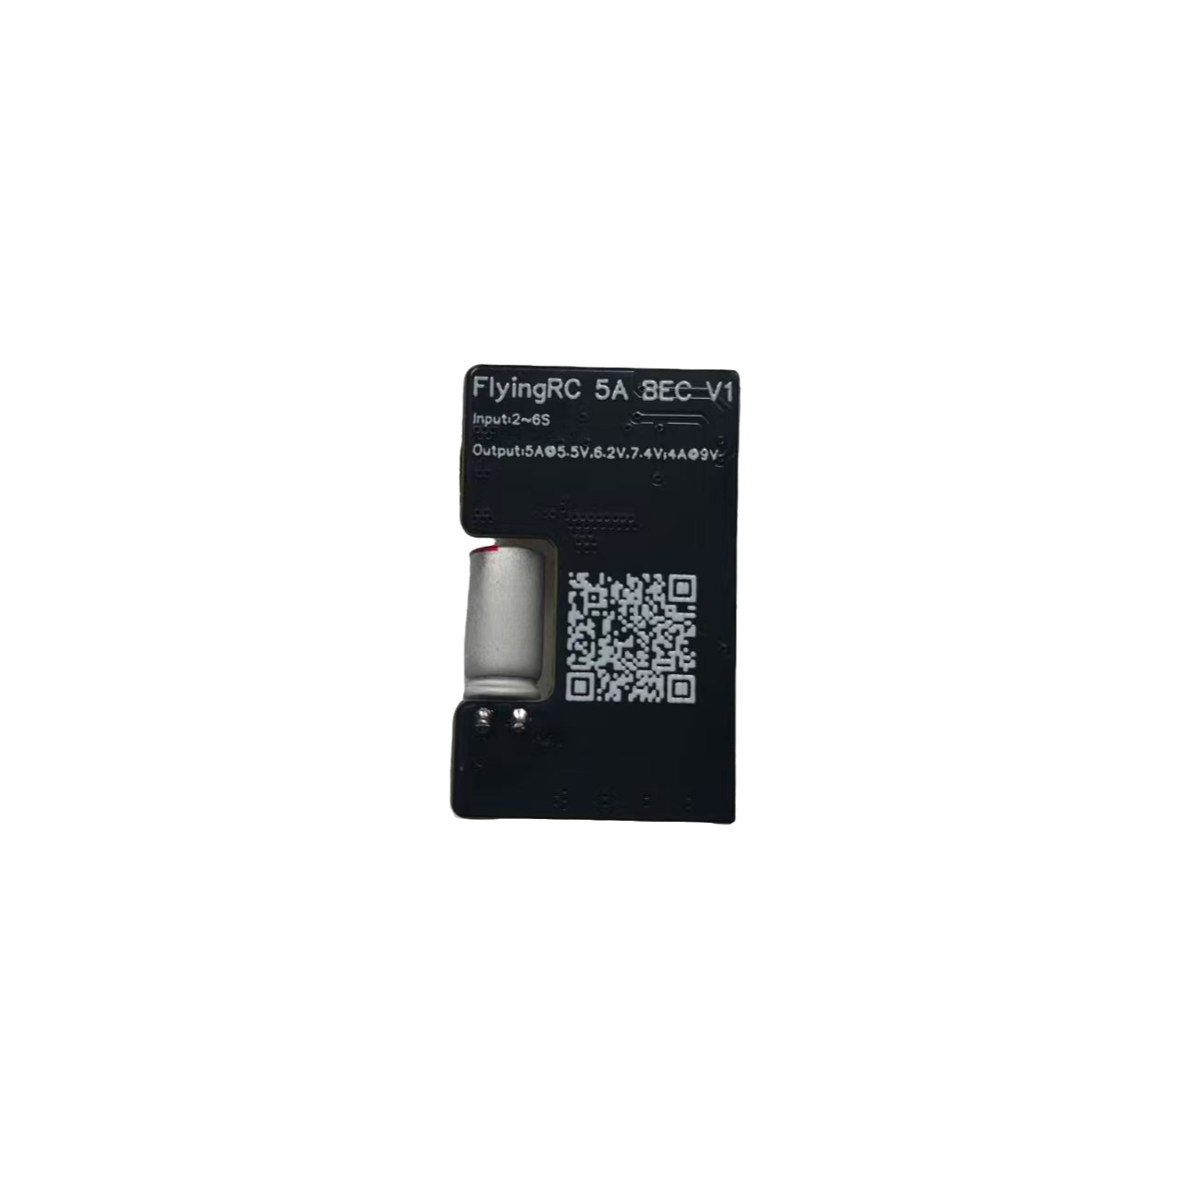

- Solder the power input wires.

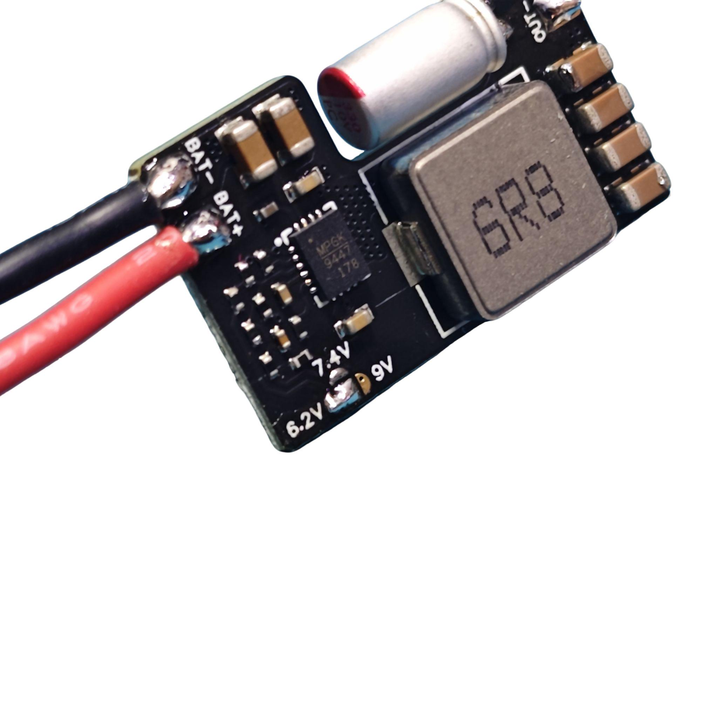

- Select the output voltage via the jumper pads (skip this step if 5V output is required).With jumper pads open, the default output is 5V.

Short the corresponding jumper pads to select other output voltages.
- When selecting the 6.2V pad: Actual output voltage is 5.9V
- When selecting the 7.4V pad: Actual output voltage is 6.9V
- When selecting the 9V pad: Actual output voltage is 8.9V


5. Solder the Power Output Wires
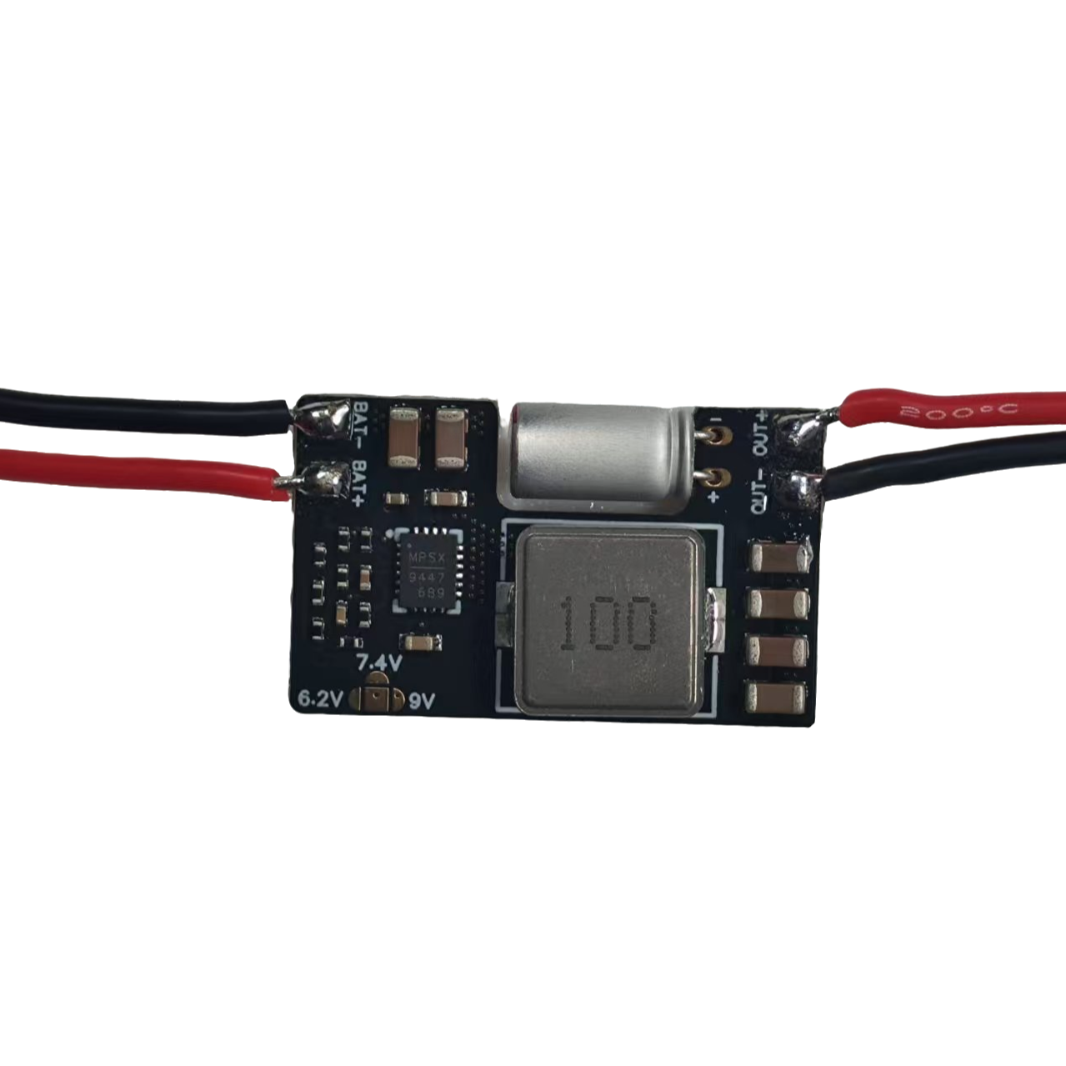

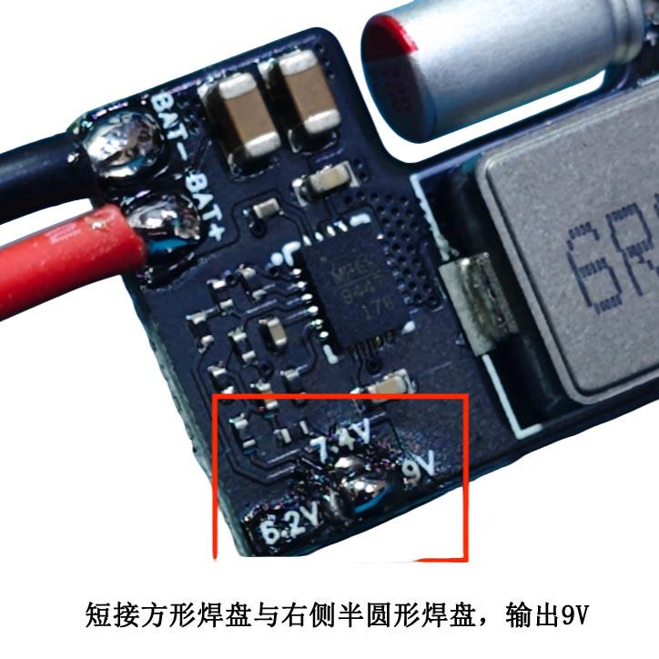
Short the square pad and the right semicircular pad to output 9V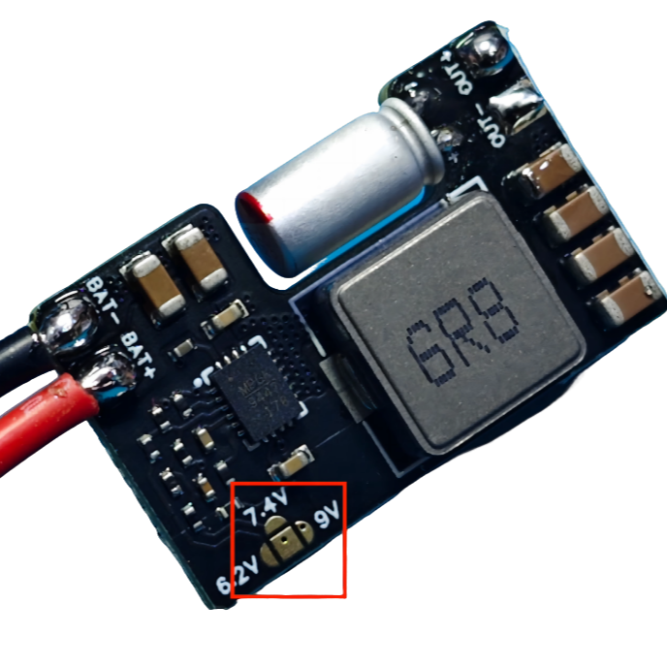
No shorting: Default output 5V

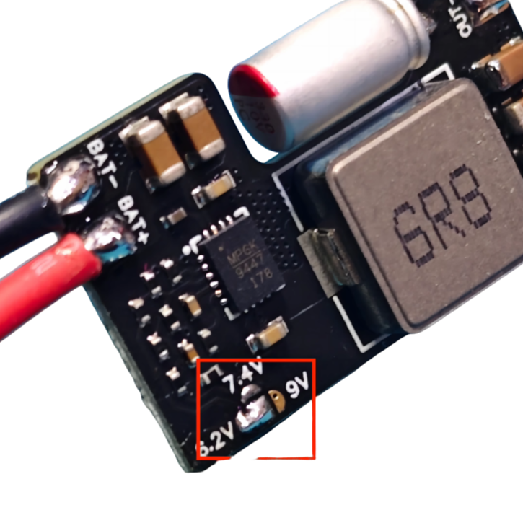
Short the middle square pad and the left semicircular pad: Output 6.2V
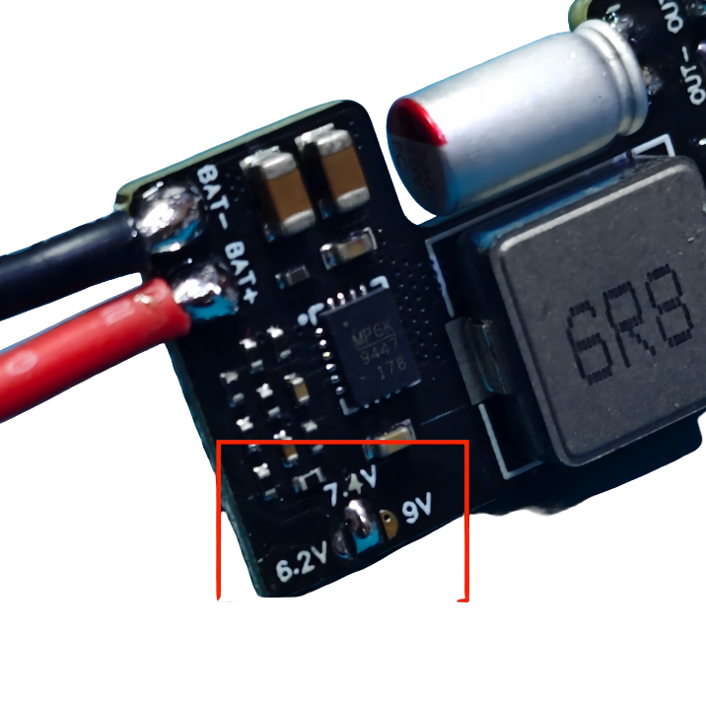
Short the middle square pad and the upper semicircular pad: Output 7.4V

Other FlyingRC® Products
 |  |  |  | - FlyingRC® F4WSE Pro - F405 Fixed-Wing Flight Controller  Upgraded Version | Enhanced Performance  Manual：https://www.kdocs.cn/l/cavm9EoVEq5A |  |  | 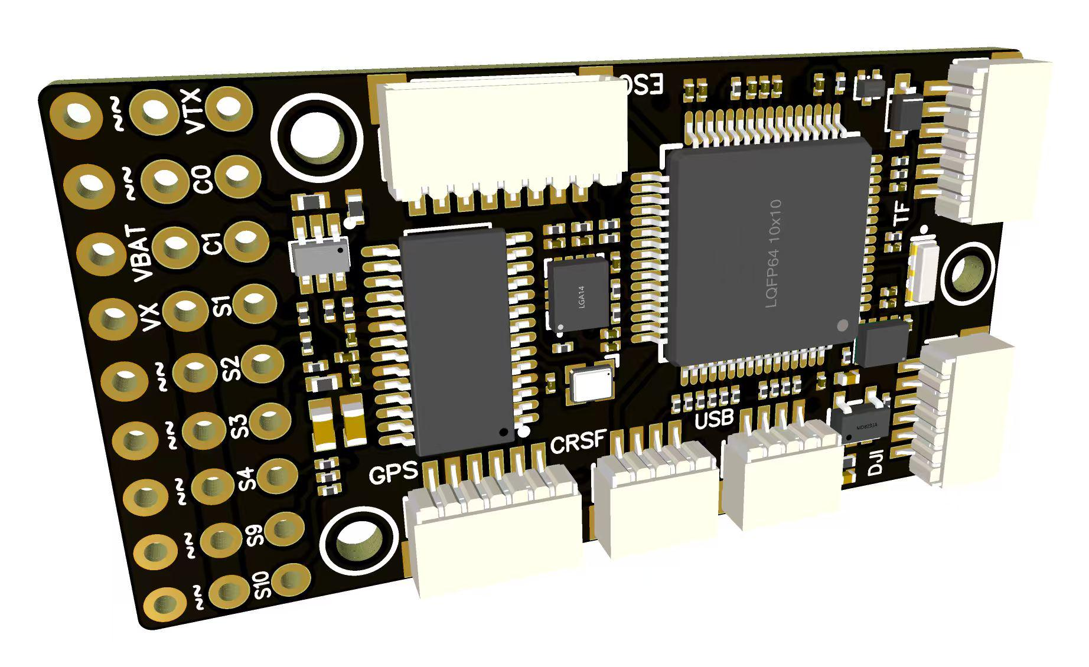
 |  |  | - FlyingRC® F4WSE MK1.5 - F405 Fixed-Wing Flight Controller  Classic model, unique design, highly acclaimed.  Manual：https://kdocs.cn/l/cpyd8MTS56DD |  |  | 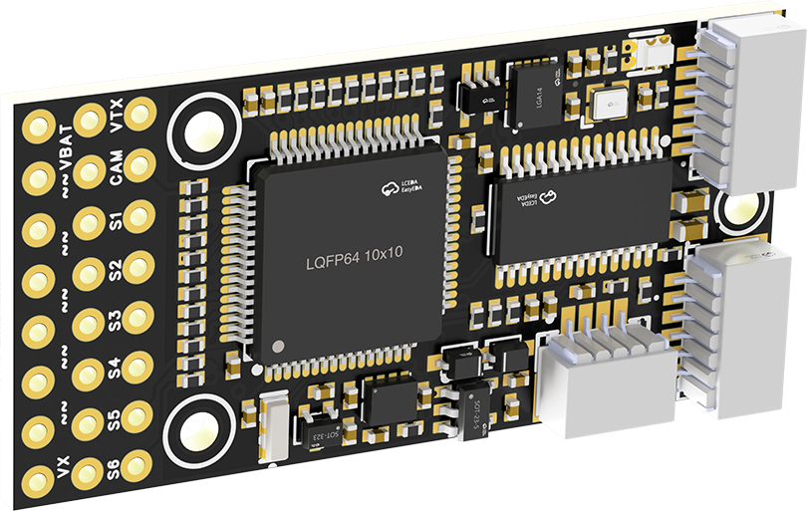
 |  |  |  | - FlyingRC® H7Wlite MK1 H743 Fixed-Wing Flight Controller  Flagship performance, full expansion, high-power BEC.  Manual：https://kdocs.cn/l/cpYaBiFKh8U1 |  |  | 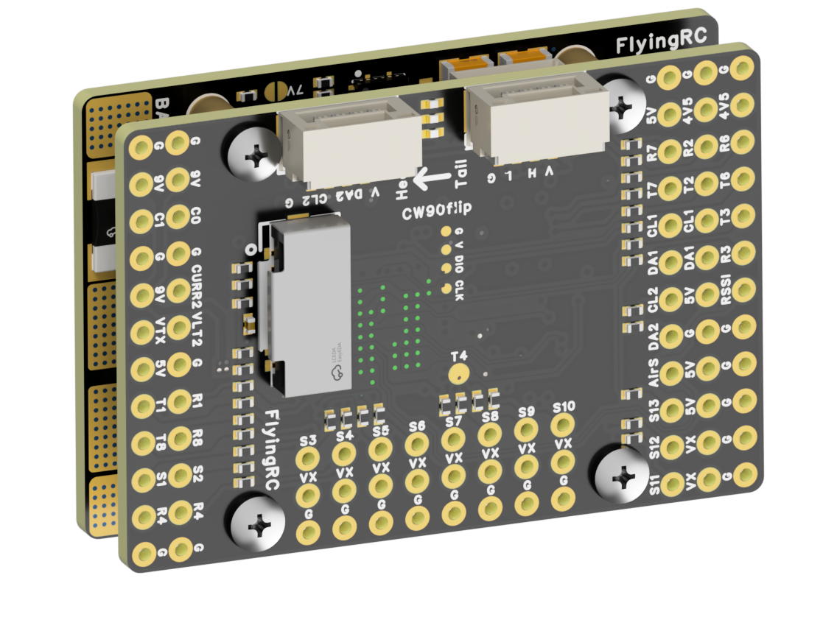
 |  |  |  | - FlyingRC® F4Wing Mini MK1 F405 Fixed-Wing Flight Controller  2025 bestseller, ultra-compact, smallest on the market, great value.  Manual：https://kdocs.cn/l/cdUIdmpSpW7J |  |  | 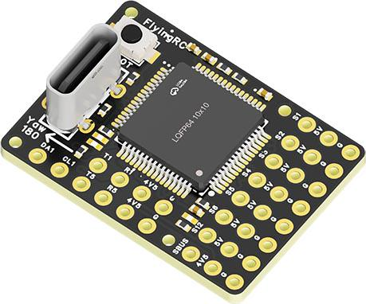
 | - FlyingRC® AM32 Dual ESC 40A 2-in-1 ESC  Unique design for dual-power aerial, land and water vehicles including drones.  Manual：https://www.kdocs.cn/l/cjwNtsKK6HeR |  |  |  | 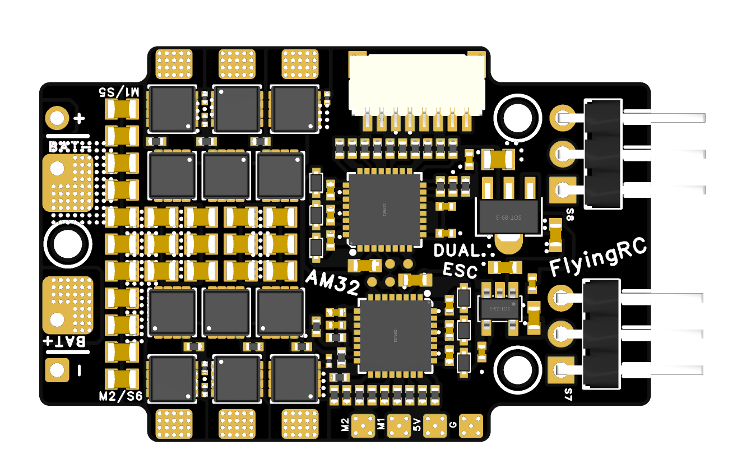
 |  |  | - FlyingRC® AM32 ESC V2.5 75A - Single ESC  Infineon gold-package MOSFETs, premium materials, superior heat dissipation.  Manual：https://kdocs.cn/l/cv6hUy67IdTJ |  |  |  | 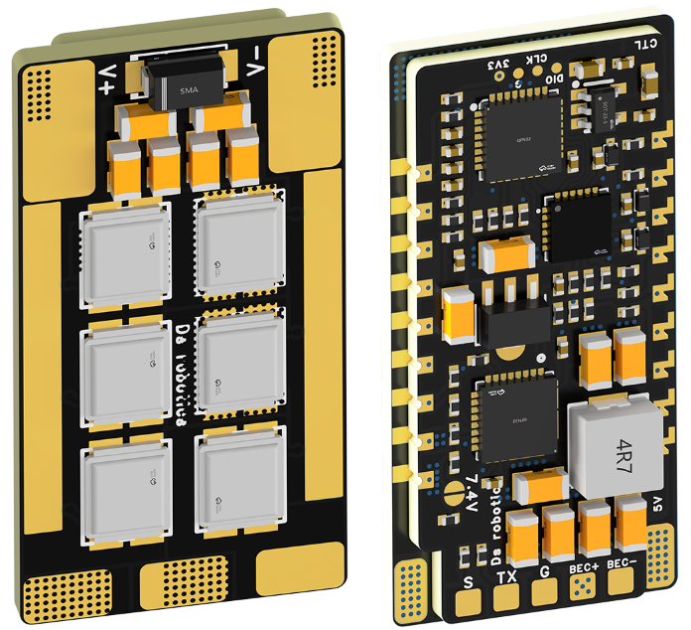
 |  |  | - FlyingRC® AM32 Mini ESC 40A V1.0 - Single ESC  Ultra-miniature, ideal for micro drones, high over-current capability, stable operation.  Manual：https://kdocs.cn/l/cqdLSysEyWFh |  |  |  |  | 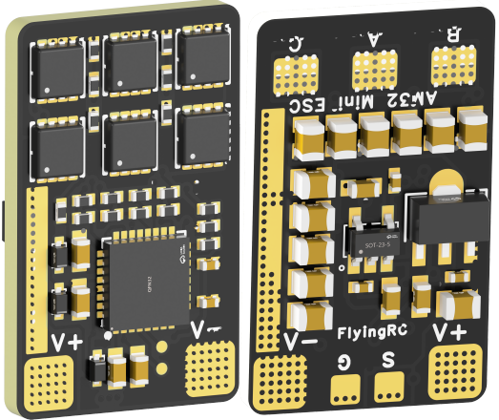
 |  |  | - FlyingRC® 10A 12S 440A Power Distribution Board for FPV Drones  Industry top choice, excellent quality and affordable price.  Manual：https://kdocs.cn/l/coel7OgrlCBP |  |  |  |  | 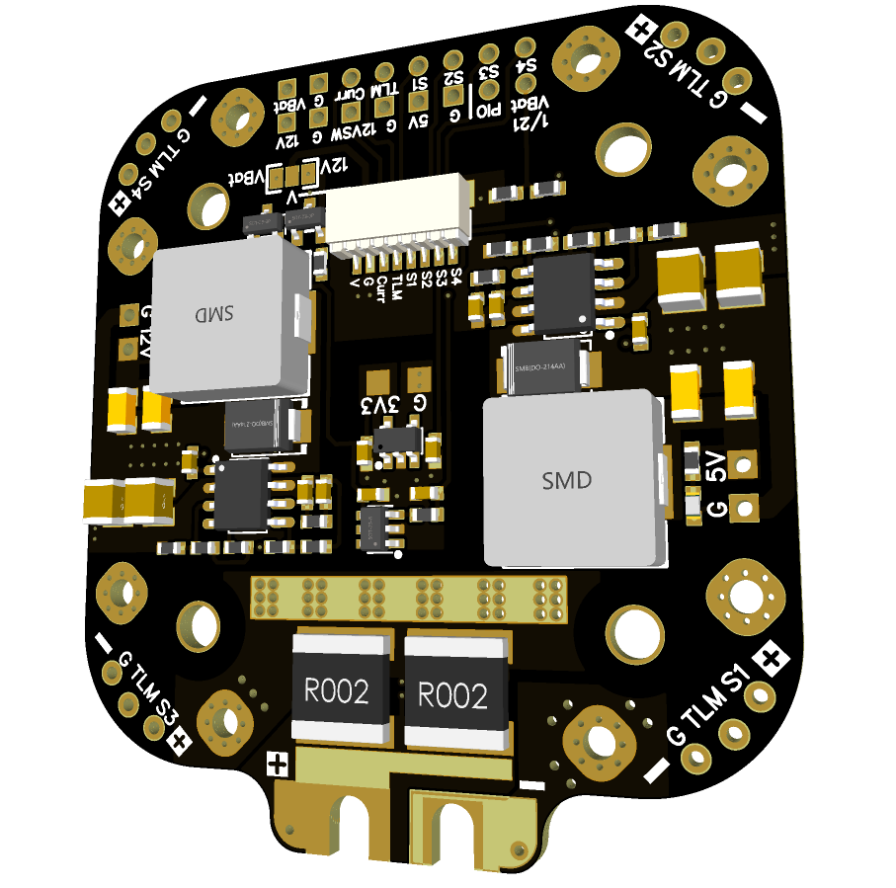
 |  |  | - FlyingRC® H7D Pro MK1 H743 FPV Flight Controller with Dual Gyro  Fully Upgraded & More Powerful  Manual：https://www.kdocs.cn/l/ctcekCy676Ez |  |  |  | 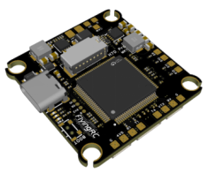
 |  |  | - FlyingRC® H7D MK1 H743 FPV Flight Controller with Dual Gyro  Powerful computing, stable and precise flight, rich interfaces, smooth control.  Manual：https://kdocs.cn/l/cqMh1I0RwAoD |  |  |  | 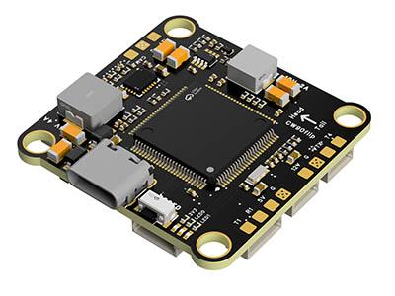
 |  |  | - FlyingRC® F420 MK1 F405 FPV Flight Controller (20/30.5mm Mounting)  Dual mounting holes, all connectors, no soldering required, compliant with Betaflight interface standards.  Manual：https://kdocs.cn/l/ctGeLiN9ZYKj |  |  |  | 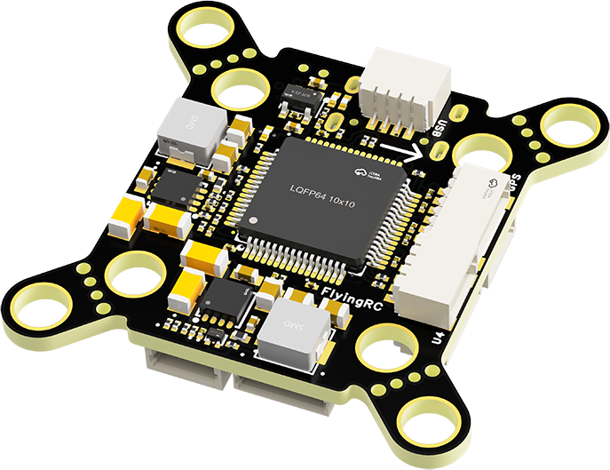
 |  | - FlyingRC® 4-in-1 75A V3.2 Gold-Sealed FPV ESC  Infineon gold-package MOSFETs, superior heat dissipation & over-current capability, premium choice.  Manual：https://kdocs.cn/l/ceLilc8Gaa21 |  |  |  |  | 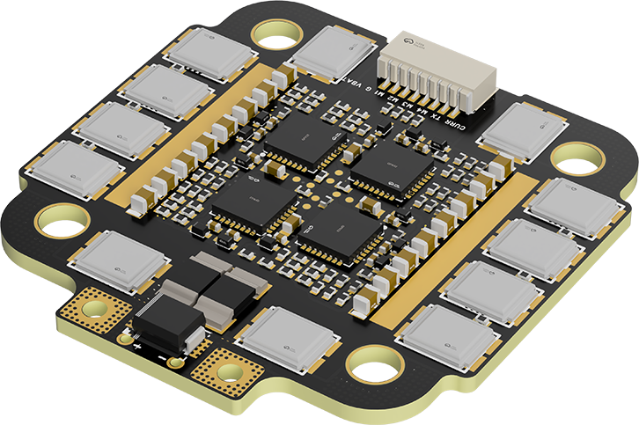
- FlyingRC® Stack Combo: H743 Flight Controller + 4-in-1 75A Gold-Sealed ESC  Professional flight choice, flagship materials & craftsmanship, reasonable price.  Manual：https://www.kdocs.cn/l/ctcekCy676Ez  https://kdocs.cn/l/ceLilc8Gaa21 |  |  |  |  |  |  | 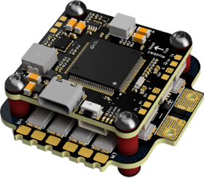
 |  | - FlyingRC® Stack Combo: F405 Flight Controller + 4-in-1 75A Gold-Sealed ESC  Best-selling combo, excellent performance, affordable price.  Manual：https://kdocs.cn/l/ctGeLiN9ZYKj  https://kdocs.cn/l/ceLilc8Gaa21 |  |  |  |  | 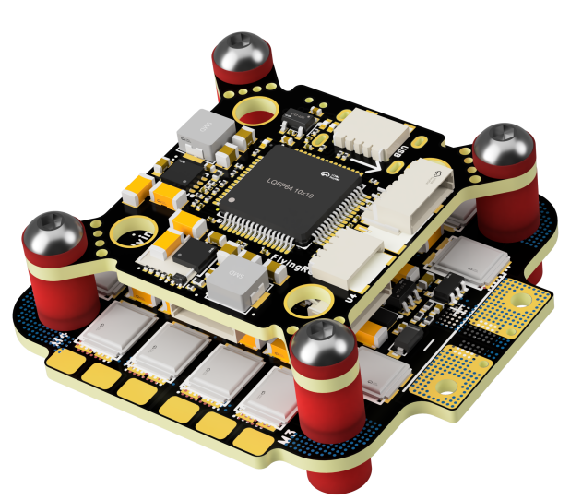
 |  | - FlyingRC® Stack Combo: H743 Flight Controller + 4-in-1 45A ESC  Winning combo: great performance, budget-friendly price  Manual：https://www.kdocs.cn/l/ctcekCy676Ez  https://kdocs.cn/l/ceLilc8Gaa21 |  |  |  |  | 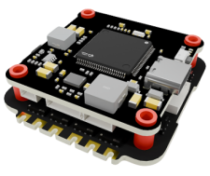
 |  | - FlyingRC® Stack Combo: F405 Flight Controller + 4-in-1 45A ESC  Hit combo, great value, budget-friendly  Manual：https://kdocs.cn/l/ctGeLiN9ZYKj  https://kdocs.cn/l/ceLilc8Gaa21 |  |  |  |  | 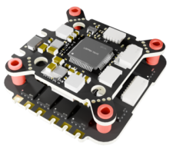
 |  | - FlyingRC® Stack Combo: F4WSE Pro - F405 Fixed-Wing Flight Controller + AM32 Dual ESC 40A 2-in-1 ESC  Unique Design • Exclusive Offer • Bestselling Bundle  Manual：https://www.kdocs.cn/l/cavm9EoVEq5A  https://www.kdocs.cn/l/cjwNtsKK6HeR |  |  |  |  | 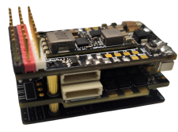
 | - FlyingRC® ELRS 2.4G Diversity Receiver  True diversity reception, temperature compensation, high-sensitivity reception.  Manual：https://kdocs.cn/l/cbvlOlShmsPS |  |  |  |  |  | 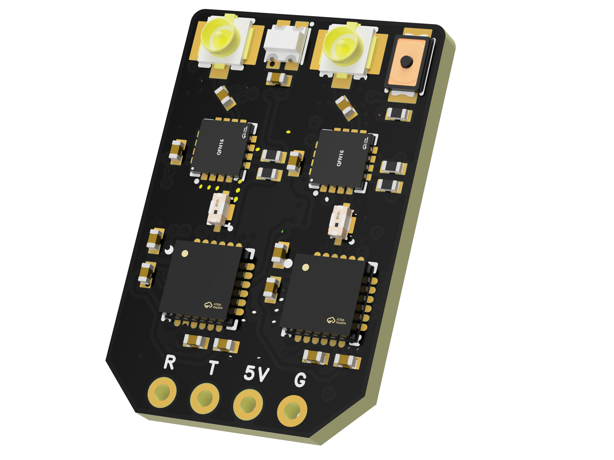
 | - FlyingRC® RM3100 SPI Module 罗盘模块  Ultra-high Resolution • Low Power • Industry Top Choice  Manual：https://www.kdocs.cn/l/cdGuHvBVyndC |  |  |  |  |  | 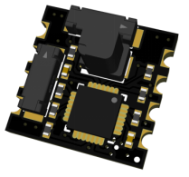
 | - FlyingRC® 10A 12S BEC Step-Down Module  Wide voltage input, high power, compact size, multiple voltages available, 10A continuous output.  Manual：https://kdocs.cn/l/clssNCKgNhLV |  |  |  |  |  | 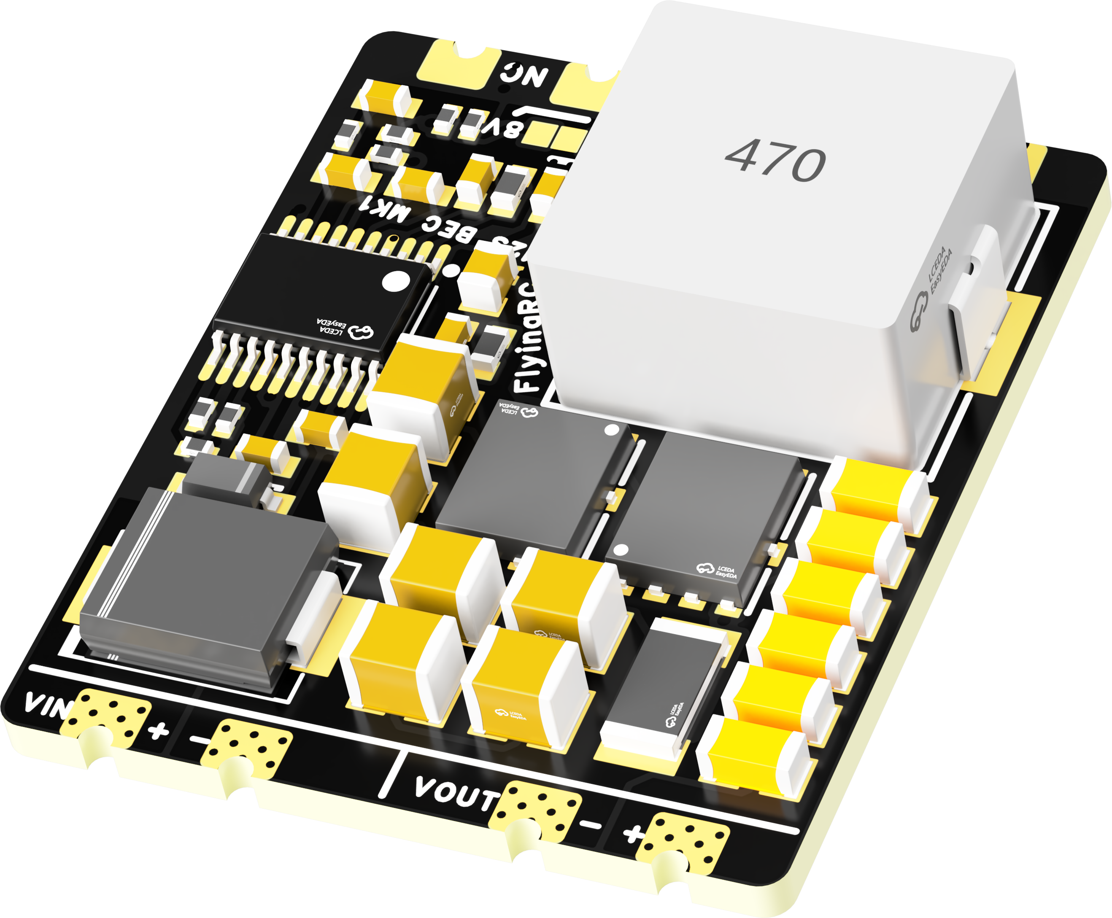
 | FlyingRC® 5A BEC Step-Down Module  Ultra-small size, multiple voltages available, 5A continuous output.  Manual：https://kdocs.cn/l/cb9VdNywqCKA |  |  |  |  |  | 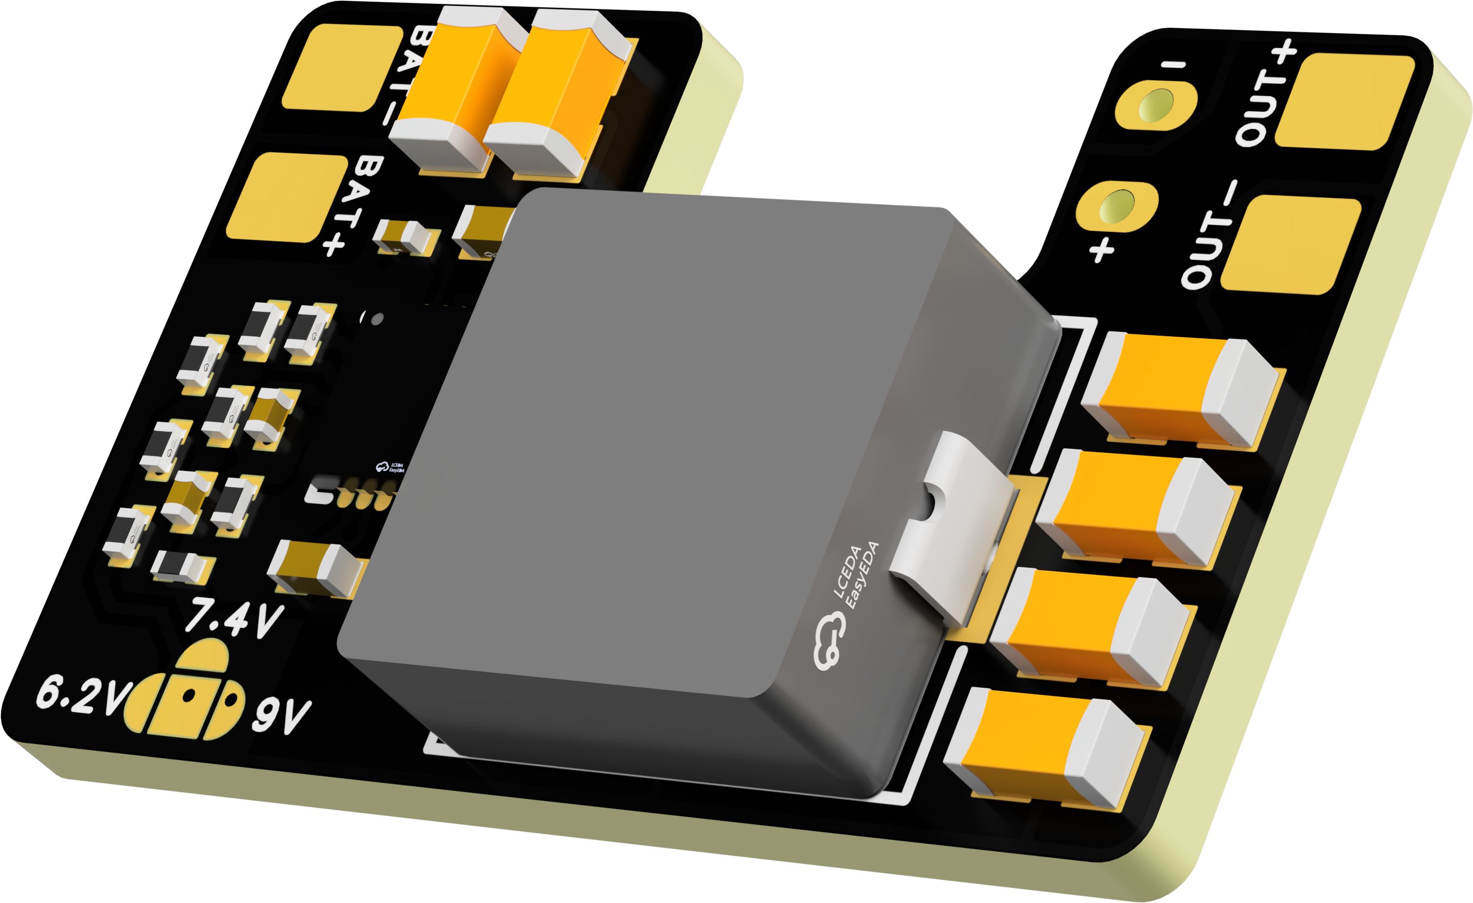
 | FlyingRC® Mini BEC For DJI O4  Easy wiring, ultra-small size, stable power supply.  Manual：https://www.kdocs.cn/l/ckkebieur37K |  |  |  |  |  | 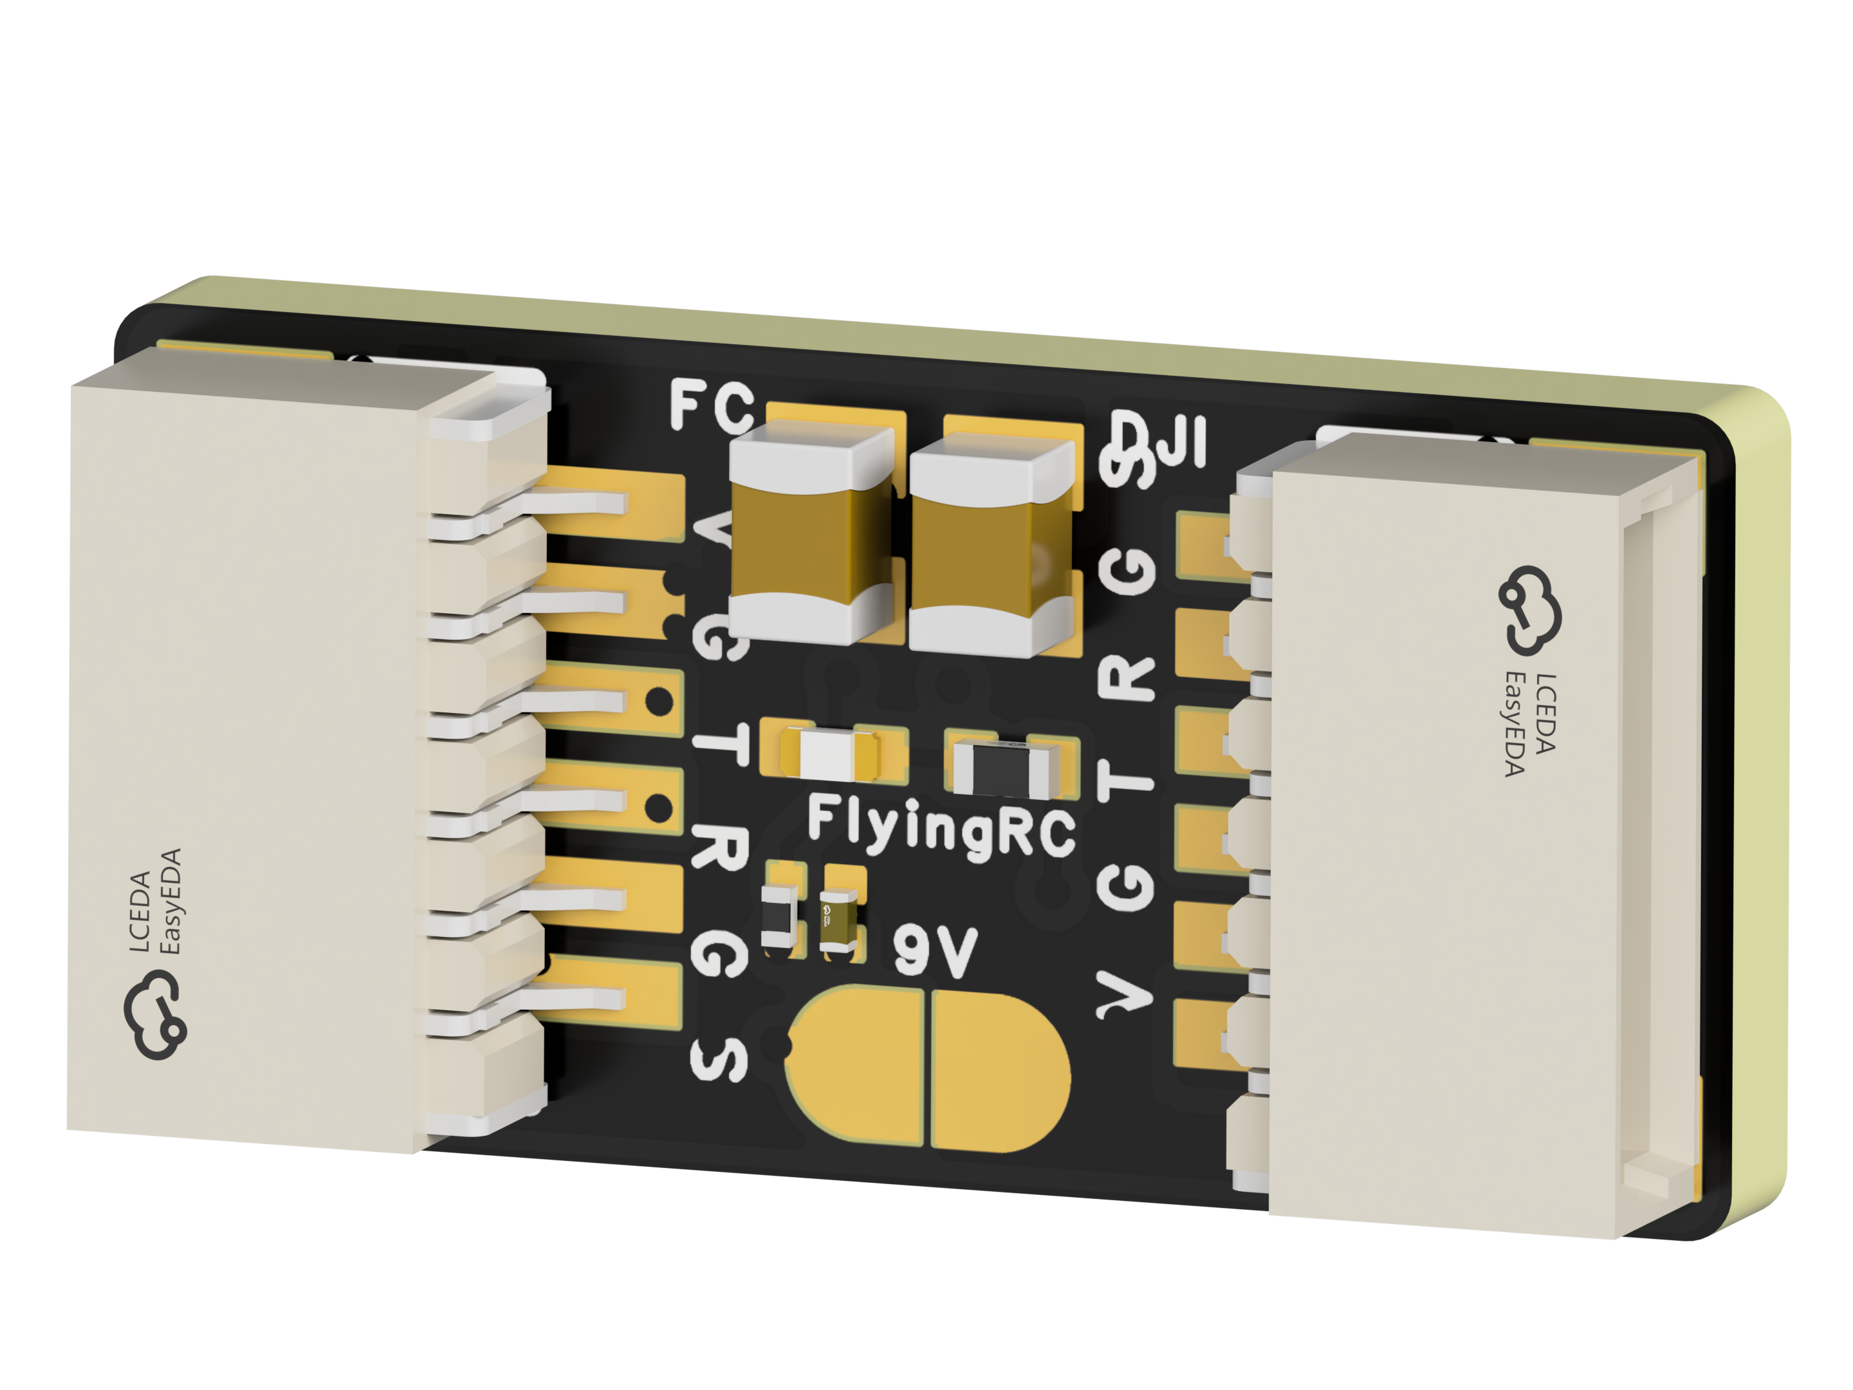
 | FlyingRC® CAN Bus Serial & PWM Expansion Board  Long-distance transmission, high speed, excellent stability.  Manual：https://www.kdocs.cn/l/cmxRyBnU4BXj |  |  |  |  |  | 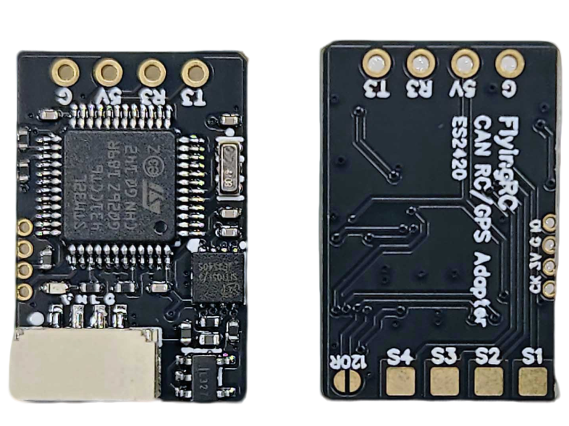
 | FlyingRC® AM3 2ESC Programmer  Supports BL, BL32, AM32. Simple and easy to use.  Manual：https://kdocs.cn/l/cogBSEBe67mE |  |  |  |  |  | 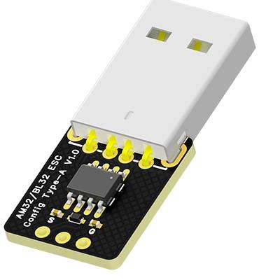
 | FlyingRC® Digital Airspeed Sensor without Pitot Tube  Integrated design, smallest on the market. MS4525D protocol, I2C interface.  Manual：https://www.kdocs.cn/l/clPvEEEcJgCC |  |  |  |  |  | 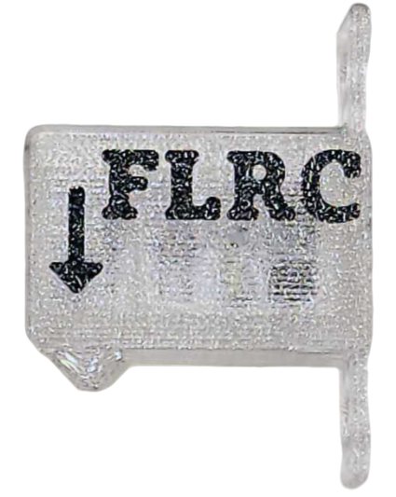
 | FlyingRC® U-Blox M10 GPS  Compatible with all open-source flight controllers.  Manual：https://www.kdocs.cn/l/cdSYQrzx74O8 |  |  |  |  |  | 