FlyingRC® Mini BEC Step-Down Module For DJI O4
Product Manual

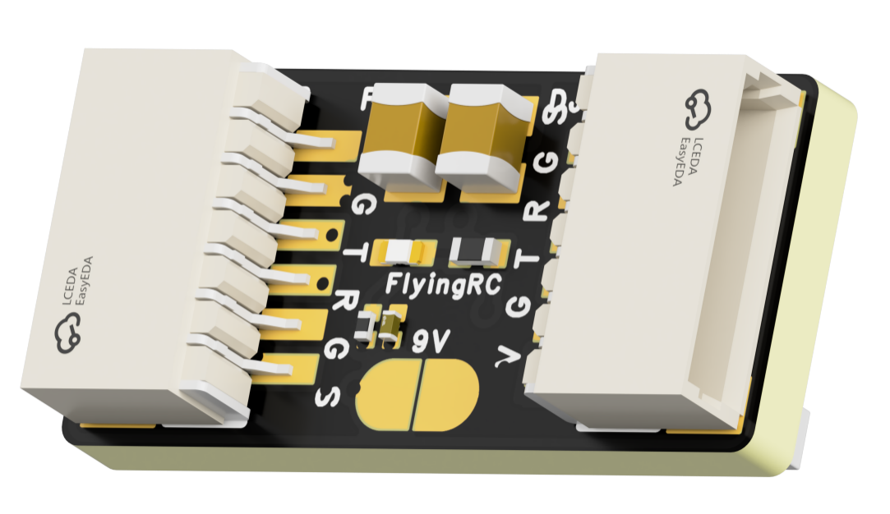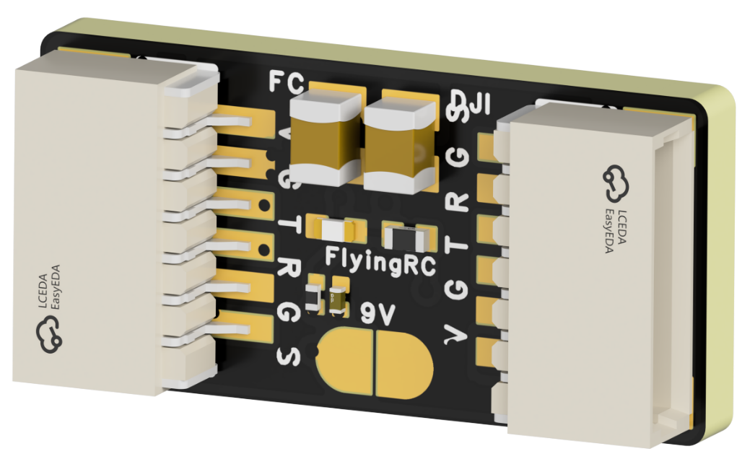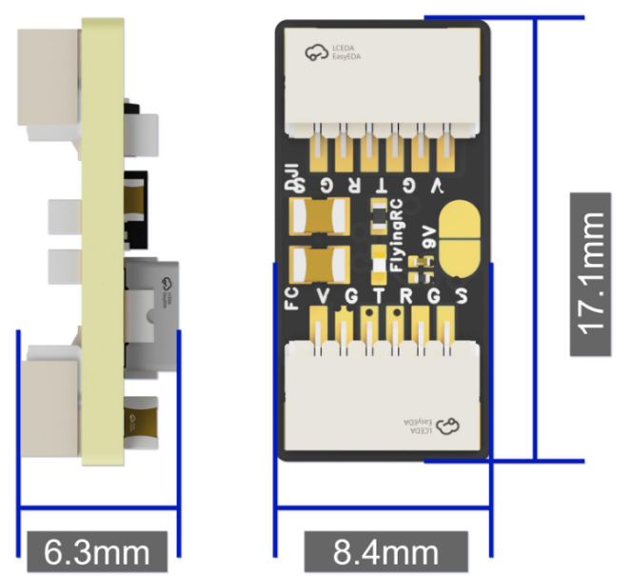
Product Dimensions Diagram
- Technical Specifications
- Input Voltage: 7–36V (2–8S LiPo)
- Output Voltage: 5V/2A; 9V/2A. Default output: 5V; 9V selected by soldering the jumper.
- Dimensions：8.4mm × 17.1mm × 6.3mm
- Weight：1g
- Package Contents: 1× module, 1× heat shrink tube
- Product Features
- Compatible with DJI O3 / O4 / O4 PRO digital VTX
- Direct plug-and-play connection with factory-standard pinout.
- Input Voltage: 7–36V, 2–8S LiPo (The Input voltage must be 0.8V higher than the set output voltage; otherwise, the output voltage will be 0.8V lower than the input voltage.)
- Output Voltage: 5V / 9V selectable. Default output: 5V; 9V can be selected via jumper pads.
- Continuous Output Current:5V/2A; 9V/2A 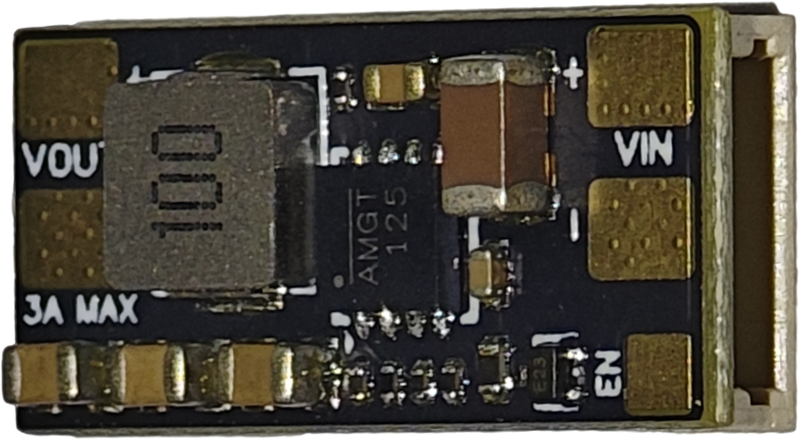
Front View
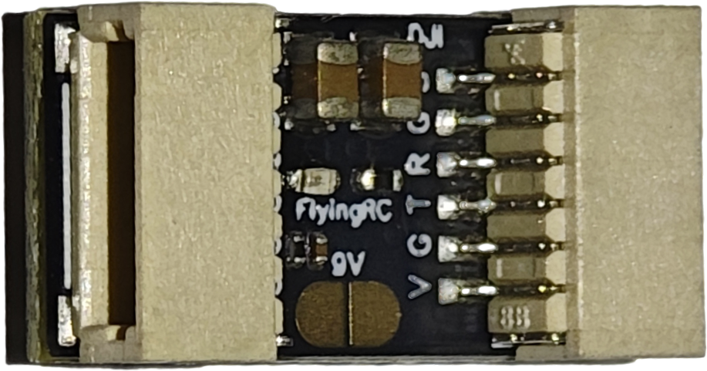
Rear View

3. User Instructions
- Input & Output Connection Diagram
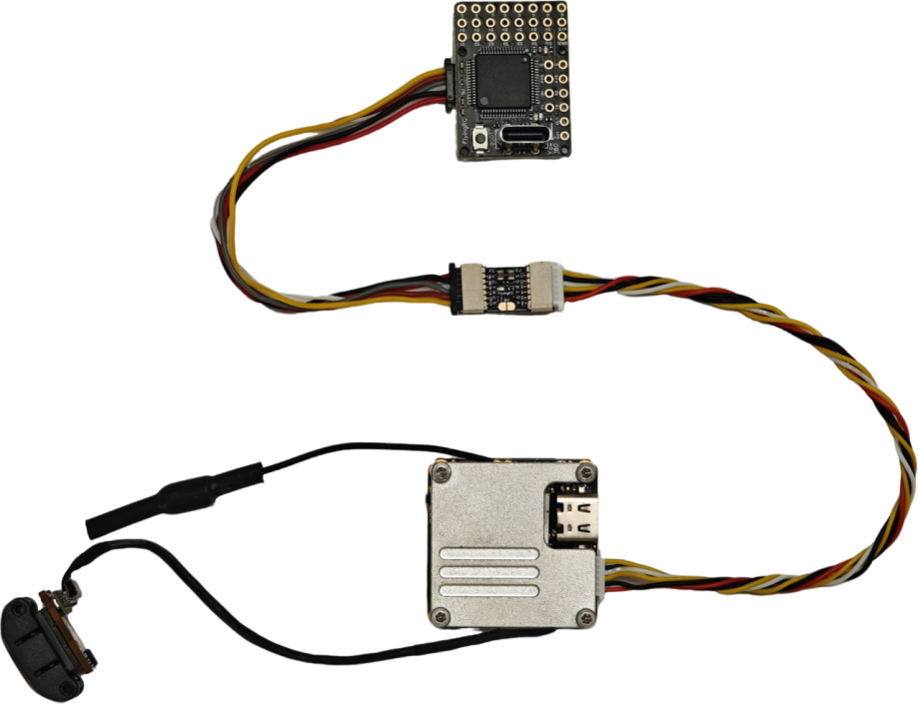
FC side: Connect to a flight controller without BEC;
DJI side: Connect to DJI Air Unit

- Select output voltage via jumper pads. Default output is 5V when jumper pads open.
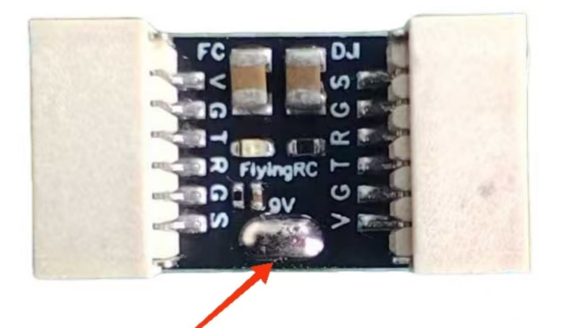
Short the 9V jumper pad

3. Short the jumper pad to set output voltage to 9V.

Other FlyingRC® Products
 | - FlyingRC® F4WSE Pro - F405 Fixed-Wing Flight Controller  Upgraded Version | Enhanced Performance  Manual：https://www.kdocs.cn/l/cavm9EoVEq5A |  |  |  | 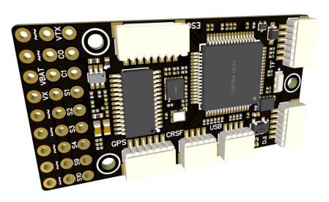
 | - FlyingRC® F4WSE MK1.5 - F405 Fixed-Wing Flight Controller  Classic model, unique design, highly acclaimed.  Manual：https://kdocs.cn/l/cpyd8MTS56DD |  |  | 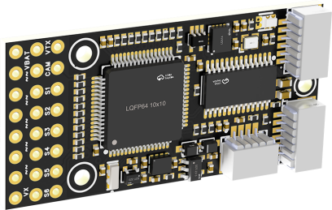
 | - FlyingRC® H7Wlite MK1 H743 Fixed-Wing Flight Controller  Flagship performance, full expansion, high-power BEC.  Manual：https://kdocs.cn/l/cpYaBiFKh8U1 |  |  |  | 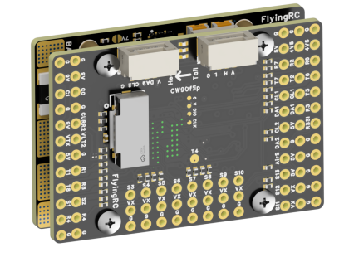
 | - FlyingRC® F4Wing Mini MK1 F405 Fixed-Wing Flight Controller  2025 bestseller, ultra-compact, smallest on the market, great value.  Manual：https://kdocs.cn/l/cdUIdmpSpW7J |  |  |  | 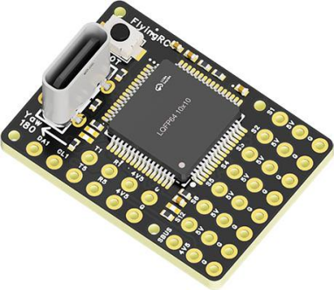
 | - FlyingRC® AM32 Dual ESC 40A 2-in-1 ESC  Unique design for dual-power aerial, land and water vehicles including drones.  Manual：https://www.kdocs.cn/l/cjwNtsKK6HeR |  | 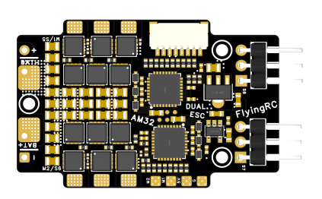
 | - FlyingRC® AM32 ESC V2.5 75A - Single ESC  Infineon gold-package MOSFETs, premium materials, superior heat dissipation.  Manual：https://kdocs.cn/l/cv6hUy67IdTJ |  |  | 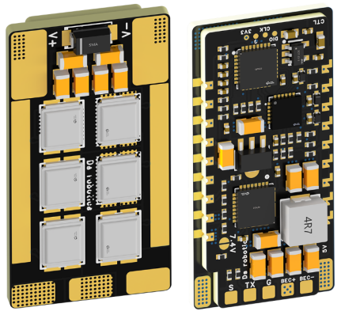
 | - FlyingRC® AM32 Mini ESC 40A V1.0 - Single ESC  Ultra-miniature, ideal for micro drones, high over-current capability, stable operation.  Manual：https://kdocs.cn/l/cqdLSysEyWFh |  |  |  |  | 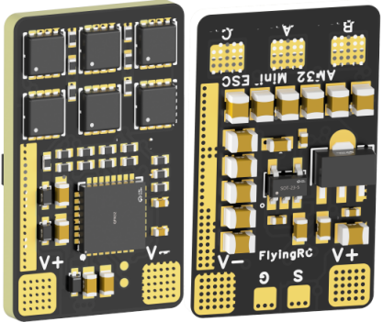
 | - FlyingRC® 10A 12S 440A Power Distribution Board for FPV Drones  Industry top choice, excellent quality and affordable price.  Manual：https://kdocs.cn/l/coel7OgrlCBP |  |  |  |  | 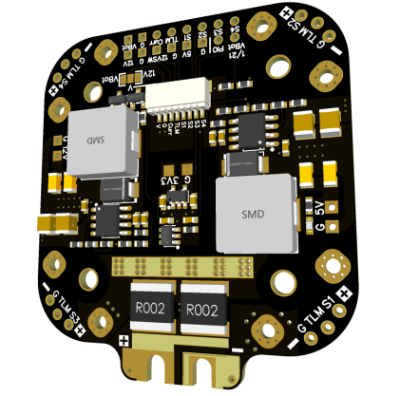
 | - FlyingRC® H7D MK1 H743 FPV Flight Controller with Dual Gyro  Powerful computing, stable and precise flight, rich interfaces, smooth control.  Manual：https://kdocs.cn/l/cqMh1I0RwAoD |  |  | 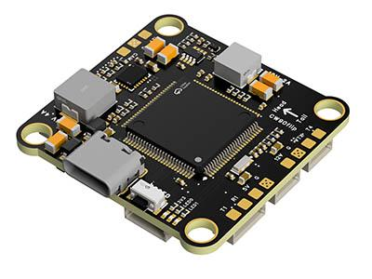
 | - FlyingRC® F420 MK1 F405 FPV Flight Controller (20/30.5mm Mounting)  Dual mounting holes, all connectors, no soldering required, compliant with Betaflight interface standards.  Manual：https://kdocs.cn/l/ctGeLiN9ZYKj |  |  |  | 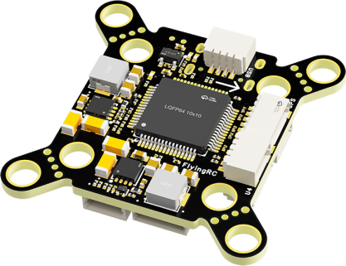
 | - FlyingRC® 4-in-1 75A V3.2 Gold-Sealed FPV ESC  Infineon gold-package MOSFETs, superior heat dissipation & over-current capability, premium choice.  Manual：https://kdocs.cn/l/ceLilc8Gaa21 |  | 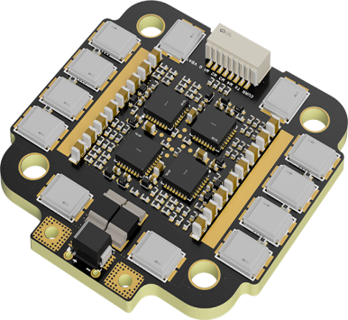
- FlyingRC® Stack Combo: H743 Flight Controller + 4-in-1 75A Gold-Sealed ESC  Professional flight choice, flagship materials & craftsmanship, reasonable price.  Manual：https://kdocs.cn/l/cqMh1I0RwAoD  https://kdocs.cn/l/ceLilc8Gaa21 |  | 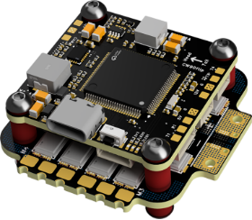
 | - FlyingRC® Stack Combo: F405 Flight Controller + 4-in-1 75A Gold-Sealed ESC  Best-selling combo, excellent performance, affordable price.  Manual：https://kdocs.cn/l/ctGeLiN9ZYKj  https://kdocs.cn/l/ceLilc8Gaa21 |  |  | 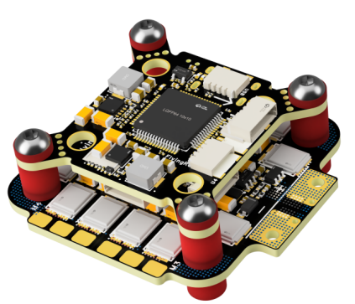
 | - FlyingRC® ELRS 2.4G Diversity Receiver  True diversity reception, temperature compensation, high-sensitivity reception.  Manual：https://kdocs.cn/l/cbvlOlShmsPS | 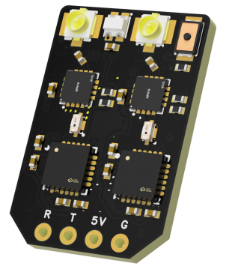
 | - FlyingRC® 10A 12S BEC Step-Down Module  Wide voltage input, high power, compact size, multiple voltages available, 10A continuous output.  Manual：https://kdocs.cn/l/clssNCKgNhLV | 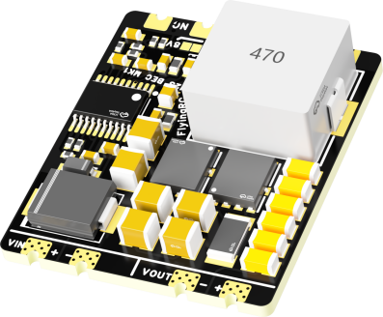
 | - FlyingRC® 5A BEC Step-Down Module  Ultra-small size, multiple voltages available, 5A continuous output.  Manual：https://kdocs.cn/l/cb9VdNywqCKA | 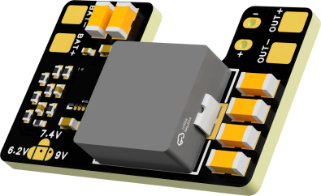
 | - FlyingRC® Mini BEC For DJI O4  Easy wiring, ultra-small size, stable power supply.  Manual：https://www.kdocs.cn/l/ckkebieur37K | 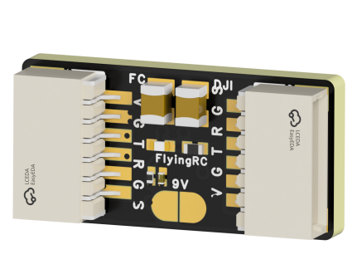
 | - FlyingRC® CAN Bus Serial & PWM Expansion Board  Long-distance transmission, high speed, excellent stability.  Manual：https://www.kdocs.cn/l/cmxRyBnU4BXj | 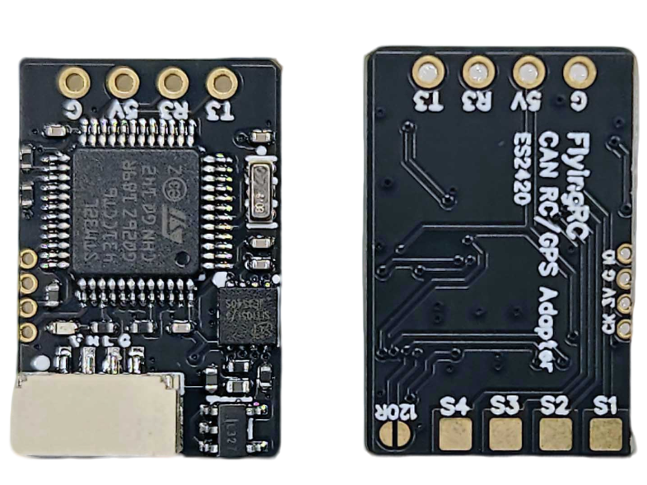
 | - FlyingRC® AM3 2ESC Programmer  Supports BL, BL32, AM32. Simple and easy to use.  Manual：https://kdocs.cn/l/cogBSEBe67mE | 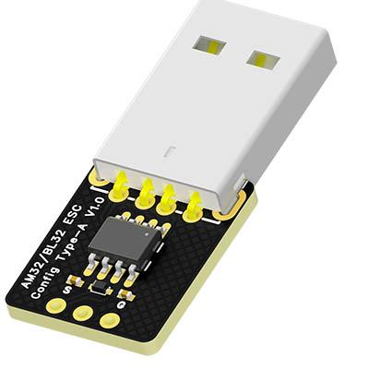
 | - FlyingRC® Digital Airspeed Sensor without Pitot Tube  Integrated design, smallest on the market. MS4525D protocol, I2C interface.  Manual：https://www.kdocs.cn/l/clPvEEEcJgCC | 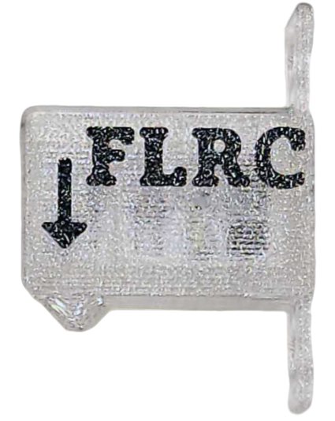
 | - FlyingRC® U-Blox M10 GPS  Compatible with all open-source flight controllers.  Manual：https://www.kdocs.cn/l/cdSYQrzx74O8 | 