FlyingRC® Pitot‑Less Digital Airspeed Sensor Product Manual

FlyingRC® is a globally-oriented professional brand of electronic devices. We specialize in the R&D and sales of drone electronics, core robot circuits and sensors. Our design team is based in Singapore, and our products are sold worldwide.

Since launched in 2023, FlyingRC® products have gained widespread recognition from customers as well as strong market response. As of April 2026, our cumulative sales volume has exceeded 46,000 units. Our products are widely applied in industries, robotics, emergency rescue, environmental protection & inspection, aerial photography, public security, retail and many other fields. Above all, we are committed to distinctive design and superior reliable quality.

Our Chief Technology Officer Liu Yuhan possesses outstanding expertise in circuit design. Over the past four years, he has designed more than 80 circuit projects and contributed 39 to open-source platforms. Moreover, he won the Design Award on the open-source platform X.JLC.com twice in 2023 and 2024, and has become the youngest certified designer on this platform.

He holds the NUS (National University of Singapore, rank 8th worldwide) Science and Technology Scholarship, and is currently majoring in Electronic Engineering with a focus on Aerospace Technology. In addition, all members of our technical team are graduates from prestigious universities with extensive professional product experience.
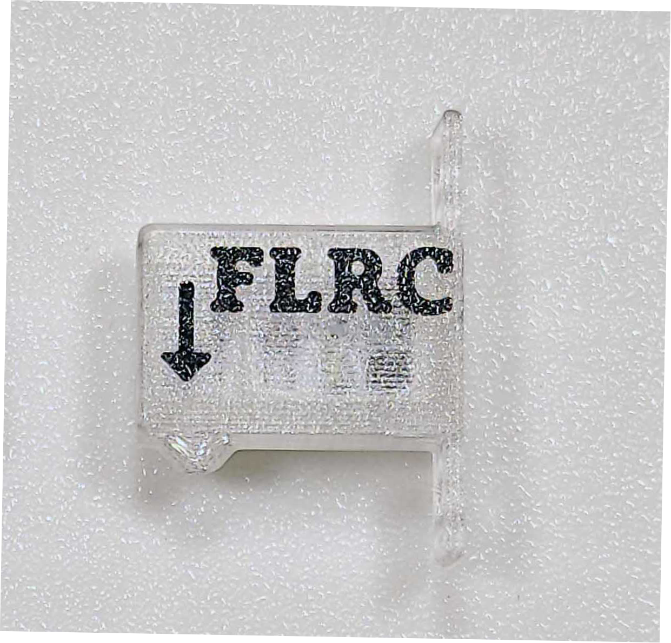

Specifications
Product Dimensions：25mm*15mm*5mm
Weight：2.8g
Refresh Rate：8Hz
Sampling Rate：512Hz
Supports temperature compensation calibration
Pressure Measurement Accuracy：0.5Pa(RMS)

- Applications：
As one of the standard aircraft instruments, the airspeed sensor measures an aircraft’s speed relative to the ambient air, guaranteeing flight safety.
- Prevents downwind stall
- Improves hand-launch success rate
- Extends flight endurance
- Precisely assists in VTOL-to-forward flight transition via real-time airspeed detection
- Supports automatic thermal soaring with ArduPilot firmware

- Features
  - MS4525D Protocol Compatible
  - Digital airspeed sensor
  - I2C interface
  - Integrated airspeed sensor and pitot tube
  - Smallest airspeed sensor available on the market
  - Supplied with plastic mounting screws and silicone wires, easy to install.

4.Usage Instructions
Setup and Configuration of FlyingRC® Airspeed Sensor on ArduPilot Firmware
Installation Prerequisite:
The aircraft and flight controller must be fully calibrated and successfully flight-tested before installing the airspeed sensor.
Install the airspeed sensor only after the maiden flight is successfully completed.

Airspeed Sensor Mounting Reference:

First Flight Setup After Installation
ARSPD_TYPE = 1 （Other parameters will only be visible after saving and power cycling）
ARSPD_OPTIONS = 15 (Check DisableVoltageCorrection)
ARSPD_AUTOCAL = 1
ARSPD_SKIP_CAL = 1
After setting all the above parameters at once, save the settings and power cycle the flight controller immediately.
After power cycling, check if ARSPD_OFFSET = 0.
If not, set it to 0 immediately, save, and power cycle again.

Each airspeed sensor is precisely calibrated for zero drift before shipment.Therefore, you can set ARSPD_SKIP_CAL = 1.
This way, there is no need to cover the airspeed sensor on power-up, and it will not be disturbed by ground wind.

First Flight Auto-Calibration
After takeoff, orbit in RTL or Loiter mode for at least 5 minutes to allow the flight controller to perform auto-calibration.
(Calibration values are automatically saved every 2 minutes into the parameter ARSPD_RATIO.) OSD will show prompts during auto-calibration.

After Auto-Calibration & Landing
After landing, disable airspeed auto-calibration (must be turned off during normal flight):set ARSPD_AUTOCAL = 0
Then check the parameter ARSPD_RATIO.
If you adjust the airspeed sensor mounting angle or replace the sensor, please reset ARSPD_RATIO = 2.0 and perform auto-calibration again.

Normal Flight with Airspeed Sensor
Only after the airspeed sensor has completed auto-calibration can you enable airspeed control by setting ARSPD_USE = 1 or 2.

When ARSPD_USE = 2, the flight controller only reads airspeed data when throttle input is 0. This mode is specially designed for gliders with the airspeed sensor installed behind the nose propeller. After enabling ARSPD_USE, the airspeed sensor will participate in throttle control in auto-throttle modes(AUTO, CRUISE, FBWB, RTL).

Set the following parameters with caution, and only operate under safe flight conditions suitable for your aircraft. All parameters are specified as direct values. If you modify them via a GUI, please convert units accordingly：

- AIRSPEED_CRUISE
Target airspeed under auto-throttle mode(Unit: m/s).(For ArduPilot versions prior to 4.5: TRIM_ARSPD_CM, unit: cm/s)

- AIRSPEED_MIN
Minimum airspeed under auto-throttle mode(climb/descent).Must be set to at least 20% above stall speed.(Unit: m/s)(For ArduPilot versions prior to 4.5: ARSPD_FWB_MIN)

- AIRSPEED_MAX
Maximum airspeed under auto-throttle mode(climb/descent).Must be set to at least 50% higher than AIRSPEED_MIN to ensure adequate throttle output during automatic climb.(Unit: m/s)(For ArduPilot versions prior to 4.5: ARSPD_FWB_MAX)

Other FlyingRC® Products
 |  |  |  | - FlyingRC® F4WSE Pro - F405 Fixed-Wing Flight Controller  Upgraded Version | Enhanced Performance  Manual：https://www.kdocs.cn/l/cavm9EoVEq5A |  |  | 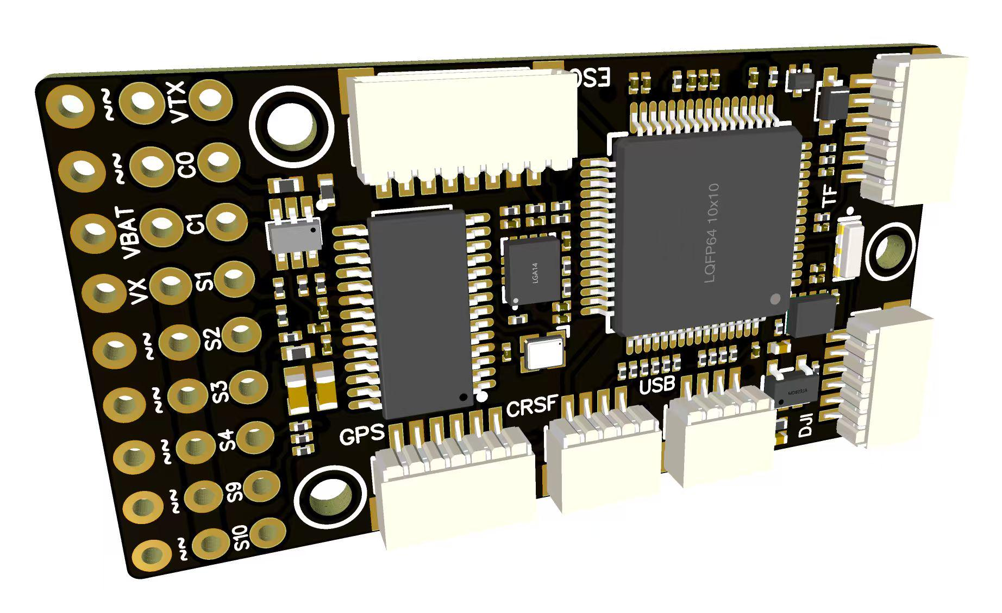
 |  |  | - FlyingRC® F4WSE MK1.5 - F405 Fixed-Wing Flight Controller  Classic model, unique design, highly acclaimed.  Manual：https://kdocs.cn/l/cpyd8MTS56DD |  |  | 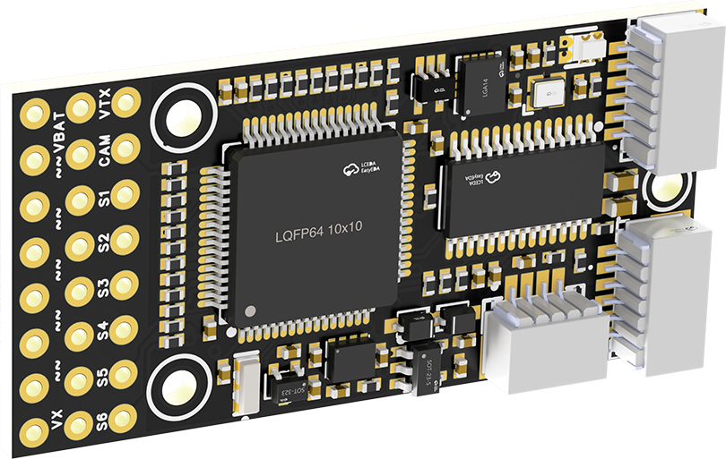
 |  |  |  | - FlyingRC® H7Wlite MK1 H743 Fixed-Wing Flight Controller  Flagship performance, full expansion, high-power BEC.  Manual：https://kdocs.cn/l/cpYaBiFKh8U1 |  |  | 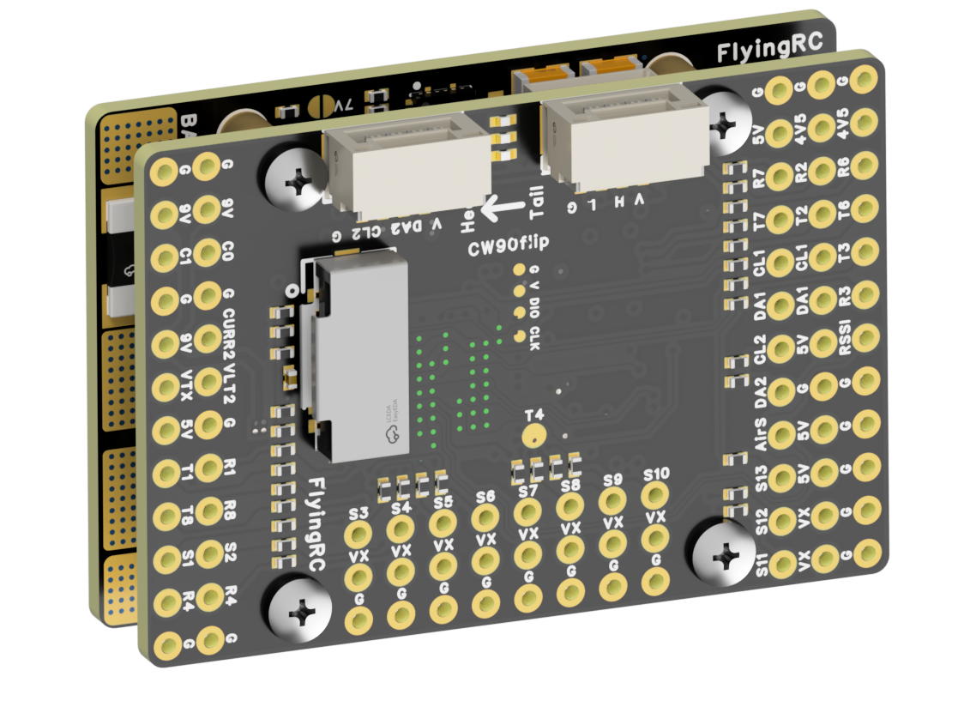
 |  |  |  | - FlyingRC® F4Wing Mini MK1 F405 Fixed-Wing Flight Controller  2025 bestseller, ultra-compact, smallest on the market, great value.  Manual：https://kdocs.cn/l/cdUIdmpSpW7J |  |  | 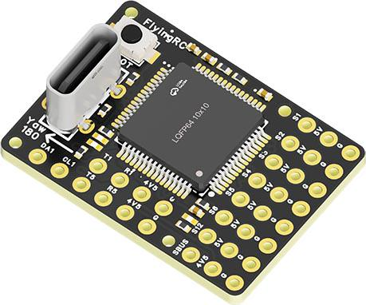
 | - FlyingRC® AM32 Dual ESC 40A 2-in-1 ESC  Unique design for dual-power aerial, land and water vehicles including drones.  Manual：https://www.kdocs.cn/l/cjwNtsKK6HeR |  |  |  | 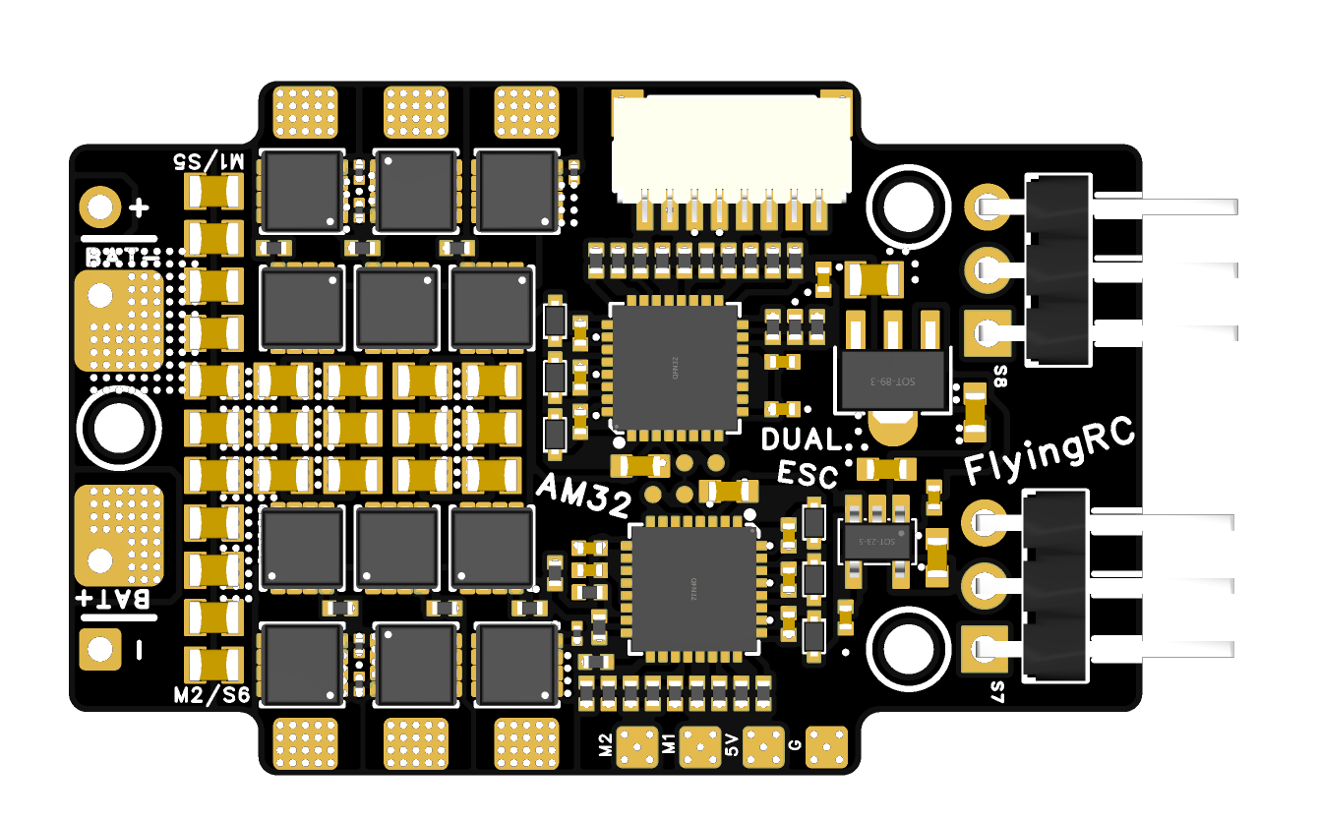
 |  |  | - FlyingRC® AM32 ESC V2.5 75A - Single ESC  Infineon gold-package MOSFETs, premium materials, superior heat dissipation.  Manual：https://kdocs.cn/l/cv6hUy67IdTJ |  |  |  | 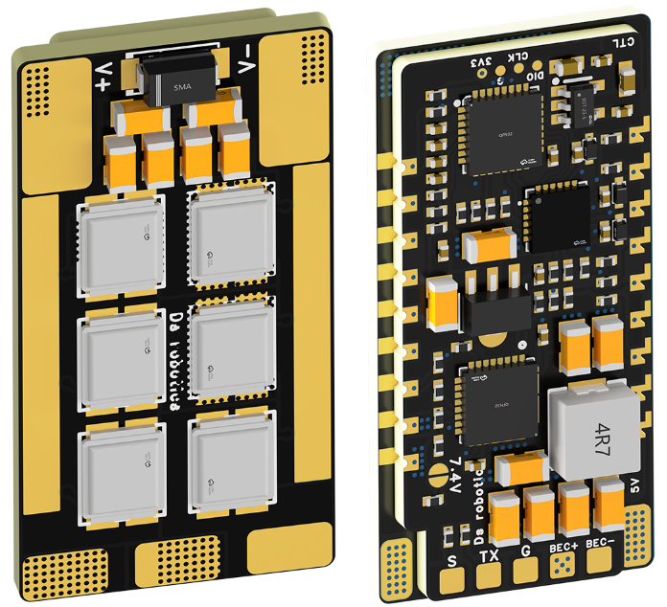
 |  |  | - FlyingRC® AM32 Mini ESC 40A V1.0 - Single ESC  Ultra-miniature, ideal for micro drones, high over-current capability, stable operation.  Manual：https://kdocs.cn/l/cqdLSysEyWFh |  |  |  |  | 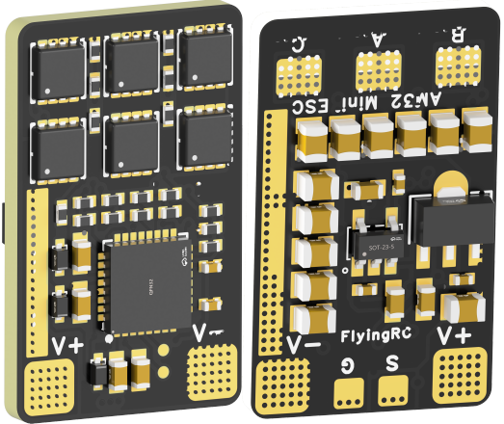
 |  |  | - FlyingRC® 10A 12S 440A Power Distribution Board for FPV Drones  Industry top choice, excellent quality and affordable price.  Manual：https://kdocs.cn/l/coel7OgrlCBP |  |  |  |  | 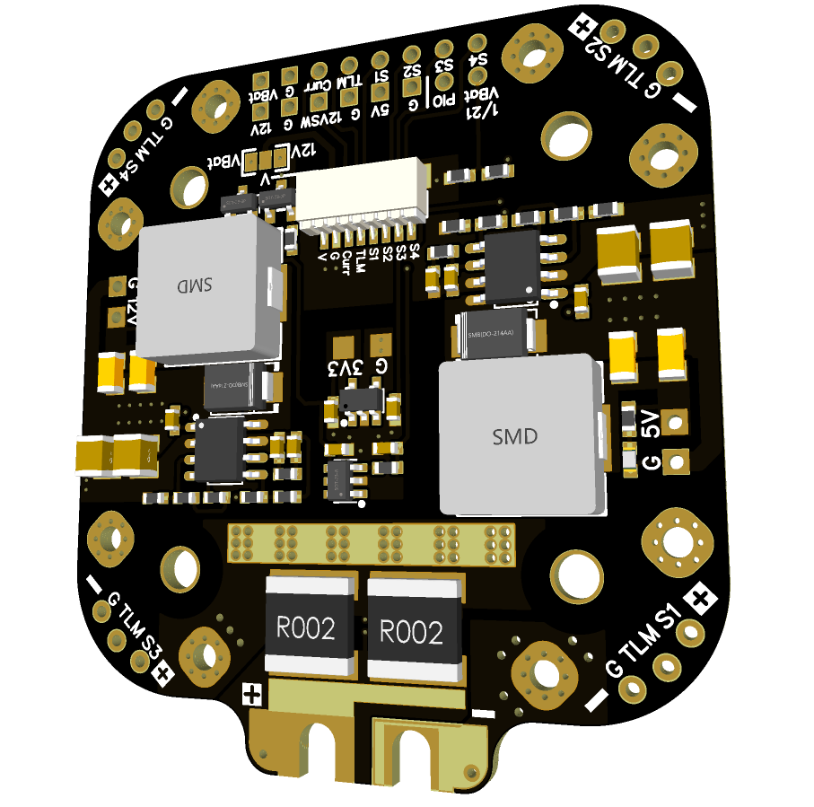
 |  |  | - FlyingRC® H7D Pro MK1 H743 FPV Flight Controller with Dual Gyro  Fully Upgraded & More Powerful  Manual：https://www.kdocs.cn/l/ctcekCy676Ez |  |  |  | 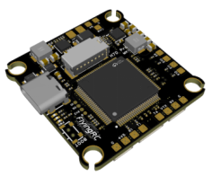
 |  |  | - FlyingRC® H7D MK1 H743 FPV Flight Controller with Dual Gyro  Powerful computing, stable and precise flight, rich interfaces, smooth control.  Manual：https://kdocs.cn/l/cqMh1I0RwAoD |  |  |  | 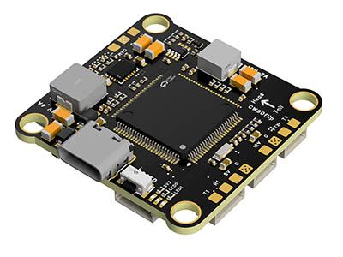
 |  |  | - FlyingRC® F420 MK1 F405 FPV Flight Controller (20/30.5mm Mounting)  Dual mounting holes, all connectors, no soldering required, compliant with Betaflight interface standards.  Manual：https://kdocs.cn/l/ctGeLiN9ZYKj |  |  |  | 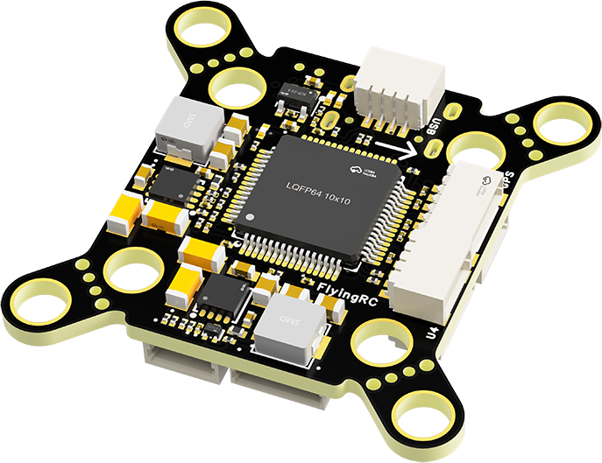
 |  | - FlyingRC® 4-in-1 75A V3.2 Gold-Sealed FPV ESC  Infineon gold-package MOSFETs, superior heat dissipation & over-current capability, premium choice.  Manual：https://kdocs.cn/l/ceLilc8Gaa21 |  |  |  |  | 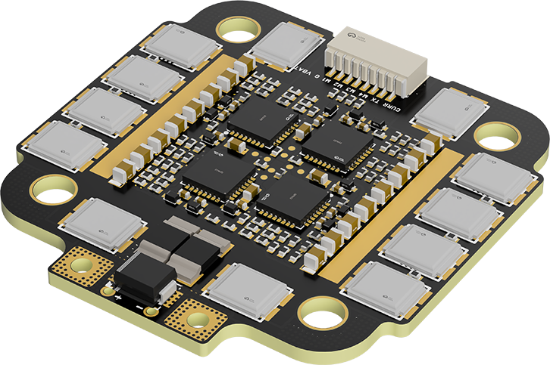
- FlyingRC® Stack Combo: H743 Flight Controller + 4-in-1 75A Gold-Sealed ESC  Professional flight choice, flagship materials & craftsmanship, reasonable price.  Manual：https://www.kdocs.cn/l/ctcekCy676Ez  https://kdocs.cn/l/ceLilc8Gaa21 |  |  |  |  |  |  | 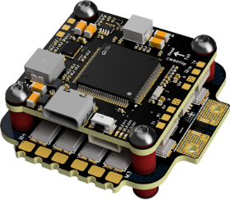
 |  | - FlyingRC® Stack Combo: F405 Flight Controller + 4-in-1 75A Gold-Sealed ESC  Best-selling combo, excellent performance, affordable price.  Manual：https://kdocs.cn/l/ctGeLiN9ZYKj  https://kdocs.cn/l/ceLilc8Gaa21 |  |  |  |  | 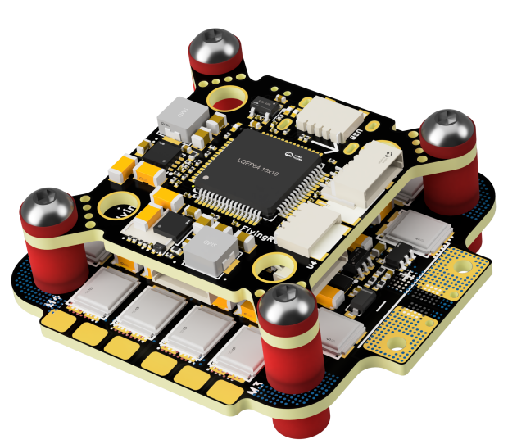
 |  | - FlyingRC® Stack Combo: H743 Flight Controller + 4-in-1 45A ESC  Winning combo: great performance, budget-friendly price  Manual：https://www.kdocs.cn/l/ctcekCy676Ez  https://kdocs.cn/l/ceLilc8Gaa21 |  |  |  |  | 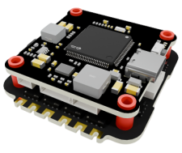
 |  | - FlyingRC® Stack Combo: F405 Flight Controller + 4-in-1 45A ESC  Hit combo, great value, budget-friendly  Manual：https://kdocs.cn/l/ctGeLiN9ZYKj  https://kdocs.cn/l/ceLilc8Gaa21 |  |  |  |  | 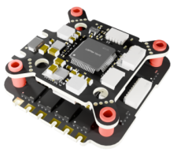
 |  | - FlyingRC® Stack Combo: F4WSE Pro - F405 Fixed-Wing Flight Controller + AM32 Dual ESC 40A 2-in-1 ESC  Unique Design • Exclusive Offer • Bestselling Bundle  Manual：https://www.kdocs.cn/l/cavm9EoVEq5A  https://www.kdocs.cn/l/cjwNtsKK6HeR |  |  |  |  | 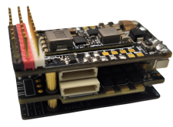
 | - FlyingRC® ELRS 2.4G Diversity Receiver  True diversity reception, temperature compensation, high-sensitivity reception.  Manual：https://kdocs.cn/l/cbvlOlShmsPS |  |  |  |  |  | 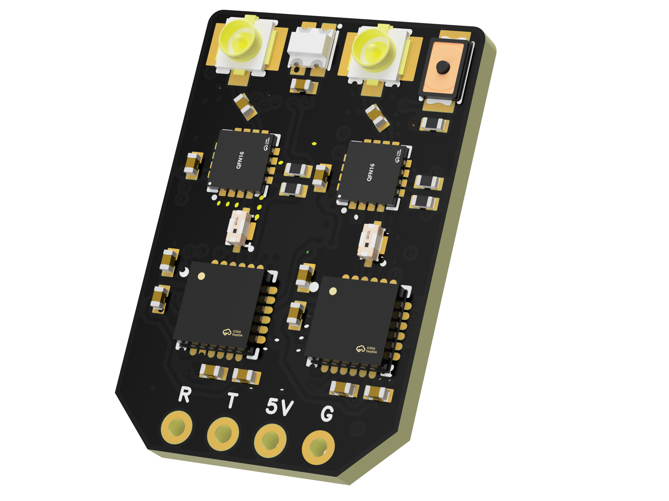
 | - FlyingRC® RM3100 SPI Module 罗盘模块  Ultra-high Resolution • Low Power • Industry Top Choice  Manual：https://www.kdocs.cn/l/cdGuHvBVyndC |  |  |  |  |  | 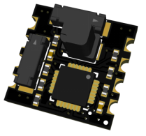
 | - FlyingRC® 10A 12S BEC Step-Down Module  Wide voltage input, high power, compact size, multiple voltages available, 10A continuous output.  Manual：https://kdocs.cn/l/clssNCKgNhLV |  |  |  |  |  | 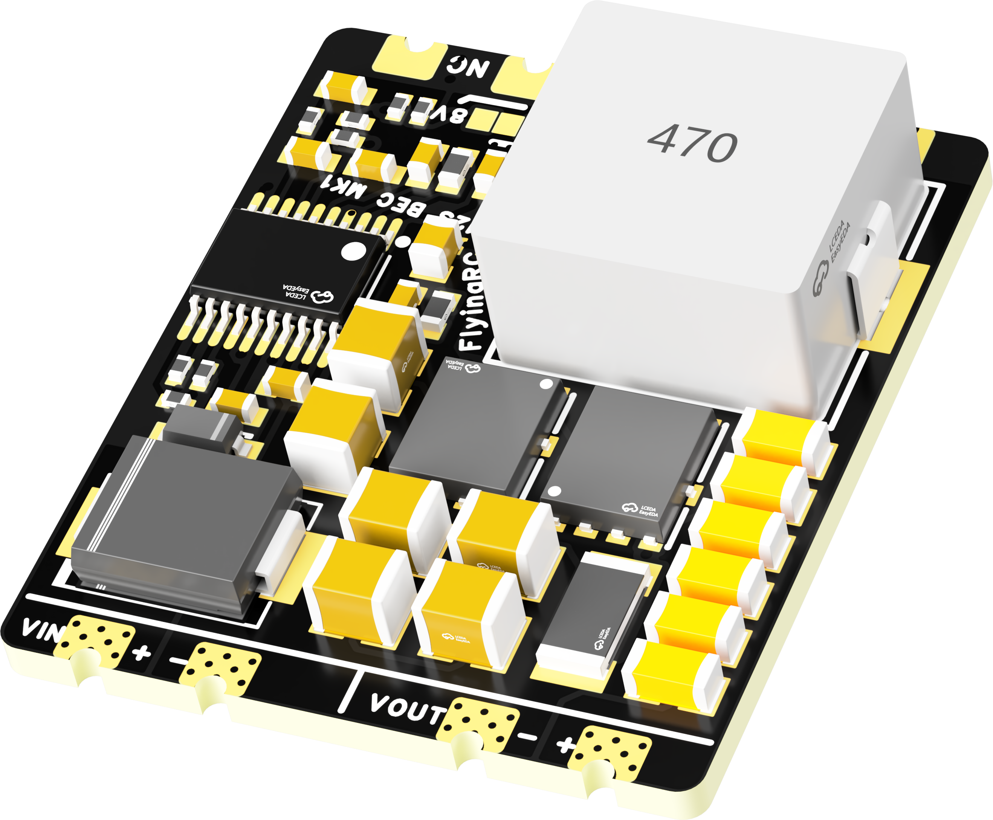
 | FlyingRC® 5A BEC Step-Down Module  Ultra-small size, multiple voltages available, 5A continuous output.  Manual：https://kdocs.cn/l/cb9VdNywqCKA |  |  |  |  |  | 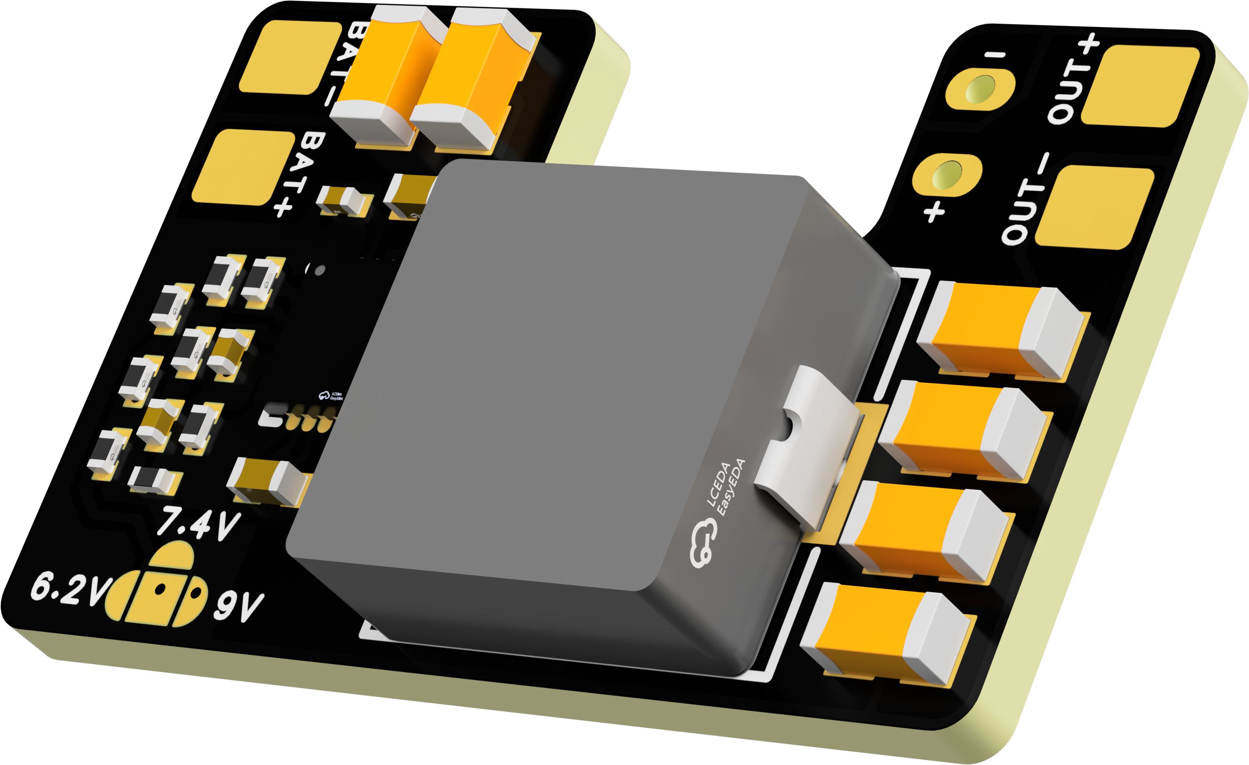
 | FlyingRC® Mini BEC For DJI O4  Easy wiring, ultra-small size, stable power supply.  Manual：https://kdocs.cn/l/cb9VdNywqCKA |  |  |  |  |  | 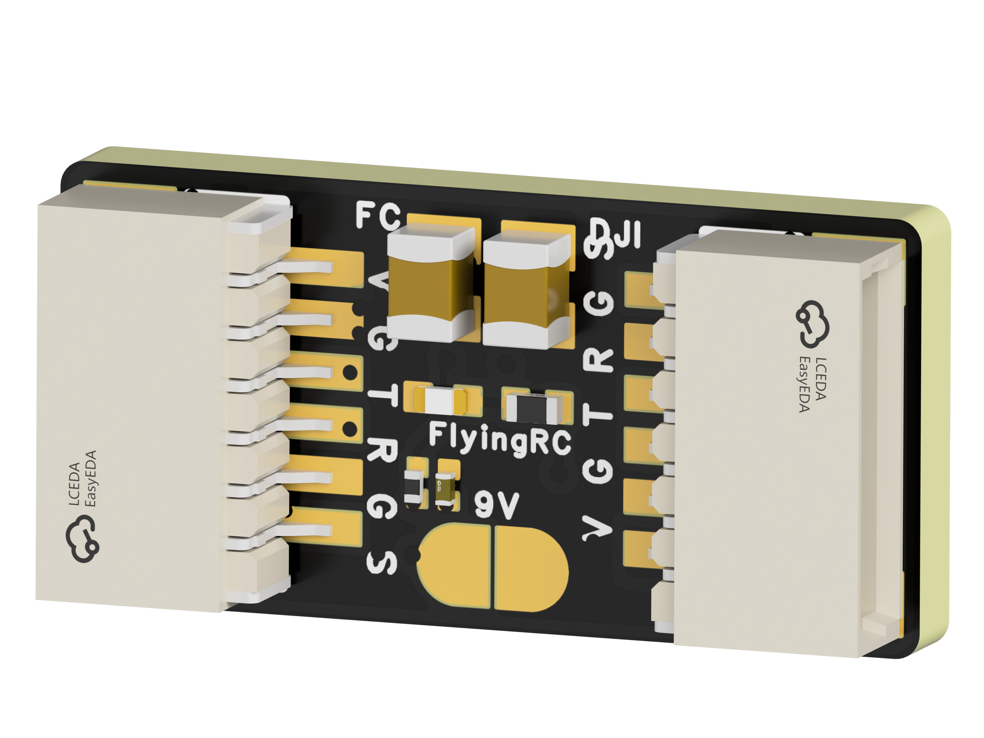
 | FlyingRC® CAN Bus Serial & PWM Expansion Board  Long-distance transmission, high speed, excellent stability.  Manual：https://www.kdocs.cn/l/cmxRyBnU4BXj |  |  |  |  |  | 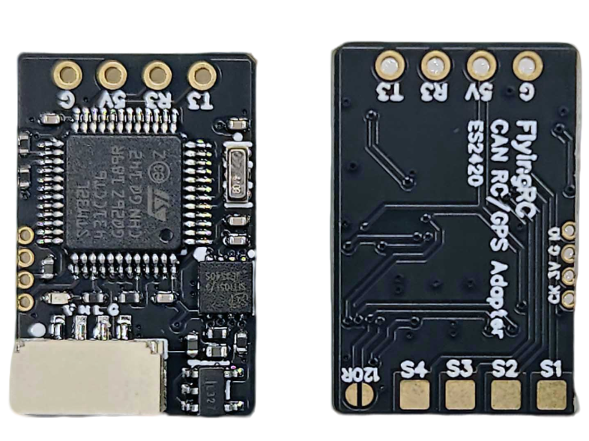
 | FlyingRC® AM3 2ESC Programmer  Supports BL, BL32, AM32. Simple and easy to use.  Manual：https://kdocs.cn/l/cogBSEBe67mE |  |  |  |  |  | 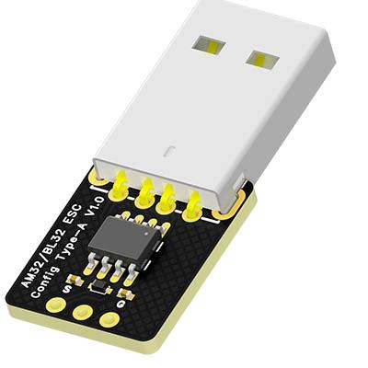
 | FlyingRC® Digital Airspeed Sensor without Pitot Tube  Integrated design, smallest on the market. MS4525D protocol, I2C interface.  Manual：https://www.kdocs.cn/l/clPvEEEcJgCC |  |  |  |  |  | 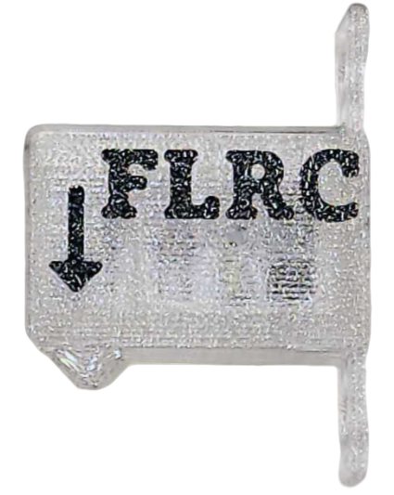
 | FlyingRC® U-Blox M10 GPS  Compatible with all open-source flight controllers.  Manual：https://www.kdocs.cn/l/cdSYQrzx74O8 |  |  |  |  |  | 