FlyingRC® ELRS 2.4G Diversity Receiver Product Manual

FlyingRC® is a globally-oriented professional brand of electronic devices. We specialize in the R&D and sales of drone electronics, core robot circuits and sensors. Our design team is based in Singapore, and our products are sold worldwide.

Since launched in 2023, FlyingRC® products have gained widespread recognition from customers as well as strong market response. As of April 2026, our cumulative sales volume has exceeded 46,000 units. Our products are widely applied in industries, robotics, emergency rescue, environmental protection & inspection, aerial photography, public security, retail and many other fields. Above all, we are committed to distinctive design and superior reliable quality.

Our Chief Technology Officer Liu Yuhan possesses outstanding expertise in circuit design. Over the past four years, he has designed more than 80 circuit projects and contributed 39 to open-source platforms. Moreover, he won the Design Award on the open-source platform X.JLC.com twice in 2023 and 2024, and has become the youngest certified designer on this platform.

He holds the NUS (National University of Singapore, rank 8th worldwide) Science and Technology Scholarship, and is currently majoring in Electronic Engineering with a focus on Aerospace Technology. In addition, all members of our technical team are graduates from prestigious universities with extensive professional product experience.
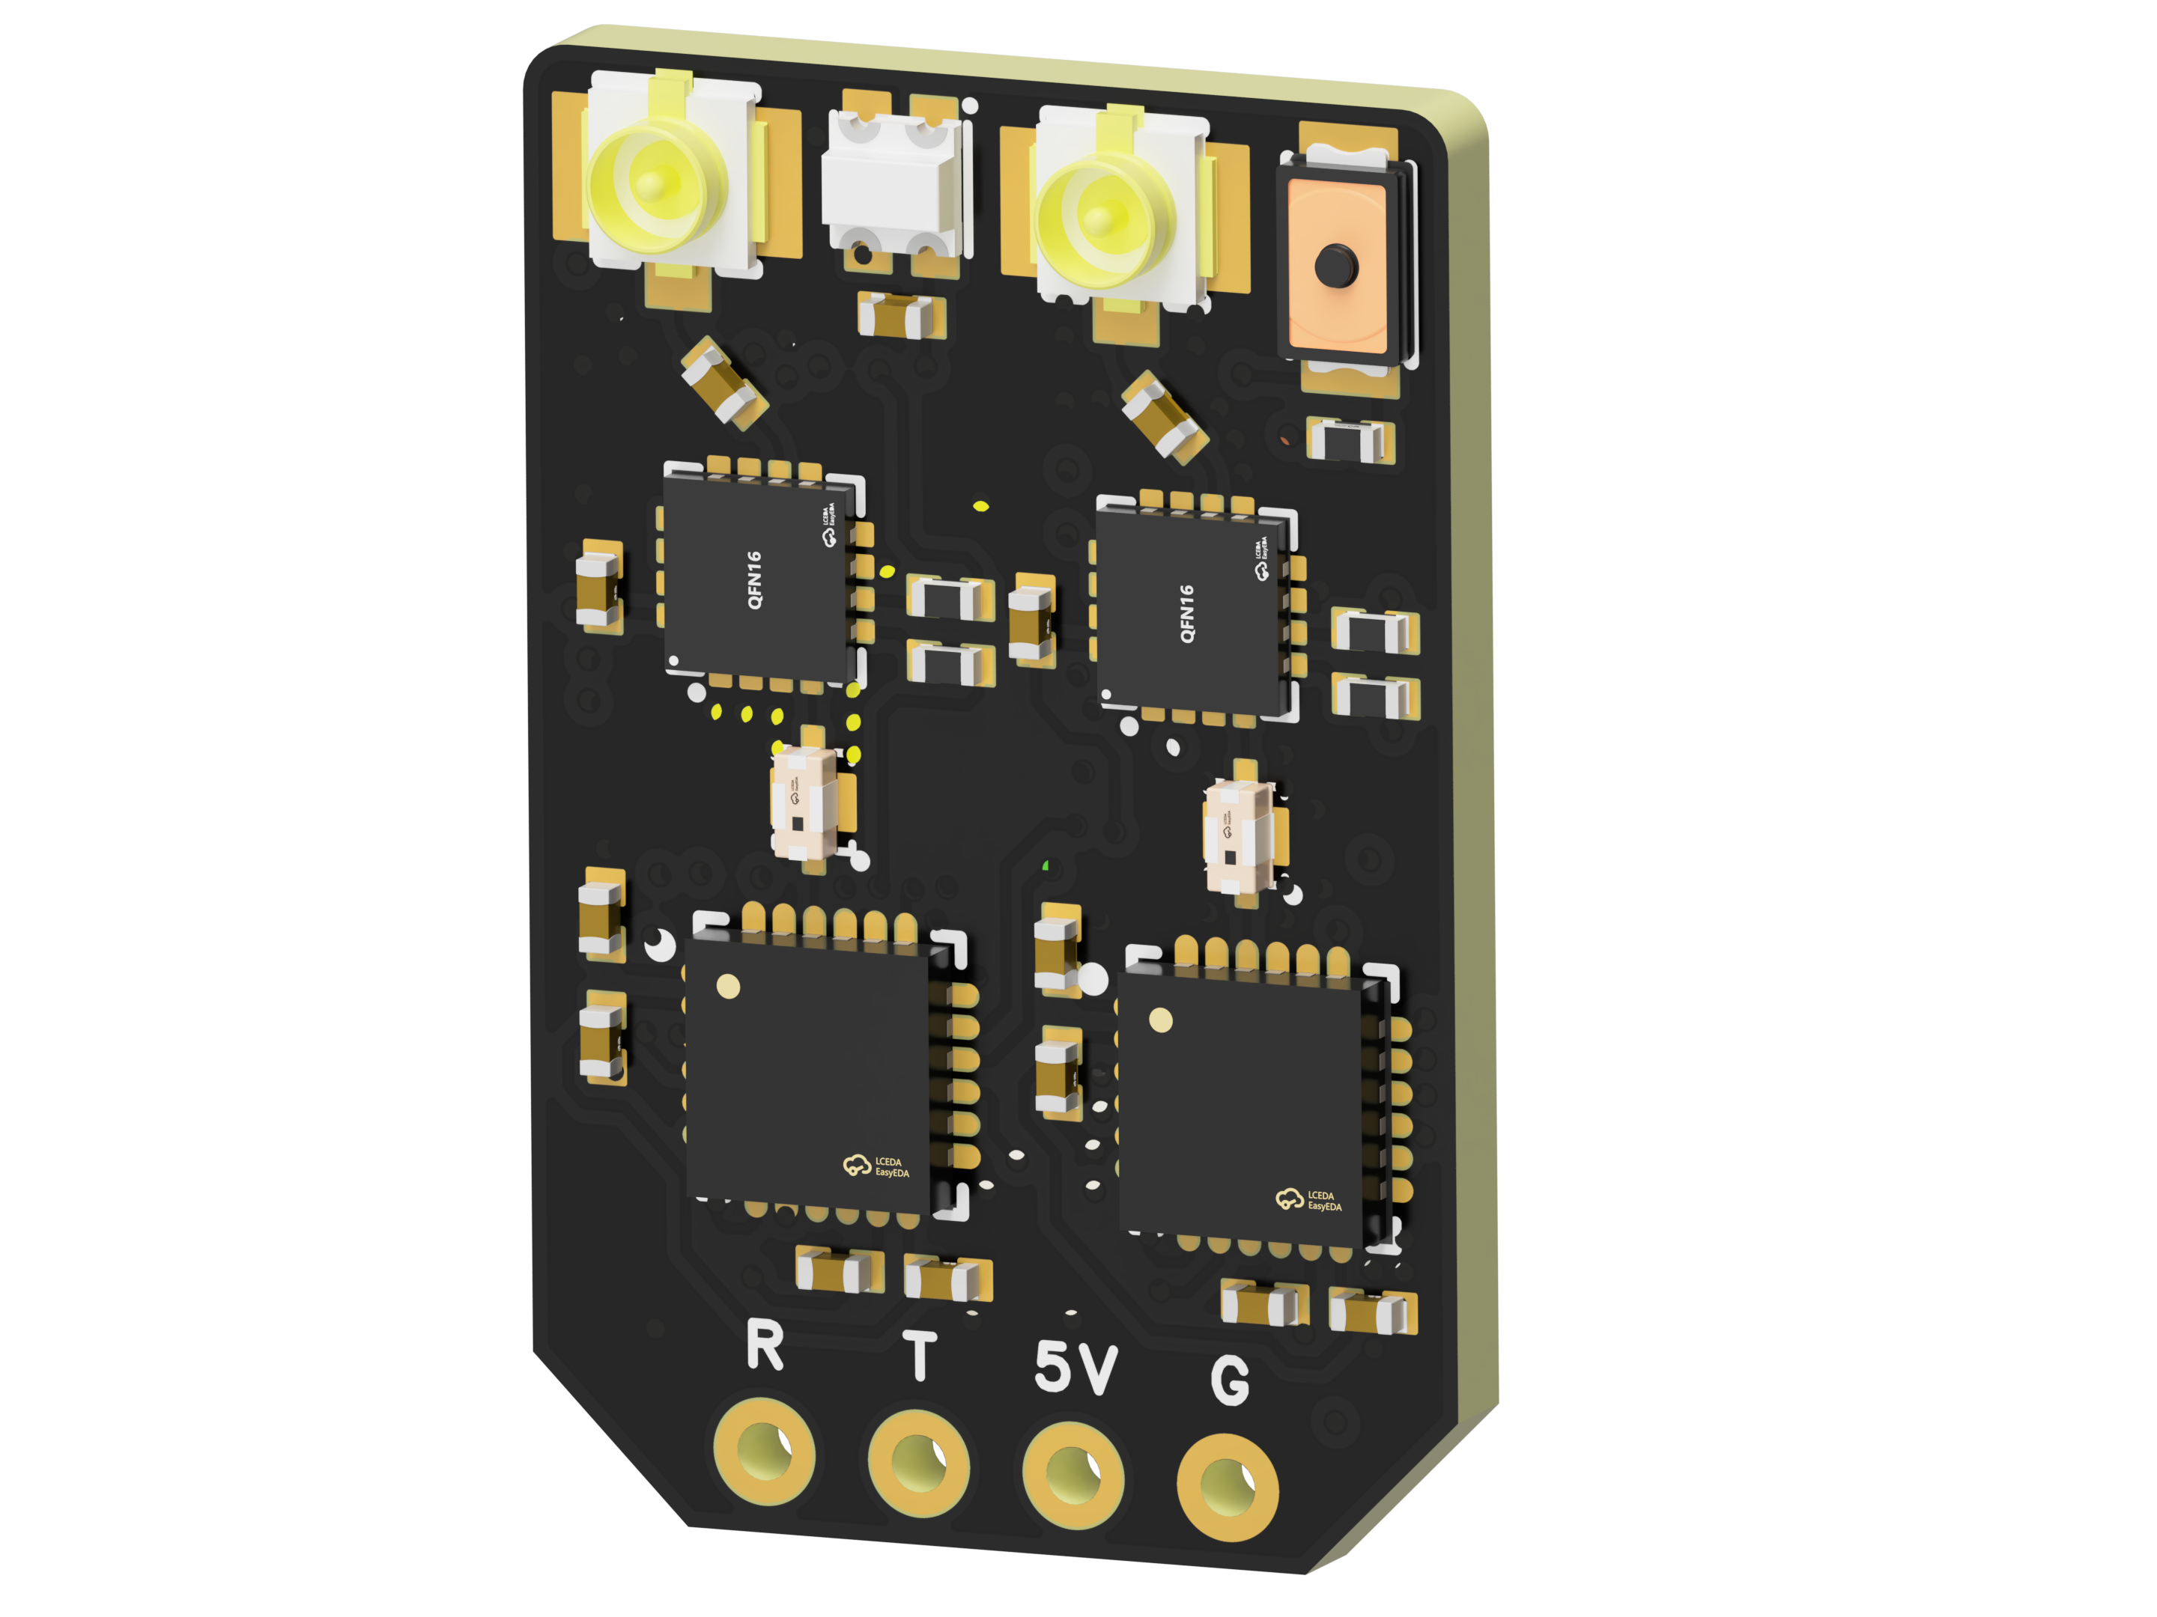
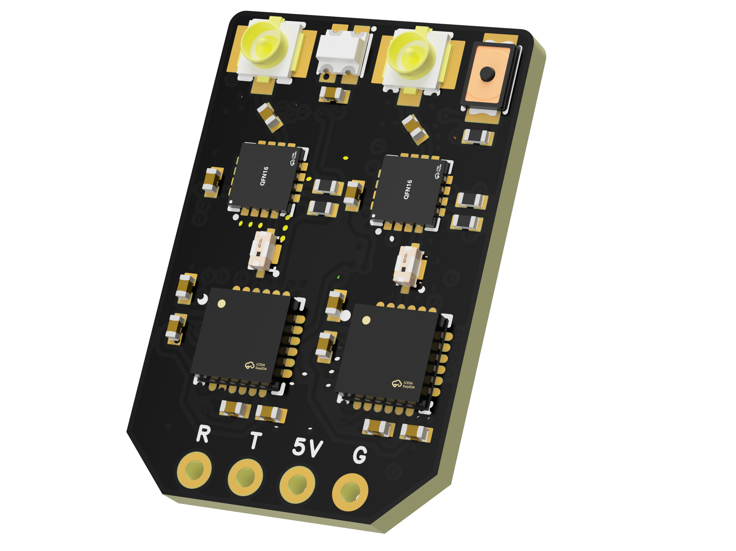

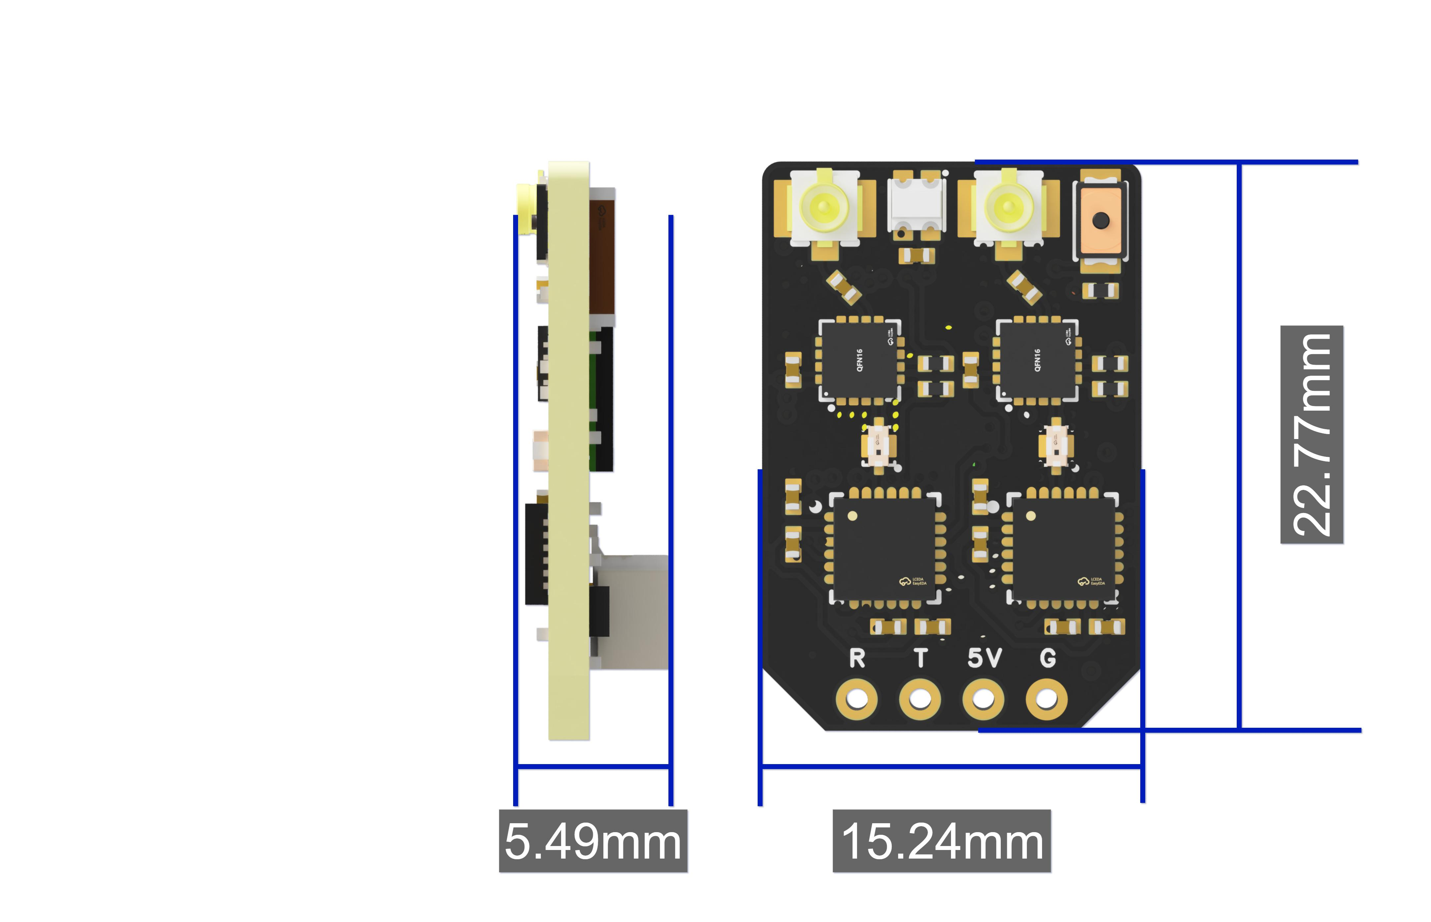
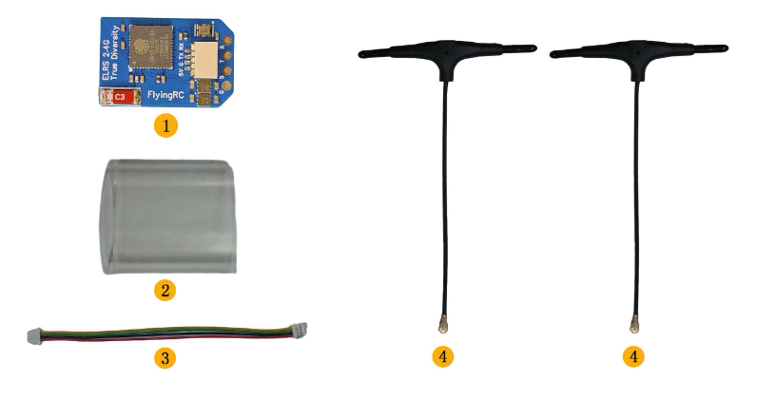
Packing list:
1. FlyingRC ELRS 2.4G True Diversity Receiver × 1
2. Heat Shrinkable Film (25mm×17mm) × 1
3. SH1.0 4-Pin double-ended Silicone Wire (15cm) × 1
4. T-Type Antenna (9cm) × 2

Technical Specifications
Product Dimensions：22.77mm*15.24mm*5.49mm
Weight：1.7g
PCB Layers:4 layers
PCB Thickness:1.60mm
Immersion Gold:Yes,1μm
Package Contents：Receiver, 2*T-type antennas, SH1.0 4P double-ended Silicone Wire, heat shrinkable film
Frequency Range: 2.4GHz
Update Rate: 50Hz–1000Hz. A high update rate enables precise control and smoother flight experience.
Communication Protocol: Supports CRSF protocol with great compatibility, suitable for a wide range of flight controllers and radio transmitters.
Chipset: Equipped with ESP32-Pico-D4, SX1281, etc., ensuring high-efficiency receiver operation and stable signal processing & transmission.

Product Features
- True Diversity Reception: The receiver adopts a dual-antenna design with two independent RF receiving chains, dynamically monitoring link quality in real time and selecting the path with superior signal performance to enhance stability and reduce signal dropouts and interference.
- Temperature Compensation: Built-in TCXO (Temperature Compensated Crystal Oscillator) prevents frequency drift caused by temperature changes, ensuring stable performance across varying ambient temperatures.
- High Power Output: With integrated PA (Power Amplifier) + LNA (Low-Noise Amplifier), the 2.4GHz model supports a maximum telemetry power output of up to 100mW, effectively extending transmission range and enhancing signal strength and stability.
- Multiple Operating Modes: Supports data rates including F1000, F500 in FLRC mode and D500, D250 in DVDA mode, to meet diverse flight requirements.
- Rich Interfaces: Equipped with IPEX1 antenna ports and SH1.0 connectors, it is convenient to connect antennas, flight controllers and other peripherals for rapid installation and debugging.

Wiring Diagram

FlyingRC® F4WSE PRO Flight Controller
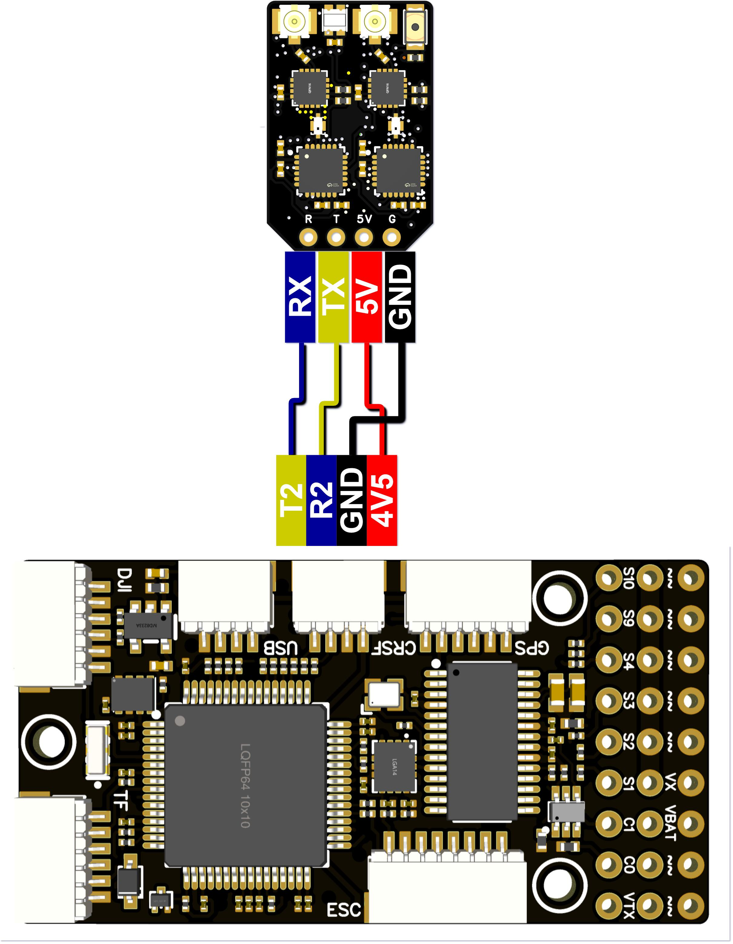
Wiring Diagram for Connection with FlyingRC® F4WSE PRO Flight Controller

FlyingRC® H7Wlite H743 Flight Controller
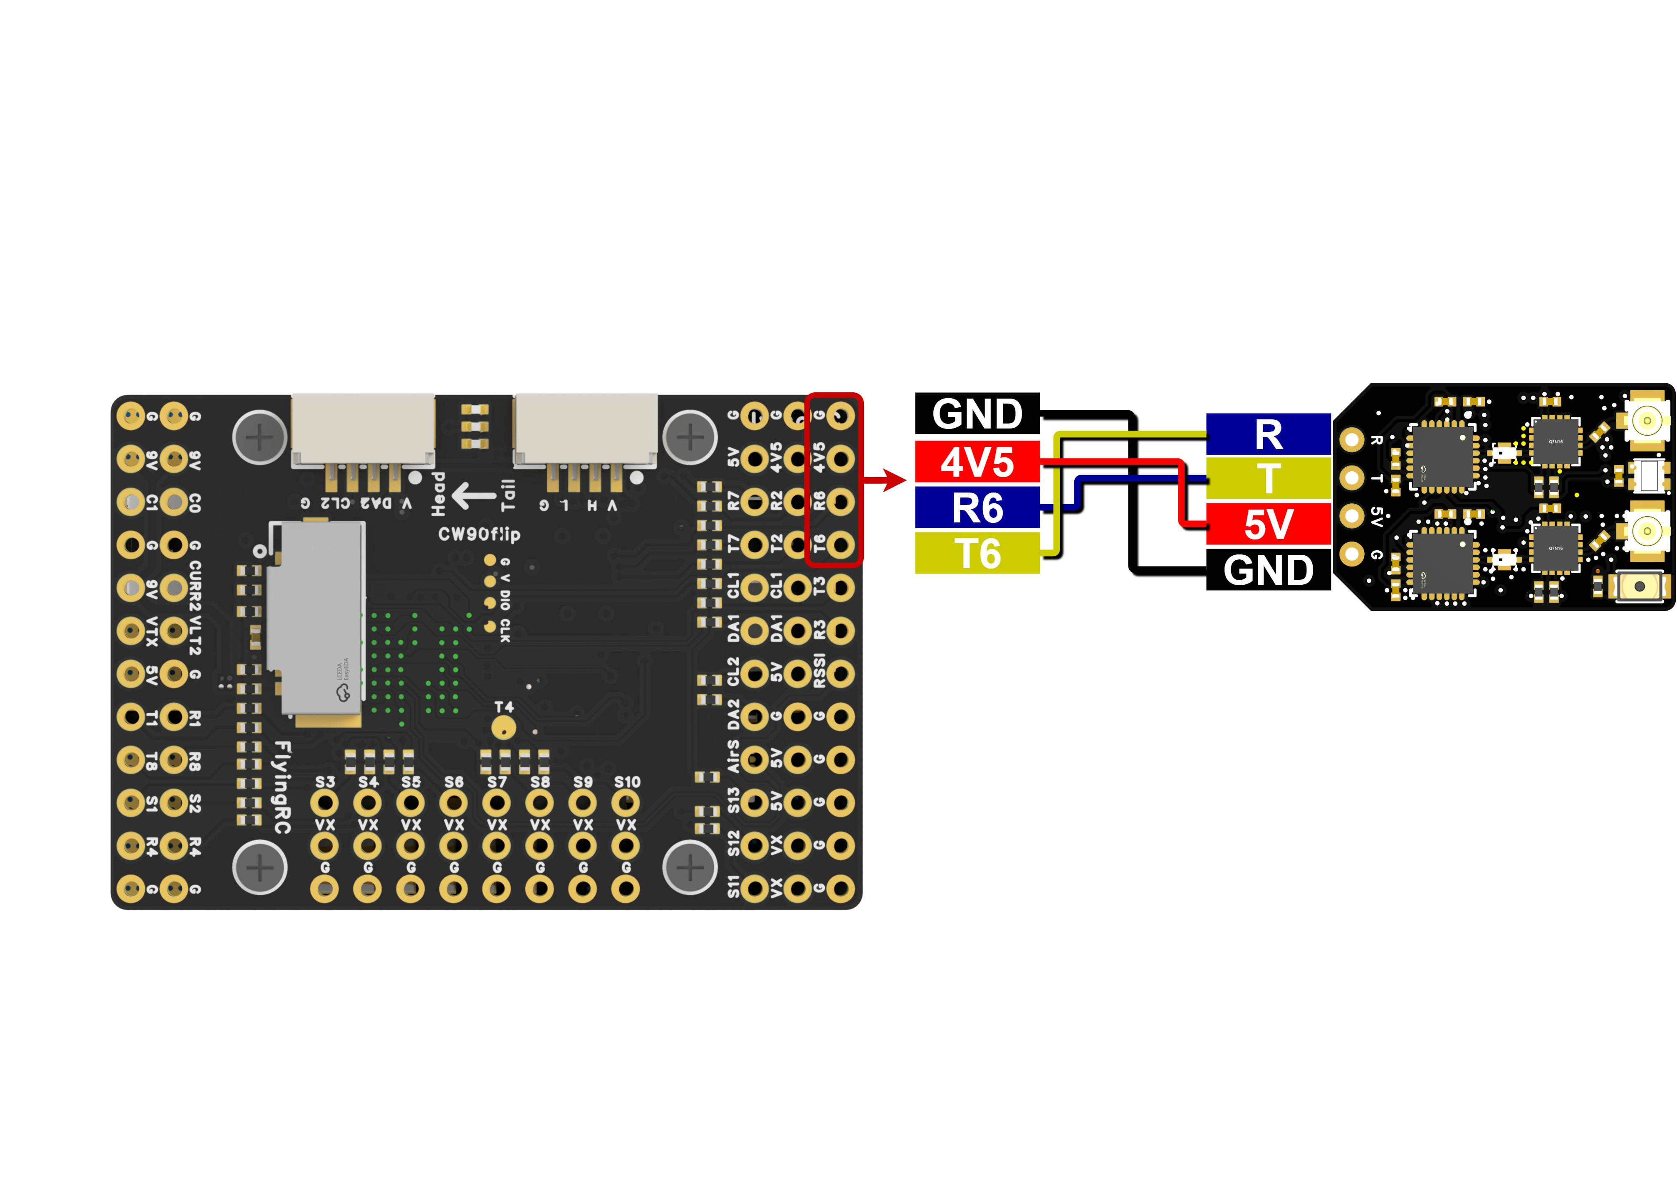
Wiring Diagram for Connection with FlyingRC® H7Wlite H743 Flight Controller

- FlyingRC® F4Wing Mini Flight Controller
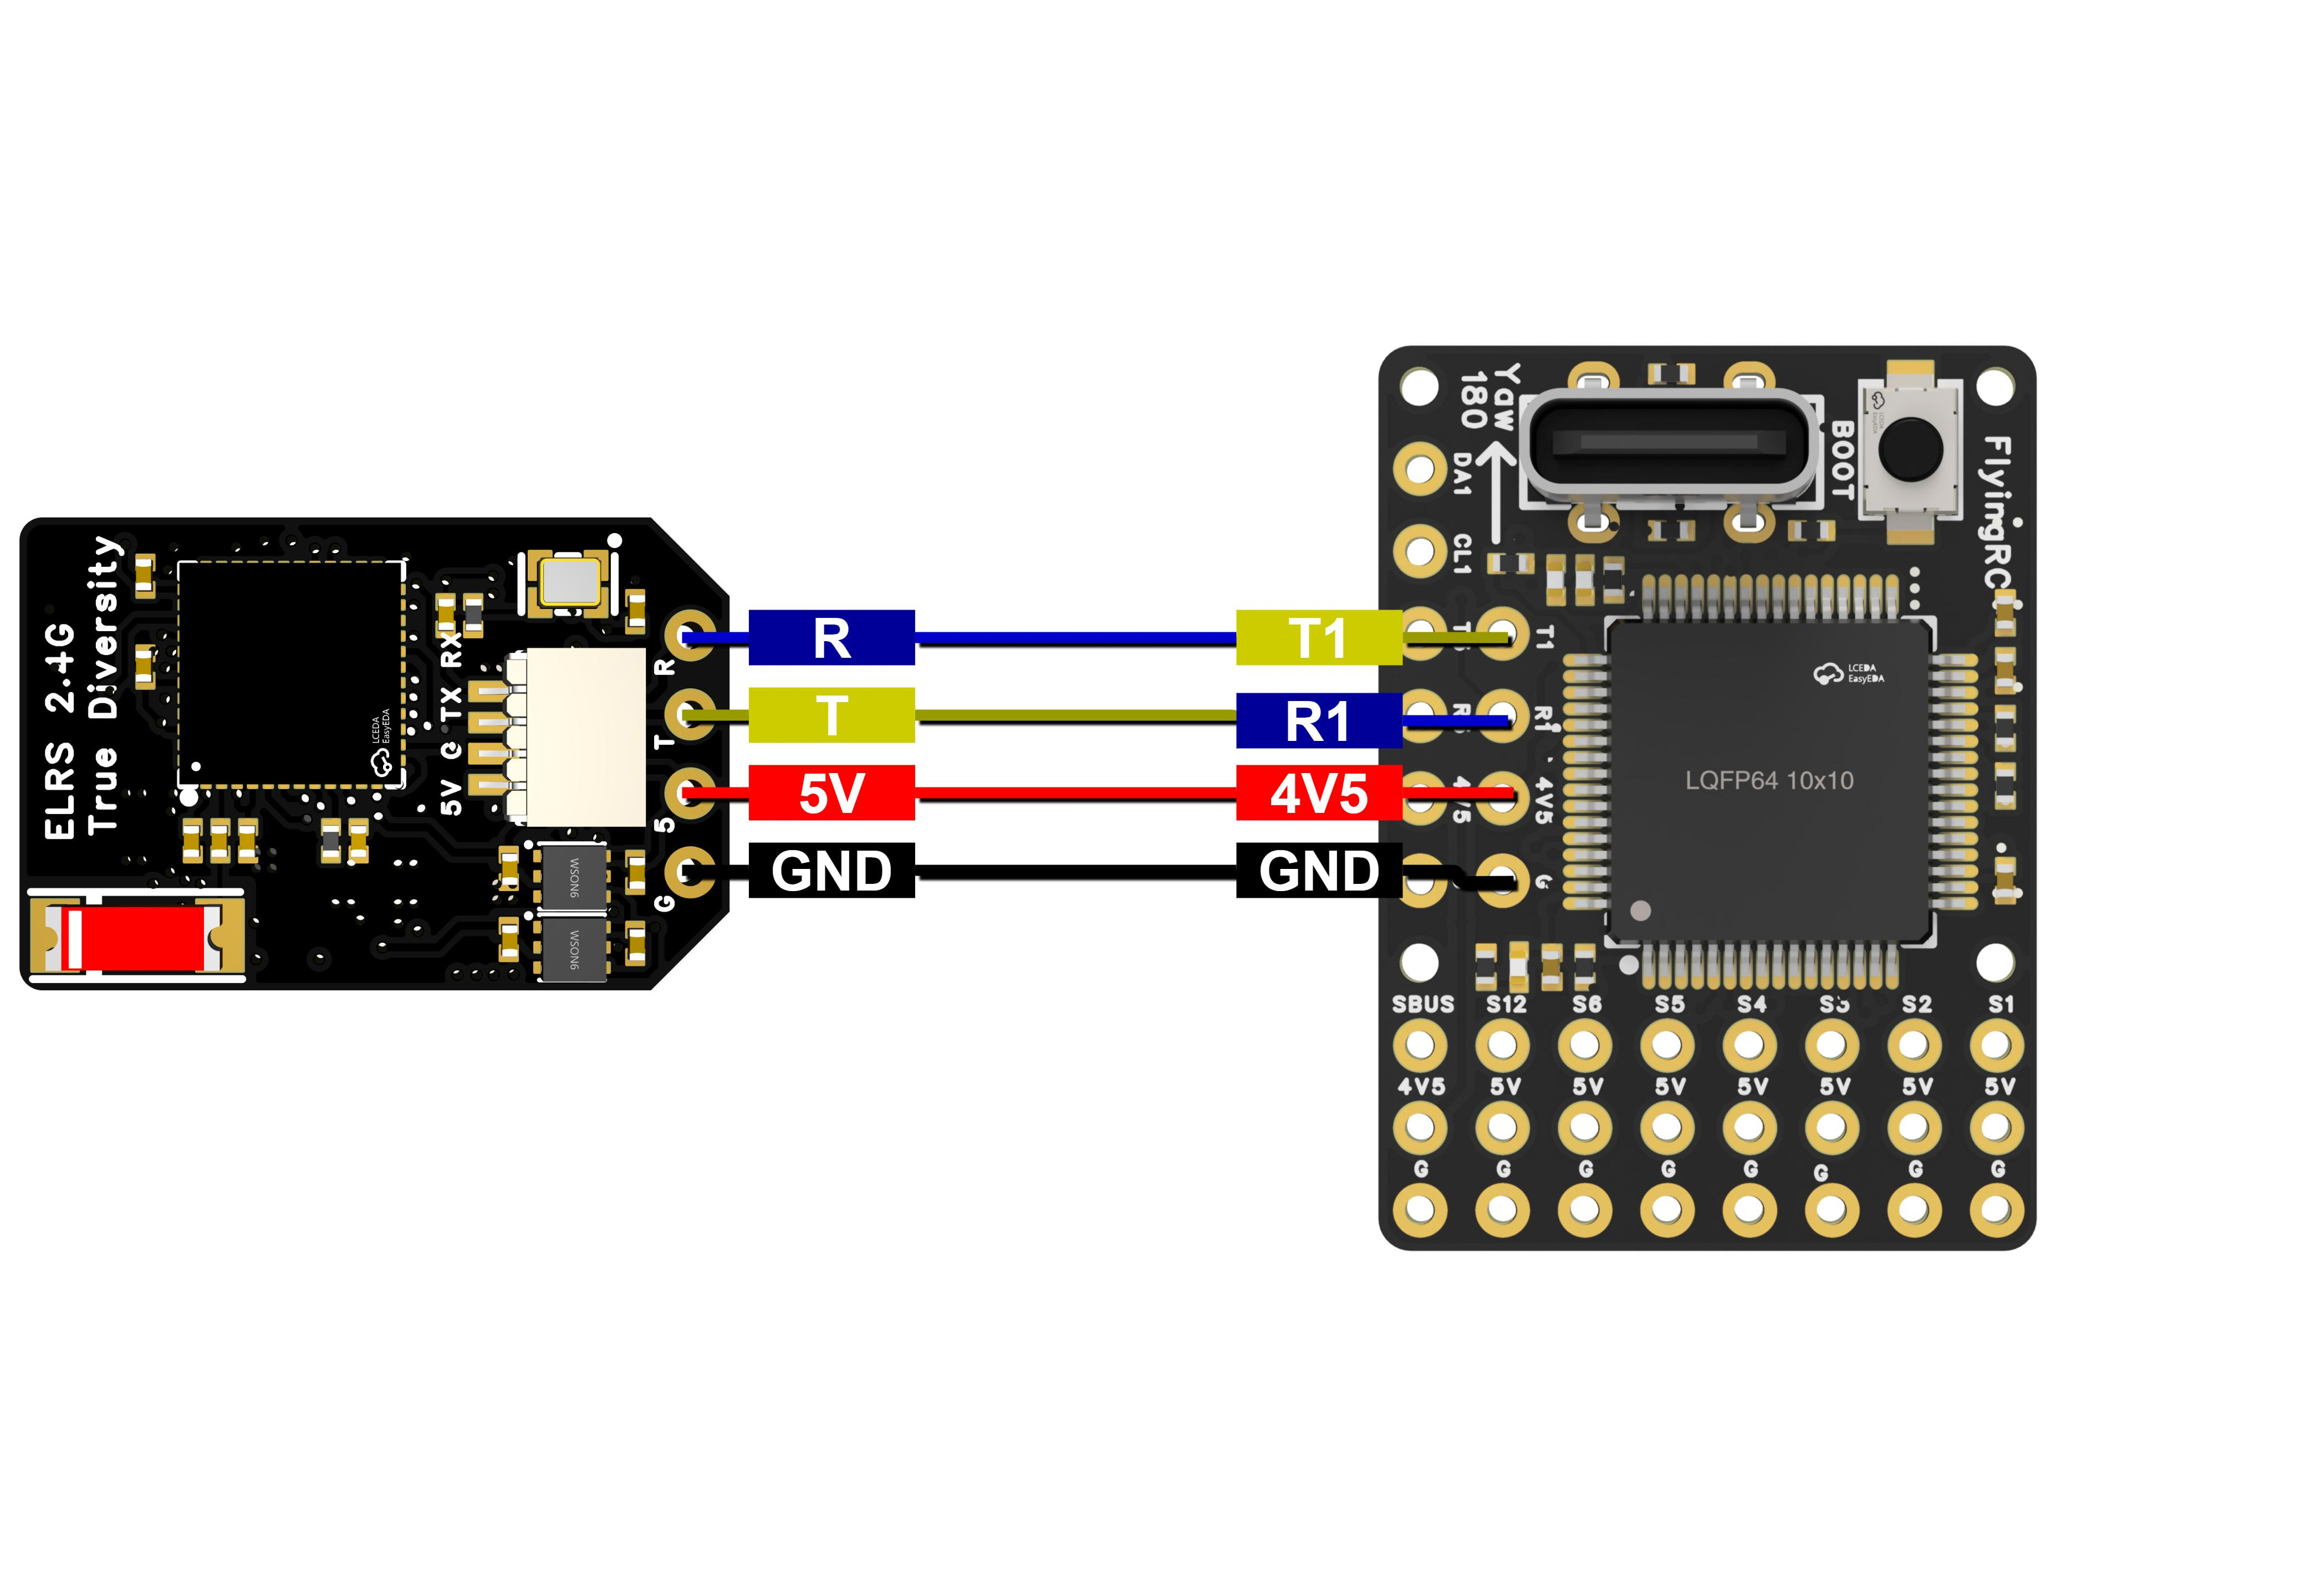
Wiring Diagram for Connection with FlyingRC® F4Wing Mini Flight Controller

Operation Instruction
- Firmware Flashing：

- Prepare the receiver and a USB-to-TTL adapter.

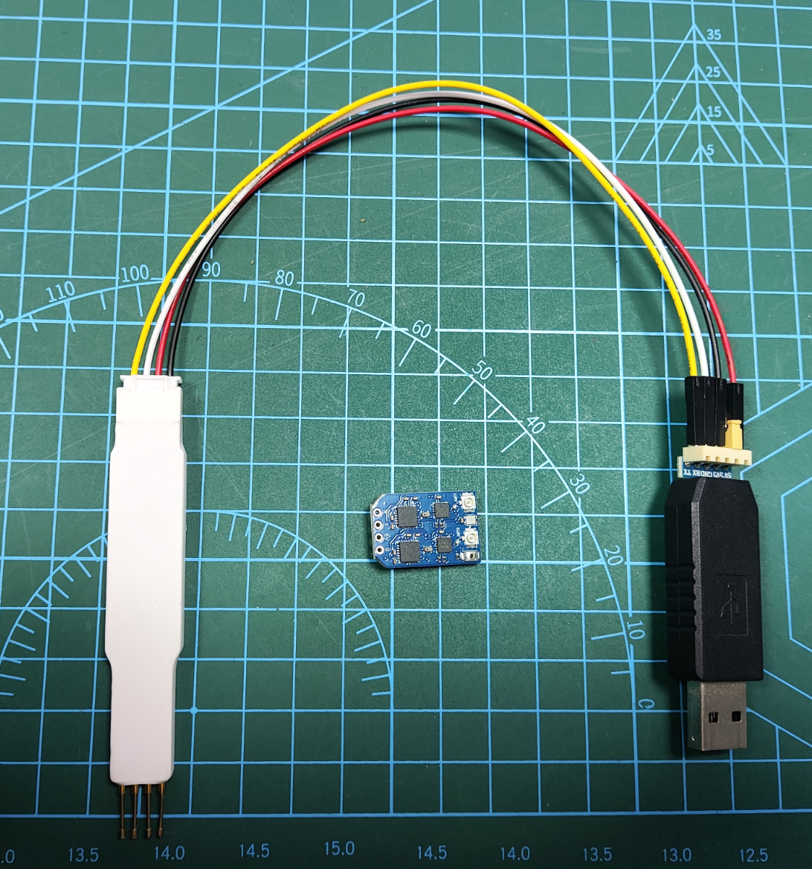

- Open the firmware flashing website：https://elrs.helloradiosky.com (as shown in the figure below)

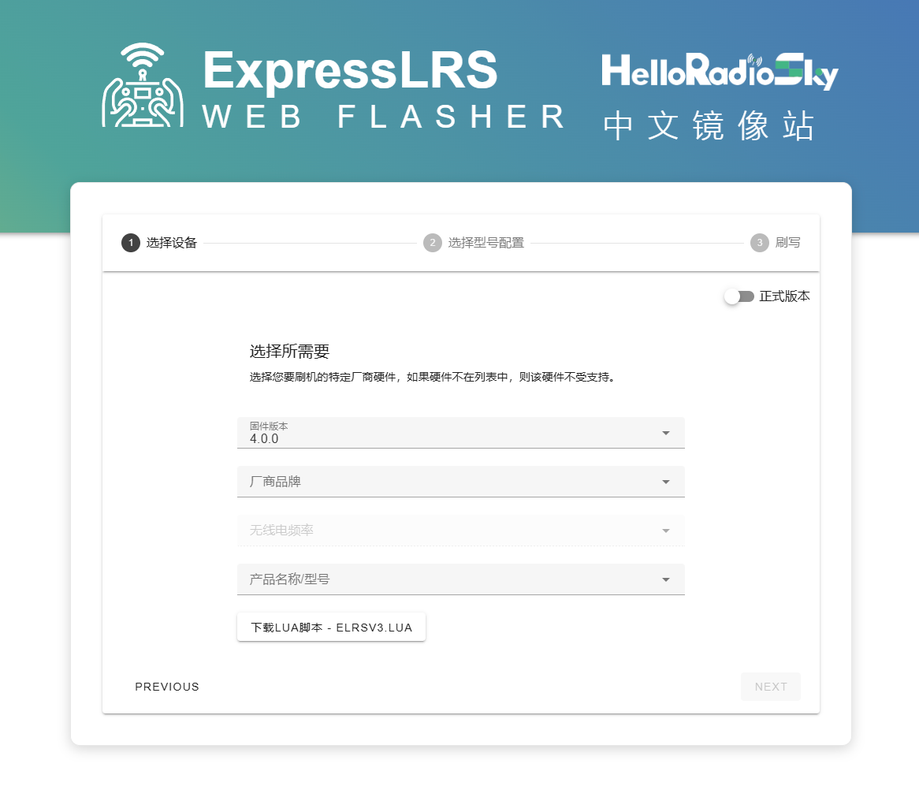

- Click NEXT in the lower right corner to enter the "Select Device" page (as shown in the figure below)
Firmware Version: Select 3.5.6
Manufacturer Brand: Select FlyingRC
Radio Frequency: Select 2.4GHz Receiver
Product Name/Model: Select FlyingRC 2.4GHz True Diversity RX

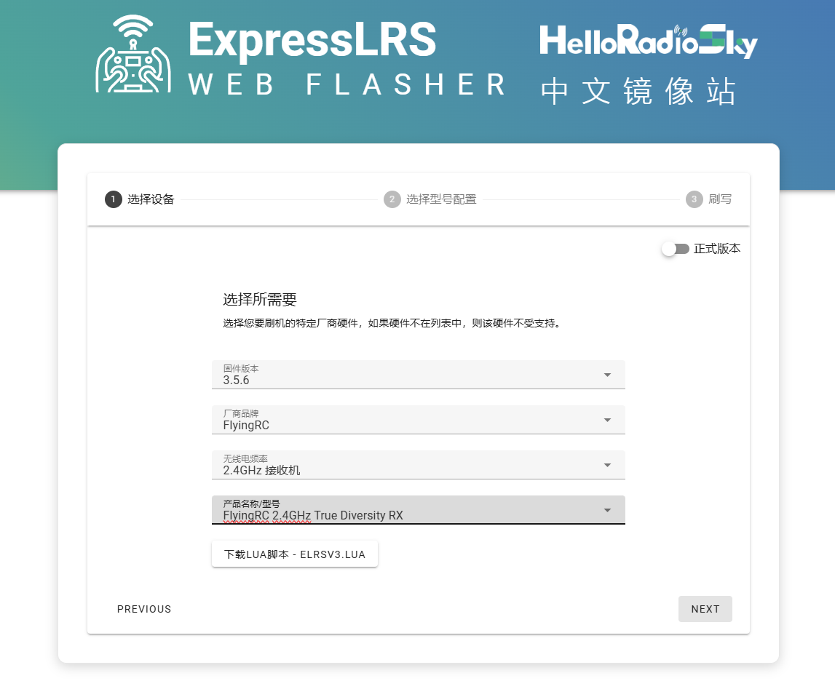

- Click NEXT in the lower right corner to enter the "Select Model Configuration" page (as shown in the figure below)
Region:Select FCC
Flashing Method:Select UART Serial Flashing



- Click NEXT in the lower right corner to enter the "Flash" page (as shown in the figure below)
Click the blue Connect button.
A pop-up window will appear in the upper left corner of the page:
From the available serial ports, select USB2.0-Serial (COM77) - Paired.
After selection, the Connect button will turn black. Click it again to proceed to the next page.

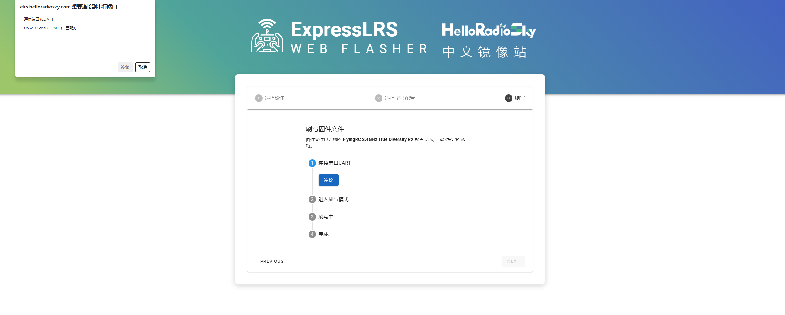

- As shown in the figure below: Click the Flash button and wait for the flashing process to complete.

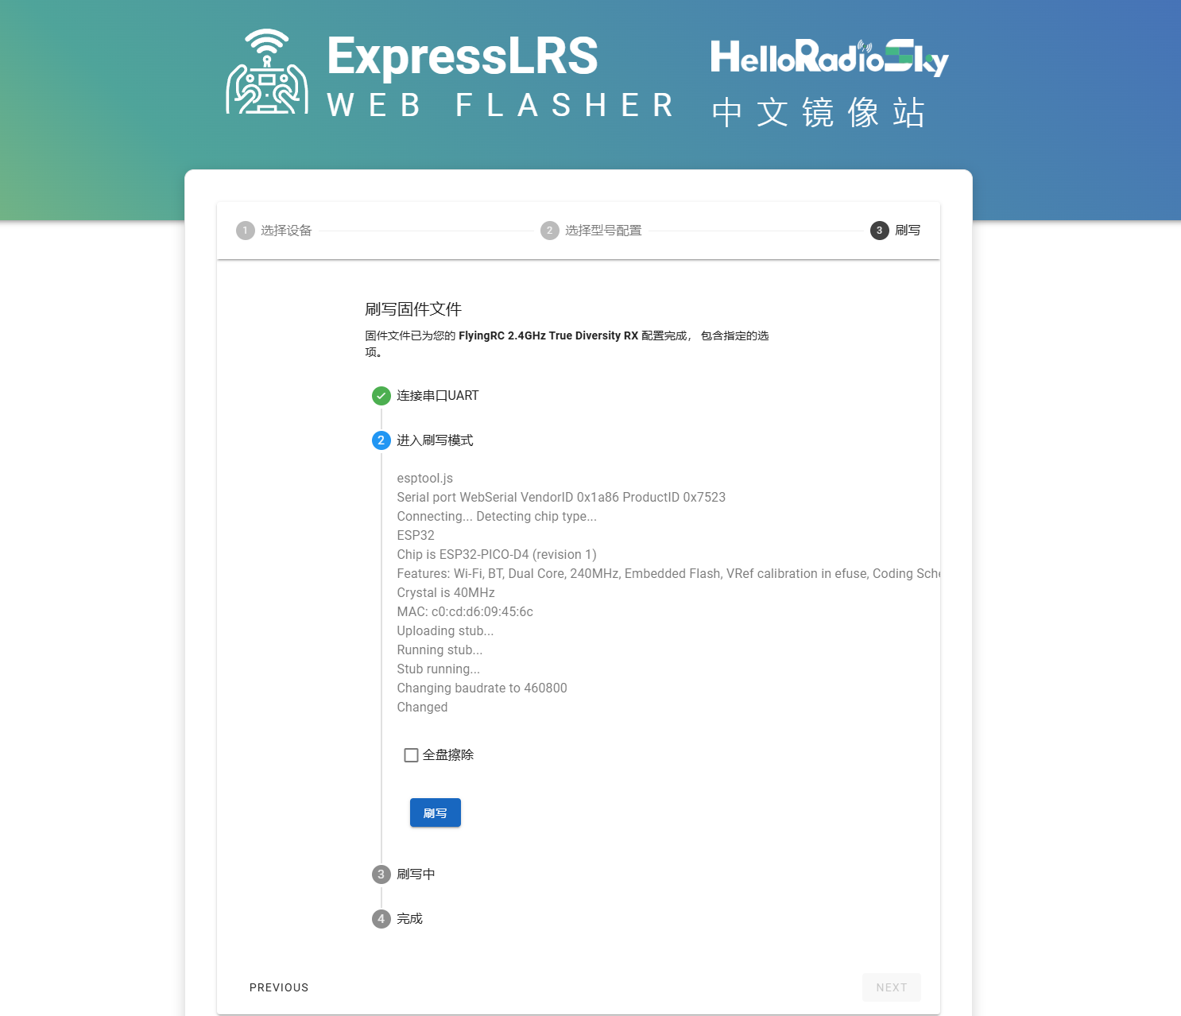

⑦ After flashing is finished, you will enter the next page (as shown in the figure below).
You can continue flashing other receivers; or click the Back button to finish this flashing session.

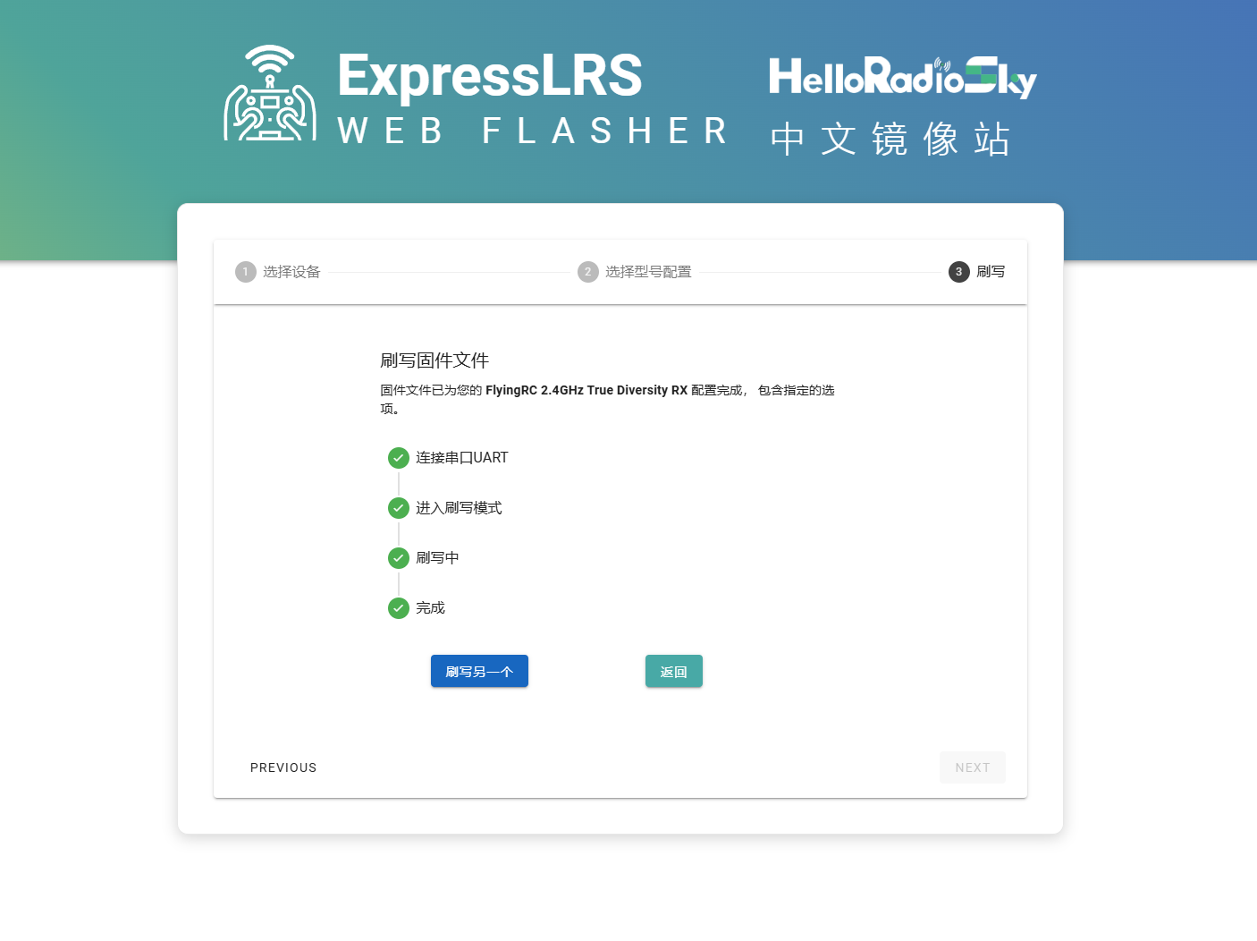

- Firmware Upgrade: The receiver comes with factory firmware version 3.5.5. Please upgrade the TX module firmware to version 3.x or higher to ensure compatibility.

- Enter Enter Binding Mode: Power the receiver on and off three times consecutively at 1‑second intervals. The receiver enters binding mode when the RGB LED flashes rapidly twice.

- BindingBinding Setup: Configure the remote control or transmitter module to bind with the receiver. After successful binding, the receiver’s RGB indicator will stay solid on.

Precautions
- Do not use the receiver in high-temperature, humid or strong electromagnetic interference environments, as this may affect its performance and service life.
- Avoid severe impact or dropping to prevent damage to internal components.
- Regularly check the receiver’s wiring connections to ensure they are secure and free from looseness or damage.
- If the device behaves abnormally during use, stop operation immediately and consult a professional technician for repair.

Other FlyingRC® Products
 |  |  |  | - FlyingRC® F4WSE Pro - F405 Fixed-Wing Flight Controller  Upgraded Version | Enhanced Performance  Manual：https://www.kdocs.cn/l/cavm9EoVEq5A |  |  | 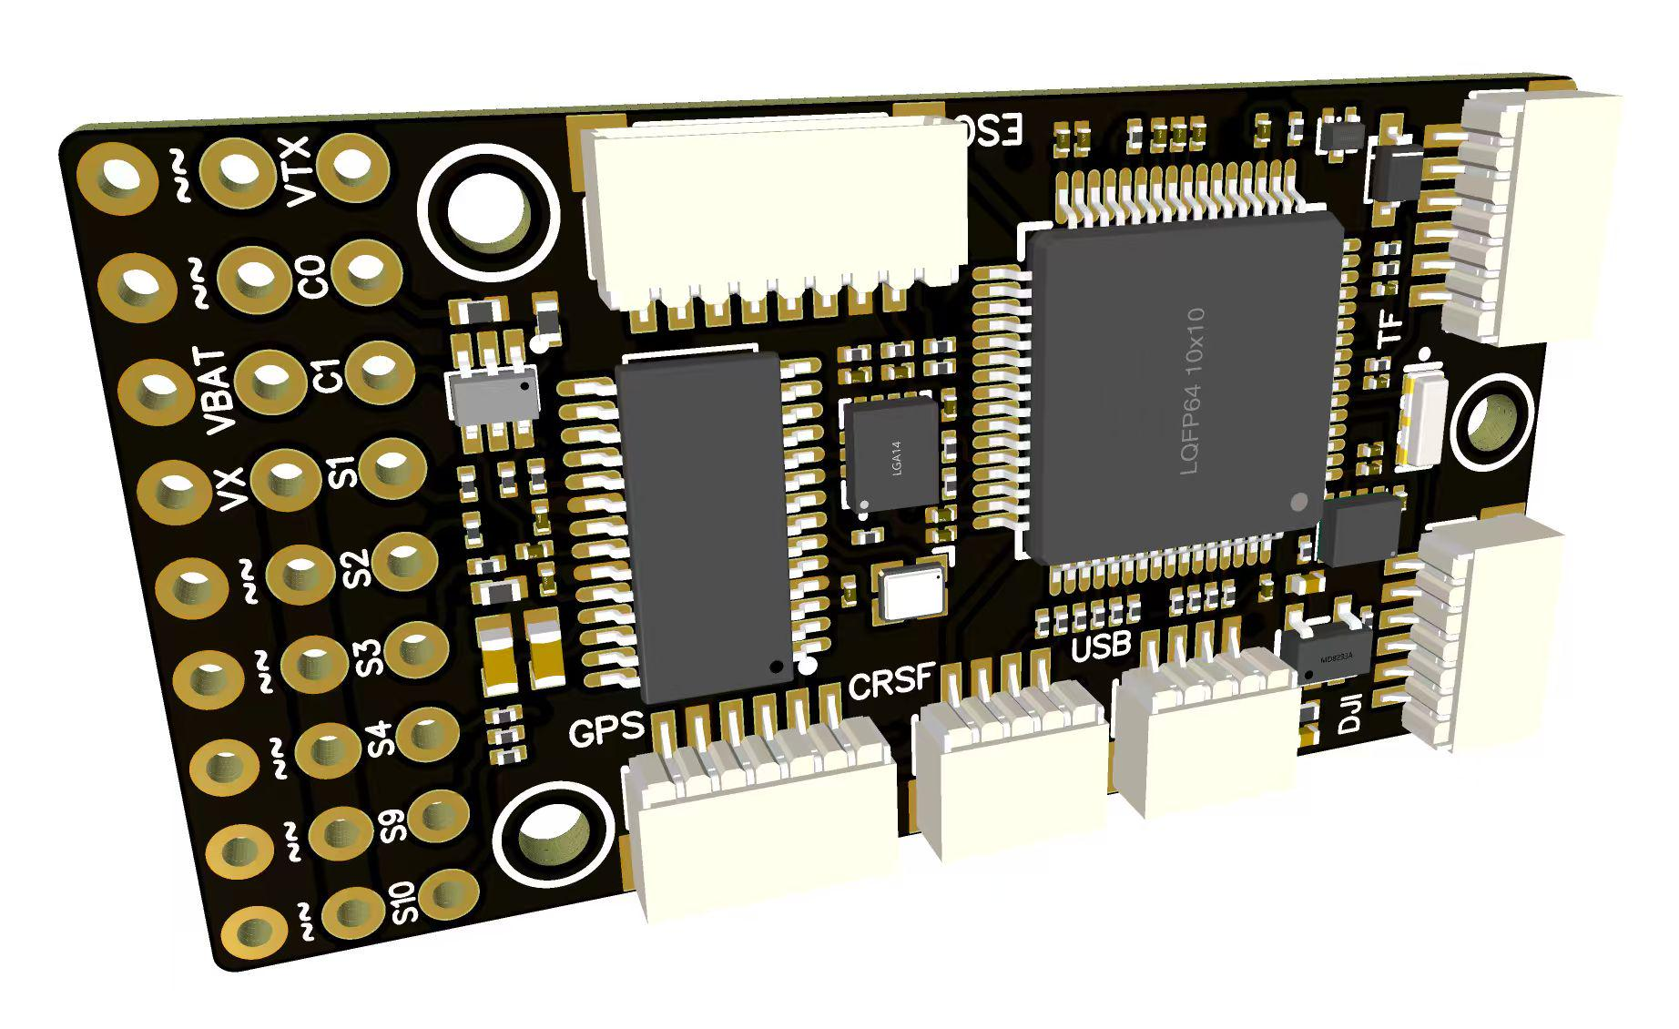
 |  |  | - FlyingRC® F4WSE MK1.5 - F405 Fixed-Wing Flight Controller  Classic model, unique design, highly acclaimed.  Manual：https://kdocs.cn/l/cpyd8MTS56DD |  |  | 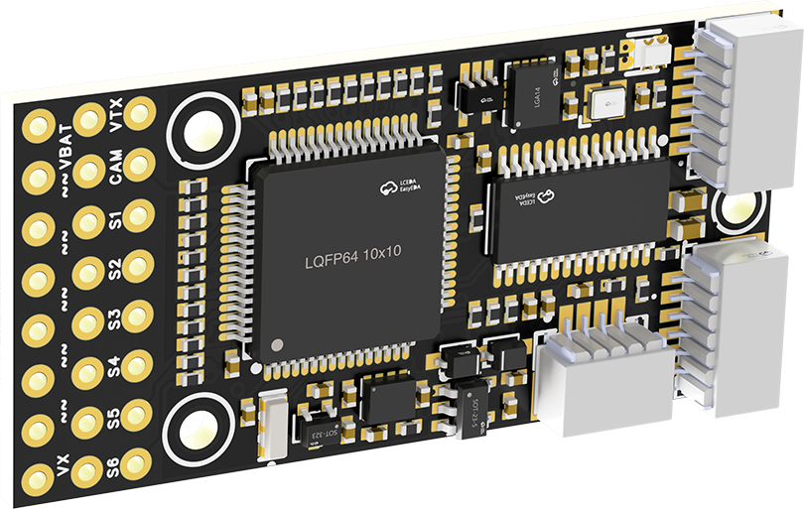
 |  |  |  | - FlyingRC® H7Wlite MK1 H743 Fixed-Wing Flight Controller  Flagship performance, full expansion, high-power BEC.  Manual：https://kdocs.cn/l/cpYaBiFKh8U1 |  |  | 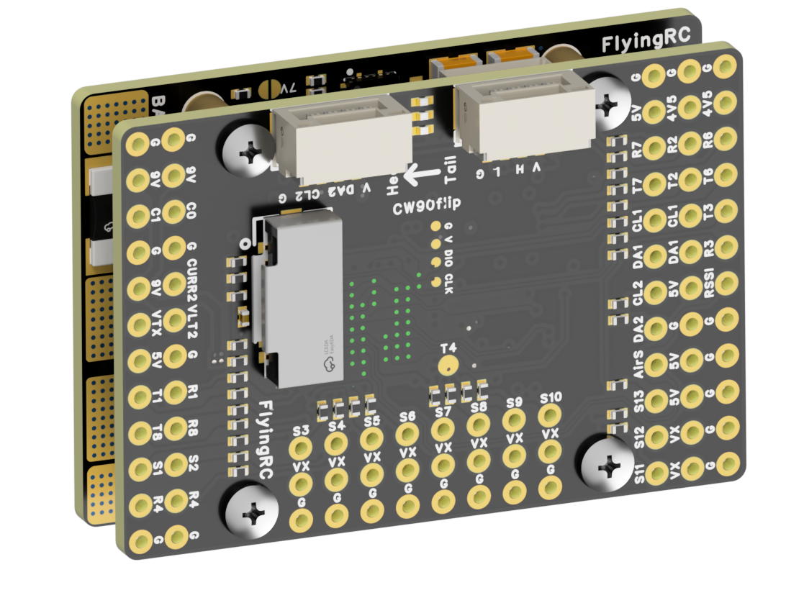
 |  |  |  | - FlyingRC® F4Wing Mini MK1 F405 Fixed-Wing Flight Controller  2025 bestseller, ultra-compact, smallest on the market, great value.  Manual：https://kdocs.cn/l/cdUIdmpSpW7J |  |  | 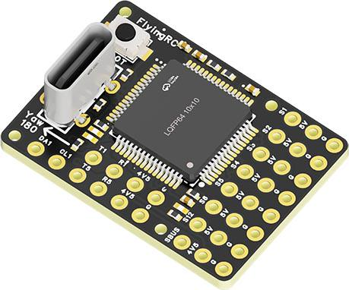
 | - FlyingRC® AM32 Dual ESC 40A 2-in-1 ESC  Unique design for dual-power aerial, land and water vehicles including drones.  Manual：https://www.kdocs.cn/l/cjwNtsKK6HeR |  |  |  | 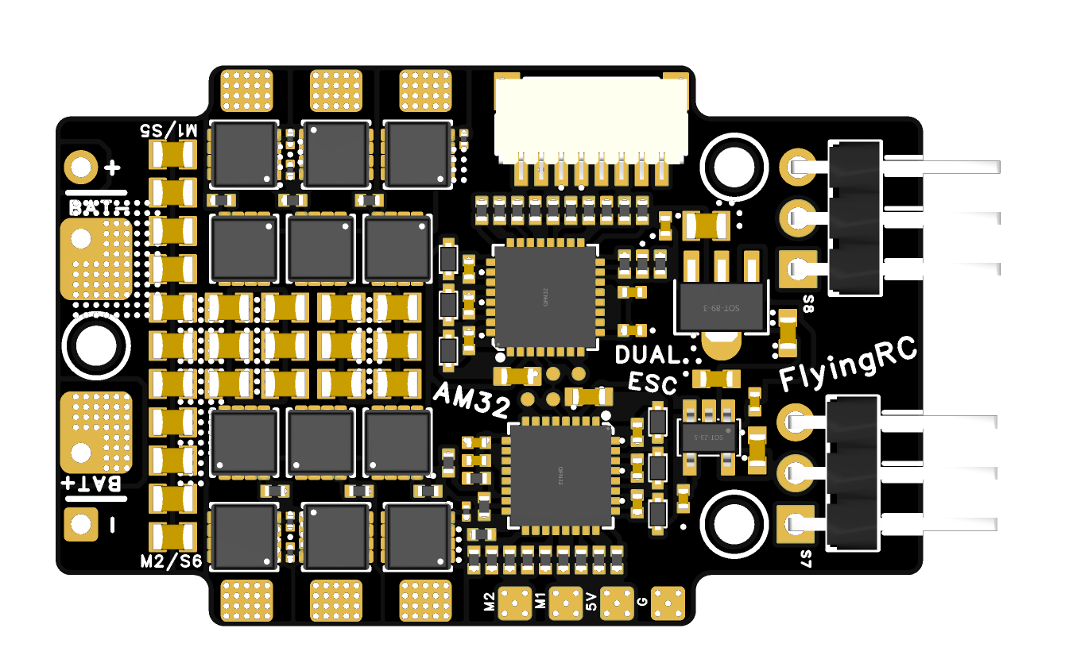
 |  |  | - FlyingRC® AM32 ESC V2.5 75A - Single ESC  Infineon gold-package MOSFETs, premium materials, superior heat dissipation.  Manual：https://kdocs.cn/l/cv6hUy67IdTJ |  |  |  | 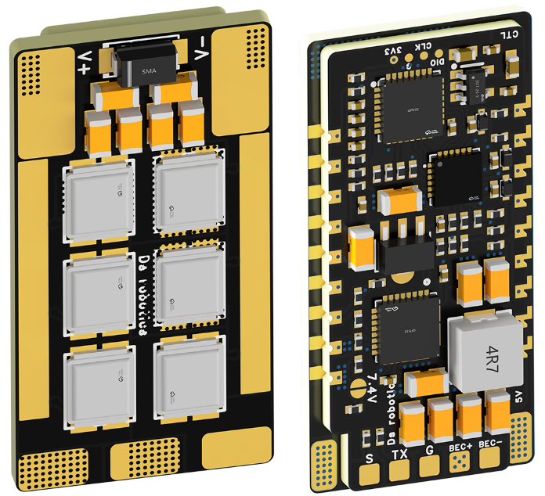
 |  |  | - FlyingRC® AM32 Mini ESC 40A V1.0 - Single ESC  Ultra-miniature, ideal for micro drones, high over-current capability, stable operation.  Manual：https://kdocs.cn/l/cqdLSysEyWFh |  |  |  |  | 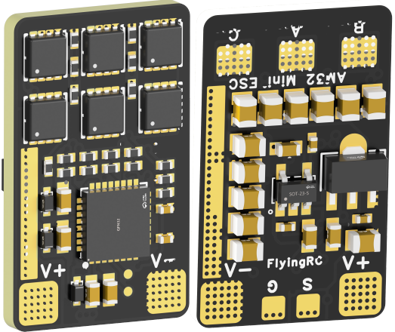
 |  |  | - FlyingRC® 10A 12S 440A Power Distribution Board for FPV Drones  Industry top choice, excellent quality and affordable price.  Manual：https://kdocs.cn/l/coel7OgrlCBP |  |  |  |  | 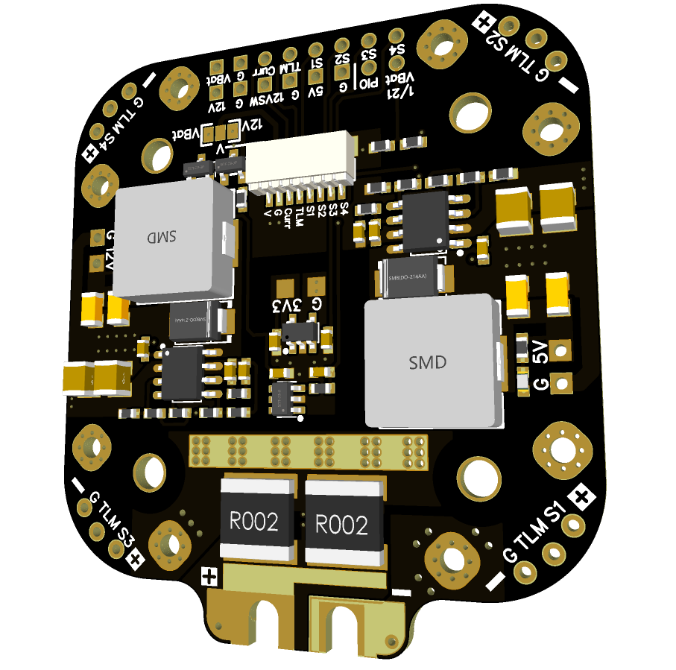
 |  |  | - FlyingRC® H7D Pro MK1 H743 FPV Flight Controller with Dual Gyro  Fully Upgraded & More Powerful  Manual：https://www.kdocs.cn/l/ctcekCy676Ez |  |  |  | 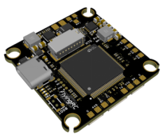
 |  |  | - FlyingRC® H7D MK1 H743 FPV Flight Controller with Dual Gyro  Powerful computing, stable and precise flight, rich interfaces, smooth control.  Manual：https://kdocs.cn/l/cqMh1I0RwAoD |  |  |  | 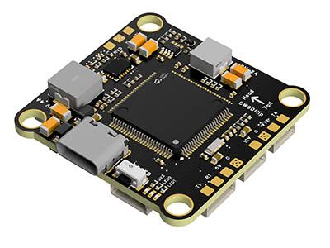
 |  |  | - FlyingRC® F420 MK1 F405 FPV Flight Controller (20/30.5mm Mounting)  Dual mounting holes, all connectors, no soldering required, compliant with Betaflight interface standards.  Manual：https://kdocs.cn/l/ctGeLiN9ZYKj |  |  |  | 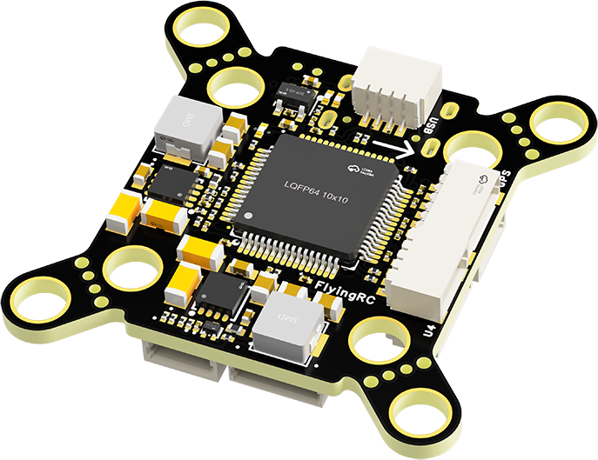
 |  | - FlyingRC® 4-in-1 75A V3.2 Gold-Sealed FPV ESC  Infineon gold-package MOSFETs, superior heat dissipation & over-current capability, premium choice.  Manual：https://kdocs.cn/l/ceLilc8Gaa21 |  |  |  |  | 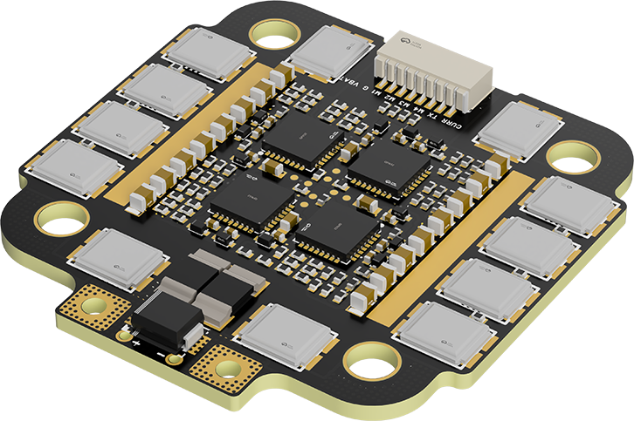
- FlyingRC® Stack Combo: H743 Flight Controller + 4-in-1 75A Gold-Sealed ESC  Professional flight choice, flagship materials & craftsmanship, reasonable price.  Manual：https://www.kdocs.cn/l/ctcekCy676Ez  https://kdocs.cn/l/ceLilc8Gaa21 |  |  |  |  |  |  | 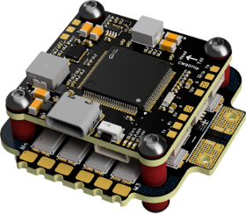
 |  | - FlyingRC® Stack Combo: F405 Flight Controller + 4-in-1 75A Gold-Sealed ESC  Best-selling combo, excellent performance, affordable price.  Manual：https://kdocs.cn/l/ctGeLiN9ZYKj  https://kdocs.cn/l/ceLilc8Gaa21 |  |  |  |  | 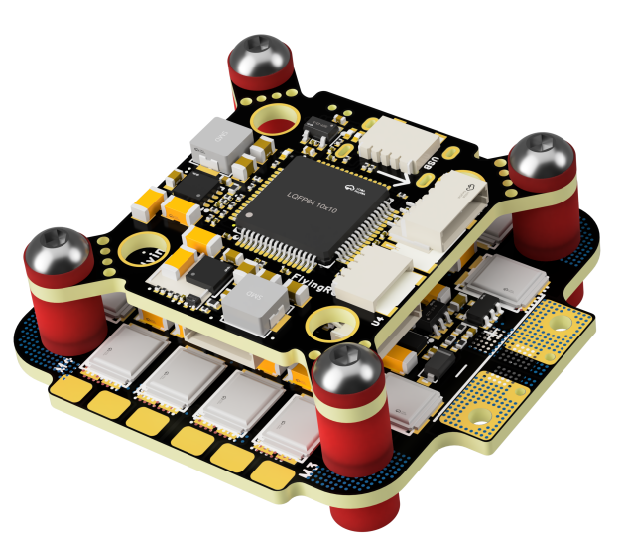
 |  | - FlyingRC® Stack Combo: H743 Flight Controller + 4-in-1 45A ESC  Winning combo: great performance, budget-friendly price  Manual：https://www.kdocs.cn/l/ctcekCy676Ez  https://kdocs.cn/l/ceLilc8Gaa21 |  |  |  |  | 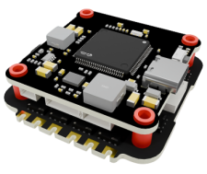
 |  | - FlyingRC® Stack Combo: F405 Flight Controller + 4-in-1 45A ESC  Hit combo, great value, budget-friendly  Manual：https://kdocs.cn/l/ctGeLiN9ZYKj  https://kdocs.cn/l/ceLilc8Gaa21 |  |  |  |  | 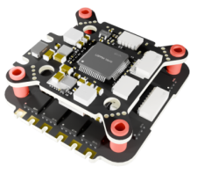
 |  | - FlyingRC® Stack Combo: F4WSE Pro - F405 Fixed-Wing Flight Controller + AM32 Dual ESC 40A 2-in-1 ESC  Unique Design • Exclusive Offer • Bestselling Bundle  Manual：https://www.kdocs.cn/l/cavm9EoVEq5A  https://www.kdocs.cn/l/cjwNtsKK6HeR |  |  |  |  | 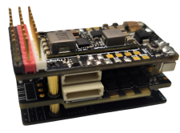
 | - FlyingRC® ELRS 2.4G Diversity Receiver  True diversity reception, temperature compensation, high-sensitivity reception.  Manual：https://kdocs.cn/l/cbvlOlShmsPS |  |  |  |  |  | 
 | - FlyingRC® RM3100 SPI Module 罗盘模块  Ultra-high Resolution • Low Power • Industry Top Choice  Manual：https://www.kdocs.cn/l/cdGuHvBVyndC |  |  |  |  |  | 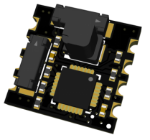
 | - FlyingRC® 10A 12S BEC Step-Down Module  Wide voltage input, high power, compact size, multiple voltages available, 10A continuous output.  Manual：https://kdocs.cn/l/clssNCKgNhLV |  |  |  |  |  | 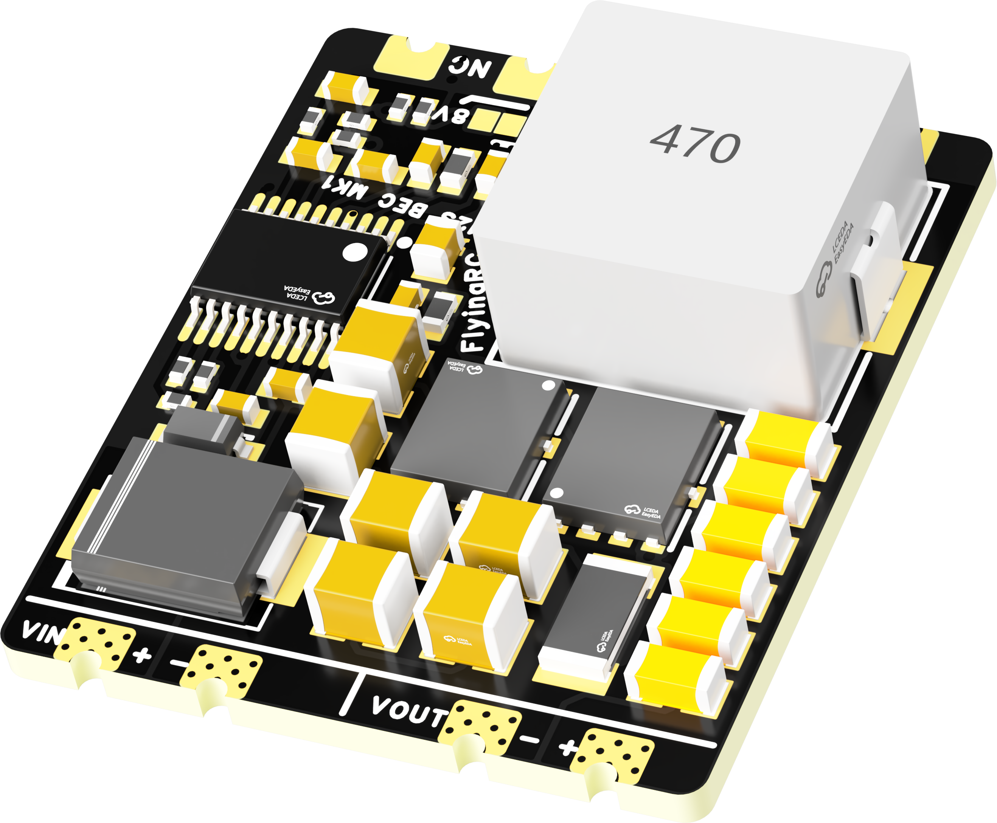
 | FlyingRC® 5A BEC Step-Down Module  Ultra-small size, multiple voltages available, 5A continuous output.  Manual：https://kdocs.cn/l/cb9VdNywqCKA |  |  |  |  |  | 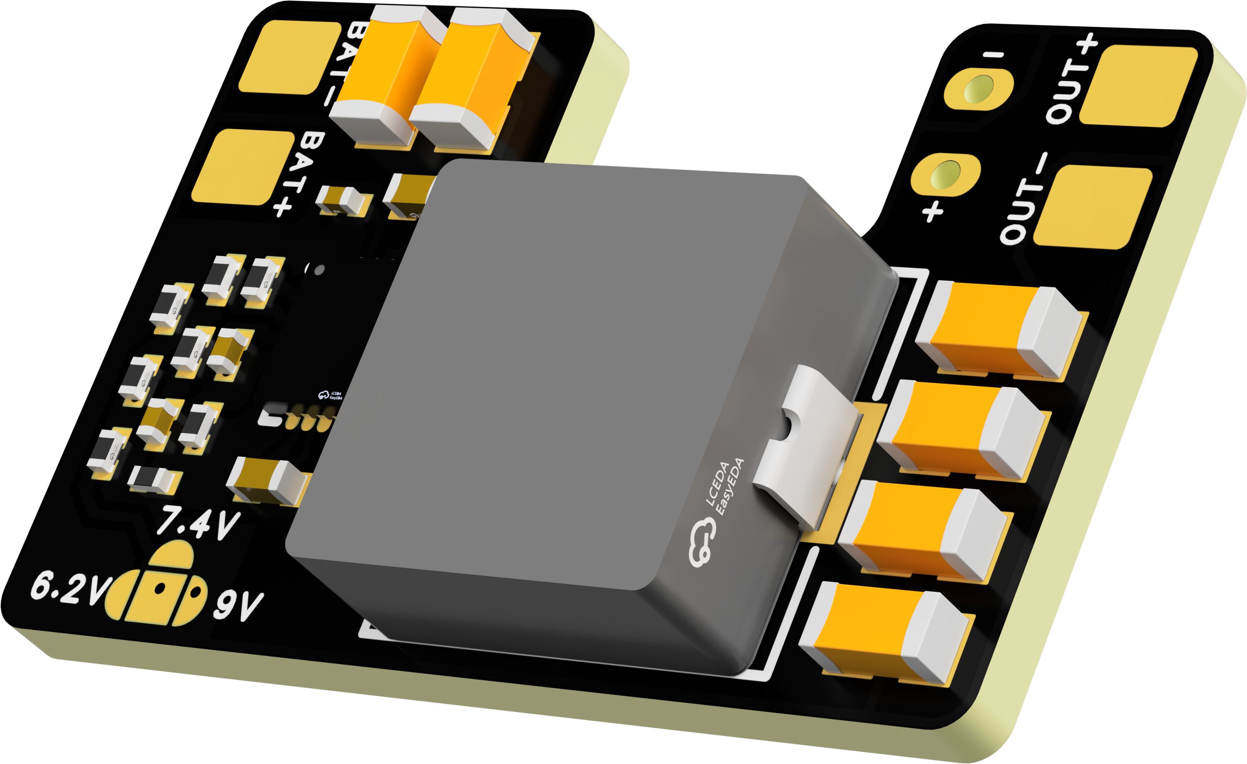
 | FlyingRC® Mini BEC For DJI O4  Easy wiring, ultra-small size, stable power supply.  Manual：https://www.kdocs.cn/l/ckkebieur37K |  |  |  |  |  | 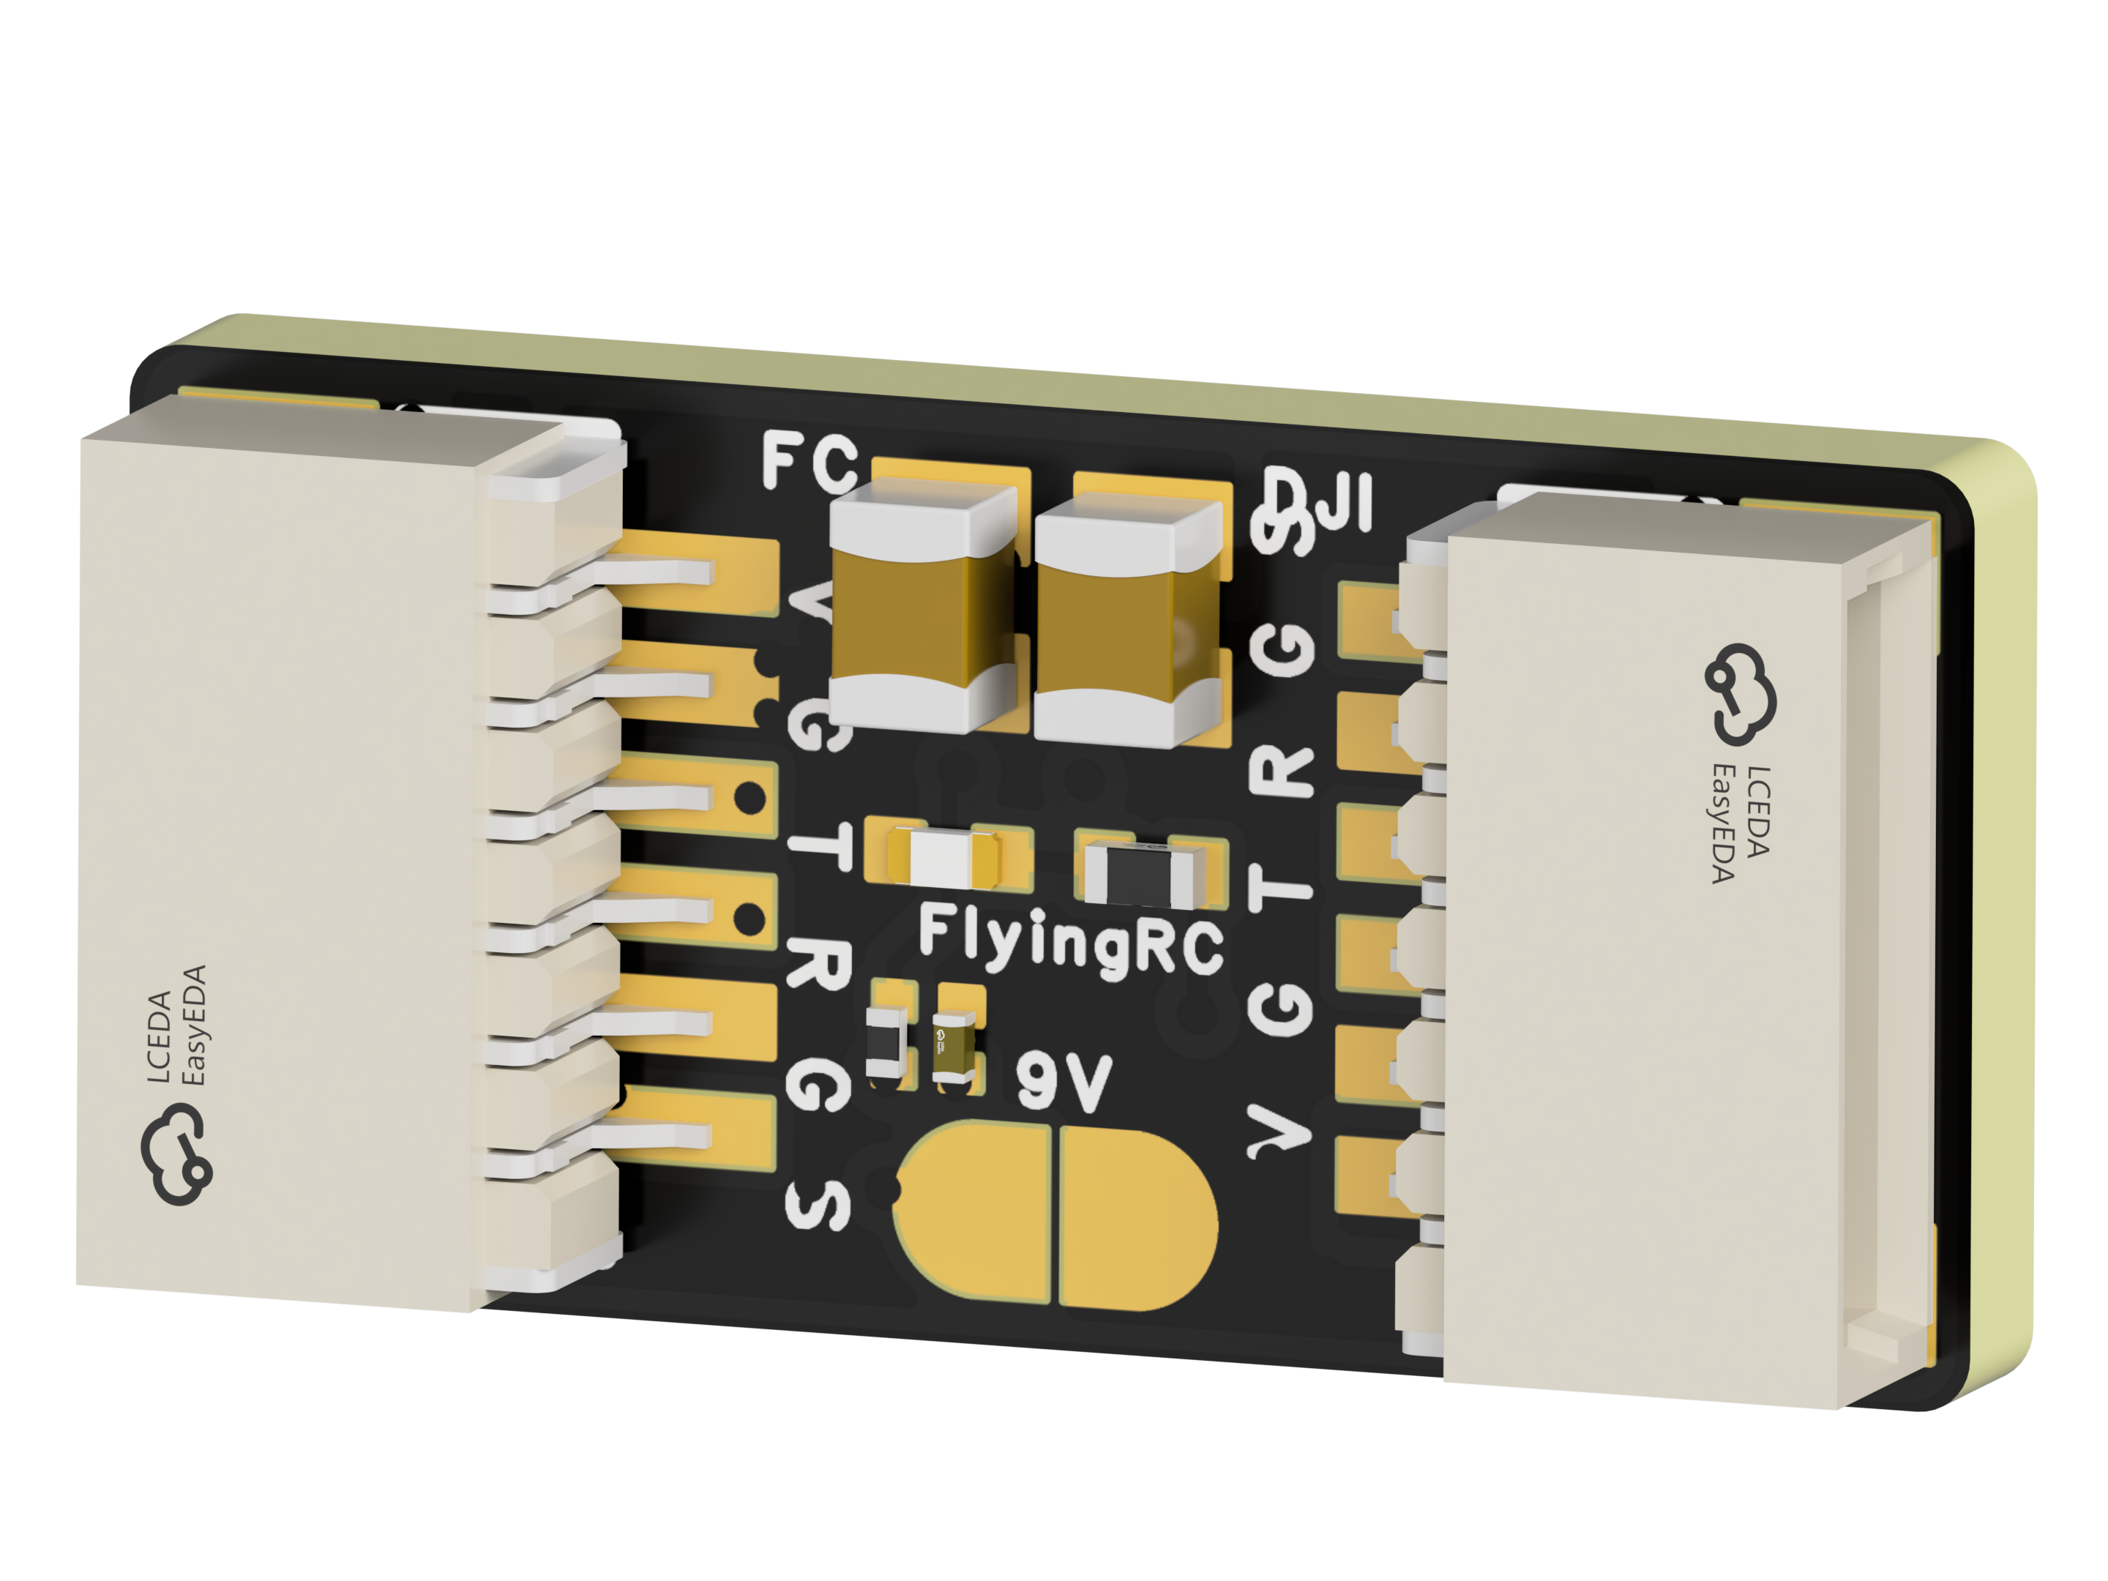
 | FlyingRC® CAN Bus Serial & PWM Expansion Board  Long-distance transmission, high speed, excellent stability.  Manual：https://www.kdocs.cn/l/cmxRyBnU4BXj |  |  |  |  |  | 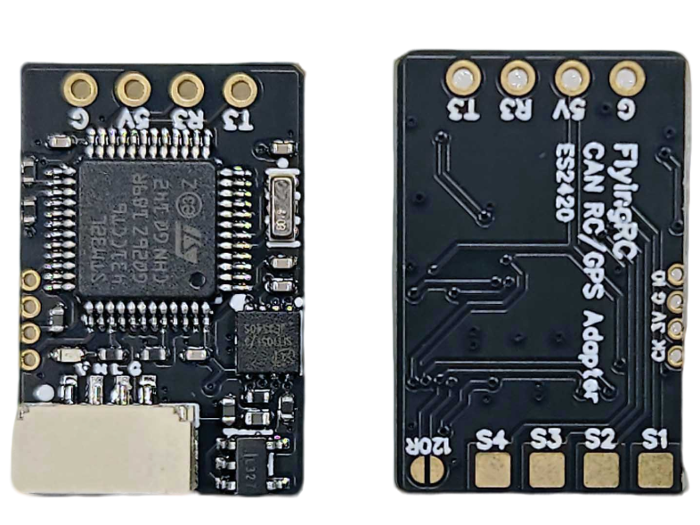
 | FlyingRC® AM3 2ESC Programmer  Supports BL, BL32, AM32. Simple and easy to use.  Manual：https://kdocs.cn/l/cogBSEBe67mE |  |  |  |  |  | 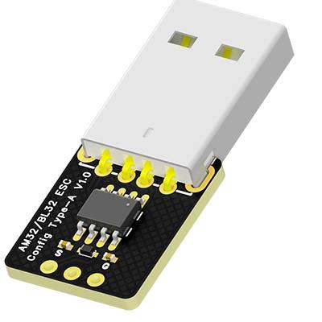
 | FlyingRC® Digital Airspeed Sensor without Pitot Tube  Integrated design, smallest on the market. MS4525D protocol, I2C interface.  Manual：https://www.kdocs.cn/l/clPvEEEcJgCC |  |  |  |  |  | 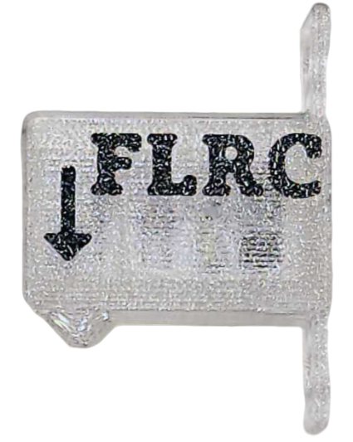
 | FlyingRC® U-Blox M10 GPS  Compatible with all open-source flight controllers.  Manual：https://www.kdocs.cn/l/cdSYQrzx74O8 |  |  |  |  |  | 