FlyingRC® U-Blox M10 GPS Product Manual
FlyingRC® is a globally-oriented professional brand of electronic devices. We specialize in the R&D and sales of drone electronics, core robot circuits and sensors. Our design team is based in Singapore, and our products are sold worldwide.

Since launched in 2023, FlyingRC® products have gained widespread recognition from customers as well as strong market response. As of April 2026, our cumulative sales volume has exceeded 46,000 units. Our products are widely applied in industries, robotics, emergency rescue, environmental protection & inspection, aerial photography, public security, retail and many other fields. Above all, we are committed to distinctive design and superior reliable quality.

Our Chief Technology Officer Liu Yuhan possesses outstanding expertise in circuit design. Over the past four years, he has designed more than 80 circuit projects and contributed 39 to open-source platforms. Moreover, he won the Design Award on the open-source platform X.JLC.com twice in 2023 and 2024, and has become the youngest certified designer on this platform.

He holds the NUS (National University of Singapore, rank 8th worldwide) Science and Technology Scholarship, and is currently majoring in Electronic Engineering with a focus on Aerospace Technology. In addition, all members of our technical team are graduates from prestigious universities with extensive professional product experience.

FlyingRC® U-Blox M10 GPS comes in three sizes: 18×18mm, 20×20mm and 28×28mm.
- The 18*18mm model does not include a compass module.
- Both the 20*20mm and 28*28mm models feature a built-in IST5883 compass.

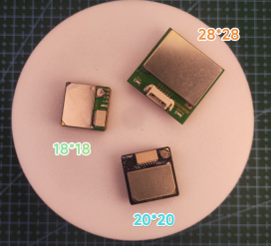

- Introduction to the 18*18mm Model
The M10 GPS is a high-performance G-MOUSE positioning module tailored for vehicle integrated navigation applications. It adopts the U-BLOX 1050-KB low-power chip, supporting concurrent reception of four major global navigation satellite systems: GPS, GLONASS, Galileo and BeiDou.

Sufficient visible satellites enable the receiver to lock onto the optimal signals, greatly enhancing positioning accuracy even in complex and challenging environments. It comes with full-range functions to meet the stringent standards of professional positioning scenarios. With a compact size and integrated flash memory, it supports parameter modification and data storage, delivering consistent and accurate positioning performance.

Technical Specifications
Parameter Category | Description | Details
Chip Features | Chip Model | U-blox UBX - 1050 - KB
 | Frequency | L1, 1575.42MHz；
 | Baud Rate | 4800bps - 921600bps (Default: 38400bps)
 | Channels | 72CH
Sensitivity | Tracking | -167dBm
 | Acquisition | -159dBm
 | Cold Start | -147dBm
Start-up Time | Cold Start | Average 32 seconds
 | Warm Start | Average 10 seconds
 | Hot Start | Average 1 second
Accuracy | Horizontal Accuracy | 2.0m CEP 2D RMS (with SBAS assistance in open sky)
 | Time Accuracy | 30 ns
Operating Limits | Maximum Altitude | 80000 m
 | Maximum Speed | 500 m/s
 | Maximum Acceleration | ≤ 4G
Output Data | Output Level | TTL Logic Level
 | Output Protocol | NMEA0183 Standard Protocol/ UBX
 | Update Rate | 0.25 - 10 Hz（Default: 1Hz）
Physical Features | Dimensions | 18 x 18 x 8mm
 | Weight | 12 grams
Operating Environment | Operating Temperature | -40℃ to 85℃
 | Storage Temperature | -40℃ to 85℃
 | PPS LED | PPS LED remains off before positioning; once positioning is successful, PPS LED flashes periodically.

Pinout Definition
Name | Definition
VCC | Main system power supply. Supply voltage: +3.3V ~ +5V. Current consumption during operation: approx. 25mA.
TX | UART/TTL interface, TXD (Transmit Data)
RX | UART/TTL interface, RXD (Receive Data)
GND | Ground

Product Highlights
1.Industry-standard 18*18*4mm high-sensitivity GPS antenna
2.Adopts a 0.5PPM high-precision TCXO
3.Built-in RTC Crystal and Picofarad Capacitor for faster hot startup
4.Built-in LNA (Low-Noise Amplifier)
5.Equipped with the U-BLOX 1050-KB chip, supporting warm start
6.Integrated flash memory supports positioning update rate from 0.25Hz to 10Hz, with settings saved after power-off.
7.Supports A-GPS services including AssistNow Online/ Offline
8.Multi-GNSS hybrid engine: GPS, BeiDou, GLONASS, Galileo (WAAS, EGNOS, MSAS, GAGAN)

- Introduction to the 20*20mm Model

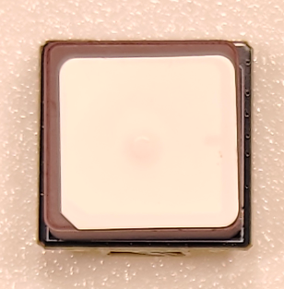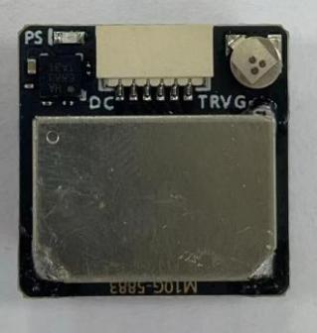

Technical Specifications
Parameter Category | Description | Details
Chip Features | Chip Model | U-blox M10050-KB
 | Frequency | GPS L1，GLONASS L1，BDS B1，GALILEO E1，SBAS L1，QZSS L1
 | Operating Modes | GPS，GLONASS，BDS，GALILEO，SBAS and QZSS. Default mode: GPS + GLONASS + SBAS + QZSS combined positioning. For high-precision applications, two optional modes: GPS + GLONASS + SBAS + QZSS + GALILEO or GPS + BDS + SBAS + QZSS + GALILEO.
 | Channels | 72 search channels
Sensitivity | Tracking | -167dBm
 | Reacquisition | -160dBm
 | Cold Start | -148dBm
 | Hot Start | -156dBm
Accuracy | Horizontal Accuracy | 2.0m CEP 2D RMS (with SBAS assistance, in open sky)
 | Velocity Accuracy | 0.1m/s 95%（SA off）
 | Time Accuracy | 1ns
Start-up Time | Cold Start | 26s
 | Warm Start | 24s
 | Hot Start | 1s
Output Data | Baud Rate | Default: 38400bps
 | Output Level | TTL Logic Level
 | Output Protocol | NMEA - 0183 Protocol
 | NMEA Sentences | RMC，VTG，GGA，GSA，GSV，GLL
 | Update Rate | 1Hz - 10Hz， Default: 1Hz
 | FLASH | 4M Flash Memory, configurable with data retained after power-off
Operating Limits | Altitude | <50,000m
 | Speed | <515m/s
 | Acceleration | <4g
Power Consumption | Voltage | DC 3.6V - 5.5V，Typical: 5.0V
 | Current | 50mA/5.0V (normal operation)
Physical Parameters | Dimensions | 20mm * 20mm * 6mm
 | Weight | 12.0 grams
 | Connector | 6-pin header with 1.25mm pitch
Environment | Operating Temperature | -40℃～+85℃
 | Storage Temperature | -40℃～+105℃
Indicator Lights | TX LED | Blue LED flashes after powered on to indicate data output.
 | PPS LED | Remains off when unpositioned; flashes after 3D positioning lock.
Compass | Compass Module | Built-in electronic compass IST5883

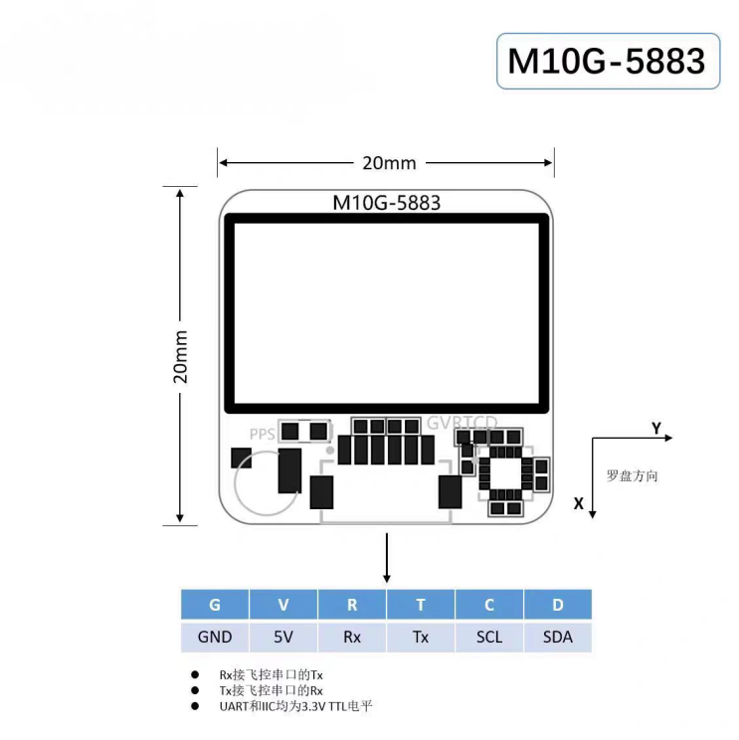
M10G-5883 U-Blox M10 GPS Module (20×20mm) Technical Drawing

Pinout Definition
No. | Name | I/O | Description | Features
1 | SDA | D | Serial Data - I2C Bus Master/Slave Data | Compass Data Pin
2 | SCL | C | Serial Data - I2C Clock Line Master/Slave Data | Compass Data Pin
3 | TX | T | UART Communication Interface, TTL Logic Level | GPS Data Output Pin
4 | RX | R | UART Communication Interface, TTL Logic Level | GPS Data Input Pin
5 | VCC | V | Main Power Supply, DC Input | DC 3.6V - 5.5V；5.0V Recommended
6 | GND | G | Ground | Ground
Indicator Lights:
1. TX LED: The green LED flashes after power-on to indicate data output.
2. PPS LED (Green): Remains off before positioning; flashes once 3D positioning is locked.

Product Features
- Adopts the M10G-5883 GNSS module, equipped with the latest-generation U-blox M10 chip.
- Equipped with a high-performance and compact antenna.
- Miniature size for easy installation: Featuring a Miniaturized design without performance compromise, it weighs only 7g, ideal for micro FPV drones, whoop drones and lightweight fixed-wing aircraft.

- Introduction to the 28*28mm Model

Technical Specifications
Parameter Category | Description | Details
Chip Features | Chip Model | U-blox M10050-KB
 | Frequency | GPS L1，GLONASS L1，BDS B1，GALILEO E1，SBAS L1，QZSS L1
 | Operating Modes | GPS, GLONASS, BDS, GALILEO, SBAS, and QZSS. Default mode: GPS + GLONASS + SBAS + QZSS. For customers requiring high precision, it is recommended to use GPS + GLONASS + SBAS + QZSS + GALILEO or GPS + BDS + SBAS + QZSS + GALILEO combined positioning modes.
 | Channels | 72 search channels
Sensitivity | Tracking | -167dBm
 | Reacquisition | -160dBm
 | Cold Start | -148dBm
 | Hot Start | -156dBm
Accuracy | Horizontal Accuracy | 2.0m CEP 2D RMS (with SBAS assistance, in open sky)
 | Velocity Accuracy | 0.1m/s 95%（SA off）
 | Time Accuracy | 1ns
Start-up Time | Cold Start | 26s
 | Warm Start | 24s
 | Hot Start | 1s
Output Data | Baud Rate | Default: 38400bps
 | Output Level | TTL Logic Level
 | Output Protocol | NMEA - 0183 protocol
 | NMEA Sentences | RMC，VTG，GGA，GSA，GSV，GLL
 | Update Rate | 1Hz - 10Hz，default: 1Hz
 | FLASH | 4M Flash Memory, configurable with data retained after power-off
Operating Limits | Altitude | <50,000m
 | Speed | <515m/s
 | Acceleration | <4g
Power Consumption | Voltage | DC 3.6V - 5.5V，typical: 5.0V
 | Current | 50mA/5.0V (normal operation)
Physical Parameters | Dimensions | 28mm*28mm*8.5mm
 | Weight | 13.0 grams
 | Connector | 6-pin header with 1.25mm pitch
Environment | Operating Temperature | -40℃～+85℃
 | Storage Temperature | -40℃～+105℃
Indicator Lights | TX LED | Blue LED flashes after power-on to indicate data output
 | PPS LED | Remains off when unpositioned; flashes periodically after 3D positioning lock
Compass | Compass Module | Built-in electronic compass IST5883

Pinout Definition:
No. | Name | I/O | Description | Features
1 | SDA | D | Serial Data - I2C Bus Master/Slave Data | Compass data pin
2 | SCL | C | Serial Data - I2C Clock Line Master/Slave Data | Compass data pin
3 | TX | T | UART Communication Interface, TTL Logic Level | GPS data output pin
4 | RX | R | UART Communication Interface, TTL Logic Level | GPS data input pin
5 | VCC | V | Main Power Supply, DC Input | DC 3.6V - 5.5V；5.0V recommended
6 | GND | G | Ground | Ground

Indicator Lights :
1. TX LED: The green LED flashes after power-on to indicate data output.
2. PPS LED (Green): Remains off before positioning; flashes once 3D positioning is locked.

Pinout Diagram：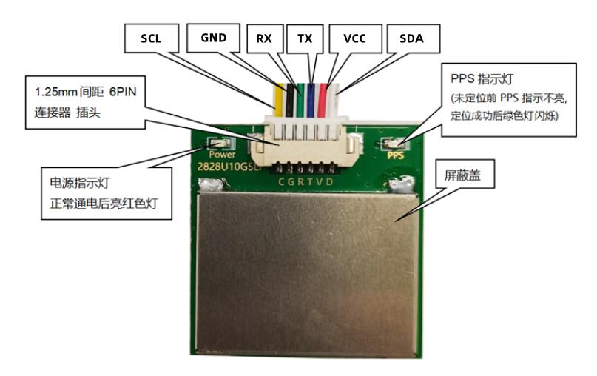

Usage Method
BF Firmware:

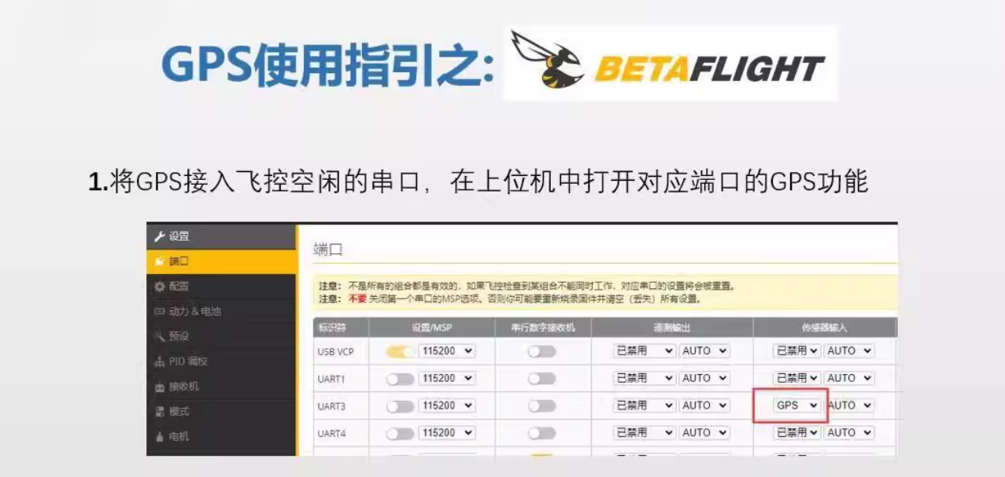
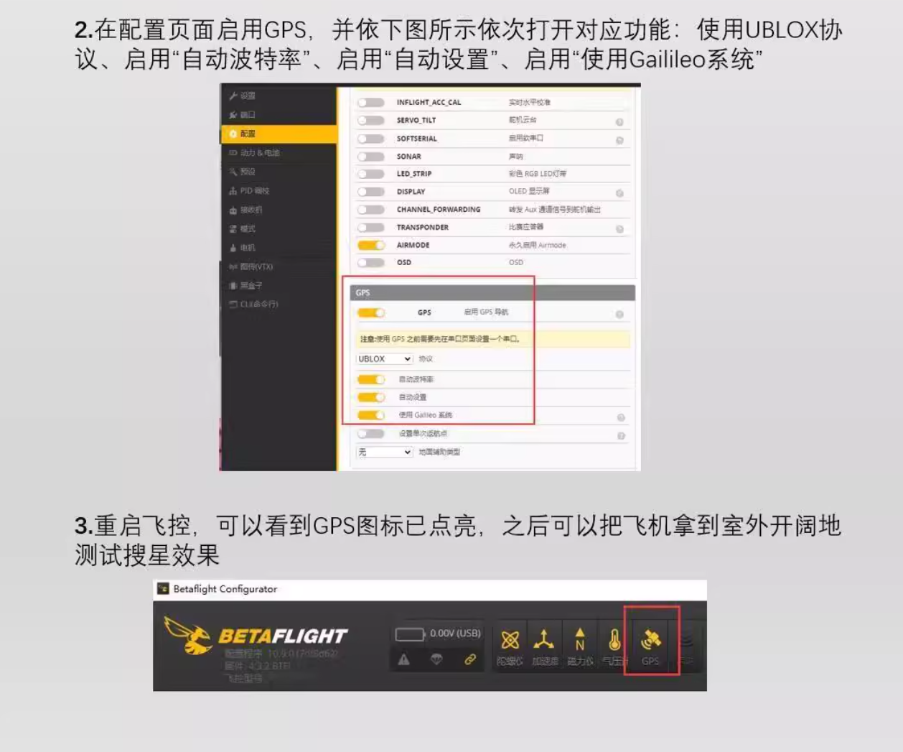

INAV Firmware:
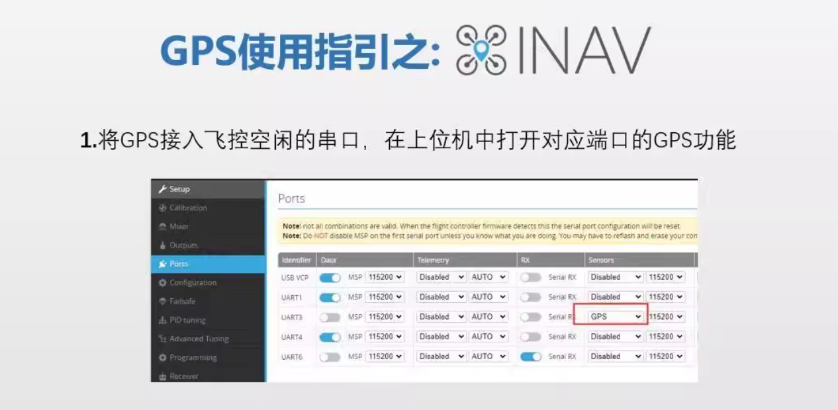
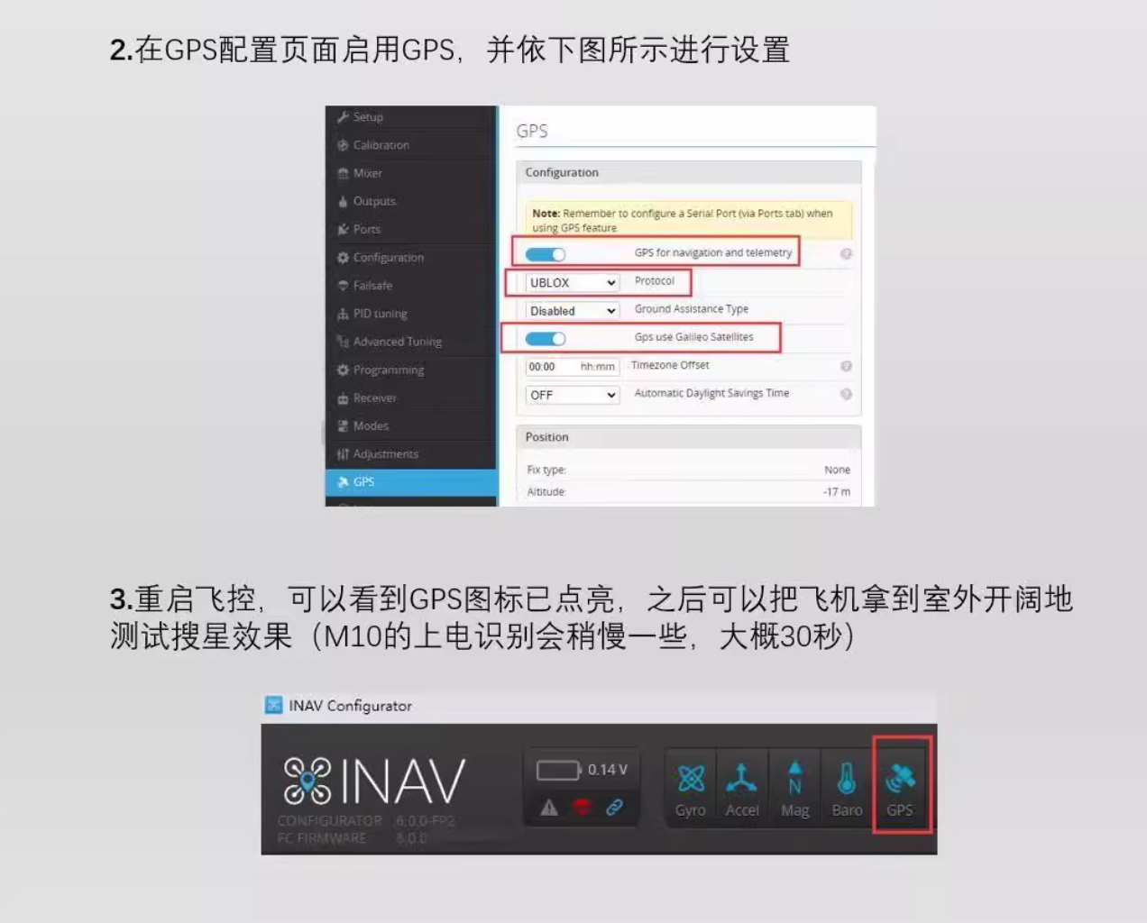

Precautions
- Do not use the receiver in high-temperature, humid or strong electromagnetic interference environments, which may degrade device performance and service life.
- Avoid severe impact or dropping of the receiver to prevent internal hardware damage.
- Regularly inspect the connecting wires to ensure secure connection without looseness or damage.
- If any abnormality is found in the device during operation, stop using it immediately and contact professional technicians for maintenance.

Other FlyingRC® Products
 |  |  |  | - FlyingRC® F4WSE Pro - F405 Fixed-Wing Flight Controller  Upgraded Version | Enhanced Performance  Manual：https://www.kdocs.cn/l/cavm9EoVEq5A |  |  | 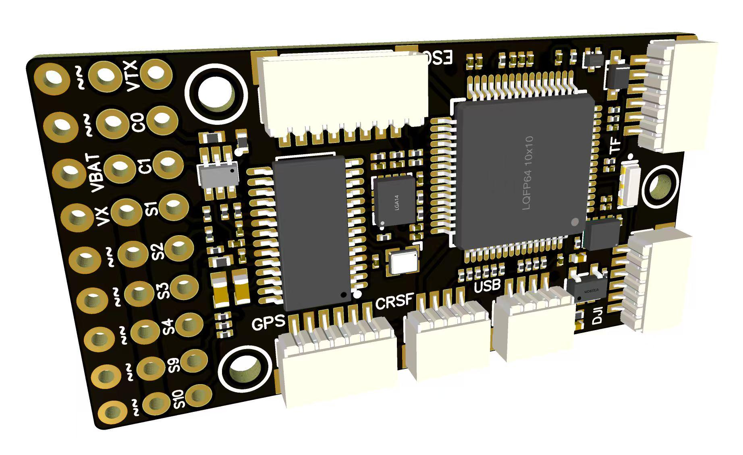
 |  |  | - FlyingRC® F4WSE MK1.5 - F405 Fixed-Wing Flight Controller  Classic model, unique design, highly acclaimed.  Manual：https://kdocs.cn/l/cpyd8MTS56DD |  |  | 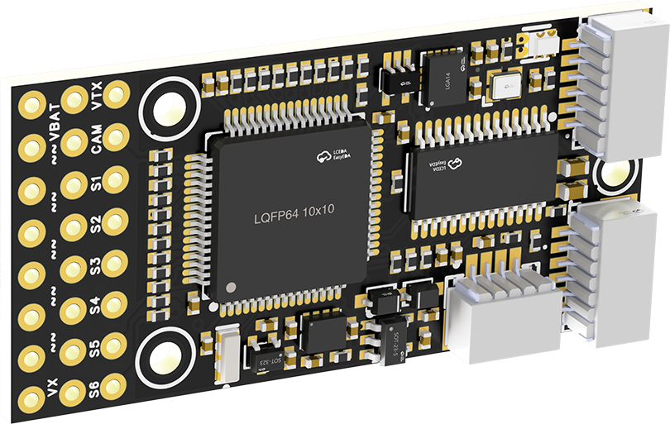
 |  |  |  | - FlyingRC® H7Wlite MK1 H743 Fixed-Wing Flight Controller  Flagship performance, full expansion, high-power BEC.  Manual：https://kdocs.cn/l/cpYaBiFKh8U1 |  |  | 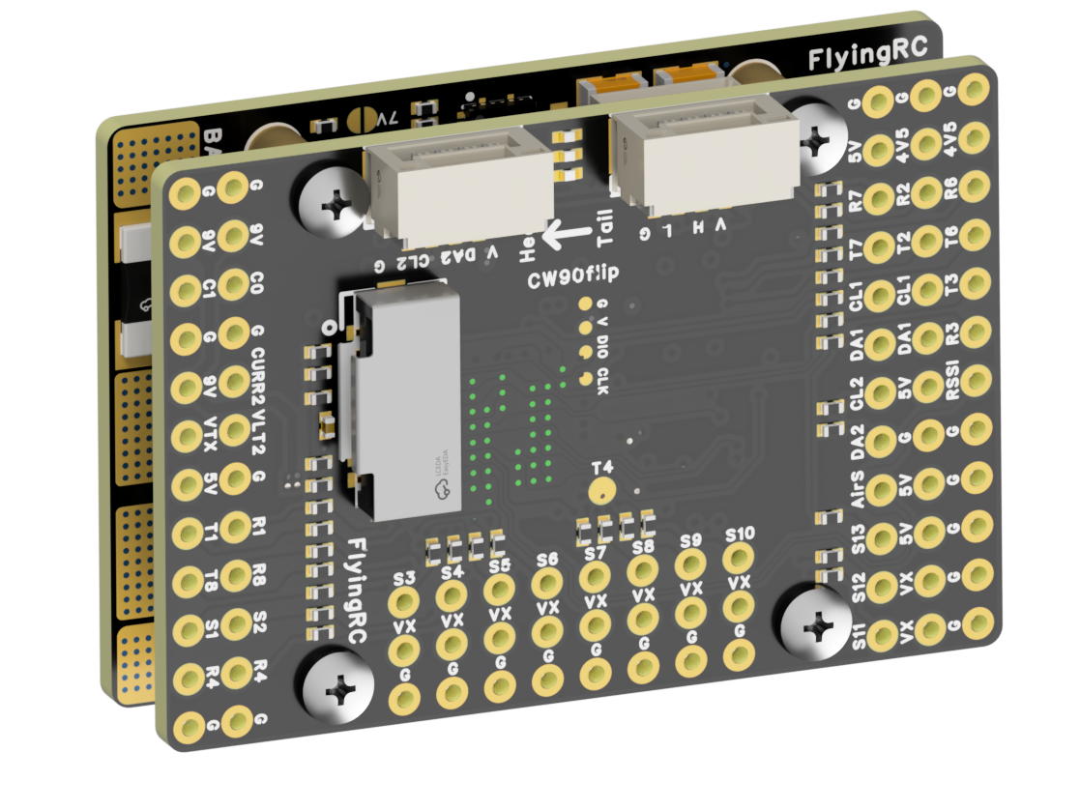
 |  |  |  | - FlyingRC® F4Wing Mini MK1 F405 Fixed-Wing Flight Controller  2025 bestseller, ultra-compact, smallest on the market, great value.  Manual：https://kdocs.cn/l/cdUIdmpSpW7J |  |  | 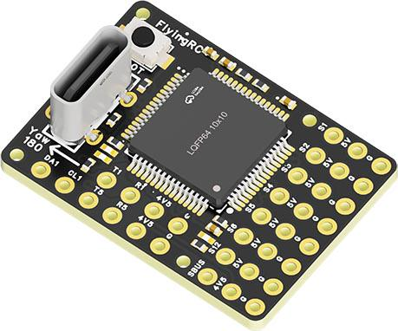
 | - FlyingRC® AM32 Dual ESC 40A 2-in-1 ESC  Unique design for dual-power aerial, land and water vehicles including drones.  Manual：https://www.kdocs.cn/l/cjwNtsKK6HeR |  |  |  | 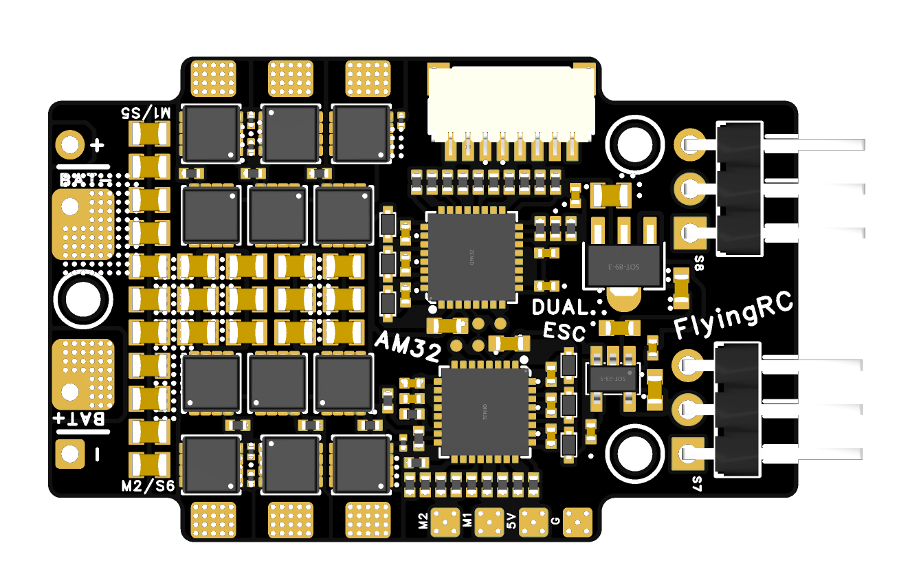
 |  |  | - FlyingRC® AM32 ESC V2.5 75A - Single ESC  Infineon gold-package MOSFETs, premium materials, superior heat dissipation.  Manual：https://kdocs.cn/l/cv6hUy67IdTJ |  |  |  | 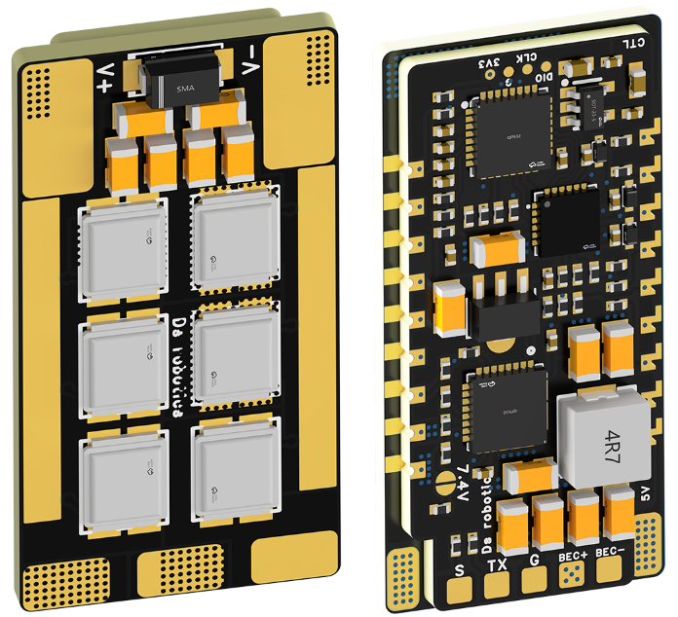
 |  |  | - FlyingRC® AM32 Mini ESC 40A V1.0 - Single ESC  Ultra-miniature, ideal for micro drones, high over-current capability, stable operation.  Manual：https://kdocs.cn/l/cqdLSysEyWFh |  |  |  |  | 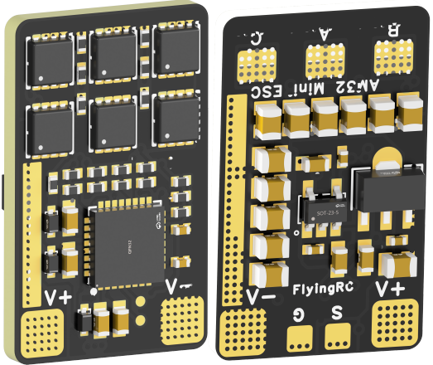
 |  |  | - FlyingRC® 10A 12S 440A Power Distribution Board for FPV Drones  Industry top choice, excellent quality and affordable price.  Manual：https://kdocs.cn/l/coel7OgrlCBP |  |  |  |  | 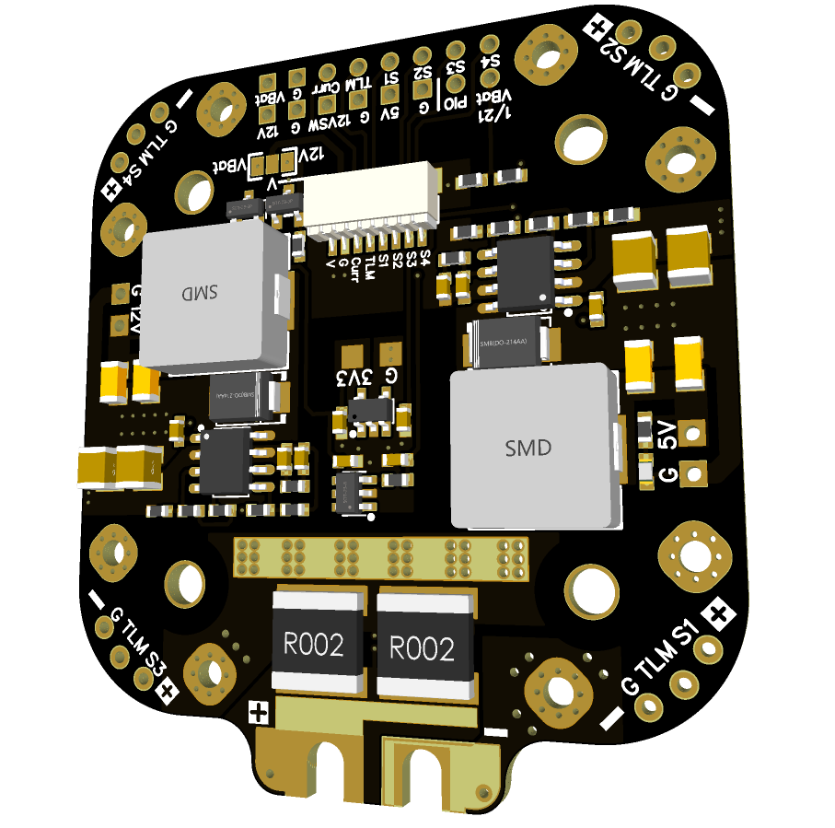
 |  |  | - FlyingRC® H7D Pro MK1 H743 FPV Flight Controller with Dual Gyro  Fully Upgraded & More Powerful  Manual：https://www.kdocs.cn/l/ctcekCy676Ez |  |  |  | 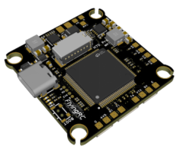
 |  |  | - FlyingRC® H7D MK1 H743 FPV Flight Controller with Dual Gyro  Powerful computing, stable and precise flight, rich interfaces, smooth control.  Manual：https://kdocs.cn/l/cqMh1I0RwAoD |  |  |  | 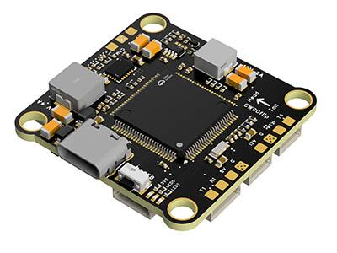
 |  |  | - FlyingRC® F420 MK1 F405 FPV Flight Controller (20/30.5mm Mounting)  Dual mounting holes, all connectors, no soldering required, compliant with Betaflight interface standards.  Manual：https://kdocs.cn/l/ctGeLiN9ZYKj |  |  |  | 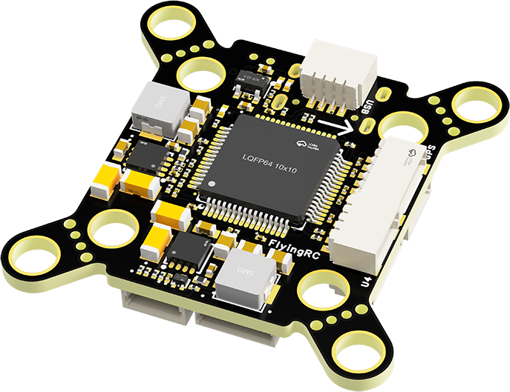
 |  | - FlyingRC® 4-in-1 75A V3.2 Gold-Sealed FPV ESC  Infineon gold-package MOSFETs, superior heat dissipation & over-current capability, premium choice.  Manual：https://kdocs.cn/l/ceLilc8Gaa21 |  |  |  |  | 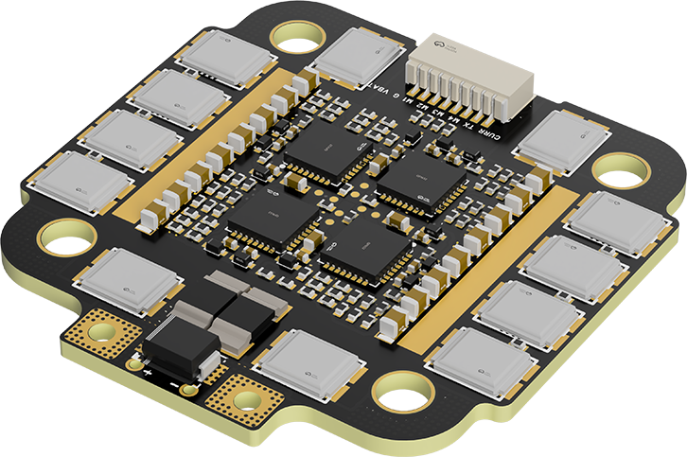
- FlyingRC® Stack Combo: H743 Flight Controller + 4-in-1 75A Gold-Sealed ESC  Professional flight choice, flagship materials & craftsmanship, reasonable price.  Manual：https://www.kdocs.cn/l/ctcekCy676Ez  https://kdocs.cn/l/ceLilc8Gaa21 |  |  |  |  |  |  | 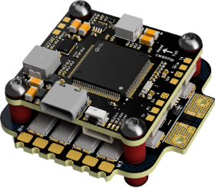
 |  | - FlyingRC® Stack Combo: F405 Flight Controller + 4-in-1 75A Gold-Sealed ESC  Best-selling combo, excellent performance, affordable price.  Manual：https://kdocs.cn/l/ctGeLiN9ZYKj  https://kdocs.cn/l/ceLilc8Gaa21 |  |  |  |  | 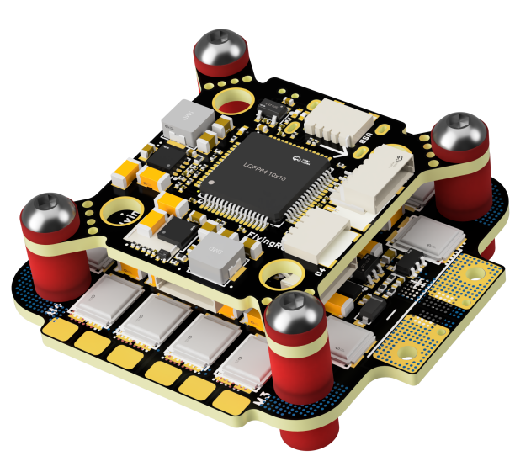
 |  | - FlyingRC® Stack Combo: H743 Flight Controller + 4-in-1 45A ESC  Winning combo: great performance, budget-friendly price  Manual：https://www.kdocs.cn/l/ctcekCy676Ez  https://kdocs.cn/l/ceLilc8Gaa21 |  |  |  |  | 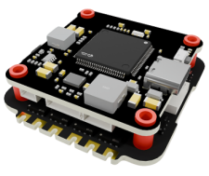
 |  | - FlyingRC® Stack Combo: F405 Flight Controller + 4-in-1 45A ESC  Hit combo, great value, budget-friendly  Manual：https://kdocs.cn/l/ctGeLiN9ZYKj  https://kdocs.cn/l/ceLilc8Gaa21 |  |  |  |  | 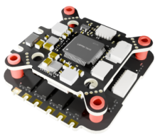
 |  | - FlyingRC® Stack Combo: F4WSE Pro - F405 Fixed-Wing Flight Controller + AM32 Dual ESC 40A 2-in-1 ESC  Unique Design • Exclusive Offer • Bestselling Bundle  Manual：https://www.kdocs.cn/l/cavm9EoVEq5A  https://www.kdocs.cn/l/cjwNtsKK6HeR |  |  |  |  | 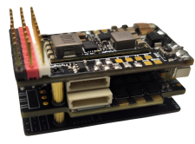
 | - FlyingRC® ELRS 2.4G Diversity Receiver  True diversity reception, temperature compensation, high-sensitivity reception.  Manual：https://kdocs.cn/l/cbvlOlShmsPS |  |  |  |  |  | 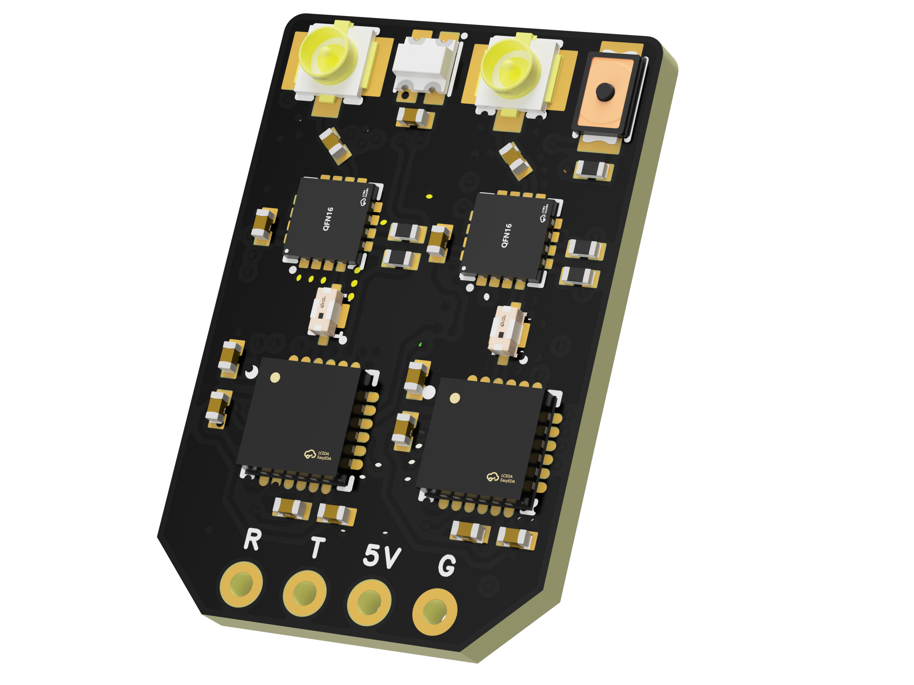
 | - FlyingRC® RM3100 SPI Module 罗盘模块  Ultra-high Resolution • Low Power • Industry Top Choice  Manual：https://www.kdocs.cn/l/cdGuHvBVyndC |  |  |  |  |  | 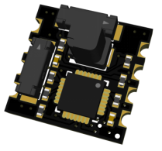
 | - FlyingRC® 10A 12S BEC Step-Down Module  Wide voltage input, high power, compact size, multiple voltages available, 10A continuous output.  Manual：https://kdocs.cn/l/clssNCKgNhLV |  |  |  |  |  | 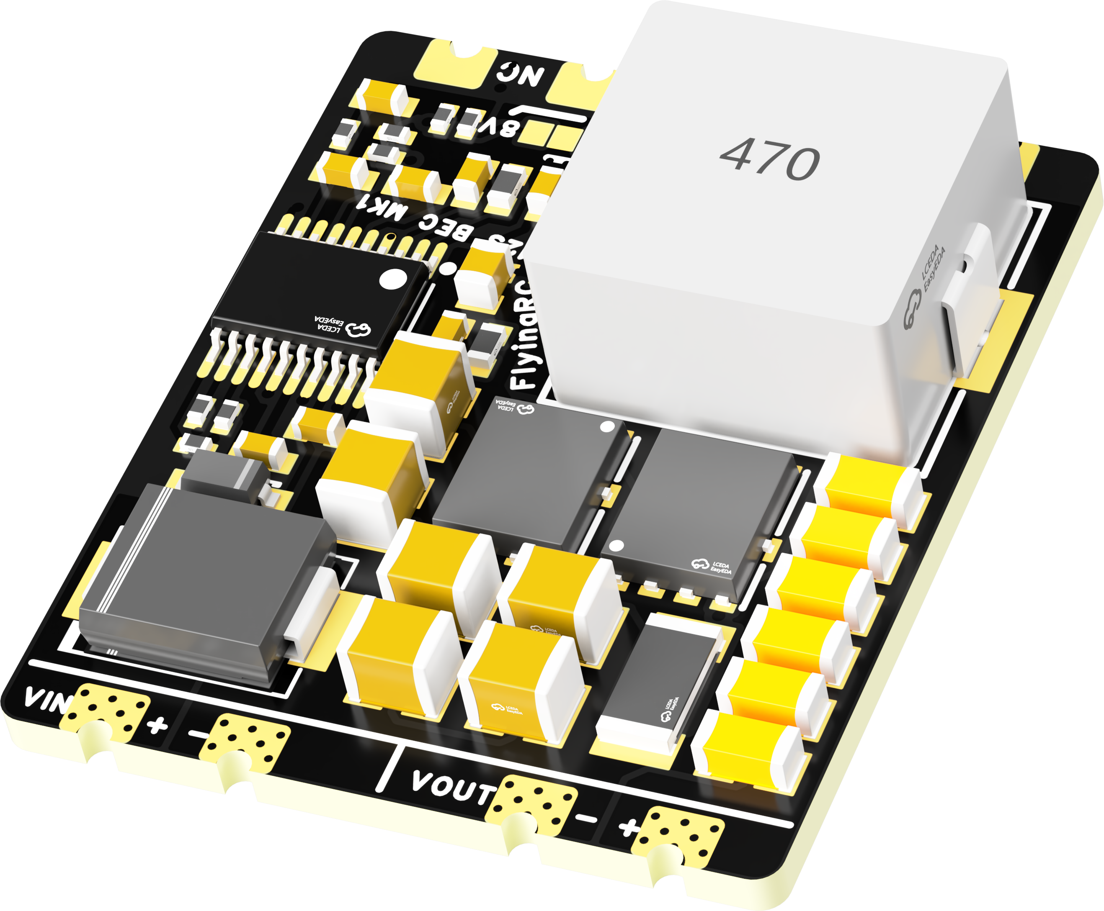
 | FlyingRC® 5A BEC Step-Down Module  Ultra-small size, multiple voltages available, 5A continuous output.  Manual：https://kdocs.cn/l/cb9VdNywqCKA |  |  |  |  |  | 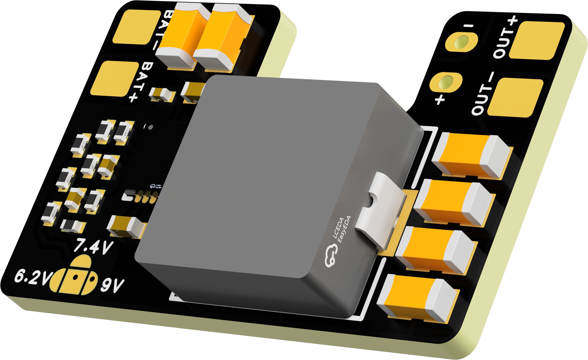
 | FlyingRC® Mini BEC For DJI O4  Easy wiring, ultra-small size, stable power supply.  Manual：https://kdocs.cn/l/cb9VdNywqCKA |  |  |  |  |  | 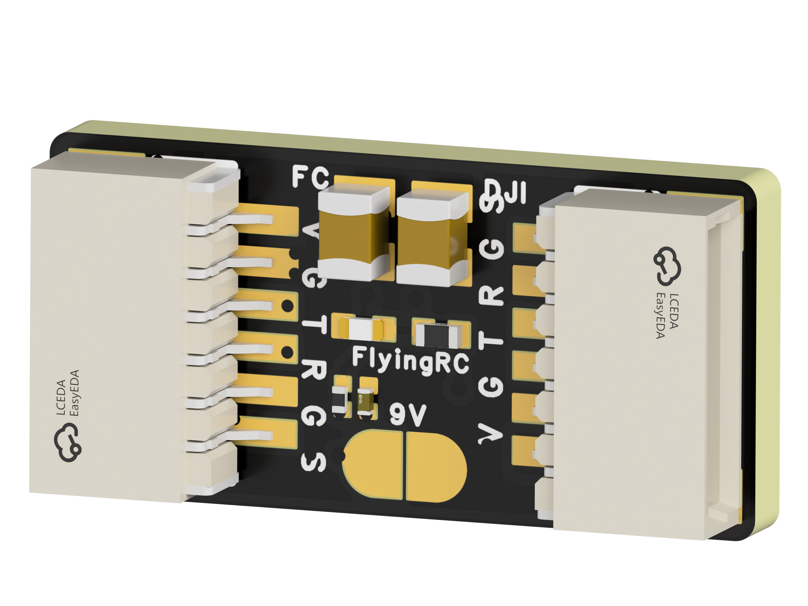
 | FlyingRC® CAN Bus Serial & PWM Expansion Board  Long-distance transmission, high speed, excellent stability.  Manual：https://www.kdocs.cn/l/cmxRyBnU4BXj |  |  |  |  |  | 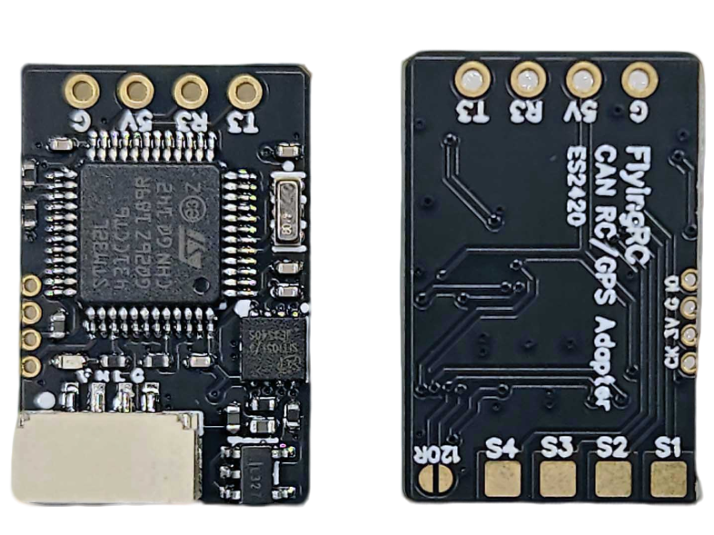
 | FlyingRC® AM3 2ESC Programmer  Supports BL, BL32, AM32. Simple and easy to use.  Manual：https://kdocs.cn/l/cogBSEBe67mE |  |  |  |  |  | 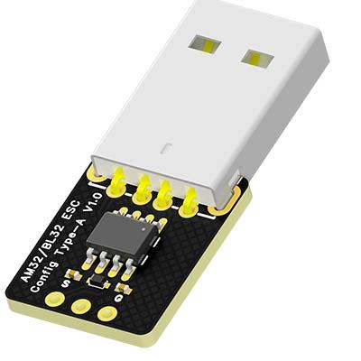
 | FlyingRC® Digital Airspeed Sensor without Pitot Tube  Integrated design, smallest on the market. MS4525D protocol, I2C interface.  Manual：https://www.kdocs.cn/l/clPvEEEcJgCC |  |  |  |  |  | 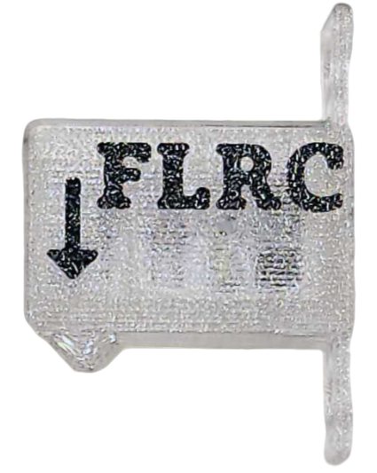
 | FlyingRC® U-Blox M10 GPS  Compatible with all open-source flight controllers.  Manual：https://www.kdocs.cn/l/cdSYQrzx74O8 |  |  |  |  |  | 