FlyingRC® 10A 8S BEC(Step-Down Module)
Product Manual
FlyingRC® is a globally-oriented professional brand of electronic devices. We specialize in the R&D and sales of drone electronics, core robot circuits and sensors. Our design team is based in Singapore, and our products are sold worldwide.

Since launched in 2023, FlyingRC® products have gained widespread recognition from customers as well as strong market response. As of April 2026, our cumulative sales volume has exceeded 46,000 units. Our products are widely applied in industries, robotics, emergency rescue, environmental protection & inspection, aerial photography, public security, retail and many other fields. Above all, we are committed to distinctive design and superior reliable quality.

Our Chief Technology Officer Liu Yuhan possesses outstanding expertise in circuit design. Over the past four years, he has designed more than 80 circuit projects and contributed 39 to open-source platforms. Moreover, he won the Design Award on the open-source platform X.JLC.com twice in 2023 and 2024, and has become the youngest certified designer on this platform.

He holds the NUS (National University of Singapore, rank 8th worldwide) Science and Technology Scholarship, and is currently majoring in Electronic Engineering with a focus on Aerospace Technology. In addition, all members of our technical team are graduates from prestigious universities with extensive professional product experience.

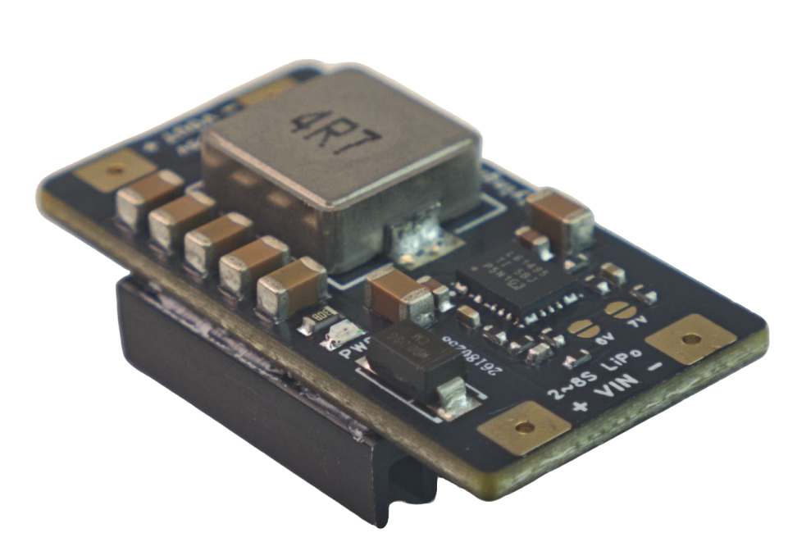

Packing List

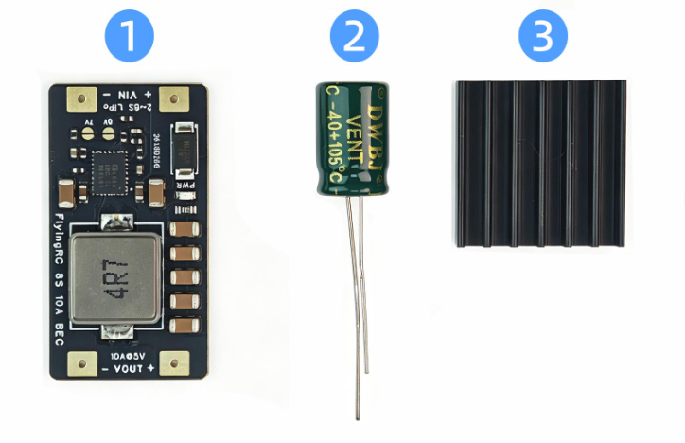
1 FlyingRC® 8S 10A BEC ×1
2 16V 680μF Capacitor ×1
3 Heat Sink ×1
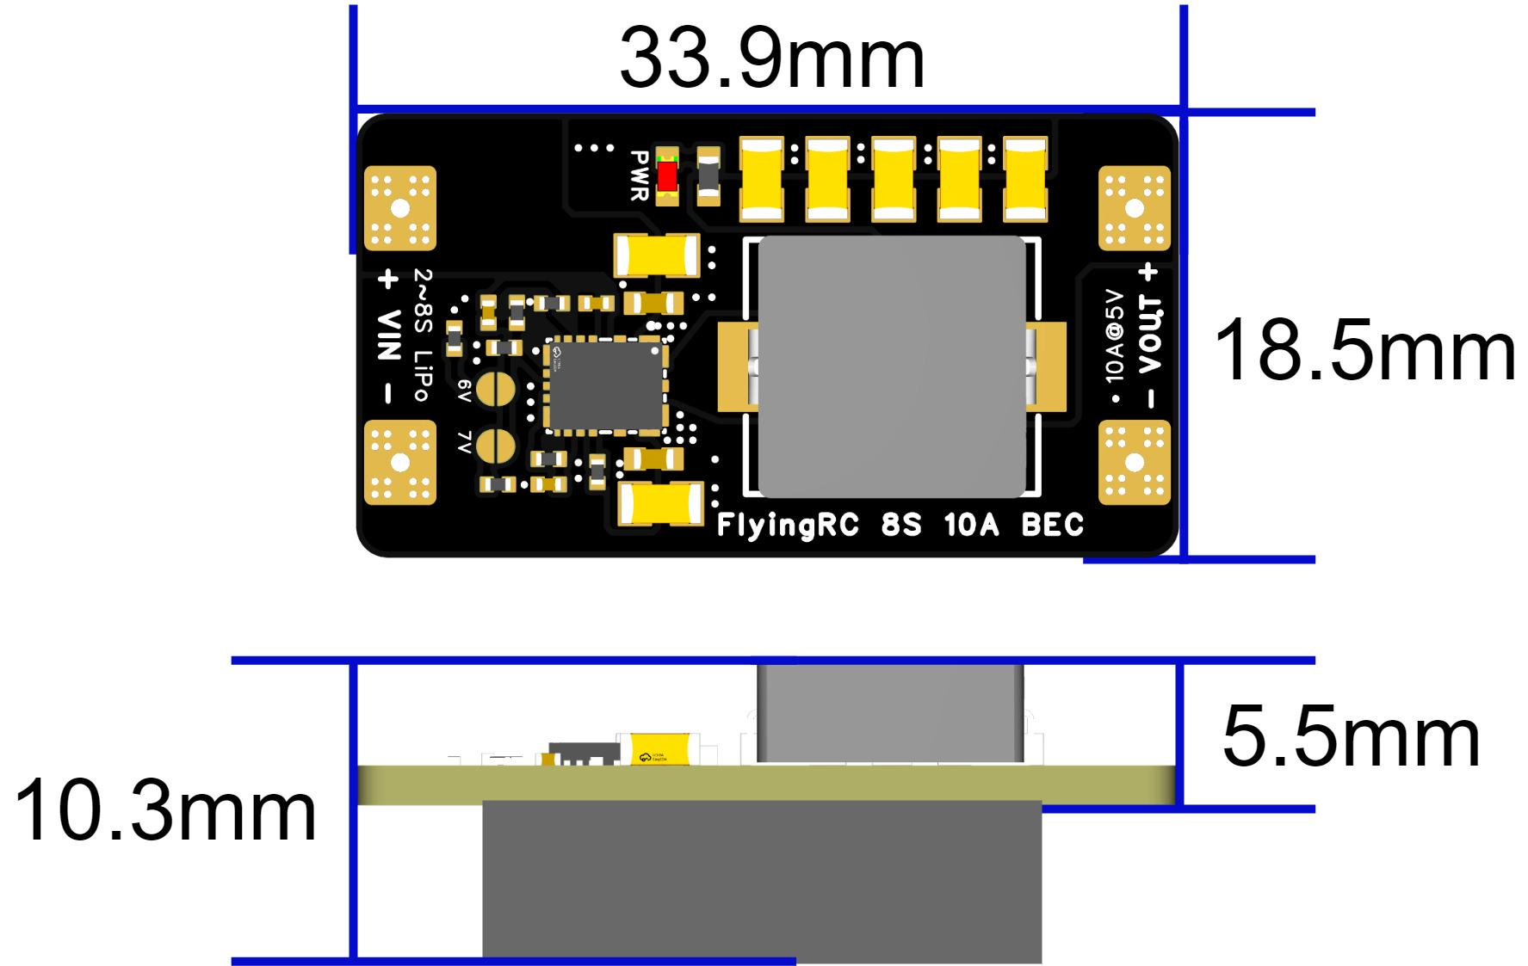

Technical Specifications
- Product Dimensions：33.9mm (L) × 18.5mm (W) × 5.5mm (H); 10.3mm (H) with heat sink installed
- Product Weight: 5g (bare module), 7.6g (with heat sink), 9g (with heat sink and capacitor)
- PCB Layers: 4-layer
- PCB Thickness: 1.60mm
- Gold Immersion: Yes, 1μm
- Packing Contents: 1× BEC Module, 1× 16V 680μF Electrolytic Capacitor, 1× Heat Sink

Product Features
- The FlyingRC® 10A 8S BEC V1 is a compact‑size, high‑performance BEC step‑down module.
- Equipped with LM61495 chip, max input voltage rated at 36V.
- Adopts current‑mode control for ultra‑fast transient response, ideal for servo power supply.
- Peak instantaneous output current: 12A
- Continuous output: 8A without heat dissipation
- Continuous output: 10A with heat dissipation

Input Voltage: 6‑36V, compatible with 2‑8S LiPo (Input voltage shall be 0.8V higher than the set output voltage)
Output Voltage: Optional 5V, 6V, 7V. 5V by default; the other two voltages can be selected via jumper pads.

Continuous Output Current
- Without heat dissipation (no heat sink & no airflow)：5V8A，6V8A，7V7A
- With heat dissipation (with heat sink or airflow)：5V10A，6V10A，7V9A
- Instantaneous Output Current：5V12A，6V11A，7V10A

Usage Instructions
Solder the power input wires.
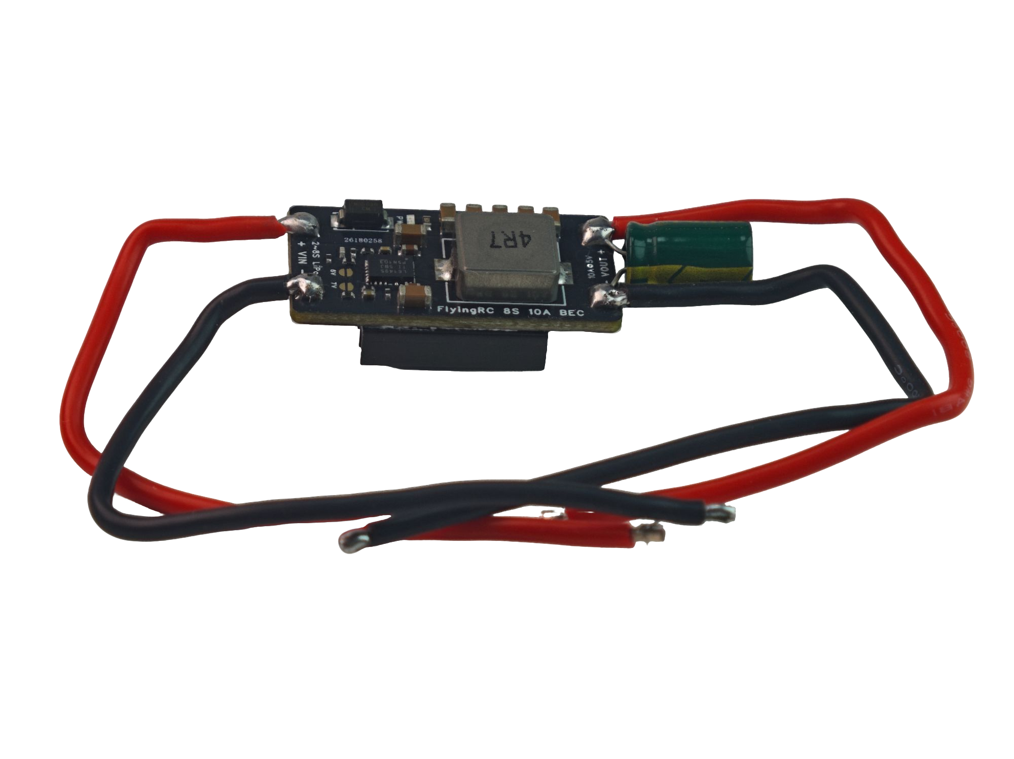
The input and output wires adopt 18AWG silicone wires with 10cm length by default.

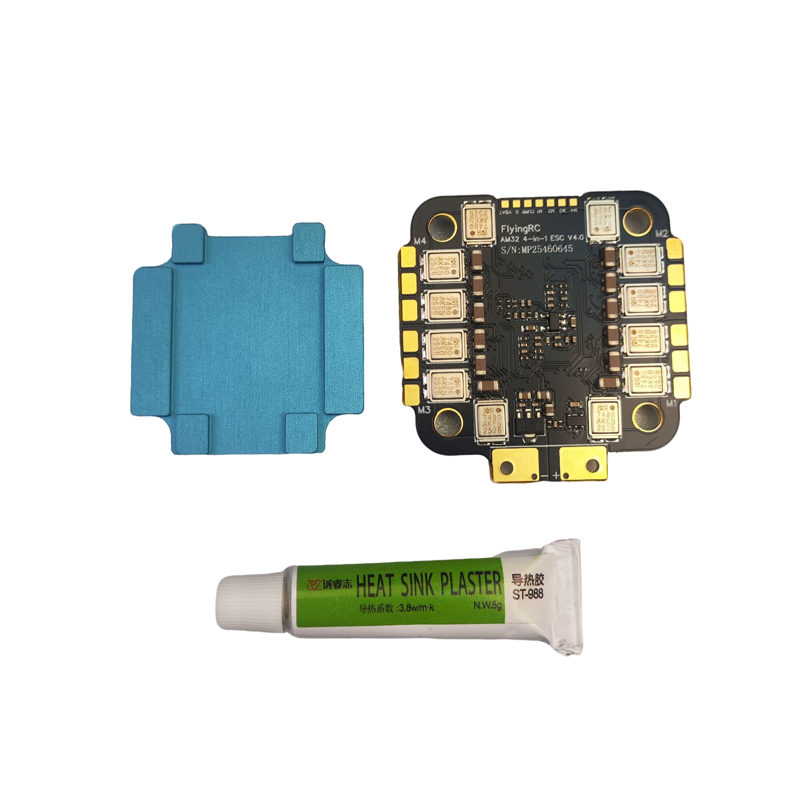
Attach the heat sink to the rear side of the BEC by applying thermally conductive adhesive.
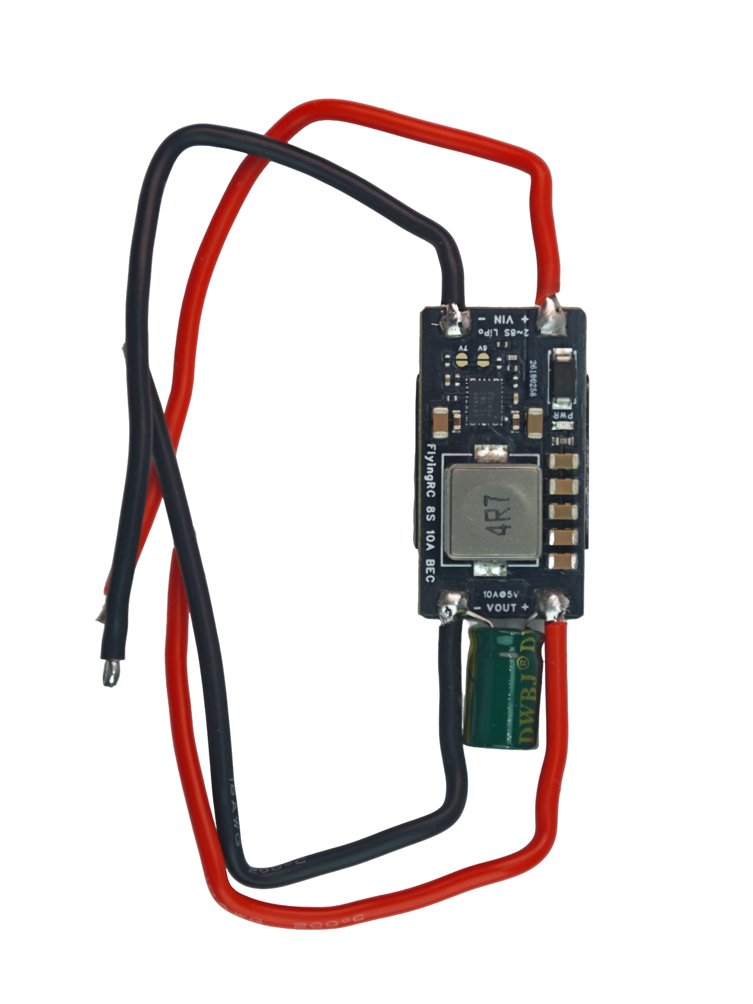
Select voltage through jumper wires

Select the output voltage via jumpers.
Connect the battery to VIN and the load to VOUT.

Other FlyingRC® Products
 |  |  |  | - FlyingRC® F4WSE Pro - F405 Fixed-Wing Flight Controller  Upgraded Version | Enhanced Performance  Manual：Product manual |  |  | 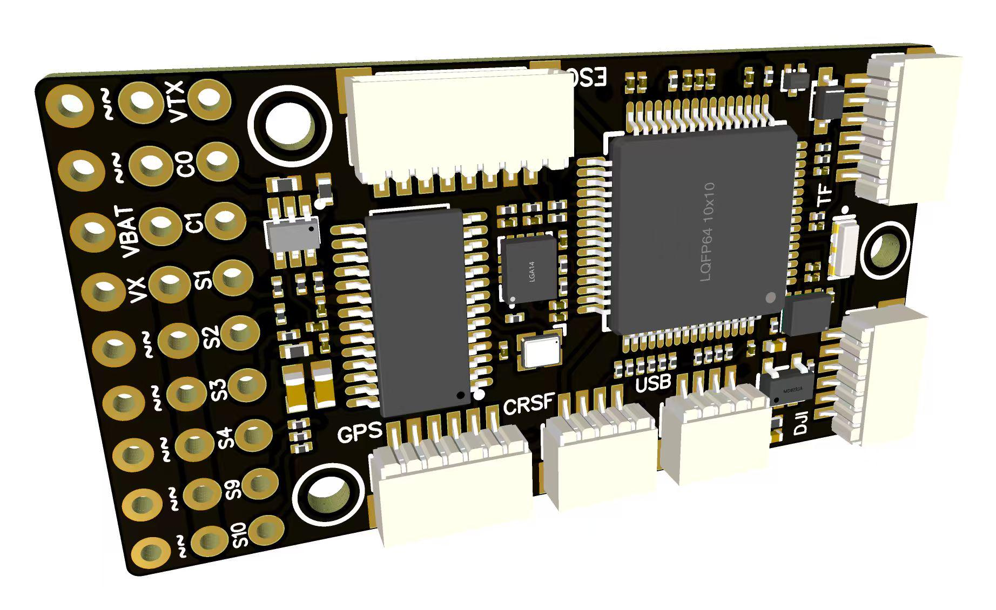
 |  |  | - FlyingRC® F4WSE MK1.5 - F405 Fixed-Wing Flight Controller  discontinue production |  |  | 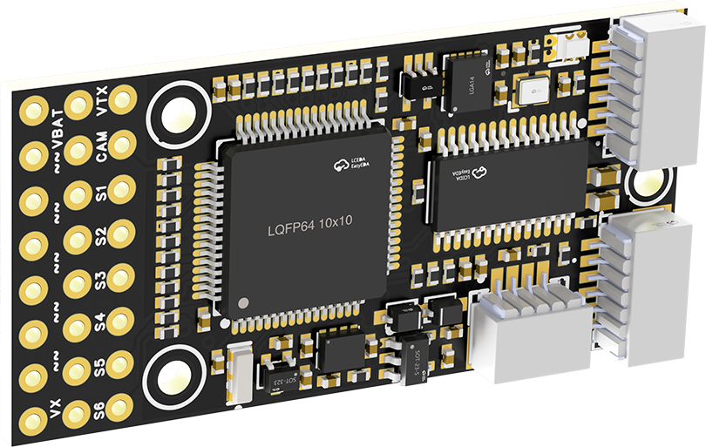
 |  |  |  | - FlyingRC® H7Wlite MK1 H743 Fixed-Wing Flight Controller  Flagship performance, full expansion, high-power BEC.  Manual：Product Manual |  |  | 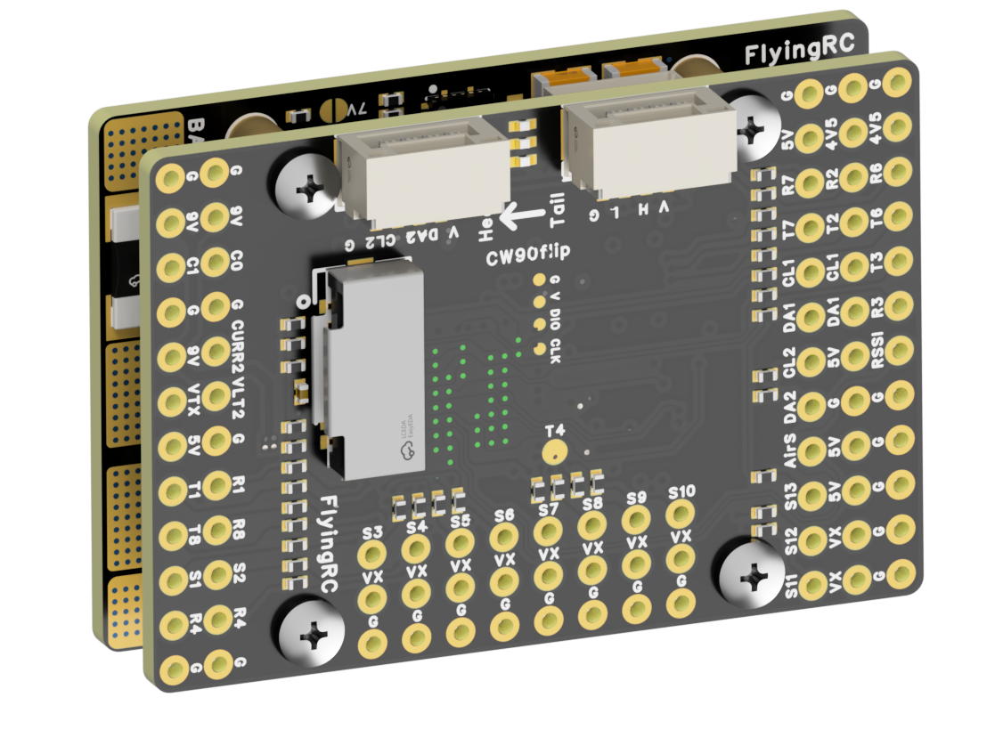
 |  |  |  | - FlyingRC® F4Wing Mini MK1 F405 Fixed-Wing Flight Controller  2025 bestseller, ultra-compact, smallest on the market, great value.  Manual：Product Manual |  |  | 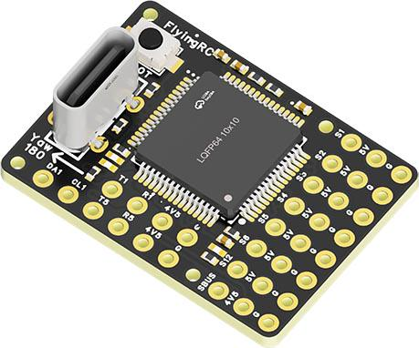
 | - FlyingRC® AM32 Dual ESC 40A 2-in-1 ESC  Unique design for dual-power aerial, land and water vehicles including drones.  Manual：Product Manual |  |  |  | 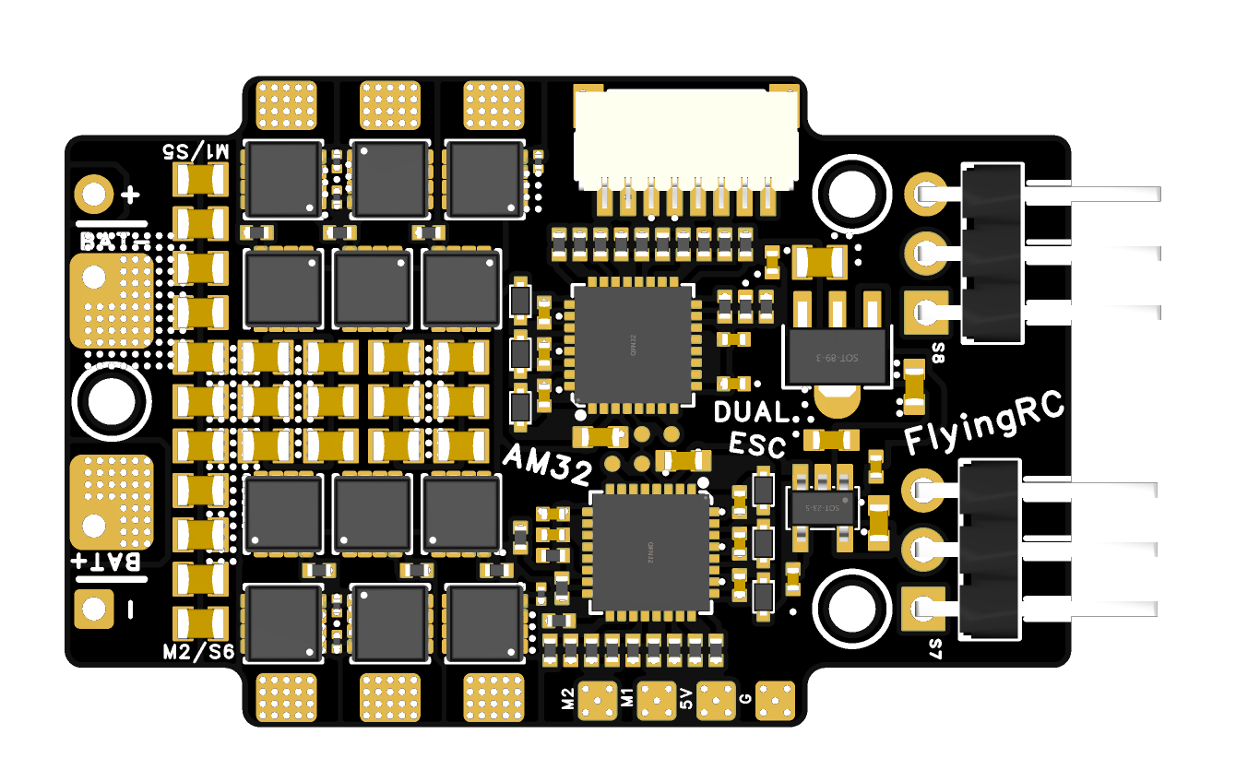
 |  |  | - FlyingRC® AM32 ESC V2.5 75A - Single ESC  Infineon gold-package MOSFETs, premium materials, superior heat dissipation.  Manual：https://kdocs.cn/l/cv6hUy67IdTJ |  |  |  | 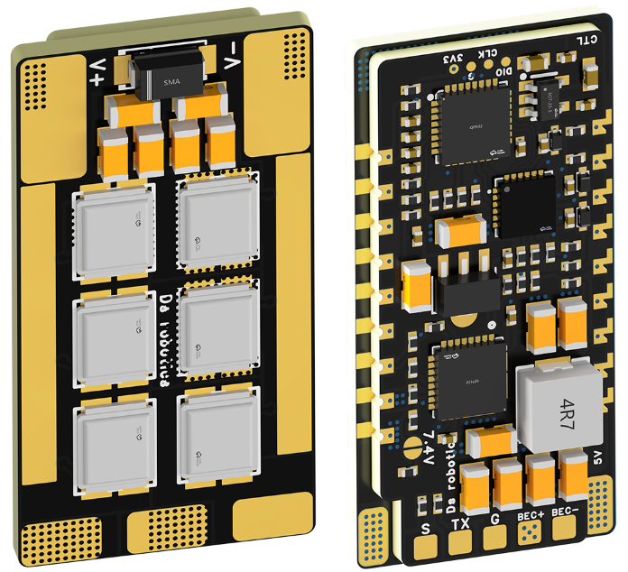
 |  |  | - FlyingRC® AM32 Mini ESC 40A V1.0 - Single ESC  Ultra-miniature, ideal for micro drones, high over-current capability, stable operation.  Manual：https://kdocs.cn/l/cqdLSysEyWFh |  |  |  |  | 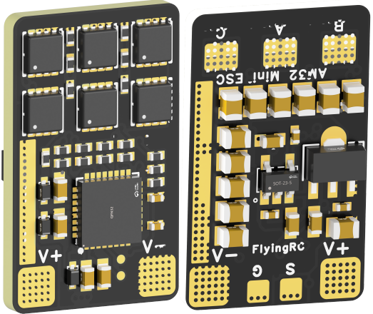
 |  |  | - FlyingRC® 10A 12S 440A Power Distribution Board for FPV Drones  Industry top choice, excellent quality and affordable price.  Manual：https://kdocs.cn/l/coel7OgrlCBP |  |  |  |  | 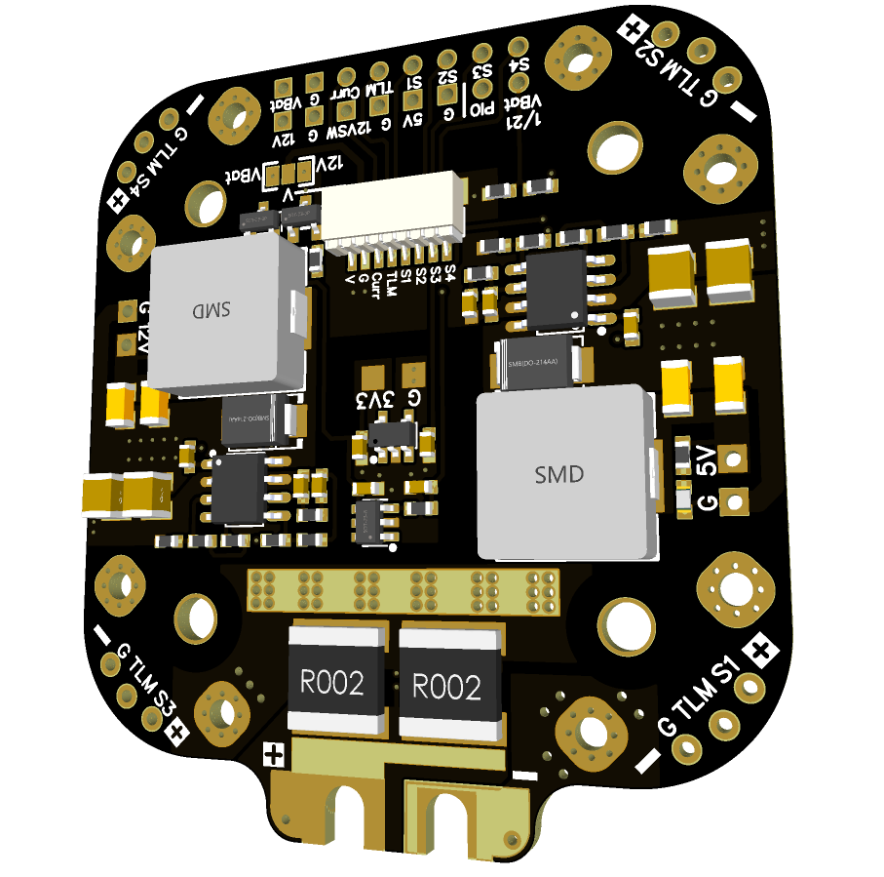
 |  |  | - FlyingRC® H7D Pro MK1 H743 FPV Flight Controller with Dual Gyro  Fully Upgraded & More Powerful  Manual：https://www.kdocs.cn/l/ctcekCy676Ez |  |  |  | 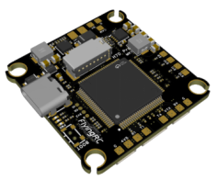
 |  |  | - FlyingRC® H7D MK1 H743 FPV Flight Controller with Dual Gyro  Powerful computing, stable and precise flight, rich interfaces, smooth control.  Manual：https://kdocs.cn/l/cqMh1I0RwAoD |  |  |  | 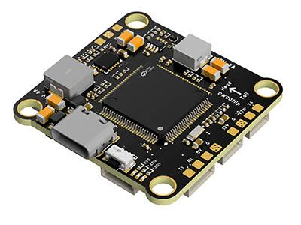
 |  |  | - FlyingRC® F420 MK1 F405 FPV Flight Controller (20/30.5mm Mounting)  Dual mounting holes, all connectors, no soldering required, compliant with Betaflight interface standards.  Manual：https://kdocs.cn/l/ctGeLiN9ZYKj |  |  |  | 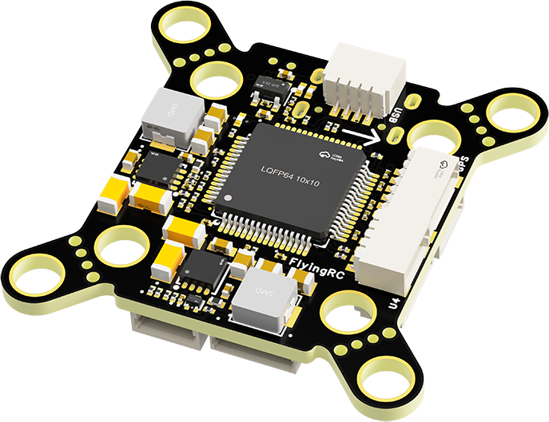
 |  | - FlyingRC® 4-in-1 75A V3.2 Gold-Sealed FPV ESC  Infineon gold-package MOSFETs, superior heat dissipation & over-current capability, premium choice.  Manual：https://kdocs.cn/l/ceLilc8Gaa21 |  |  |  |  | 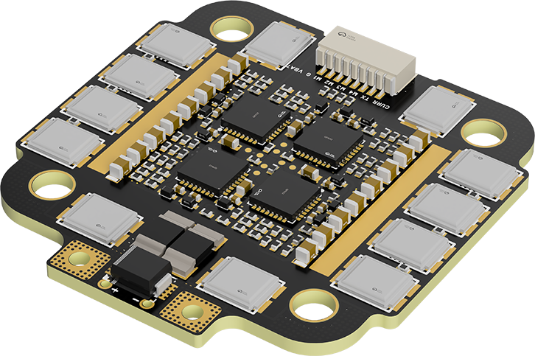
- FlyingRC® Stack Combo: H743 Flight Controller + 4-in-1 75A Gold-Sealed ESC  Professional flight choice, flagship materials & craftsmanship, reasonable price.  Manual：https://www.kdocs.cn/l/ctcekCy676Ez  https://kdocs.cn/l/ceLilc8Gaa21 |  |  |  |  |  |  | 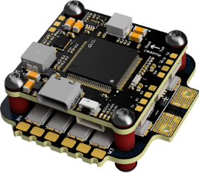
 |  | - FlyingRC® Stack Combo: F405 Flight Controller + 4-in-1 75A Gold-Sealed ESC  Best-selling combo, excellent performance, affordable price.  Manual：https://kdocs.cn/l/ctGeLiN9ZYKj  https://kdocs.cn/l/ceLilc8Gaa21 |  |  |  |  | 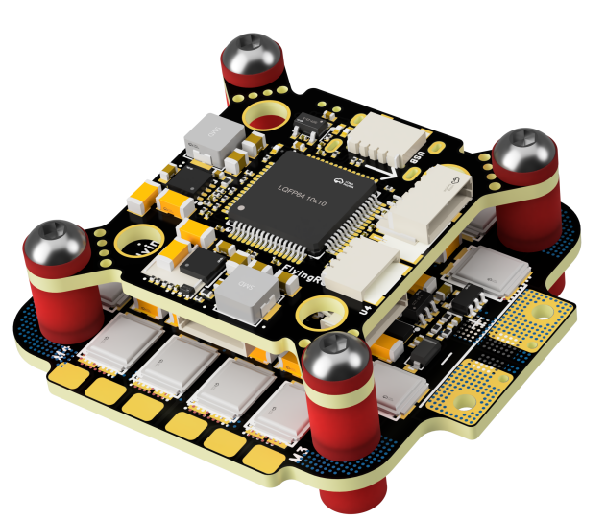
 |  | - FlyingRC® Stack Combo: H743 Flight Controller + 4-in-1 45A ESC  Winning combo: great performance, budget-friendly price  Manual：https://www.kdocs.cn/l/ctcekCy676Ez  https://kdocs.cn/l/ceLilc8Gaa21 |  |  |  |  | 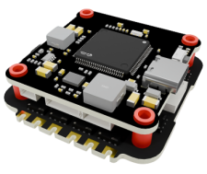
 |  | - FlyingRC® Stack Combo: F405 Flight Controller + 4-in-1 45A ESC  Hit combo, great value, budget-friendly  Manual：https://kdocs.cn/l/ctGeLiN9ZYKj  https://kdocs.cn/l/ceLilc8Gaa21 |  |  |  |  | 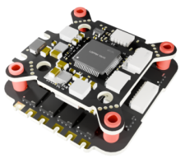
 |  | - FlyingRC® Stack Combo: F4WSE Pro - F405 Fixed-Wing Flight Controller + AM32 Dual ESC 40A 2-in-1 ESC  Unique Design • Exclusive Offer • Bestselling Bundle  Manual：https://www.kdocs.cn/l/cavm9EoVEq5A  https://www.kdocs.cn/l/cjwNtsKK6HeR |  |  |  |  | 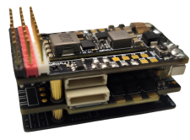
 | - FlyingRC® ELRS 2.4G Diversity Receiver  True diversity reception, temperature compensation, high-sensitivity reception.  Manual：https://kdocs.cn/l/cbvlOlShmsPS |  |  |  |  |  | 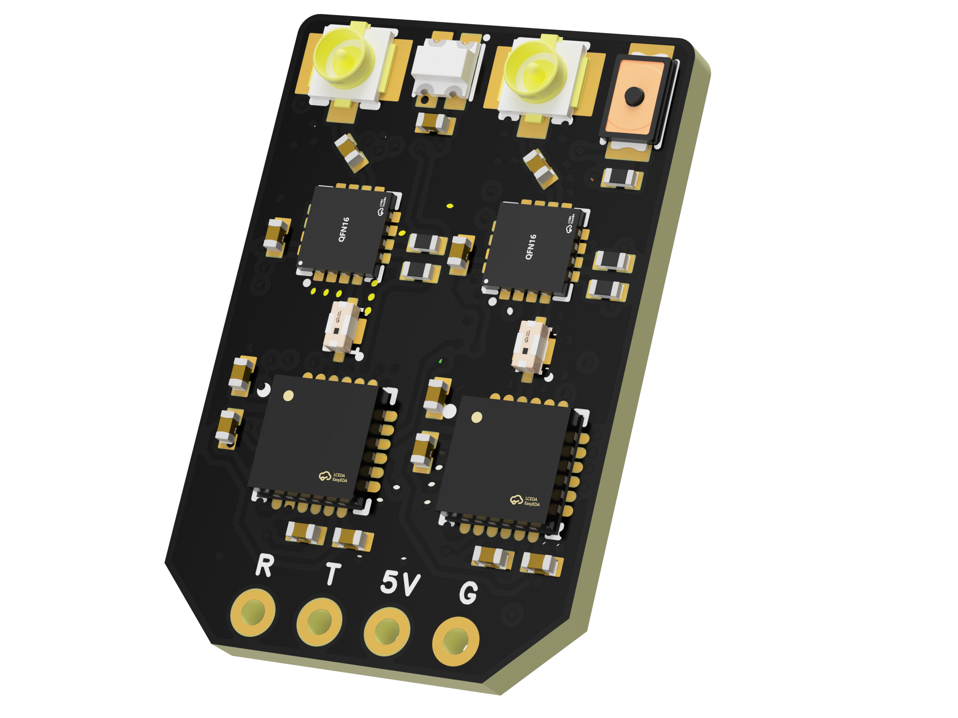
 | - FlyingRC® RM3100 SPI Module 罗盘模块  Ultra-high Resolution • Low Power • Industry Top Choice  Manual：https://www.kdocs.cn/l/cdGuHvBVyndC |  |  |  |  |  | 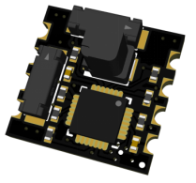
 | - FlyingRC® 10A 12S BEC Step-Down Module  Wide voltage input, high power, compact size, multiple voltages available, 10A continuous output.  Manual：https://kdocs.cn/l/clssNCKgNhLV |  |  |  |  |  | 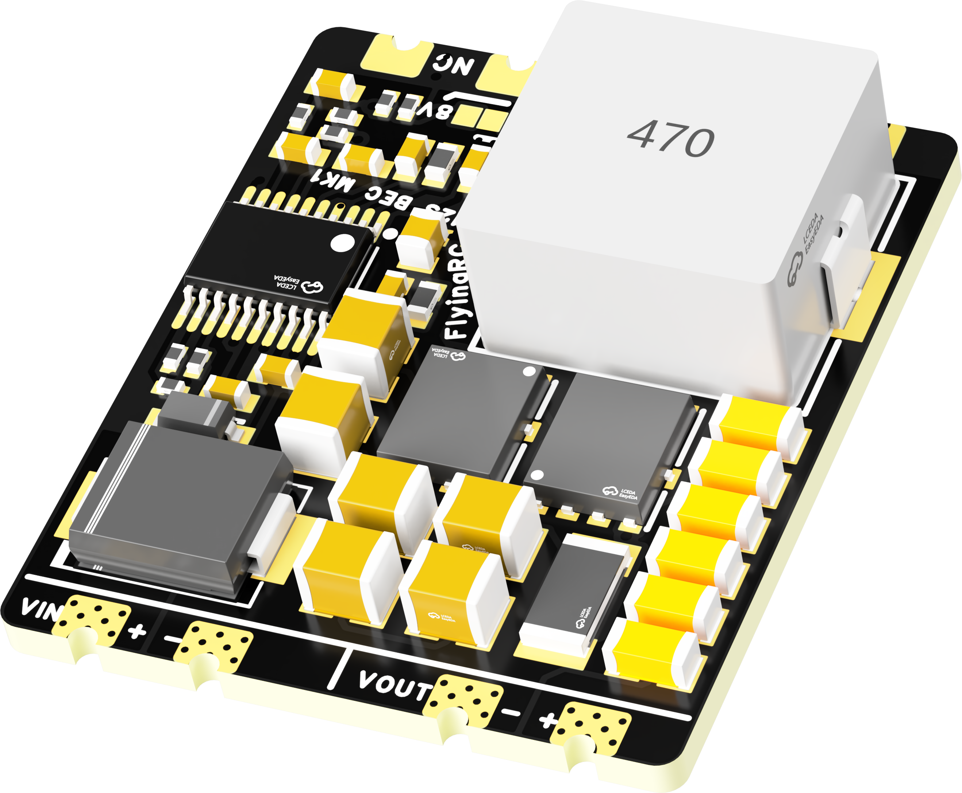
 | FlyingRC® 5A BEC Step-Down Module  Ultra-small size, multiple voltages available, 5A continuous output.  Manual：https://kdocs.cn/l/cb9VdNywqCKA |  |  |  |  |  | 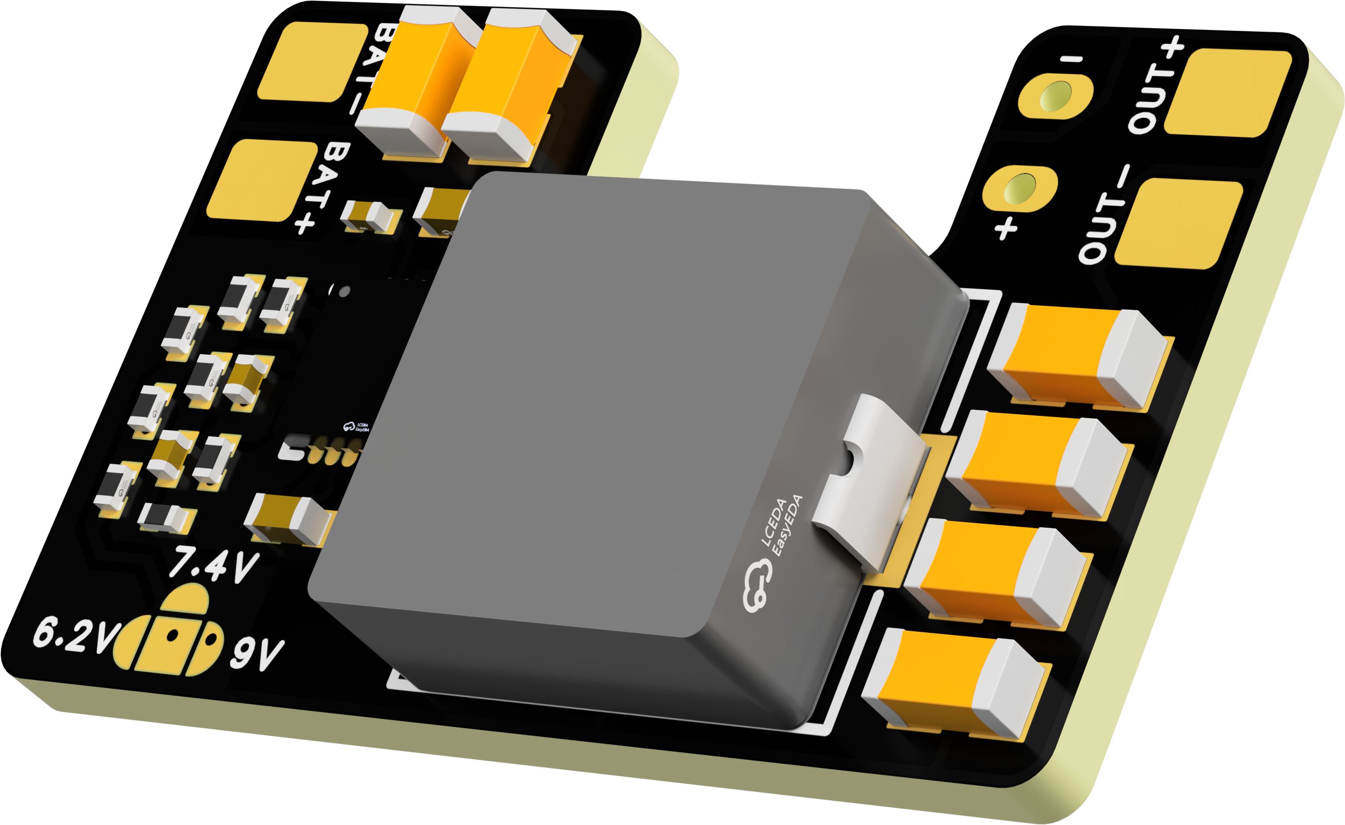
 | FlyingRC® Mini BEC For DJI O4  Easy wiring, ultra-small size, stable power supply.  Manual：https://www.kdocs.cn/l/ckkebieur37K |  |  |  |  |  | 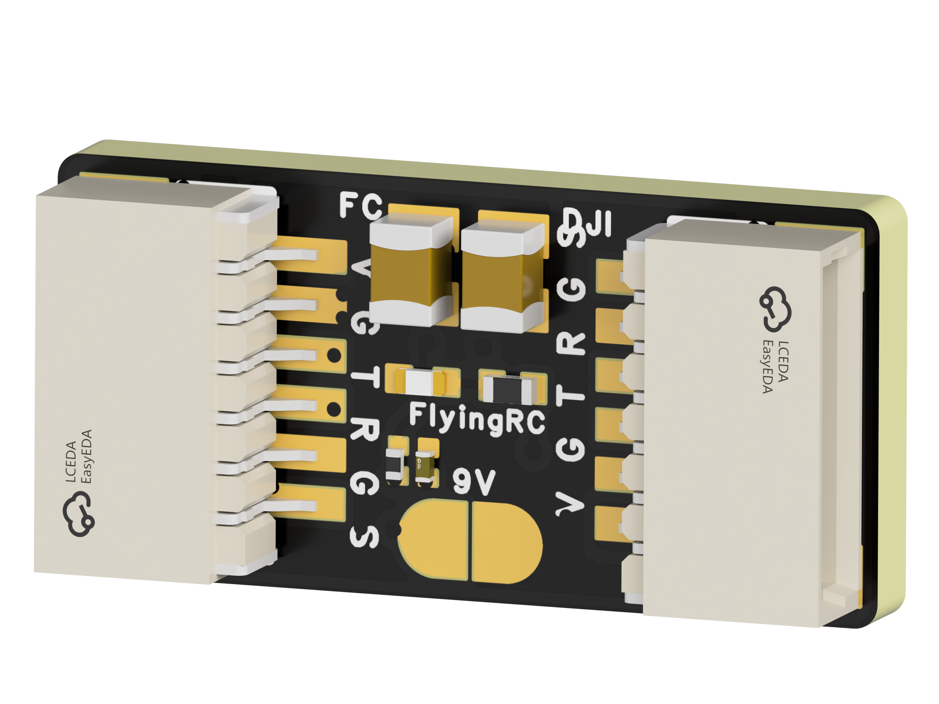
 | FlyingRC® CAN Bus Serial & PWM Expansion Board  Long-distance transmission, high speed, excellent stability.  Manual：https://www.kdocs.cn/l/cmxRyBnU4BXj |  |  |  |  |  | 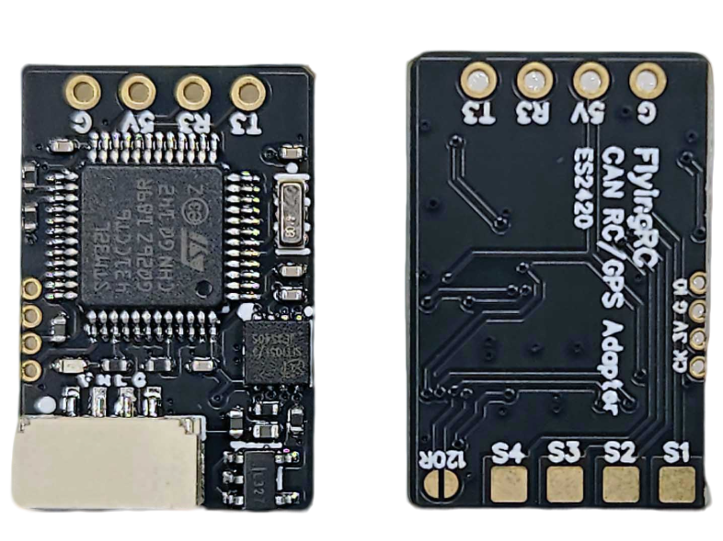
 | FlyingRC® AM3 2ESC Programmer  Supports BL, BL32, AM32. Simple and easy to use.  Manual：https://kdocs.cn/l/cogBSEBe67mE |  |  |  |  |  | 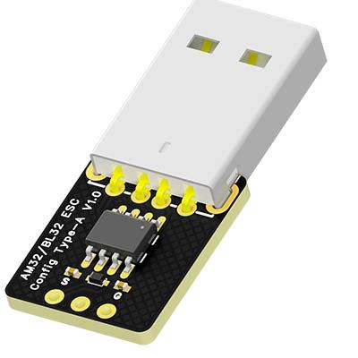
 | FlyingRC® Digital Airspeed Sensor without Pitot Tube  Integrated design, smallest on the market. MS4525D protocol, I2C interface.  Manual：https://www.kdocs.cn/l/clPvEEEcJgCC |  |  |  |  |  | 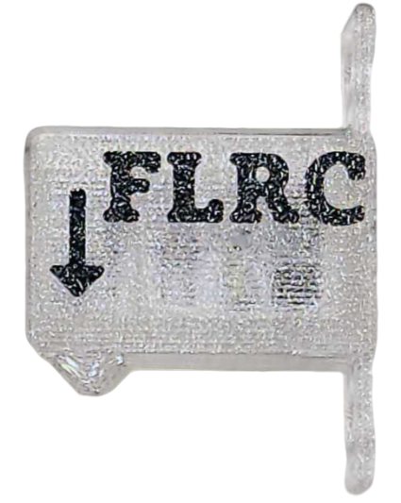
 | FlyingRC® U-Blox M10 GPS  Compatible with all open-source flight controllers.  Manual：https://www.kdocs.cn/l/cdSYQrzx74O8 |  |  |  |  |  | 