FlyingRC® RM3100 SPI Module(Compass Module) Product Manual

FlyingRC® is a globally-oriented professional brand of electronic devices. We specialize in the R&D and sales of drone electronics, core robot circuits and sensors. Our design team is based in Singapore, and our products are sold worldwide.

Since launched in 2023, FlyingRC® products have gained widespread recognition from customers as well as strong market response. As of April 2026, our cumulative sales volume has exceeded 46,000 units. Our products are widely applied in industries, robotics, emergency rescue, environmental protection & inspection, aerial photography, public security, retail and many other fields. Above all, we are committed to distinctive design and superior reliable quality.

Our Chief Technology Officer Liu Yuhan possesses outstanding expertise in circuit design. Over the past four years, he has designed more than 80 circuit projects and contributed 39 to open-source platforms. Moreover, he won the Design Award on the open-source platform X.JLC.com twice in 2023 and 2024, and has become the youngest certified designer on this platform.

He holds the NUS (National University of Singapore, rank 8th worldwide) Science and Technology Scholarship, and is currently majoring in Electronic Engineering with a focus on Aerospace Technology. In addition, all members of our technical team are graduates from prestigious universities with extensive professional product experience.

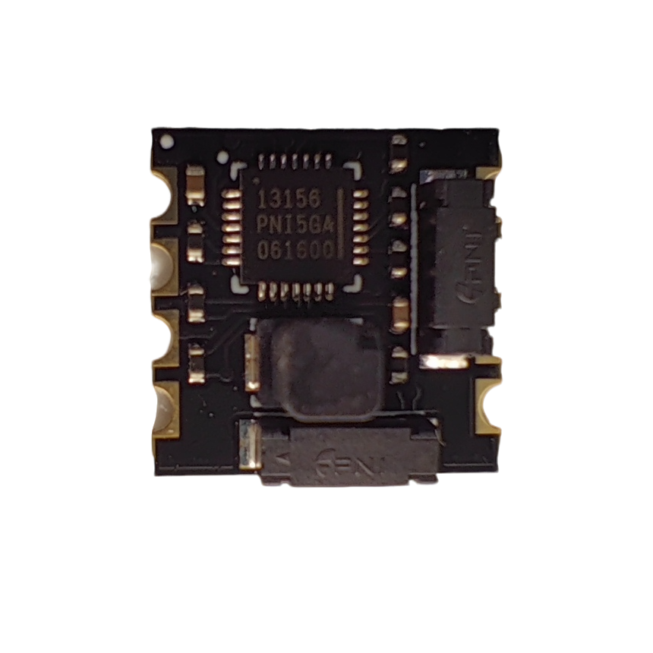
1.Product Overview
1.1 Product Introduction
The RM3100 magnetic sensor kit consists of two X/Y-axis magnetic sensors Sen-XY-f (13104), one Z-axis magnetic sensor Sen-Z-f (13101) and one MagI2C ASIC controller. Featuring 10-fold higher resolution and over 20‑fold lower noise than Hall‑effect sensors, the RM3100 stands out as a high-performance magnetic sensor in its class, ensuring high-precision heading and azimuth measurement. Based on PNI’s patented magnetic induction technology, the RM3100 delivers high‑resolution and repeatable data output at ultra‑low noise levels, alongside a high sampling rate, zero magnetic hysteresis, and freedom from temperature calibration.

1.2 ​Typical Applications
​UAV / RC aircraft electronic compass
Vehicle navigation, Attitude and Heading Reference System
Robot positioning, geological exploration and magnetic field detection
Industrial instruments, security equipment, AR/VR attitude perception

1.3 Technical Specifications
Product dimensions: 12.70mm×12.70mm×7.42mm
Product weight: 0.53g
PCB layers: 4 layers
PCB thickness: 1.16mm
Immersion gold plating: Yes, 1μm
Package contents: Compass module
Chipset: PNI RM3100 3-axis geomagnetic magnetometer IC

2.Technical Specifications
Parameters | Value | Unit
Measurement Range | ±400 | μT
Sensitivity | 13 | nT
Noise | 15 | nT
Noise Density | 1.2 | nT/Hz
Linearity （within±200μT） | 0.5 | %
Magnetic Hysteresis (within ±200 μT) | ≤15 | nT
Repeatability (within ±200 μT) | ≤8 | nT
Maximum Single-axis Sampling Rate | 440 | Hz
Maximum Tri-axis Sampling Rate | 550 | Hz

3. Pin Definition（RM3100‑8Pin）
Viewed from the top of the module (silkscreen readable on the bottom side), pins are arranged as follows: upper row Pin1 to Pin4 from left to right, lower row Pin5 to Pin8 from left to right.
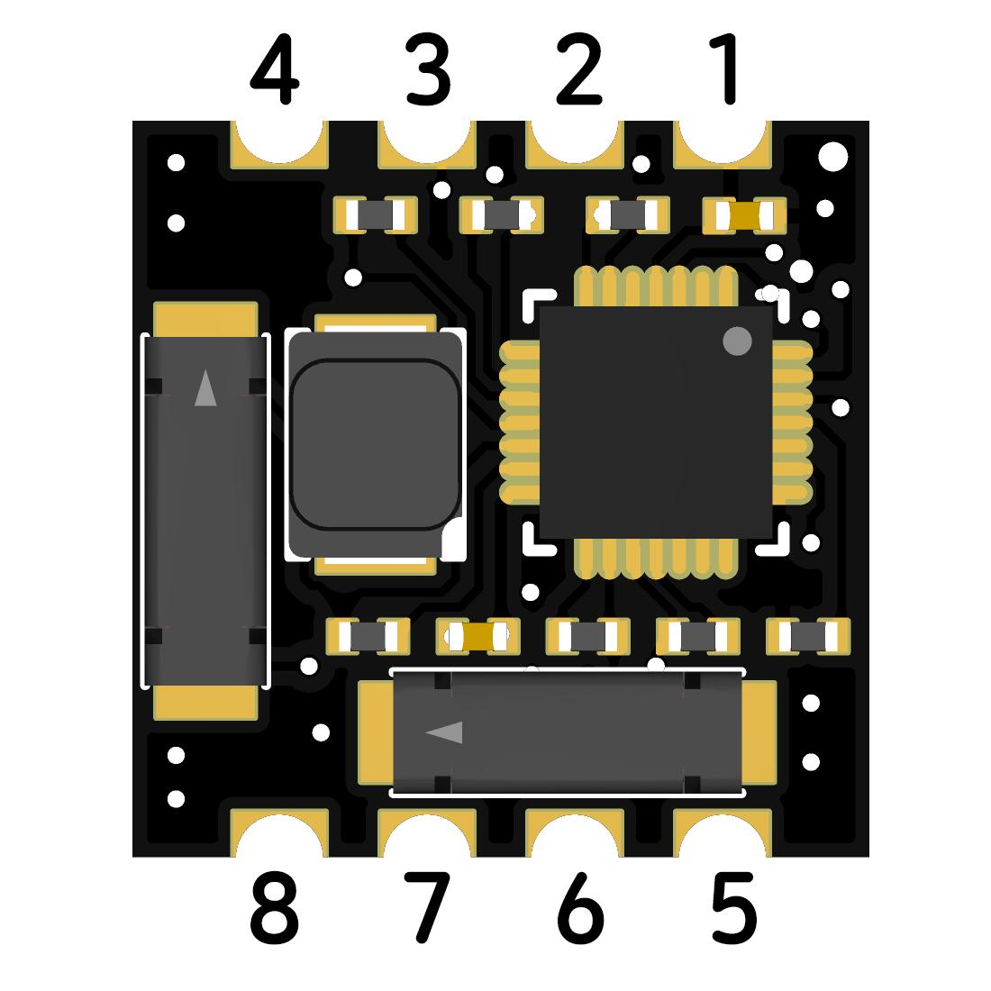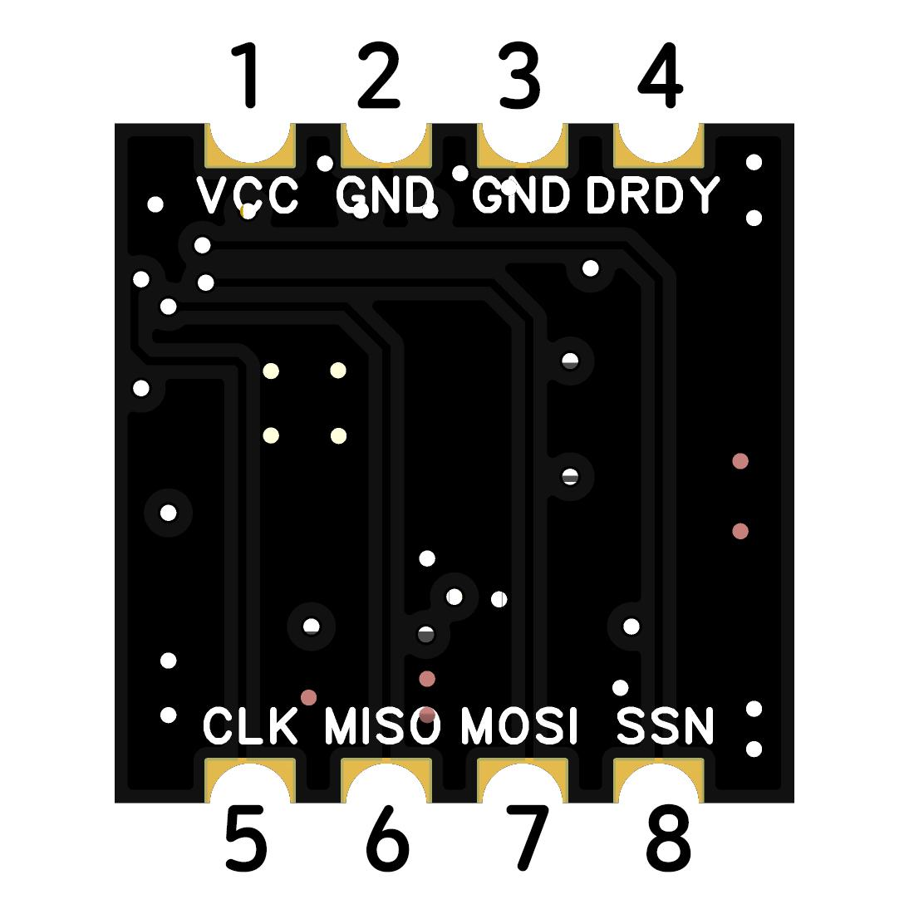

Pin No. | Pin Silkscreen | Pin Alias | Function Description
1 | VCC | VDD | Power Input, recommended voltage: 3.3V
2 | GND | GND | Power Ground
3 | GND | GND | Power Ground (dual-GND design for enhanced anti-interference performance)
4 | DRDY | DRDY | Data Ready (Active High; asserted high upon measurement completion)
5 | CLK | SCK | SPI Clock
6 | MISO | SDO | SPI MISO (Master Input, Slave Output)
7 | MOSI | SDI | SPI MOSI (Master Output, Slave Input)
8 | SSN | CS / Chip Select | SPI Chip Select (Active Low)

4、Device Wiring Table
RM3100 Module Pins | MCU SPI Pins | Description
VCC(Pin1) | 3.3V Power Supply | Recommended 3.3V, operating voltage range: 2.0–3.6V
GND(Pin2/Pin3) | GND | dual-GND design, connect either one or both pins
CLK(Pin5) | SPI_SCK | SPI Clock, master output
MISO(Pin6) | SPI_MISO | SPI MISO: Master Input, Slave Output
MOSI(Pin7) | SPI_MOSI | SPI MOSI: Master Output, Slave Input
SSN(Pin8) | SPI_CS | SPI Chip Select, active low
DRDY(Pin4) | MCU Interrupt Pin (Optional) | Data ready interrupt for data reading trigger; can be left floating in polling mode.
Note: On-site full attitude calibration is mandatory after installation before use.

Other FlyingRC® Products
 |  |  |  | - FlyingRC® F4WSE Pro - F405 Fixed-Wing Flight Controller  Upgraded Version | Enhanced Performance  Manual：https://www.kdocs.cn/l/cavm9EoVEq5A |  |  | 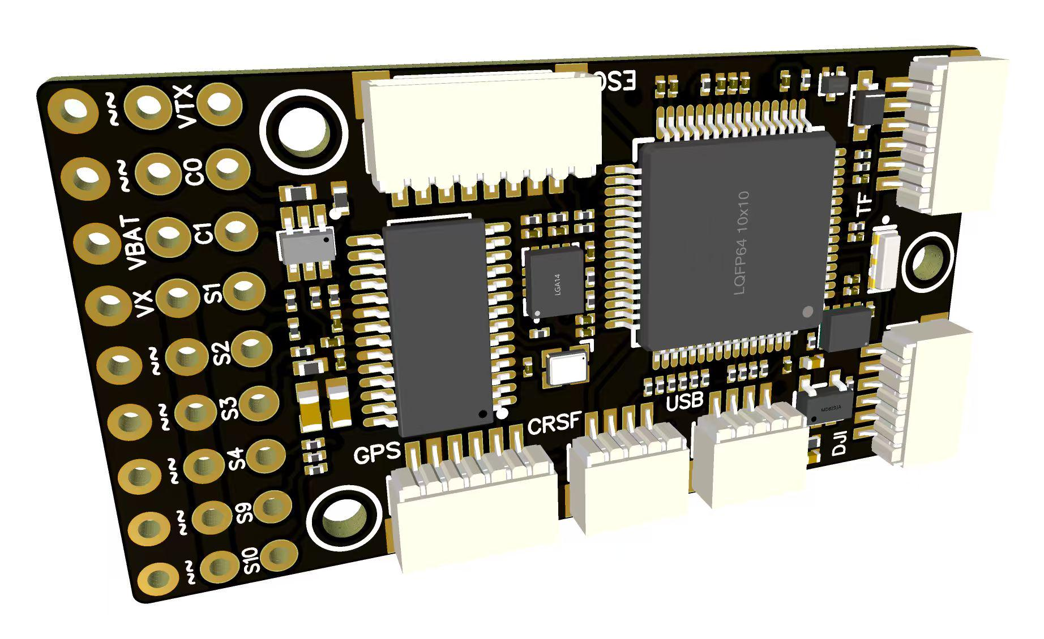
 |  |  | - FlyingRC® F4WSE MK1.5 - F405 Fixed-Wing Flight Controller  Classic model, unique design, highly acclaimed.  Manual：https://kdocs.cn/l/cpyd8MTS56DD |  |  | 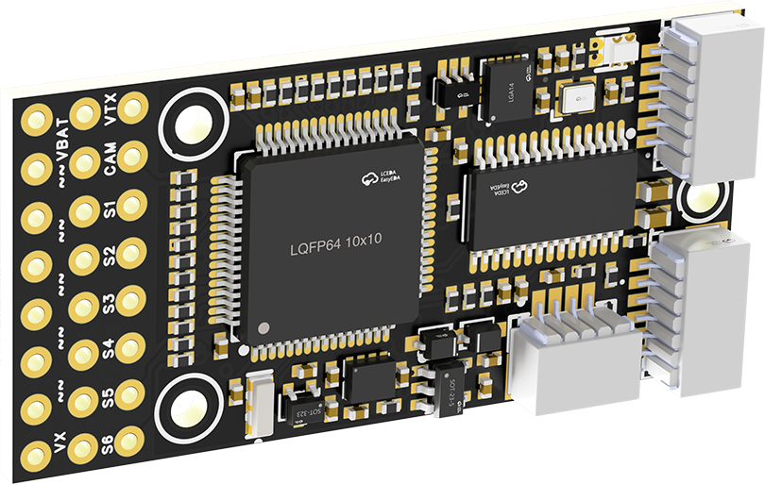
 |  |  |  | - FlyingRC® H7Wlite MK1 H743 Fixed-Wing Flight Controller  Flagship performance, full expansion, high-power BEC.  Manual：https://kdocs.cn/l/cpYaBiFKh8U1 |  |  | 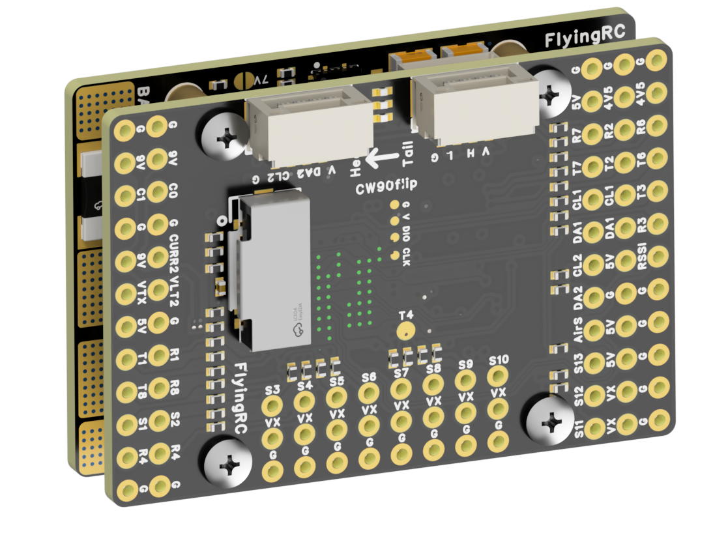
 |  |  |  | - FlyingRC® F4Wing Mini MK1 F405 Fixed-Wing Flight Controller  2025 bestseller, ultra-compact, smallest on the market, great value.  Manual：https://kdocs.cn/l/cdUIdmpSpW7J |  |  | 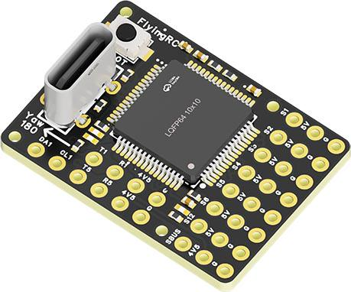
 | - FlyingRC® AM32 Dual ESC 40A 2-in-1 ESC  Unique design for dual-power aerial, land and water vehicles including drones.  Manual：https://www.kdocs.cn/l/cjwNtsKK6HeR |  |  |  | 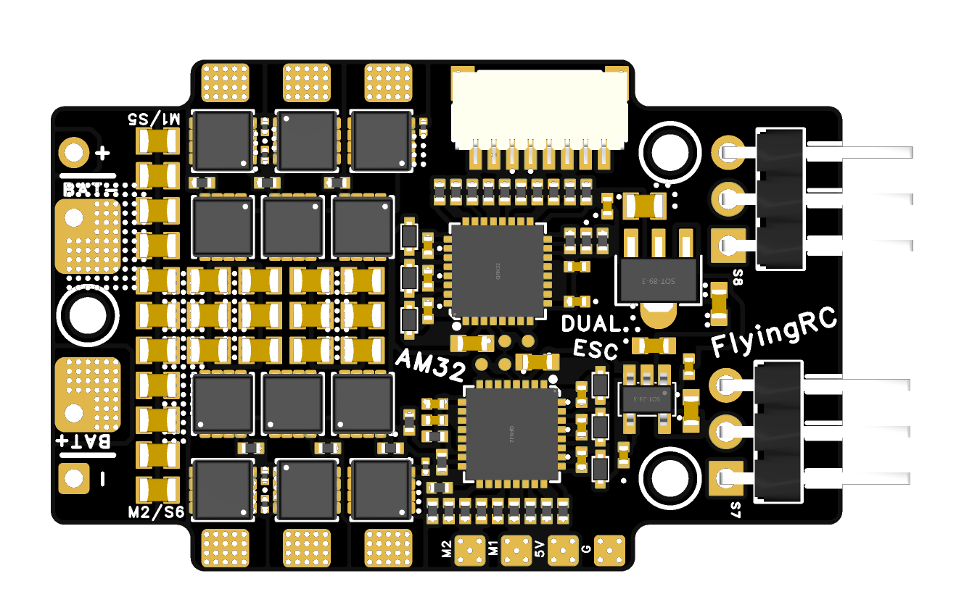
 |  |  | - FlyingRC® AM32 ESC V2.5 75A - Single ESC  Infineon gold-package MOSFETs, premium materials, superior heat dissipation.  Manual：https://kdocs.cn/l/cv6hUy67IdTJ |  |  |  | 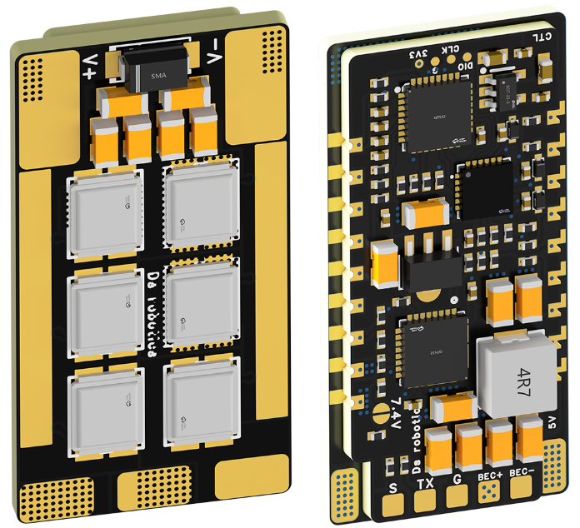
 |  |  | - FlyingRC® AM32 Mini ESC 40A V1.0 - Single ESC  Ultra-miniature, ideal for micro drones, high over-current capability, stable operation.  Manual：https://kdocs.cn/l/cqdLSysEyWFh |  |  |  |  | 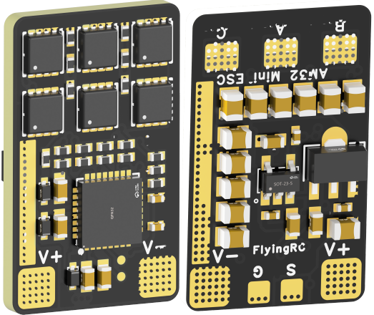
 |  |  | - FlyingRC® 10A 12S 440A Power Distribution Board for FPV Drones  Industry top choice, excellent quality and affordable price.  Manual：https://kdocs.cn/l/coel7OgrlCBP |  |  |  |  | 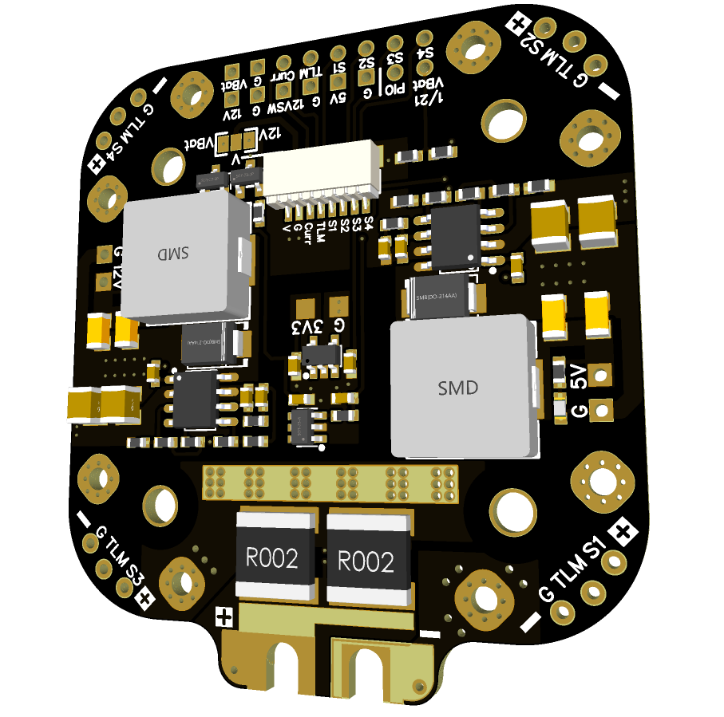
 |  |  | - FlyingRC® H7D Pro MK1 H743 FPV Flight Controller with Dual Gyro  Fully Upgraded & More Powerful  Manual：https://www.kdocs.cn/l/ctcekCy676Ez |  |  |  | 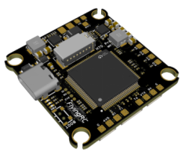
 |  |  | - FlyingRC® H7D MK1 H743 FPV Flight Controller with Dual Gyro  Powerful computing, stable and precise flight, rich interfaces, smooth control.  Manual：https://kdocs.cn/l/cqMh1I0RwAoD |  |  |  | 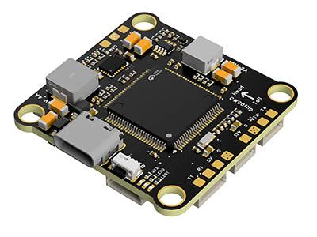
 |  |  | - FlyingRC® F420 MK1 F405 FPV Flight Controller (20/30.5mm Mounting)  Dual mounting holes, all connectors, no soldering required, compliant with Betaflight interface standards.  Manual：https://kdocs.cn/l/ctGeLiN9ZYKj |  |  |  | 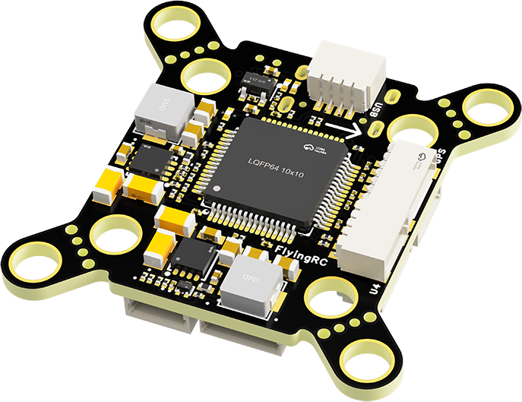
 |  | - FlyingRC® 4-in-1 75A V3.2 Gold-Sealed FPV ESC  Infineon gold-package MOSFETs, superior heat dissipation & over-current capability, premium choice.  Manual：https://kdocs.cn/l/ceLilc8Gaa21 |  |  |  |  | 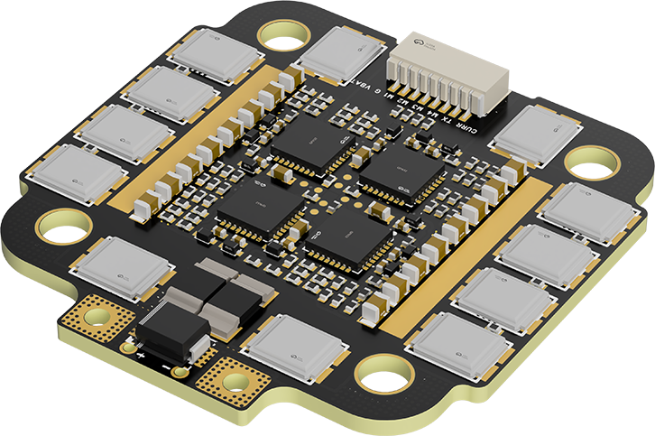
- FlyingRC® Stack Combo: H743 Flight Controller + 4-in-1 75A Gold-Sealed ESC  Professional flight choice, flagship materials & craftsmanship, reasonable price.  Manual：https://www.kdocs.cn/l/ctcekCy676Ez  https://kdocs.cn/l/ceLilc8Gaa21 |  |  |  |  |  |  | 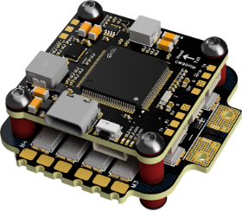
 |  | - FlyingRC® Stack Combo: F405 Flight Controller + 4-in-1 75A Gold-Sealed ESC  Best-selling combo, excellent performance, affordable price.  Manual：https://kdocs.cn/l/ctGeLiN9ZYKj  https://kdocs.cn/l/ceLilc8Gaa21 |  |  |  |  | 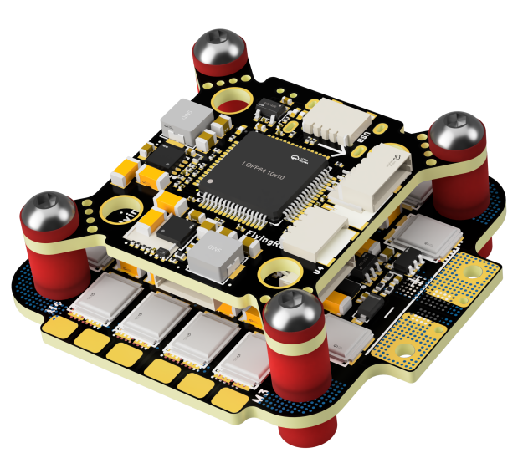
 |  | - FlyingRC® Stack Combo: H743 Flight Controller + 4-in-1 45A ESC  Winning combo: great performance, budget-friendly price  Manual：https://www.kdocs.cn/l/ctcekCy676Ez  https://kdocs.cn/l/ceLilc8Gaa21 |  |  |  |  | 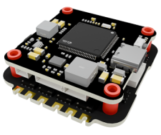
 |  | - FlyingRC® Stack Combo: F405 Flight Controller + 4-in-1 45A ESC  Hit combo, great value, budget-friendly  Manual：https://kdocs.cn/l/ctGeLiN9ZYKj  https://kdocs.cn/l/ceLilc8Gaa21 |  |  |  |  | 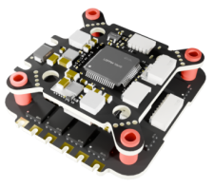
 |  | - FlyingRC® Stack Combo: F4WSE Pro - F405 Fixed-Wing Flight Controller + AM32 Dual ESC 40A 2-in-1 ESC  Unique Design • Exclusive Offer • Bestselling Bundle  Manual：https://www.kdocs.cn/l/cavm9EoVEq5A  https://www.kdocs.cn/l/cjwNtsKK6HeR |  |  |  |  | 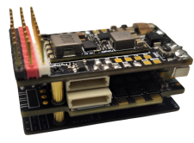
 | - FlyingRC® ELRS 2.4G Diversity Receiver  True diversity reception, temperature compensation, high-sensitivity reception.  Manual：https://kdocs.cn/l/cbvlOlShmsPS |  |  |  |  |  | 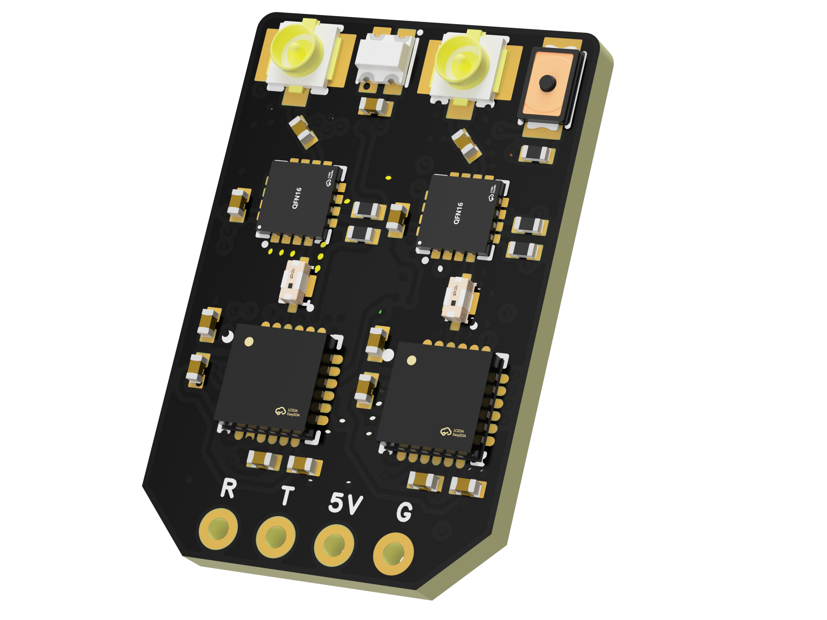
 | - FlyingRC® RM3100 SPI Module 罗盘模块  Ultra-high Resolution • Low Power • Industry Top Choice  Manual：https://www.kdocs.cn/l/cdGuHvBVyndC |  |  |  |  |  | 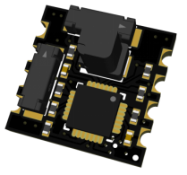
 | - FlyingRC® 10A 12S BEC Step-Down Module  Wide voltage input, high power, compact size, multiple voltages available, 10A continuous output.  Manual：https://kdocs.cn/l/clssNCKgNhLV |  |  |  |  |  | 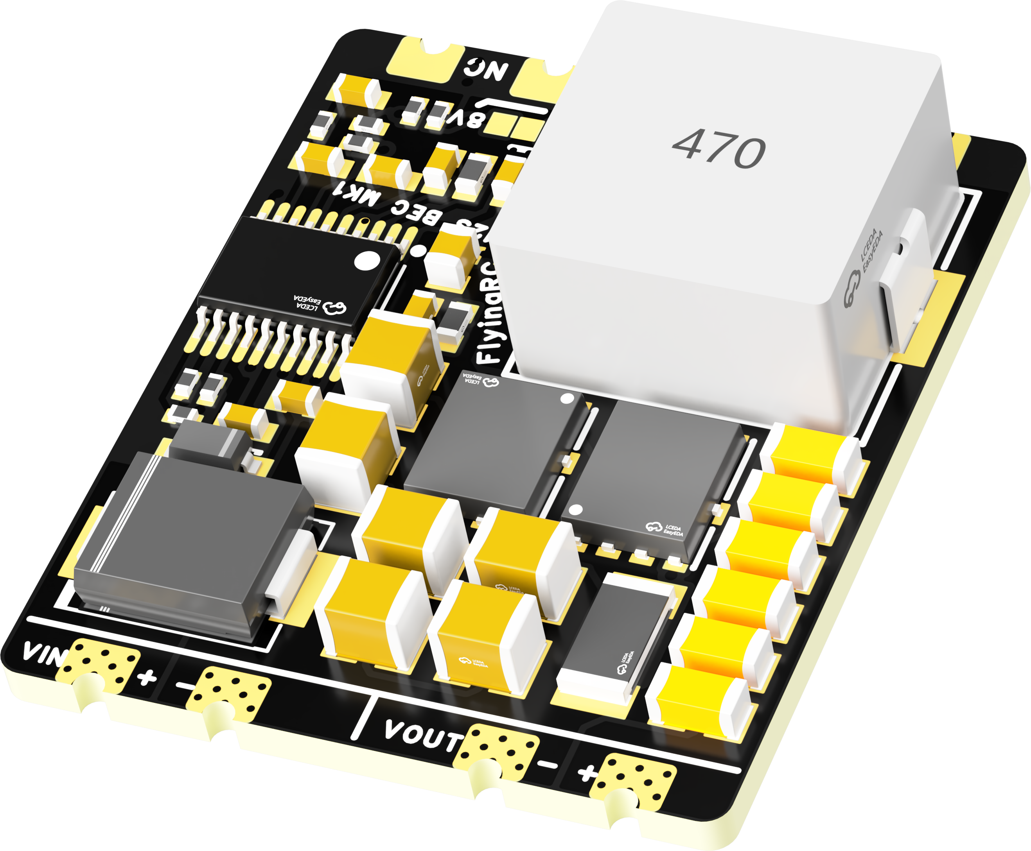
 | FlyingRC® 5A BEC Step-Down Module  Ultra-small size, multiple voltages available, 5A continuous output.  Manual：https://kdocs.cn/l/cb9VdNywqCKA |  |  |  |  |  | 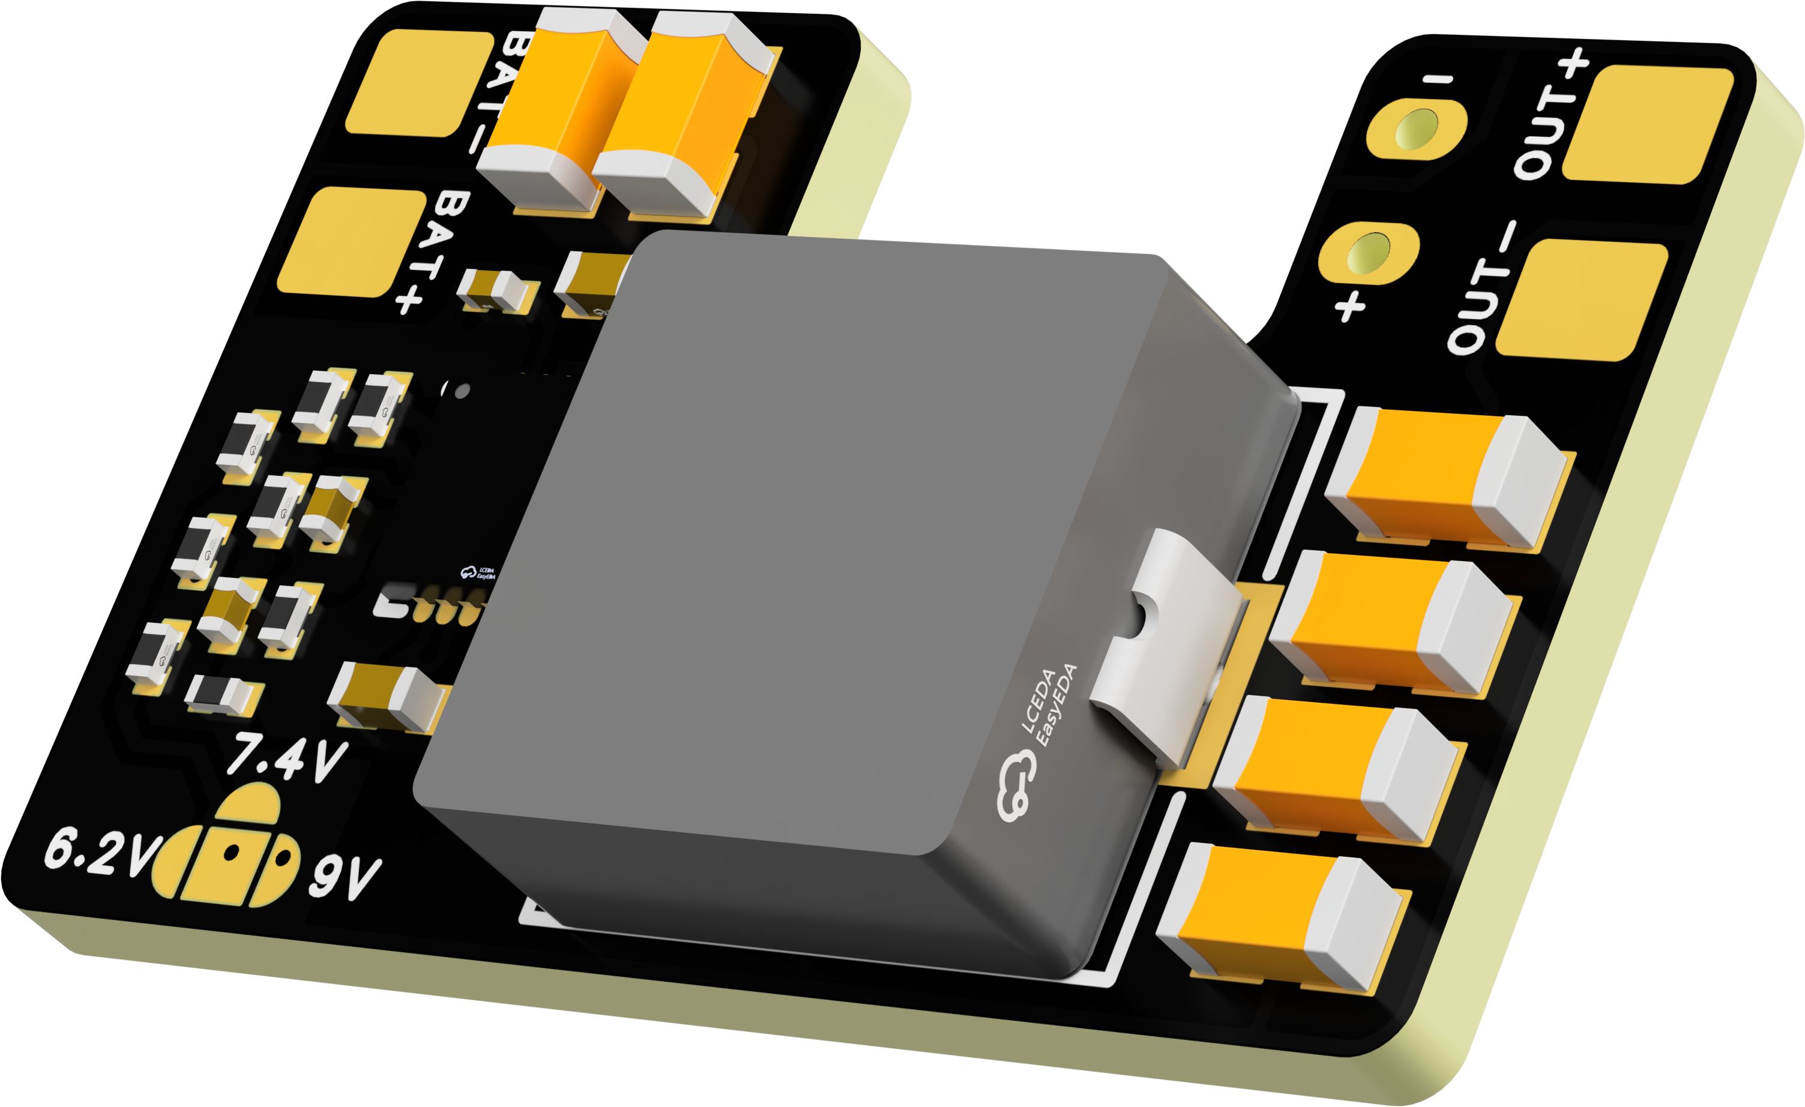
 | FlyingRC® Mini BEC For DJI O4  Easy wiring, ultra-small size, stable power supply.  Manual：https://kdocs.cn/l/cb9VdNywqCKA |  |  |  |  |  | 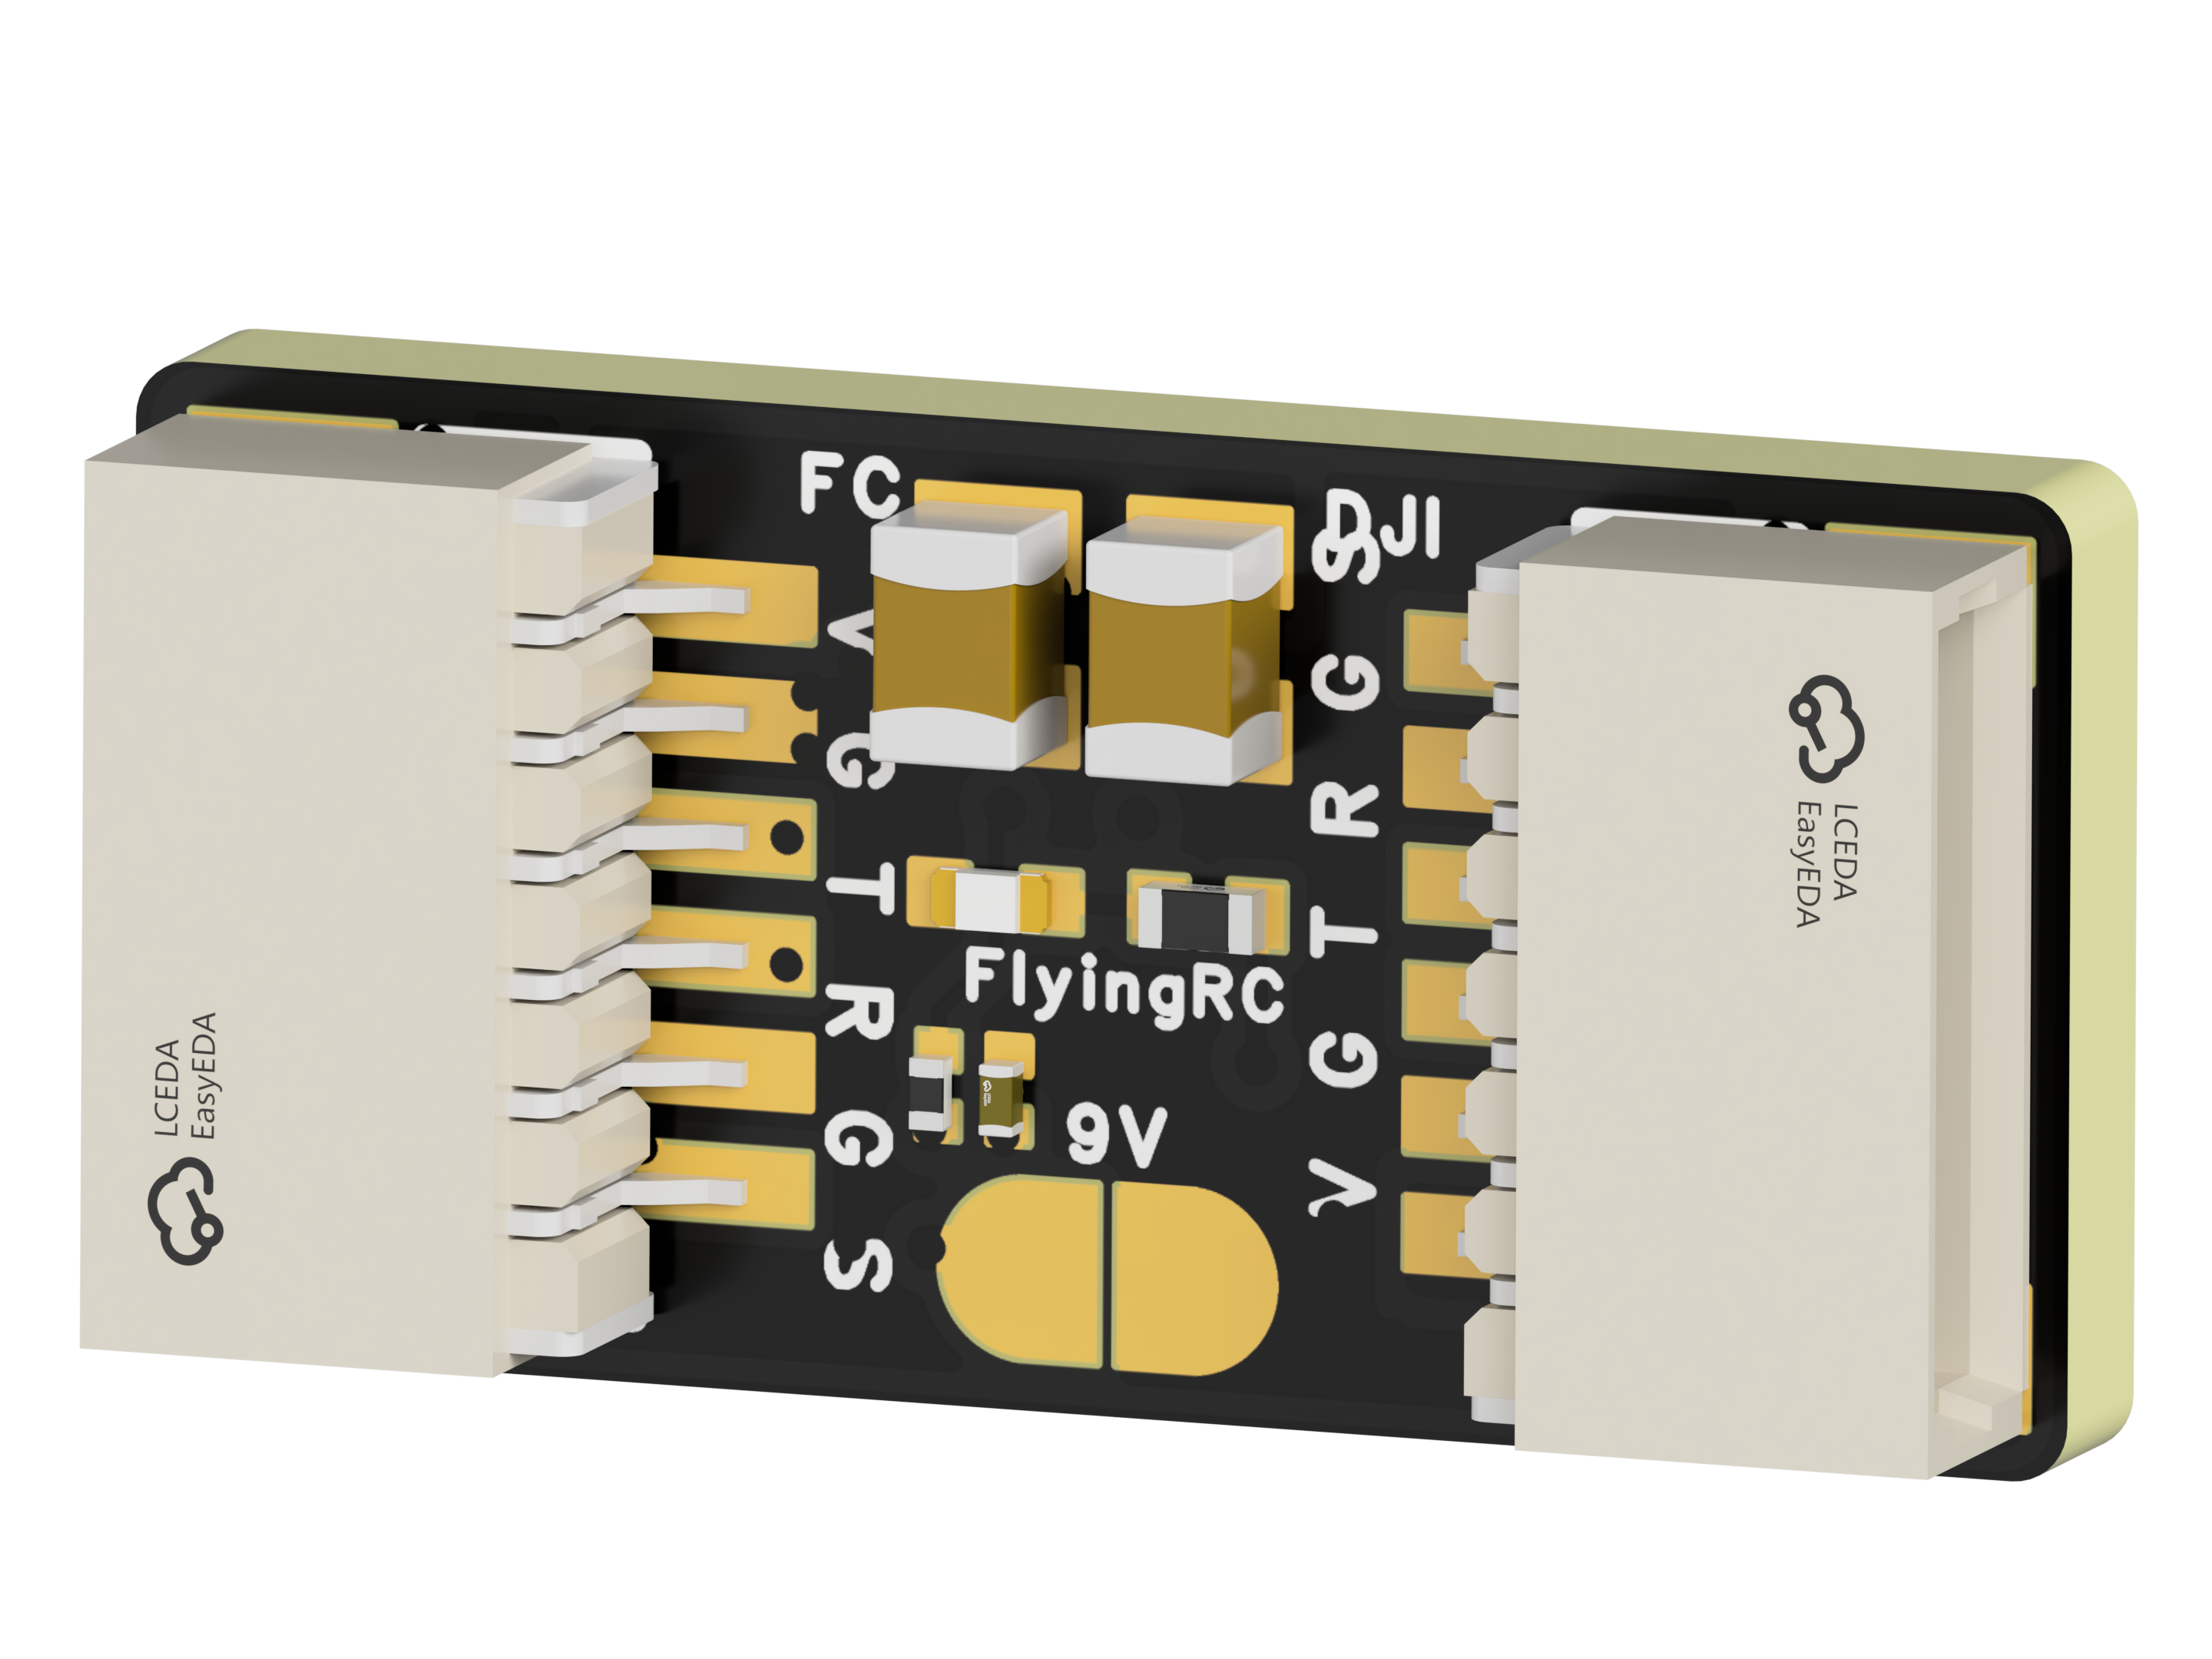
 | FlyingRC® CAN Bus Serial & PWM Expansion Board  Long-distance transmission, high speed, excellent stability.  Manual：https://www.kdocs.cn/l/cmxRyBnU4BXj |  |  |  |  |  | 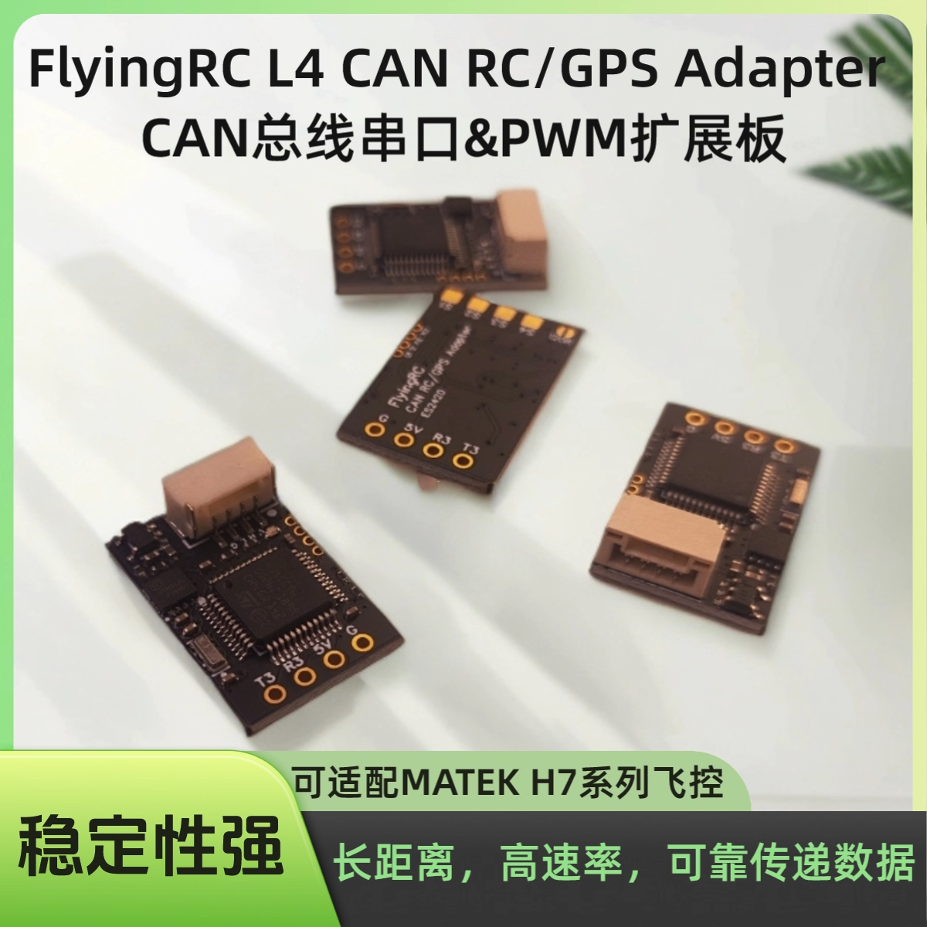
 | FlyingRC® AM3 2ESC Programmer  Supports BL, BL32, AM32. Simple and easy to use.  Manual：https://kdocs.cn/l/cogBSEBe67mE |  |  |  |  |  | 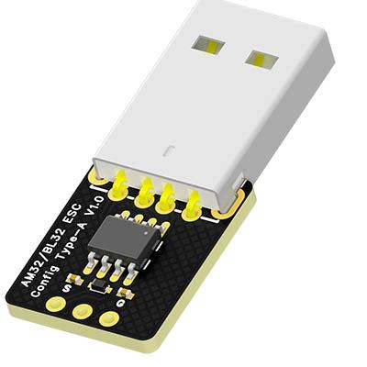
 | FlyingRC® Digital Airspeed Sensor without Pitot Tube  Integrated design, smallest on the market. MS4525D protocol, I2C interface.  Manual：https://www.kdocs.cn/l/clPvEEEcJgCC |  |  |  |  |  | 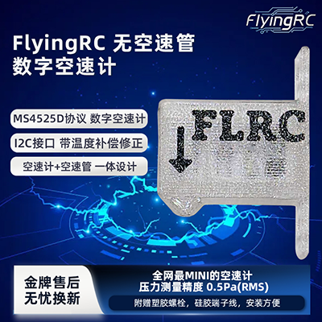
 | FlyingRC® U-Blox M10 GPS  Compatible with all open-source flight controllers.  Manual：https://www.kdocs.cn/l/cdSYQrzx74O8 |  |  |  |  |  | 