Table of Contents

1. Project description 4

1.1 Introduction 4

1.2 Project rationale 4

1.3 Design approach 5

2. Finite elements analysis 6

2.1 Common scheme 6

2.2 Problem statement 8

2.3 Variational functional of the problem 10

2.4 Mixed finite elements method 12

3. Implementation 15

3.1. Environment 15

3.2. Implementation 15

3.3. GUI 16

4. Verification and testing 20

**Test 1.** 21

Test 2. 23

Test 3. 25

**Test 4.** 28

**Test 5.** 30

Test 6. 33

5. Conclusion 36

References 37

6. Appendices 38

6.1. Complex number 38

6.2. Matrixes 39

6.3. Characteristics 44

6.4. Example of saved characteristics. 47

Project brief

Supervisor: Prof. Gerald Farrell

Phone +353-1-4024577

Mobile:

e-mail: gerald.farrell@dit.ie

School: Electronic and Communication Engineering

Title: Mixed Finite Element Analysis of Real and Complex Magnetodielectrical Waveguide Waves

Objective: To create an application which allows analysing dispersion characteristics of magnetodielectrical waveguide waves

Prerequisites:

Description: This project was completed as a part of collaboration program between DIT(Dublin Institute of Technology) and MSTU MIREA(Moscow State Technical University Institute of Radioengineering Electronics and Automation).

1. Project description
   1. Introduction

One of the means to transmit the waves is waveguides. Commonly, waveguide is a tube, which allows waves to propagate inside. Waveguide may have filler or may be hollow and fillers can be absolutely different, with different characteristics.

The main property of the waveguide is the existence in it of a discrete set of normal waves (modes) propagating with their phase and group velocities. All modes have dispersion – their phase velocities depend on frequency and differ from group velocity.

Thereby, waveguides are characterized by dispersion characteristics. These characteristics represent a ratio of propagation constant to wavenumber. Analyzing them we can find the best waveguides parameters which cause the less decay of waves.

The purpose of this project is to implement an application which allows calculating dispersion characteristics and critical values of limited decay of multilayer waveguide waves.

This application is implemented for OS family Windows with combining of resources of Visual Studio 2010 and Matlab 7.11. These two systems are powerful enough to do calculations of this project and suitable to work with complicated structures. Also, this combination offers convenient display of information with relatively small usage of resources.

Modern applications need to be convenient and present all proper information in suitable way. That’s why this application must have interface, suitable for every the user, that is easy to use, and be a good tool for serious analysis. The user should be able to use system without special preparation.

* 1. Project rationale

Waveguides are one of the means that are used to transmit the waves. According to critical wavelength, which is twice bigger than waveguide’s diameter, they are suitable for microwaves.

Power loss is small enough relatively to other types of transmission lines – that is their obvious advantage.

For more efficient usage of waveguide is better to improve its capacity. To do that waveguides are created with a variable index of refraction. To solve the problem of synthesis of multilayer waveguide it is necessary to calculate the dispersion curves with given refractive index. From mathematical point of view, the problem lies in the solution of Maxwell’s equations in a cylinder with variable index of refraction, which varies along the radios of cylinder.

Non-physical solutions can appear during solving the problem and finite elements method helps to get rid of them.

* 1. Design approach

Application must be suitable, quick and informative. It’s not necessary for user to see the calculation process. According to that we come to idea of separating application on logic modules. The application should consist of 3 parts:

* Entering waveguides characteristics (interacting with user). User should know what the characteristics he should enter, probably, this window should have reference of type and edges of characteristics
* Calculation core (hidden from user). At the same time user should see the progress of calculations and should be able to interrupt process
* Work with results (interacting with user). Should consist of informative plots with output with ability to have more information about results (initial characteristics, numeric form of results)

So, we’re coming to solution:

* All characteristics are entered on one page so that user could see all of them and change them quickly; user data is validated and used in calculation core.
* Calculation core includes different levels of calculations from the simplest to quite complicated. Final calculations lead to computation of dispersion characteristics of waveguide or critical conditions (values) of limited decay according to users options.
* Finally, the results are submitted in graphical form with capability of saving in numerical way.
* Calculation core (CC) works independently with GUI. This was reached by separation CC and GUI in different threads. That allows working with GUI all the time of calculations and prevents absence of response from application.

1. Finite elements analysis
   1. Common scheme

Finite elements analysis is based on idea of approximation continuous function with discrete model, which is based on a set of piecewise continuous functions defined on a finite number of subdomains called finite elements. On every element unknown function is approximated by test function (as general rule polynomial) and boundary conditions coincide with the boundary conditions of initial problem.

We consider usage of finite elements analysis on example of spectral problem in domain Ω:

A (1.1)



on domain boundary (1.2)



Then we reduce the original problem (1.1), (1.2) to a problem in the variational formulation.

To do this, we multiply on right on and take the scalar product of left and right parts of equation, finaly we have:



(A) (1.3)



on domain boundary (1.4)



So we have the problem equivalent to problem (1.1), (1.2). It is variational formulation of spectral problem and is solved in this formulation. Equality of differential equations and variational problems forms the basis of the choice of the computational scheme. Differential equations might be approximated with discrete system, using finite differences, and variational functional can be minimized on finite-dimensional space as in finite elements analysis.

We search the solution of the problem (1.3), (1.4) in form of expansion in the system of basic functions:



Here ci – coefficients of expansion, Ni(G) – basic functions.

Substitute (1.5) in (1.3) and set , then we have:



So, the problem transforms into system of algebraic equations, which looks as matrix:



where λ is eigenvalue and elements of matrices B and C are:

= (A) , = () (1.8)



Finally we have generalised problem of eigenvalues. Now we should define basic functions. In finite element analysis polynomials of different orders are used as basic hosts, they are called finite functions, which are not null in finite domains. In one-dimensional case are used equal segments, in two-dimensional – triangles and rectangles.

Further, we consider one-dimensional scalar problem on segment [a,b]. We set uniform grid {xi}: i = 0,1,..,M, x0 = a, xM = b, xi = ih, h – is grid spacing, M – number of finite elements. As finite elements are meant equal segments of which consists the original segment. Finite functions are defined be equation:

(1.9)



According to attachment x to segment [a,b] and in (1.9) t = (x-xi)/h, we have:

=



=



In the aggregate these functions are designated as N, which includes both basic functions on one finite element.

Graphically it looks like:

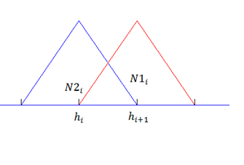

Here are the first-order functions. In the same way are defined polynomials of second, third, etc. order. This will improve accuracy of the method, but at the same time matrices become less sparse and technical implementation of elements of higher order will be more difficult. With modern computers accuracy can be reached on the elements of the first order.

* 1. Problem statement

We consider cylindrical waveguide with circular cross-section Ω with unitary radius r=1. In one point on its axis we set cylindrical coordinating system, axis Oz goes along cylinder axis. Let the waveguide be filled with material with characteristics:



ε(r) is piecewise continuous in Ω, the waveguide walls are perfectly conducting.

Electromagnetic field inside the waveguide is described by a system of eight Maxwell’s equations for 6 unknowns.

(2.1)

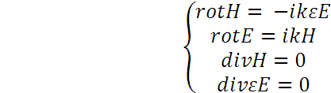

We expand the equation for rotor and rewrite them in cylindrical coordinate system:

(2.2)

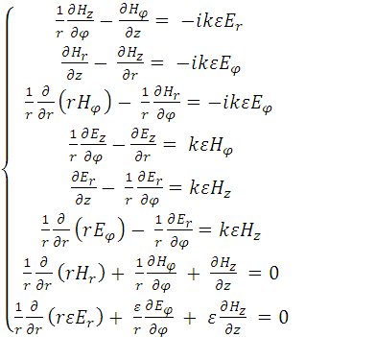

The solution will be in form of normal waves – functions that depend on r, z and φ:

E, H = E(r)eiγz+imφ.

Substituting these normal waves in (2.2), reduce exponential factor – and we come to the problem of finding eigenvalues on segment [0; 1], where γ is eigenvalue:

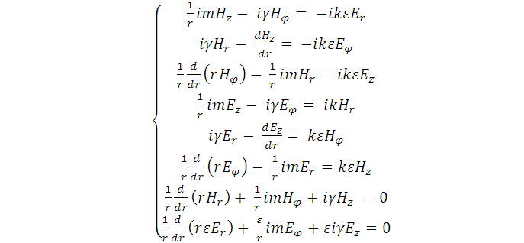

(2.3)

To solve the problem we choose 6 equations:

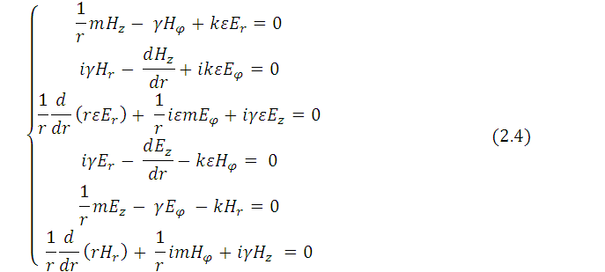

Then, we set X = (Hr, Hφ, Ez)T = (H┴, Ez)T, Y = (εEr, εEφ, Hz)T = (εE┴, Hz)T

If we substitute Y from first 3 equations (2.4) in last 3, we have the problem of finding eigenvalues:

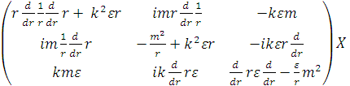

(2.5)

X belongs to the set of vectors from C∞[0,1] and satisfies boundary conditions:

Hr(0) = 0 and Ez(0) = 0

Hr(1) = 0 and Ez(1) = 0,



and to Maxwell’s equation:



and (in case of distontinued ε) the conditions of conjugation are specified:

s = s = 0, s = s = 0



* 1. Variational functional of the problem

We write down the variational functional (weak formulation) for the original problem. To do this, we multiply (2.5) on the left by arbitrary vector = () and integrate over r from 0 to 1. Finally, we have:

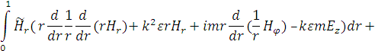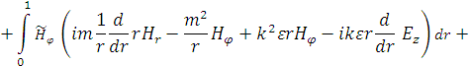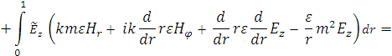

(2.6)

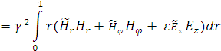

Using boundary conditions, we integrate (2.6) by parts:

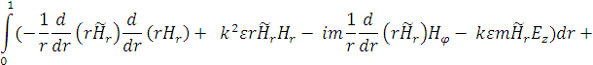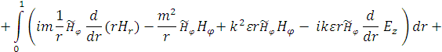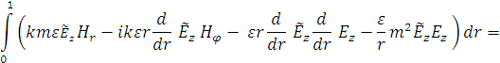

We make the following changes to simplify the calculations in the future, as well as get rid of imaginary one:



Finally, we have variational functional with complex numbers:

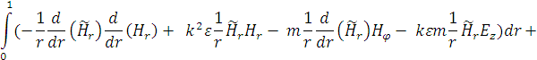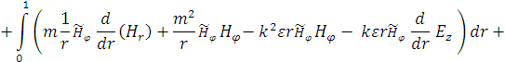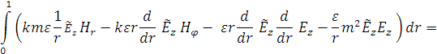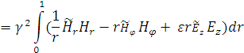

(2.7)

The problem (2.7) has peculiarity in 0. At integration appears indeterminacy – natural logarithm of zero. To avoid it, we put on cylinder axis thin conducting cylinder with radius α and will integrate from α:

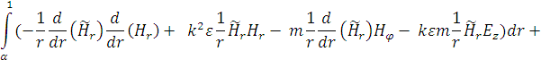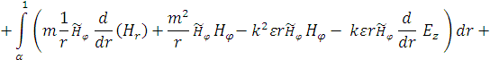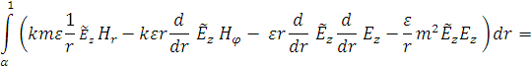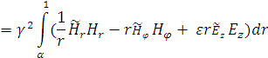

(2.8)

Tend α to zero, then, by theorem of Samarsky, eigenvalues of the problem (2.8) will tend to eigenvalues of original problem (2.7).

The final problem is to find eigenvalues γ – the propagation constant – and to construct dispersion curves – dependence of propagation constant on the wavenumber k.

* 1. Mixed finite elements method

The problem has infinite core:

X = ()



where φ is arbitrary function.

While using standard finite elements method operators core approximates in the wrong way, that causes emergence of non-physical solutions, “spirits” of specter, which locate between genuine values – so we can’t tell the difference. Mixed finite elements analysis helps to avoid it. Method consists of approximation components of vector X with polynomials of different order. In our problem we will approximate Hr and Ez by continuous polynomials of first order and Hφ by discontinuous polynomials of zero order.

We set on segment [α, 1] uniform grid {xi}: i = 0,1,..,n, x0 = a, xn = b, xi = ih, h – is grid spacing, n – number of finite elements.

We assume permittivity to be constant on every finite element. Further, we expend in the basic functions every component of vectors X and



Now we have changes:

|  |  |  |
| --- | --- | --- |
|  |  |  |
|  |  |  |

Where Ni = θN1i+σN2i on segment [hi, hi+1] (on finite element with number i).

Graphically it looks as:

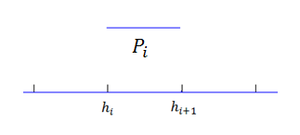

Finite element analysis allows approximate operators core, which tends into zero state, multiplicity of which is about one third of dimension of the matrix eigenvalue problem.

Applying changes, we rewrite variational functional in this way:

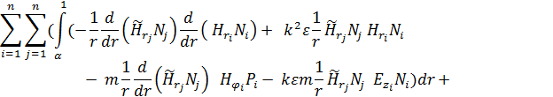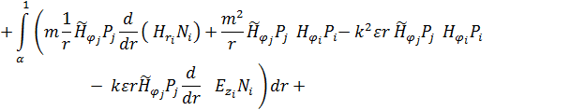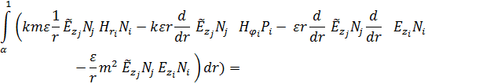

(2.9)

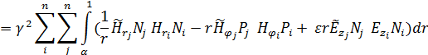

In this way have generalized problem of eigenvalues:

AX = γ2 BX

where A and B are matrices of expansion coefficients of X in the basic functions.

1. Implementation

## 3.1. Environment

Initially, algorithm was implemented in m-language used by Matlab. Matlab is powerful tool for calculations, but to use it you must understand basics of m-language, which is not really suitable for those people, who want to pay more attention to data analysis than to changing source-code. But there is flexible tool for calculations, that works with complicated structures and convenient GUIs. In OS Windows this tool is Visual Studio 2010 with .Net Framework 4.0. As language of program was chosen C#. This language is both powerful and flexible enough for creating wide variety of tools, multilevel hierarchy and simple linking between modules of project, simplifies work with allocated memory.

Probably, the only disadvantage of using C# is that implementing quick numerical algorithms of finding generalized eigenvalues may last for really long time. But the problem can be solved by using combination of Visual Studio and Matlab, whereas VS allows references to third-party libraries (libraries of Matlab for example) and Matlab allows creating dynamic libraries using side compilers (MS VS compiler).

Hereinafter implemented program will be called FEAA (Finite Elements Analysis Application).

## 3.2. Implementation

Characteristics which are to be presented for the waveguide are dispersion characteristics. They demonstrate wave propagation in waveguide. More important is to find critical conditions of limited decay. They show limits of waves decay in waveguides and conditions of existence complex waves in multilayer waveguides. Critical values are all values between conditions. Within the curve of critical values waves decay.

Program consists of several separate modules: program calculating core and GUI.

In calculating core are modules of:

* Complex numbers with operations (arithmetic, sorting, conversion to decimal numbers and strings)
* Matrices with operations (matrix arithmetic, eigenvalues)
* Final calculations of propagation constant

Source code of main functions of the core are in appendices.

Calculations go according to finite elements analysis. First we should form matrices of expansion coefficients (A and B). Whatever we calculate – dispersion characteristics or conditions of limited decay – we have to compute generalized eigenvalues of A and B. The best way to find them was using m-function from Matlab libraries: e = eig(A,B). This function uses following algorithms and functions [1]:

* Reduction to Hessenberg matrix with orthogonal conversion
* Memorizing all conversions using “orthan” function
* QR-algorithm of Francis and Cublanovskaya for conversion to upper mold Hessenberg matrix
* QZ-algorithm of finding eigenvalues

Eigenvalues are sorted and we make selection to compose dispersion characteristics (app. 6.3). Special selection is made for conditions of limited decay.

Final phase of application is plot assay. On charts you can see the results, detail them and save in both numeric and graphic ways. Results are saved in .csv file, which includes:

* Type of calculations
* Initial layers characteristics
* Characteristics of wavenumber change (and radius if type is critical conditions of limited decay)

and

* Dispersion characteristics or critical conditions/values of limited decay. Dispersion characteristics are the table of wavenumbers and corresponding propagation constant. As a result of computing critical conditions is essential to present radiuses where they appear. Commonly, propagation constant is complex, so it is presented as ‘a+i*b’.

Both plots – real and imaginary parts of results – are saved as .png pictures.

## 3.3. GUI

GUI consists of three windows.

Introducing window (pic.1) allows user to enter all data needed for calculations and get information about program usage and system requirements.

Progress-page shows time estimated for calculations and percentage of completed calculations (pic. 2-3). Calculations works in parallel thread with GUI – that allows user interact with program at the same time.

When calculations are finished appears window with charts containing chosen values: dispersion characteristics or critical conditions/values of limited decay (pic. 4).

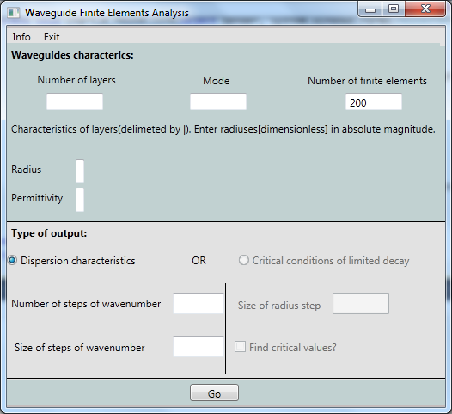

Picture 1. Introducing window.

Every field has its own tooltip with information what should be users input, its limits and form. Also, we can see menu with item Info which contains full information about program usage.

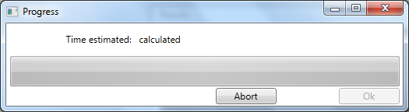

Picture 2. Progress-page: time is calculated at the beginning.

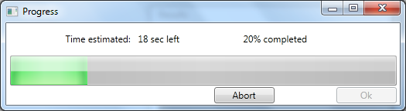

Picture 3. Calculations in progress.

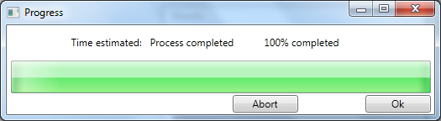

Picture 3.1. Calculations finished.

While calculations are running progress-page shows approximate time estimated and percentage of completed calculations. Also, this page provides ability to abort calculations any time.

When calculations are finished “OK” button changes its state to enabled and results will appear after pressing it. Even pages title changes according to users choice. It would be “Dispersion characteristics”, “Critical conditions” or “Critical values”. You can see two charts showing dependence between propagation constant and wavenumber. Upper one shows real part of constant and lower shows imaginary part.

Dispersion characteristics always appear on two chart (real and imaginary parts of propagation constant). Critical conditions of limited decay by their definition are imaginary, so the only chart is imaginary part of constant. Critical values are all the values between critical conditions for every radius, that’s why the best way to present them is to create its own chart for every radius.

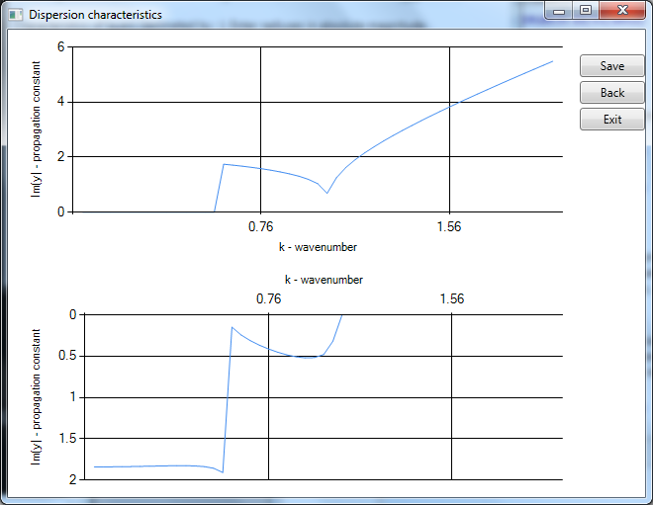

Picture 4. Charts showing dispersion characteristics.

1. Verification and testing

Every application related with calculations must have high precision of results. This application works on algorithm initially programmed in Matlab. Matlab doesn’t allow to automatize all the calculations and graphical from of results, but gives high precision. Facilities of .Net Framework and C# language allow to simplify work with pure functions and results using GUI. So, usage of combination of both tools is efficient, but before using the application widely the results must be verified and compared with ready computations.

The program is not real-time. When you need results with good precision it may take long time. FEAA program gives better precision than initial Matlab program.

Results of initial program on m-language for 2 layers waveguides were compared with source [2], so we can compare results of implemented application with them.

Results for 6-layer waveguide are compared between the programs.

Tests check correctness of results of different types and with different characteristics and precision. First we should check that base – waveguides with two layers – is computed correctly. Then – 6 layers. And finally, critical conditions of limited decay and critical values.

Table 1. Tests summary.

|  |  |  |
| --- | --- | --- |
| Test # | Output type | Summary |
| 1 | Dispersion characteristics | Simple waveguide with two layers; comparison with original program |
| 2 | Dispersion characteristics | Waveguide with 6 layers; mode 2(primary mode); comparison with original program |
| 3 | Critical conditions | Comparison with original program; different steps of wavenumber: 0.01 and 0.04 |
| 4 | Dispersion characteristics | Waveguide with 6 layers; modes 3 and 4 (higher-order mode); comparison with original program |
| 5 | Critical values | Purpose of the test is to show how precision changes in dependence with precision of initial characteristics (in this test – step of radius of inside layer) |
| 6 | Critical conditions | Comparison with source [2]; demonstration that if not sure in graphical results – you may compare with table. |

**Test 1.**

Waveguide with 2 layers. Permittivity changes as:

$ε(r)$ = $\left\{\begin{aligned}10, r≤0.2 \\ 1, r>0.2\end{aligned}\right.$

Original program results – picture 5. Time – about 20 minutes.

FEAA results – picture 6. Time – about 15 minutes.

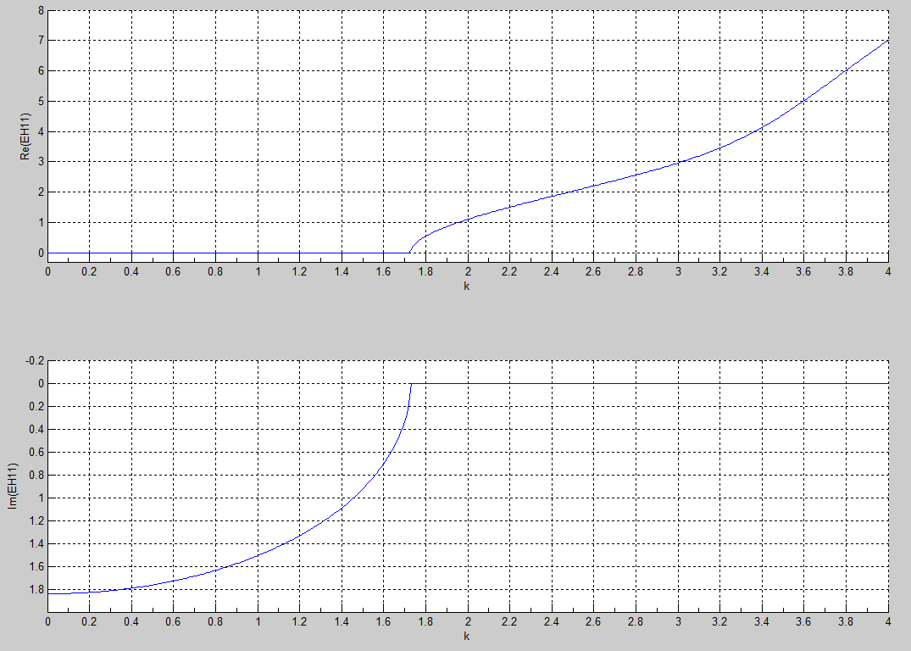

Picture 5. Original program results. Layers – 2, inside layer radius – 20% of total waveguide radius.

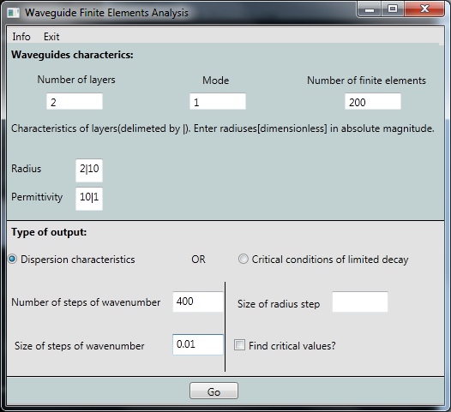

Picture 6. FEAA input matching original input.

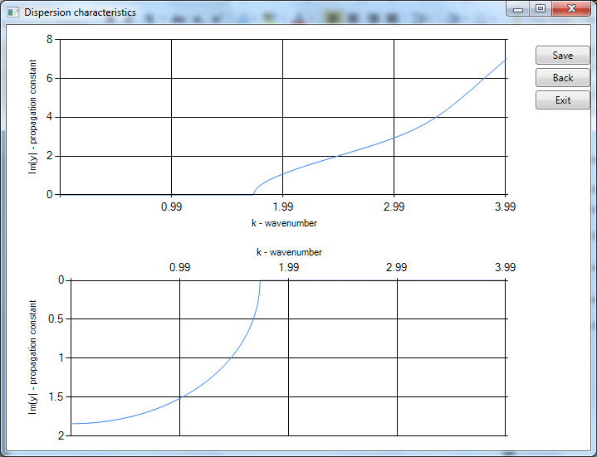

Picture 7. FEAA results. Layers – 2, inside layer radius – 20% of total waveguide radius.

## Test 2.

Dispersion characteristics of waveguide with 6 layers.

Layers characteristics:

|  |  |  |  |  |  |  |
| --- | --- | --- | --- | --- | --- | --- |
| Radius | 0.2 | 0.4 | 0.6 | 0.8 | 0.9 | 1 |
| Permittivity | 1 | 0.5 | 8 | 2 | 1.9 | 10 |

Mode: 2

Number of operations: 50.

Original program – time: about 4 minutes of calculation.

FEAA – time: about 3 minutes.

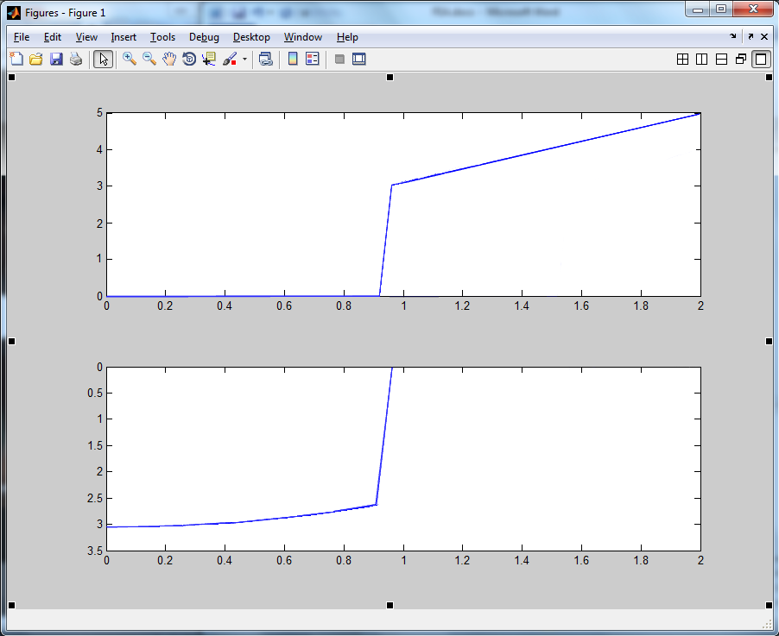

Picture 8. Original program results.

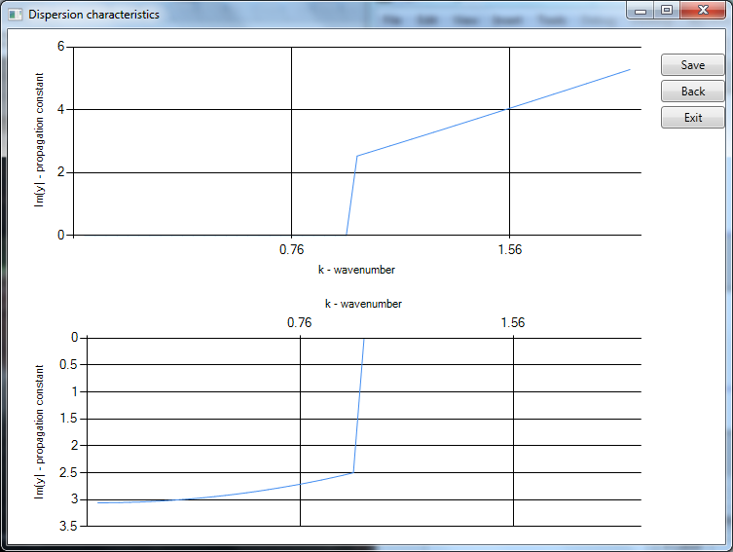

Picture 9. FEAA results.

## Test 3.

Critical conditions for waveguide with 2 layers.

Original program – picture 10. Time – about 150 minutes of pure calculations. Also it needs manual finding of critical conditions of limiting decay.

FEAA results – picture 12. Time – 133 minutes of pure calculations and about 20-40sec to form charts.

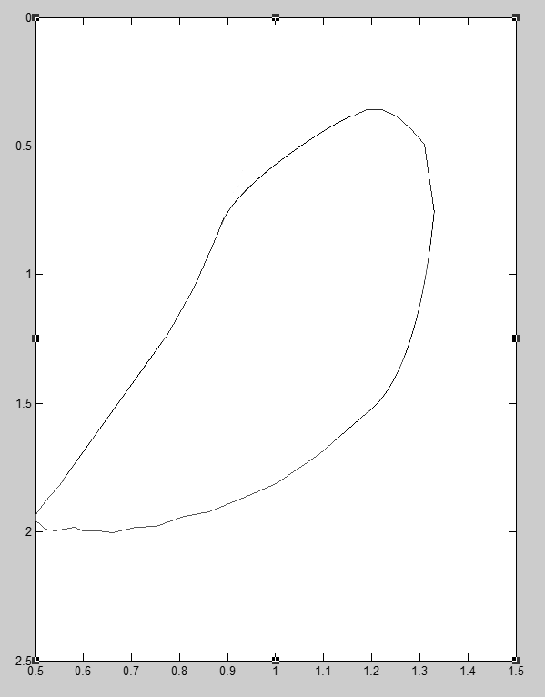

Picture 10. Original program results.

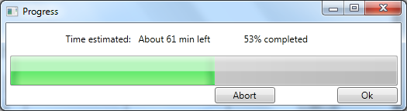

Picture 11. Progressbar while calculations.

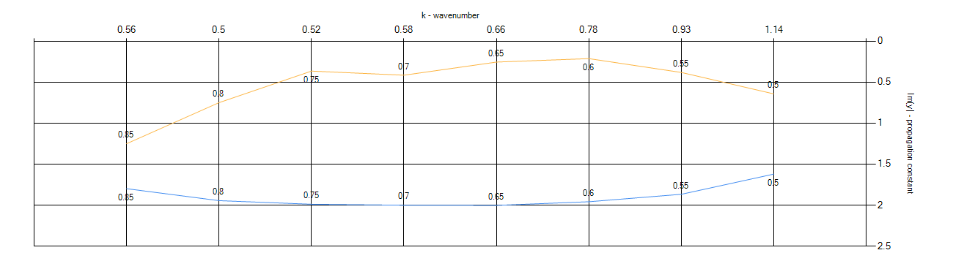

Picture 12a. FEAA results(wavenumber step 0.01). Results have numerical and graphical compliance with original program and source [2].

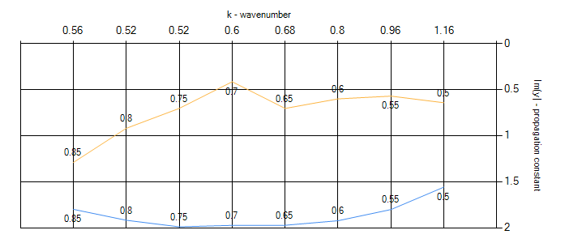

Picture 12b. FEAA results(wavenumber step 0.04).

**Test 4.**

Waveguide with 6 layers. For modes 3 and 4.

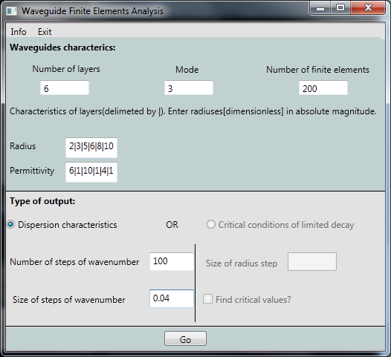

Picture 13. Waveguides characteristics.

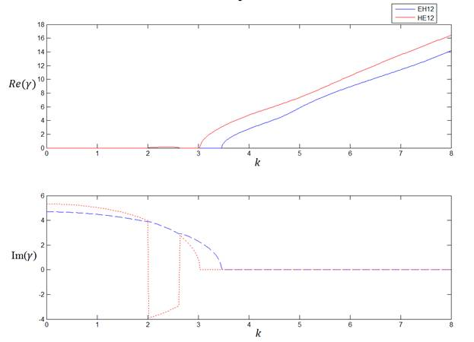

Picture 14. Original program result.

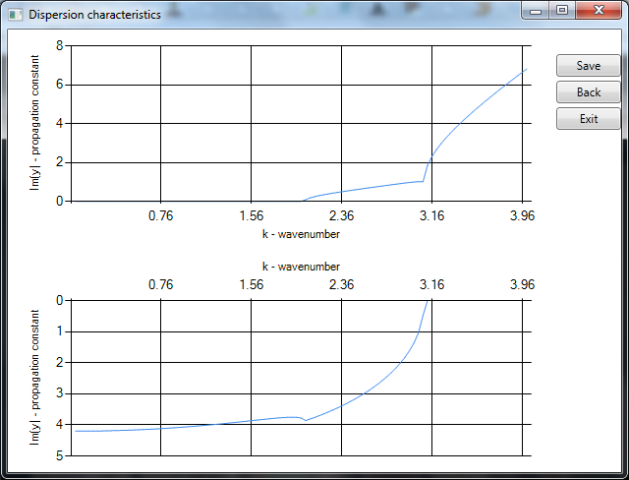

Picture 15.1. FEAA results: mode 3.

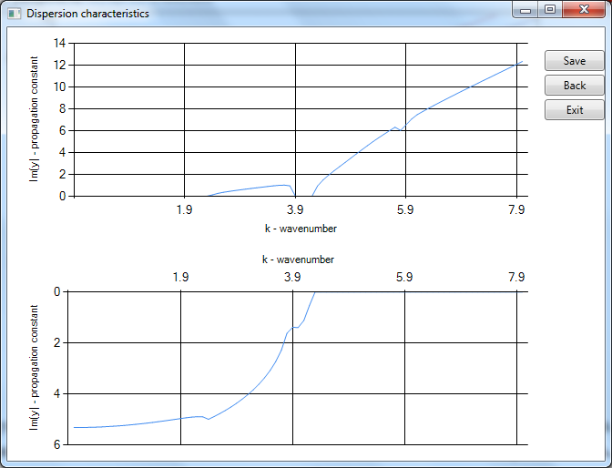

Picture 15.2. FEAA results: mode 4.

**Test 5.**

Critical values. Quantity of found critical values depends on initial precision – size of wavenumber steps. As you can see on pic. 16 and 18 all other characteristics are the same, but size and number of steps of wavenumber and size of radius are changed. The results are represented on pic. 17 and 19.

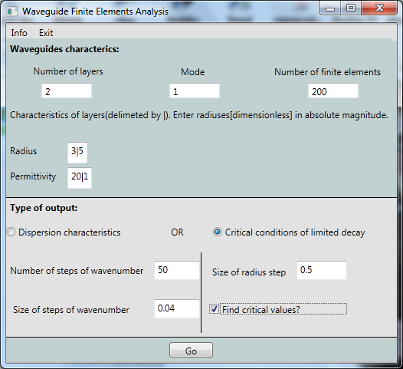

Picture 16.

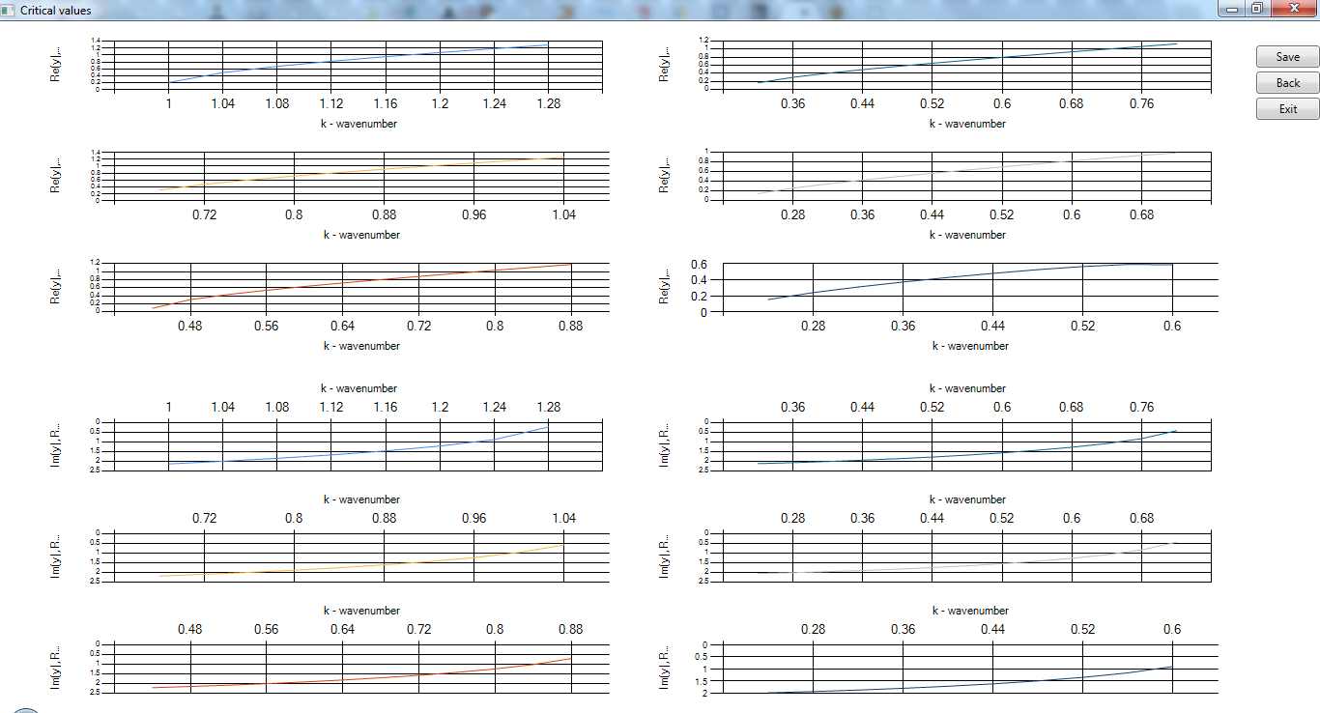

Picture 17. Critical values.

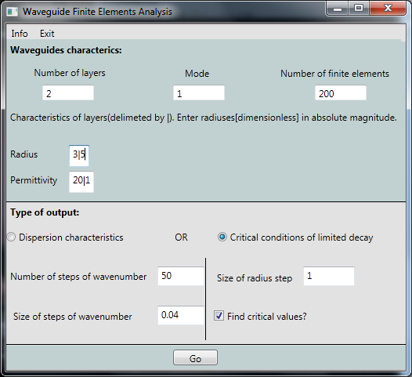

Picture 18.

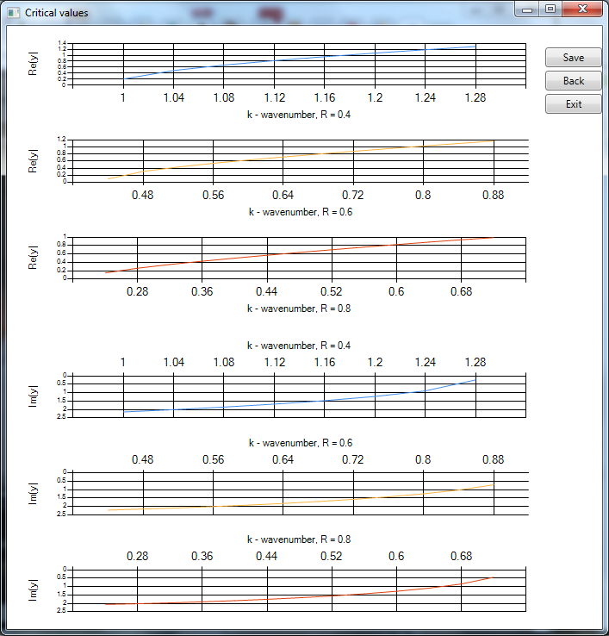

Picture 19. Less critical values.

## Test 6.

Critical conditions.

Permittivity changes as:

=

In this test we can see comparison between source [2] and program results.

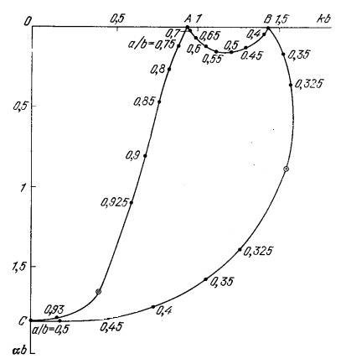

Picture 20. Original chart from source.

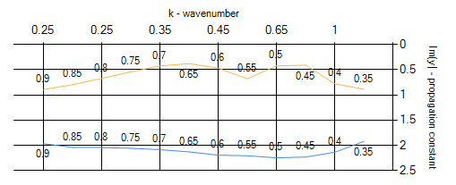

Picture 21. FEAA charts.

We can see offset. But if we compare results in table 2 and pic.20 we can find that results are approximately the same in accordance with precision.

Table 2. Critical conditions.



1. Conclusion

Problem of searching for waveguides dispersion characteristics is really complicated and takes lots of computing sources, but FEAA solves this problem in acceptable time and limits memory allocation. With further development of application and algorithm itself the problem can get more précised solution.

Finite elements analysis is method which allows avoiding non-physical solutions while searching for dispersion characteristics, but its usage may cause memory leaks. FEAA applies this method in a way that memory allocation in every moment of time is limited.

Usage of built-in libraries of Matlab system contributes to increasing speed of application computing and presents high precision of results.

Program includes convenient GUI simplifying users calls to calculation core and permitting analyzing of obtained results both as plots and numerically.

Despite its obvious advantages, application has certain shortcomings. First of them is necessity to limit users input, for example, number of finite elements: it is bounded from below with minimal needed precision and to the top – with average computing capacity of modern PC.

Though the program works quite fast, it’s always better to see it computing faster and with the same precision.

In line with two previous paragraphs it seems appropriate to further work in improving the accuracy of calculations and optimization of timing. When time optimization is done, e.g. quicker algorithm or calculations in different threads, accuracy automatically improves.

Also, future work should be aimed on finding dispersion characteristics for complex permittivity and critical conditions of limited decay for multilayer waveguides (more than two layers), but these calculations are connected with time and memory allocation.

References

1. Garbow B. S., Boyle J. M., Dongarra J. J., Moler C. B.. Matrix Eigensystem Routines - EISPACK Guide Extension//Lecture Notes in Computer Science. Berlin, 1977. Vol. 51.
2. Veselov G.I., Raevskij S.B.. Multilayer metal dielectric waveguides. Moscow, 1988.
3. Wait R., Mitchell A.R.. Finite Element Analysis and Applications. 1985.
4. Wait R., Mitchell A.R.. Finite Element Analysis in PDEs. 1981.
5. Vainshtein L.A.. Electromagnetic waves. Moscow, 1988
6. Basharin A.A., Menshih N.L.. Features of the propagation of electromagnetic waves in a waveguide of a metamaterial with losses. (E-magazine) 2010. URL: <http://jre.cplire.ru/jre/nov10/2/text.pdf>
7. Caloz C., Itoh T. Electromagnetic metamaterials: transmission line theory and microwave applications. N.Y.: John Wiley and Sons, Inc., 2006.
8. Smolentsev N.K.. Matlab. Programming in Visual C#, Borland JBuilder, VBA.
9. Appendices

## 6.1. Complex number

Comparison(according to Matlab comparison)

public static bool operator <(Complex c1, Complex c2)

{

double a1 = c1.re;

double a2 = c2.re;

double b1 = c1.im;

double b2 = c2.im;

if (c1.Abs() < c2.Abs()) return true;

if (c1.Abs() > c2.Abs()) return false;

if (c1.Abs() == c2.Abs())

{

if ((a1 > 0 && a2 > 0 && b1 > 0 && b2 > 0) || (a1 < 0 && a2 < 0 && b1 < 0 && b2 < 0))

{

if (c1.Arg() < c2.Arg()) return true;

return false;

}

if ((a1 < 0 && a2 > 0 && b1 > 0 && b2 > 0))

{

return false;

}

if ((a1 > 0 && a2 < 0 && b1 < 0 && b2 < 0))

{

return false;

}

if ((a1 < 0 && a2 < 0 && b1 > 0 && b2 > 0) || (a1 > 0 && a2 > 0 && b1 < 0 && b2 < 0))

{

if (Math.Abs(c1.Arg()) > Math.Abs(c2.Arg())) return true;

return false;

}

if (b1 > 0 && b2 < 0) return true;

if (a1 == 0 || a2 == 0)

{

if (c1.im < c2.im) return true;

return false;

}

if (b1 == 0 || b2 == 0)

{

if (c1.re < c2.re) return true;

return false;

}

return false;

}

return false;

}

## 6.2. Matrixes

#region Final Matrices

/// <summary>

/// Setting of matrix A

/// </summary>

/// <param name="n">number of columns and rows</param>

/// <param name="kc">wave number</param>

/// <param name="ec">permitivity</param>

/// <param name="mc">mode</param>

/// <param name="r">Width of layer</param>

public void SetA(int n, double kc, int mc, WorkObject.LAY[] layers)

{

double eps = epsR;

double hc = 1.0/n;

double ec = layers[0].perm;

double ec1 = 0;

if (this.Cols() == 0 || this.Rows() == 0)

{

this.rows = 3*n-2;

this.cols = 3*n-2;

this.matrix = new double[3 * n - 2, 3 * n - 2];

}

{

this.matrix[0, 0] = (pA22(eps,hc,kc,ec)+ pA11(1,hc,kc,ec));

this.matrix[0, 1] = (pA23(eps, hc, mc));

this.matrix[0, 2] = (pA25(eps, hc, kc, ec, mc) + pA14(1, hc, kc, ec, mc));

this.matrix[1, 0] = (pA32(eps, hc, mc));

this.matrix[1, 1] = (pA33(eps, hc, kc, ec, mc));

this.matrix[1, 2] = (pA35(eps, hc, kc, ec));

this.matrix[2, 0] = (pA52(eps, hc, kc, ec, mc) + pA41(1, hc, kc, ec, mc));

this.matrix[2, 1] = (pA53(eps, hc, kc, ec));

this.matrix[2, 2] = (pA55(eps, hc, ec, mc) + pA44(1, hc, ec, mc));

this.matrix[0, 3] = (pA12(1, hc, kc, ec));

this.matrix[0, 4] = (pA13(1, hc, mc));

this.matrix[0, 5] = (pA15(1, hc, kc, ec, mc));

this.matrix[2, 3] = (pA42(1, hc, kc, ec, mc));

this.matrix[2, 4] = (pA43(1, hc, kc, ec));

this.matrix[2, 5] = (pA45(1, hc, ec, mc));

this.matrix[3, 0] = (pA21(1, hc, kc, ec));

this.matrix[3,2] = (pA24(1,hc,kc,ec,mc));

this.matrix[3,3] = (pA22(1,hc,kc,ec) + pA11(2,hc,kc,ec));

this.matrix[3,4] = (pA23(1,hc,mc));

this.matrix[3,5] = (pA25(1,hc,kc,ec,mc) + pA14(2,hc,kc,ec,mc));

this.matrix[4,0] = (pA31(1,hc,mc));

this.matrix[4,2] = (pA34(1,hc,kc,ec));

this.matrix[4,3] = (pA32(1,hc,mc));

this.matrix[4,4] = (pA33(1,hc,kc,ec,mc));

this.matrix[4,5] = (pA35(1,hc,kc,ec));

this.matrix[5,0] = (pA51(1,hc,kc,ec,mc));

this.matrix[5,2] = (pA54(1,hc,ec,mc));

this.matrix[5,3] = (pA52(1,hc,kc,ec,mc) + pA41(2,hc,kc,ec,mc));

this.matrix[5,4] = (pA53(1,hc,kc,ec));

this.matrix[5,5] = (pA55(1,hc,ec,mc) + pA44(2,hc,ec,mc));

this.matrix[3,6] = (pA12(2,hc,kc,ec));

this.matrix[3,7] = (pA13(2,hc,mc));

this.matrix[3,8] = (pA15(2,hc,kc,ec,mc));

this.matrix[5,6] = (pA42(2,hc,kc,ec,mc));

this.matrix[5,7] = (pA43(2,hc,kc,ec));

this.matrix[5,8] = (pA45(2,hc,ec,mc));

this.matrix[6,3] = (pA21(2,hc,kc,ec));

this.matrix[6,5] = (pA24(2,hc,kc,ec,mc));

this.matrix[6,6] = (pA22(2,hc,kc,ec) + pA11(3,hc,kc,ec));

this.matrix[6,7] = (pA23(2,hc,mc));

this.matrix[6,8] = (pA25(2,hc,kc,ec,mc) + pA14(3,hc,kc,ec,mc));

this.matrix[7,3] = (pA31(2,hc,mc));

this.matrix[7,5] = (pA34(2,hc,kc,ec));

this.matrix[7,6] = (pA32(2,hc,mc));

this.matrix[7,7] = (pA33(2,hc,kc,ec,mc));

this.matrix[7,8] = (pA35(2,hc,kc,ec));

this.matrix[8,3] = (pA51(2,hc,kc,ec,mc));

this.matrix[8,5] = (pA54(2,hc,ec,mc));

this.matrix[8,6] = (pA52(2,hc,kc,ec,mc) + pA41(3,hc,kc,ec,mc));

this.matrix[8,7] = (pA53(2,hc,kc,ec));

this.matrix[8,8] = (pA55(2,hc,ec,mc) + pA44(3,hc,ec,mc));

for (int i1 = 1; i1 < n-3; i1++)

{

double pec1 = ec;

for (int ii = 1; ii < layers.Length; ii++)

{

if (pec1 != ec) ec1 = pec1;

else ec1 = ec;

if ((i1 + 3) * hc > layers[ii - 1].R - st2)

{

ec1 = layers[ii].perm;

pec1 = ec1;

}

if ((i1 + 3) * hc > layers[ii - 1].R - st1)

{

ec = layers[ii].perm;

}

}

this.matrix[3 + i1 * 3, 6 + i1 * 3] = (pA12(2 + i1, hc, kc, ec));

this.matrix[3 + i1 * 3, 7 + i1 * 3] = (pA13(2 + i1, hc, mc));

this.matrix[3 + i1 * 3, 8 + i1 * 3] = (pA15(2 + i1, hc, kc, ec, mc));

this.matrix[5 + i1 * 3, 6 + i1 * 3] = (pA42(2 + i1, hc, kc, ec, mc));

this.matrix[5 + i1 * 3, 7 + i1 * 3] = (pA43(2 + i1, hc, kc, ec));

this.matrix[5 + i1 * 3, 8 + i1 * 3] = (pA45(2 + i1, hc, ec, mc));

this.matrix[6 + i1 * 3, 3 + i1 * 3] = (pA21(2 + i1, hc, kc, ec));

this.matrix[6 + i1 * 3, 5 + i1 * 3] = (pA24(2 + i1, hc, kc, ec, mc));

this.matrix[6 + i1 * 3, 6 + i1 * 3] = (pA22(2 + i1, hc, kc, ec) + pA11(3 + i1, hc, kc, ec1));

this.matrix[6 + i1 * 3, 7 + i1 * 3] = (pA23(2 + i1, hc, mc));

this.matrix[6 + i1 * 3, 8 + i1 * 3] = (pA25(2 + i1, hc, kc, ec, mc) + pA14(3 + i1, hc, kc, ec1, mc));

this.matrix[7 + i1 * 3, 3 + i1 * 3] = (pA31(2 + i1, hc, mc));

this.matrix[7 + i1 * 3, 5 + i1 * 3] = (pA34(2 + i1, hc, kc, ec));

this.matrix[7 + i1 * 3, 6 + i1 * 3] = (pA32(2 + i1, hc, mc));

this.matrix[7 + i1 * 3, 7 + i1 * 3] = (pA33(2 + i1, hc, kc, ec, mc));

this.matrix[7 + i1 * 3, 8 + i1 * 3] = (pA35(2 + i1, hc, kc, ec));

this.matrix[8 + i1 * 3, 3 + i1 * 3] = (pA51(2 + i1, hc, kc, ec, mc));

this.matrix[8 + i1 * 3, 5 + i1 * 3] = (pA54(2 + i1, hc, ec, mc));

this.matrix[8 + i1 * 3, 6 + i1 * 3] = (pA52(2 + i1, hc, kc, ec, mc) + pA41(3 + i1, hc, kc, ec1, mc));

this.matrix[8 + i1 * 3, 7 + i1 * 3] = (pA53(2 + i1, hc, kc, ec));

this.matrix[8 + i1 * 3, 8 + i1 * 3] = (pA55(2 + i1, hc, ec, mc) + pA44(3 + i1, hc, ec1, mc));

}

this.matrix[6 + 3 * (n - 4), 9 + 3 * (n - 4)] = (pA13(3 + n - 4, hc, mc));

this.matrix[8 + 3 * (n - 4), 9 + 3 * (n - 4)] = (pA43(3 + n - 4, hc, kc, ec));

this.matrix[9 + 3 * (n - 4), 6 + 3 * (n - 4)] = (pA31(3 + n - 4, hc, mc));

this.matrix[9 + 3 * (n - 4), 8 + 3 * (n - 4)] = (pA34(3 + n - 4, hc, kc, ec));

this.matrix[9 + 3 * (n - 4), 9 + 3 * (n - 4)] = (pA33(3 + n - 4, hc, kc, ec, mc));

}

}

/// <summary>

/// Setting of matrix B

/// </summary>

/// <param name="n">number of columns and rows</param>

/// <param name="kc">wave number</param>

/// <param name="ec">permitivity</param>

/// <param name="mc">mode</param>

/// <param name="r">Width of layer</param>

public void SetB(int n, double kc, int mc, WorkObject.LAY[] layers)

{

double eps = epsR;

double hc = 1.0/n;

double ec = layers[0].perm;

double ec1 = 0;

if (this.Cols() == 0 || this.Rows() == 0)

{

this.rows = 3 * n - 2;

this.cols = 3 * n - 2;

this.matrix = new double[3 * n - 2, 3 * n - 2];

}

{

this.matrix[0, 0] = (pB22(eps, hc) + pB11(1, hc));

this.matrix[1, 1] = (pB33(eps, hc));

this.matrix[2, 2] = (pB55(eps, hc, ec) + pB44(1, hc, ec));

this.matrix[0, 3] = (pB12(1, hc));

this.matrix[2, 5] = (pB45(1, hc, ec));

this.matrix[3, 0] = (pB21(1, hc));

this.matrix[3, 3] = (pB22(1, hc) + pB11(2, hc));

this.matrix[4, 4] = (pB33(1, hc));

this.matrix[5, 2] = (pB54(1, hc, ec));

this.matrix[5, 5] = (pB55(1, hc, ec) + pB44(2, hc, ec));

this.matrix[3, 6] = (pB12(2, hc));

this.matrix[5, 8] = (pB45(2, hc, ec));

this.matrix[6, 3] = (pB21(2, hc));

this.matrix[6, 6] = (pB22(2, hc) + pB11(3, hc));

this.matrix[7, 7] = (pB33(2, hc));

this.matrix[8, 5] = (pB54(2, hc, ec));

this.matrix[8, 8] = (pB55(2, hc, ec) + pB44(3, hc, ec));

for (int i1 = 1; i1 < n-3; i1++)

{

double pec1 = ec;

for (int ii = 1; ii < layers.Length; ii++)

{

if (pec1 != ec) ec1 = pec1;

else ec1 = ec;

if ((i1 + 3) * hc > layers[ii - 1].R - st2)

{

ec1 = layers[ii].perm;

pec1 = ec1;

}

if ((i1 + 3) * hc > layers[ii - 1].R - st1)

{

ec = layers[ii].perm;

}

}

this.matrix[3 + i1*3,6 + i1*3] = (pB12(2 + i1,hc));

this.matrix[5 + i1*3,8 + i1*3] = (pB45(2 + i1,hc,ec));

this.matrix[6 + i1*3,3 + i1*3] = (pB21(2 + i1,hc));

this.matrix[6 + i1*3,6 + i1*3] = (pB22(2 + i1,hc) + pB11(3 + i1,hc));

this.matrix[7 + i1*3,7 + i1*3] = (pB33(2 + i1,hc));

this.matrix[8 + i1*3,5 + i1*3] = (pB54(2 + i1,hc,ec));

this.matrix[8 + i1*3,8 + i1*3] = (pB55(2 + i1,hc,ec) + pB44(3 + i1,hc,ec1));

}

this.matrix[6 + 3*(n-4),9 + 3*(n-4)] = (pB12(3 + n-4,hc));

this.matrix[9 + 3*(n-4),6 + 3*(n-4)] = (pB21(3 + n-4,hc));

this.matrix[9 + 3*(n-4),9 + 3*(n-4)] = (pB33(3 + n-4,hc));

}

}

#endregion

#region "Eigenvalues"

//Matlab Arrays for eigenvalues

private MWArray[] res = null;

private MWNumericArray real = null;

private MWNumericArray imag = null;

private Complex[] eigenvalues;

/// <summary>

/// Generalised eigenvalues of A and B (analog to MATLAB M = eig(A,B))

/// </summary>

/// <param name="B">Matrix B</param>

/// <returns>Generalised eigenvalues</returns>

public Complex[] eige(Matrix B)

{

//calling Matlab API

Eig testob = new Eig();

//Matlab Array which gets result of Matlab function eig(A,B)

res = testob.Eigenvalues(2, (MWNumericArray)this.matrix, (MWNumericArray)B.matrix, this.Rows());

//arrays for real and imaginary parts

real = (MWNumericArray)res[0];

imag = (MWNumericArray)res[1];

//copying parts into CSharp arrays

double[,] resCR = (double[,])real.ToArray(MWArrayComponent.Real);

double[,] resCI = (double[,])imag.ToArray(MWArrayComponent.Real);

this.eigenvalues = new Complex[21];

Complex[] eigenbuf = new Complex[this.rows];

for (int i = 0; i < this.rows; i++)

{

eigenbuf[i] = new Complex(resCR[i, 0], resCI[i,0]);

eigenbuf[i] = eigenbuf[i].Pow(0.5);

}

Complex buf = new Complex();

buf.quickSort(ref eigenbuf, 0, this.rows-1);

for (int i = 0; i < 21; i++)

{

this.eigenvalues[i] = eigenbuf[200 + i - 1];

}

return this.eigenvalues;

}

#endregion

## 6.3. Characteristics

#region "Critical values and conditions"

/// <summary>

/// Function searches critical values and condition. Result depends on param "isCond"

/// </summary>

/// <param name="fe">#finite elements</param>

/// <param name="Cstep">Step for radius checking</param>

/// <param name="Nsteps">Step of wave number</param>

/// <param name="step">Size of step of wave number</param>

/// <param name="mode">Mode #</param>

/// <param name="ec">Permittivity</param>

/// <param name="isCond">Choise of return</param>

/// <returns>

/// If isCond = true: function returns critical conditions, values that are the first and the last complex numbers in all

/// dispersion characteristics

/// If isCond = false: function returns critical values: all the numbers between critical(including them)

/// </returns>

public CRIT[] Crit(int fe, double Cstep, int Nsteps, double step, int mode, LAY[] L, ref System.ComponentModel.BackgroundWorker bg, bool isCond = true)

{

if (L.Length == 2)

{

int N = Convert.ToInt32(1 / Cstep);

LAY[] bufL = new LAY[L.Length];

bufL = L;

CRIT[] buf = new CRIT[N];

CRIT[] precrit = new CRIT[N];

for (int i = 0; i < N; i++)

{

precrit[i].D = new DISP[2];

}

CRIT[] critVal = new CRIT[N];

bool isChecked = false;

int iniProgress = 0;

int coef = N;

//all the dispersion characteristics for every radius

for (int i = 0; i < N; i++)

{

buf[i].R = i * Cstep;

bufL[0].R = i * Cstep;

if (i == 0) isChecked = false;

else isChecked = true;

buf[i].D = dispersion(fe, Nsteps, step, mode, bufL, ref bg, ref iniProgress, coef, isChecked);

}

#region "Filling critical values and conditions"

for (int i = 0; i < N; i++)

{

int Beg = 0, End = 0;

for (int ii = 0; ii < Nsteps; ii++)

{

if (buf[i].D[ii].y.isComplex())

{

precrit[i].R = buf[i].R;

precrit[i].D[0] = buf[i].D[ii];

Beg = ii;

break;

}

}

if (Beg != 0)

{

for (int ii = Nsteps - 1; ii > 1; ii--)

{

if (buf[i].D[ii].y.isComplex())

{

precrit[i].R = buf[i].R;

precrit[i].D[1] = buf[i].D[ii];

End = ii;

break;

}

}

}

if (Beg != 0 && End != 0 && !isCond)

{

critVal[i].D = new DISP[End - Beg + 1];

critVal[i].R = buf[i].R;

for (int ii = Beg; ii <= End; ii++)

{

critVal[i].D[ii - Beg] = buf[i].D[ii];

}

}

}

if (!isCond)

{

int counter = 0;

CRIT[] bufcrit = new CRIT[N];

for (int j = 0; j < N; j++)

{

if (!isNull(critVal[j].R))

{

bufcrit[counter] = critVal[j];

counter++;

}

}

critVal = new CRIT[counter];

for (int j = 0; j < counter; j++)

critVal[j] = bufcrit[j];

return critVal;

}

else

{

//deleting "null" in precrit

int counter = 0;

CRIT[] bufcrit = new CRIT[N];

for (int i = 0; i < N; i++)

{

if (!isNull(precrit[i].R))

{

bufcrit[counter] = precrit[i];

counter++;

}

}

CRIT[] critCond = new CRIT[counter];

//final array of critical conditions

for (int i = 0; i < counter; i++)

{

critCond[i] = bufcrit[i];

}

#endregion

return critCond;

}

}

else

{

CRIT[] c = new CRIT[1];

c[0].R = 0.0;

c[0].D = new DISP[1];

c[0].D[0].k = 0.0;

c[0].D[0].y = new Complex();

return c;

}

}

#endregion

## 6.4. Example of saved characteristics.

