Program Brief

I have been asked to create a program to converting between ASCII art to RLE. The program allows i to compress the file size of ASCII art files. The aim of compression is to reduce the number of bits needed to represent data. Reducing the number of bits used means that the data will take up less storage space and be quicker to transfer. My program needs to be created so it can compress ASCII art using RLE and decompress ASCII art that has been compressed using RLE.

Two text files have been provided that I may choose to use when testing my program:

* **LogoArt.txt** contains the ASCII art image

* **LogoRLE.txt** contains the compressed version of the ASCII art image

When completing this programming project, I should always use two digits to represent the length of a run, even if the run could be represented using just one digit.

A menu is displayed allowing the user to select from the following options:

* Enter RLE
* Display ASCII art
* Convert to ASCII art
* Convert to RLE
* Quit.

If the user selects the ‘Quit’ option then a suitable message should be displayed and the program ends.

If the user selects the ‘Enter RLE’ option:

* + the user is asked how many lines of RLE compressed data they want to enter
  + the program should check that the number entered is greater than 2 and if it isn’t display a suitable error message and get the user to keep re-entering the number until it is valid
  + if the user entered a valid number, they then enter the compressed data one line at a time until they have entered the specified number of lines
  + once all the compressed data has been entered, the program decompresses the data and displays the ASCII art image
  + The user is returned to the main menu.

If the user selects the ‘Display ASCII art' option:

* + the user is asked to enter the name of the text file that contains the ASCII art
  + the program reads the contents of the text file and displays the ASCII art image
  + The user is returned to the main menu.

If the user selects the ‘Convert to ASCII art’ option:

* + the user is asked to enter the name of the text file that contains the RLE compressed data
  + the program reads the contents of the text file, decompresses the data and displays the ASCII art image
  + The user is returned to the main menu.

If the user selects the ‘Convert to RLE’ option:

* + the user is asked to enter the name of the text file that contains the ASCII art
  + the program reads the contents of the text file, compresses each line and stores the compressed data in a new text file
  + the program calculates the difference between the number of characters used in the compressed and uncompressed versions of the ASCII art and displays this value
  + The user is returned to the main menu.

I am writing this program using Python programming language. It is version 3.7.4 and the writing is in the IDLE window.

Designing the Solution

C:\Users\wea-15thsi\AppData\Local\Microsoft\Windows\INetCache\Content.Word\NEA programming-Copy of Convert to RLE (1).pngC:\Users\wea-15thsi\AppData\Local\Microsoft\Windows\INetCache\Content.Word\NEA programming-Copy of Convert to RLE (1).pngC:\Users\wea-15thsi\AppData\Local\Microsoft\Windows\INetCache\Content.Word\NEA programming-Copy of Convert to RLE (1).pngC:\Users\wea-15thsi\AppData\Local\Microsoft\Windows\INetCache\Content.Word\NEA programming-Copy of Convert to RLE (1).png

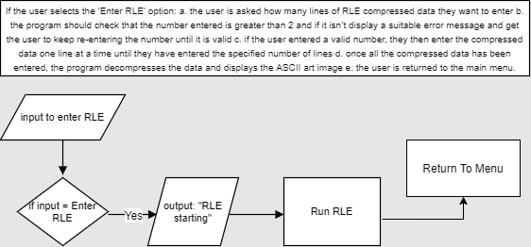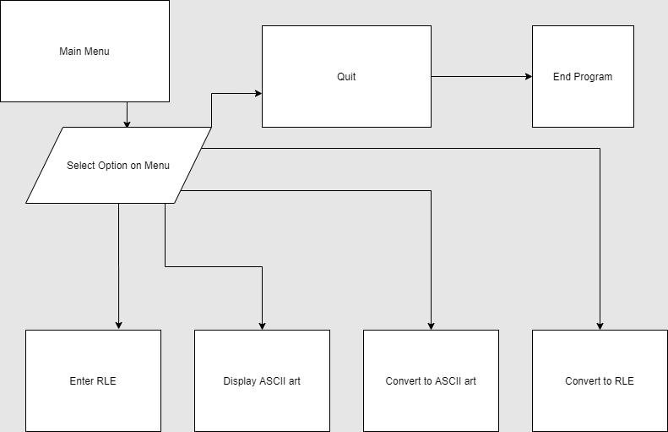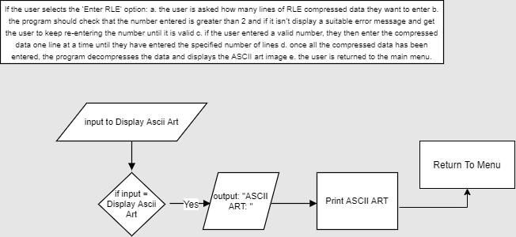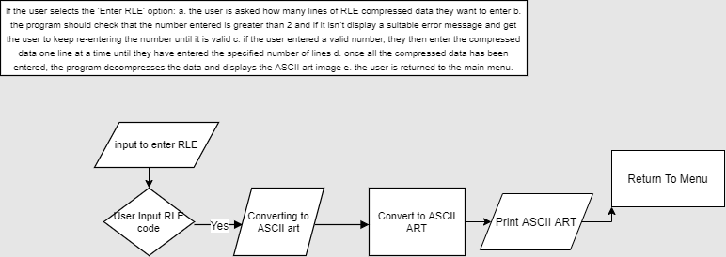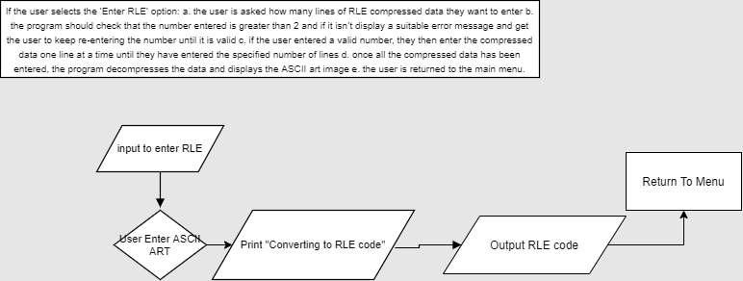

Creating the Solution

I have programmed the solution in python code

Screenshots with comments and explanation

 Importing the functions

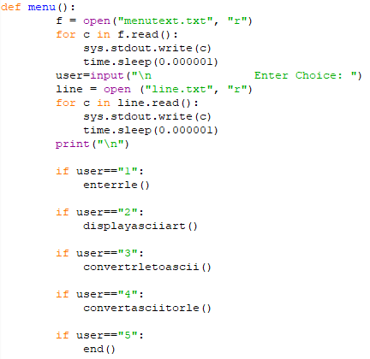Main menu gives options to the user to input a number for a selection.

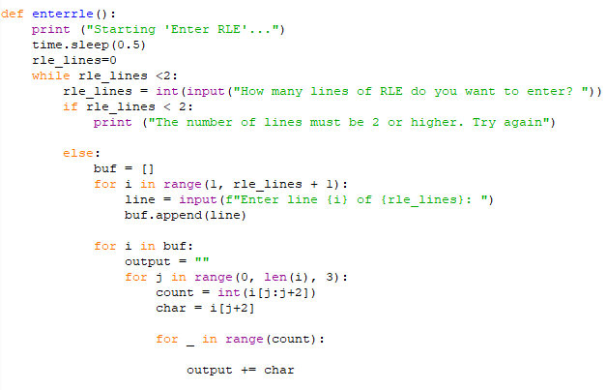ENTER RLE lets the user input line at a line of RLE code and then it will instantly decompress it to ASCII art.

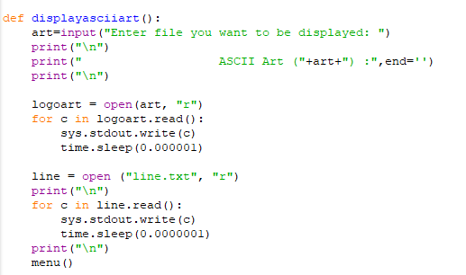displays the inputted ascii art.

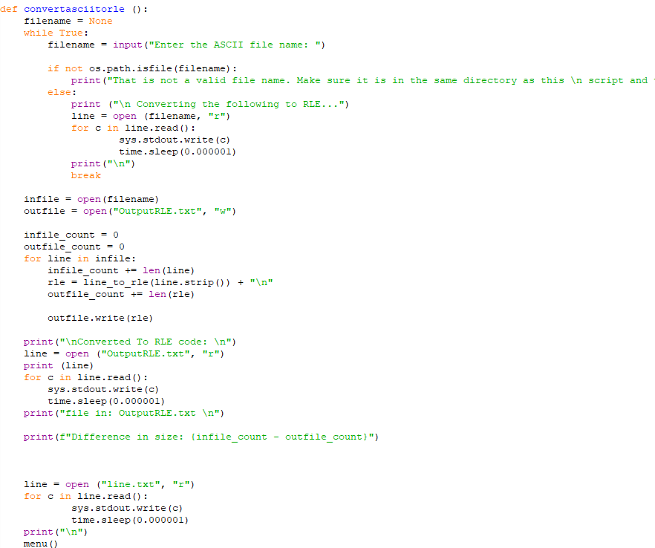converts the inputted ascii file to an rle file

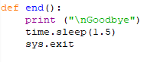ends the program

Testing the solution

|  |  |  |
| --- | --- | --- |
| Function | Expected Result | Result Achieved?  (passed or failed) |
| MAIN MENU |  |  |
| Load Menu | Start printing out the menu onto the program shell. | Passed |
| Menu Options | Options allow the user to sel\\ceat.ceatcloud.org.uk\DFS\WEA\WEAStudentHome\Year2015\wea-15thsi\Documents\Downloads\NEA programming-Copy of Convert to RLE.png\\ceat.ceatcloud.org.uk\DFS\WEA\WEAStudentHome\Year2015\wea-15thsi\Documents\Downloads\NEA programming-Copy of Convert to RLE.pngect the part of the program that they want to run and use. | |  |  | | --- | --- | | 1 | passed | | 2 | passed | | 3 | Passed | | 4 | Passed | | 5 | Passed | | QUIT | Passed | |
| Enter RLE | Outputs the line of line numbers for the user to input the RLE code | passed |
| Display ASCII | Output the ASCII conversion from the RLE input | passed |
| Convert RLE to ASCII | Output the ASCII conversion of a RLE file | passed |
| Convert ASCII to RLE | Output a RLE file from an ASCII input | passed |

Testing Evidence

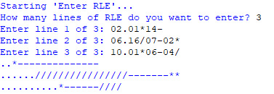converting RLE to ASCII instantly

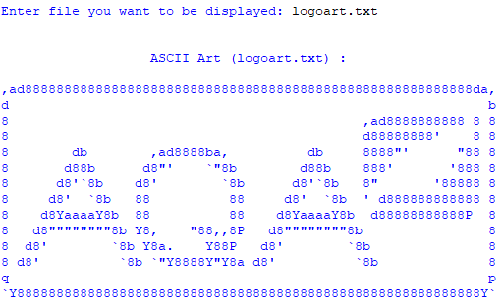displaying ascii art

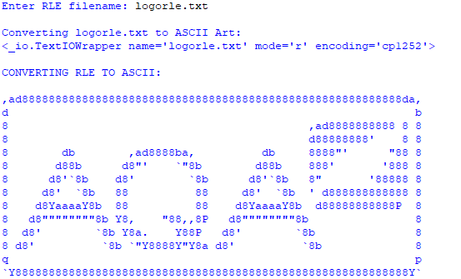RLE to ASCII

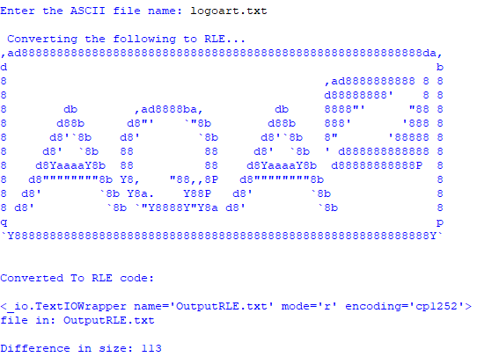Ascii to RLE

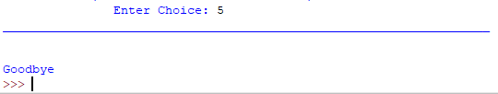QUIT

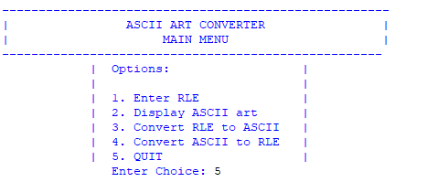MENU

Potential enhancements and refinements

If I had more time and unlimited resources I would make a user interface to make the program more visually appealing to the user and possible make the program into a fully working application and make it look better using a GUI.