How-To Edit Catalog for LSGiWebConsole

Author: Janneth Rivera, Tere Gonzalez

Creation date: September 16, 2016

Last modification date: September 16, 2016

Contents

**Overview** 1

1. Manual configuration 1

2. Using the Editing tool 2

# **Overview**

This document describes the steps to add/modify an execution environment for the LSGiWebConsole catalog. In order to do this, a few configuration files can be modified:

* environments.json
* datasets.json
* nodes.json

For more details on the content of these configuration files, please refer to the following document in our GitHub repository: <https://github.hpe.com/labs/LSGi/blob/master/docs/ConfiguringLSGiWebConsole2.docx>

This can be accomplished by either **1)** manually editing the configuration files or **2)** through the LSGiWebConsole editing tool.

# Manual configuration

1. In Tomcat web server, go to **TOMCAT_HOME/webapps/** directory.
2. Now go to the configuration files located at **LSGiWebService/WEB-INF/classes/properties/ folder.**
3. **Open the** “**environments.json**” file with your preferred text editor.
4. Edit the file by adding/modifying an element with proper values. Make sure to follow JSON format.

For example:

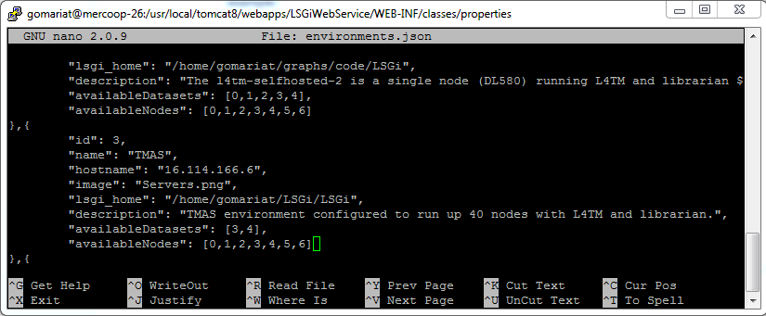

1. Save changes.
2. In the browser, hit Ctrl + F5 to refresh the LSGiWebConsole web page, to make sure the new changes are visible in the catalog.

# Using the Editing tool

1. In the **LSGiWebConsole** web page, go to the footer section and click **“Settings”**.
2. Select “**environments.json**” file from the dropdown menu and click **“Load”.**
3. Edit the file in the text editor by adding/modifying an element with proper values. Make sure to follow JSON format.
4. Click **“Save”**.

For example:

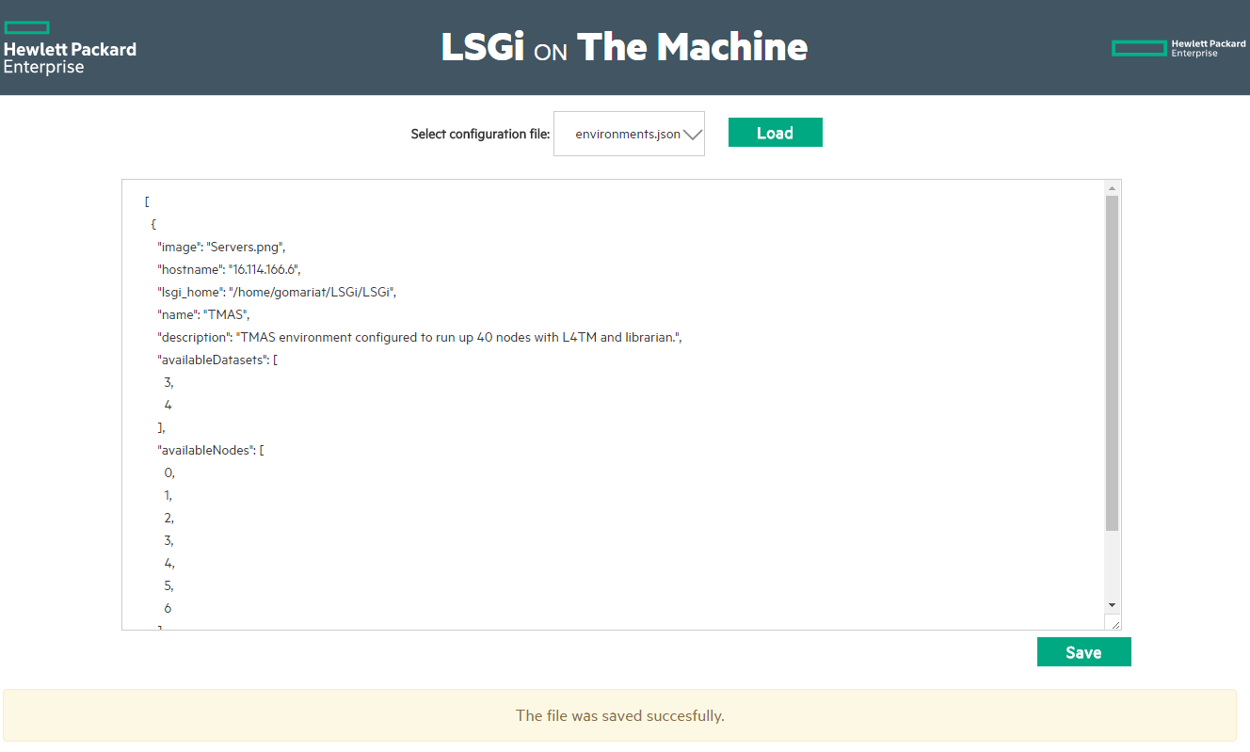

1. In the browser, go back to the home page or click **“Home”** in the footer section. Hit Ctrl + F5 to refresh the **LSGiWebConsole** web page to make sure the new changes are visible in the catalog.

Regardless the method you choose, the new/modified execution environment should be visible in the LSGiWebConsole catalog.

Same steps can be applied to edit the rest of the configuration files for **datasets** and **nodes** in LSGiWebConsole.

