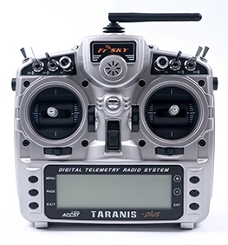

Transmitter

* Directly steer UAV

Ground Station

* Vehicle parameters
* Mission creation
* Data collection

