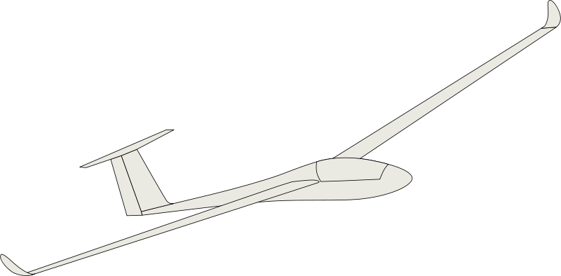

$$\hat{X}$$

$${\hat{X}}_{0}$$

$${\hat{Z}}_{0}$$

$$Y_{0}$$

*error*

Ground Track

Ground Plane

$$\hat{Z}$$

$$\hat{Y}$$