Black Bell
Power Families and Their Statuses
Draft for discussion · October 2026. Family background comes from the design boards (World’s Powers and Power Families); statuses “today” are what the game runs now; the standard set is a draft, not yet built.
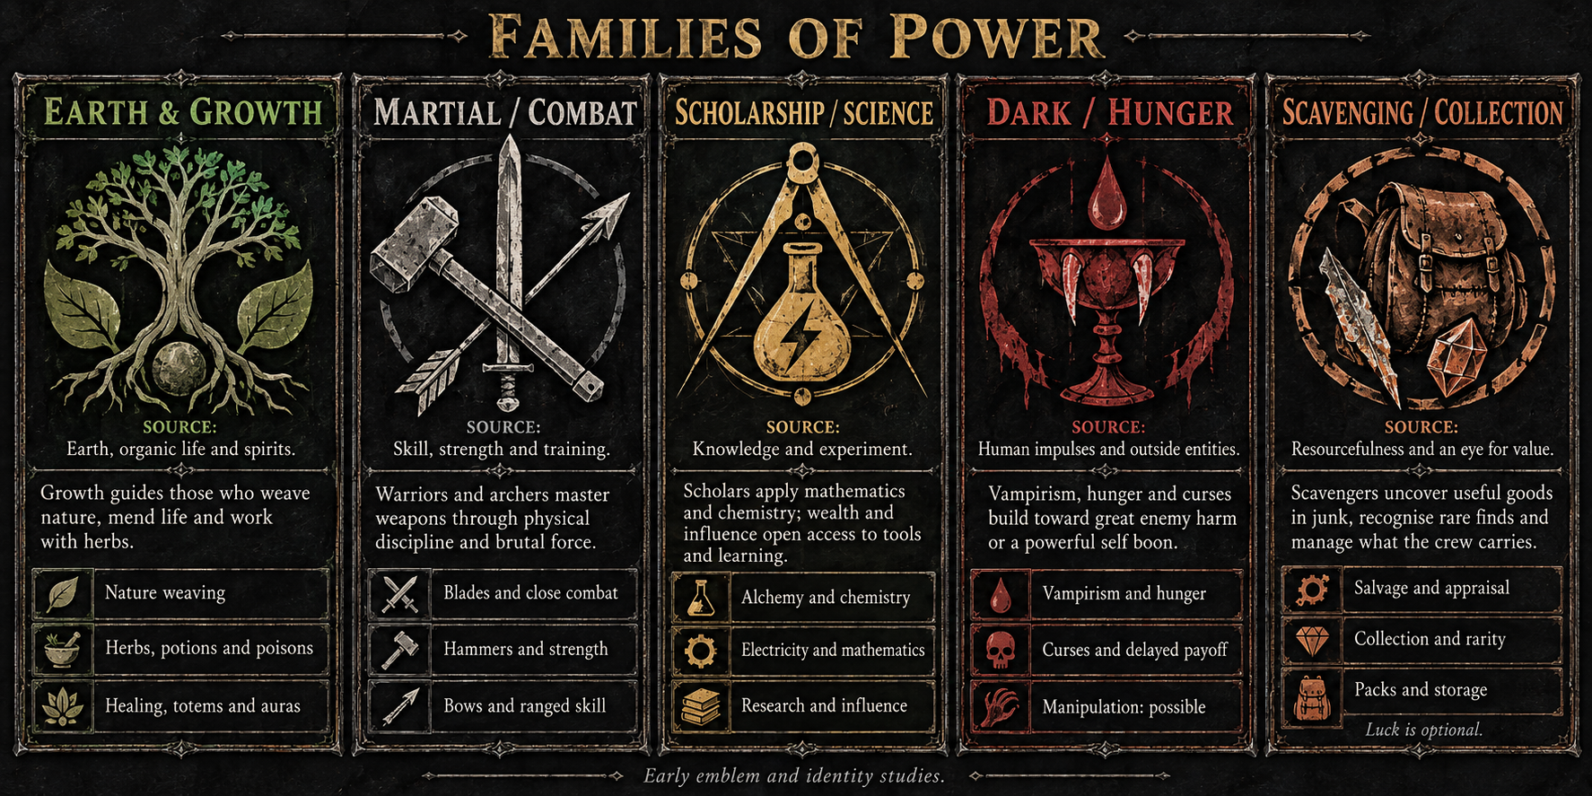
Families of Power: early emblem and identity studies (assets/concepts/power-family-cards.png).

The five families
The world has five provisional power families. Each item belongs to one family by its tags, but family never restricts who can equip an item: any hero can use anything, and items can combine families.
Family | Source of power | Chosen feeling
Martial / Combat | Traditional fighting through weaponry, skill and strength. Close combat and ranged combat. | Formation. Power comes from where items stand: lines, columns and items touching. The grid is the weapon.
Earth & Growth | Earth-elemental power, expressed through nature, organic materials and spiritual effects. Philosophy: growth (its deeper meaning is still open). | Endurance. Outlast everything: healing, regrowth, thorns that punish attackers. You win by not dying.
Scholarship / Science | Power through knowledge, mathematics and scholarly practice. Chemistry, alchemy and electricity are possible foundations. | Control. Weaken, delay and disrupt the foe: it acts later, hits softer and loses its tricks.
Dark / Hunger | Human emotions and impulses mixed with outside supernatural entities. Vampirism, hunger and slow-burning curses. | Bloodlust. Every kill or wound feeds a frenzy that keeps escalating within the fight.
Scavenging / Collection | A crew member who finds useful goods in junk, recognises unusual value and manages what the party carries. | Gamble. Dice and luck: wild swings, sometimes a jackpot, sometimes nothing.

Shared ground
- Alchemy bridges nature and scholarship. Items can combine families.
- Storage is available across all families; scavengers specialise in it.
- Names, access to power and exact rules remain open.

Shared effect types
Families give flavour; any item can combine these behaviours.
Type | What it changes | Example
Act | Damage, heal, mend, guard. Targets a crew member, enemy or item. | A potion restores health; a kit repairs gear.
Modify | Empower, weaken, cleanse, apply a status. Duration and stacks need limits. | Oil empowers one blade use; a curse builds pressure.
Produce / Convert | Create supply; turn ingredients into another resource. Inputs are spent; output needs room. | Herb + bottle → potion.
Transfer / Store | Send charges or resources to another item; keep them for later. Capacity limits storage. | Coil → battery → tool.
Space / Access | Expand grid space, reveal properties or unlock access. | A pack adds right columns; a lens appraises loot.

Grid connections
Items connect through a touching neighbour, a facing direction, a row, or a linked item. Sockets can hold modifiers; an aura reaches a defined area.

Family emblems
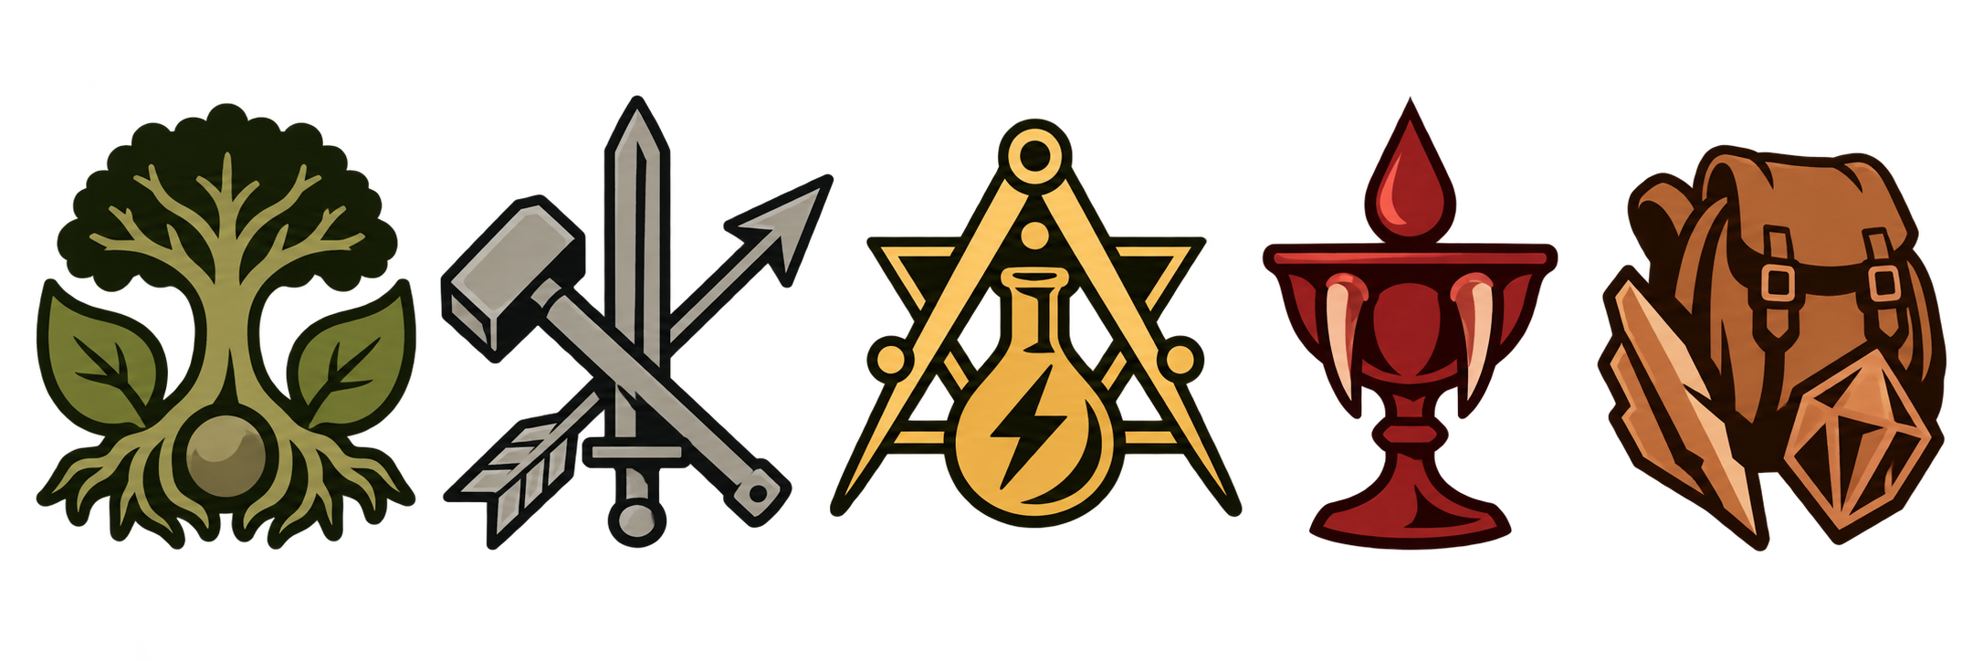
Growth · Combat · Scholarship · Hunger · Scavenging. In game the emblems show as small white marks on items (assets/ui/families/).

Family powers
With 3 placed items of one family its power turns on; with 5 it is doubled. The power follows the grid live: move an item off and the power goes out.
Family | Power | Effect
Combat | Arms Drill | Weapons deal +25% damage.
Growth | Living Bark | Every heal you receive also gives that much guard.
Scholarship | Resonance | Every status stack you put on the foe also deals 1 damage, through guard.
Hunger | Blood Frenzy | Each hit you take feeds you 1 Hunger. Below half health, weapons deal +40% damage.
Scavenging | Lucky Haul | Each cycle, roll a die for Salvage; weapons get +1 damage per 2 Salvage you hold.

The status standard (draft)
Restrictions make design easier and play clearer. Every status follows one grammar, so it reads as a single line: “[Timing]: [N per stack] [does X]. [Fade].” In the end each status is simple arithmetic and a sequence rule.
Rule | The fixed choices
Two per family | One Boon (on you or your items) and one Mark (on the foe). Ten statuses in all.
One timing | Always (a passive number) · Start (cycle start) · Act (when the bearer takes its turn) · Hit (when the bearer deals damage) · Struck (when the bearer is hit) · End (cycle end).
One fade rule | Fade: −1 stack at cycle end · Halve: half the stacks at cycle end · Spend: all stacks used when it acts · Keep: lasts the whole fight.
Stacks are the number | Every effect is “N per stack”. No hidden multipliers.
Counters by kind | Marks are Harm (damage over time) or Weaken (they make the foe worse). Purifier removes all Harm; a new threat, Steadfast, ignores Weaken.
Geometry belongs to items | Statuses never look at the grid. Items decide who gets stacks (row, column, touching).

The draft set at a glance
Family | Status | Kind | Timing | Rule | Fade
Combat | Drill | Boon, on a weapon | Always | +1 damage per stack | Keep
 | Exposed | Mark: Weaken | Struck | Each hit it takes deals +1 per stack | Fade
Growth | Regeneration | Boon, on you | Start | Heal 1 per stack | Fade
 | Poison | Mark: Harm | End | 1 damage per stack, through guard | Halve
Scholarship | Focus | Boon, on you | Act | Your next Mark gets +1 stack per Focus stack | Spend
 | Shock | Mark: Weaken | Act | The foe’s attack deals −1 per stack | Spend
Hunger | Frenzy | Boon, on you | Always | Weapons +1 damage per stack | Keep
 | Bleed | Mark: Harm | End | 1 damage per stack, through guard | Keep
Scavenging | Luck | Boon, on you | Always | Every die roll +1 per stack, up to the die’s highest face | Keep
 | Jinx | Mark: Weaken | Act | Roll a d6: if it is ≤ stacks, the foe’s attack misses | Fade

The engine already supports almost all of this. Four small rules are new: the Act and Struck timings on statuses, the Halve fade, and Luck’s die bonus.
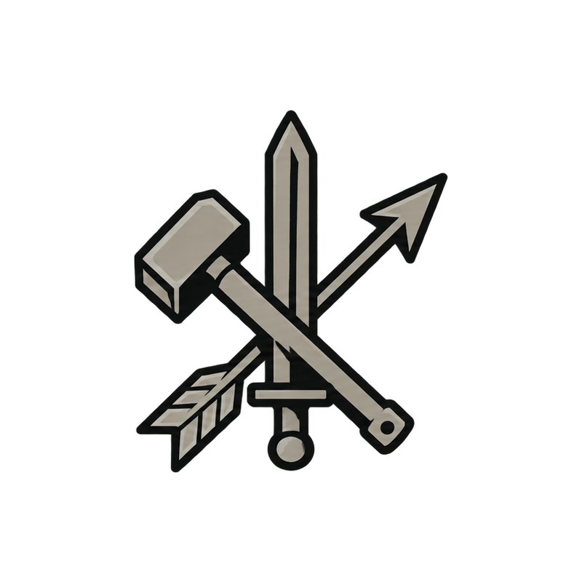

Martial / Combat
Feeling: Formation. Power comes from where items stand: lines, columns and items touching. The grid is the weapon.

Background
Traditional fighting through weaponry, skill and strength. Close combat and ranged combat.
Bloody, brutal violence. Physical combat is a force in this world. Power is skill and strength: learned fighting ability and physical force.

Practices
- Blades and hand-to-hand: traditional warriors and close-range fighters.
- Hammers and heavy force: skill and strength both remain relevant.
- Bows and ranged skill: fighting through weapon handling and trained skill.

Grid ideas from the design
- Whetstone empowers a touching blade.
- Blade strikes → shield reacts.
- Bow gains preparation from an adjacent quiver.
Left open: Combat philosophy · how skill and strength differ · how injury affects fighting.

Family power
Arms Drill: Weapons deal +25% damage.

Statuses today
Status | What it does | Items that apply it
Grit | Cycle start: gain guard equal to stacks. Lasts the fight. | Iron Helm (when you are hit)

Draft standard statuses
Status | Kind | Timing | Rule | Fade
Drill | Boon, on a weapon | Always | +1 damage per stack | Keep
Exposed | Mark: Weaken | Struck | Each hit it takes deals +1 per stack | Fade
Drill goes onto weapons through placement and stacks for the whole fight, so the layout is the build. Exposed rewards many hits.
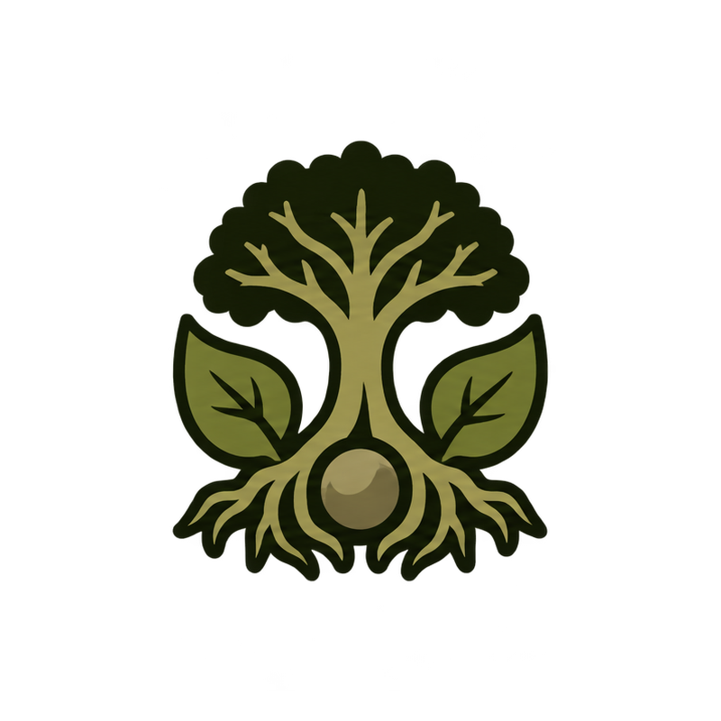

Earth & Growth
Feeling: Endurance. Outlast everything: healing, regrowth, thorns that punish attackers. You win by not dying.

Background
Earth-elemental power, expressed through nature, organic materials and spiritual effects. Philosophy: growth (its deeper meaning is still open).
Plants, herbs and other organic materials. Relics and totems act as spiritual foci that carry or channel auras.

Practices
- Nature weaving: druidic work with nature and organic materials.
- Herbal alchemy: herbalists, potions and poisons.
- Spiritual foci: relics and totems channel auras and spiritual effects.
- Mending and healing.

Grid ideas from the design
- Totem empowers touching herbs.
- Herb → mortar → potion.
- Potion coats a neighbouring blade or heals its wielder.
Left open: Meaning of growth · nature of the spirits · how foci work · who can access the power.

Family power
Living Bark: Every heal you receive also gives that much guard.

Statuses today
Status | What it does | Items that apply it
Poison | Cycle end: damage equal to stacks, through guard; then −1 stack and −⅕ of the rest. | Venom Vial (coats weapons), Thorn Totem, Blight Mortar, Bramble Throne, Rot Cauldron
Regeneration | Cycle start: heal equal to stacks, then −1 stack. | Living Sprig, Heartleaf Poultice, Bread Loaf
Sapped | The foe deals −1 damage per stack (keeps the highest, not the total). | Sapwood Staff, Rootwarden Staff, Smoke Flask (no family)
Venom coating | The coated weapon’s next hit applies Poison. | Venom Vial
Thornsap | +potency for one cycle. | Thornsap Vial

Draft standard statuses
Status | Kind | Timing | Rule | Fade
Regeneration | Boon, on you | Start | Heal 1 per stack | Fade
Poison | Mark: Harm | End | 1 damage per stack, through guard | Halve
Heal steadily while Poison chips through guard. Open choice: swap Poison for Thorns (attackers take 1 per stack), which fits Endurance better.
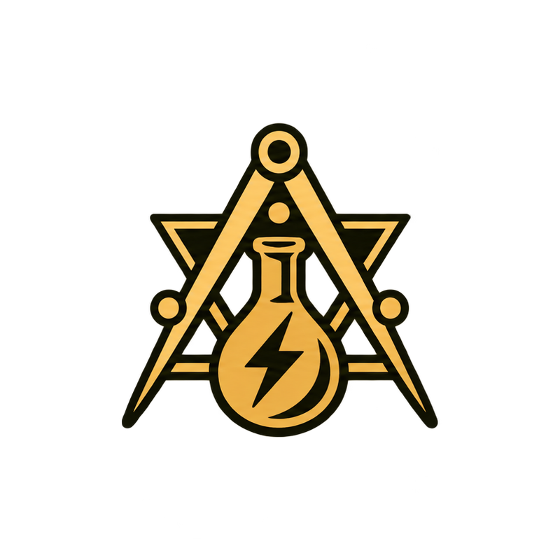

Scholarship / Science
Feeling: Control. Weaken, delay and disrupt the foe: it acts later, hits softer and loses its tricks.

Background
Power through knowledge, mathematics and scholarly practice. Chemistry, alchemy and electricity are possible foundations.
Observation, calculation and experiment: learn how materials and forces behave, then put that knowledge to use. Wealth and influence enable access to reagents, research, equipment and expertise.

Practices
- Chemistry and alchemy: mixtures, reactions and catalysts; remedies, acids, smoke and volatile preparations.
- Electricity: store charge, conduct it through linked items, then discharge.
- Mathematics: ratios, patterns and prediction; refine mixtures, improve precision, optimise an item chain.

Grid ideas from the design
- Reagent → catalyst → mixture.
- Coil transfers charge to a linked tool.
- Ratios or grid patterns could boost a recipe.
Left open: Technology level · relation to magic · whether wealth and influence affect battles, supplies or the wider run.

Family power
Resonance: Every status stack you put on the foe also deals 1 damage, through guard.

Statuses today
Status | What it does | Items that apply it
Shock | Cycle end: all stacks go off at once as damage through guard (max 99). | Storm Totem, Tempest Totem, Wax Candle, Moon Amulet, Static Bow
Burn | Cycle end: damage equal to stacks, blocked by guard; never fades. | Oil Lantern
Insight | Builds on Scroll of Study; at 4 stacks it is spent for a hit. | Scroll of Study

Draft standard statuses
Status | Kind | Timing | Rule | Fade
Focus | Boon, on you | Act | Your next Mark gets +1 stack per Focus stack | Spend
Shock | Mark: Weaken | Act | The foe’s attack deals −1 per stack | Spend
Blunt the foe’s next blow and boost your other Marks: a support family. Shock changes from burst damage to control, so its storm items need retuning.


Dark / Hunger
Feeling: Bloodlust. Every kill or wound feeds a frenzy that keeps escalating within the fight.

Background
Human emotions and impulses mixed with outside supernatural entities. Vampirism, hunger and slow-burning curses.
Power with appetite. It comes from within people and from entities that engage with or exploit those feelings; that relationship is still open.

Practices
- Hunger: taking, needing, feeding.
- Vampirism: drain vitality and sustain the user; feeding could empower a linked item.
- Curses: slow build-up across rounds with a delayed, powerful payoff (great harm to an enemy or a strong benefit to the user).
- Manipulation and temptation: fear, desire and control (still an idea).

Grid ideas from the design
- Curse gathers pressure in a vessel.
- A blade feeds it through draining.
- Release stored power as enemy harm or a self boon.
Left open: What builds the curse · how it pays off, expires and is sustained · entity nature and feeding costs.

Family power
Blood Frenzy: Each hit you take feeds you 1 Hunger. Below half health, weapons deal +40% damage.

Statuses today
Status | What it does | Items that apply it
Curse | Does nothing alone; Reaping Seal consumes it for triple damage. | Curse Idol, Hex Idol, Penitent Chains, Hangman’s Rope
Bleed | Cycle end: damage equal to stacks, through guard; never fades. | War Pick
Rage | +1 damage per stack on the weapon. | Blood-Rage Cap (touching weapons, when you are hit)

Draft standard statuses
Status | Kind | Timing | Rule | Fade
Frenzy | Boon, on you | Always | Weapons +1 damage per stack | Keep
Bleed | Mark: Harm | End | 1 damage per stack, through guard | Keep
Both statuses last the whole fight (Keep), the only family where both do, so a fight escalates. Reaping Seal consumes Bleed instead of Curse.
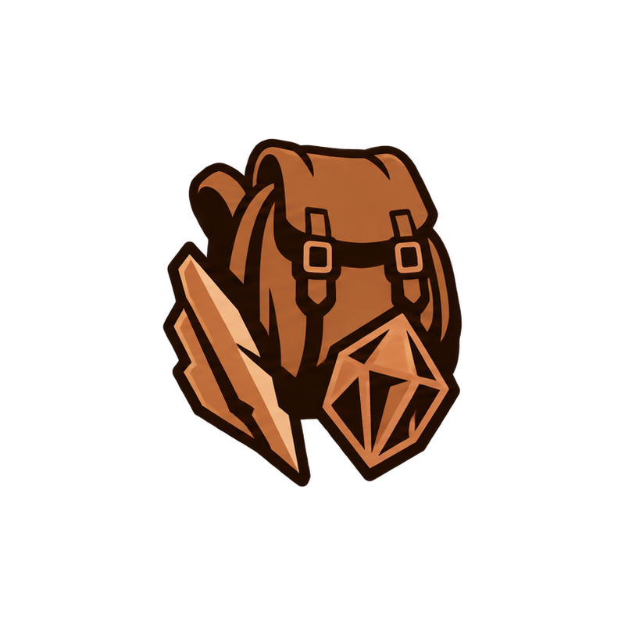

Scavenging / Collection
Feeling: Gamble. Dice and luck: wild swings, sometimes a jackpot, sometimes nothing.

Background
A crew member who finds useful goods in junk, recognises unusual value and manages what the party carries.
Resourcefulness: an eye for usable parts, careful collection and practical organisation. Fortune (chance, omens, lucky finds) adds flavour; recognising value is central.

Practices
- Scavenge and salvage: find goods among junk and dungeon debris.
- Packs and storage: pouches and packs add full-height columns to the right of the grid.
- Appraisal and collection: recognise rarity, hidden properties and useful combinations.

Grid ideas from the design
- Sorter reveals value in junk.
- Pack adds full-height columns to the right.
- Chains cross the new boundary.
Left open: How finds are discovered · how rarity is recognised · collection rewards · whether salvage repairs, crafts or recovers.

Family power
Lucky Haul: Each cycle, roll a die for Salvage; weapons get +1 damage per 2 Salvage you hold.

Statuses today
Status | What it does | Items that apply it
(none) | The family runs on the Salvage resource and dice rolls, not on statuses. | —

Draft standard statuses
Status | Kind | Timing | Rule | Fade
Luck | Boon, on you | Always | Every die roll +1 per stack, up to the die’s highest face | Keep
Jinx | Mark: Weaken | Act | Roll a d6: if it is ≤ stacks, the foe’s attack misses | Fade
Swingy by design: a lucky Jinx roll wipes out a whole enemy turn.

From today to the draft
Today | In the draft
Grit (guard per stack) | Removed. Combat items give guard directly.
Sapped | Becomes Shock (control, Scholarship).
Shock as burst damage | Its storm items are retuned to apply control Shock.
Burn, Curse | Removed. Bleed covers Hunger’s damage over time; Reaping Seal consumes Bleed.
Rage | Becomes Frenzy.
Insight, Thornsap, Venom coating | Become item mechanics, not statuses.
Poison fades by 1 and ⅕ of the rest | Halve, the standard rule. A steady stream levels off at about 2× what is added each cycle (about 5× today), so Poison items need retuning.

Open questions
- Growth: keep Poison as its Mark, or swap it for Thorns (attackers take 1 per stack)? Thorns fits Endurance better; Poison has five items.
- Combat and Scavenging: are Exposed and Jinx the right Marks?
- Set size: strictly two per family, or may a family earn a third status later?
- Counters: should anything counter Boons, or do only Marks have counters?

