Black Bell
The Feeling
What every feature is tested against · October 2026 · draft for the game design document.

Statement
“With a candle, a pack of scavenged scraps and every potion I could keep, I went down into the old dark — and found strange ways to make those scraps enough.”

Pillars
- Every scrap counts. Resources are limited, so every spend is a decision. At a shop, a chest or a level-up, the player weighs what they can afford against what their build needs, and works out the best buy within their limits.
- Simple pieces, creative depth. Few rules, each readable at a glance, that combine into builds nobody planned.
- The dark punishes. Death is common and costly. Fights play themselves, but a bad plan is never excused.
- Earned, not given. Every upgrade is felt and valued, inside a run and between runs. Nothing comes in floods.
- The old book voice. Ink, candlelight and one strange line per item, enemy and floor. The world is bigger than the player understands.
Notes

The profile
Topic | Decision
Player fantasy | A flexible explorer in a deep, retro, text-flavoured dark fantasy
Items | Bare scraps and gear scavenged on the way; each one precious and strange
Mood | Old-school grim: candlelight, ink and mystery. Warmth only at the tavern.
Credit for a win | Build and luck in equal parts; luck offers the pieces, the build decides
Death | Still pays toward permanent upgrades, at a much smaller scale; each permanent gain should feel earned
Run pace | Idle-friendly: fights play themselves; the challenge is the plan
During a fight | Small interventions at key moments (consumables)
Difficulty | Highly punishing, but fair
Peak moment | A plan comes together and works
The chase | Depth record, rare items, builds to discover, the world’s story
Surprise | From drops and the stair itself, with creative interactions
The crew | Strange wanderers for hire; many come and go
Voice | Sparse but evocative text, not dialogue
Hub | A dark-fantasy tavern of hireable adventurers, with a crafting table
Power in a run | Humble start, hard-won strength
Other players | Solo and private

Changes to plan (not yet made)
The balance work of October 2026 leaned toward abundance. Against these pillars, plan to review:
- No item cap and the forced new-item card: abundant finds work against “every scrap counts”.
- 30% lucky training and jackpot chests: keep the spikes, but make them rarer and more valued.
- The planned stat shop: keep it, but price each buy as a real trade-off; no free spam.
- Bells per run and the endless tower: shrink the scale so each permanent upgrade feels earned.
- Item and enemy text: add one strange line to each item, enemy and floor.

Moodboard
Reference art collected by the owner; for direction only, not for use in the game.
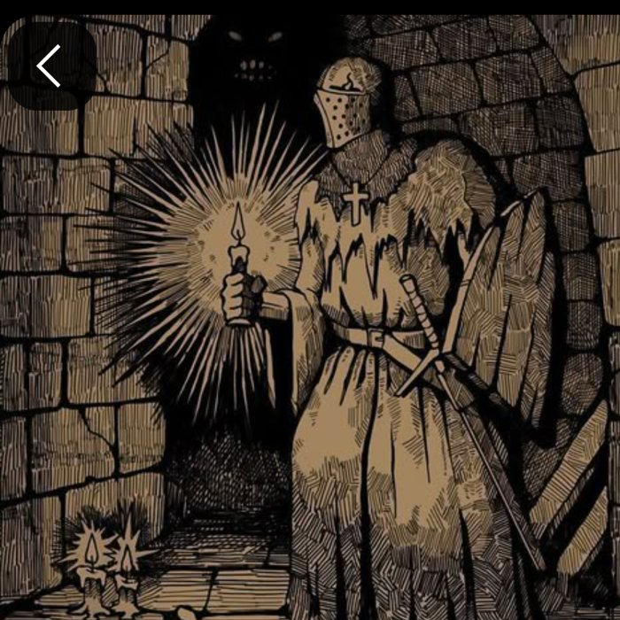  Candle knight in an ink dungeon | 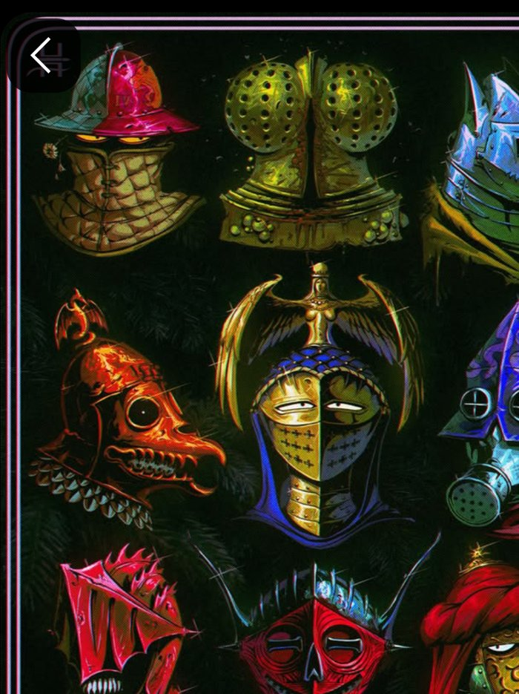  Strange helmed wanderers | 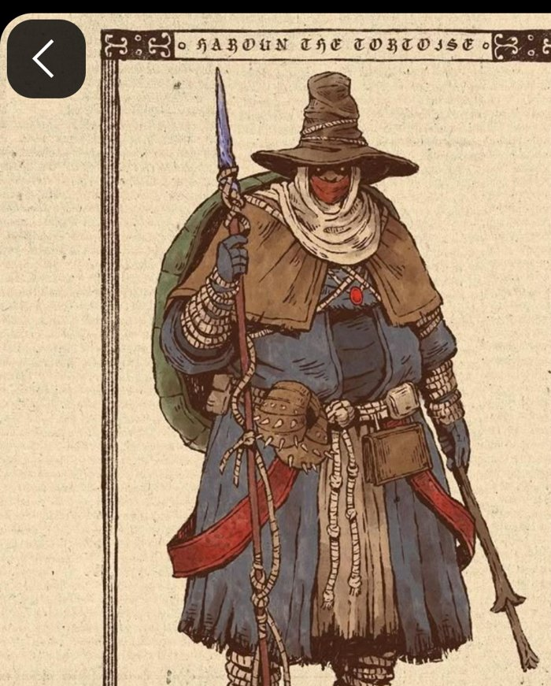  A scavenging traveller
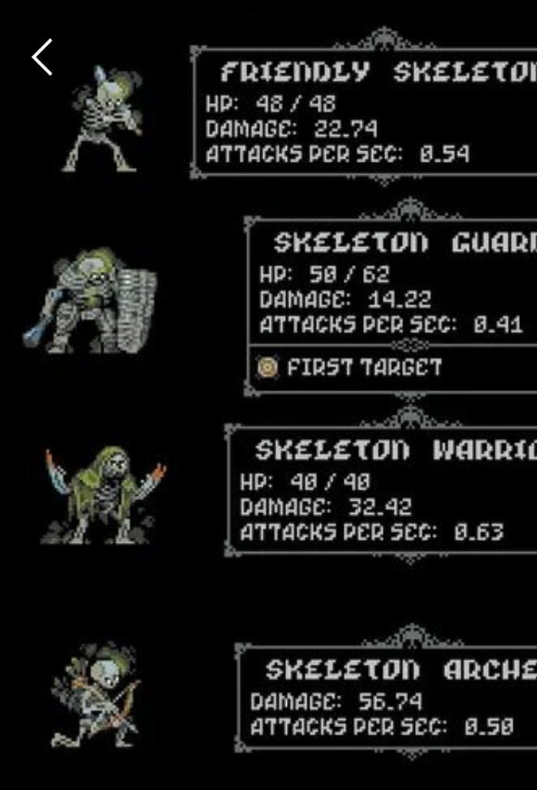  Plain stat cards | 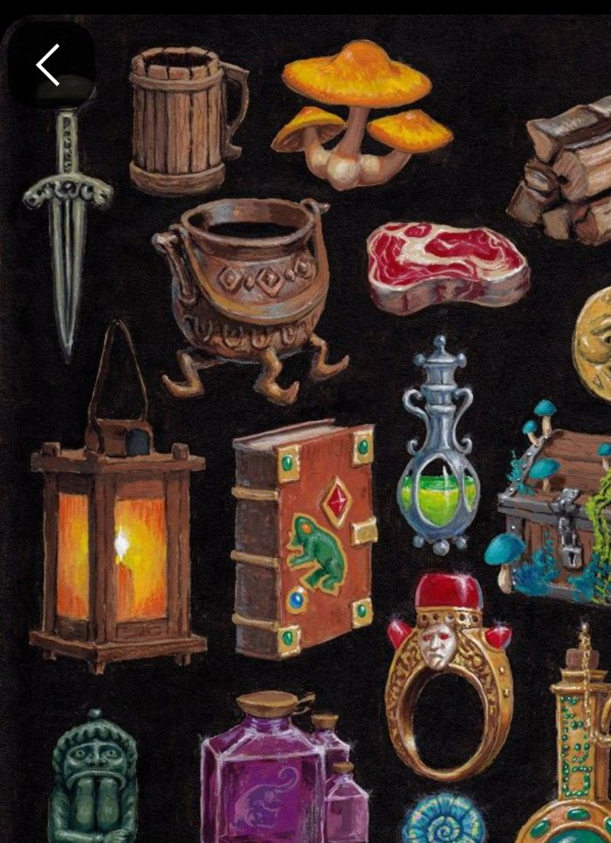  Found objects with stories | 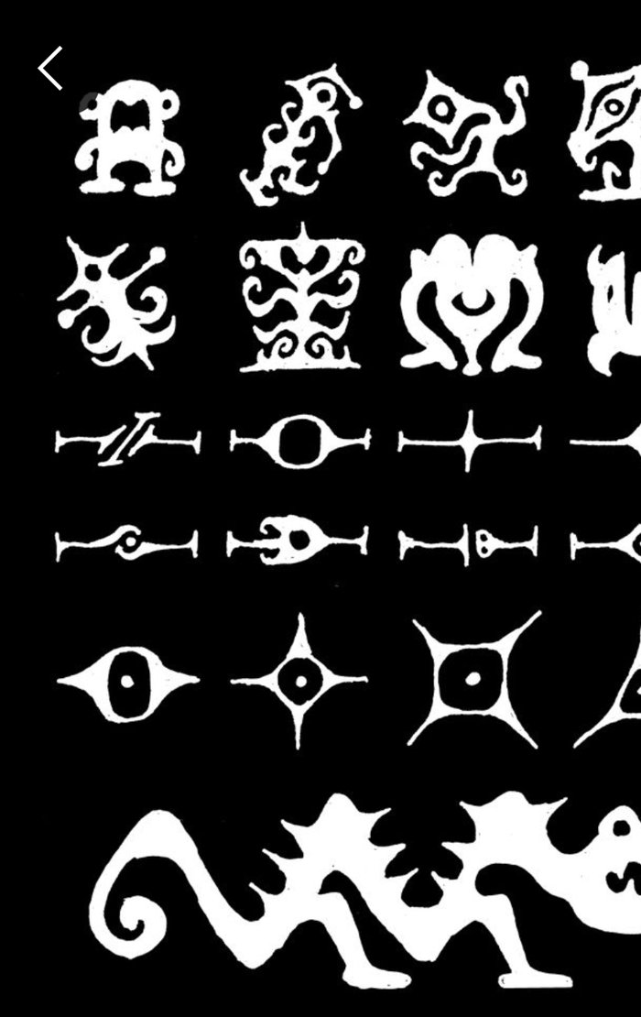  Glyphs nobody can read
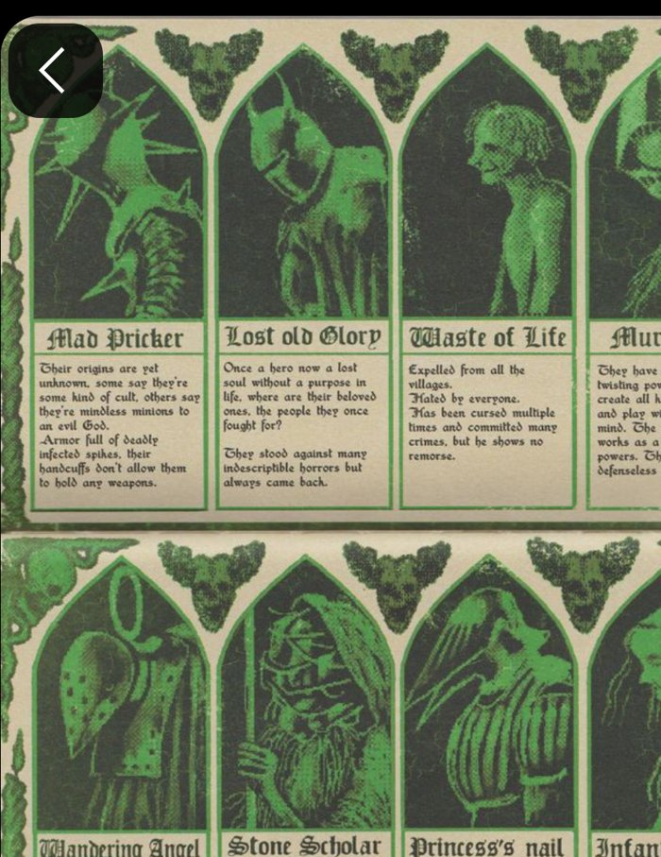  Old book plates with lore blurbs (Vermis) | 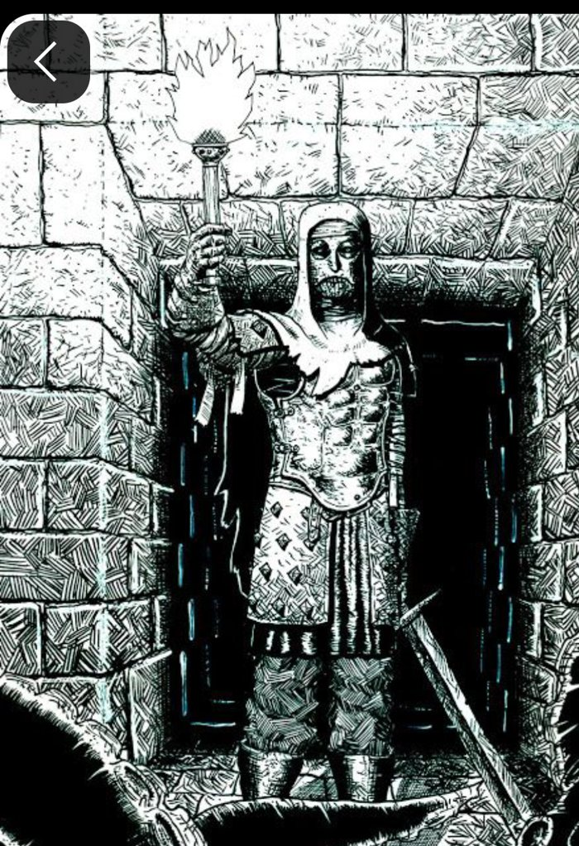  Torch-bearer at the door | 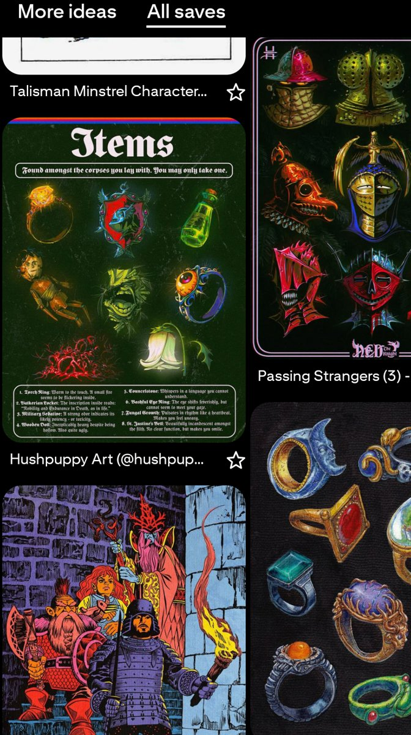  The board: items, rings, a party on the stair

What the moodboard says
- Ink and candlelight: cross-hatched walls and one small flame against the dark.
- Old fantasy books: plates with short, strange lore blurbs; the world speaks in text, not cutscenes.
- Found objects with stories: rings, keys, lanterns, odd potions, each with a one-line mystery.
- Glyphs nobody can read: some things are never explained.
- Plain stat cards: honest, readable numbers.
- Odd wanderers: memorable strangers, never polished heroes.

Genre research: the feelings other games give
Independent research by a fresh reviewer with web search and no knowledge of Black Bell. Full text: project/design/research/feelings.md.
Game | Core feeling, in a player’s words
Diablo III (after Loot 2.0) | “When something good drops, I drop everything.”
Diablo IV | “I’m spending more time reading item stats than playing.” (a failure case)
Path of Exile | “Everything I pick up might be a piece of my build, and I decide how.”
Last Epoch | “I can aim at the item I want.”
Vampire Survivors | “I’m tiny, then suddenly I’m a god.”
Hades | “Even when I die, something moves forward.”
Slay the Spire | “My deck is a machine I built, and I understand why it works.”
Balatro | “The pieces click and the numbers go absurd.”
Dead Cells | “It never feels cheap when I die.”
Backpack Hero / Battles | “Packing my bag well is the game.”
Auto-battlers | “I made the plan, now I watch it play out.”
Idle games | “Numbers go up while I’m away, and each reset makes them go up faster.”

Seven shared core feelings, each with a test
Feeling | In one sentence | Test
Earned surprise | A random result changed my plan. | Can the player recall a surprise from one session?
I built this | I can explain why my build works. | After a win, can they name the 2–3 decisions that mattered?
Power I can see | I am visibly stronger. | Could you tell from a muted recording?
Failure still pays | A loss leaves me something new. | What does the worst run leave behind?
Anticipation | Something good is possible soon. | Do they name a chase item unprompted?
Fluent control | When I die, it is on me. | Do they blame themselves?
Light mastery | I understand a bit more each time. | Does the second run look different from the first?

Loot lesson (Path of Exile, Diablo): loot excites when it can change how you play right now. Rarity alone does not do it; shortcuts to the item kill it; stats players cannot read turn a find into homework.
Notes

