Short description:  
The task is to develop a solution for the following problem:  
A tennis shop owner is offering stringing services to “repair” rackets with broken strings which he either gets from a customer directly or indirectly through a customer agent. He wants a kind of database where he can store all service requests (incl. customer, racket and other information) and can inform a customer or his agent via e-mail with one click. The customer agents should also be able to enter new entries in the database and see all of their currently open service requests.  
  
Detailed description:  
Kind of solution: You are free to pitch a solution of your choice. We were thinking of a web-based solution with a MySQL database, but solution proposals can also include other options such as an app, cloud-based files, etc. Please mention any additional external costs (e.g. licenses) which might apply.  
  
Functionalities:  
Please also refer to the visualization in the attached file.  
- A new service request (incl. additional information such as customer name, racket model, due date, customer e-mail, etc.) can be entered into the system by either the shop owner (admin role) or a customer agent (agent role)  
- At the input form, it can be selected whether it is a new customer or an already existing customer can be selected via drop-down  
- Since one customer can have multiple rackets, the racket can be again selected from a drop down menu or a new racket can be added  
- The entry form will ask for specific input fields with different formats (some input fields might be free text, some will be of the format “date”, etc. -> the form gives an error if the entry does not fit to the form)  
- The service request will get an ID and be stored in a database with all additional information plus a tag of who created the entry  
- Admin and agents can both access the database and have an overview over the customers as well as apply basic analysis (e.g. filter, sort)  
- Admin can edit see all service requests, agents can only see the service requests of themselves (not those of other agents or the admin)  
- Admin can edit all fields, some columns can be read-only for agents (even if they are regarding their own customers)  
- Agent can send out standardized e-mail to the customer with one click (automated e-mail might contain personalized content from the fields of the Database, e.g. “Dear #customername”)  
- Agent can send out standardized e-mail to the agent of this customer with one click (different automated e-mail, might contain personalized content from the fields of the Database, e.g. “Dear #customername”)  
  
  
  
  
Additional requirements:  
- Solution should be accessible from different devices (smartphone, computer, tablet)  
- User-friendliness is key  
- Design should be appropriate for customers (a logo of the shop should be included)  
- Fluency in English of the developer is mandatory  
  
Optional requirements (please indicate impact on price if they should become mandatory):  
- The owner should easily be able to add additional users to predefined roles (e.g. second admin, new customer  
- New entries can be entered by a guest account who has no viewing rights  
- Data entry: If an existing customer has been selected with an existing racket, the input for some fields will be pre-defined from his last service request of this racket (e.g. e-mail address, special requests, …) but the admin / agent can edit this information if desired during the data entry  
- Some fields (e.g. racket names) will have a drop down which shows all already entered values for this field (i.e. racket names which were already used by alphabet, like a database for the rackets)  
  
By submitting your bit, please briefly describe your solution.

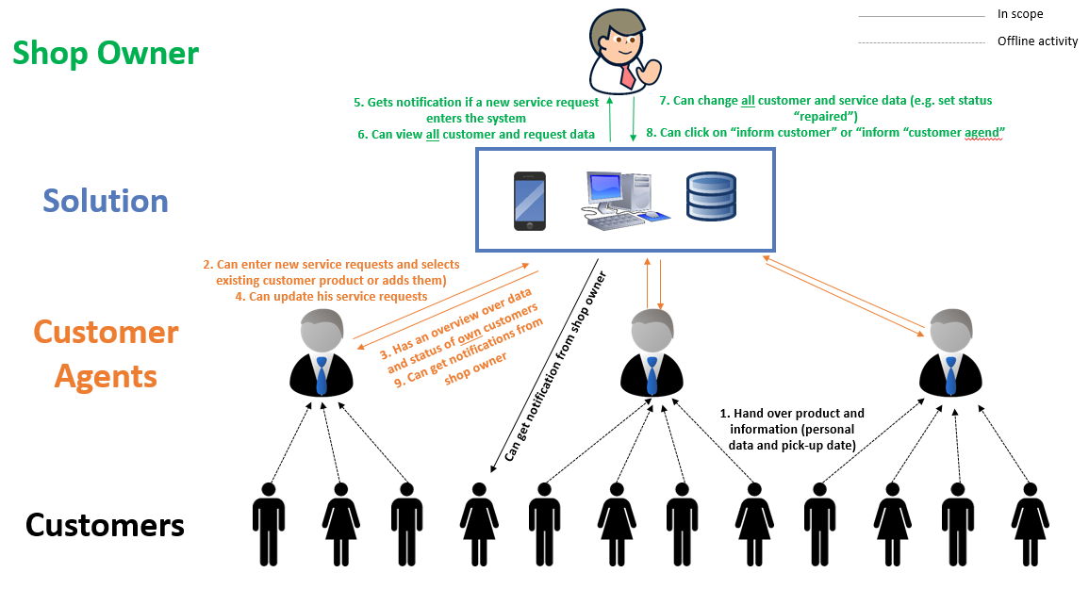

Conversation

1. It is just a database for the owner and the agents to keep transparency how many rackets are due to for strining etc. Customers usually do not use the website. Maybe if one of the agents asks them to enter information into it but they will give their device to the customer then. So it will only be accessable by owners or agents
2. Yes, once I awarded you the project I will send you an excel with the headlines of the input fields in what their format is (e.g. any text, date, etc.)
3. This will also be marked in the excel sheet I will provide you later
4. Actually this is a typo. It should be Owner can send e-mail (to customer or to agent). The difference is this: Some Customers will pick it up directly in the shop (then they need to be alerted via e-mail). Some customers only know their agents and do not even know that the agent gives the racket to a third person. So in this case the owner only informs the agent who can then tell their customer in person or via whatever offline/online way they wantsorry, that was 4.
5. Yes, I will also provide you the e-mail template once I assigned you the projectI6. We do not have any design idea yet. We will provide you a logo from the shop. Otherwise, you are free to use open source designs or something. It should look nice but it does not need to be highly customized

Yes, no need for sign-ups, as long as the admin user can add agents

Yes, and changing a request, especially the status.  These are the main functions as well as the little things which I put in the project description.

I think it woul dbe best if I would give you access to the server of the shop owner (he already has a webseite but might buy a different domain for it). So you could directly work on it. You just need to tell me what kind of stuff you would need when he orders the additional domain (e.g. mysql database, etc.)

Budget would be your bit. Timeline is kind of flexible. It would be nice to have a final solution in 2 weeks, but if for some reason you will ask for some extra time (for example if you get some very important other projects which have a tight deadline), we can talk about it and can extend it. I have been a freelancer myself and now that it can be sometimes hard to manage the utilization.

FTP-SERVER  
Logindaten  
  
Host:

[ds-sport.de](https://www.freelancer.com/users/l.php?url=http:%2F%2Fds-sport.de&sig=37430f55c8f13a603f4401b461bbc1cb2eb13fcd62ecc52746c64a072536799b" \t "_blank)

Login: web67\_besaitung  
Passwort: xvhVSk3M9@Can you create a new folder "besaitung"? that will be the folder of the solution then.

For the MySQL Database:  
Datenbank-Benutzer: 2020\_ds\_sport  
Datenbank-Name: 2020\_ds\_sport  
Datenbank-Passwort: narcRMMt\_L74

[http://www.ds-sport.de/phpmyadmin/](https://www.freelancer.com/users/l.php?url=http:%2F%2Fwww.ds-sport.de%2Fphpmyadmin%2F&sig=bb9df18bdad170f4ffdb712c09a6389d73720ca13aa9d23091b4f2a1aad0d4b1" \t "_blank)

anything else you need?Ioh and one last thing: if you file in a new service request, you need to make a "check" that you have read and accepted the data privacy conditions (we will link that later to a different website). But I guess that is very easy (3min) to implement.

There are the 3 E-Mails and a little update of the excel file that you can more easily use it

And I also marked which column cannot be edited by the agents

[www.ds-enterprise.de:3100](http://www.ds-enterprise.de:3100)

I got access for you (incl. SSH)

This is the backend panel: CPanel: https://s001.cjm-it.de:2083

Usename: dsenterprise

Passwort: ucqgDqtERyN9

Host name (e.g. for SSH): s001.cjm-it.de

SSH user should be dsenterprise. However, the key must be stored in advance in the CPanel.

Alternatively, you can also use the "Terminal" in the CPanel, a Web SSH client, so to speak.

Email retrieval:

Secure SSL / TLS Settings (Recommended)

Username: \_mainaccount@ds-enterprise.de

Password: Use your cPanel password.

Incoming server: s001.cjm-it.de

IMAP port: 993 POP3 port: 995

Outgoing mail server: s001.cjm-it.de

SMTP port: 465

IMAP, POP3 and SMTP require authentication.