运动会成绩数据库系统

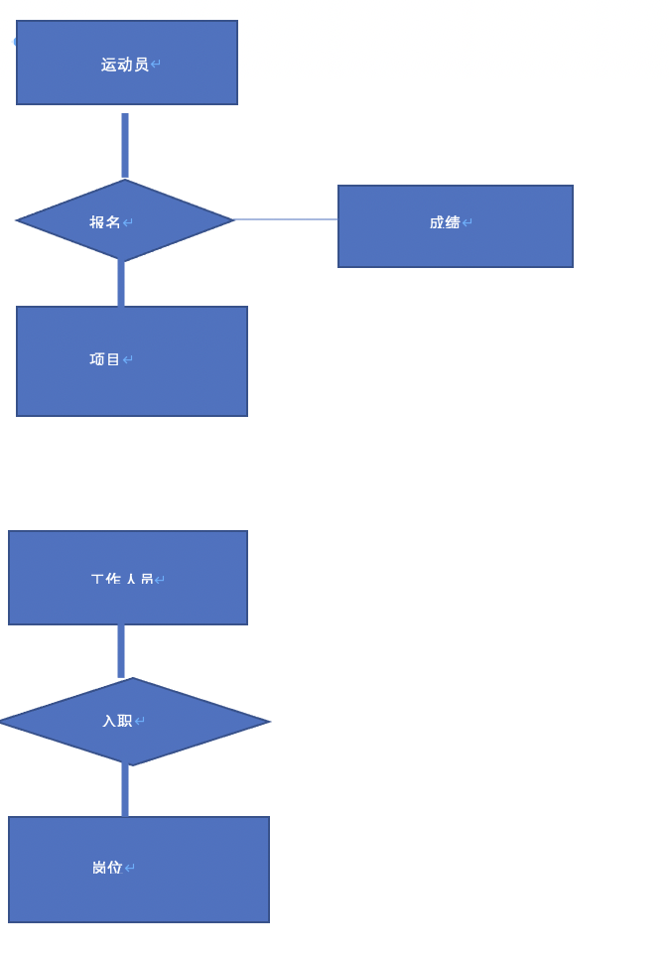

1. 运动员表

|  |  |
| --- | --- |
| YID | Yname |

1. 项目表

|  |  |
| --- | --- |
| XID | Xname |

1. 成绩表

|  |  |  |
| --- | --- | --- |
| XID | YID | Score |

1. 工作人员表

|  |  |  |
| --- | --- | --- |
| GName | GID | G_ID |

1. 工作岗位表

|  |  |
| --- | --- |
| G_name | G_ID |