Nama : Muhamad Rafly
NPM : 247006516043
Matkul : Mobile Programming

Aktivitas Praktikum

- Tampilan Ganjil Genap
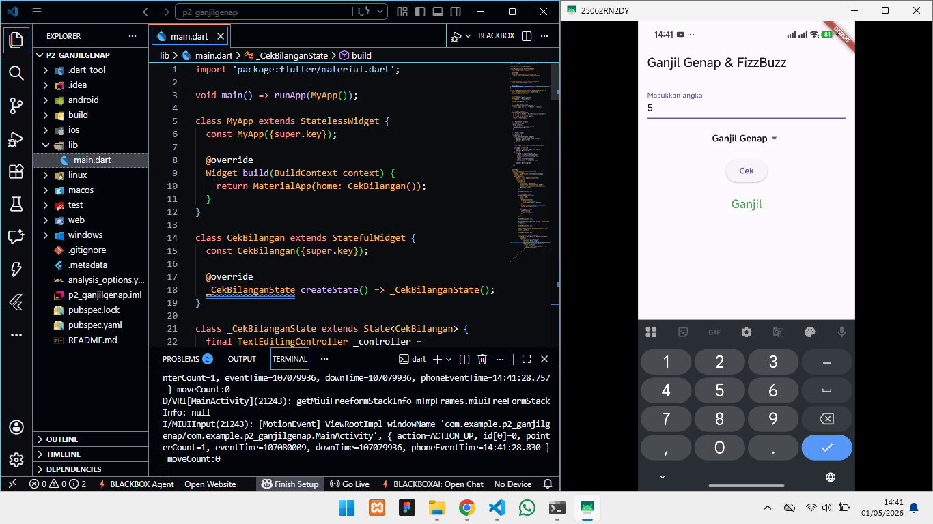
- Tampilan FizzBuzz
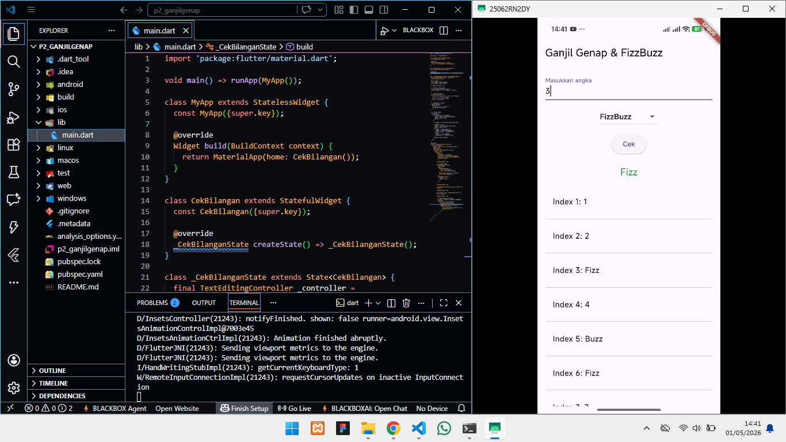
- Tampilan Deret FizzBuzz
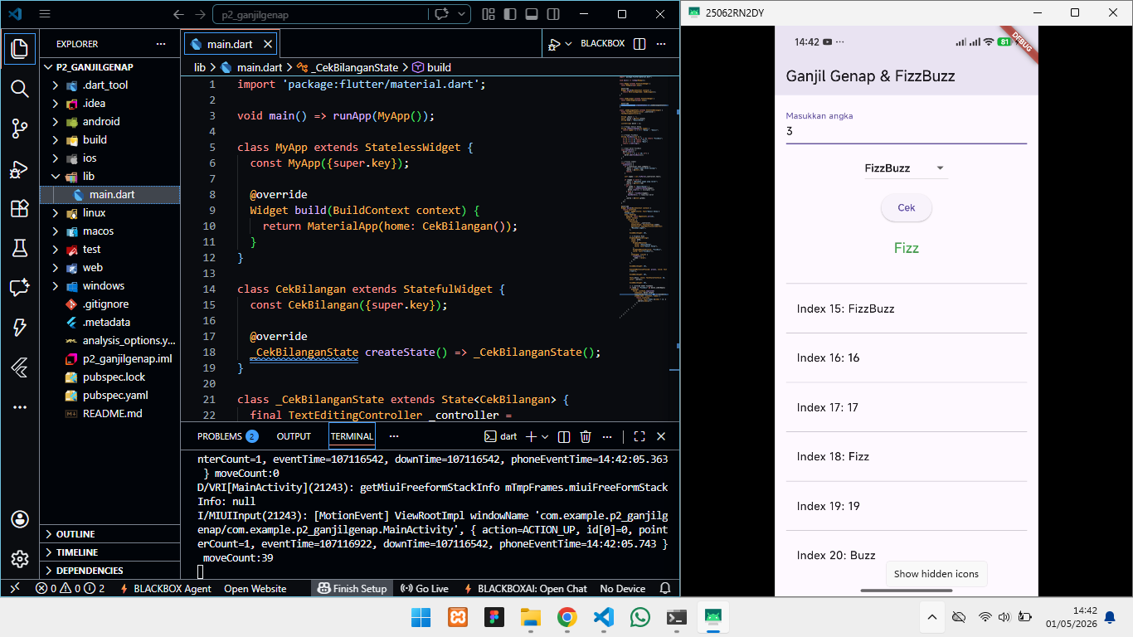
Link github : https://github.com/Flyyy88/Tugas-Flutter-MuhamadRafly/tree/main/p2-ganjilgenap

Tampilan Kakulator
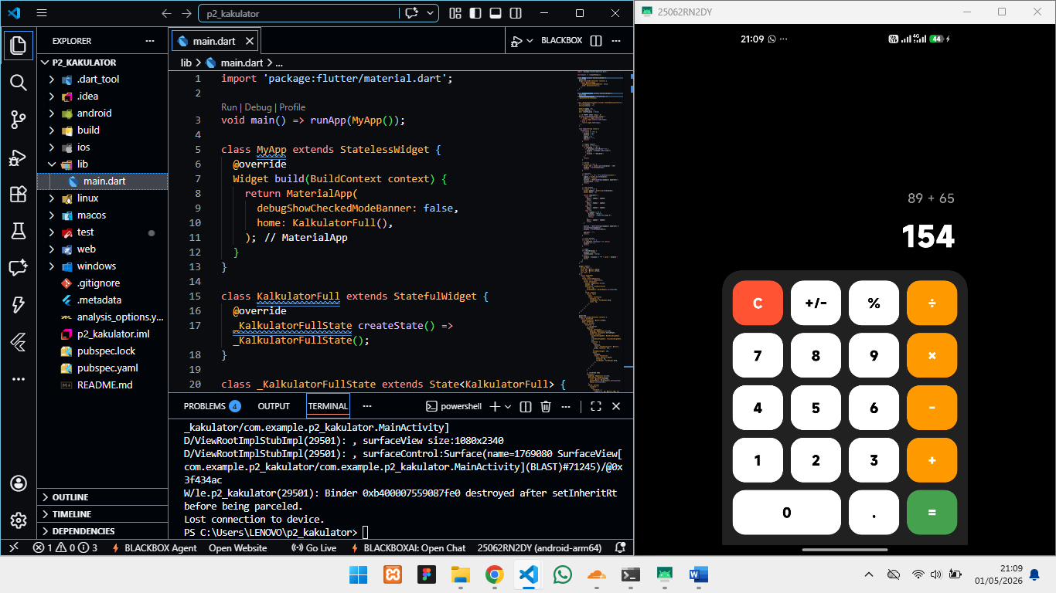
Link Gituhub : https://github.com/Flyyy88/Tugas-Flutter-MuhamadRafly/tree/main/p2-kakulator

