<<%Make sure that
%* You select the parent folder (“SimpleOneColumn” in this example) as the Compile Group
%* The “Treat compile group as entire draft” options is checked
%* the “Article” is included
%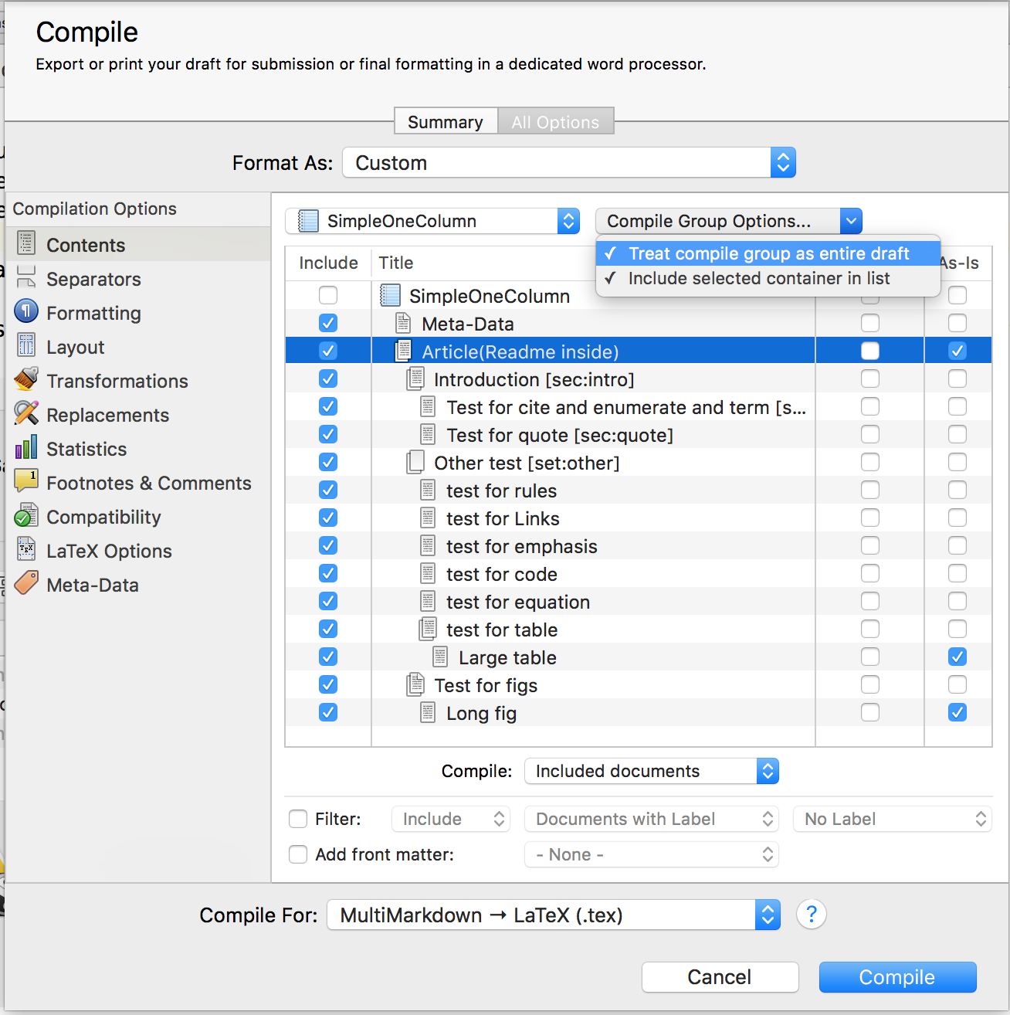
% Make a folder that have the same name as your .tex file (if the folder does not exists, you need do this only once)
% Because we want to make the root folder clean (as latex will generate lots of temp file when compile)
%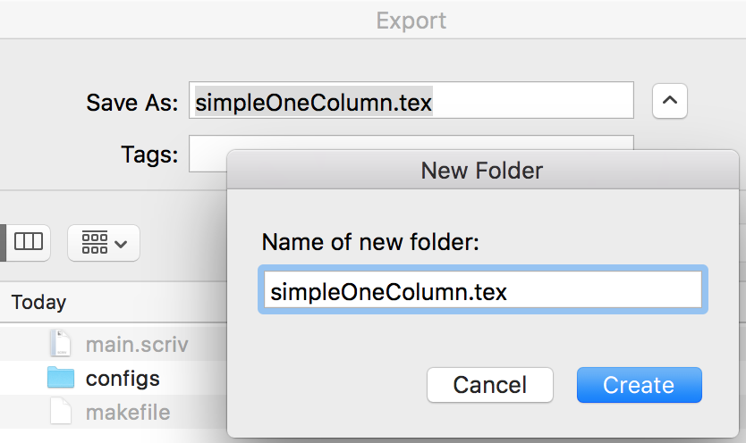
% Click Replace here, and finish export
%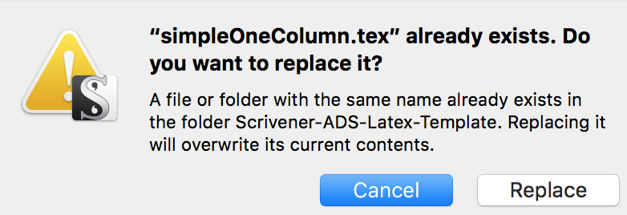
>>

<<
% use \newsinglepage to generate another page
>>

