Compile format:
Formatting:
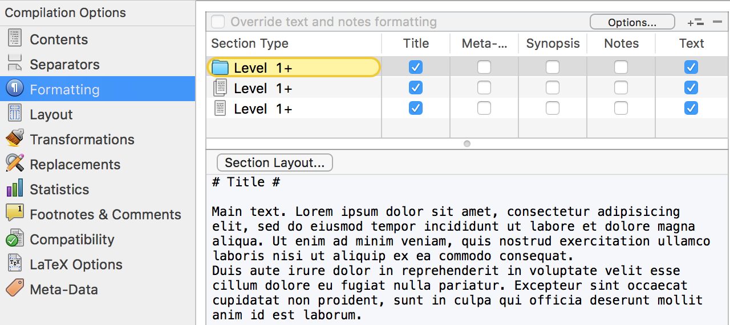
Replacements: (now you can use latex command in <<>> pair)
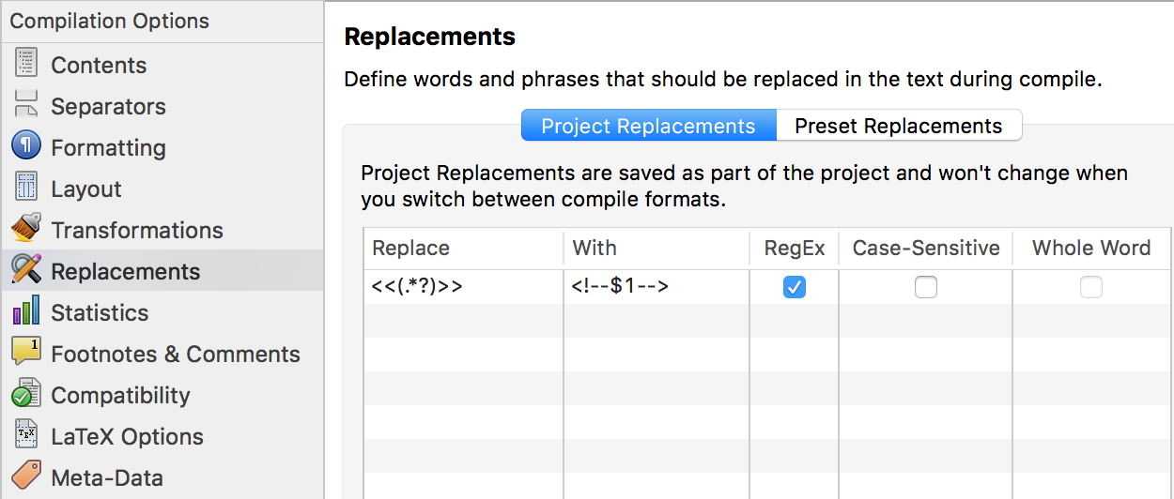
Latex Options:
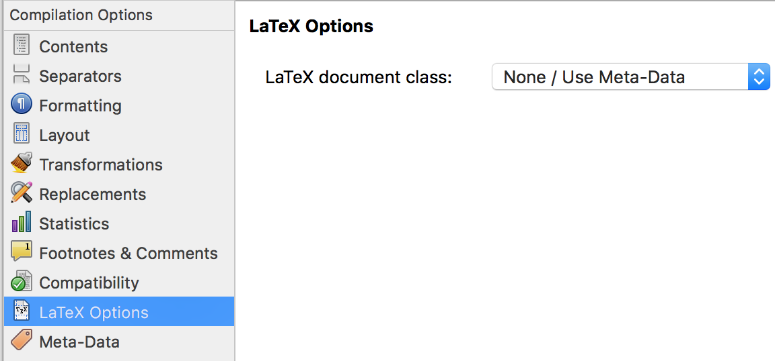

Open the inspector(), there are several important configurations.
1. : This text will be include in the final .tex only if this is checked
2. : if checked, the text will NOT generate a '/section{}', '/subsection{}' or '/subsubsection{}' according to its level.

1. text inside <!-- --> comment pair will be directly inserted into the output .tex file
2. because we have set the "Replacements" configuration, now we can use << >> pair as abbreviate of <!-- -->, but the inside text can not contains "<" or ">", e.g. <<\latex>> will result in "\latex" command.
3. the "Meta-Data" text in each demo contains basic tex compile configurations, make sure the relative path of "latex input" is correct, the <$Compilegroup> will be replaced by the selected compile group
(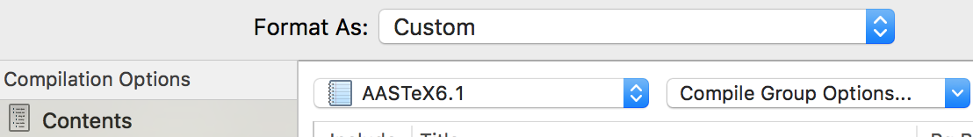in this example it is AASTeX6.1)
4. also make sure all the relative path inside the "latex input" files are correct
5. you can first try to compile the SimpleOneColumn and AASTeX6.1 demo (read the "Article(Readme inside)" text to see more compile detail)
SimpleOneColumn show you some basic MultiMarkdown Syntax
AASTeX6.1 is the full MultiMarkdown version of AASTeX6.1 template, you can find the origin template .tex file in _demoResources/configs/AASTeX6.1/sample61.tex
the compiled pdf are also attached here (simpleOneColumn, AASTeX6.1), you can compare your compiled result with them
6. After successfully compile the two demo, now you can replicated one of these demos or convert your own tex template into MultiMarkdown version. In the Meta-Data text
file of "latex input" will be compiled into "\intput{}" and inserted in front of the output .tex file
file of "latex footer" will be compiled into "\input{}" and append on the tail of the output .tex file
"Base Header Level" should be 1

