Some equations: [eq:0](#eq:0)

$${x}_{1,2} = \frac{-b\pm \sqrt{{b}^2}-4ac}{2a} \label{eq:0}$$ <<%equation with no equation number>>

\\[{x}_{1,2} = \frac{-b\pm \sqrt{{b}^2}-4ac}{2a} \label{eq:5} \\] <<%equation with equation number>>

Inline: \\({x}_{1,2} = \frac{-b\pm \sqrt{{b}^2}-4ac}{2a}\\) , blabla

Inline: ${x}_{1,2} = \frac{-b\pm \sqrt{{b}^2}-4ac}{2a}\label{eq:3}$ , blabla

[eq:1](#eq:5) [eq3 inline](#eq:3)
<<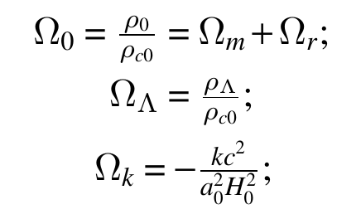>> <<% This figure will not include in the final test>>
<<% Any thing in the comment region will be inserted directly into the output .tex file>>
<!--
\begin{equation}
1=\Omega_0+\Omega_{\Lambda}+\Omega_k, \label{eq:1}
\end{equation}
And:
\begin{eqnarray}
&\Omega_0=\frac{\rho_0}{\rho_{c0}}=\Omega_m+\Omega_r; \\
&\Omega_{\Lambda}=\frac{\rho_{\Lambda}}{\rho_{c0}}; \\
&\Omega_k=-\frac{kc^2}{a_0^2H_0^2}; \label{eq:2}
\end{eqnarray}
-->

