EVIDENCE REPORT | STATIONS 3–4
MarketLens
Walk-forward funds, finance-aware sentiment, and a governed fusion experiment
FINS5545 Assignment 3 / Project B
12  OOS FUNDS | 36  MONTHLY DECISIONS | 146,836  HEADLINES | 2021–23  LIVE SAMPLE

Prepared by z5646230
Course data through 31 December 2023 • Prepared August 2026
Report stance
Historical evidence is reported after a 10 bps one-way cost unless stated. The sentiment candidate is not promoted as alpha because its discovery-window selection is zero and its small holdout benefit is cost-fragile.

01

Executive evidence
A comparison-first product for investors who need transparent trade-offs, not another unexplained score.
MarketLens converts the cleaned Project A price and news panels into three investable research families—equity, crypto, and combined—then applies four portfolio rules to each. Every displayed return is generated by weights estimated on earlier data only. The app lets a user compare all twelve funds, open a complete fact sheet, inspect news tone, and test an illustrative allocation with a fee.
12.6%  EQUITY EW RETURN | 0.82  EQUITY EW SHARPE | -22.4%  COMBINED RP MDD | 0.95  CRYPTO MV SHARPE

What the evidence says
Equity Equal-Weight is the strongest equity benchmark by net Sharpe (0.82) and earns 12.6% annualised with 16.1% volatility. That is a useful restraint on estimated-return optimisation: Maximum-Sharpe turns over much more and does not beat it.
Crypto Minimum-Variance has the sample's highest annualised return and Sharpe, but its 74.3% volatility and −72.2% drawdown make it a speculative satellite, not a default recommendation.
Combined Risk Parity is the steadier mixed-asset compromise: 12.7% annualised, 17.4% volatility, 0.77 Sharpe, and −22.4% maximum drawdown. Combined Equal-Weight earns more but with larger risk and drawdown.
Innovation conclusion
The pre-set +0.25 sentiment tilt raises 2023 net Sharpe from 0.51 to 0.52 at 10 bps, but 2021–2022 discovery selects λ=+0.00. The small 2023 advantage disappears near 25 bps. Sentiment remains research analytics pending stronger evidence.

02

Backtest and fund architecture
The design follows Week 10: expanding estimates, monthly walk-forward decisions, and asset-specific calendars.

Past-only decision rule
The initial window is calendar year 2020. On the first observed date of each month from 2021 onward, each method estimates weights using only rows strictly earlier than that date. Returns then realise until the next decision while holdings drift. Initial formation turnover is 100%; later turnover is half the L1 distance from drifted pre-trade holdings to the new target. One-way costs equal turnover multiplied by the cost rate.
Family | Assets | Calendar | Annualise | First live | Cap
Equity | 50 | Equity trading days | 252 | 2021-01-04 | 20.0%
Crypto | 10 | Calendar days | 365 | 2021-01-01 | 25.0%
Combined | 60 | Equity trading days | 252 | 2021-01-04 | 20.0%
Table 1. Walk-forward contract by asset family.
Source: results/tables/backtest_design.csv; student calculations.

Four methods, one controlled comparison
Equal-Weight allocates 1/N and estimates no moments. Minimum-Variance minimises expanding covariance risk. Maximum-Sharpe uses expanding average returns and covariance, making it most sensitive to estimation error. Risk Parity targets equal volatility contribution. All are long-only, fully invested, and capped at 20% per asset for equity/combined and 25% for crypto.

Calendar and annualisation choices
Equity and crypto simple returns are computed separately on their native calendars. Crypto returns are then sampled on the equity calendar for the combined family, preventing a weekend price gap from being created by a post-merge price calculation. Equity and combined funds use 252 periods per year; crypto uses 365. Sharpe assumes a zero risk-free rate, consistent with the course examples.
Automated audit
A synthetic test replaces all future returns after a cutoff and verifies that earlier monthly weights are unchanged. Generated target weights also pass sum-to-one, non-negativity, and cap checks.

03

Fund evidence and customer choice
The strongest result depends on whether the user values growth, drawdown control, or simplicity.
Fund | Return | Vol. | Sharpe | MDD | Turnover/yr
Equity Equal-Weight | 12.6% | 16.1% | 0.82 | -20.3% | 0.65x
Combined Risk Parity | 12.7% | 17.4% | 0.77 | -22.4% | 0.71x
Crypto Minimum-Variance | 53.6% | 74.3% | 0.95 | -72.2% | 1.13x
Combined Maximum-Sharpe | 7.1% | 32.7% | 0.37 | -48.6% | 2.08x
Table 2. Selected net fact-sheet metrics, monthly OOS, 2021–2023.
Source: results/tables/performance_metrics.csv. Return is CAGR; cost is 10 bps one-way; zero risk-free rate.
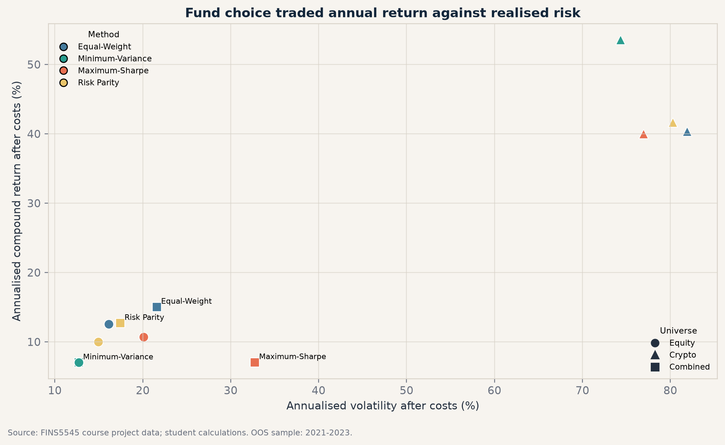
Figure 1. Net annualised return versus realised volatility for all twelve funds, 2021–2023.
Source: FINS5545 prices; student calculations. Equity/combined annualised at 252, crypto at 365; 10 bps one-way cost.
The crypto cluster occupies an entirely different risk scale. Within equities, Equal-Weight sits above the other methods on return without the highest volatility. Combined Maximum-Sharpe is the clearest estimation-error warning.
Interpretation boundary
These rankings describe one short regime. They do not establish expected future dominance. The app therefore shows the full distribution of trade-offs rather than presenting a single ‘best fund’ badge.

04

Fact sheets, holdings, and risk
Each of the twelve funds has growth, drawdown, metrics, turnover, and a latest target allocation in the app.
Combined method | Return | Sharpe | MDD | Top current targets
Equal-Weight | 15.0% | 0.76 | -27.9% | ABBV 1.7%; ABT 1.7%; ADA-USD 1.7%
Minimum-Variance | 7.0% | 0.60 | -17.8% | WMT 19.9%; MRK 12.8%; ABBV 11.9%
Maximum-Sharpe | 7.1% | 0.37 | -48.6% | ABBV 20.0%; NVDA 20.0%; NUE 20.0%
Risk Parity | 12.7% | 0.77 | -22.4% | WMT 3.2%; GILD 3.1%; MRK 3.0%
Table 3. Combined-family fact-sheet snapshot and top three December 2023 targets.
Source: results/tables/performance_metrics.csv and results/data/current_holdings.csv. Top holdings are target weights, not drifted end-of-day weights.

What changed across methods
Equal-Weight holds every asset at 1.67% at each rebalance, so its combined crypto sleeve is 16.7%. Minimum-Variance allocates effectively no crypto because crypto covariance risk dominates its objective; that is why its realised metrics nearly match Equity Minimum-Variance. Risk Parity produces a steadier diversified mix. Maximum-Sharpe changes sector and crypto exposures sharply as estimated means change.

Investor-facing risk language
A fund fact sheet must show maximum drawdown beside return. The top-return crypto result lost more than 70% from peak to trough. Even the combined methods experienced meaningful losses: Combined Equal-Weight fell 27.9%, while Combined Risk Parity fell 22.4%. The app does not turn historical Sharpe into a forecast or guarantee.
Recommended default journey
Open on Equity Equal-Weight as the transparent benchmark; show Combined Risk Parity as a diversified alternative; place crypto funds behind a high-volatility warning. Let users compare rather than preselecting based on the highest historical return.

05

Finance-aware sentiment index
The index measures headline tone with transparent aggregation and an explicit live-data lag.
Titles are scored once with plain VADER and finVADER while preserving casing, punctuation and negation. finVADER augments VADER with SentiBigNomics and Henry finance terms (Consoli et al., 2022; Henry, 2008; Koráb, 2023). Headlines are first averaged within ticker-day. Sector values then equally weight tickers, preventing heavily covered names from dominating.
Model | Headline rows | Mean | Exactly neutral | Positive | Negative
Plain VADER | 146,830 | 0.106 | 48.8% | 37.9% | 13.2%
finVADER | 146,830 | 0.069 | 16.9% | 64.5% | 18.6%
Table 4. Descriptive sentiment-model coverage on the course headline panel, 2020–2023.
Source: results/tables/sentiment_model_validation.csv. Shares classify compound score relative to zero; repeated news rows remain part of ticker-day coverage after exact duplicate removal.
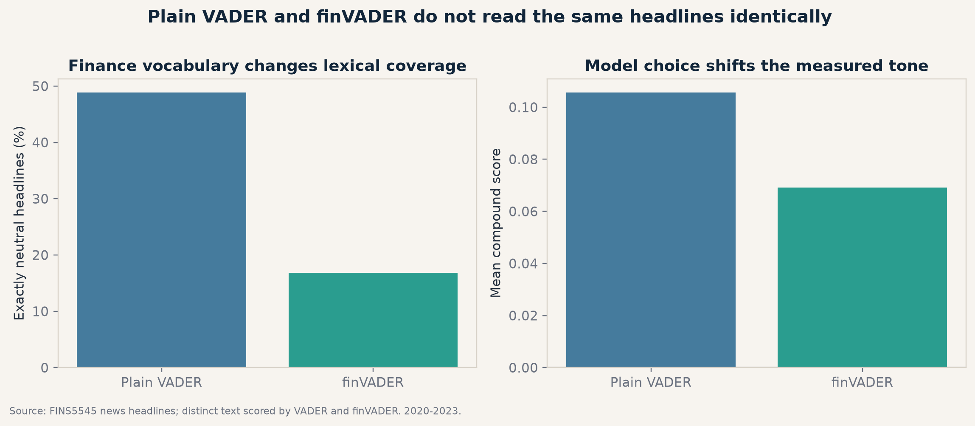
Figure 2. Plain VADER versus finVADER classification coverage and mean tone.
Source: FINS5545 news headlines; student calculations; 2020–2023.
finVADER reduces exact-neutral classifications from 48.8% to 16.9%, evidence that the finance lexicons detect domain language. The lower mean tone also shows that model choice materially changes the index; it does not demonstrate predictive ability.
Missing days and live use
A ticker’s last score carries for at most five equity trading days, then becomes neutral. The filled signal is shifted one full trading day before 21-day smoothing. Fear/greed standardisation uses expanding history; the full-sample z-score is descriptive only.

06

Innovation: fusion with an honest null
Finance-specific sentiment is tested inside the allocation process, then challenged with turnover and costs.
At each monthly equity rebalance, the lagged 21-day finVADER signal is cross-sectionally standardised and winsorised at ±2.5. Equity Minimum-Variance base targets are multiplied by exp(λz) and renormalised, preserving long-only full investment. A mild momentum candidate λ=+0.25 is specified for the before/after test. Separately, a grid from −0.75 to +0.75 is evaluated only in 2021–2022; 2023 remains untouched.
2023 holdout | Return | Vol. | Sharpe | MDD | Turnover
Base Equity Minimum-Variance | 5.1% | 11.0% | 0.51 | -8.6% | 0.27x
Finance-Sentiment Tilt | 5.3% | 11.0% | 0.52 | -8.5% | 1.04x
Table 5. Required before/after fusion test on the untouched 2023 holdout, net of 10 bps one-way costs.
Source: results/tables/fusion_performance.csv. Base is Equity Equal-Weight; signal is lagged finVADER.
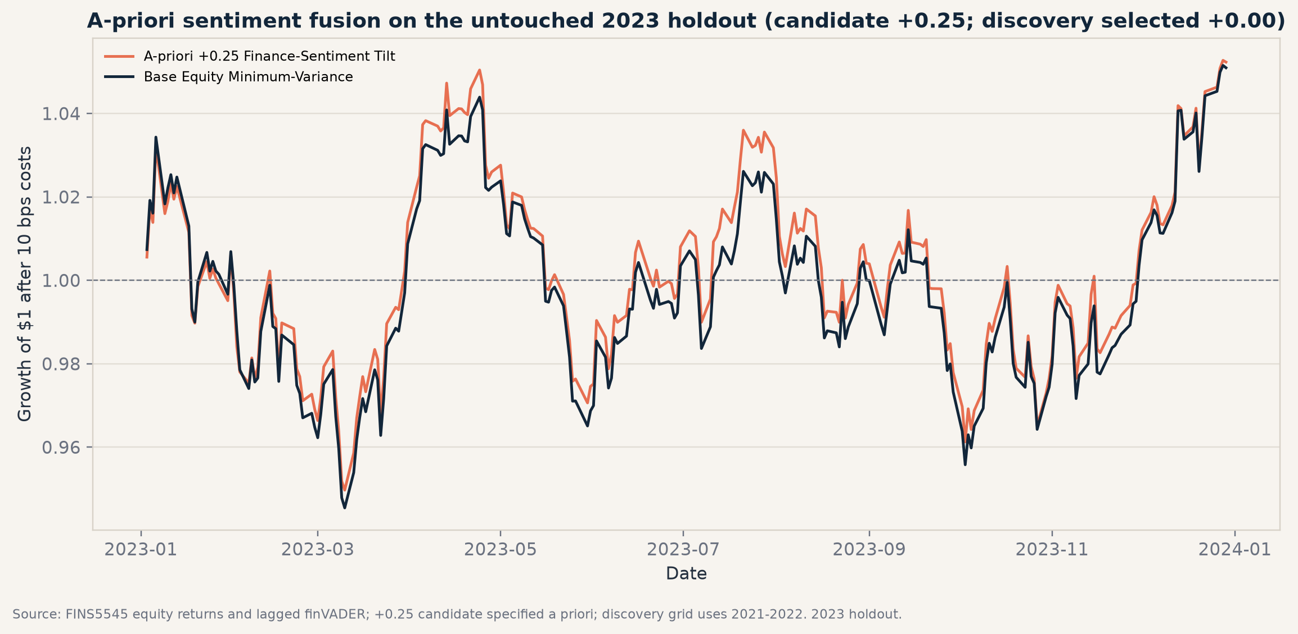
Figure 3. Growth of $1 for the base and pre-set sentiment candidate in 2023.
Source: FINS5545 equity returns and headlines; student calculations; 10 bps one-way cost.
The candidate finishes slightly ahead in 2023, but the difference is small. The discovery grid selects λ=0.00, and the candidate’s higher turnover makes the result fragile to cost.
Governance decision
Do not productise the tilt. Preserve it as a monitored research layer, require rolling pseudo-holdouts across additional regimes, and introduce an explicit turnover budget before reconsideration.

07

Investor journey and recommendations
The app turns the evidence into five decisions a user can complete without rerunning the model.
App task | What the user can do
Compare | Filter universes; rank all twelve funds; overlay growth paths.
Fact sheet | Choose any fund; inspect growth, drawdown, net metrics, turnover, and latest holdings.
Allocation lab | Blend 2–4 funds with normalised sliders and an annual fee; view an illustrative constant-mix path.
Sentiment | Read fear/greed, sector tone, model coverage, fusion holdout, and cost scenarios.
Method & limits | See the backtest contract, no-look-ahead controls, and non-advice warnings.
Table 6. MarketLens precomputed Streamlit customer journey.
Source: streamlit_app.py. The deployed app reads committed results CSVs only; it performs no NLP, download, or optimisation.

Recommendation 1 — launch comparison before recommendation
Use Equity Equal-Weight as the default benchmark and Combined Risk Parity as a mixed-asset alternative. Always place return beside volatility, drawdown, turnover, and holdings.

Recommendation 2 — treat crypto as a risk-labelled satellite
The high crypto return does not offset its 70%+ drawdown for a general investor. Add an explicit high-risk acknowledgement before exposing crypto allocation controls.

Recommendation 3 — research sentiment under a turnover budget
Keep the sector and fear/greed indices as explanatory analytics. Re-test fusion using rolling discovery/holdout windows, capped monthly turnover, several carry/smoothing settings, and cost thresholds fixed before observing results.
Critical reflection
The most valuable innovation finding is not the small positive 2023 difference; it is the process that prevents that difference from becoming a claim. Model coverage, timing, selection, turnover and cost all have to survive separate checks.

Narrative ends here (8 pages including cover). Required exhibits, detailed tables, reproducibility evidence, and references follow in appendices and are excluded from the narrative page limit.

APPENDIX A

Required exhibit: full performance table
All twelve funds; monthly walk-forward OOS; 2021–2023; net of 10 bps one-way costs.
Fund | Return | Vol. | Sharpe | MDD | Turnover/yr
Equity Equal-Weight | 12.6% | 16.1% | 0.82 | -20.3% | 0.65x
Equity Maximum-Sharpe | 10.7% | 20.1% | 0.61 | -36.0% | 1.67x
Equity Minimum-Variance | 7.0% | 12.7% | 0.60 | -17.8% | 0.70x
Equity Risk Parity | 10.0% | 14.9% | 0.71 | -19.4% | 0.64x
Combined Equal-Weight | 15.0% | 21.6% | 0.76 | -27.9% | 0.79x
Combined Maximum-Sharpe | 7.1% | 32.7% | 0.37 | -48.6% | 2.08x
Combined Minimum-Variance | 7.0% | 12.7% | 0.60 | -17.8% | 0.70x
Combined Risk Parity | 12.7% | 17.4% | 0.77 | -22.4% | 0.71x
Crypto Equal-Weight | 40.4% | 81.9% | 0.83 | -81.6% | 1.03x
Crypto Maximum-Sharpe | 40.0% | 77.0% | 0.82 | -78.0% | 1.28x
Crypto Minimum-Variance | 53.6% | 74.3% | 0.95 | -72.2% | 1.13x
Crypto Risk Parity | 41.6% | 80.3% | 0.84 | -80.5% | 1.03x
Exhibit A1. Complete net performance metrics table.
Source: results/tables/performance_metrics.csv. Return is compound annual growth; volatility and Sharpe use 252 for equity/combined and 365 for crypto; zero risk-free rate.
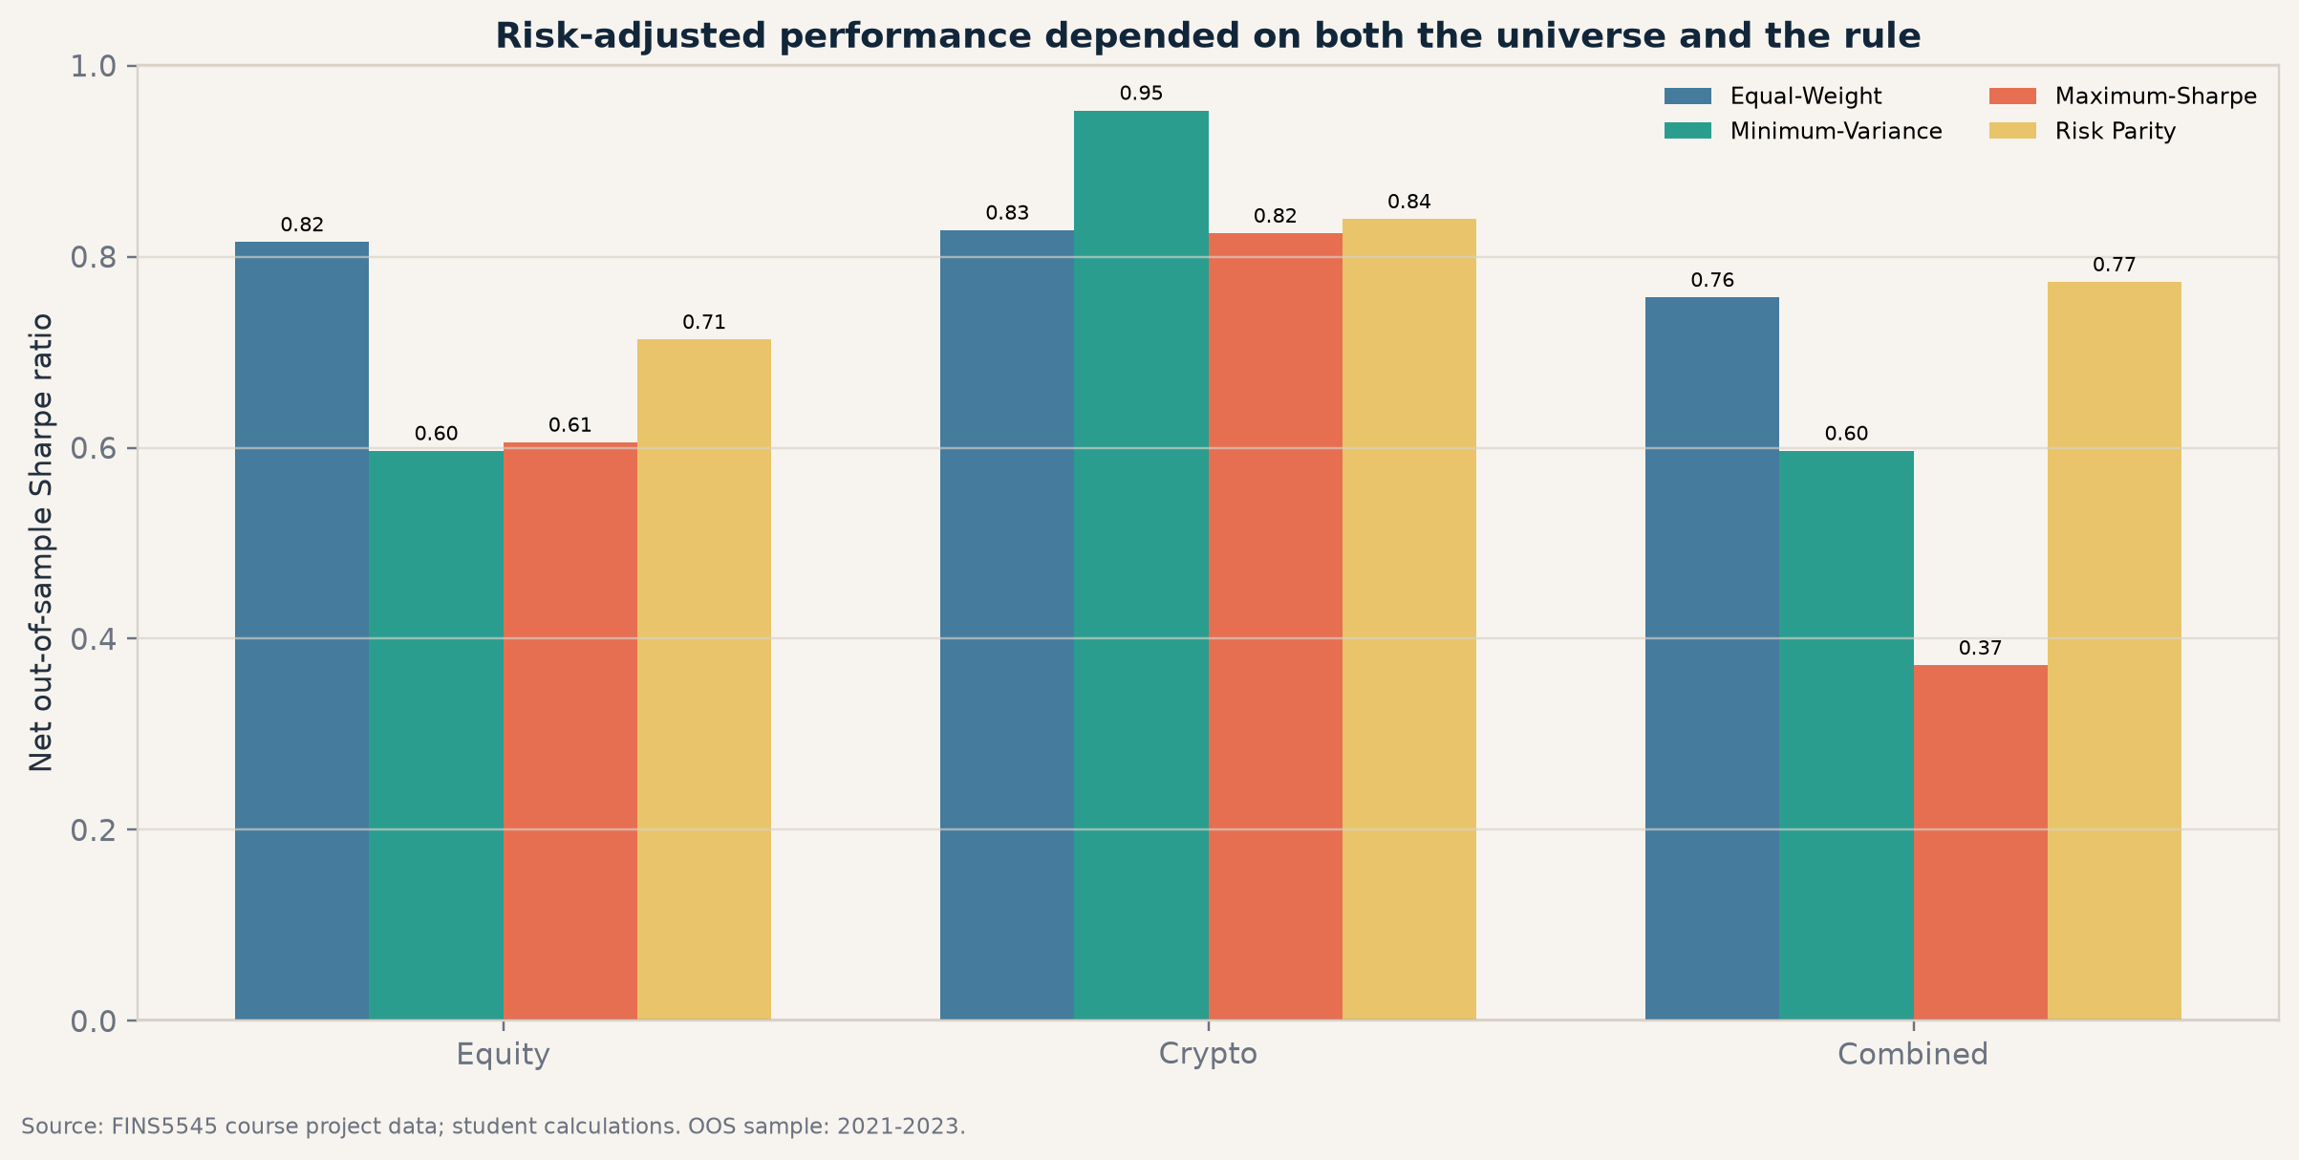
Exhibit A2. Net out-of-sample Sharpe ratio by method and family.
Source: FINS5545 prices; student calculations; 2021–2023; 10 bps one-way cost.
Crypto leads risk-adjusted rankings in this sample but at a separate risk scale. Among equities, Equal-Weight is hard to improve on; Combined Risk Parity narrowly leads Combined Equal-Weight by Sharpe.

APPENDIX B

Required exhibits: growth and drawdown
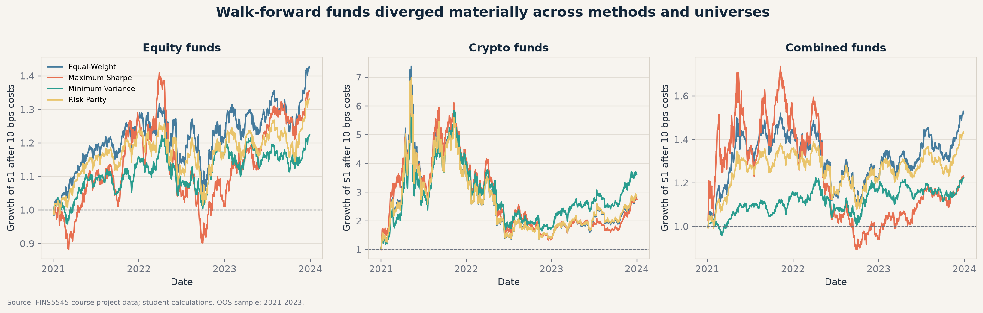
Exhibit B1. Growth of $1 across all twelve funds, grouped by universe.
Source: FINS5545 prices; student calculations; net of 10 bps one-way costs; 2021–2023.
Crypto paths dominate the vertical range and also experience the largest reversals. Equity and combined panels provide a more decision-relevant view for moderate-risk users.
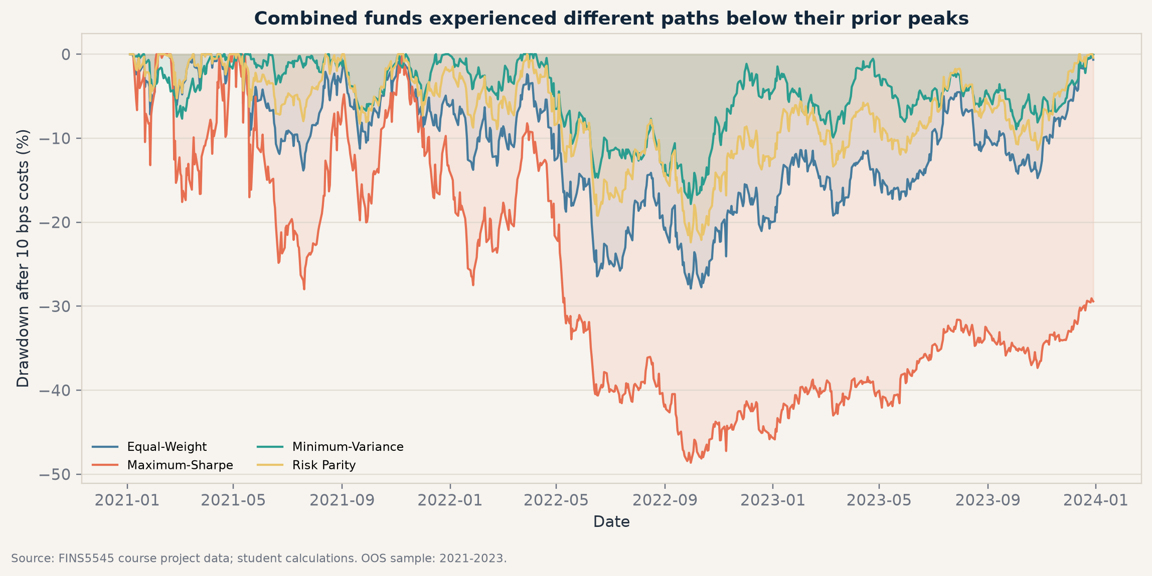
Exhibit B2. Drawdown paths for the four combined funds.
Source: FINS5545 prices; student calculations; net of 10 bps one-way costs; 2021–2023.
Risk Parity reduces the worst combined-family drawdown relative to Equal-Weight; Maximum-Sharpe is much less stable.

APPENDIX C

Required exhibit: portfolio weights over time
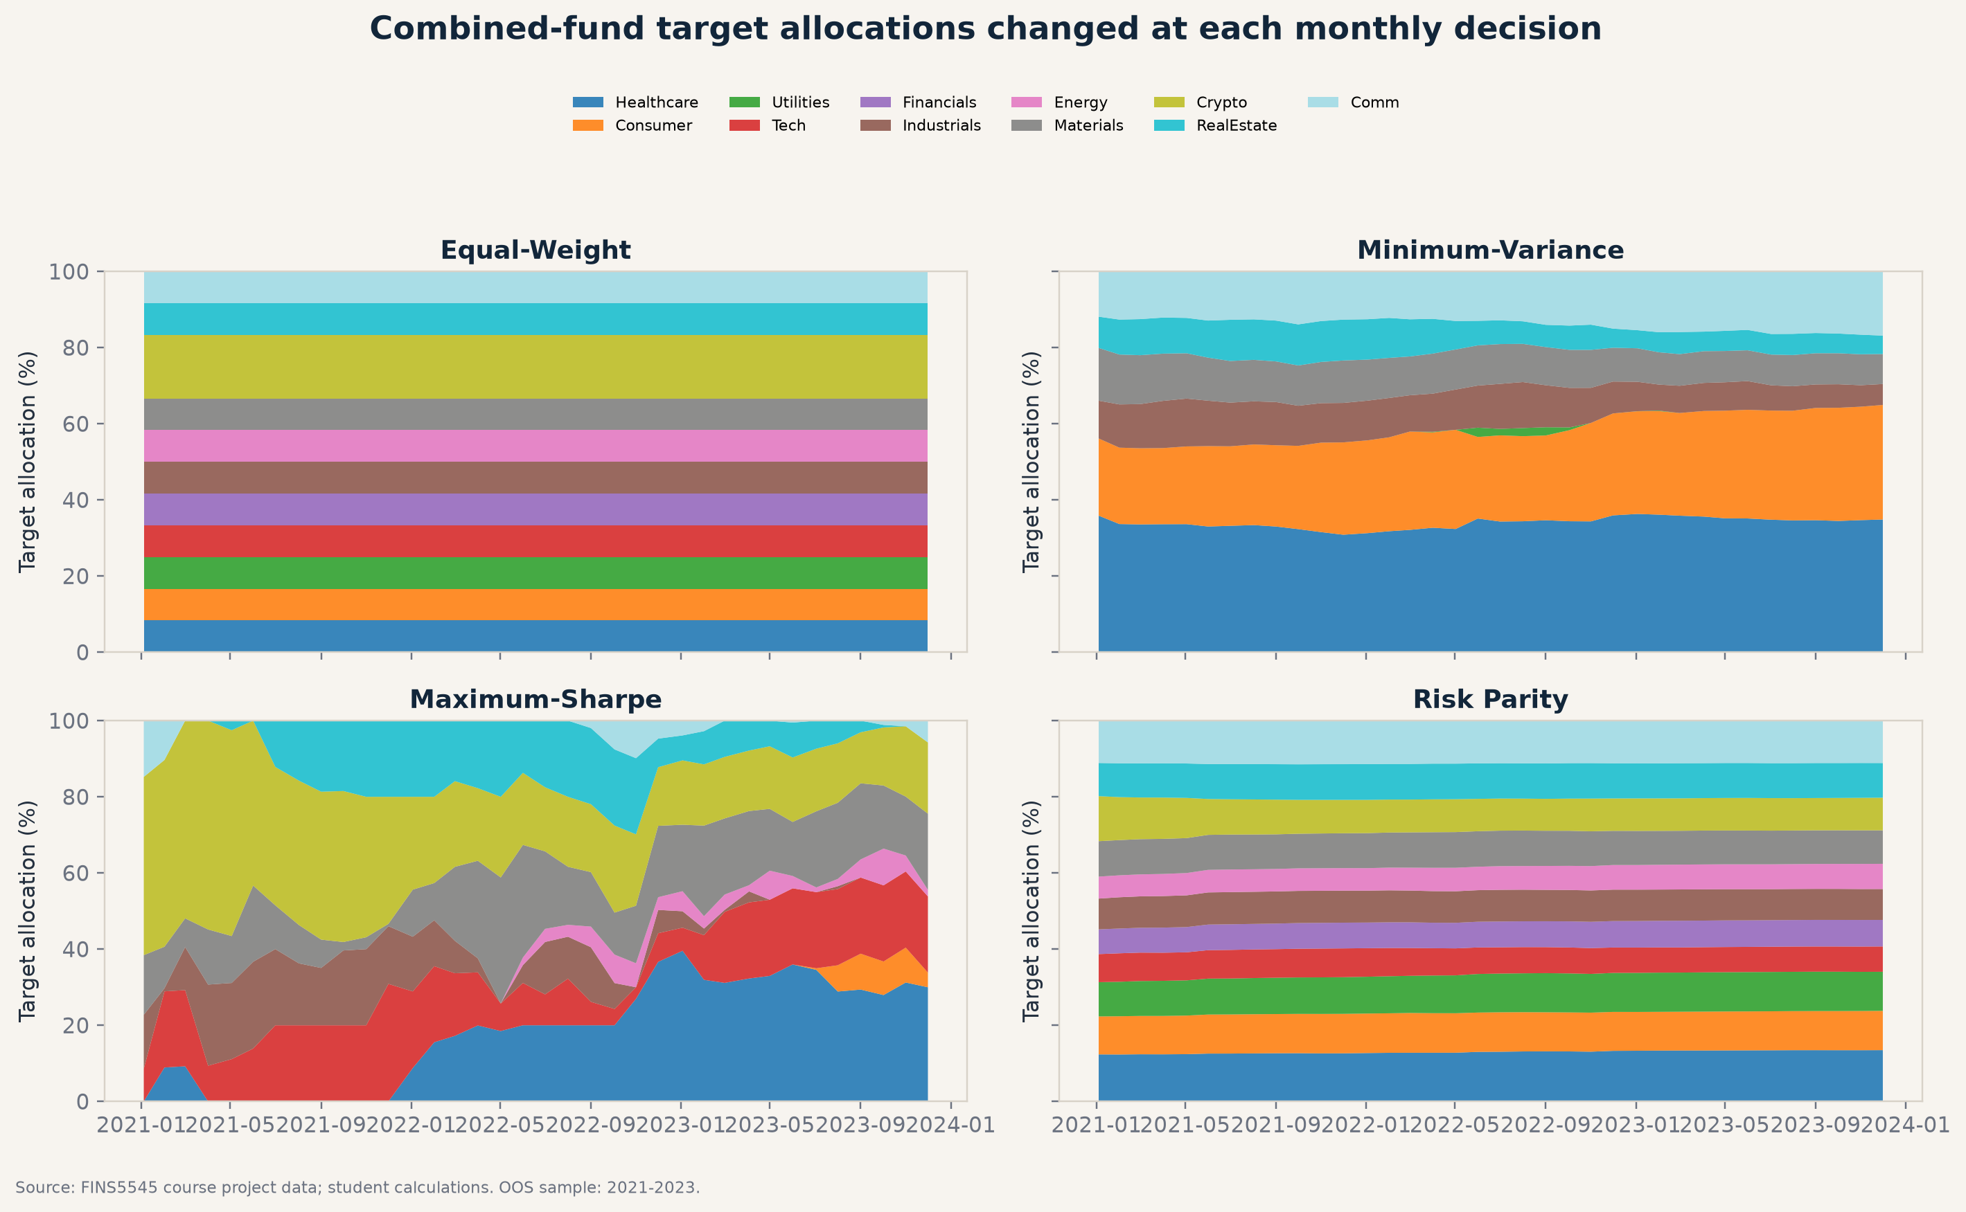
Exhibit C1. Monthly target allocations by group for all four combined-fund methods.
Source: FINS5545 prices; expanding estimates use prior observations only; 2021–2023.
Equal-Weight is constant by construction. Minimum-Variance avoids crypto; Risk Parity evolves gradually; Maximum-Sharpe produces large allocation shifts as estimated returns change.
Audit link
The underlying ticker-level monthly targets are in results/data/fund_weights.csv. results/tables/portfolio_constraint_checks.csv records weight sum, minimum, and maximum for every fund-rebalance pair.

APPENDIX D

Required exhibit: sector sentiment over time
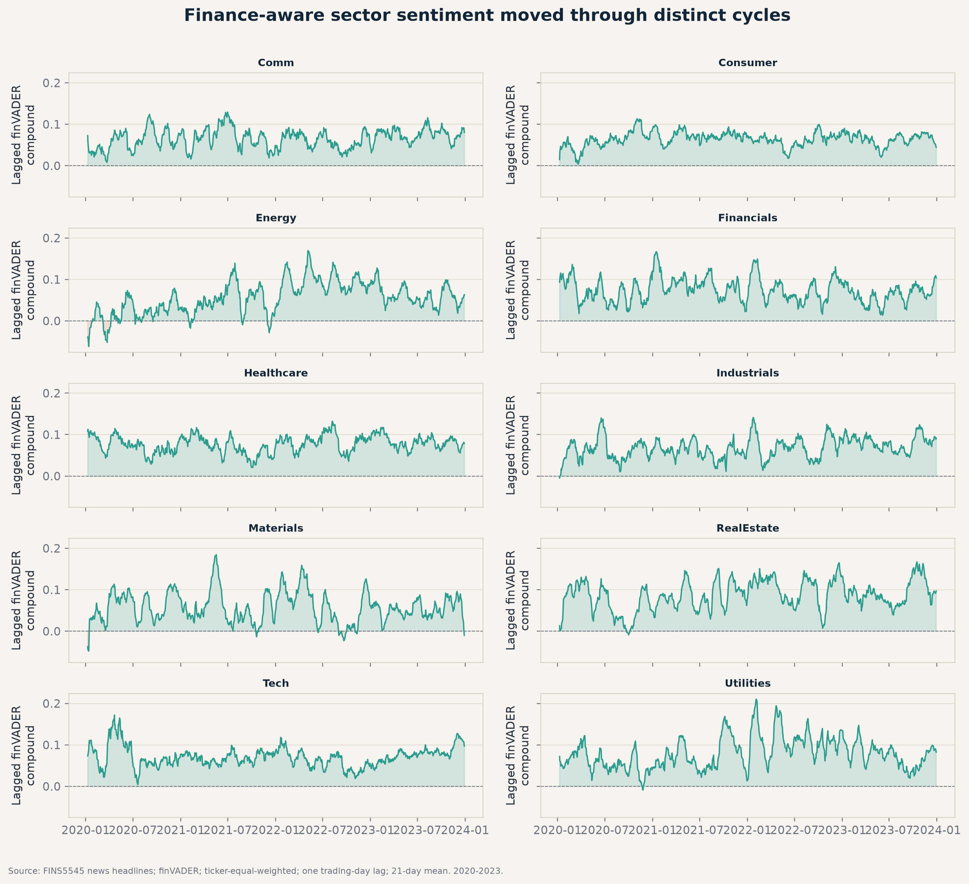
Exhibit D1. Lagged 21-day finVADER sentiment by sector, 2020–2023.
Source: FINS5545 headlines; headline scores average within ticker-day, then equally across tickers; five-day carry; one trading-day lag.
Sector tone moves through common regimes but retains cross-sector dispersion. Equal-ticker aggregation prevents firms with more headlines from dominating the index.
Interpretation
The sector chart is a descriptive state variable. It is not itself a trading result. Any allocation use is evaluated separately in Appendix E with the prescribed lag, holdout, turnover, and costs.

APPENDIX E

Sentiment diagnostics and fear/greed
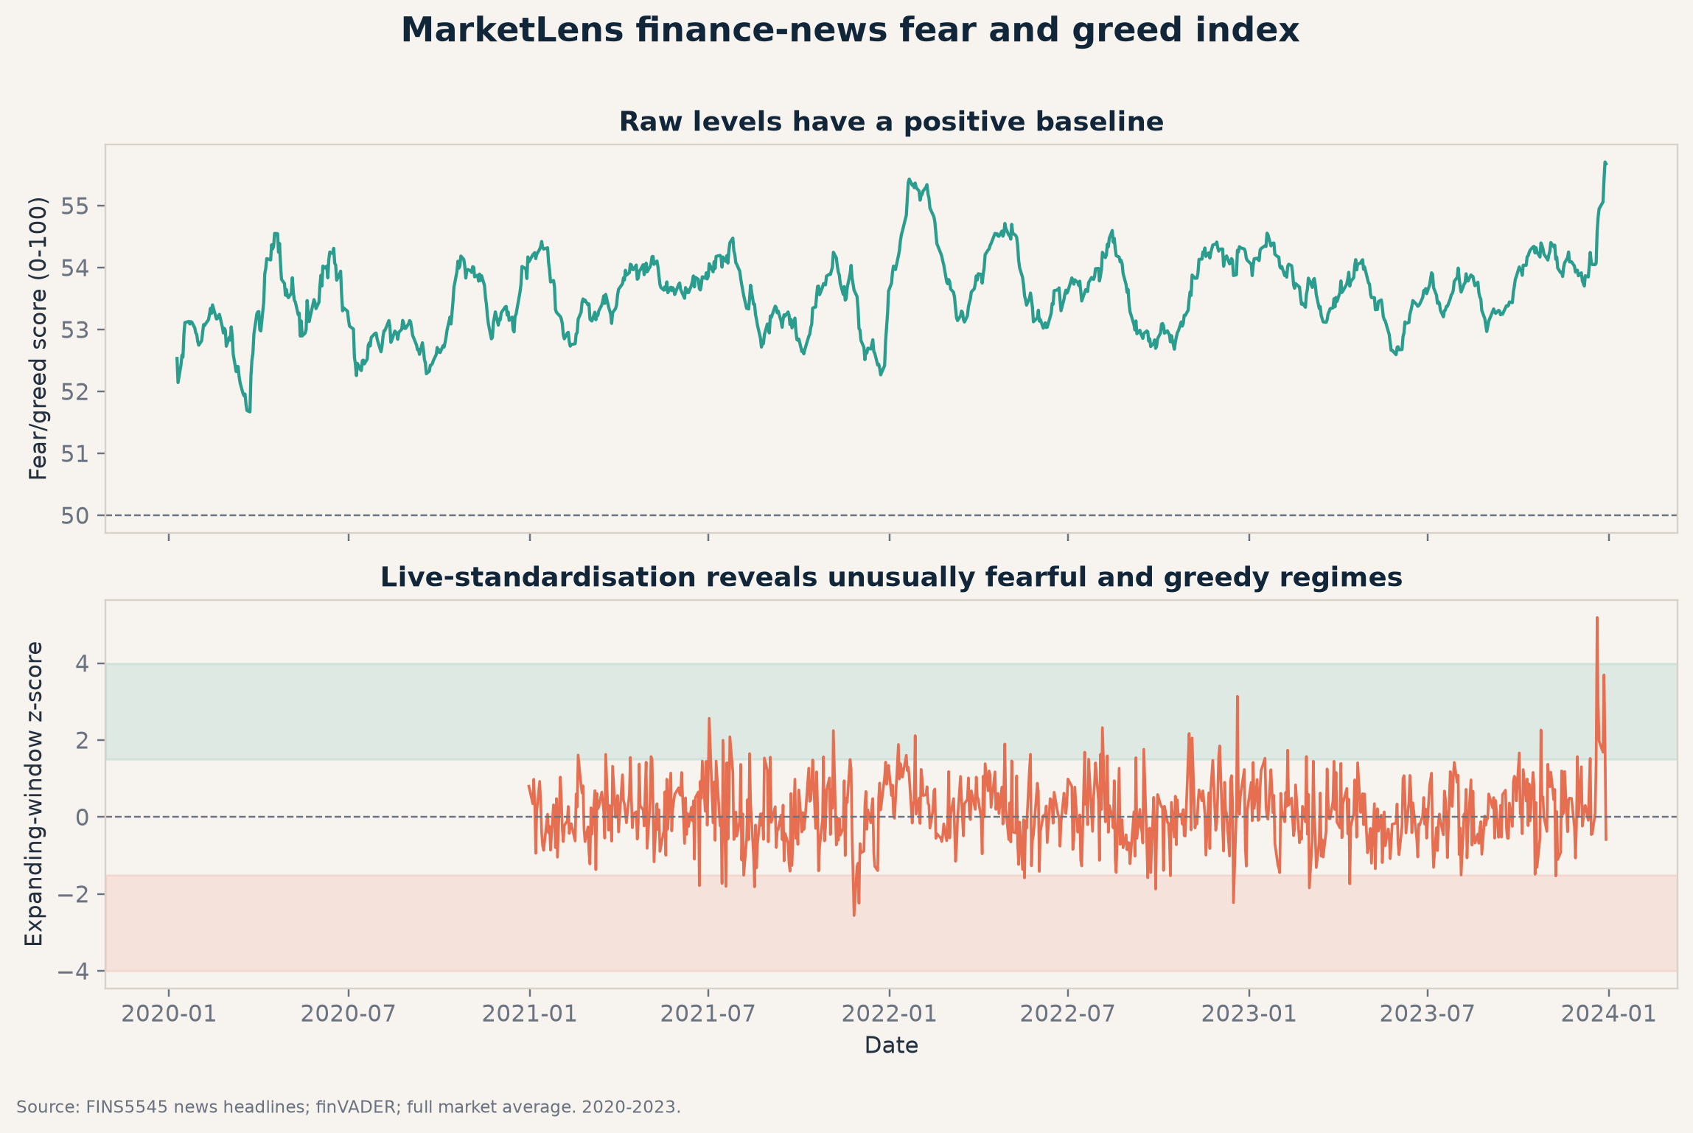
Exhibit E1. MarketLens news fear/greed level and expanding live z-score.
Source: FINS5545 headlines; finVADER; equal headline contribution after ticker-day aggregation; 2020–2023.
The expanding z-score only uses history available by each date; the full-sample standardisation is retained in CSV for descriptive comparison, not live decisions.

Exhibit E2. Sentiment model coverage robustness.
Source: results/tables/sentiment_model_validation.csv; 2020–2023.

APPENDIX F

Required fusion evidence and robustness
Period | Model | Return | Sharpe | MDD | Turnover
Full OOS (descriptive; strength tuned within period) | Base Equity Minimum-Variance | 7.0% | 0.60 | -17.8% | 2.09x
Full OOS (descriptive; strength tuned within period) | Finance-Sentiment Tilt | 6.9% | 0.59 | -18.1% | 4.79x
Discovery (strength selected here) | Base Equity Minimum-Variance | 8.0% | 0.63 | -17.8% | 1.82x
Discovery (strength selected here) | Finance-Sentiment Tilt | 7.7% | 0.62 | -18.1% | 3.75x
Untouched holdout | Base Equity Minimum-Variance | 5.1% | 0.51 | -8.6% | 0.27x
Untouched holdout | Finance-Sentiment Tilt | 5.3% | 0.52 | -8.5% | 1.04x
Exhibit F1. Base versus pre-set +0.25 sentiment candidate in discovery and untouched holdout periods.
Source: results/tables/fusion_performance.csv; net of 10 bps one-way costs.

Exhibit F2. Required before/after fusion growth comparison in 2023.
Source: FINS5545 equity returns and lagged finVADER; student calculations.

APPENDIX F (CONTINUED)

Transaction-cost robustness
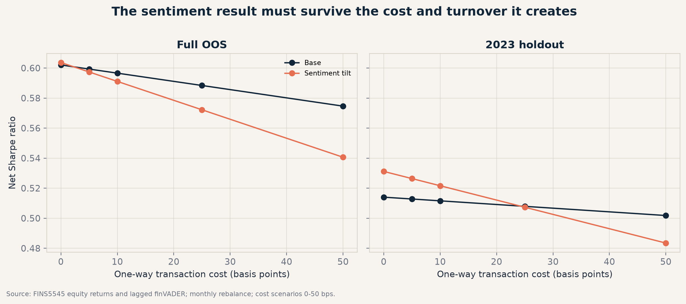
Exhibit F3. Fusion Sharpe sensitivity to one-way trading costs and turnover.
Source: results/tables/fusion_cost_robustness.csv; cost scenarios 0–50 bps.
The candidate advantage is not robust: it is erased around 25 bps in the holdout and is weaker over the full OOS period. This supports the no-productisation decision.

APPENDIX G

Reproducibility, limitations, and references

Reproducibility chain
Layer | Control
Data | Official hosted ZIP loaded only through src/data_access.py; raw files excluded.
Build | scripts/run_part_b.py recreates cleaned panels, all funds, sentiment, fusion, tables, and figures.
Deploy | streamlit_app.py loads only committed results CSVs; no runtime data download, NLP, or optimisation.
Tests | pytest checks future-data invariance, required artifacts, weight sums, non-negativity, and known metrics; Streamlit AppTest reports zero exceptions.
AI audit | AGENTS.md and ai/ record the constraints, prompts, risks, rejected selection, chart corrections, and student responsibilities.
Exhibit G1. Reproduction and hand-in controls.
Source: project repository; see README.md and docs/FINAL_HANDOFF.md.

Limitations
The 2021–2023 live sample is short and regime-specific. Headline titles omit article context, lexical sentiment can misread sarcasm or entity scope, and the news panel covers equities rather than crypto. Optimiser estimates remain noisy. Cost assumptions are scenarios rather than broker-specific estimates; taxes, slippage, market impact and asset-management operations are outside scope.

References
Consoli, S., Barbaglia, L., & Manzan, S. (2022). Fine-grained, aspect-based sentiment analysis on economic and financial lexicon. Knowledge-Based Systems, 247, 108781.
DeMiguel, V., Garlappi, L., & Uppal, R. (2009). Optimal versus naive diversification: How inefficient is the 1/N portfolio strategy? Review of Financial Studies, 22(5), 1915–1953.
Henry, E. (2008). Are investors influenced by how earnings press releases are written? Journal of Business Communication, 45(4), 363–407.
Hutto, C. J., & Gilbert, E. (2014). VADER: A parsimonious rule-based model for sentiment analysis of social media text. ICWSM, 8(1), 216–225.
Koráb, P. (2023). FinVADER: VADER sentiment classifier updated with financial lexicons. Python package.
Maillard, S., Roncalli, T., & Teiletche, J. (2010). The properties of equally weighted risk contribution portfolios. Journal of Portfolio Management, 36(4), 60–70.
Markowitz, H. (1952). Portfolio selection. Journal of Finance, 7(1), 77–91.
Sharpe, W. F. (1966). Mutual fund performance. Journal of Business, 39(1), 119–138.
UNSW FINS5545 (2026). Week 9: From Text to a Fear and Greed Index; Week 10: Revision and Project B guidance; Project B brief and official course data.

