Disturbance Stem Maps

Jeff Atkins

April 3, 2019

## Disturbance Stem Maps

The following document produces stem maps that assign mortality and treatments DRAFT DRAFT DRAFT

## A01

## A01E, 85%, Bottom-Up

##   
## kill live   
## 96 8

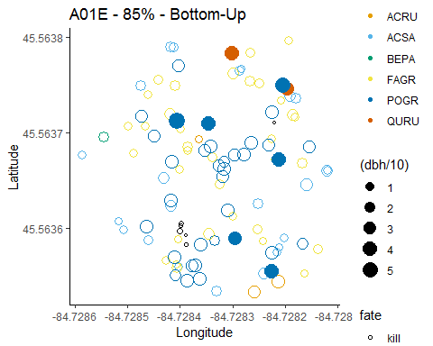

## A01W, 85%, Top-Down

##   
## kill live   
## 67 42

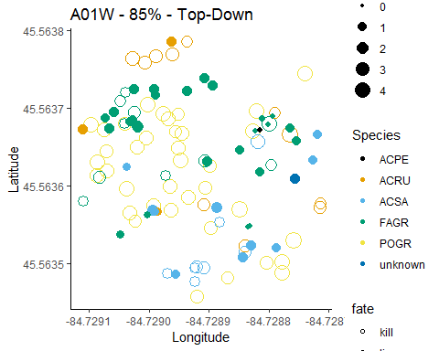

## A02

## A02E, 45%, top-down

##   
## kill live   
## 19 65

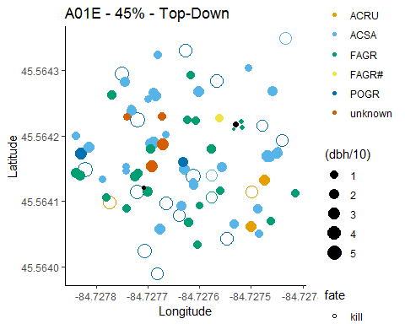

## A02W, 45%, Bottom-Down

##   
## kill live   
## 65 32

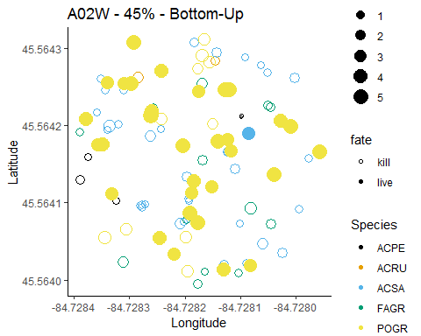

## A03

## A03E, 65%, Bottom-Down

##   
## kill live   
## 88 20

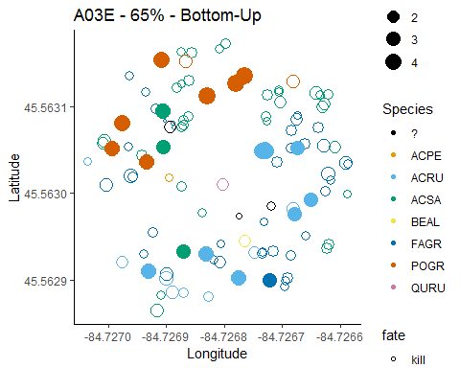

## A02E, 45%, top-down

##   
## kill live   
## 48 69

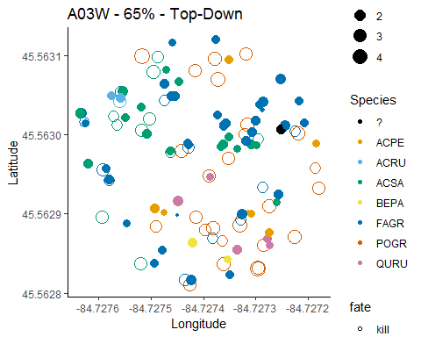

## A04

## A04E, 0%, Control

##   
## live   
## 98

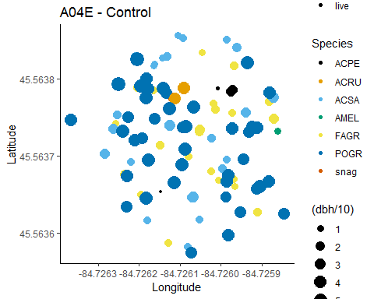

## A04W, 0%, Control

##   
## live   
## 100

