disturbance_stem_maps_group_b

Jeff Atkins

April 3, 2019

## Disturbance Stem Maps

The following document produces stem maps that assign mortality and treatments DRAFT DRAFT DRAFT

## B01

## B01E, 0%, Control

##   
## live   
## 94

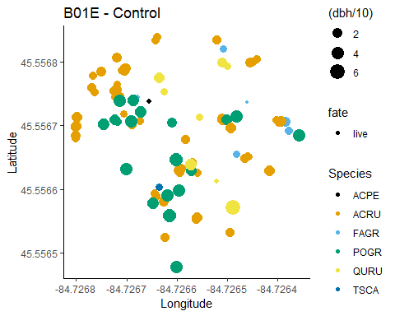

## B01W, 0%, Control

##   
## live   
## 105

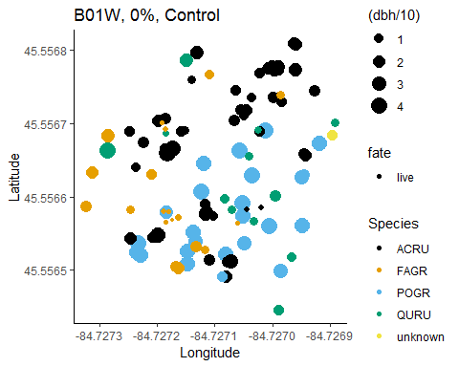

## B02

## B02E, 45%, top-down

##   
## kill live   
## 22 75

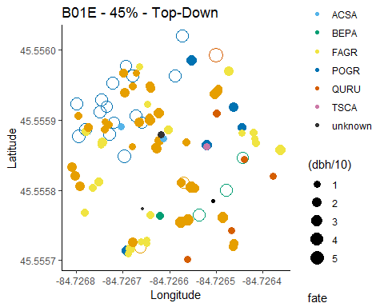

## B02W, 45%, Bottom-Down

##   
## kill live   
## 75 39

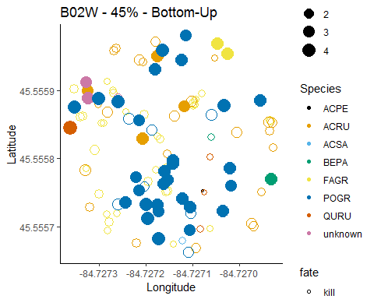

## B03

## B03E, 85%, Bottom-Up

##   
## kill live   
## 70 5

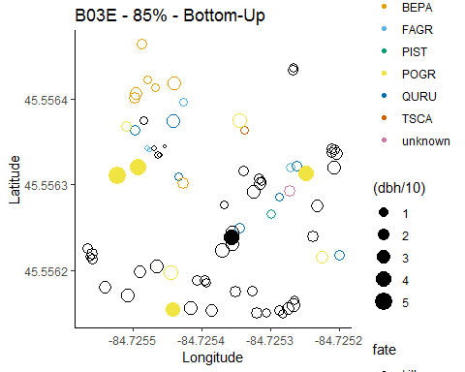

## B03W, 85%, Top-Down

##   
## kill live   
## 72 40

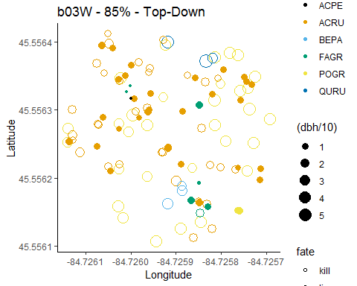

## B04

## B04E, 65%, top-down

##   
## kill live   
## 39 64

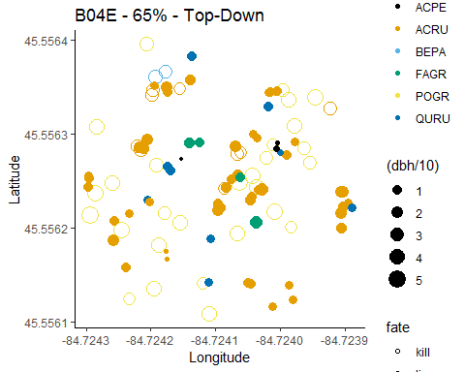

## B04W, 65%, Bottom-Down

##   
## kill live   
## 83 17

