disturbance_stem_maps_group_c

Jeff Atkins

April 3, 2019

## Disturbance Stem Maps

The following document produces stem maps that assign mortality and treatments DRAFT DRAFT DRAFT

## C01

## C01E, 0%, Control

##   
## live   
## 105

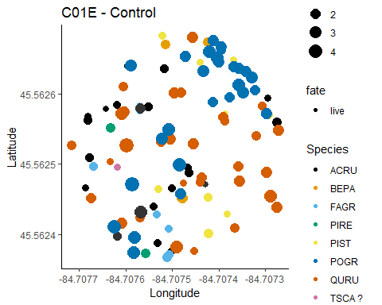

## C01W, 0%, Control

##   
## live   
## 75

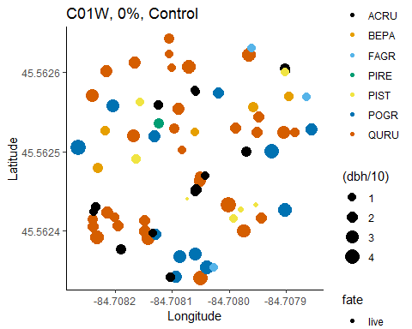

## C02

## C02E, 65%, Bottom-Down

##   
## kill live   
## 96 27

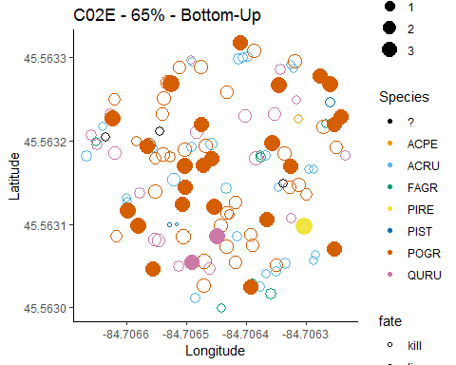

## C02W, 65%, top-down

##   
## kill live   
## 60 71

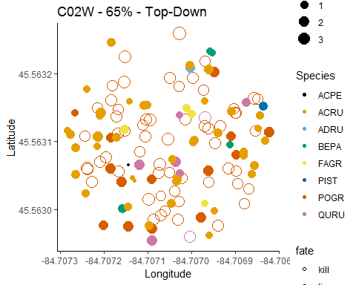

## C03

## C03E, 85%, Bottom-Up

##   
## kill live   
## 91 6

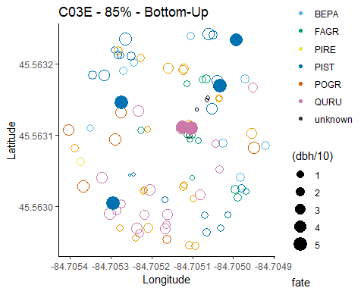

## C03W, 85%, Top-Down

##   
## kill live   
## 77 38

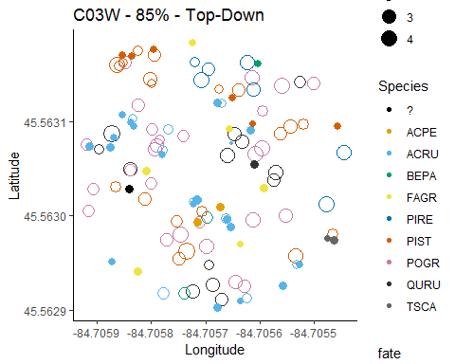

## B04

## C04E, 45%, top-down

##   
## kill live   
## 23 61

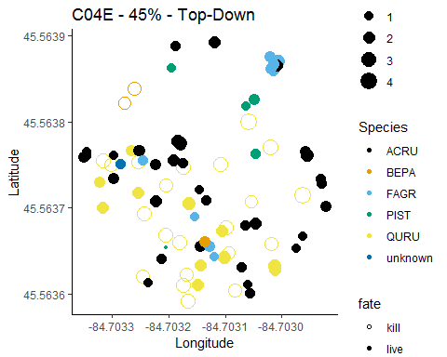

## C04W, 65%, Bottom-Down

##   
## kill live   
## 86 19

