This is a description of FoRTE subplot identifiers used in the 2018 field season.

Experimental treatments have not been assigned (as of the end of June 2018), but eventually these plots will be re-identified.

Replicate clusters were lettered A – D moving from west to east across the landscape. Likewise, within each replicate, plots were numbered 1 – 4 from west to east. Subplots (0.1 ha circular areas in west and east halves of each plot) were labeled “W” or “E.”

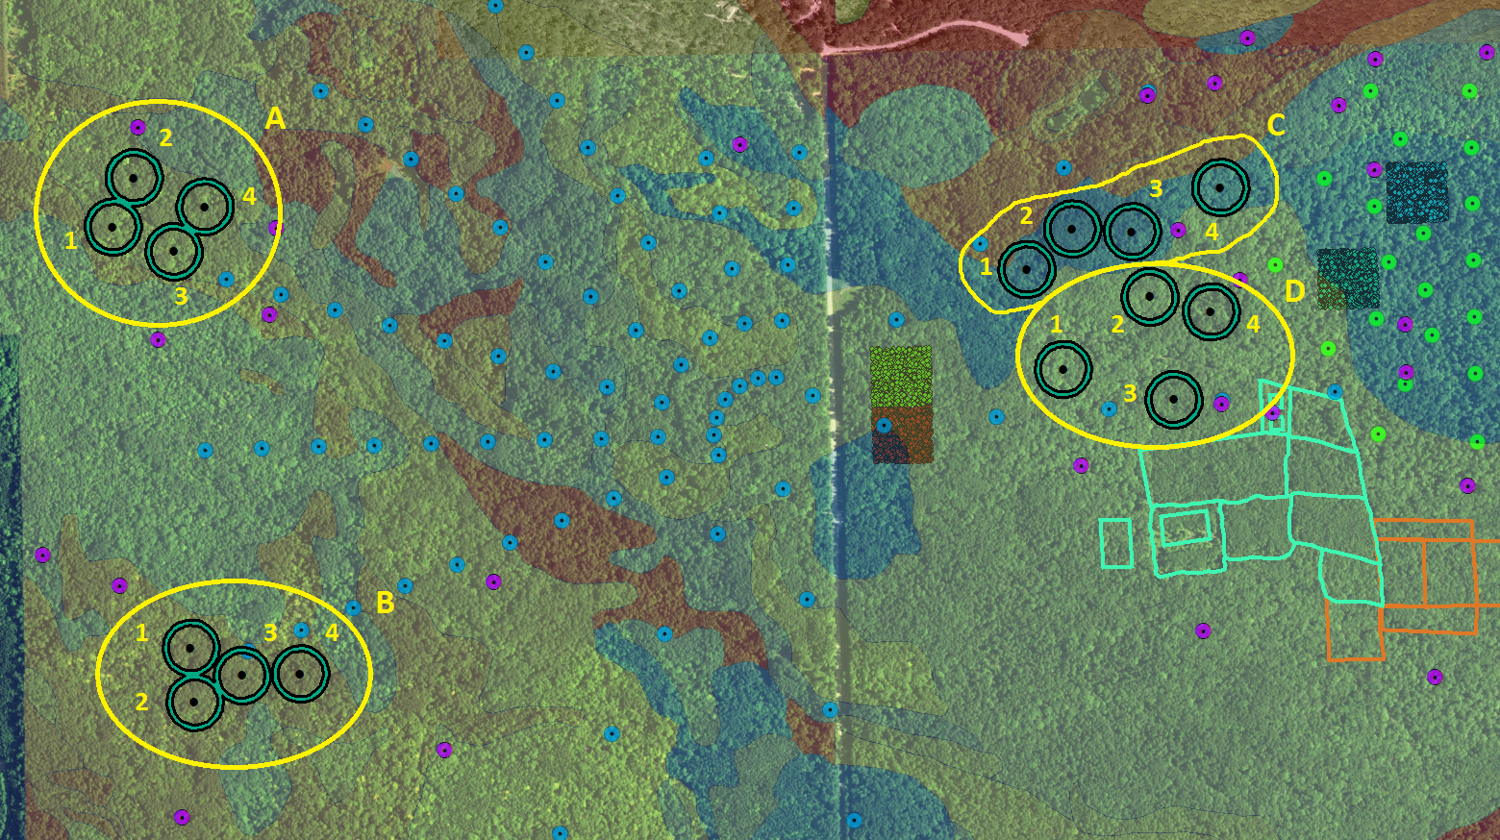

“Plots” generated on the Haglof Postex computer could only be identified with a three digit code. Below is a table listing the three digit codes (i.e. Haglof file names) associated with each subplot. Multiple files may be associated with a single subplot if some stems were occluded when viewed from subplot center (where tripod and transponders were located), necessitating movement of the Haglof system to a new area for measurement and creation of a new “plot” file.

In general, we assigned Haglof codes/file names to reflect the position of subplots within the above described scheme, with replicate A-D becoming the first digit 1-4, plot number remaining the same (1-4), and subplot E or W becoming 1 or 2. So, D04W would become 442 for the primary plot, and additional plots that had to be created would be given an unique identifier 42_.

|  |  |
| --- | --- |
| **Subplot ID** | **Haglof Postex plot identifiers (file names)** |
| A01W | 111 |
| A01E | 112, 113, 114, 115 |
| A02W | 121, 120, 119 |
| A02E | 122, 123, 124 |
| A03W | 131, 130, 129 |
| A03E | 132, 133, 134, 135 |
| A04W | 141 |
| A04E | 142, 143, 144, 145 |
| B01W | 211, 210, 209, 208, 207 |
| B01E | 212, 213 |
| B02W | 221, 220, 219 |
| B02E | 222, 223, 224 |
| B03W | 231, 230, 229 |
| B03E | 232, 233, 234, 235 |
| B04W | 241, 240, 239 |
| B04E | 242, 243, 244, 245 |
| C01W | 311, 310 |
| C01E | 312, 313, 314 |
| C02W | 321, 320 |
| C02E | 322 |
| C03W | 331, 330 |
| C03E | 332, 333, 334, 335, 336 |
| C04W | 341, 340 |
| C04E | 342, 343 |
| D01W | 411, 410 |
| D01E | 412, 413 |
| D02W | 422, 423, 424 |
| D02E | 421, 420, 419 |
| D03W | 432, 433 |
| D03E | 431, 428, 430, 429 |
| D04W | 443, 445 |
| D04E | 441 |