Disturbance Stem Maps

Jeff Atkins

April 3, 2019

## Disturbance Stem Maps

The following document produces stem maps that assign mortality and treatments DRAFT DRAFT DRAFT

## A01

## A01E, 85%, Bottom-Up

##   
## kill live   
## 99 5

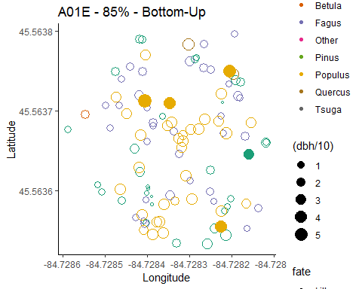

## A01W, 85%, Top-Down

##   
## kill live   
## 55 54

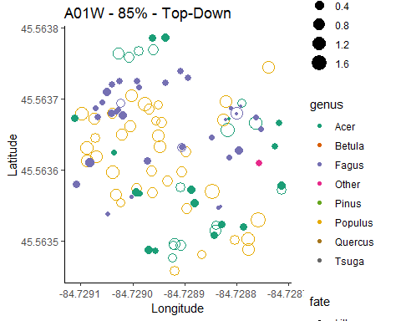

## A02

## A02E, 45%, top-down

##   
## kill live   
## 13 71

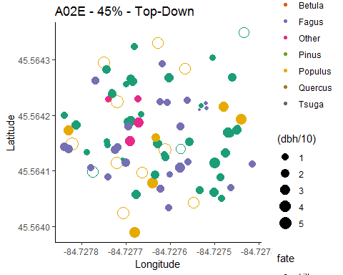

## A02W, 45%, Bottom-Down

##   
## kill live   
## 73 24

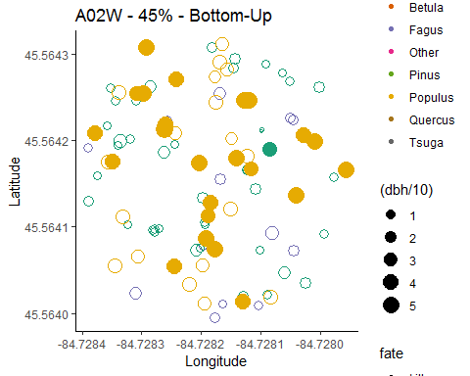

## A03

## A03E, 65%, Bottom-Down

##   
## kill live   
## 94 13

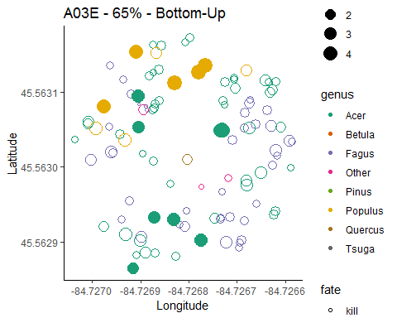

## A03W, 45%, top-down

##   
## kill live   
## 32 85

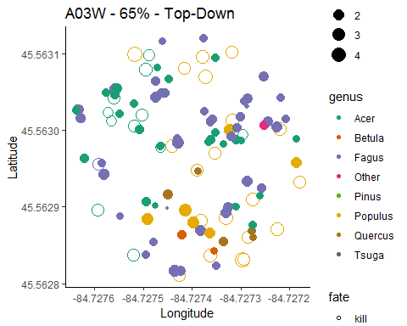

## A04

## A04E, 0%, Control

##   
## live   
## 97

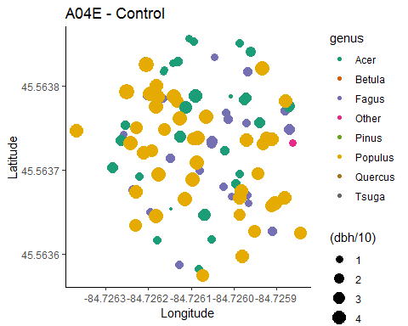

## A04W, 0%, Control

##   
## live   
## 99

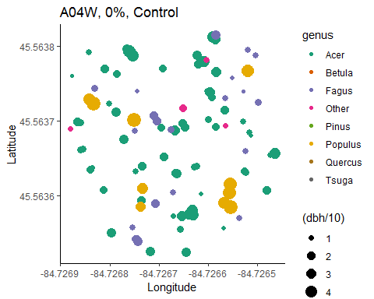

## Picking joint bandwidth of 1.44

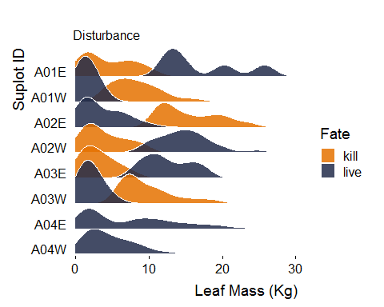

## Total mortality count

##   
## kill live   
## 366 447

## Estimated total number of trees killed for all 0.5 ha plots combined in Group A

## [1] 915

