disturbance_stem_maps_group_b

Jeff Atkins

April 3, 2019

## Disturbance Stem Maps

The following document produces stem maps that assign mortality and treatments DRAFT DRAFT DRAFT

## B01

## B01E, 0%, Control

##   
## live   
## 94

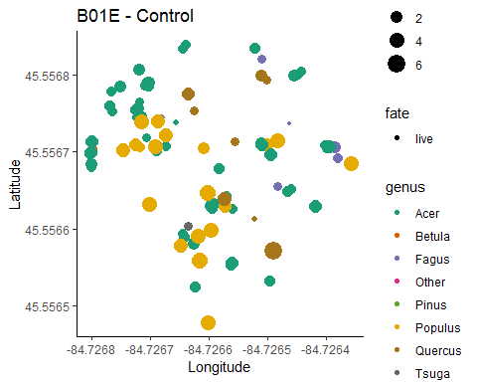

## B01W, 0%, Control

##   
## live   
## 105

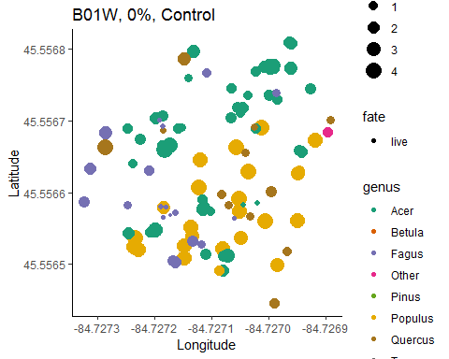

## B02

## B02E, 45%, top-down

##   
## kill live   
## 14 83

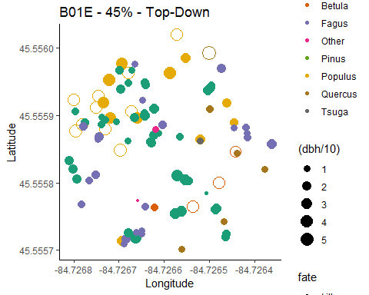

## B02W, 45%, Bottom-Down

##   
## kill live   
## 84 30

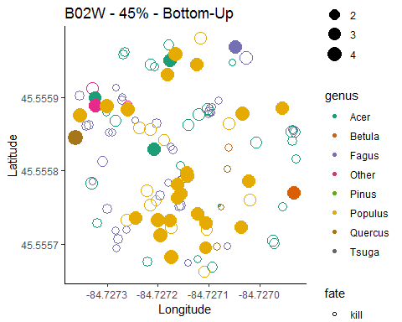

## B03

## B03E, 85%, Bottom-Up

##   
## kill live   
## 72 3

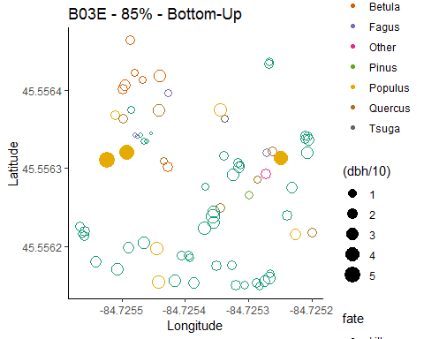

## B03W, 85%, Top-Down

##   
## kill live   
## 54 58

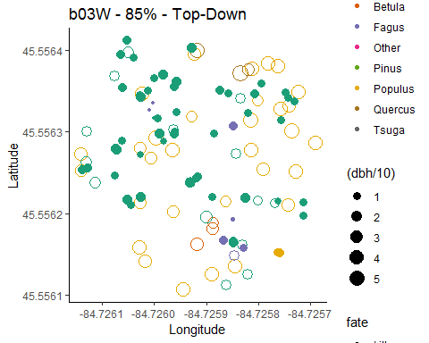

## B04

## B04E, 65%, top-down

##   
## kill live   
## 26 77

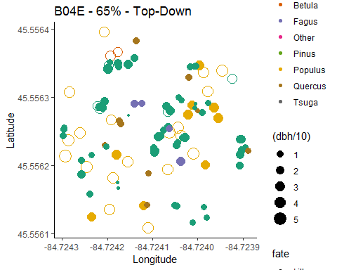

## B04W, 65%, Bottom-Down

##   
## kill live   
## 90 10

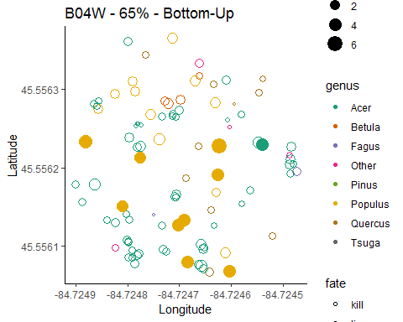

## Picking joint bandwidth of 1.12

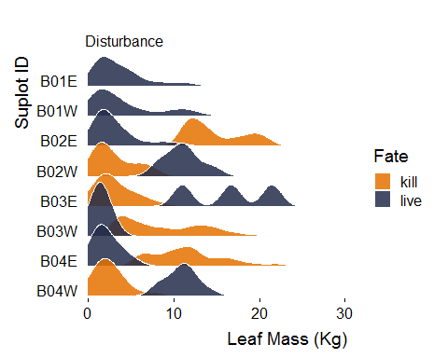

## Total mortality count

##   
## kill live   
## 340 460

## Estimated total number of trees killed for all 0.5 ha plots combined in Group B

## [1] 850

