disturbance_stem_maps_group_c

Jeff Atkins

April 4, 2019

## Disturbance Stem Maps

The following document produces stem maps that assign mortality and treatments DRAFT DRAFT DRAFT

## C01

## C01E, 0%, Control

##   
## live   
## 100

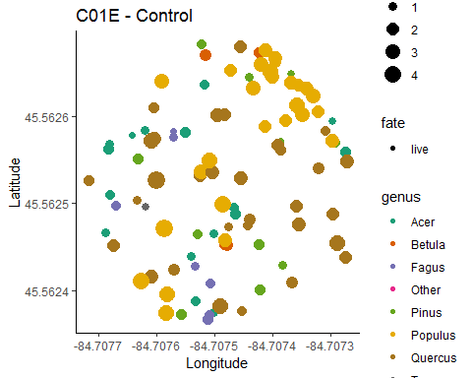

## C01W, 0%, Control

##   
## live   
## 75

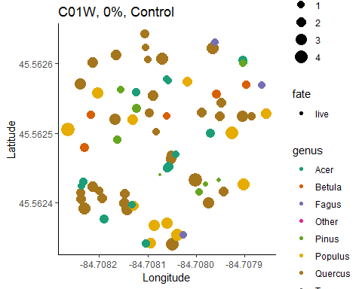

## C02

## C02E, 65%, bottom-down

##   
## kill live   
## 106 14

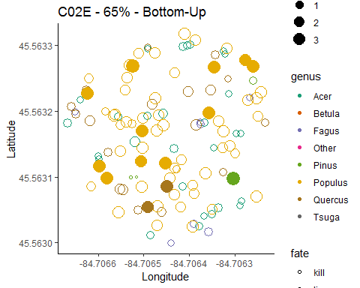

## C02W, 65%, Top-Down

##   
## kill live   
## 50 81

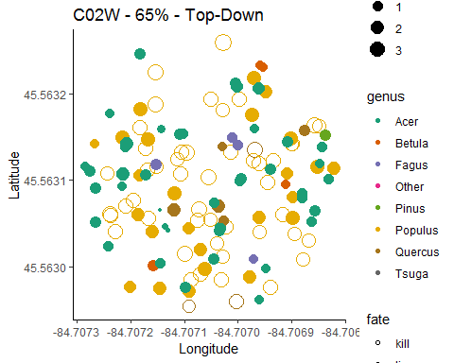

## C03

## C03E, 85%, Bottom-Up

##   
## kill live   
## 91 4

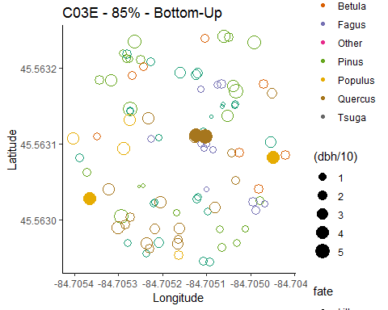

## C03W, 85%, Top-Down

##   
## kill live   
## 43 71

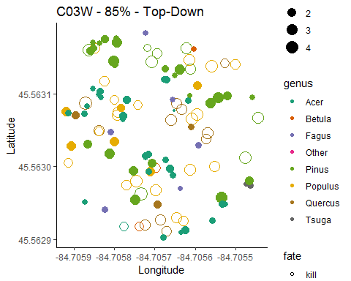

## C04

## C04E, 45%, top-down

##   
## kill live   
## 17 66

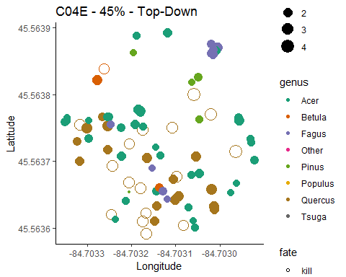

## C04W, 45%, Bottom-Down

##   
## kill live   
## 81 24

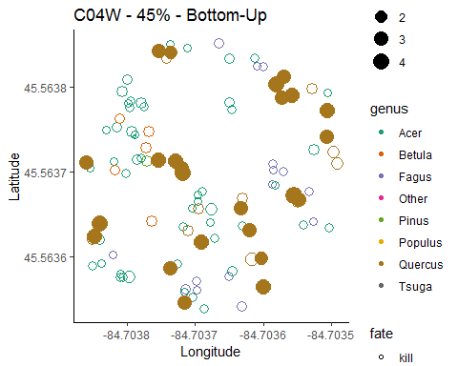

## Picking joint bandwidth of 0.707

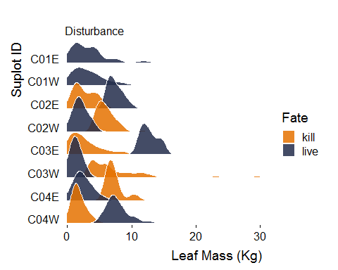

## Total mortality count

##   
## kill live   
## 388 435

## Estimated total number of trees killed for all 0.5 ha plots combined in Group C

## [1] 970

