disturbance_stem_maps_group_d

Jeff Atkins

April 4, 2019

## Disturbance Stem Maps

The following document produces stem maps that assign mortality and treatments DRAFT DRAFT DRAFT

## D01

## D01E, 0%, Control

##   
## live   
## 73

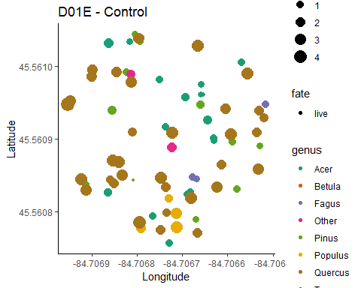

## D01W, 0%, Control

##   
## live   
## 59

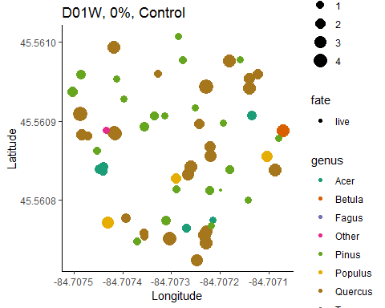

## D02

## D02w, 85%, top-down

##   
## kill live   
## 45 39

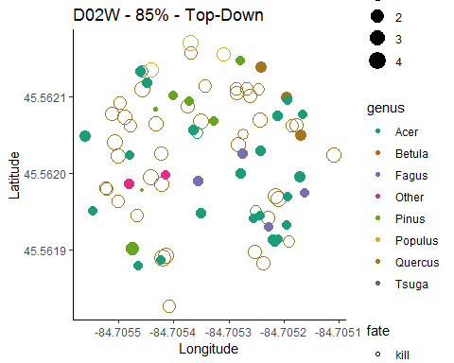

## D02E, 85%, Bottom-Down

##   
## kill live   
## 90 4

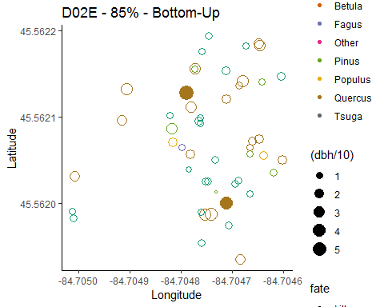

## D03

## D03E, 45%, Bottom-Up

##   
## kill live   
## 85 28

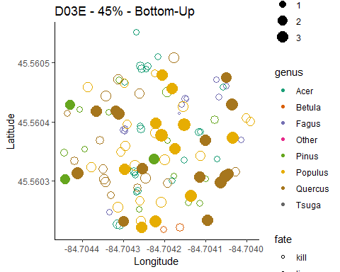

## D03W, 45%, Top-Down

##   
## kill live   
## 16 69

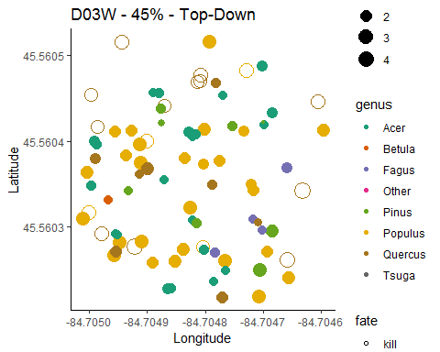

## D04

## D04E, 65%, top-down

##   
## kill live   
## 10 52

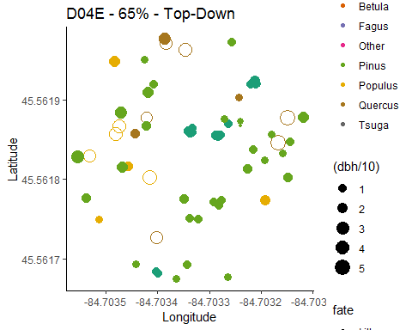

## D04W, 65%, Bottom-Down

##   
## kill live   
## 132 11

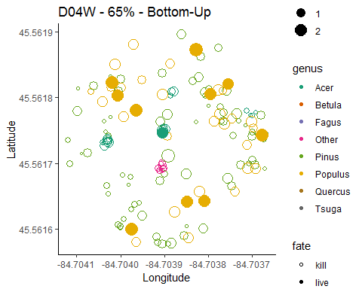

## Picking joint bandwidth of 0.764

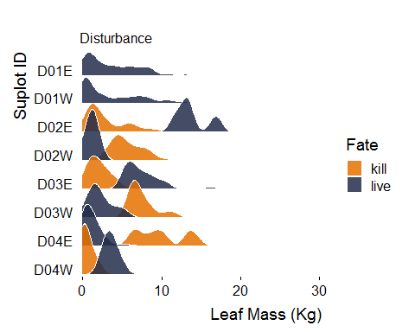

## Total mortality count

##   
## kill live   
## 378 335

## Estimated total number of trees killed for all 0.5 ha plots combined in Group D

## [1] 945

