|  |  |  |  |  |  |  |
| --- | --- | --- | --- | --- | --- | --- |
| pre-setting  the x input | | pre-setting  the y input | | selecting between computing + or & | post-setting the output | Resulting  ALU output |
| **Zx** | **Nx** | **zy** | **ny** | **F** | **no** | **out** |
| if zx  then  x=0 | if nx  then  x=!x | if zy  then  y=0 | if ny  then  y=!y | if f  then out=x+y  else out=x&y | if no  then  out=!out | out(x,y)= |
| 1 | 1 | 0 | 1 | 0 | 0 | !y |
| 1 | 1 | 0 | 1 | 0 | 1 | Y |
| 1 | 1 | 1 | 1 | 0 | 1 | 0 |
| 1 | 1 | 1 | 1 | 1 | 0 | -2 |
| 0 | 1 | 0 | 1 | 1 | 1 | X+y+1 |

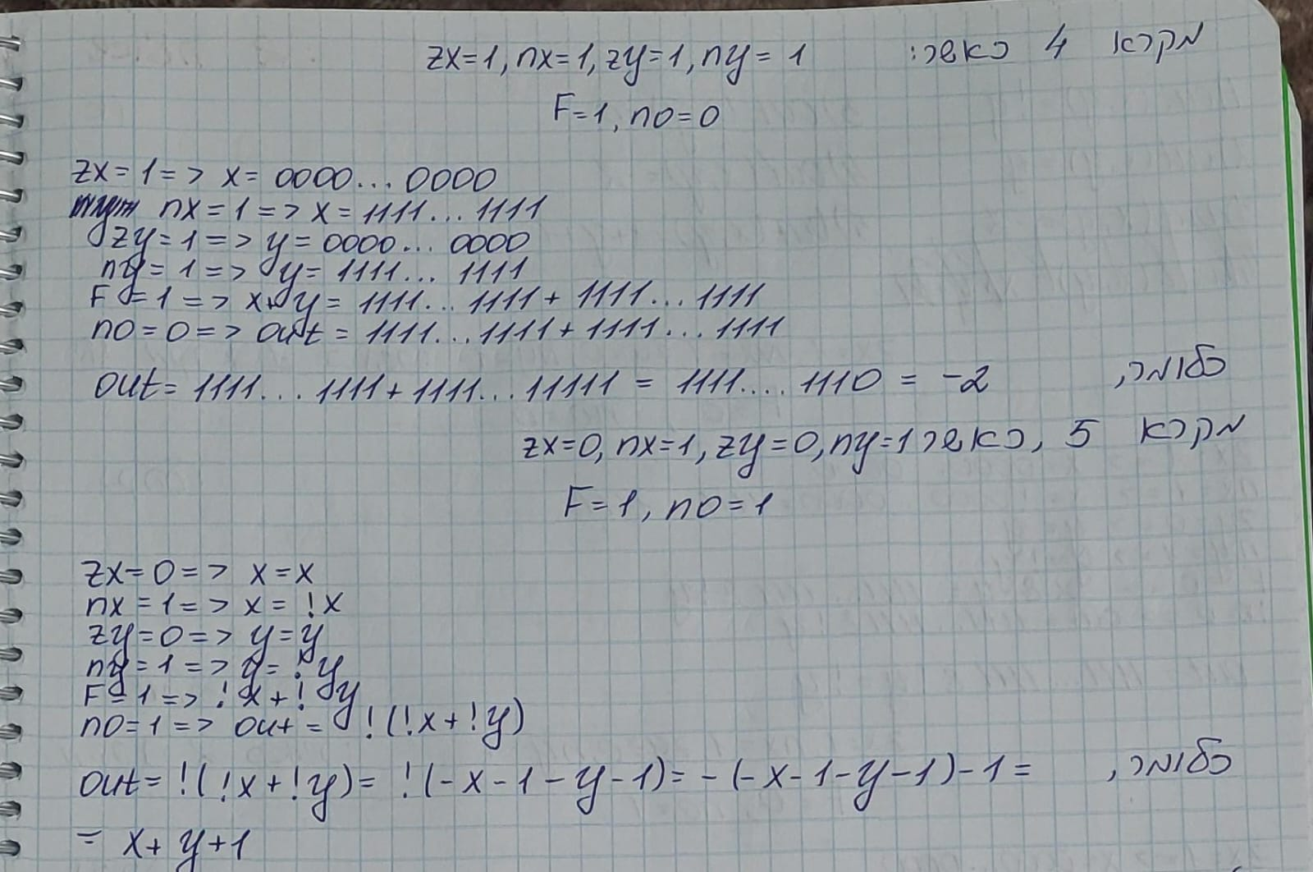

ג)

|  |  |
| --- | --- |
| חישוב ידני | Hardware Simulator |
| A math equations on a graph paper  Description automatically generated  מקרה 1 |  |
| מקרה 2 |  |
| מקרה 3  שייך למקרה 3 |  |
| מקרה 4 | ; |
|  |  |
|  |  |
|  |  |