Xcode App Store Upload Guide
Audience: New Team Members
Platforms: iOS and macOS
Developer Account: Focus KPI
Last Updated: August 18, 2026

Table of Contents
1. Step 1: Update the Version Number
2. Step 2: Configure Xcode and Build the Project
3. Step 3: Archive the Build
4. Step 4: Distribute to the App Store
5. Step 5: Submit for Review on App Store Connect
6. Frequently Asked Questions

Step 1: Update the Version Number
Important: Make sure the new version has been fully tested and is free of critical bugs before starting the release process.
Once the new version has passed all tests, instruct your AI Agent (Cursor, Antigravity, Claude Code, Codex, or any other available tool) to update the version number.

Key Requirements
- iOS and macOS version numbers must be updated separately. Do not share the same configuration between them.
- Have the AI confirm that CFBundleShortVersionString (version number) and CFBundleVersion (build number) in ios/Runner/Info.plist have been correctly incremented.
- Have the AI confirm that CFBundleShortVersionString (version number) and CFBundleVersion (build number) in macos/Runner/Info.plist have been correctly incremented.

Example Prompt
Please update the iOS version from 2.1 to 2.2 and the build number from 70 to 71.
Also update the macOS version from 2.0.0 to 2.1.0 and the build number from 71 to 72.

Step 2: Configure Xcode and Build the Project

2.1 Open the Correct Xcode Project
Open the Xcode project files for iOS and macOS separately. You can verify which platform you are working on by checking the toolbar at the top of the Xcode window.

2.2 Select the Correct Build Destination
Warning: This step is critical. You must select the correct target device, otherwise the Archive option will be grayed out.
Platform | Build Destination
macOS | Any Mac (arm64, x86_64)
iOS | Any iOS Device

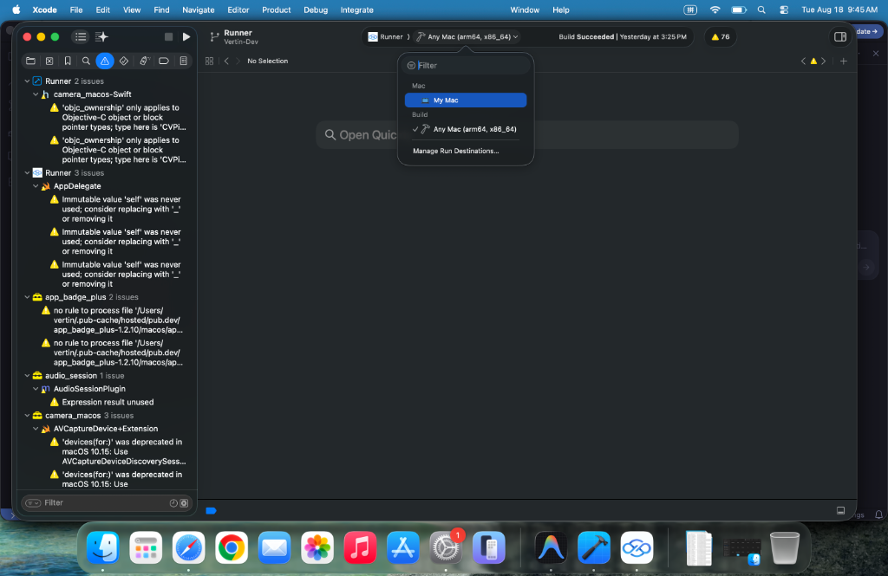
Figure 1: Selecting Any Mac as the Build Destination

2.3 Handling Build Warnings and Errors
During the build process, the left-hand navigator may display various issues:
Type | Icon | Action Required
Yellow Warning | Yellow triangle | Can be safely ignored; does not affect archiving
Red Error | Red circle | Must be resolved -- take a screenshot and submit it to your AI Agent

2.4 Wait for the Build to Complete
When the toolbar displays "Build Succeeded", the build is complete and you can proceed to the next step.

Step 3: Archive the Build

3.1 Create the Archive
- Confirm that the toolbar shows "Build Succeeded".
- In the Xcode menu bar at the top of the screen, click Product.
- From the dropdown menu, select Archive.
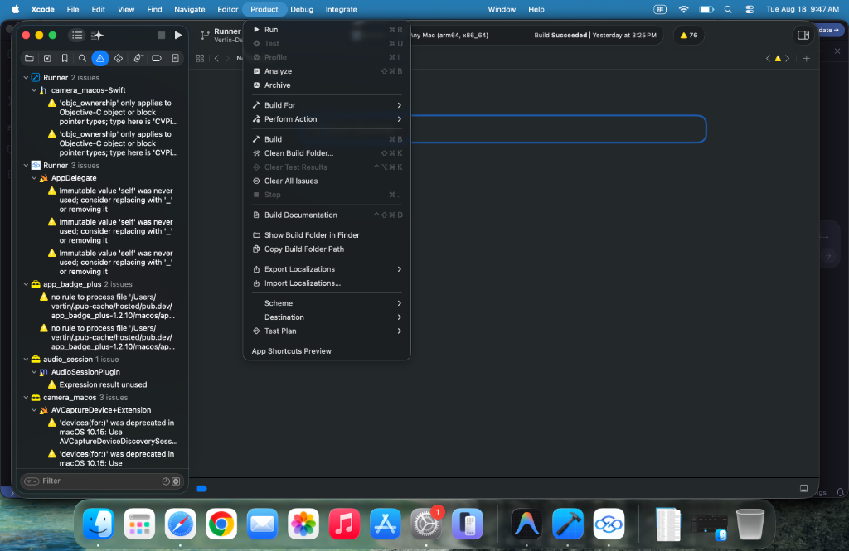
Figure 2: Selecting Product > Archive from the menu bar

3.2 Wait for Archiving to Finish
- The archiving process takes approximately 5 minutes.
- Do not close Xcode or perform other operations while archiving is in progress.
- When archiving is complete, the Organizer window will appear automatically, displaying a list of all available archives.
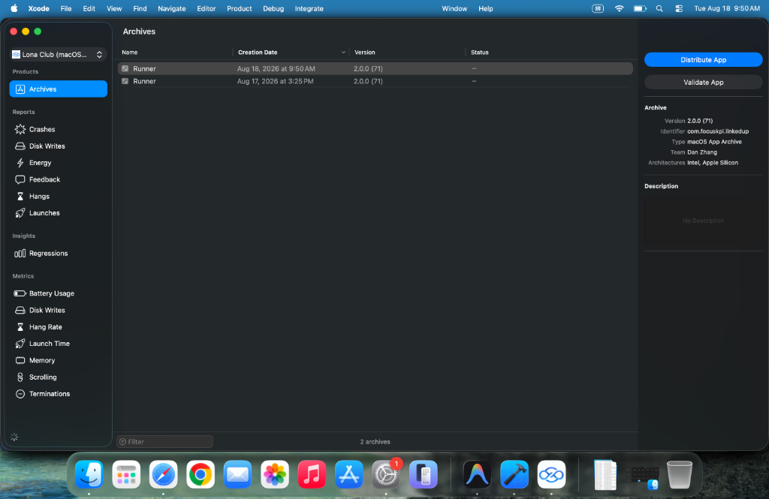
Figure 3: The Organizer window showing completed archives

Step 4: Distribute to the App Store

4.1 Start Distribution
- In the Organizer window, select the most recent archive (verify by checking the Creation Date column).
- Click the "Distribute App" button on the right side of the window.

4.2 Choose a Distribution Method
In the distribution method dialog, choose based on your needs:
Method | Purpose | Description
App Store Connect | Production Release | Publish to the App Store for end users to download
TestFlight Internal Only | Internal Testing | Available only to internal testers
Direct Distribution | Direct Distribution | Distribute outside the App Store
Debugging | Debug Builds | For debugging purposes only

Tip: Selecting App Store Connect allows you to use the build for both production release and TestFlight testing. If you only want to release a test version, you may also choose TestFlight Internal Only.
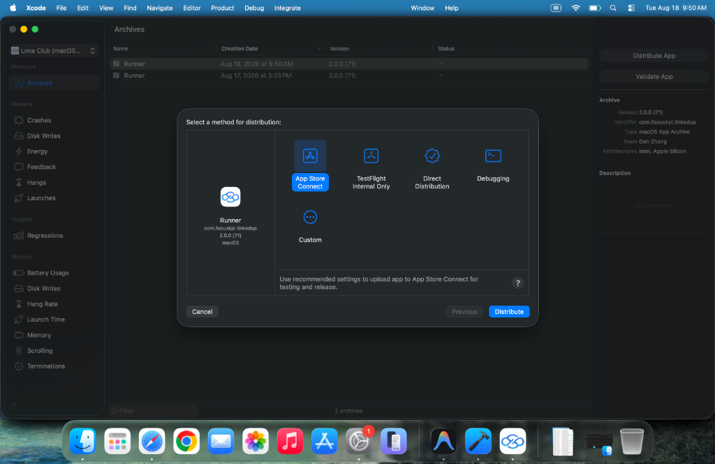
Figure 4: Selecting a distribution method
After making your selection, click the "Distribute" button in the lower-right corner to begin uploading.

4.3 Interpreting Upload Results
Result | Explanation
Upload succeeded with yellow warning | This is normal. The upload was successful; yellow warnings can be ignored.
Upload failed with red error | Action required -- take a screenshot and submit it to your AI Agent for troubleshooting.

Step 5: Submit for Review on App Store Connect

5.1 Log In to App Store Connect
- Open your browser and navigate to https://appstoreconnect.apple.com
- Sign in with the Focus KPI developer account.

5.2 Wait for Build Processing
Note: After a successful Distribute from Xcode, allow approximately 20 to 30 minutes for Apple's servers to finish processing the uploaded build.

5.3 Select the Build and Submit for Review
Using macOS as an example:
- In the left sidebar, locate the version under macOS App (e.g., "2.00 Prepare for Submission").
- In the Build section in the center of the page, find and select the build you just uploaded.
- Fill in the release notes under "What's New in This Version".
- Click "Save" in the upper-right corner.
- Click "Add for Review" to submit the build for Apple's review.
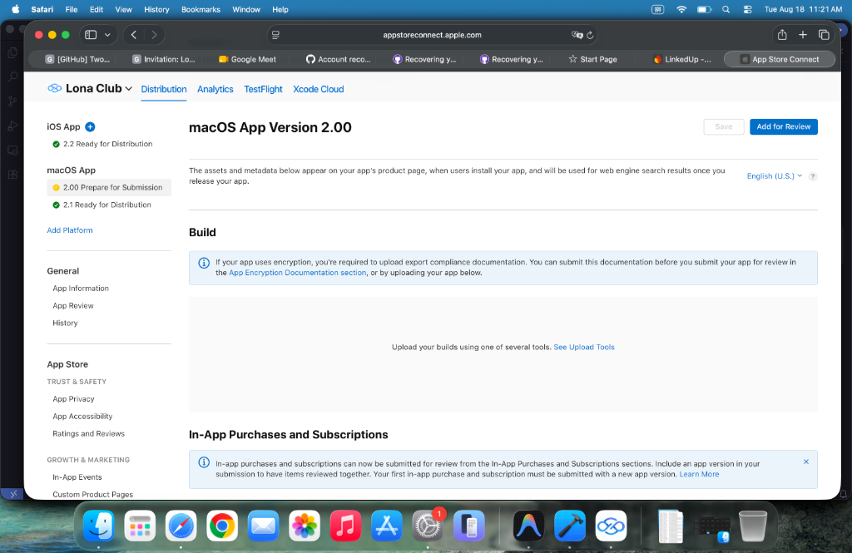
Figure 5: The App Store Connect submission page

5.4 Wait for Review Approval
Important: After submission, Apple's review team typically takes about 2 days to complete the review. Once approved, you will receive a notification email and the new version will go live on the App Store.

Frequently Asked Questions

Q1: Can I archive and upload iOS and macOS at the same time?
Yes, but it is recommended to complete one platform at a time to avoid confusion.

Q2: The Archive option in the Product menu is grayed out. Why?
Make sure you have selected the correct Build Destination. For macOS projects, select Any Mac. For iOS projects, select Any iOS Device. Do not select a Simulator.

Q3: I am getting a code signing error during upload.
Take a screenshot and send it to your AI Agent. Common causes include expired certificates, mismatched Provisioning Profiles, or insufficient developer account permissions.

Q4: I cannot see my uploaded build in App Store Connect.
Confirm that the Distribute step completed successfully with no red errors. Allow 20 to 30 minutes for Apple's servers to process the build. Also check your registered email, as Apple may send a notification if processing fails.

Q5: My submission was rejected by Apple. What should I do?
Review the rejection reason provided by Apple, fix the issue, re-upload, and submit again. You can share the rejection details with your AI Agent for analysis.

Process Overview
Testing complete -> AI updates version number -> Xcode Build -> Archive (~5 min) -> Distribute upload -> App Store Connect select build (wait ~30 min) -> Fill in release notes -> Add for Review -> Wait for review (~2 days) -> Published on the App Store

Tip: If you encounter any red errors at any point in this process, take a screenshot immediately and send it to your AI Agent (Cursor, Antigravity, Claude Code, Codex, etc.). They can quickly help you diagnose and resolve most build and upload issues.

Note: If you need to deploy the web version, there is an existing deploy script in the project repository. Simply ask your AI Agent to locate and run it.

