



**Sentiment analysis for marketing**

**Phase 1: Problem Definition and**

**Design Thinking**

BY: G.VINEETH KUMAR

B.E CSE,3rd YEAR,5th SEM 311421104109

MEENAKSHI COOLEGE OF ENGINEERING-3114

**TABLE OF CONTENTS**



## INTRODUCTION

* 1. **PROBLEM DEFINITION**
     + Objective
     + Goal
     + Aim
     + Methodology
     + Outcome

## DESIGN THINKING

* + - Data Collection
    - Data Preprocessing
    - Sentiment Analysis Techniques
    - Feature Extraction
    - Visualization
    - Insights Generation

**INTRODUCTION TO SENTIMENT**

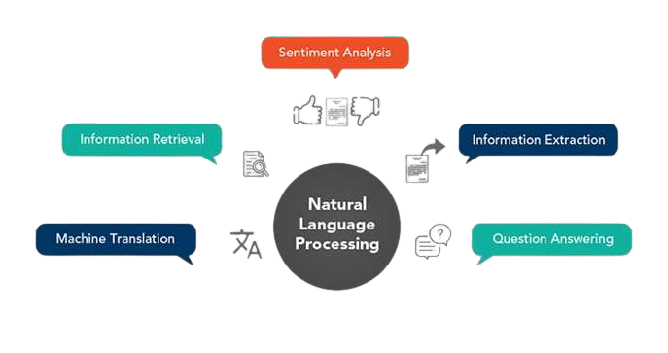

**. ANALYSIS**

**Sentiment analysis is a powerful natural language processing (NLP) technique that aims to decipher the emotional tone, attitude, or subjective information conveyed within a piece of text. At its core, sentiment analysis seeks to answer a fundamental question: Is the sentiment expressed in the text positive, negative, or neutral? However, it has evolved to handle more nuanced emotions and even fine-grained sentiment analysis, which can discern emotions like joy, anger, sadness, and more.**

# Problem Definition for Sentiment Analysis in Marketing:

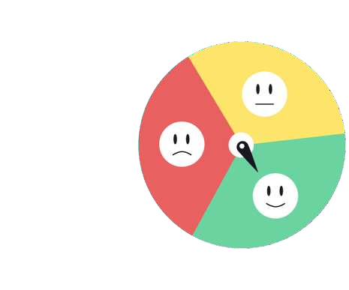

1. **Objective:** To perform sentiment analysis on marketing-related textual data, such as customer reviews, social media comments, and survey responses, in order to gain insights into customer perceptions and emotions.
2. **Goal:** The primary goal is to better understand customer sentiment regarding products, services, marketing campaigns, and brand interactions.
3. **Aim**: The ultimate aim is to leverage sentiment analysis in marketing to:

* Enhance customer experiences by addressing concerns and improving products or services.
* Optimize marketing strategies by tailoring them to customer sentiment.
* Monitor and manage brand reputation effectively.
* Identify opportunities for growth and competitive advantage.

### METHODOLOGY OF SENTIMENT ANALYSIS

* + **Data Collection:**➢ Gather relevant textual data from various sources, including social media, customer reviews, surveys, or news articles.
  + **Data Preprocessing:** Clean and prepare the text data to ensure

consistency and reliability.

* + **Sentiment Classification:** Create rules or patterns to identify sentiment in text

based on keywords, phrases, or syntactic structures.

* + **Visualizations and Reporting:**Create visualizations, such as sentiment distribution histograms, pie charts, or word clouds, to present the sentiment analysis results in a visually informative manner.

### OUTCOME OF SENTIMENT ANALYSIS

1. Marketing and Advertising:
   * **Tailored Marketing Campaigns**
2. Customer Insights:
   * **Understanding Customer Sentiment**
     + **Campaign Evaluation**: **Content Creation** ➢ **Customer Satisfaction Assessment**

### Customer Support and Engagement:

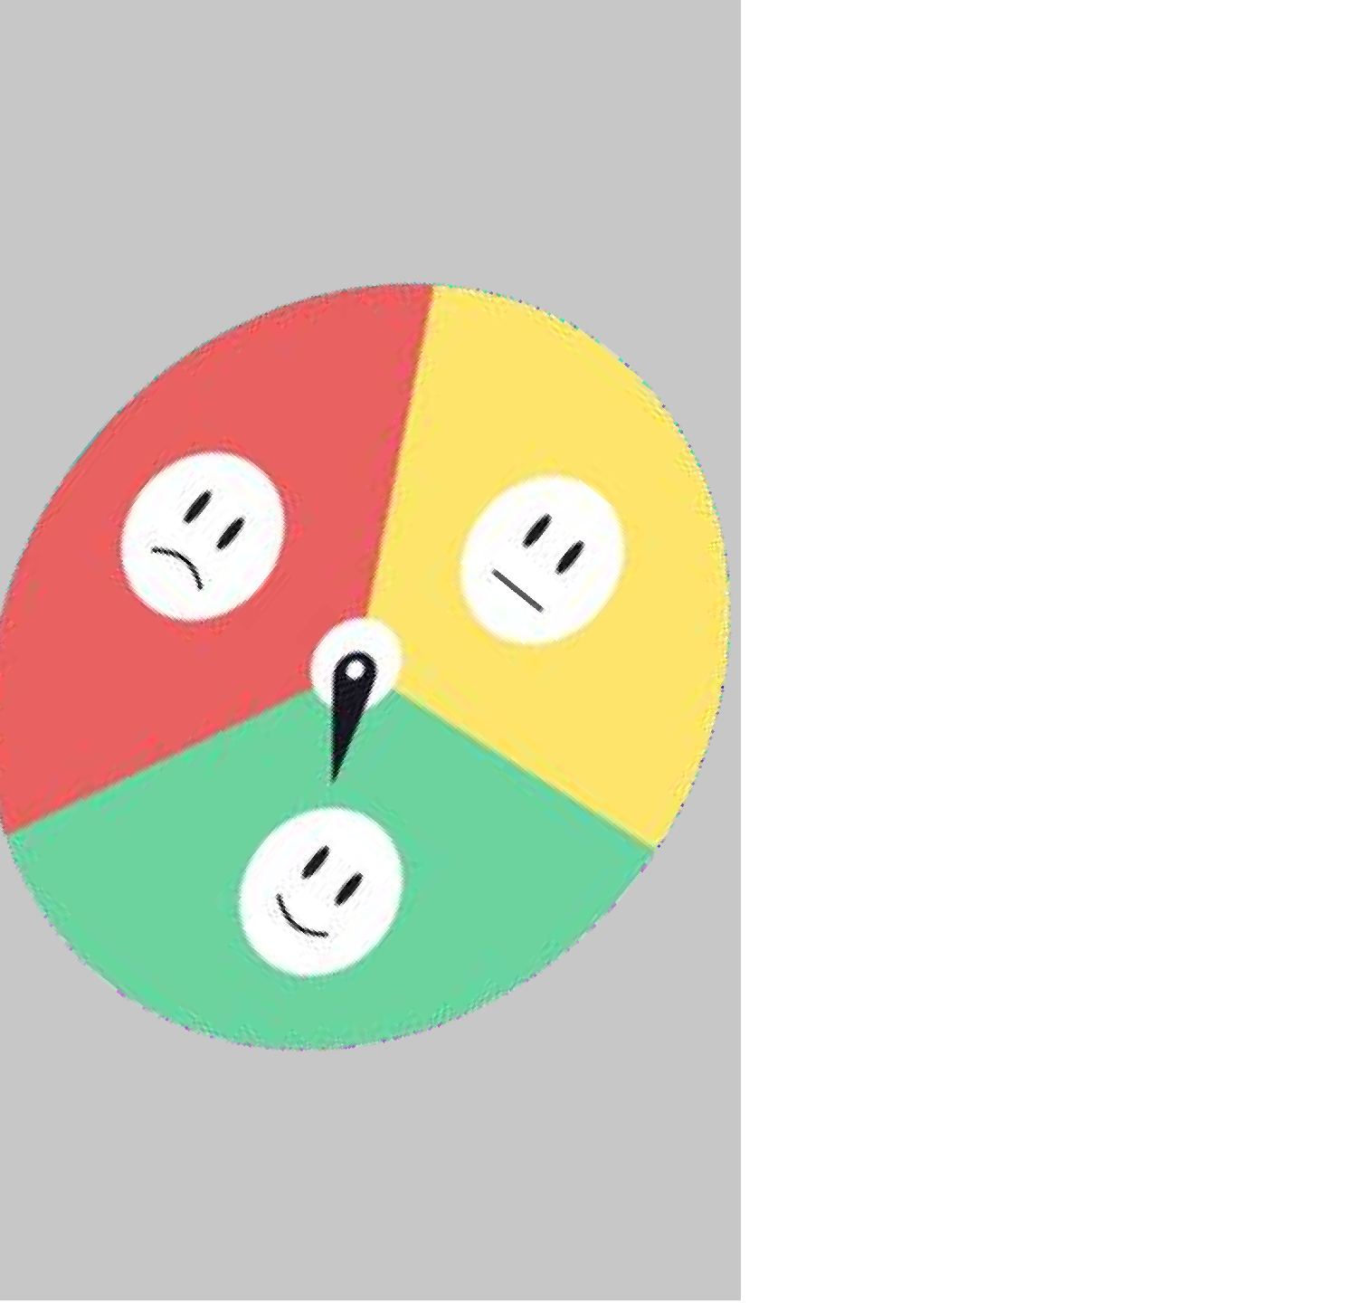

* + **Efficient Customer Support**
  + **Personalized Recommendations**
* **Product and Service Enhancement**

### Market Research

* + **Market Trend Analysis**
  + **Investment Decisions**

# DESIGN THINKING

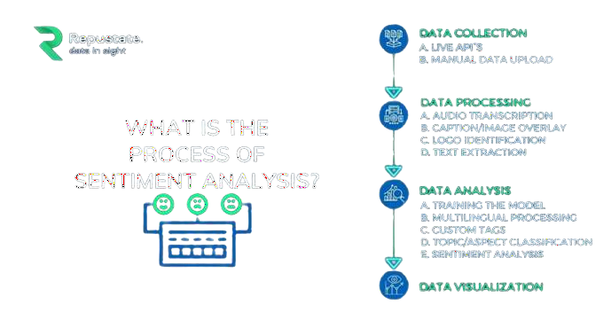

1. **Data Collection:**
   * Identify relevant datasets containing customer reviews and sentiments about competitor products. Sources may include social media, review websites, or in-house customer feedback.
   * Understand the limitations and biases of the selected dataset, and consider how these might impact the analysis.
2. **Data Preprocessing:**
   * Clean the textual data by removing HTML tags, special characters, and irrelevant information.
   * Tokenize the text into words or subword units.
   * Handle issues like stemming, lemmatization, and handling negations to improve the quality of the data.
3. **Sentiment Analysis Techniques:**

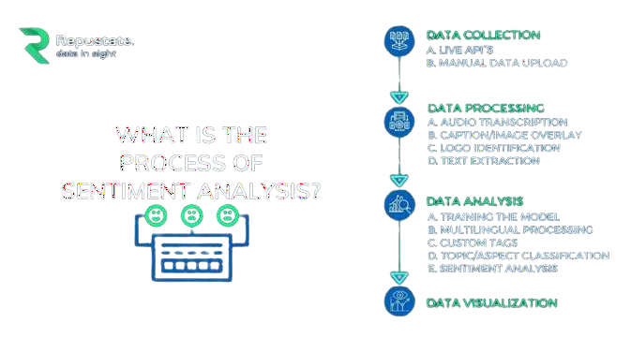

* + Implement various NLP techniques for sentiment analysis, such as:
    - Bag of Words (BoW): Convert text data into numerical vectors representing word frequencies.
    - Word Embeddings (e.g., Word2Vec, GloVe): Represent words as dense vectors capturing semantic meaning.
    - Transformer Models (e.g., BERT, GPT): Utilize pre-trained models for context-aware sentiment analysis.

1. **Feature Extraction:**
   * Use the chosen sentiment analysis technique to extract sentiment scores or labels for each review.
   * Consider fine-grained sentiment analysis to capture emotions like joy, anger, or sadness, if necessary.
   * Include additional features like review length, date, or user rating, which may provide context.
2. **Visualization:**



* + Create visualizations to convey sentiment distribution and trends. Examples

include:

* + - Histograms or bar charts showing sentiment distribution (positive, negative, neutral).
    - Time series plots to track sentiment changes over time.
    - Word clouds to highlight frequently mentioned positive and negative terms.

1. **Insights Generation:**
   * Analyze the visualizations and sentiment analysis results to extract meaningful insights:
     + Identify the most common positive and negative sentiments expressed by customers.
     + Discover patterns or trends in sentiment over time or across different

products.

* + - Compare sentiment distributions for different competitors' products.

