**Sentiment Analysis for Marketing: Understanding Customer Preferences through Data**

**Phase 2: innovation**

**INTRODUCTION**

In a data-driven world, understanding customer sentiment is crucial for effective marketing. This innovation model for AI sentiment analysis offers a comprehensive approach to harness the power of emerging technologies, real-time insights, and ethical considerations for informed marketing strategies.

**Sentiment Analysis Innovation :**

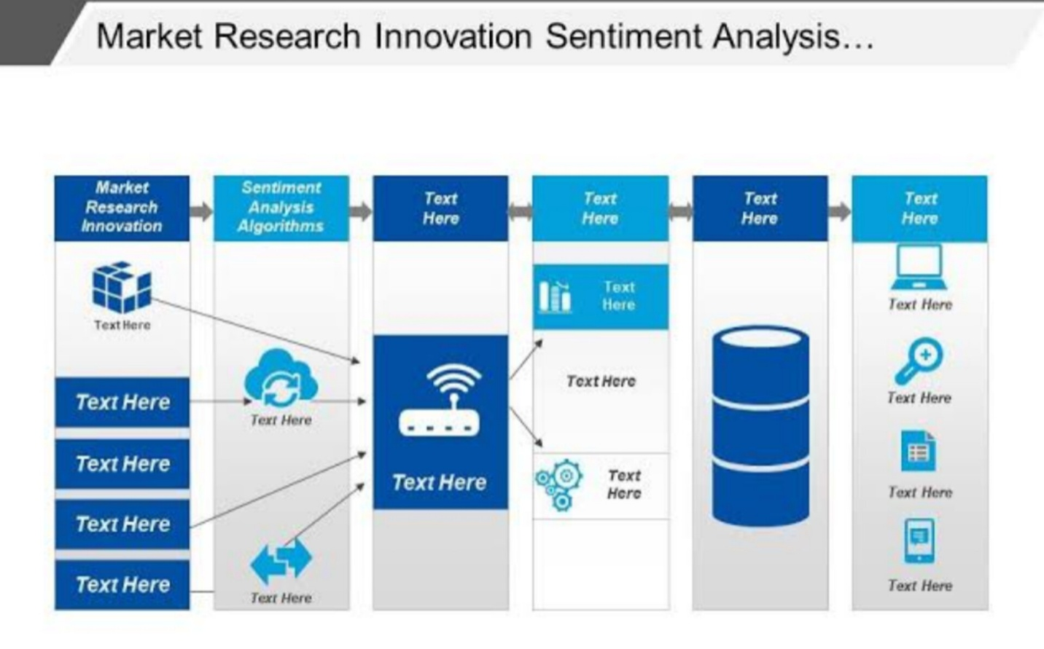

1. Advanced Data Preparation:

* Multimedia Data Handling: Develop techniques to preprocess multimedia data (audio, images, videos) alongside text.
* Multilingual Support: Implement multilingual capabilities to analyze sentiments in different languages, broadening the analysis scope.

1. Continuous Learning and Adaptation:

* Adapt to Language Trends: Develop models that adapt to changing customer communication patterns and evolving language trends.
* Semi-Supervised Learning: Utilize semi-supervised learning to reduce the need for labeled data and adapt to specific customer language.

1. Real-time Sentiment Analysis:

* Immediate Feedback: Create systems for real-time sentiment analysis to provide immediate feedback on marketing campaigns and product launches.
* Edge Computing: Utilize edge computing and IoT for on-the-fly sentiment analysis of in-store customer interactions.

1. Personalized Insights:

* Personalized Sentiment Insights: Implement AI-driven personalized sentiment insights for customers to understand their brand perception.
* Recommendation Engines: Develop recommendation engines based on sentiment analysis for customized marketing strategies.

1. Emotional Analysis:

* Emotion Recognition: Extend sentiment analysis to recognize a broader range of emotions (excitement, frustration, surprise) for deeper insights.
* Facial Recognition and Voice Analysis: Use technologies like facial recognition and voice analysis for emotional sentiment detection.

1. Predictive Analytics:

* Sentiment-based Predictions: Develop predictive models that forecast sentiment changes based on external factors and market dynamics.
* Customer Behaviour Prediction: Use sentiment data to predict customer behaviour and adapt marketing strategies accordingly.

1. Explainable AI:

* Transparency: Ensure AI models are transparent by incorporating explainable AI techniques to help marketers understand sentiment analysis results.
* Actionable Suggestions: Provide actionable suggestions based on sentiment analysis for better decision-making.

1. Cross-Channel Integration:

* Multi-Channel Integration: Integrate sentiment analysis across various marketing channels like email, social media, website, and customer support.
* Unified Dashboard: Maintain a unified dashboard for comprehensive sentiment tracking and analysis.

1. Ethical Considerations:

* Data Ethics: Prioritize ethical considerations such as data privacy, consent, and bias mitigation in AI sentiment analysis.
* Regular Audits: Conduct regular audits of AI models for fairness and accuracy in sentiment classification.

1. Feedback Loop:

* Continuous Improvement: Establish a feedback loop involving marketers, data scientists, and customers for continual model improvement.
* Customer Communication: Maintain open communication with customers to address concerns and improve satisfaction.

1. Agile Development:

* Agile Approach: Adopt an agile approach to AI model development, allowing for quick iterations and adjustments in response to changing marketing dynamics.

This innovation model emphasizes staying ahead with evolving data sources, advanced techniques, and ethical practices while providing real-time insights and personalized recommendations to drive marketing strategies based on customer sentiment.

**Conclusion:**

With this model, businesses can not only track customer sentiment but also adapt in real-time, predict behaviour and provide personalized experiences, all while maintaining trust and transparency. It is a forward-looking blueprint for leveraging AI sentiment analysis to excel in the dynamic marketing landscape.

DONE BY:

Vineethkumar. G

CSE 3rd yr. 5th SEM

311421104109

Meenakshi College of Engineering – 3114