DataTools Matching Viewer User Manual
This manual documents the DataTools Matching Viewer in read-only mode.
It includes detailed workflows, keyboard-first operation, and troubleshooting.

Purpose
The Matching Viewer is used to inspect existing matcher data without changing it.
Main capabilities:
- View pool, matched, paired, and assembled states
- Inspect one serial quickly via Enter-based lookup
- Plot single curves or left/right pair overlays
- Filter any list by date range to reduce scrolling
- Open timeframe overlay to display many curves together
- Export a read-only CSV snapshot of all data

Navigation
- Open DataTools.
- Click the Matching tile.
- The viewer opens in the same window.
- Use Back to Home to return.

Home Screen
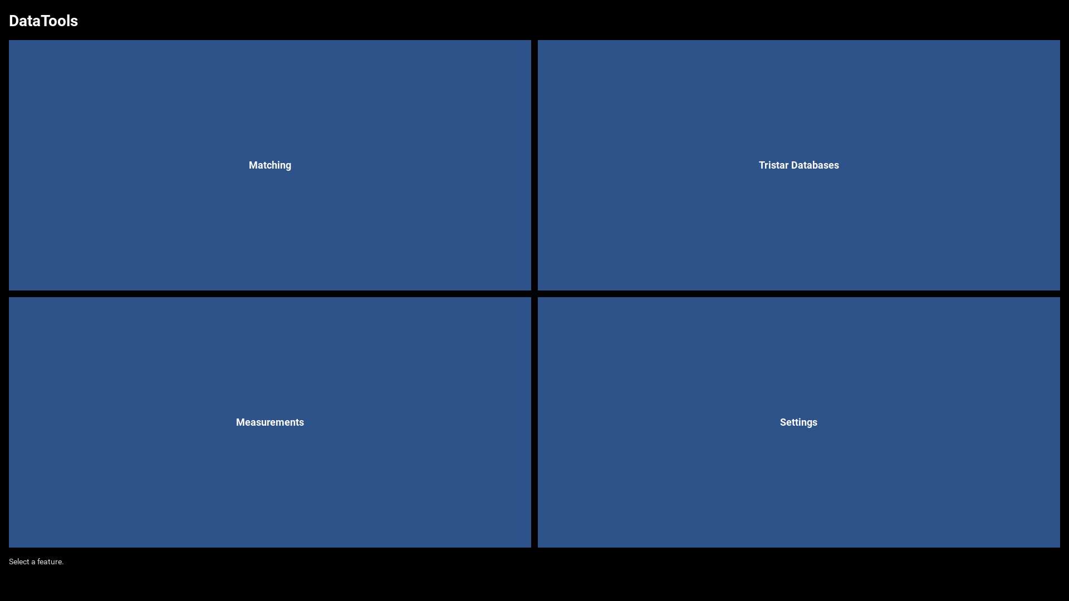

Matching Viewer Overview
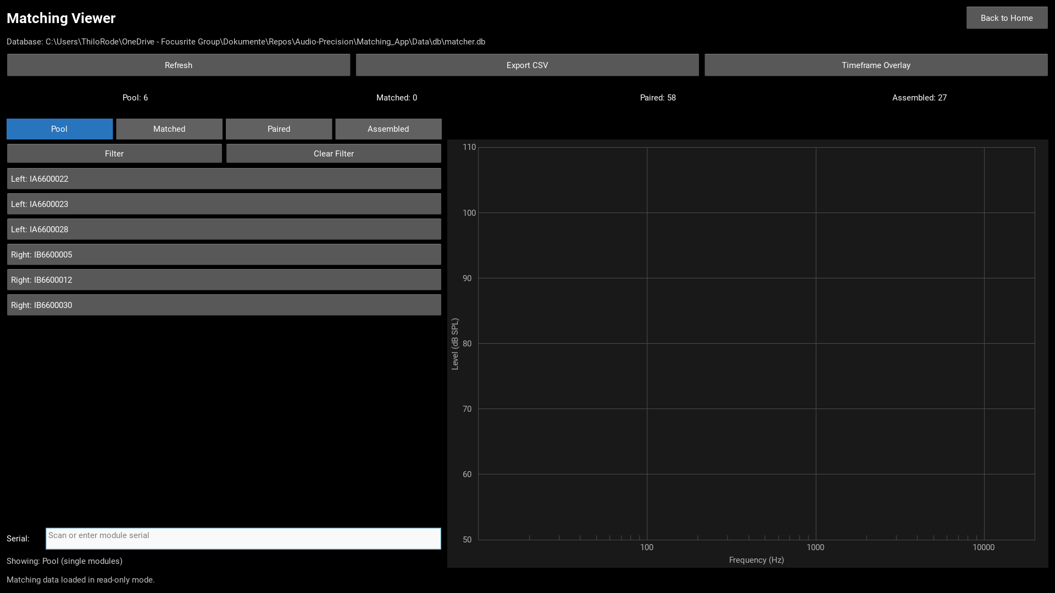
Areas in this screen:
- Top toolbar: Refresh, Export CSV, Timeframe Overlay
- Summary row: Pool, Matched, Paired, and Assembled counts
- Left panel: mode selection, date filter buttons, and serial input
- Right panel: selected item label with RMSE, and chart
- Footer line: status and error feedback
- Error messages are highlighted in red for fast operator recognition

Mode Selection
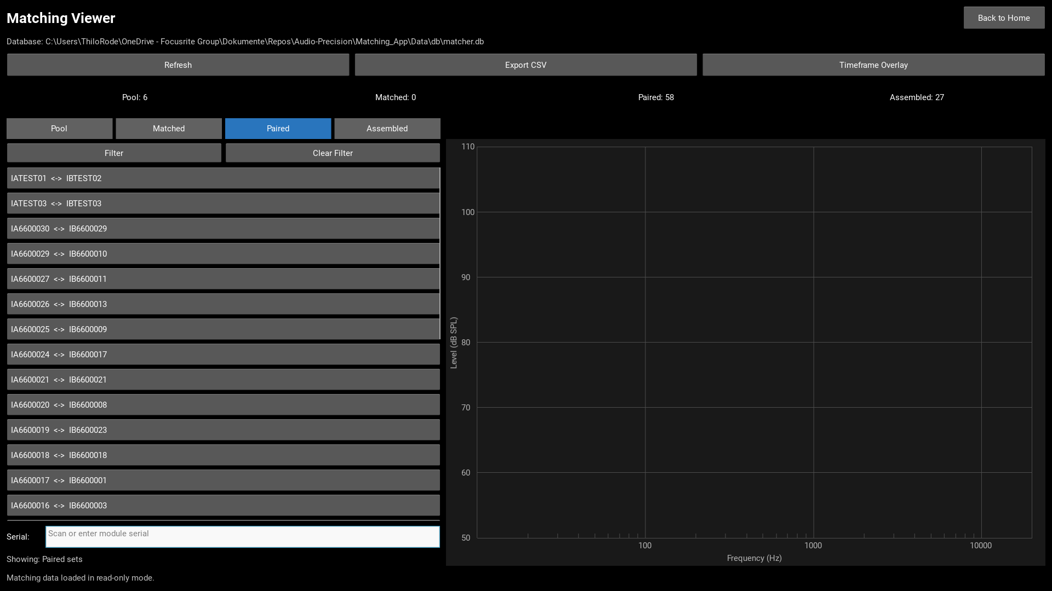
Modes:
- Pool: Single unmatched drivers awaiting matching.
- Matched: Left/right pairs suggested by the matching tool, but not yet confirmed for installation. A worker has seen the suggested match serial on screen but has not yet scanned it.
- Paired: Confirmed pairs sorted for installation. The worker scanned both module serials, marking them as a set to be installed together.
- Assembled: Completed systems. Each entry links a system serial number to the two installed driver modules and the date of assembly.

Filtering by Date Range
All list views support date-range filtering to reduce scrolling in long lists. Each mode filters by a different date field:
Mode | Date field | Meaning
----------- | -------------- | --------------------------------------------
Pool | `loaded_at` | Measurement date of the driver
Matched | `loaded_at` | Measurement date of the driver
Paired | `matched_at` | Date when the worker confirmed the pair
Assembled | `built_at` | Date when the system was assembled

How to Filter
- Switch to the desired mode (Pool, Matched, Paired, or Assembled).
- Click the Filter button in the left panel.
- Enter a Start date (e.g., 2026-06-22).
- Enter an End date (e.g., 2026-06-29).
- Click Apply or press Enter in either date field.
- Only items within the date range are shown in the list.
- Click Clear Filter to show all items again.

Supported Date Formats
- YYYY-MM-DD
- YYYY-MM-DD HH:MM
- YYYY-MM-DD HH:MM:SS
- YYYY-MM-DDTHH:MM
- YYYY-MM-DDTHH:MM:SS

Filter Behavior
- Auto-save: The last used date range is saved per mode. Switching between modes preserves each mode's own filter settings independently.
- Default range: If no filter has been set before, the default is the last 30 days.
- Error feedback: Invalid dates or an end date before start date are highlighted in red.
- Count display: After filtering, you see how many items match the range, e.g., Filtered: 12 of 58 items in range.

Serial Lookup (Enter Only)
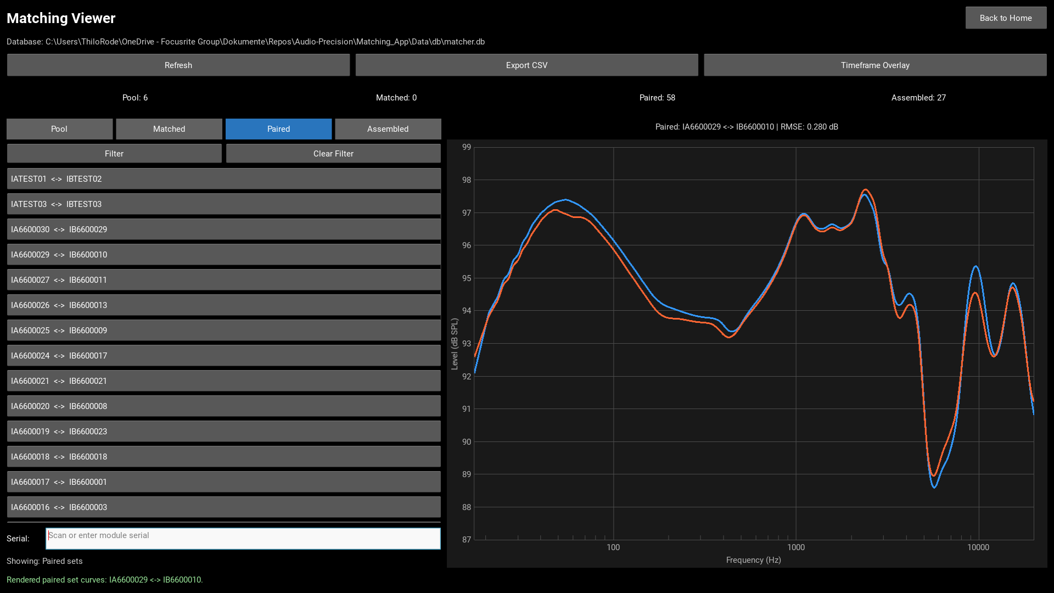
Workflow:
- Scan or type module serial in the Serial field.
- Press Enter.
- Viewer auto-switches to the relevant mode and displays curve(s).
- Input field is cleared after a successful lookup.

Important: Lookup Ignores Active Filters
Serial lookup searches the entire database, not just the filtered list. This means:
- If you search for a serial that is outside the active timeframe filter, it will still be found and displayed.
- The filter only affects what is shown in the list view; it does not restrict the search capability.
- This allows you to quickly access any module even if it falls outside your current date range.

Timeframe Overlay
The overlay popup draws all curves in one selected period in one shared chart.
Color coding:
- Blue: left modules
- Red: right modules
- Both are thin and semi-transparent for dense overlays

Default Overlay on Open
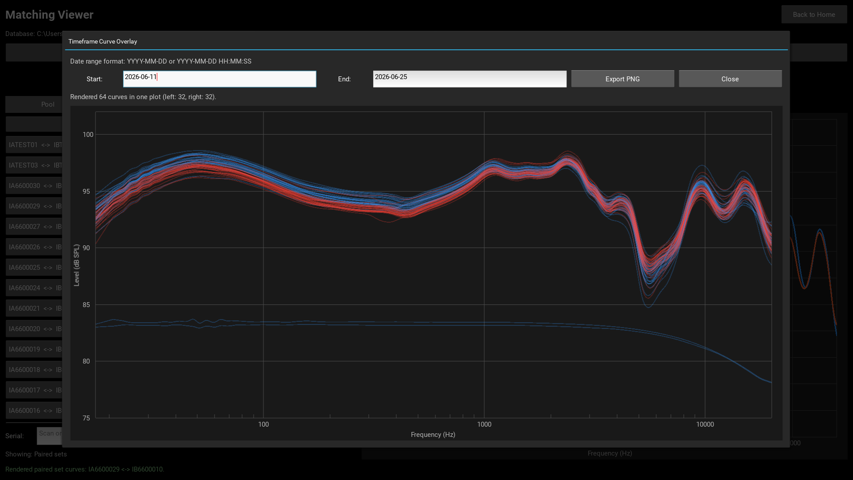
Behavior:
- Last used timeframe is restored automatically
- If no value exists yet, default is last 7 days
- Overlay is rendered automatically when popup opens

Date Input Formats
Accepted formats:
- YYYY-MM-DD
- YYYY-MM-DD HH:MM
- YYYY-MM-DD HH:MM:SS
- YYYY-MM-DDTHH:MM
- YYYY-MM-DDTHH:MM:SS
Press Enter in either date field to refresh the overlay.

Validation Error: Invalid Date Format
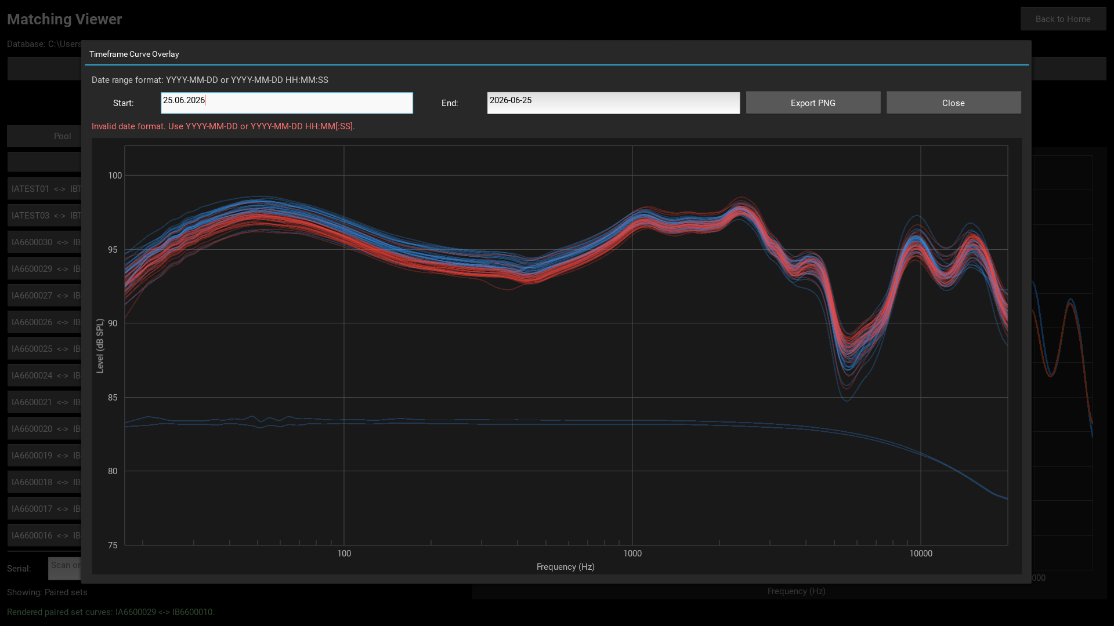
If date format is invalid, an error is shown in red and plot is not updated.

Validation Error: End Before Start
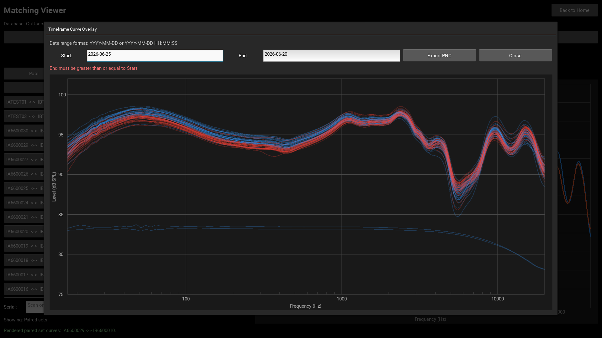
If End is before Start, an error is shown in red and no new query is executed.

Custom Valid Range Result

When range is valid, all matching curves are rendered and count summary is shown.

Export Overlay Plot as PNG
After rendering an overlay, you can export the current plot to a PNG file without opening a separate window:
- Render a valid overlay by entering dates and clicking Apply (or pressing Enter).
- Click the Export PNG button in the popup controls.
- A native save dialog opens.
- Choose a destination and confirm.
- The plot is saved as PNG in light mode with a legend showing left/right curve labels.
Features:
- Matplotlib renders in the background (no additional window appears).
- PNG uses light-mode styling (white background, black text) for better printing and sharing.
- Title shows the timeframe of the exported overlay (Start to End dates).
- Individual curves shown as thin semi-transparent lines.
- Median curves calculated and shown as thick dotted lines for each side (blue for left, red for right) to ignore outliers.
- Legend shows: individual modules, left median, right median.
- Log-scale frequency axis and all curve colors and transparency are preserved.
- Default filename is overlay_plot.png, can be changed in save dialog.

Read-Only Guarantee
The Matching Viewer does not change matcher database content.
Operations are read-only, except CSV and PNG exports which write separate output files.

CSV Export
- Click Export CSV.
- Choose destination in native save dialog.
- The file contains two sections:
Section 1 - Drivers (serial, side, status, partner, loaded_at, matched_at)
Section 2 - Assembled (system_serial, module_1, module_2, built_at)
The export summary shows how many driver rows and assembled system rows were written, e.g., Exported 64 drivers + 27 assembled systems.

Troubleshooting

Overlay shows no curves
- Check selected timeframe includes known loaded_at data.
- Verify matching DB path in Settings is correct.
- Confirm matcher DB contains level arrays.

Serial lookup returns not found
- Verify scanned serial matches database value.
- Ensure scanner input has no trailing hidden characters.
- Confirm current DB file is the expected production/test DB.

Viewer opens but data is empty
- Use Settings to validate matching DB path.
- Check DB file exists and is not locked by another process.
- Press Refresh in viewer toolbar.

Assembled list is empty
- Confirm the matcher DB contains a system_builds table.
- Press Refresh to reload data from the current DB file.

