DataTools Measurements Viewer
This manual covers the full workflow for loading APx measurement CSV files,
visualising frequency-response charts, and generating reference curves and limit files.

Overview
The Measurements viewer provides three main functions:
- Select Measurements — choose a product category and one or more result folders.
- Chart — visualise individual runs, medians, limits and sub-channel curves.
- Create Refs... — compute median reference curves and statistical limits; export CSVs, PNG plots and a README.

Home Screen
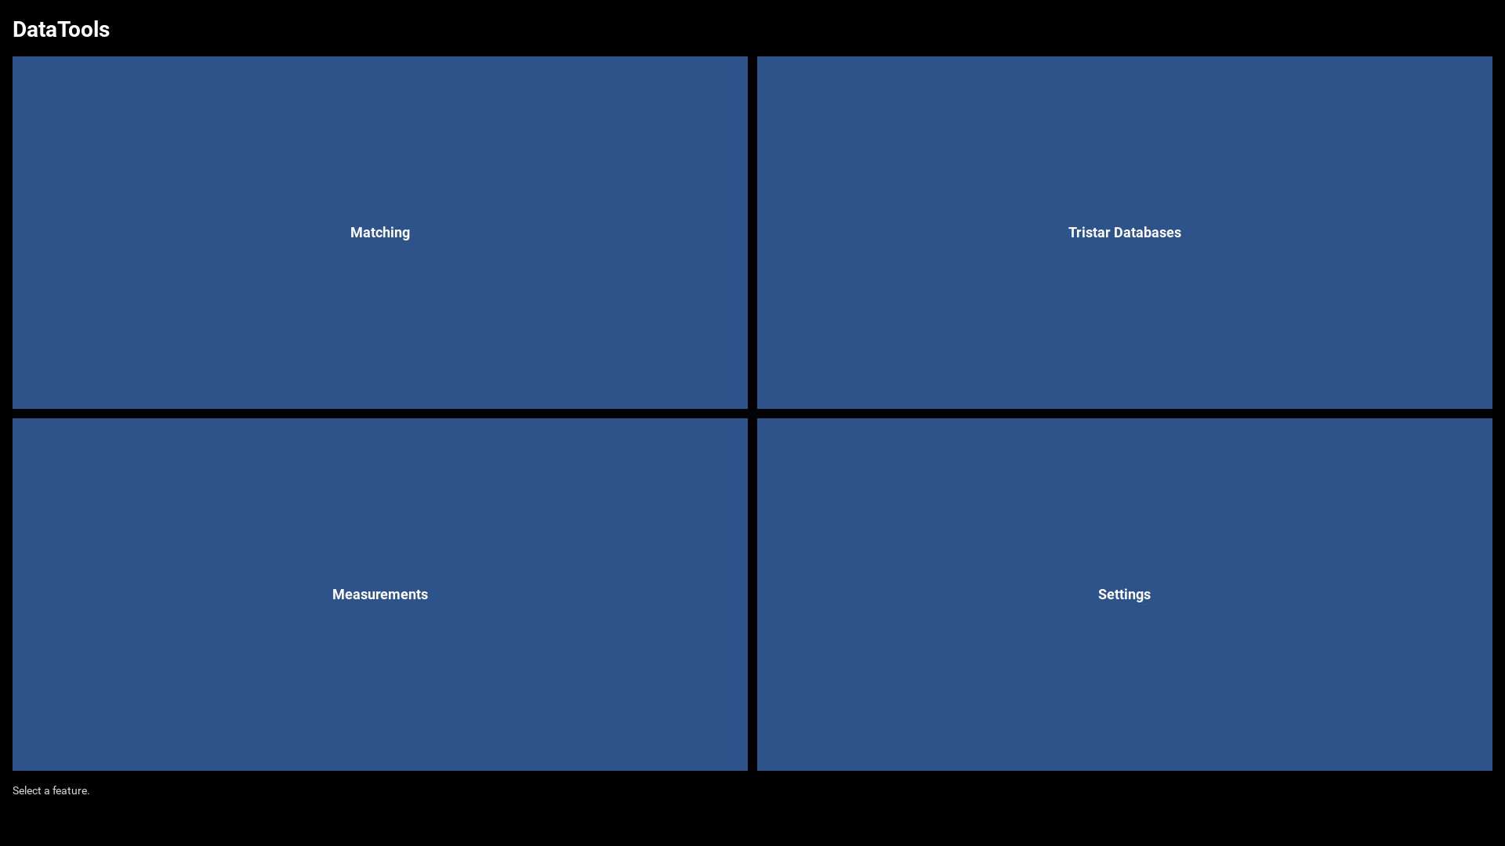
Click the Measurements tile to open the viewer.

Selecting Measurements
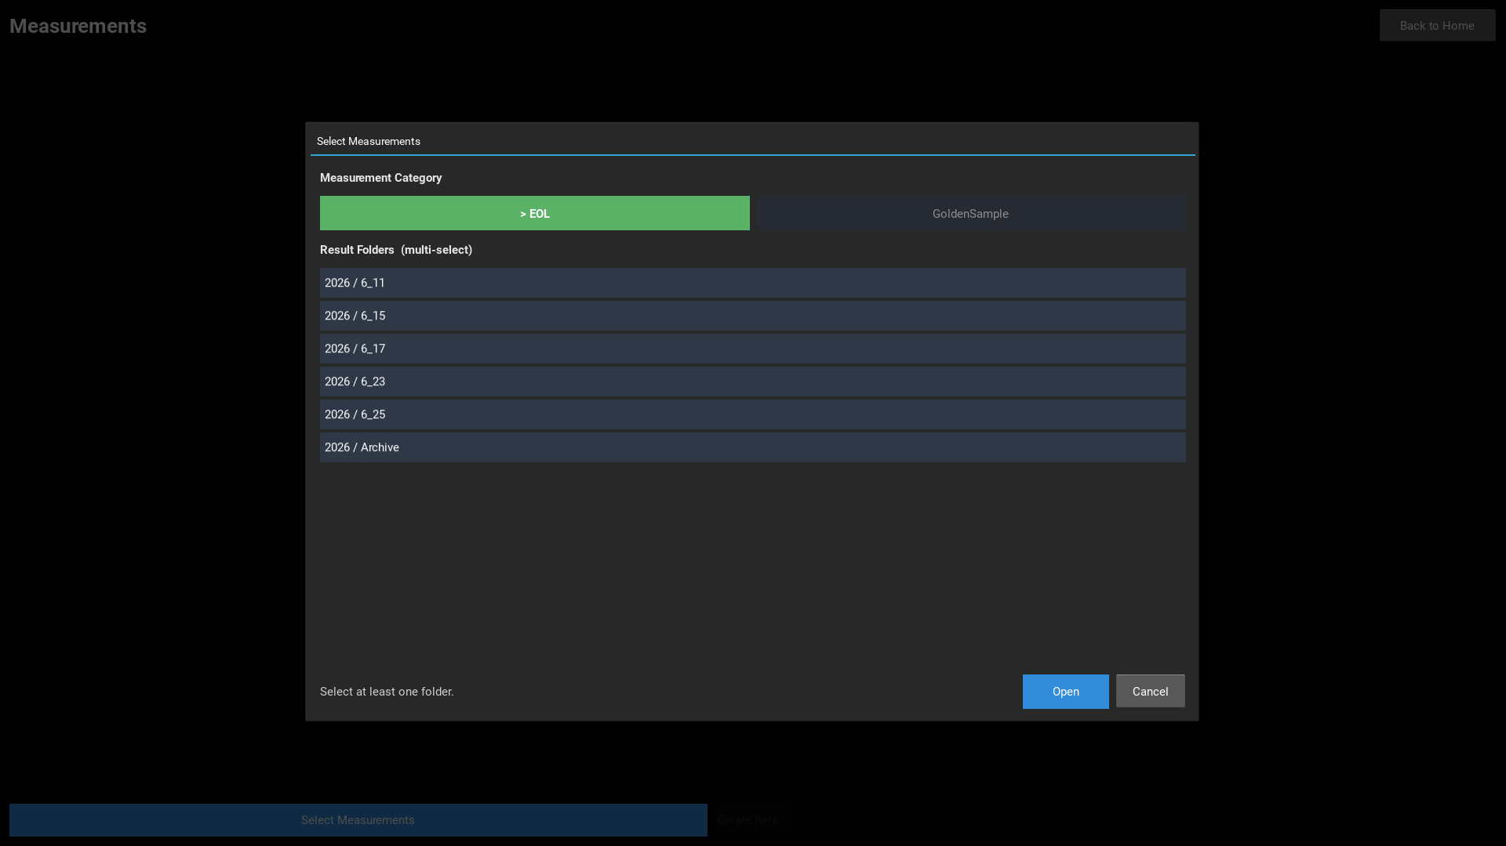
The Select Measurements popup opens automatically when the viewer starts.
It can also be reopened at any time via the Select Measurements button.

Step 1 — Choose a Category
Toggle buttons at the top select the measurement category:
Category | Description
--- | ---
EOL | End-of-line production measurements
GoldenSample | Reference golden-sample measurements
Reference | Reference measurements for limit generation

Step 2 — Select Result Folders
The scrollable list shows all available result folders under Measurements/<Category>/.
Multiple folders can be selected at once — all selected runs are loaded together.
Click Open to load the selection into the chart.

Chart — Stereo Example (H715)
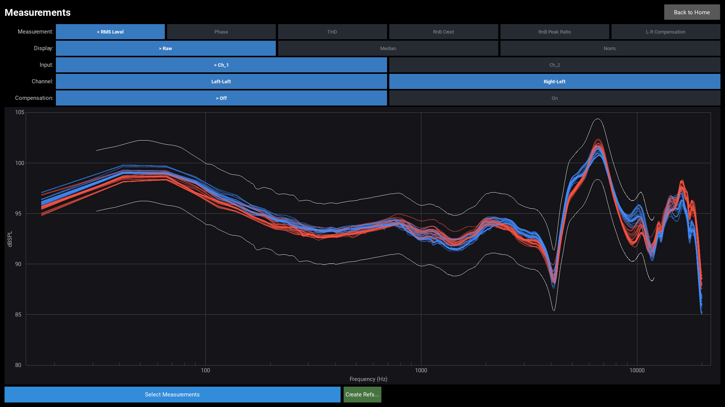

Measurement Type
Buttons in the Measurement row switch the plotted data type:
Type | Y-axis | Description
--- | --- | ---
RMS Level | dBSPL | Frequency-response amplitude
Phase | degrees | Frequency-response phase
THD | % | Total Harmonic Distortion
RnB Crest | dB | Rub-and-Buzz crest factor
RnB Peak Ratio | dB | Rub-and-Buzz peak ratio
L-R Compensation | dB | Left-Right difference curve (only when loaded)

Display Mode
Mode | Description
--- | ---
Raw | All individual measurement curves (semi-transparent)
Median | Per-channel median curve only
Norm. | Each curve shown as deviation from its channel median

Input Channel
For multi-input measurements, the Input row filters to one input channel at a time.

Sub-Channel (Channel row)
When a measurement type has multiple sub-columns (e.g. Left / Right for stereo),
individual sub-channels can be toggled on and off independently.

L-R Compensation (stereo RMS Level only)
When a L-R-Diff.csv fixture compensation curve is present,
the Compensation row appears for RMS Level in stereo mode:
Setting | Effect
--- | ---
Off | Raw levels displayed
On | L-R difference applied (±½ diff per channel) to equalise fixture offsets

Chart — Phase View
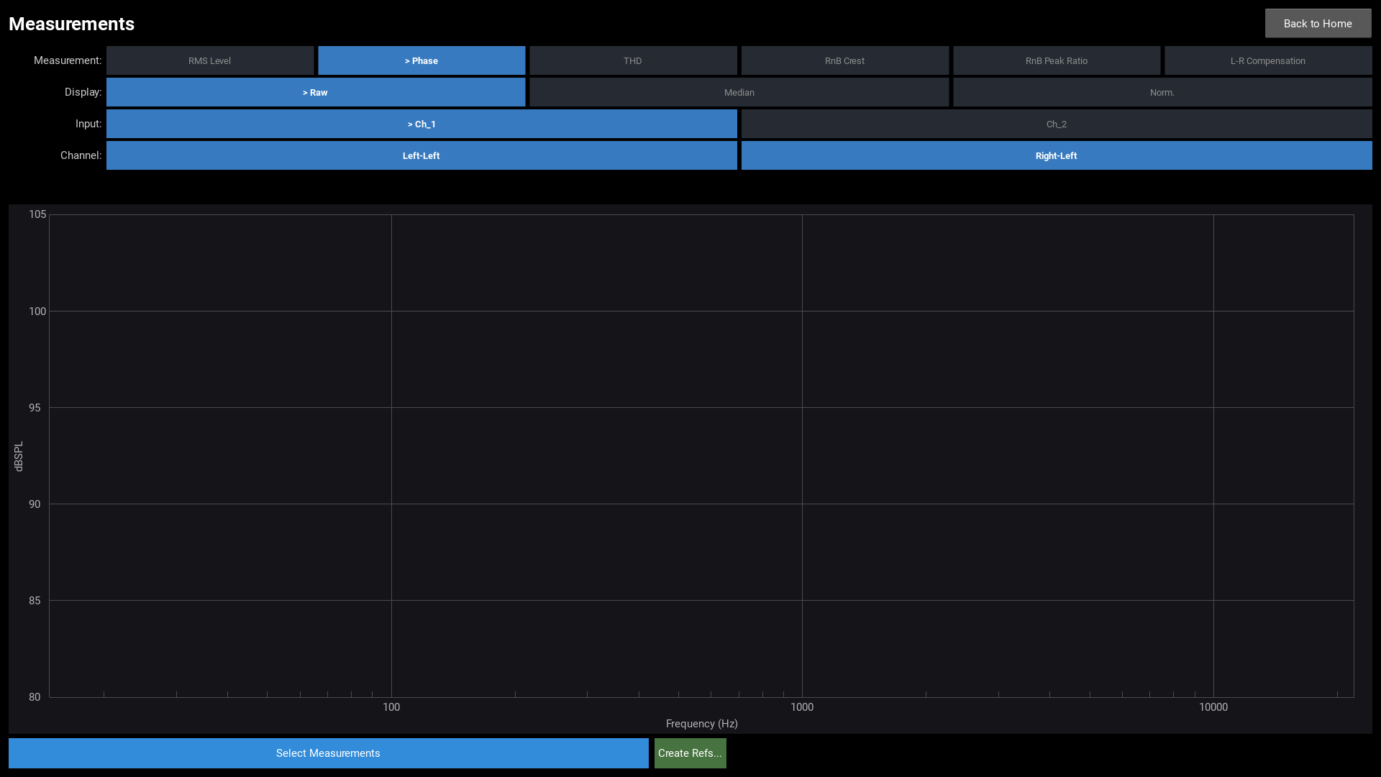
Switching to the Phase type shows the frequency-response phase curves.
Reference limit bands (if available) are overlaid automatically.

Chart — Mono Example (Sub8PRO)
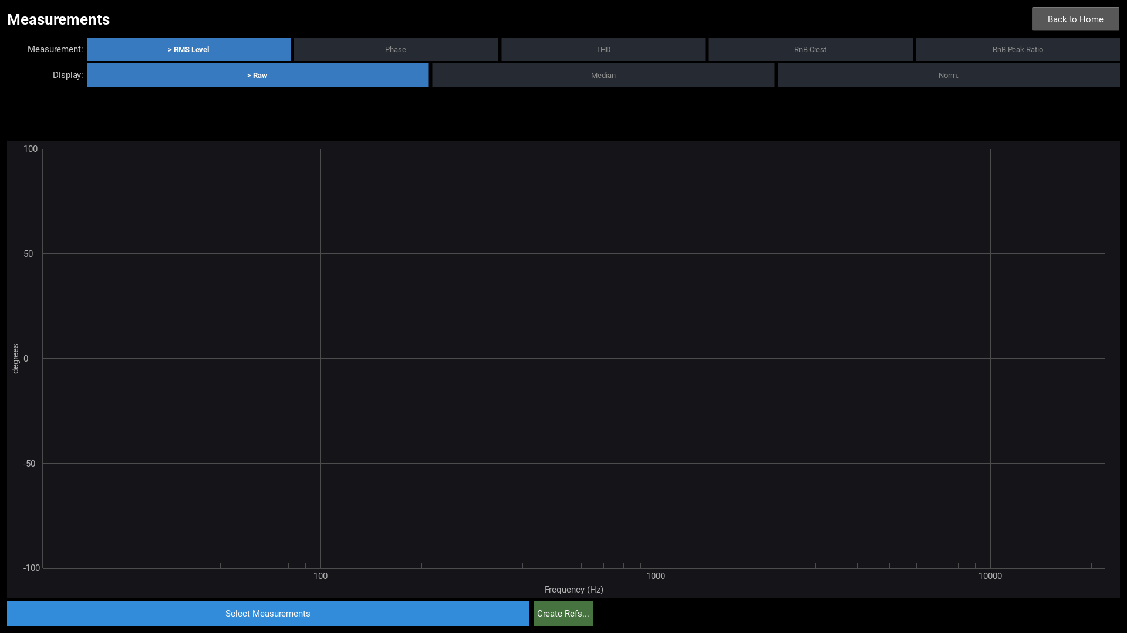
Measurements with a single data column show one curve set.
The Channel sub-column row and the Compensation toggle are not shown.
A single-input product can still have Left/Right sub-columns — in that case
the Channel row and Compensation toggle appear just as they do for multi-input data.

Analysis Dialog
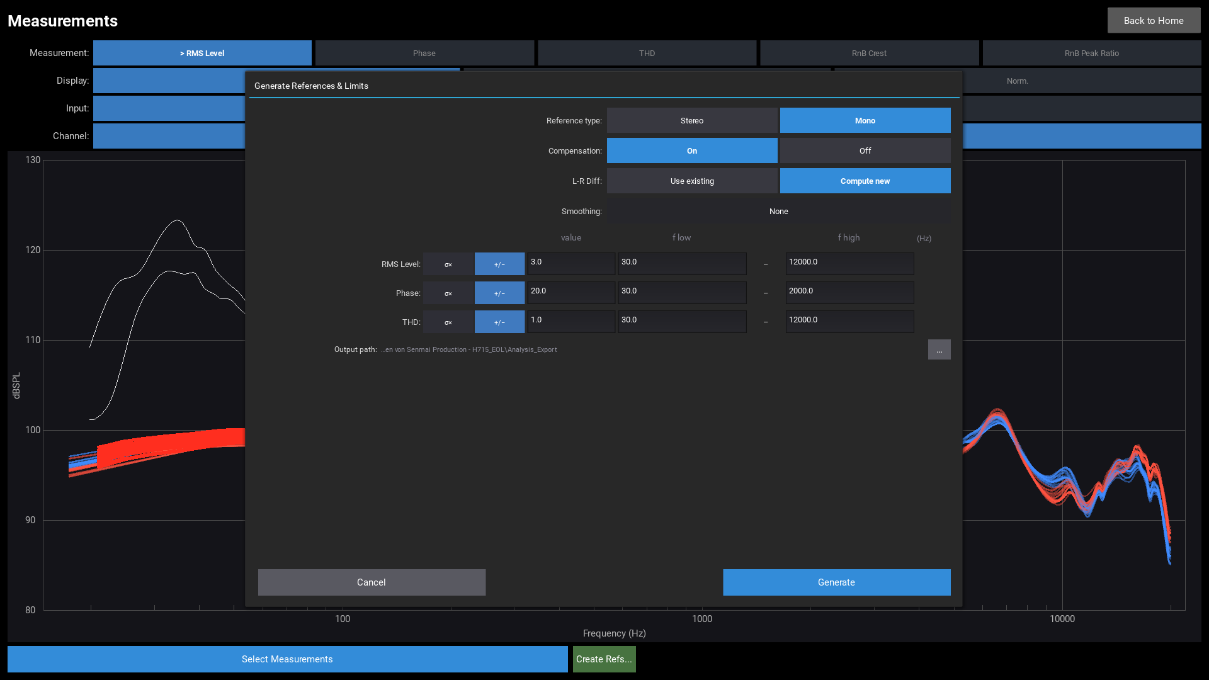
Open via the Create Refs... button (available after data is loaded).

Reference Type (stereo only)
Option | Description
--- | ---
Stereo | Separate Left and Right reference curves
Mono | Average Left and Right into a single reference curve

Compensation (stereo only)
Option | Description
--- | ---
On | Apply L-R fixture compensation before computing the reference
Off | Compute reference without compensation

L-R Diff (stereo only)
Option | Description
--- | ---
Use existing | Load `L-R-Diff.csv` from the References folder
Compute new | Recompute from current measurements and export Right−Left

Smoothing
1/N octave log-scale smoothing applied to reference and limit curves before export.
None disables smoothing.

Per-Type Limit Settings
Each measurement type (RMS Level, Phase, THD) has independent limit settings:
Control | Description
--- | ---
σ× | Limit width = value × standard deviation (frequency-dependent)
+/− | Fixed absolute offset — stored as a constant 2-point boundary line
Value | Multiplier (σ× mode) or offset magnitude (+/− mode)
f low | Lower frequency bound for limit computation [Hz]
f high | Upper frequency bound for limit computation [Hz]

Output Path
The output folder is set via the … Browse button.
All files are written into this folder:
File / Folder | Content
--- | ---
`RMS.csv` | Median RMS reference curve(s)
`Phase.csv` | Median phase reference curve(s)
`THD.csv` | Median THD reference curve(s)
`L-R-Diff.csv` | Right−Left compensation curve (if Compute new selected)
`Limits/` | Six limit CSVs (upper/lower per type)
`Plots/` | PNG plots: individual curves + median + limit bands
`README.md` | Deployment instructions and file overview
Click Generate to run the analysis and save all files.

Deploying the Analysis Output
The workstation reads references from a References/ folder inside the
measurements root directory (configured in Settings → Measurements Root Folder).
Copy the generated files as follows:
<Measurements root>/
├── References/
│ ├── EOL/ ← or GoldenSample — mirrors the Measurements structure
│ │ ├── RMS.csv
│ │ ├── Phase.csv
│ │ ├── THD.csv
│ │ └── Limits/ ← copy the limit files here
│ │ ├── RMS.csv
│ │ ├── PhaseUpper.csv
│ │ ├── PhaseLower.csv
│ │ └── THD.csv
│ ├── GoldenSample/ ← same structure if GoldenSample refs exist
│ │ └── ...
│ └── L-R-Diff.csv ← stereo only: shared Left/Right compensation curve
└── ...
> Note: The Plots/ subfolder contains PNG overview charts for visual
> inspection. These plots are not used by the workstation.

Exported File Reference
File | Description | Unit
--- | --- | ---
`RMS.csv` | Median RMS level reference curve(s) | dBSPL
`Phase.csv` | Median phase reference curve(s) | deg
`THD.csv` | Median THD reference curve(s) | %
`L-R-Diff.csv` | Median Right−Left difference curve (stereo only) | dB
`Limits/RMS.csv` | RMS tolerance — half-width of the pass band | dB
`Limits/PhaseUpper.csv` | Phase upper tolerance | deg
`Limits/PhaseLower.csv` | Phase lower tolerance (negated) | deg
`Limits/THD.csv` | THD tolerance as a relative factor | %
All CSV files use the AP 4-header format: 4 rows of header followed by X/Y data pairs.

Limit Modes
Each measurement type can use one of two limit modes:
Mode | Stored as | Description
--- | --- | ---
**σ×** | Full-resolution curve | Limit = value × standard deviation at each frequency point
**+/−** | 2-point boundary line | Fixed absolute offset — constant across the frequency range
The chosen mode and value are recorded in the README.md inside the export folder.

Measurements Root Folder
The root folder must follow this structure:
Root/
Measurements/
EOL/ ← or GoldenSample
2026/
6_25/ ← result folder (one run = one set of CSV files)
GoldenSample/ ← same structure
2026/
...
References/ ← mirrors the Measurements category structure
EOL/
RMS.csv ← median reference (generated by Create Refs...)
Phase.csv
THD.csv
Limits/
GoldenSample/ ← same structure
...
L-R-Diff.csv ← stereo only: shared compensation curve
Configure the root folder in Settings → Measurements Root Folder.

