DataTools Overview
DataTools is a production-support desktop application for data handling. It is used to process and analyse measurement data produced by the APx500 Flex Production Tool, and consolidates measurement analysis, module matching, device provisioning, and configuration into a single interface.

Home Screen
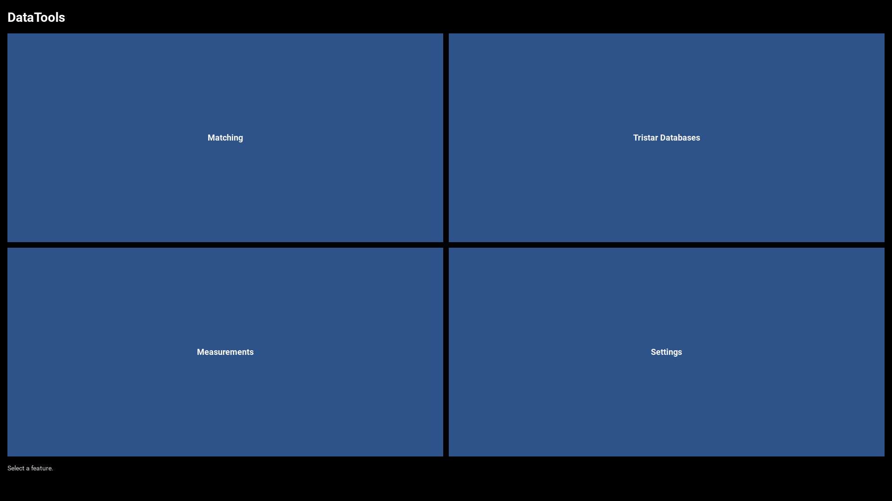
The home screen shows four feature tiles. Click a tile to open the corresponding viewer.

Features

Matching Viewer
Inspects driver-module matching data from the production database. Module pairs are matched algorithmically by frequency-response similarity so that left and right drivers in a stereo headphone are acoustically consistent.
Key tasks:
- Browse Pool, Matched, Paired, and Assembled states
- Look up any module serial and view its measurement curve
- Overlay many curves in a single chart for batch inspection
- Filter all lists by date range
- Export a read-only CSV snapshot
→ See Matching Viewer Manual for detailed workflows.

Tristar Databases Viewer
Provides a unified read-only view of Serial Number / Firmware (SN/FW) test records and MAC address provisioning status for Tristar production units. It also handles automated MAC address assignment for spare backplate units.
Key tasks:
- Browse all produced units with their test result, firmware, and parts
- Filter by date range or look up a specific serial number
- Check MAC provisioning status per unit
- Provision spare backplate units with a new MAC address via OCA
- Export unit and parts data to CSV
→ See Tristar Databases Manual for detailed workflows.

Measurements Viewer
Loads Audio Precision APx CSV measurement files, visualises frequency-response charts, and generates reference curves and statistical limit files used by production test programs.
Key tasks:
- Select one or more result folders from the measurements root
- Plot RMS Level, Phase, THD, Rub-and-Buzz, and L-R Compensation curves
- Switch between Raw, Median, and Normalised display modes
- Toggle individual sub-channels (Left / Right / Mono) on and off
- Run analysis to compute median reference curves and ±σ limits
- Export Reference CSV, Limit CSV, PNG chart, and a README summary
→ See Measurements Viewer Manual for detailed workflows.

Settings
Password-protected configuration panel for all DataTools path and provisioning settings. All values are persisted in a local SQLite store.
Configurable items:
Setting | Description
--- | ---
Measurements Root Folder | Root folder containing Measurements/ and References/ sub-folders
Matching DB path | SQLite database used by the Matching Viewer
SN FW Workstation DB path | SQLite database used by the SN/FW workstation
MAC addresses DB path | SQLite database used by the MAC provisioning system
Backplate Default Serial | Placeholder serial for unprovisioned backplate units
Backplate Default MAC | Placeholder MAC address for unprovisioned backplate units
Settings password | Password required to open the Settings panel
→ See Settings Manual for detailed workflows.

Data Folder Layout
All measurement data is organised under a single Measurements Root Folder configured in Settings. The structure mirrors the product hierarchy used at the production sites.
<Measurements Root>/
├── Measurements/ # Raw APx CSV exports from production
│ ├── EOL/ # End-of-line test results
│ │ └── <Year>/
│ │ └── <Month_Day>/ # One folder per production day
│ └── GoldenSample/ # Reference golden-sample measurements
└── References/ # Generated reference and limit CSVs (mirrors Measurements/)
├── EOL/
│ └── <Year>/
│ └── <Month_Day>/
└── GoldenSample/

Quick Start

First-time setup
- Click Settings and enter the password.
- Set the Measurements Root Folder to your product's data root.
- Set the Matching DB path if you use the Matching Viewer.
- Set the SN FW Workstation DB path and MAC addresses DB path if you use Tristar Databases.
- Click Apply and close Settings.

Inspecting a daily production batch
- Open Measurements Viewer.
- Click Select Measurements, choose EOL, and select today's folder.
- Review the RMS Level chart for outliers.
- If the batch looks representative, run Analyze to update the Reference and Limit files.

Checking module matching status
- Open Matching Viewer.
- Use Matched mode to see all suggested pairs awaiting operator confirmation.
- Use the serial input to look up a specific module if needed.

