* Result with cv=10:

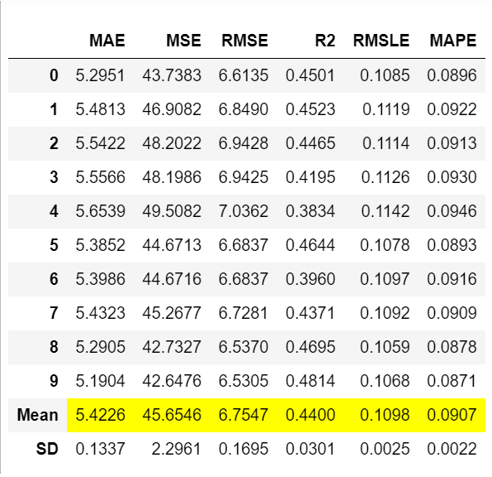

* Top feature importance:

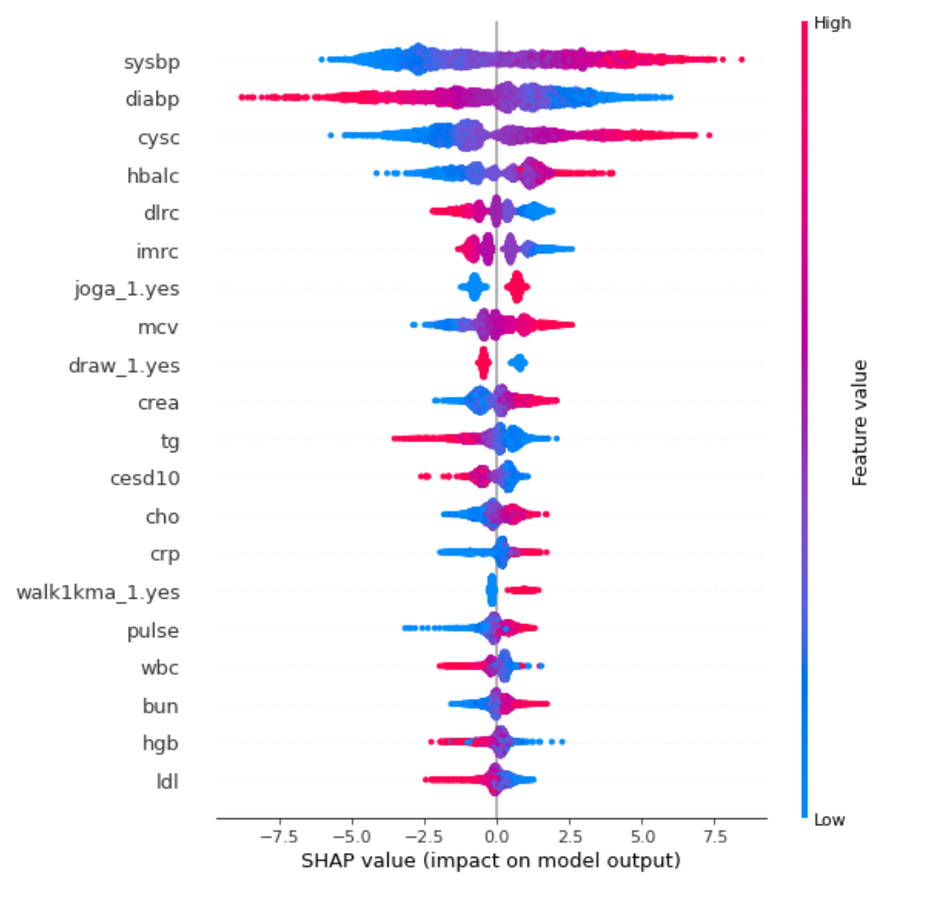

* Predicted values on 2011 dataset with dropna of [cysc,dlrc,imrc]:

Number of Abs(prediction - age) <=5: 4179, Number of Abs(prediction -age)>5:2465, 62.9%

Number of Abs(prediction - age) <=10: 6093, Number of Abs(prediction -age)>5:551, 91.7%