**Task1 :**

Include [‘cysc’] Model training result with cv=10:

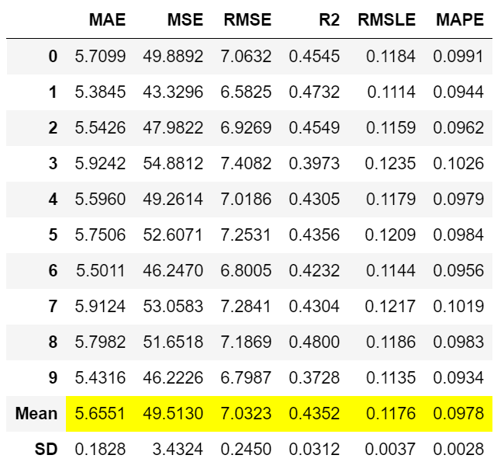

**Task2:**

