**Task1**

Exclude cystatinc & walktime

Sample_size = 10027

Training result with cv =10:

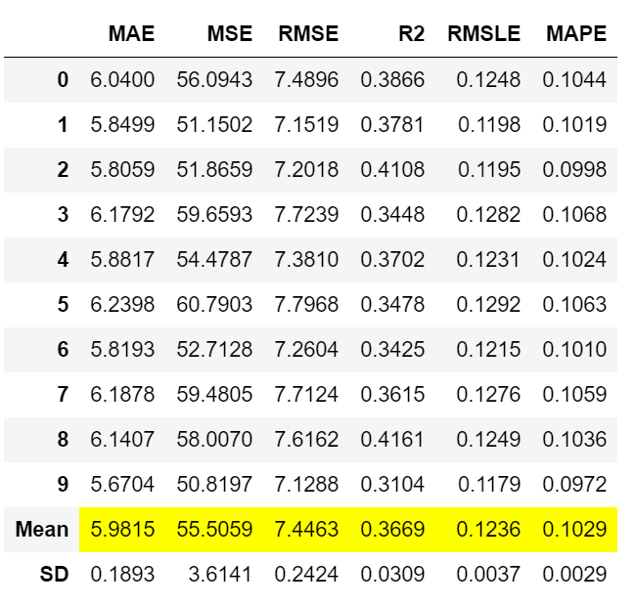

Predict result on 2011 dataset with cystatinc & walktime excluded:

abs|pred – origin|<= 5, 66.59%,

abs|pred – origin|<=10, 92.92%.

**Task2**

Sample_size = 10027

Training result with cv =10:

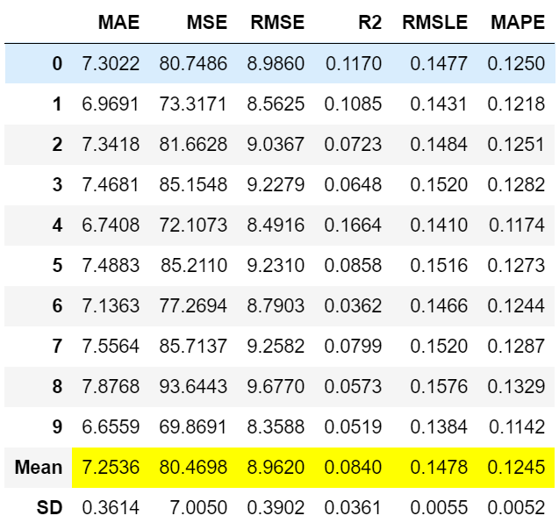

Predict result on 2011 dataset:

abs|pred – origin|<= 5, 55.2%,

abs|pred – origin|<=10, 85.7 %.