Exclude cystatinc & walktime

Sample_size = 10027

Training result with cv =10:

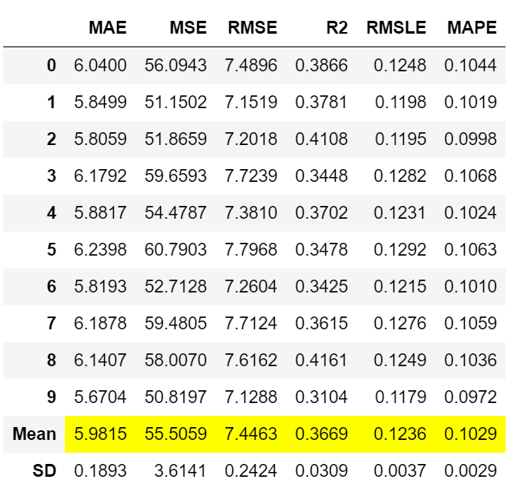

Predict result on 2011 dataset with cystatinc & walktime excluded:

abs|pred – origin|<= 5, 66.59%,

abs|pred – origin|<=10, 92.92%.