4.3

select *from payment where amount in ("1.98","7.98","9.98");

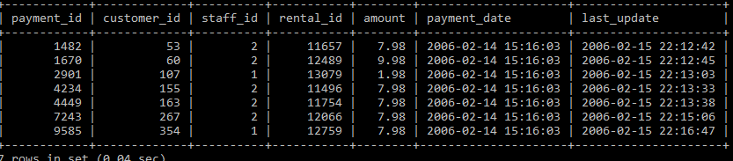

4.4

select *from customer where last_name like '_A%W%';

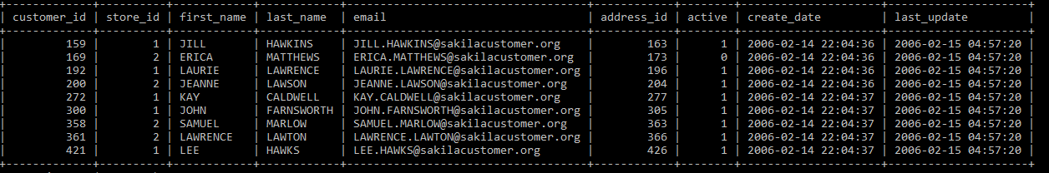

Свои запросы

select *from cd where cost > 50;

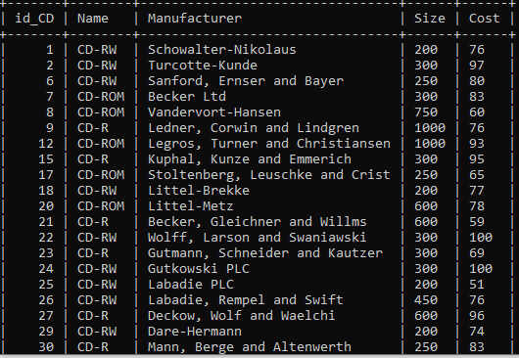

select *from video where Director like 'Mr.%';

