6.1

A union В = {L M N O P Q R S T}

A union all B = {L M N O P P Q R S T}

A intersect В = {Р}

A except В = {L М N 0}

6.2

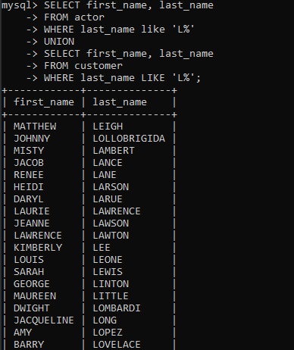

6.3

