**Star formation near the Sun is driven by expansion of the Local Bubble**

**太阳附近的恒星形成是由局部气泡的膨胀所驱动的**

[**https://doi.org/10.1038/s41586-021-04286-5**](https://doi.org/10.1038/s41586-021-04286-5)

**Received: 18 August 2021**

**Accepted: 26 November 2021**

**Published online: 12 January 2022**

**Check for updates**

**Author:**

**Catherine Zucker, Alyssa A. Goodman, João Alves, Shmuel Bialy, Michael Foley1, Joshua S. Speagle, Josefa Groβschedl, Douglas P . Finkbeiner, Andreas Burkert9, Diana Khimey & Cameren Swiggum**

**ABSTRACT**

For decades we have known that the Sun lies within the Local Bubble, a cavity of low-density, high-temperature plasma surrounded by a shell of cold, neutral gas and dust.

**几十年来，我们已经知道太阳位于局部气泡内。局部气泡是一个低密度的高温等离子体腔，周围是一层寒冷的中性气体和尘埃。**

However, the precise shape and extent of this shell, the impetus and timescale for its formation, and its relationship to nearby star formation have remained uncertain, largely due to low-resolution models of the local interstellar medium. Here we report an analysis of the three-dimensional positions, shapes and motions of dense gas and young stars within 200 pc of the Sun, using new spatial and dynamical constraints.

**然而，这个壳的精确形状和范围、它形成的动力和时间尺度以及它与附近恒星形成的关系仍然不确定，这主要是因为局部星际介质的低分辨率模型导致的。在这里，我们利用新的空间和动力学约束，分析了距离太阳200pc范围内致密气体和年轻恒星的三维位置、形状和运动。**

解释：parsec（pc）是天文学上的一种长度单位“秒差距”。也是最古老和最标准的测量恒星间距离的方法之一。它基于三角形视差。对应于地球轨道平均半径(一个天文单位，日地距离，AU)底的三角形内角称为视差。

We find that nearly all of the star-forming complexes in the solar vicinity lie on the surface of the Local Bubble and that their young stars show outward expansion mainly perpendicular to the bubble’s surface. Tracebacks of these young stars’ motions support a picture in which the origin of the Local Bubble was a burst of stellar birth and then death (supernovae) taking place near the bubble’s centre beginning approximately 14 Myr ago.

**我们发现，太阳附近几乎所有的恒星形成的复合物都位于局部气泡的表面，而它们的年轻恒星主要向外扩张，垂直于气泡的表面。对这些年轻恒星运动的追溯支持了这样一种说法——即局部气泡的起源是大约1400万年以前发生在气泡中心附近的恒星诞生和死亡(超新星)的爆发【即超新星的爆发】。**

解释：Myr即Millon Years，时间单位，指百万年。

The expansion of the Local Bubble created by the supernovae swept up the ambient interstellar medium into an extended shell that has now fragmented and collapsed into the most prominent nearby molecular clouds, in turn providing robust observational support for the theory of supernova-driven star formation.

**由超新星产生的局部气泡的膨胀将周围的星际介质扫进了一个扩展的外壳，现在这个外壳已经破碎并坍缩成附近最显著的分子云，并反过来为超新星驱动恒星形成的理论提供了有力的观测支持。**

解释：分子云（molecular cloud），是星际云的一种，它的密度和大小允许分子的形成。（最常见的是氢分子H2)，即它的密度高到可以开始产生分子。

**main body**

In Fig. 1a (Supplementary Fig. 1), we present a three-dimensional (3D) map of the solar neighbourhood, including a new Gaia-era 3D model of the Local Bubble’s inner surface of neutral gas and dust and the 3D shapes and positions of local molecular clouds constrained at approximately 1 pc resolution.

**在图1a（补充图1）中，我们展示了太阳附近的三维（3D）地图，包括一个新的盖亚时期局部气泡内表面的中性气体和尘埃的3D模型，以及局部分子云的3D形状和位置，限制在约1pc分辨率。**

The Local Bubble’s shell is shown as a closed surface, but evidence suggests it could be a ‘Galactic chimney’ , having blown out of the disk a few hundred parsecs above and below the Galactic plane. The distribution of dense gas in star-forming molecular clouds is shown with a set of topological ‘spines’ derived by ‘skeletonizing’ the clouds in 3D volume density space.

**局部气泡的外壳被显示为一个封闭的表面，但有证据表明它可能是一个“星系通道”，在银河平面上下几百pc的地方从圆盘中喷出的。恒星形成的分子云中稠密气体的分布是用一组拓扑“棘”来表示的，这是通过在三维体积密度空间中“骨架化”云得到的。**

We find that every well-known molecular cloud within approximately 200 pc of the Sun lies on the surface of the Local Bubble. These ‘surface’ clouds include not just every star-forming region in the Scorpius-Centaurus (Sco-Cen) association (Ophiuchus, Lupus, Pipe, Chamaeleon and Musca), but also the Corona Australis region and the Taurus Molecular Cloud, the latter of which lies 300 pc away from Sco-Cen on the opposite side of the bubble.

**我们发现，距离太阳约200pc的每一个著名的分子云都位于局部气泡的表面。这些“表面”云不仅包括天蝎座-半人马座联盟中的每一个恒星形成区域(Ophiuchus, Lupus, Pipe, Chamaeleon and Musca)，还包括南冕座区域和金牛座分子云，后者距离天蝎座-半人马座300pc，位于气泡的另一边。**

The one exception is the Perseus Molecular Cloud, at a distance of 300 pc, which has probably been displaced by the recently discovered Per-Tau Superbubble, containing Taurus on its near side and Perseus on its far side (see the green sphere in Fig. 1b (Supplementary Fig. 1)). The Taurus Molecular Cloud complex lies at the intersection of the Per-Tau Bubble and Local Bubble, displaying a sheet-like morphology consistent with being shaped by a bubble–bubble collision. Every Local Bubble surface cloud shows evidence of a similar sheet-like (for example, Taurus) or filamentary (for example, Corona Australis) morphology, uniformly elongated along the bubble’s surface.

**一个例外是英仙座分子云，距离约300pc，它可能已经被最近发现的Per-Tau超级气泡所取代，其中金牛座在它的近侧，英仙座在它的远侧(见图1b中的绿色球体(补充图1))。金牛座分子云复合体位于Per-Tau气泡和局部气泡的交汇处，呈现出片状的形态，与气泡-气泡碰撞形成的形状一致。每个局部气泡表面云都显示出类似片状(例如金牛座)或丝状(例如南冕座)的形态，沿着气泡表面均匀地拉长。**

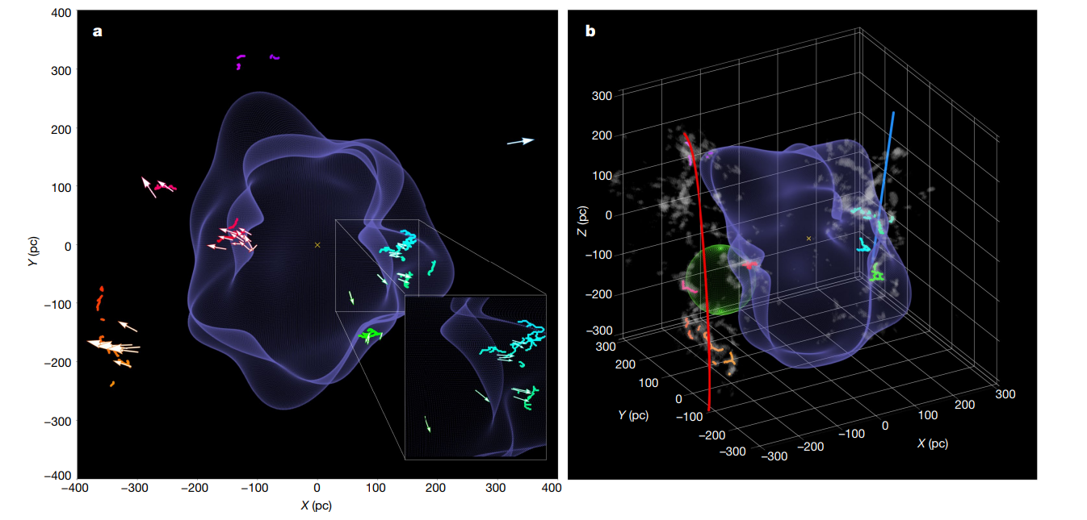

**Fig. 1 | A 3D spatial view of the solar neighbourhood.** For the best experience, please view the online 3D interactive version available in Supplementary Fig. 1.

**图1 |太阳附近的三维空间视图。**为了获得最佳体验，请查看补充图1中提供的在线3D交互版本。**https://faun.rc.fas.harvard.edu/czucker/Paper_Figures/Interactive_Figure1.html**

a, A top-down projection of star-forming regions on the surface of the Local Bubble, whose young stars show motion mainly perpendicular to its surface. The surface of the Local Bubble is shown in purple. The short squiggly coloured lines (or ‘skeletons’) demarcate the 3D spatial morphology of dense gas in prominent nearby molecular clouds. The 3D arrows indicate the positions of young stellar clusters, with the apex of the arrow’s cone pointing in the direction of stellar motion. Clusters are colour-coded by longitude, as in Extended Data Table 1. The Sun is marked with a yellow cross. The enlargement to the lower right shows a close-up of Ophiuchus, Pipe, Lupus and Corona Australis on the bubble’s surface, along with arrows illustrating the outward motion of their young stellar clusters.

a、 恒星形成区域在局部气泡表面上的自上而下投影，其年轻恒星的运动主要垂直于其表面。**局部气泡的表面显示为紫色。短而弯曲的彩色线条（或“骨架”）界定了附近突出分子云中稠密气体的3D空间形态。**3D箭头指示年轻星团的位置，箭头圆锥体的顶点指向恒星运动的方向。聚类按经度进行颜色编码，如扩展数据表1所示。**太阳上有一个黄色的十字架**。右下角的放大图显示了在气泡表面的Ophiuchus, Pipe, Lupus and Corona Australis的特写镜头，以及显示年轻星团向外运动的箭头。

b, A 3D view of the relationship between the Local Bubble, prominent nearby star-forming regions and Galactic structure. The Local Bubble and cloud skeletons are the same as in a. We also overlay the morphology of the 3D dust (grey blobby shapes) and the models for two Galactic scale features—the Radcliffe Wave (red) and the Split (blue)10. The Per-Tau Superbubble (green sphere) is also overlaid. The interactive version offers views from any direction (not just top-down), provides floating labels for star-forming regions and includes additional layers (some not shown in this snapshot), which can be toggled on/off.

b、 局部气泡、附近突出的恒星形成区域和银河系结构之间关系的3D视图。局部气泡和云骨架与a中的相同。我们还覆盖了3D尘埃的形态（灰斑形状），**以及两个银河系尺度的模型，分别是拉德克利夫波（红色）和分裂（蓝色）**。Per-Tau Superbubble（绿色球体）也被覆盖。交互式版本提供任何方向的视图（不仅仅是自上而下），为恒星形成区域提供浮动标签，并包括附加层（som）

In Fig. 1b, in addition to the Local Bubble surface, we show models for two kiloparsec-scale Galactic features discovered in the Gaia era: the Radcliffe Wave and the Split. The Radcliffe Wave is a 2.7-kpc-long filament of gas corresponding to the densest part of the Local Arm of the Milky Way. It has the shape of a damped sinusoid, extending above and below the plane of the Galaxy.

**在图1b中，除了局部气泡表面，我们还展示了盖亚时期发现的2000pc尺度的银河系特征模型:拉德克利夫波和斯普利特。拉德克里夫波是一条2.7千克长的气体长丝，与银河系本臂最密集的部分相对应。它具有阻尼正弦曲线的形状，在银河系平面的上方和下方延伸。**

The Split, an at least 1-kpc-long gaseous feature situated in the disk, is argued to be a spur-like feature, bridging the Local and Sagittarius-Carina arms. Also shown (in the interactive version in Supplementary Fig. 1 only) is a model of the Gould’s Belt, a disk of young stars, gas and dust, tilted by about 20° with respect to the Galactic plane, which has long shaped our understanding of the architecture of the local interstellar medium. Previous work has suggested that the Gould’s ‘Belt’ is a superposition of unassociated structures seen in projection, with all well-known regions of the ‘Belt’ being part of either the Radcliffe Wave or the Split large-scale gaseous structures.

**斯普利特Split，一个至少1千立方厘米长的气体特征。位于盘，被认为是一个尖刺状特征，桥接局部和**Sagittarius-Carina**臂。此外(仅在补充图1的交互式版本中)还展示了一个古尔德带的模型，这是一个由年轻恒星、气体和尘埃组成的圆盘，相对于银河平面倾斜了大约20°，它长期以来塑造了我们对当地星际介质结构的理解。先前的研究表明，古尔德的“带”是在投影中看到的无关联结构的叠加，“带”的所有已知区域要么是拉德克里夫波的一部分，要么是斯普利特大型气体结构的一部分。**

解释：古尔德带（Gould Belt）是横跨3,000光年直径，由恒星组成的星环的一部分，包含一些O型和B型的OB星恒星，从银河盘面翘起16至20°。古尔德带被怀疑是包含太阳系在内的螺旋臂，太阳系距离旋臂中心约325光年。

As illustrated in Fig. 1b (and the interactive version in Supplementary Fig. 1), this argument about the nature of the Gould’s Belt is confirmed here. The right-hand side of the assumed Gould’s Belt (the Sco-Cen association) consists of the entire rightward wall of the Local Bubble, whereas its left-hand side consists of clouds in the Radcliffe Wave, well beyond the leftward wall of the Local Bubble. The Local Bubble lies at the closest distance between the Radcliffe Wave and the Split, with most of the dense gas at its surface co-spatial with these two kiloparsec-scale features.

**如图1b所示(以及补充图1中的交互式版本)，关于古尔德带性质的争论在这里得到了证实。假设的古尔德带(the Sco-Cen association )的右侧包含了整个“局部气泡”的右侧墙，而其左侧则是雷德克里夫波中的云，远远超出了“局部气泡”的左侧墙。“局部气泡”位于拉德克里夫波和斯普利特之间最近的距离，其表面的大部分致密气体都具有这2000pc尺度的特征。**

We use measurements of the 3D positions and motions of stellar clusters to reconstruct the star formation history near the Local Bubble. We rely on curated samples of young stars from the literature, as summarized in Extended Data Table 1. Our sample includes: clusters associated with star-forming regions on the surface of the bubble (Taurus, Ophiuchus, Lupus, Chamaeleon and Corona Australis), older members of the Sco-Cen association (Upper Centaurus Lupus (UCL), Lower Centaurus Crux (LCC) and Upper Scorpius) up to a maximum age of 20 Myr; and clusters in known star-forming regions along the Radcliffe Wave and the Split but beyond the boundaries of the Local Bubble itself (Perseus, Serpens and Orion).

**我们通过测量星团的三维位置和运动来重建局部气泡附近的恒星的形成历史。我们依赖于文献中年轻的恒星样本，如扩展数据表1所总结。我们的样本包括:与气泡表面恒星形成的区域相关的星团(Taurus, Ophiuchus, Lupus, Chamaeleon and Corona Australis)，天蝎座-半人马座联盟的老成员(上半人马座狼疮座(UCL)、下半人马座十字座(LCC)和上天蝎座)，最大年龄为2000万年;以及拉德克利夫波和分界沿线的已知恒星形成区域(英仙座、大蛇座和猎户座)的星团。**

As described in the Methods, we derive the ‘tracebacks’ of stellar clusters associated with the Local Bubble and related structures. The current 3D space motions of the young stellar clusters are shown as cones in Supplementary Fig. 1 with the apex of the cone pointing in the direction of motion.

**如方法中所述，我们推导出与局部气泡相关的星团和相关结构的“回溯”。在补充图1中，年轻星团当前的三维空间运动以圆锥的形式显示，圆锥的顶点指向运动方向。**

Previous research has shown that the 3D space motions of the youngest clusters (≲3 Myr) can be considered probes of the 3D space motions of the parental gas clouds in which they were born. Using the young stars’ motions to trace cloud motion, we see that not only do all star-forming clouds presently observed within 200 pc lie on the surface of the Local Bubble, but they also show strong evidence of outward expansion, primarily perpendicular to the bubble’s surface.

**先前的研究表明，最年轻的星团(≲3 Myr)的3D空间运动可以被认为是它们诞生时的母气体云的3D空间运动的探测。利用年轻恒星的运动来追踪云的运动，我们发现，目前观察到的200pc范围内的所有恒星形成云不仅位于局部气泡的表面，而且它们还显示出向外扩张的有力证据，主要垂直于气泡的表面。**

Tracebacks of the clusters’ motions over the past 20 Myr point to the likely origin of the Local Bubble—presumably the region where the supernovae driving the bubble went off. The clear implication of the observed geometry and motions is that all of the well-known star-forming regions within 200 pc of the Sun formed as gas was swept up by the Local Bubble’s expansion.

**追溯星团在过去20 Myr的运动，指出了局部气泡可能的起源——可能是超新星驱动气泡爆炸的区域。从观测到的几何形状和运动可以清楚地看出，太阳200pc范围内所有著名的恒星形成区域都是在气体被局部气泡膨胀时形成的。**

Supplementary Fig. 1 also includes a model for Gould’s Belt, which illustrates that much of the motion previously attributed to the expansion of the assumed Gould’s Belt is instead probably due to the expansion of the Local Bubble. Recent work using complementary catalogues of young stars bolster this interpretation, finding evidence that the Sco-Cen stellar association—a key anchor of the Gould Belt—has an arc-like morphology consistent with recent sequential star formation, which we now know to be triggered by the Local Bubble.

**补充图1还包括了一个Gould 's belt模型，该模型说明了大部分先前归因于假设的Gould 's belt膨胀的运动可能是由于局部气泡的膨胀。最近的研究利用年轻恒星的补充目录支持了这一解释，发现证据表明，Sco-Cen恒星联盟——一个古尔德带的关键锚点——具有与最近的连续恒星形成相一致的弧形形态，我们现在知道这是由局部气泡引发的。**

A full animation of the stellar tracebacks is provided in Fig. 2 (Supplementary Fig. 2). In the static version, we show select snapshots at −16 Myr, −15 Myr, −14 Myr, −10 Myr, −6 Myr, −2 Myr and the present day. We observe multiple epochs of star formation, with each generation of stars consistent with being formed at the edge of the Local Bubble’s expanding shell. We find that 15–16 Myr ago, the UCL and LCC clusters in the Sco-Cen stellar association were born about 15 pc apart, and that the Bubble itself was probably created by supernovae whose surviving members belong to these clusters.

**图2提供了恒星回溯的完整动画(补充图2)。在静态版本中，我们显示了−16 Myr, −15 Myr, −14 Myr, −10 Myr, −6 Myr, −2 Myr和当前的精选快照。我们观察到恒星形成的多个时期，每一代恒星都是在局部气泡不断膨胀的外壳边缘形成的。我们发现15 - 16** Myr**以前，在Sco-Cen恒星联盟中，UCL和LCC星团的诞生间隔约为15%，而气泡本身很可能是由那些幸存成员属于这些星团的超新星创造的。**

On the basis of the amount of momentum injection required by supernovae to sweep up the total mass of the shell (1.4+0.65−0.62 ×106 *M*☉) given its present-day expansion velocity (6.7+0.5−0.4 km s−1), we estimate that 15+11−7 supernovae were required to form the Local Bubble (Methods).

**基于超新星扫掠壳体总质量**(1.4+0.65−0.62 ×106 *M*☉)**所需的动量注入量，在现有膨胀速度**(6.7+0.5−0.4 km s−1)**的条件下，估计需要**15+11−7**颗超新星才能形成局部气泡(Methods)。**

Through an analysis of their existing stellar membership and an adopted initial mass function, previous studies agree that UCL and LCC have produced 14–20 supernovae over their lifetimes. However, previous work also claims that UCL and LCC formed outside the present-day boundary of the Local Bubble, only entering its interior in the past few megayears, inconsistent with an argument that they are the progenitor population.

**通过分析它们现有的恒星成员和采用的初始质量函数，先前的研究一致认为，UCL和LCC在其生命周期内产生了14-20颗超新星。然而，先前的工作也声称UCL和LCC形成于现在的局部气泡边界之外，只是在过去的几亿年才进入其内部，这与它们是祖先种群的论点不一致。**

By adopting new Gaia EDR3 estimates of the clusters’ 3D velocities, better orbit integration and a more accurate value for the Sun’s peculiar motion, we find that UCL and LCC indeed coincide with the centre of the bubble at its birth, lying just interior to its inner surface in the present day, thereby resolving this discrepancy. We explain the inconsistency between the stellar tracebacks for UCL and LCC proposed in this work and those from previous work in more detail in the Methods.

**采用新盖亚EDR3估计集群的三维速度，更好的集成和更准确的值太阳轨道的特殊运动。我们发现UCL和LCC在气泡诞生时确实与气泡的中心重合，现在它们正好位于气泡内表面的内侧，从而解决了这种差异。我们在方法中详细解释了本工作中提出的UCL和LCC的恒星追溯与之前工作中的不一致。**

Under the assumption that each star-forming molecular cloud formed because of the shell’s expansion—powered by UCL and LCC near its centre—we fit for the temporal and radial evolution of the Local Bubble by building on recent analytic frameworks. As described in the Methods, our idealized, spherical shell expansion model fits for the age of the Local Bubble, the duration between supernova explosions powering its expansion, and the ambient density of the interstellar medium before the first explosion. We find that an age of 14.4+0.7−0.8 Myr, a time between supernova explosions of 1.1+0.6−0.4 Myr and an ambient density of 2.7+1.6−1.0 cm­­­­­-3­­ provides the best-fit to the dynamical tracebacks. This best-fit model for the Local Bubble’s expansion is also shown in Fig. 2 (static version) and Supplementary Fig. 2 (interactive version).

**假设每一个恒星形成的分子云都是由于壳层的膨胀而形成的——由其中心附近的UCL和LCC提供动力——我们通过建立最近的分析框架来适应局部气泡的时间和径向演化。如方法中所述，我们的理想球形壳膨胀模型适合于局部气泡的年龄，超新星爆炸推动其膨胀之间的持续时间，以及第一次爆炸前星际介质的环境密度。我们发现，**14.4+0.7−0.8 **Myr的年龄，超新星爆炸之间的时间为**1.1+0.6−0.4 **Myr和**2.7+1.6−1.0 **cm-3的环境密度提供了最适合的动力学追溯。图2(静态版本)和补充图2(交互式版本)也显示了Local Bubble扩展的最佳拟合模型。**

After the presumed birth of the Local Bubble 14 Myr ago, we observe four subsequent epochs of star formation at the surface of its expanding shell, taking place approximately 10 Myr ago, 6 Myr ago, 2 Myr ago and the present day. Around 10 Myr ago, we observe the formation of the Upper Scorpius association, as well as an older, recently discovered companion stellar population in Ophiuchus. Next, 6 Myr ago, both Corona Australis and the older stellar population of Taurus were born. Around 2 Myr ago, we detect the birth of stars in Lupus and Chamaeleon, as well as the younger stellar populations of Taurus and Ophiuchus. Finally, in the present day, we observe the current distribution of dense star-forming molecular gas, enveloping the Local Bubble.

**在假定局部气泡诞生在14Myr前之后，我们观察到在它膨胀的外壳表面随后的四个恒星形成时期，大约发生在10Myr前、6Myr前、2Myr前和现在。大约10Myr前，我们观察到天蝎座上半星座的形成，以及最近在蛇夫座发现的一个更古老的伴星群体。接下来，6Myr前，南冕星座和更老的金牛座恒星都诞生了。大约在2Myr年前，我们发现了狼疮星和变色龙星的诞生，以及金牛座和蛇夫座较年轻的恒星群体。最后，在今天，我们观察致密恒星形成分子气体的电流分布，包围着局部气泡。**

In Fig. 2, we also overlay the solar orbit, which indicates that the Sun only entered the bubble around 5 Myr ago, and that it was about 300 pc away when the first supernovae went off in UCL and LCC. If this expanding shell scenario is true, we would expect a total of 1.7+0.97−0.63 ×106*M*☉of gas to be swept up by the Local Bubble over its lifetime, given our inferred ambient density of 2.7+1.6−1.0 cm−3 and the current radius of 165±6pc (Methods and Extended Data Fig. 2). On the basis of the 3D dust currently enveloping the shell’s surface, we obtain an actual swept-up mass of 1.4+0.65−0.62 ×106 *M*☉, in agreement with the model estimate.

**在图2中，我们也覆盖了太阳轨道，这表明太阳只在5Myr之前进入了气泡，当UCL和LCC的第一颗超新星爆炸时，它离气泡大约有300pc的距离。如果扩大壳的情况是如此,我们预计总共**1.7+0.97−0.63 ×106*M*☉**气体可以被当地的泡沫终其一生,鉴于我们推断环境密度**2.7+1.6−1.0 cm−3**和当前半径165±6pc(方法和扩展数据图2)。在此基础上的3D尘埃目前包络壳的表面,得到的实际扫掠质量为**1.4+0.65−0.62 ×106 *M*☉**，与模型估计一致。**

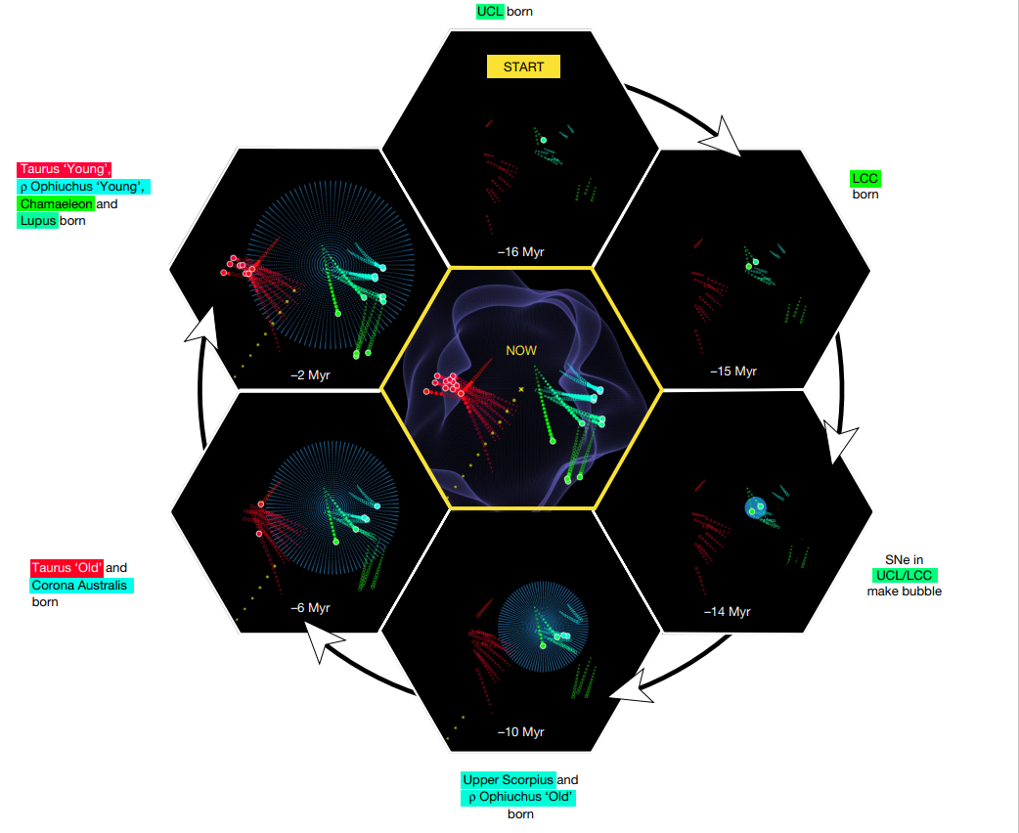

**Fig. 2 | The evolution of the Local Bubble and sequential star formation at the surface of its expanding shell.** Selected time snapshots (seen from a top-down projection) are shown here. For a full time-sequence, viewable from any angle (not just top-down), see the online 3D interactive version in Supplementary Fig. 2. The central figure shows the present day. Stellar cluster tracebacks are shown with the coloured paths. Before the cluster birth, the tracebacks are shown as unfilled circles meant to guide the eye, since our modelling is insensitive to the dynamics of the gas before its conversion into stars. After the cluster birth, the tracebacks are shown with filled circles and terminate in a large dot, which marks the cluster’s current position. For time snapshots ≤14 Myr ago, we overlay a model for the evolution of the Local Bubble (purple sphere), as derived in the Methods. The position of the local standard of rest (LSR) corresponds to the centre of each panel. A more detailed overview of this evolutionary sequence, including the birth positions of all clusters, is provided in Extended Data Table 2. The solar orbit is shown in yellow and indicates that the Sun entered the Local Bubble approximately 5 Myr ago.

**图2 |局部气泡的演化及其膨胀壳表面的连续恒星形成。**此处显示了选定的时间快照（从自上而下的投影中看到）。对于可以从任何角度（而不仅仅是从上到下）查看的完整时间序列，请参见补充图2中的在线3D交互版本。中间的数字显示了今天。星团回溯以彩色路径显示。在星团诞生之前，回溯显示为引导眼睛的未填充圆圈，因为我们的模型对气体转化为恒星之前的动力学不敏感。集群出生后，回溯显示为填充圆，并以一个大点终止，该点标记集群的当前位置。时间快照≤14Myr前，我们叠加了一个局部气泡（紫色球体）演化的模型，正如在方法中推导的那样。当地休息标准（LSR）的位置与每个面板的中心相对应。关于这一进化序列的更详细概述，包括所有集群的出生位置，见扩展数据表2。太阳轨道显示为黄色，表明太阳大约在5Myr前进入了当地的气泡。

The circumstances that led to the birth of the progenitor populations UCL and LCC are more difficult to constrain. Given the close proximity of both the Radcliffe Wave and the Split to the Local Bubble, the origin of UCL and LCC could be related to one of these kiloparsec-scale gaseous structures or to a past interaction between the two. Although current kinematic data are limited, the 3D tracebacks of young stars in two constituent clouds along the Radcliffe Wave (Orion) and the Split (Serpens), but beyond the Local Bubble’s influence suggest that the Radcliffe Wave and the Split could have converged 20 Myr ago at the location where UCL and LCC were born. However, future follow-up work on the 3D motions of these two linear features would be needed to shed light on the true architecture of interstellar gas on kiloparsec scales at the time of the formation of UCL and LCC.

**而导致UCL和LCC祖种群诞生的环境则更加难以约束。考虑到拉德克里夫波和局部气泡分裂都很接近，UCL和LCC的起源可能与千秒尺度的气体结构之一或两者之间过去的相互作用有关。虽然目前的运动学数据有限，但在拉德克利夫波(猎户座)和斯普里特(大蛇座)的两个组成云中，年轻恒星的3D追溯，但超出局部气泡的影响，表明拉德克利夫波和斯普里特可能在20年前在UCL和LCC诞生的地方融合。然而，未来需要对这两个线性特征的3D运动进行后续工作，以阐明UCL和LCC形成时千秒尺度上星际气体的真正结构。**

Regardless of the potential origins of UCL and LCC, we find six-dimensional (6D; 3D position and 3D velocity) observational support for the theory of supernova-driven star formation in the interstellar medium23–26—a long-invoked theoretical pathway for molecular cloud formation found in numerical simulations27. The abundance of new stellar radial velocity data expected in Gaia DR3 should not only enable more refined estimates of the Local Bubble’s evolution, but also enable similar studies farther afield, providing further observational constraints on supernova-driven star formation across our Galactic neighbourhood.

**无论UCL和LCC的潜在起源如何，我们发现六维(6D;这是在数值模拟中发现的一个被长期引用的分子云形成的理论途径。盖亚DR3中大量的新恒星径向速度数据不仅可以对本地气泡的演化进行更精确的估计，而且可以在更远的地方进行类似的研究，为银河系附近超新星驱动的恒星形成提供进一步的观测约束。**

[**https://faun.rc.fas.harvard.edu/czucker/Paper_Figures/Interactive_Figure1.html**](https://faun.rc.fas.harvard.edu/czucker/Paper_Figures/Interactive_Figure1.html) **在线模型**