Assignment: Population dynamics

20 February 2019

Remember the frog matrix? Your first task is to investigate how changing the population vector affects the short term dynamics in the frog population:

library(popbio) #load popbio package

## Warning: package 'popbio' was built under R version 3.5.2

#create an empty matrix and specify the dimensions (3 * 3)   
#The arguments nrow and ncol defines the number of rows and columns.  
A <-matrix(nrow=3, ncol=3)   
  
#Add fecundity measures:  
A[1,] <- c(0, 52, 279.5) #fill first row  
#add survival probabilites:  
A[2,] <- c(0.019, 0.25, 0) #fill second row  
A[3,] <- c(0, 0.08, 0.43) #fill third row  
  
A # inspect your matrix

## [,1] [,2] [,3]  
## [1,] 0.000 52.00 279.50  
## [2,] 0.019 0.25 0.00  
## [3,] 0.000 0.08 0.43

In the first case, we start with 100 individuals distributed over the different life-stages according to the stable stage distribution:

n0_1 <- stable.stage(A)*100   
n0_1

## [1] 98.1353378 1.7136847 0.1509774

In the second case, we start with 100 individuals, all adults.

n0_2 <- c(0,0,100)   
n0_2

## [1] 0 0 100

In the third case, start with 100 individuals, all pre-juveniles.

n0_3 <- c(100,0,0)   
n0_3

## [1] 100 0 0

Track each scenario for 14 years (iterations=15).

N1 <- pop.projection(A, n0_1, 14+1)   
N1$pop.sizes

## [1] 100.0000 133.8048 179.0373 239.5605 320.5434 428.9025 573.8922  
## [8] 767.8954 1027.4810 1374.8190 1839.5739 2461.4384 3293.5229 4406.8921  
## [15] 5896.6335

N2 <- pop.projection(A, n0_2, 14+1)   
N2$pop.sizes

## [1] 100.00 27993.00 12568.04 33194.10 33638.15 52101.35 65047.31  
## [8] 90107.41 118547.19 159951.67 213147.94 285778.04 382005.82 511391.52  
## [15] 684102.36

N3 <- pop.projection(A, n0_3, 14+1)   
N3$pop.sizes

## [1] 100.00000 1.90000 99.42700 69.28331 134.65812 152.57148  
## [7] 222.31508 285.51344 389.89757 516.52494 694.54177 927.08861  
## [13] 1241.96429 1660.83724 2222.91888

1. Why do you think that the population sizes differ so much?

*The answer should include that individuals from the different stages don’t contribute equally to future populations. In this case, adults contribute the most to future population sizes (adults have the highest reproductive value) and pre-juveniles contribute the least (have the lowest reproductive value).*

1. If you would attempt a reintroduction program, would you release juveniles or adults?

*Adults*

Your second task is to calculate the growth rate and sensitivities for a population of orcas. Orcas have expanded northwards in response to climate change. This is expected to result in trophic cascades in their new foraging areas because they feed on other marine mammals.

Load the whale matrix from popbio:

library(popbio) #load popbio package  
data(whale)  
whale

## yearling juvenile mature postreprod  
## yearling 0.0000 0.0043 0.1132 0.0000  
## juvenile 0.9775 0.9111 0.0000 0.0000  
## mature 0.0000 0.0736 0.9534 0.0000  
## postreprod 0.0000 0.0000 0.0452 0.9804

Calculate the long term deterministic lambda for the population:

lambda(whale)

## [1] 1.025441

1. What does this say about future population sizes?

*Lambda is larger than = 1 which means that the population is increasing. Future population sizes are likely to increase*

1. Do you trust that using this measure would result in accurate estimates of future population sizes of this natural orca population? Why/why not?

*It could perhaps be trusted in the short term because it is based on actual reproduction and survival probabilities in a real population.* *Main reason not to trust it is that it doesn’t take stochastic factors (environmental variation, local conditions, demographic factors…) into account. Stochastic lambda could be lower than the deterministic lambda (which is already close to 1 [the population is decreasing when lambda < 1]). That is, the population size could in fact decrease in the future.*

Calculate sensitivities and elasticities for the transitions in the whale matrix. Plot the resulting sensitivity and elasticity matrices.

image2(sensitivity(whale))

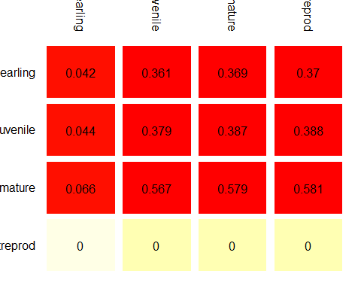

image2(elasticity(whale))

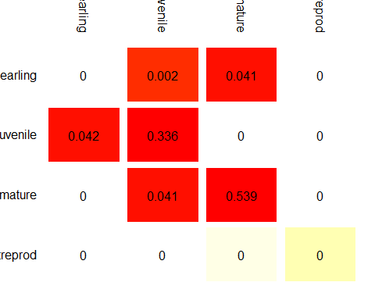

1. What do these values say about the importance of the different transitions in the matrix for the population growth rate? What would be the implications for management?

*Answer should include something in terms of:*

*The sensitivities say how sensitive the population growth rate is to a tiny change in each vital rate/matrix element.* *Elasticities are proportional sensitivities that allow us to compare the importance of changes in vital rates for the population growth rate among vital rates/matrix elements*

*Survival of mature individuals has a large effect on population growth rate and so does survival of juveniles. (Probably because survival in each of these classes means that individuals can reproduce year after year after year and thereby contribute to population growth). I would focus my efforts on management that lead to an increased survival in these classes.*

*(We get sensitivities for several impossible transitions. In theory this would indicate that if it were possible to increase transitions from e.g. post-repoductive to mature this would have a large effect on population growth rate.)*