Adaptive Control – Final Project

Eduardo Rosado

Brandon Foggie

# Introduction:

When designing a car, one of the most important components is nailing down how good it drives. Handling qualities in cars can be a make-or-break factor for customers on the look for a new vehicle. This project involves designing an adaptive controller that yields desired handling qualities given any car model and some extra specifications. In order to accomplish this, a simple car model is used with second order system approximations for both throttle and steering engine and actuator models respectively. A robust controller is to be designed for sportier cars where the performance will be determined based on responsiveness throughout different input frequencies and amplitudes.

# System Modeling:

A car’s steering characteristics is determined by wheelbase and speed, therefore a throttle and steering mechanism needs to be modeled in order to asses performance for the goal in mind (car handling qualities). We will assume a AWD car model where equal force is exerted by all four wheels. The front wheels rotate and induce a moment in the car that causes the car to turn due. The force of the wheels is calculated via the wheel speed and the moment it would induce per wheel. The diagram below shows the general diagrams from which the equations of motion are going to be derived.

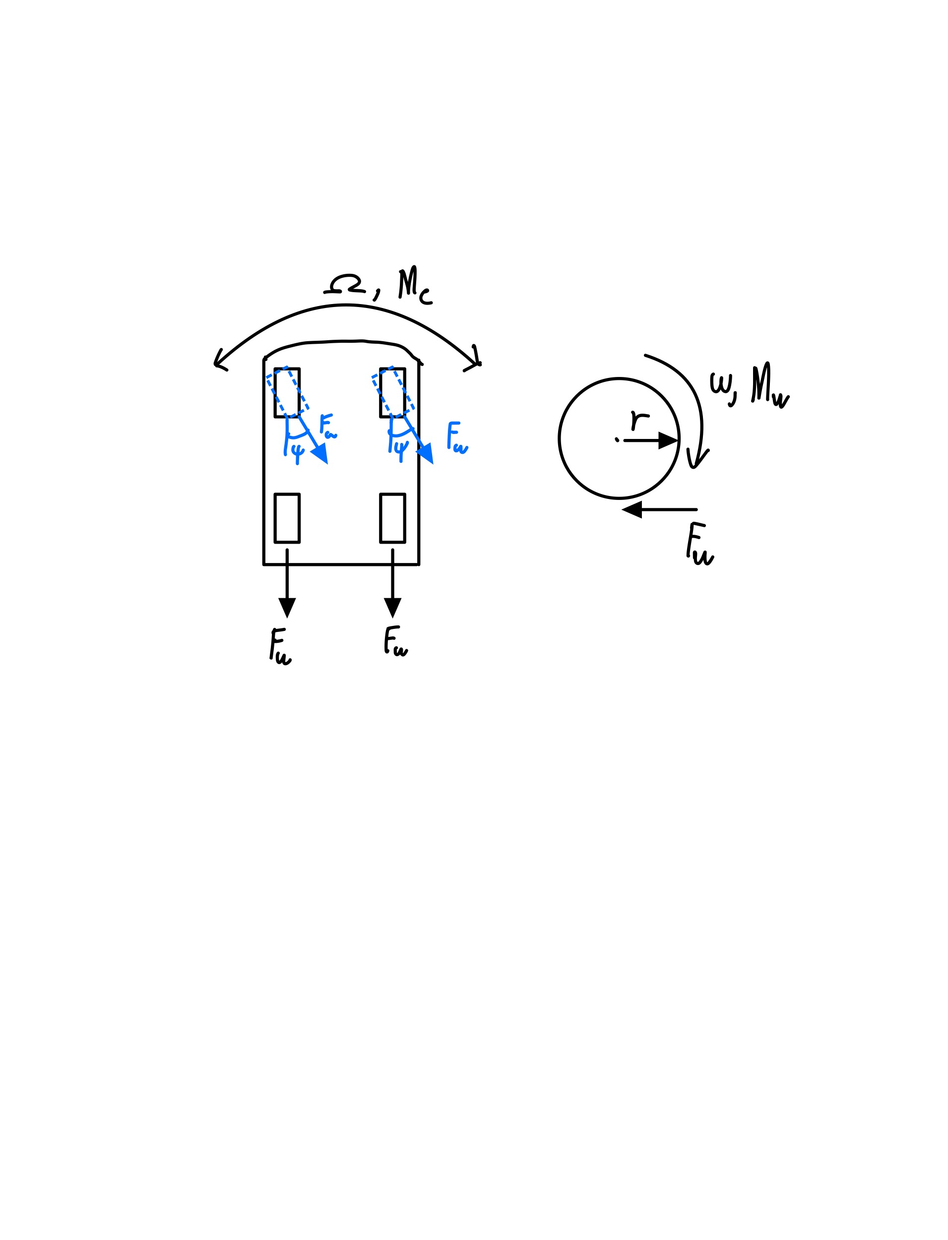

The symbols are described below:

$$ω=wheel angular velocity$$

$$M_{w}= wheel moment$$

$$F_{w}=wheel force$$

$$r=wheel radius$$

$$ψ=wheel rotation angle$$

$$Ω=car angular velocity$$

The equations of motion are then organized by forces and moments in X and Y as shown below.

$ΣF_{x}=2F_{w}+2F_{w}cosψ=m\ddot{x}$

$ΣF_{y}=2F_{w}sinψ$

$M_{c}=ΣF_{y}R=I_{c}\dot{Ω}$

$M_{w}=F_{w}r=I_{w}\dot{ω}$

These can be organized into state space format as follows:

$$\left[\begin{matrix}\dot{x} \\ \ddot{x} \\ \dot{Ω}\end{matrix}\right]=\left[\begin{matrix}0 & 1 & 0 \\ 0 & -c_{x} & 0 \\ 0 & 0 & -c_{Ω}\end{matrix}\right]\left[\begin{matrix}x \\ \dot{x} \\ Ω\end{matrix}\right]+\left[\begin{matrix}0 & 0 \\ \frac{4I_{w}}{mr} & 0 \\ \frac{I_{w}R}{I_{c}}ψ & \frac{I_{w}R}{I_{c}}\end{matrix}\right]\left[\begin{matrix}\dot{ω} \\ ψ\end{matrix}\right]$$

Where road friction was modeled by the damping terms $c_{x}$ and $c_{Ω}$ for forward acceleration and angular acceleration respectively.

# Control Law Design and Simulation:

Given the dynamics that were explained above that contains multiple inputs and multiple outputs (MIMO) a choice had to be made in terms of what type of adaptive controller we wanted to use. So with this information at hand we chose to design a MIMO robust controller. With the knowledge that we also want to focus on the heading of the car and making sure that the heading converges to the input given as well as the acceleration we designed a baseline PI controller augmented with MRAC to be able to easily tune the system to our needs. The reason this method was chosen, is for its ease of use, due to the extended states that are inherit within the controller design. Having the two added states being the error of the acceleration and heading these were obvious candidates to target for higher penalties within the Q matrix used in the LQR method to determine the optimal gains for our system. Utilizing this method also gives you a lot of control in terms of the response of the reference model. The same methodology was also used while tuning the gain matrix in the adaptive block of the model as shown below.

Figure 2: CARSIM Simulink model

In terms of robustness, we wanted to utilize one of the methods we learned in class to account for things such as gravel or any other sudden losses of traction. To simulate this affect, disturbance was added to the state space model, and we used dead zone to account for

this extra noise within the system.

Figure 3: Adaptive block with dead zone

# Results & Discussion: