COVID 19 Forecasting

Introduction
COVID-19 has become an urgent global issue since last year and is likely to affect our lives for another long period in the future. To know when will the pandemic end, we need to discover the growth trend of confirmed case. These can be achieved by applying formulas and models that former medical scholars and scientists have concluded for us. However, based on the high-speed development of machine learning in recent years, we are able to generate our own models using raw data to predict the future. This project is aimed to generate a model that can predict the future cumulative confirmed cases of COVID-19 in America using the LSTM (Long-Short Term Memory) Neural Network (NN).
An Artificial Neural Network (ANN) or just Neural Network (NN) is a series of algorithms that endeavors to recognize underlying relationships in a set of data through a process that mimics the way the human brain operates. In this sense, neural networks refer to systems of neurons, either organic or artificial in nature. Neural networks can adapt to changing input, so they can generate the best possible result without needing to redesign the output criteria.
Figure 1 A Simple Neural Network
LSTM is a special type or RNN (Recurrent Neural Networks). It is explicitly designed to avoid the long-term dependency problem, so its default behavior is to remember information for long periods of time. LSTM networks are well-suited to classifying, processing and making predictions based on time series data. Its specialty on making predictions based on time series data welly fits the purpose of this project.

Data Source
The data source of the cumulative confirmed cases of COVID-19 in America is from World Health Organization (WHO) COVID-19 Dashboard.
The reason why I chose America is because it has the largest confirmed number and has been proceeding mass vaccination for a period, this dataset shows the rapid growing and the gradual slowdown of increments clearly.
Date_reported | Country_code | Country | WHO_region | New_cases | Cumulative_cases | New_deaths | Cumulative_deaths
2021/3/18 | UG | Uganda | AFRO | 14 | 40607 | 0 | 334
2020/1/30 | US | United States of America | AMRO | 1 | 10 | 0 | 0
2020/1/31 | US | United States of America | AMRO | 1 | 11 | 0 | 0
2020/2/1 | US | United States of America | AMRO | 1 | 12 | 0 | 0
2020/2/2 | US | United States of America | AMRO | 0 | 12 | 0 | 0
2020/2/3 | US | United States of America | AMRO | 2 | 14 | 0 | 0
2020/2/4 | US | United States of America | AMRO | 1 | 15 | 0 | 0
2020/2/5 | US | United States of America | AMRO | 0 | 15 | 0 | 0
2020/2/6 | US | United States of America | AMRO | 1 | 16 | 0 | 0
Table 1 Sample Piece of the Raw Data
The only required columns are the ‘Date_reported’ and ‘Cumulative_cases’ and the required rows are the ones with ‘Country_code’ equal to ‘US’.

Machine Learning Framework and Code
import numpy as np
import pandas as pd
import matplotlib.pyplot as plt
import matplotlib.dates as mdates
from keras.models import Sequential
from keras.models import load_model
from keras.layers import Dense
from keras.layers import LSTM
from keras.callbacks import EarlyStopping
from sklearn.metrics import r2_score
from sklearn.preprocessing import MinMaxScaler
# WHO Coronavirus (COVID-19) Dashboard, World Health Organization, 19 March 2021, https://covid19.who.int/
data_path = './WHO-COVID-19-global-data.csv'
model_path = './Covid_cumulative_USA.h5'
# Import the raw csv
df = pd.read_csv(data_path)
# Filtered US data only
data = df[df.loc[:, 'Country_code'] == 'US']
print('size: ', data.shape)
print(data.head())
date = np.array(pd.to_datetime(data['Date_reported']))
cumulative = data['Cumulative_cases']
# Take the first 90% data as the train set, the remained as the test set
train_size = int(0.9 * len(cumulative))
data_train = cumulative[:train_size]
data_test = cumulative[train_size:]
# Plot the original cumulative curve
plt.figure(figsize=(100, 20))
ax = plt.subplot()
ax.xaxis.set_major_formatter(mdates.DateFormatter('%Y-%m-%d'))
plt.xticks(pd.date_range(date[0], date[-1], freq='D'), rotation=45)
ax.plot(date, cumulative)
ax.set_title('Conformed COVID-19 Cases in United States of America', fontsize=30)
ax.set_xlabel('Date Reported', fontsize=20)
ax.set_ylabel('Cumulative Cases', fontsize=20)
plt.show()
# Plot the cumulative curve shows train and test set division
plt.figure(figsize=(100, 20))
ax = plt.subplot()
ax.xaxis.set_major_formatter(mdates.DateFormatter('%Y-%m-%d'))
plt.xticks(pd.date_range(date[0], date[-1], freq='D'), rotation=45)
ax.plot(date[:train_size], data_train)
ax.plot(date[train_size:], data_test)
ax.legend(['train', 'test'], fontsize=20)
ax.set_title('Conformed COVID-19 Cases in United States of America', fontsize=30)
ax.set_xlabel('Date Reported', fontsize=20)
ax.set_ylabel('Cumulative Cases', fontsize=20)
plt.show()
# Normalize the data between 0 and 1
scaler = MinMaxScaler(feature_range=(0, 1))
train_set = scaler.fit_transform(data_train.values.reshape(-1, 1))
test_set = scaler.transform(data_test.values.reshape(-1, 1))
X_train = train_set[:-1]
y_train = train_set[1:]
X_test = test_set[:-1]
y_test = test_set[1:]
# Train and save the model
x_train = X_train.reshape(len(X_train), 1, 1)
lstm_model = Sequential()
lstm_model.add(LSTM(7, activation='relu', kernel_initializer='lecun_uniform', return_sequences=False))
lstm_model.add(Dense(1))
lstm_model.compile(loss='mean_squared_error', optimizer='adam')
early_stop = EarlyStopping(monitor='loss', patience=5, verbose=1)
history_lstm_model = lstm_model.fit(x_train, y_train, epochs=100, batch_size=1, verbose=1, shuffle=False, callbacks=[early_stop])
# Save the model in the given path
lstm_model.save(model_path)
# Calculate the R-squared (degree of fitting)
x_test = X_test.reshape(len(X_test), 1, 1)
y_train_pred = lstm_model.predict(x_train)
y_test_pred = lstm_model.predict(x_test)
print('R2 score on the Train set:{:0.3f}'.format(r2_score(y_train, y_train_pred)))
print('R2 score on the Test set:{:0.3f}'.format(r2_score(y_test, y_test_pred)))
# Denormalize the data
y_test_pred_origin = scaler.inverse_transform(y_test_pred)
y_test_origin = scaler.inverse_transform(y_test)
# Calculate 10 days accuracy
print('10 Days Prediction Accuracy')
acc = np.ones(10).reshape(-1, 1)-abs(y_test_origin[:10]-y_test_pred_origin[:10])/y_test_origin[:10]
print(acc)
# Plot the Original and predicted data together
plt.figure(figsize=(10, 6))
plt.plot(y_test_origin, label='True')
plt.plot(y_test_pred_origin, label='LSTM')
plt.title("Cumulative Cases Prediction")
plt.xlabel('Days in Advance')
plt.ylabel('Cumulative Cases')
plt.legend()
plt.show()

Results
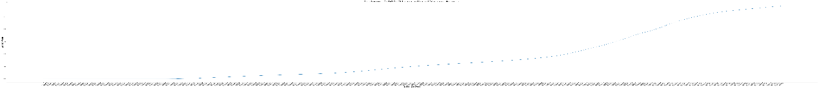
Figure 2 Original Cumulative Curve

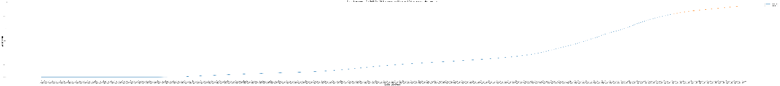
Figure 3 Curve Divided into Train and Test Sets
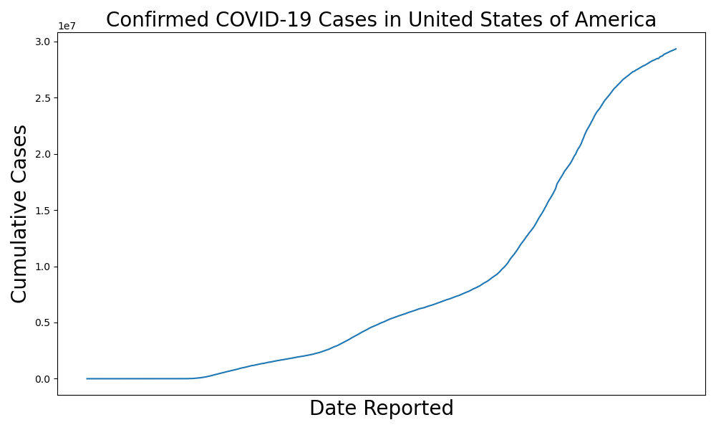
Figure 4 Original Cumulative Curve (No Date Labelled)
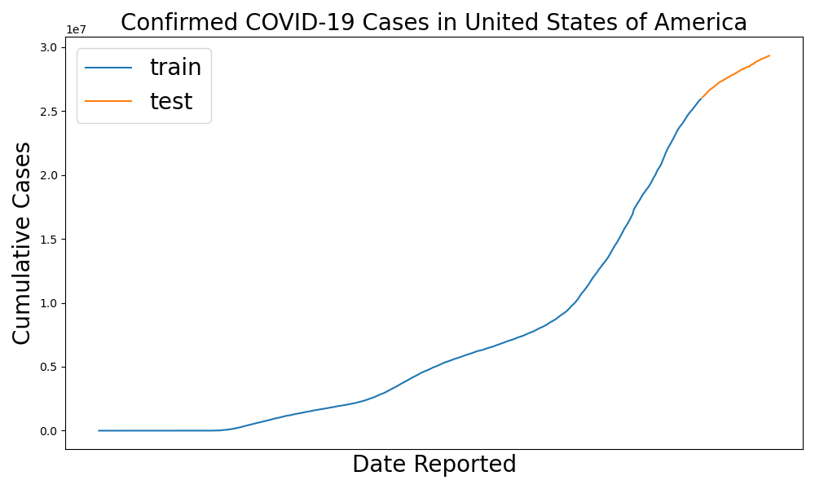
Figure 5 Curve Divided into Train and Test (No Date Labelled)
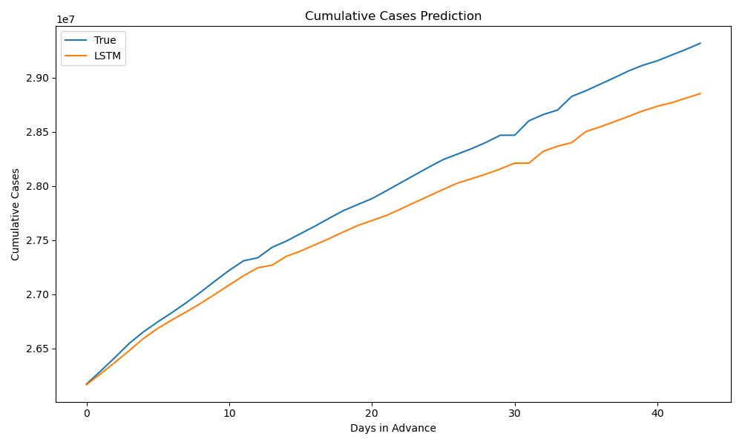

Figure 6 Original Curve and Predicted Curve (Test Section)
R² (Degree of Fitting):
R² on the Train set: 0.986
R² on the Test set: 0.907

Accuracy of 10 Days in Advance Prediction:
Days in Advance | Accuracy
1 | 0.99975165
2 | 0.99903678
3 | 0.99830146
4 | 0.99749943
5 | 0.99771581
6 | 0.99775757
7 | 0.99747459
8 | 0.99686247
9 | 0.99616134
10 | 0.99548594
Table 2 Accuracy of Future Prediction

Conclusion
From the results, we can see that the model performs a good regression. The accuracy of the 10 days in advance prediction again validates this conclusion. The prediction of the cases is usually lower than the actual values, and the accuracy decreases as the days go beyond. If there is no emergency that affects the pandemic, the model should be able to predict the cumulative confirmed cases in the future or even when will the pandemic end in America in an acceptable region.

Reference

James Chen, Michael J Boyle, Neural Network, Investopedia, 23 December 2020, https://www.investopedia.com/terms/n/neuralnetwork.asp
Sabrina Jiang, Neural Network, Investopedia, 23 December 2020, https://www.investopedia.com/terms/n/neuralnetwork.asp
Colah, Understanding LSTM Networks, GitHub, 27 August 2015, https://colah.github.io/posts/2015-08-Understanding-LSTMs/
Long short-term memory, Wikipedia, 25 March 2021, https://en.wikipedia.org/wiki/Long_short-term_memory
WHO Coronavirus (COVID-19) Dashboard, World Health Organization, 19 March 2021, https://covid19.who.int/

