|  |
| --- |
| **ITNE 2005R Network Security Implementation**  **Lab Tutorial 1- Task 1** |

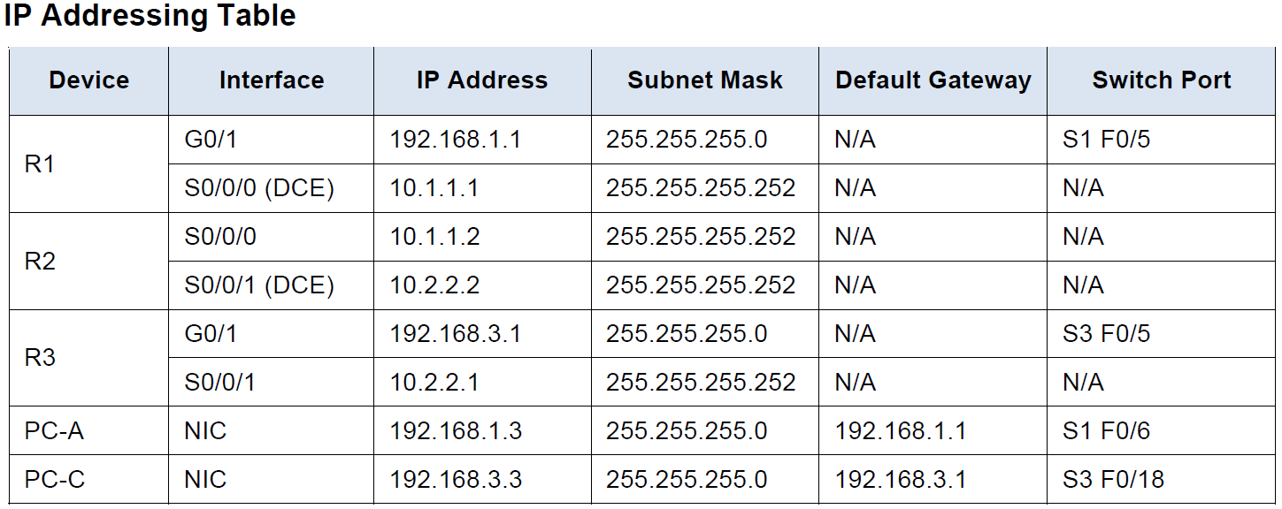

**Task 1: Configure Basic Device Settings**

**Step 1: Deploy router in Packet Tracer.**

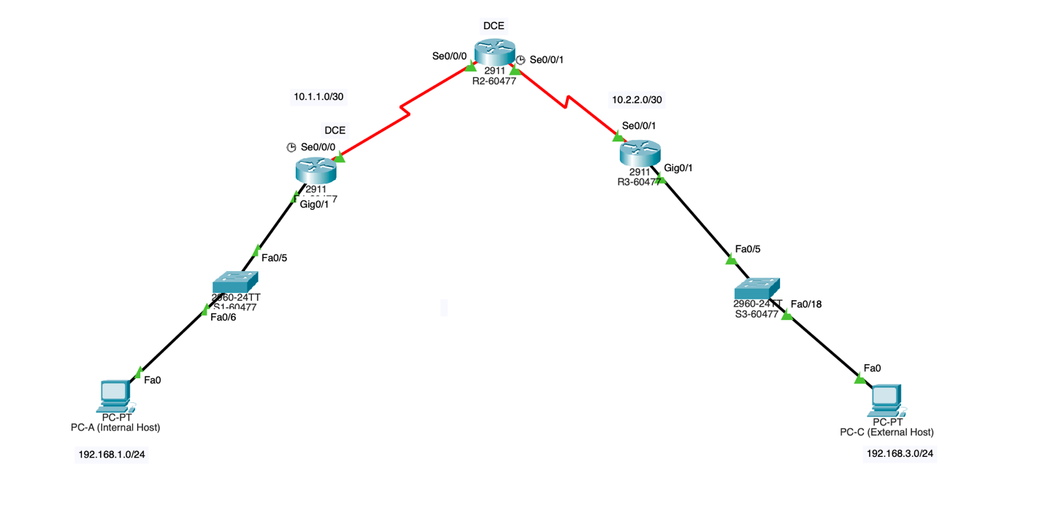

**Step 2: Configure basic settings for each router.**

**a.** Configured host names as shown in the topology plus my student ID - 59585.

Router R1-60477

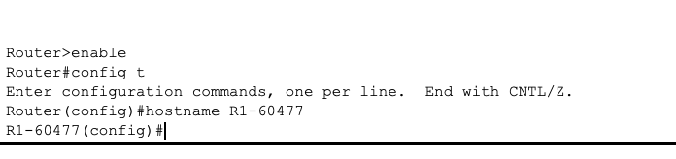

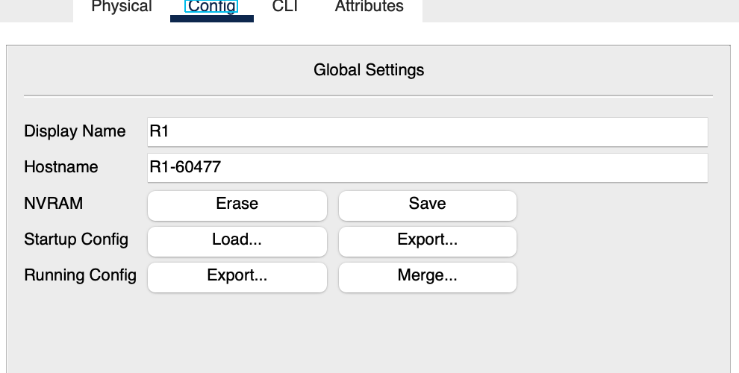

Router R2-60477

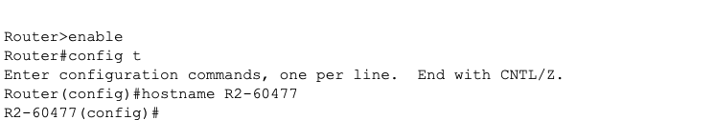

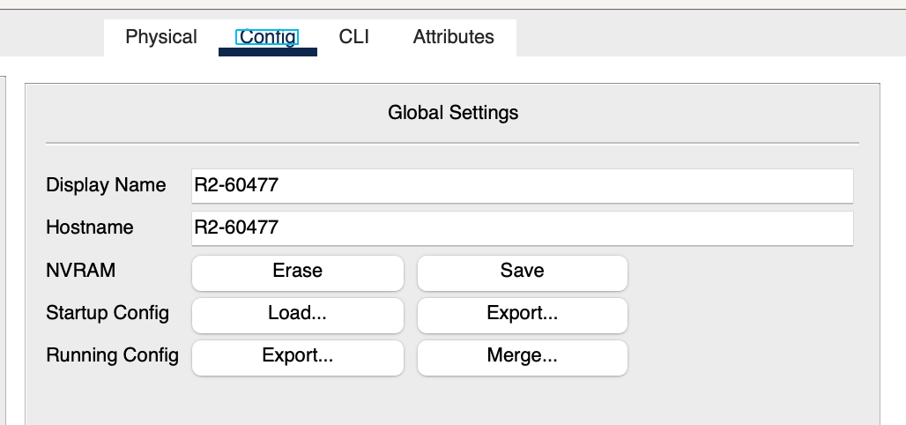

Router R3-60477



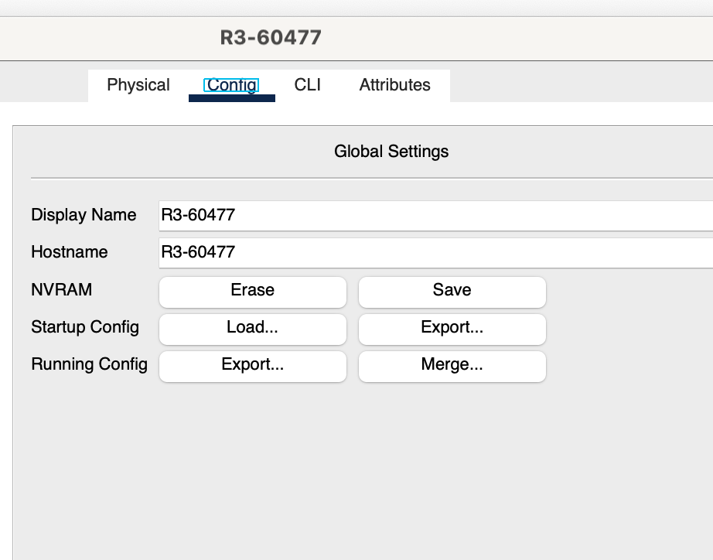

**b.** Configured interface IP addresses as shown in the IP Addressing Table.

R1-60477 Configuration:

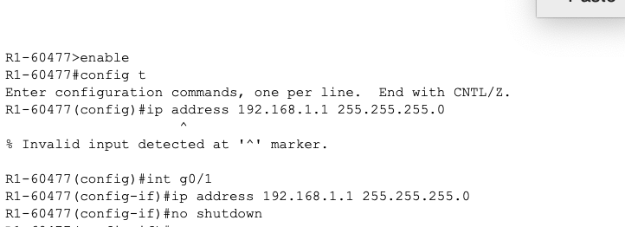

R1- 60477 Interface brief

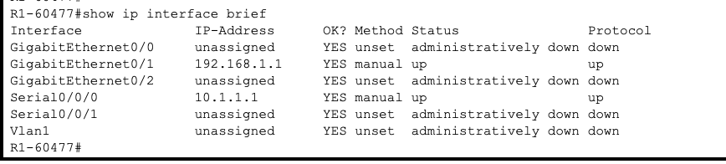

R2-60477 Configuration:

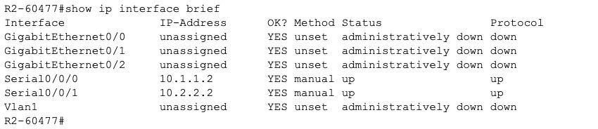

R2- 60477 Interface brief

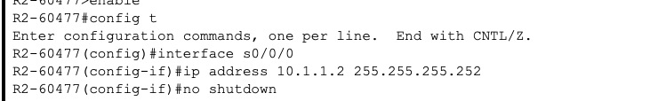

R3-60477 Configuration:

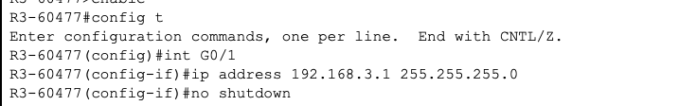

R3- 60477 Interface brief

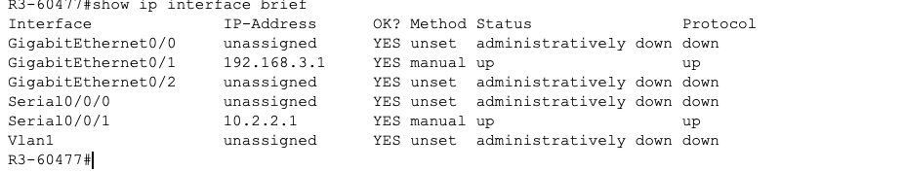

c. Clock Rate Configured for routers with a DCE serial cable attached.

R1-60477

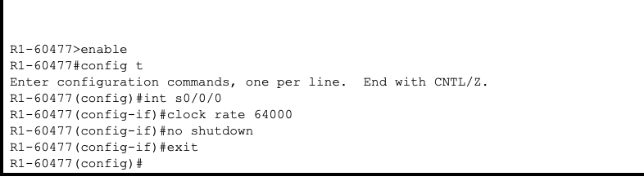

R2-60477

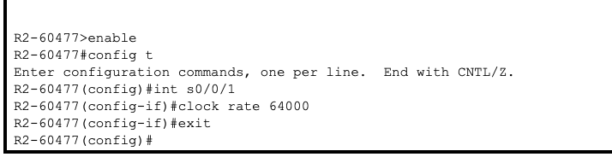

d. DNS Lookup disabled for R1-60477

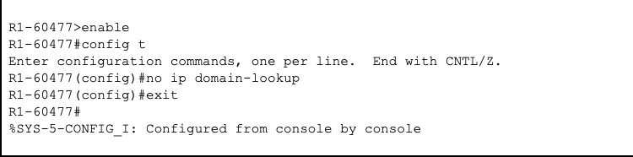

DNS Lookup disabled for R2-60477

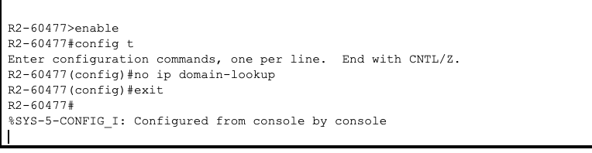

DNS Lookup disabled for R3-60477

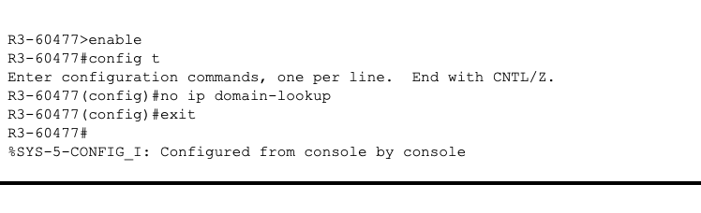

**Step 3: OSPF Routing configured on the routers.**

1. **Global configuration mode enabled**

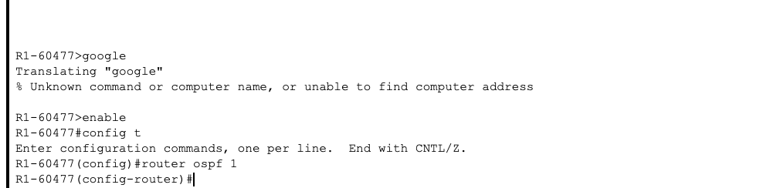

1. Statements configured and Area ID of 0 in use.

R1:

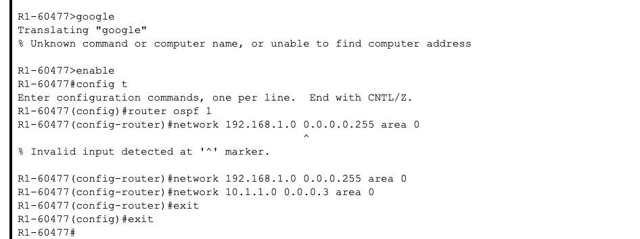

R2:

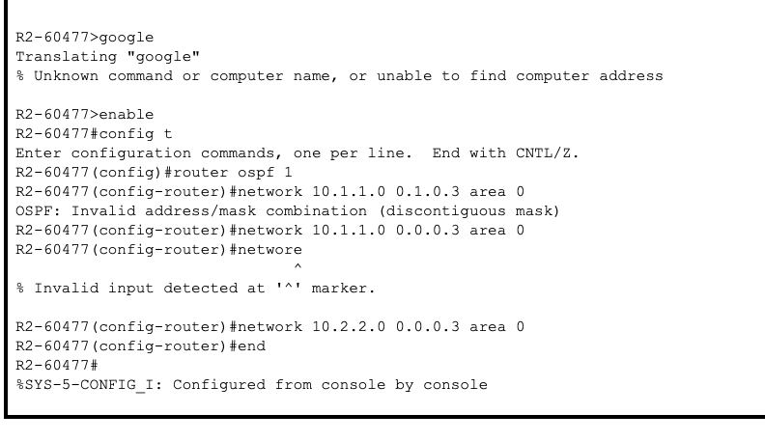

R3:

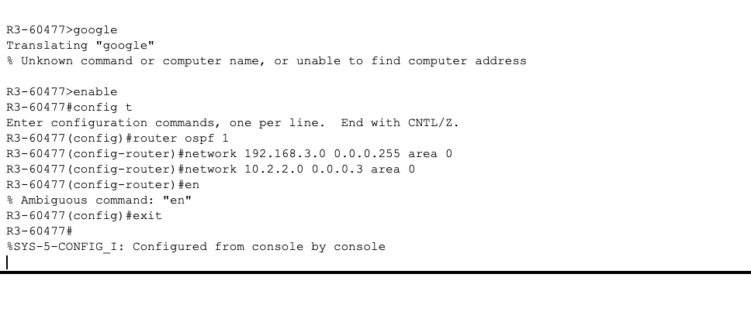

1. Passive -interface command issued to change the g0/1

R1:

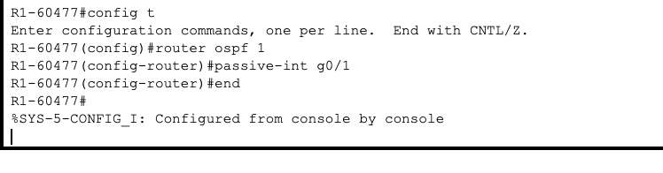

R3:

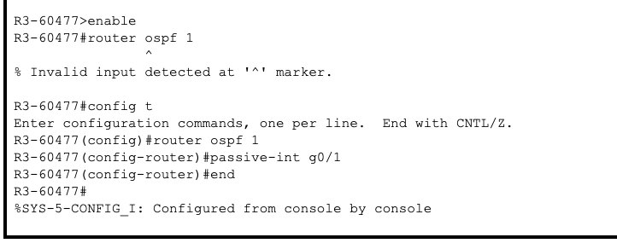

**Step 4: Verified OSPF neighbors and routing information.**

1. The output below confirms R1 has formed a FULL neighbor relationship with R2 (Neighbor ID 10.2.2.2).

R1:

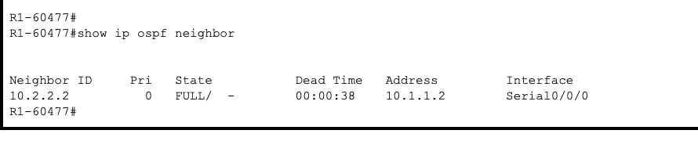

R2:

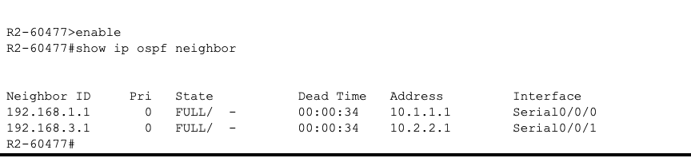

R3:

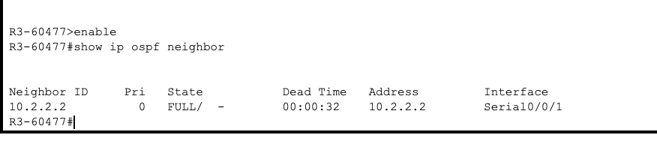

b.

R1: The routing table for R1 now shows a route to the 192.168.3.0/24 network learned via OSPF, indicated by the **'O'** in the left column.

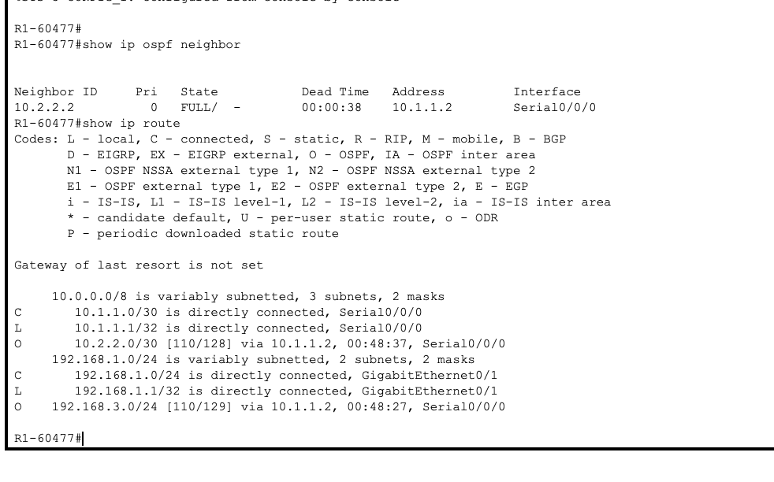

R2:

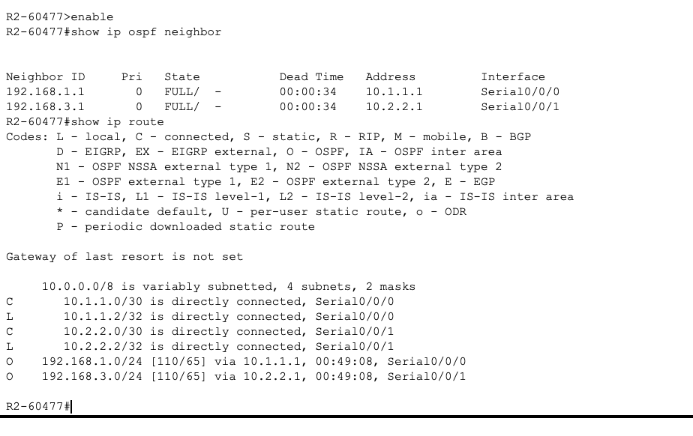

R3:

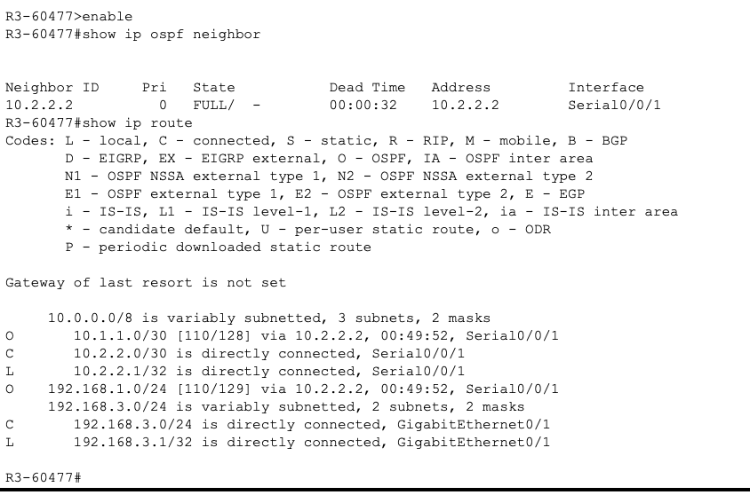

**Step 5: Configure PC host IP settings.**

PC-A

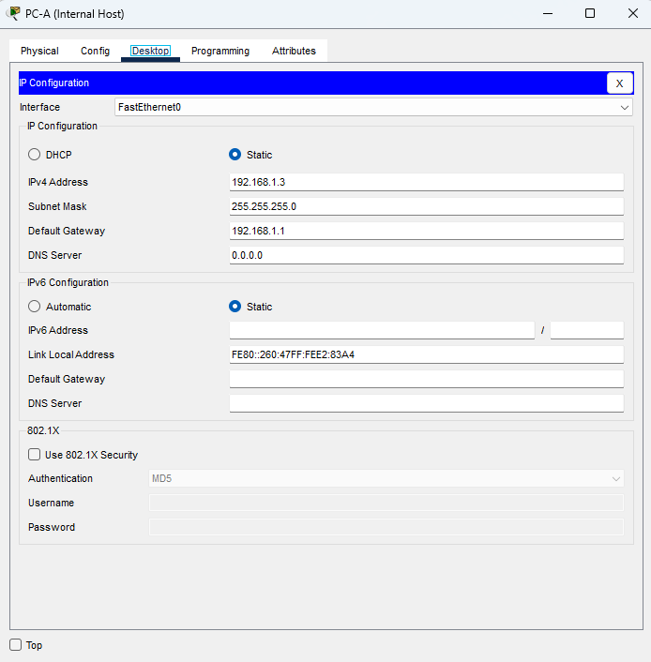

PC-B

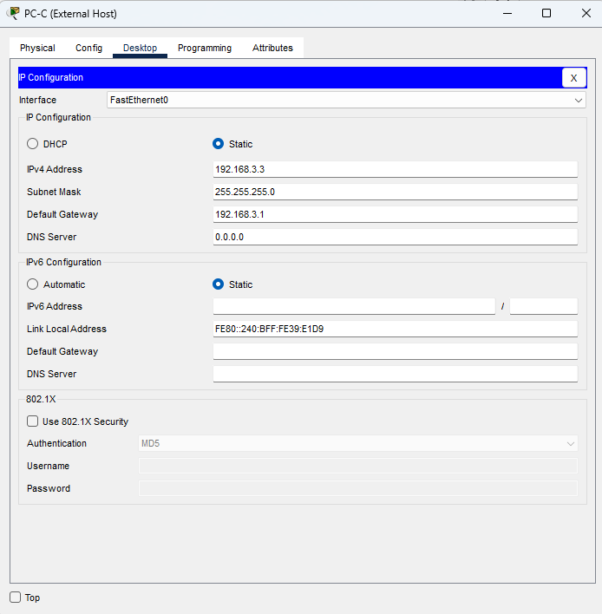

**Step 6: Verify connectivity between PC-A and PC-C.**

Ping test 100% success from PC-A to PC-C

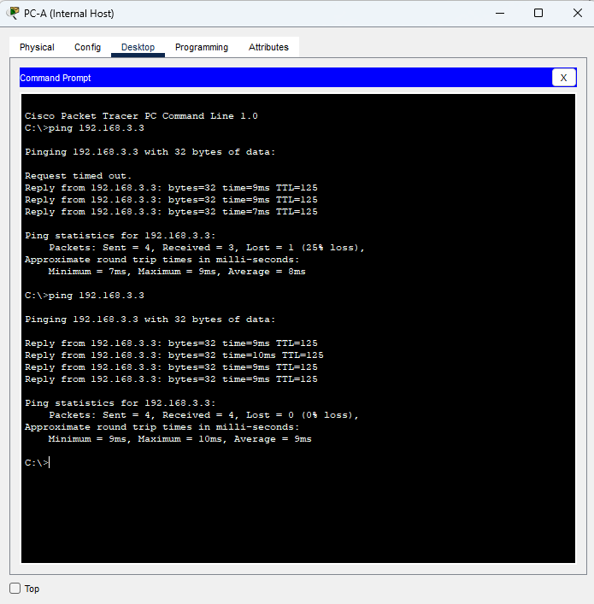

**Step 7: Save the basic running configuration for each router.**

**Saved (similar for the R1,R2,R3)**

